## Горизонтальная линия



Test result report

The Calculator Application 1.0

Created by Kravets Alina

11/28/2021

# TABLE OF CONTENTS

Summary………………………………………………………………………………………………………...3

Test Team………………………………………………………………………………………………………..3

Testing process description………………………………………………………………………………..3

Timetable……………………………………………………………………………………………………….4

All Bugs………………………………………………………………………………………………………….4

New Bugs……………………………………………………………………………………………………….5

Recommendations…………………………………………………………………………………………...7

# 

# Summary

In the period from 18 to 24 November was held application build testing Calculator 1.0.

The following test documentation was compiled for testing: Smoke Check-list (22 tests), Check-list for the Critical path test (22 tests), Test suit for the “Subtraction” module (18 tests), Test suit for the “Addition” module (18 tests).

Completed 90% of Smoke tests and 70% of Сritical path tests. It was not possible to finish the Smoke tests due to the lack of the functionality of “Squaring”, “Square root extraction”. Extended testing was carried out on the “Addition” module.

The application contains too many bugs even for the initial stage of development: **17** bugs of Critical severity, **10** bugs of Major severity, **8** bugs of Minor severity were found.

It was found that **68%** of high priority requirements were implemented incorrectly, which allows us to conclude that the quality of the product is low.

Due to the large number of problems, there is a risk that we will not be able to fix them in a short time, as a result of which the testing and development process may be delayed.

It is planned for the next iteration: fixing of identified bugs, completion of work on writing test cases of the critical path, completion of application testing.

# Test Team

Kravets Alina, Junior QA

* Analysis and design of test scenarios
* Creation of test cases
* Manual functional testing
* Documentation of defects

# Testing process description

Product: Calculator application, build 1.0 [**calculator**](https://drive.google.com/file/d/1hLMsZz4sWjRCTPis3iMJz-O25TpDg3ZV/view?usp=sharing)

Test cases are based on [**requirements**](https://docs.google.com/document/d/1V-ZPCIO1dajGp_W40xlih0axyZQcs5dy9_LwuOUfO-A/edit?usp=sharing)

Setting: Windows 10 version of 21H1

Testing method: black box method Testing

Level: System testing.

Types of testing performed: Functional testing, installation testing, GUI testing.

The test results can be viewed in Testrail at the link: [**https://kravetsalina.testrail.io/index.php?/runs/view/1&group_by=tests:status_id&group_order=asc**](https://kravetsalina.testrail.io/index.php?/runs/view/1&group_by=tests:status_id&group_order=asc)

# Testing Timetable

|  |  |  |
| --- | --- | --- |
| **Date** | **Activity** | **Duration** |
| 11/18/2021 | Creating of Smoke Check-list, Check-list for the Critical path test | 2 hours |
| 11/19/2021 | Creating Test cases corresponding Test suite for requirement # 22.2 | 3 hours |
| 11/22/2021 | Transfer of checklists and test cases to the testrail | 1 hour |
| 11/23/2021 | Test cases execution | 3 hours |
| 11/24/2021 | Documentation of bugs | 3 hours |

# All Bugs

|  |  |  |  |  |
| --- | --- | --- | --- | --- |
| **Status** | **Quantity** | **Importance** | | |
| **Minor** | **Major** | **Critical** |
| Found | 35 | 8 | 10 | 17 |
| Fixed | 0 | 0 | 0 | 0 |
| Verified | 0 | 0 | 0 | 0 |
| Reopened | 0 | 0 | 0 | 0 |
| Rejected | 0 | 0 | 0 | 0 |

# 

# 

# 

# New Bugs

|  |  |  |
| --- | --- | --- |
| **ID** | **Summary** | **Severity** |
| 1_T22 | The application requires the installation of an additional Visual C ++ package, if you download the application from the link "vcredist_x86.exe" | Critical |
| 2_T22 | The application is implemented in the C ++ programming language, which contradicts the system requirements for the product | Critical |
| 3_T22 | After launched, the application runs in an unknown mode | Critical |
| 4_T22 | The picture and the name of application - Calculator in the top left corner of the app's window does not correspond to the requirements | Critical |
| 5_T1 | Used English languages ​​to display some errors | Critical |
| 6_T2 | There is no default field value in the I / O field | Critical |
| 8_T2 | The entered number disappears from the I / O field after pressing the arithmetic action button | Critical |
| 17_T3 | Button "9" is not illuminated on the keyboard layout and not pressed | Critical |
| 23_T5 | No additional arithmetical button for squaring in "Engineering" mode | Critical |
| 24_T5 | No additional arithmetical button for square root extraction in "Engineering" mode | Critical |
| 26_Т7 Т11 | Incorrect addition result in the I / O field when the second term has a value greater than "100" | Critical |
| 27_Т8 T12 | Incorrect subtraction result in the I / O field when the subtracted number has a value greater than "100" | Critical |
| 28_T9 T13 | Incorrect multiplication results in the I / O field when the second multiplier has a value greater than "100" | Critical |
| 29_T10 T14 | Incorrect division results in the I / O field when the divisor has a value greater than "100" | Critical |
| 30_T10 T14 | Error pop-up appears when trying to divide by zero | Critical |
| 32_T | Incorrect result of calculating in the I / O field when creating a sequence of calculations | Critical |
| 33_T | The app crash when pressing to an empty field between buttons | Critical |
| 7_T2 | An unlimited number of sings are entered in the I / O field | Major |
| 9_T2 | Record of a sequence of calculations is not displayed in the I / O field | Major |
| 10_T2 | The result of the calculation is not displayed in the I / O field when the "Enter" button is pressed from the keyboard | Major |
| 13_T2 | No numbers are entered in the I / O field from the keyboard without first placing the text cursor in the I / O field | Major |
| 14_T2 | An error pop-up window appears if enter arithmetic formulas from the keyboard | Major |
| 15_T2 | The results of the arithmetic action changes in the I / O field when we enter the symbol in the field | Major |
| 16_T2 | An error pop-up appears if you enter the number 1 in the I / O field after several 5 or more characters have already been entered in the field | Major |
| 31_T20 | Button "☐" is not illuminated in the top right corner of the app's window and not pressed | Major |
| 34_T2 | An error pop-up window appears if enter arithmetic sings in the empty I / O field | Major |
| 35_T2 | An error pop-up window appears if enter two arithmetic signs after number in the I / O field | Major |
| 11_T2 | The result obtained after the arithmetic operation appears in the I / O field as the line "The result is:" | Minor |
| 12_T2 | 0 is displayed before an integer and before a whole decimal fraction in an I / O field if entered before entering another number | Minor |
| 18_T3 | The font on button "2" is different in size and color on the keyboard layout | Minor |
| 19_T3 | The "0" button is displayed with a dot on the keyboard layout | Minor |
| 20_T3 | A contextual hint appears with incorrect information near button "8" if the cursor is hovering over button "8" on the keyboard | Minor |
| 21_T5 | The field of numbers turns red after selecting the "Normal" mode | Minor |
| 22_T5 | The size of the application window becomes larger when the application is in "Engineering" mode | Minor |
| 25_T6 | A grammatical error in the name of the option "About" in the menu bar | Minor |

# Recommendations

Based on the analysis of the test results, it was found that one of the main reasons for the presence of a large number of errors is incompleteness, ambiguity, and incorrectness of requirements. It is worth making the necessary changes and additions to the requirements.

It is also worth paying attention to the development process, making it mandatory to conduct unit tests.

# Applications

**Picture 1. Total number of bugs**

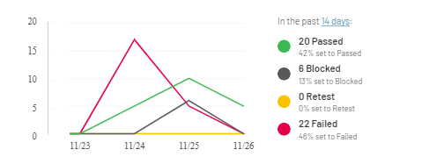

**Picture 2. Diagram of results of Smoke test - cases execution**

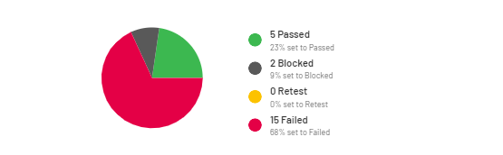

**Picture 3. Diagram of results of Test Suite “Addition” execution**

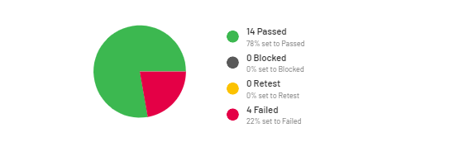

Links

1**.** To the bug reports:

[https://docs.google.com/ spreadsheets / d / 1w5M60FWeiTPjKFhcITdrit7kWSsYT6lESaTGG8L0vig / edit? usp = sharing Defect](https://docs.google.com/spreadsheets/d/1w5M60FWeiTPjKFhcITdrit7kWSsYT6lESaTGG8L0vig/edit?usp=sharing)

2. To the testing documentations: <https://docs.google.com/spreadsheets/d/1yzNtuQ3vTqnFZhpQMyCWJo70W3qKD95zrYbIE_HMkT8/edit?usp=sharing>