Stak1.3.2
1:

Function: Create a function that takes an integer as an argument and returns "Even" for even numbers or "Odd" for odd numbers.

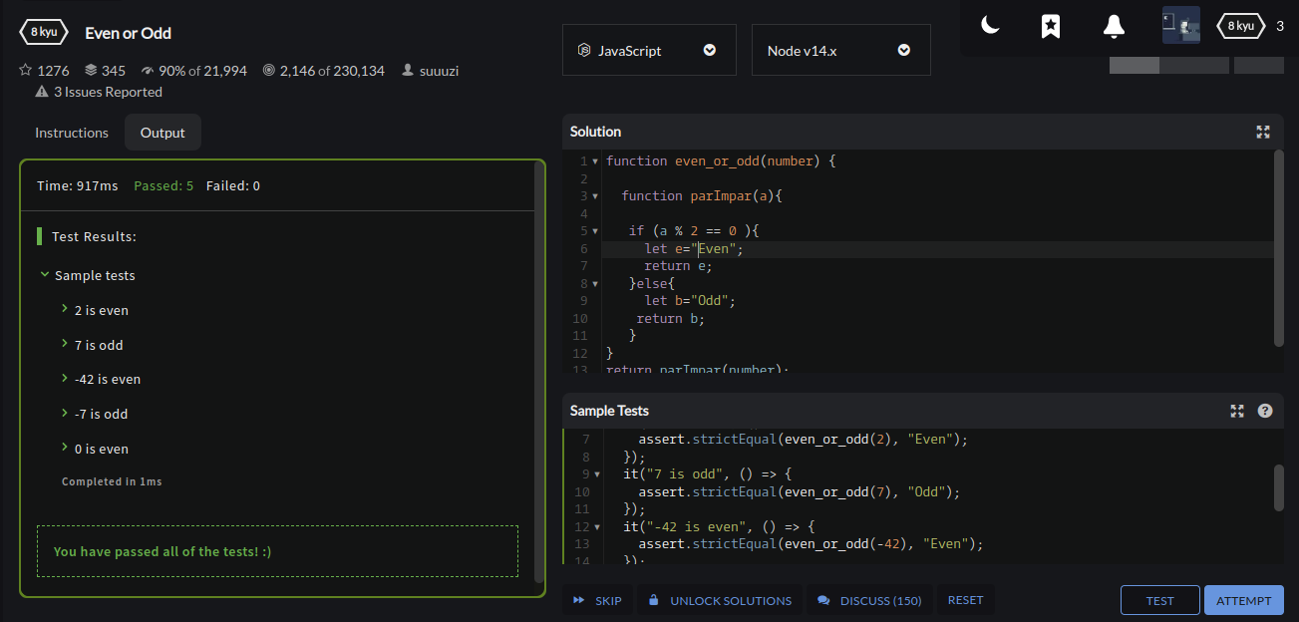

2:
Given a number return the closest number to it that is divisible by 10.
Example input:
22
25
37
Expected output:
20
30
40
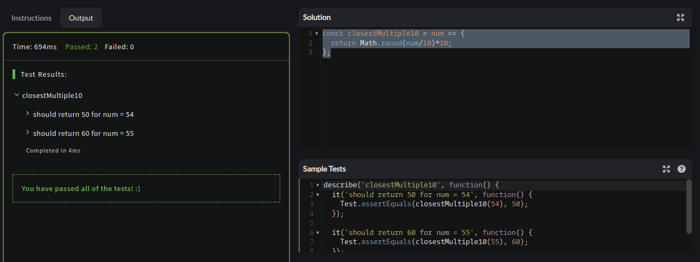

3:

In this Kata, we will calculate running pace. To do that, we have to know the distance and the time.

Create the following function:

runningPace(distance, time)

Where: distance - An float with the number of kilometres

time - A string containing the time it took to travel the distance. It will always be minutes:seconds. For example "25:00" means 25 minutes. You don't have to deal with hours.

The function should return the pace, for example "4:20" means it took 4 minutes and 20 seconds to travel one kilometre.

Note: The pace should always return only the number of minutes and seconds. You don't have to convert these into hours. Floor the number of seconds.
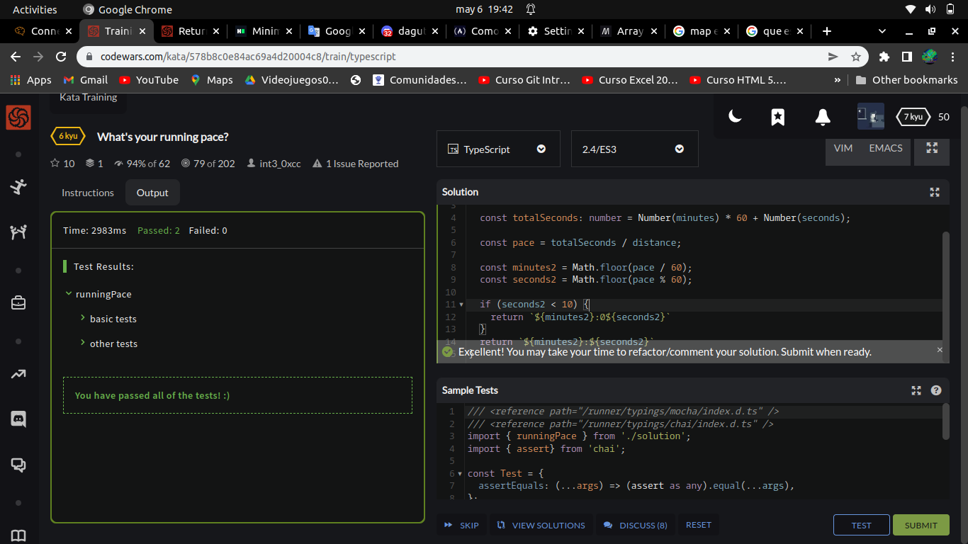
4:
Given n, take the sum of the digits of n. If that value has more than one digit, continue reducing in this way until a single-digit number is produced. The input will be a non-negative integer.

Examples
16 --> 1 + 6 = 7
942 --> 9 + 4 + 2 = 15 --> 1 + 5 = 6
132189 --> 1 + 3 + 2 + 1 + 8 + 9 = 24 --> 2 + 4 = 6
493193 --> 4 + 9 + 3 + 1 + 9 + 3 = 29 --> 2 + 9 = 11 --
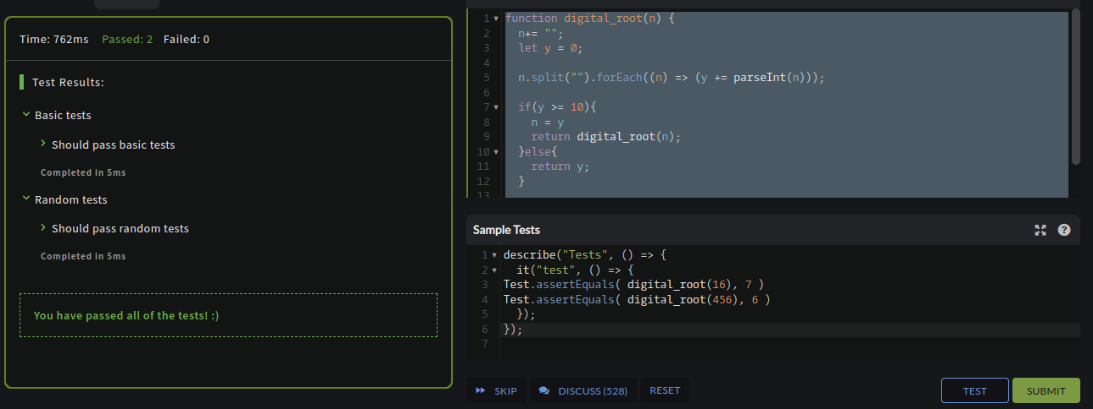
5 The Mormons are trying to find new followers and in order to do that they embark on missions.

Each time they go on a mission, every Mormons converts a fixed number of people (reach) into followers. This continues and every freshly converted Mormon as well as every original Mormon go on another mission and convert the same fixed number of people each. The process continues until they reach a predefined target number of followers (target).

Converted Mormons are unique so that there's no duplication amongst them.

Complete the function that calculates how many missions Mormons need to embark on, in order to reach their target. While each correct solution will pass, for more fun try to make a recursive function.
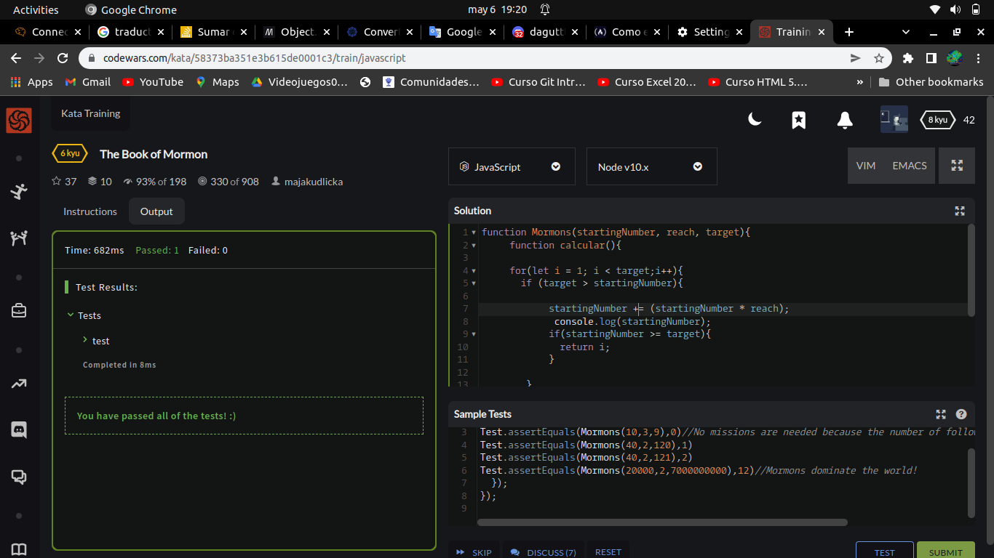
All inputs are valid positive integers.

Examples
starting_number = 10, reach = 3, target = 9 --> 0
# No missions needed because the number of followers already exceeds target

starting_number = 40, reach = 2, target = 120 --> 1
# Every mormon converts 2 people, so after 1 mission there are 40 + 80 = 120 mormons

starting_number = 20_000, reach = 2, target = 7_000_000_000 --> 12
# Mormons dominate the world after only 12 missions!
6
The absolute difference is the positive difference between two values and , is written or and they are equal. If and , . Given an array of integers, find the minimum absolute difference between any two elements in the array.

Example.

There are pairs of numbers: and . The absolute differences for these pairs are , and . The minimum absolute difference is .
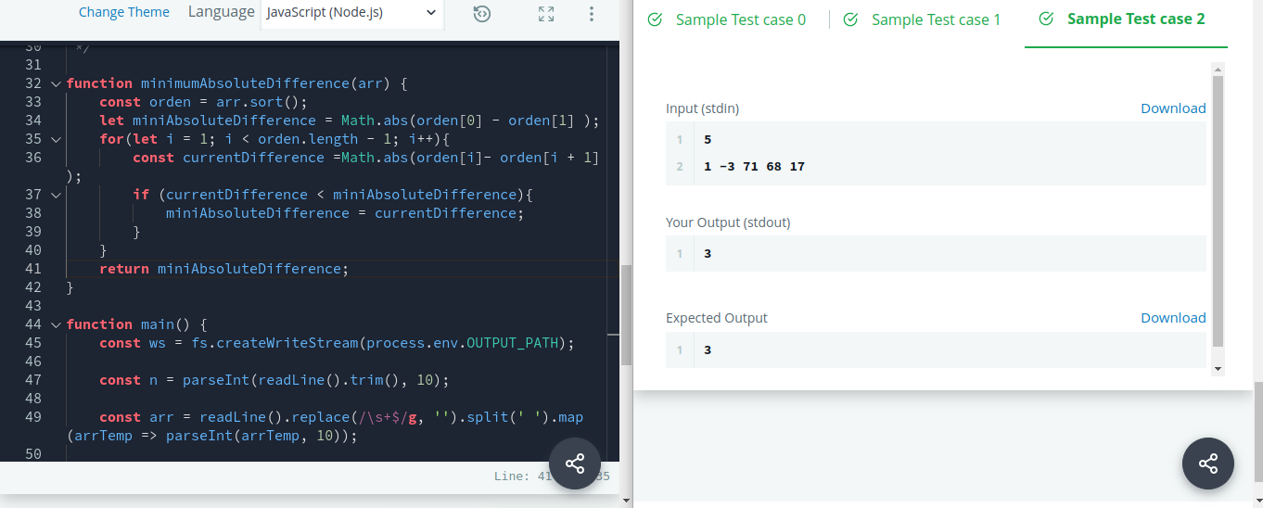
7

ou are choreographing a circus show with various animals. For one act, you are given two kangaroos on a number line ready to jump in the positive direction (i.e, toward positive infinity).
- The first kangaroo starts at location and moves at a rate of meters per jump.
- The second kangaroo starts at location and moves at a rate of meters per jump.
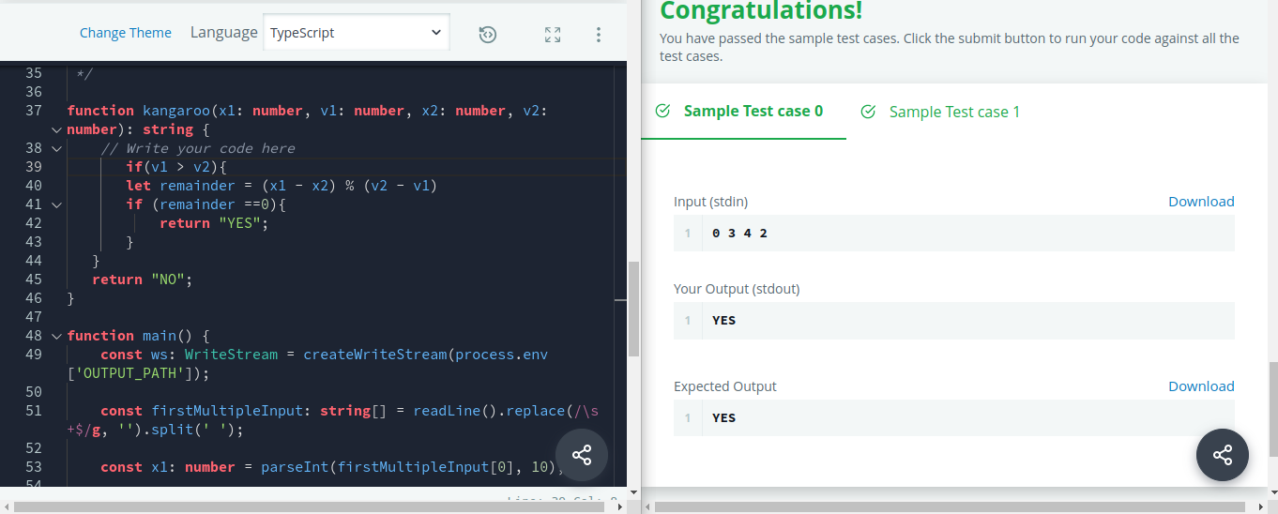
You have to figure out a way to get both kangaroos at the same location at the same time as part of the show. If it is possible, return YES, otherwise return NO.

