BFFL – Handout

Team name: BFFL

Team members: 1. Lars Hudalla (hudla01@gmx.de)

2. Felix Hirschel (felix.hirschel@outlook.de)

3. Bastian Schäfer (schaefer.bastian@mail.de)

4. Fabian Schwickert (fabian.schwickert@me.com)

GitHub: https://github.com/Krayaty/bffl

BFFL-Webapp: https://bfflshort.de

Blog: https://bffl612917651.wordpress.com

Time report:

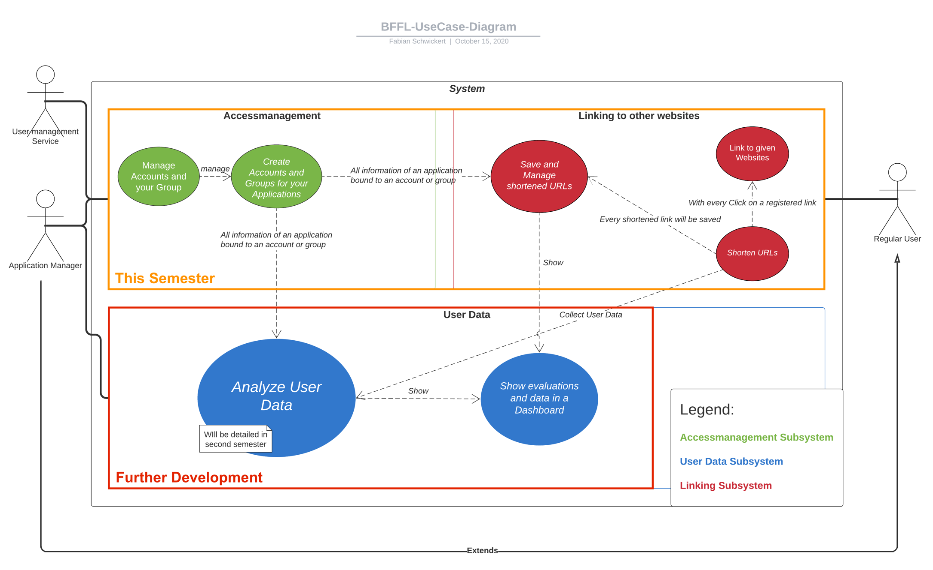Overall use case diagram: