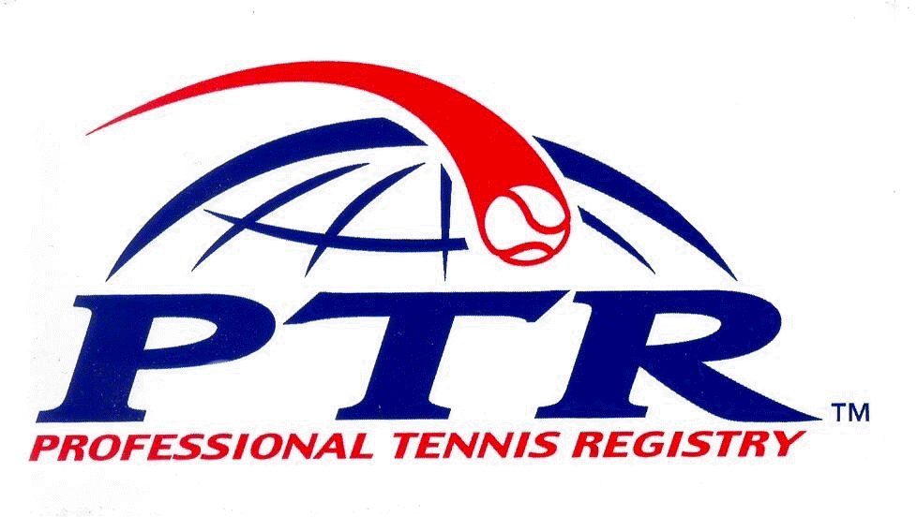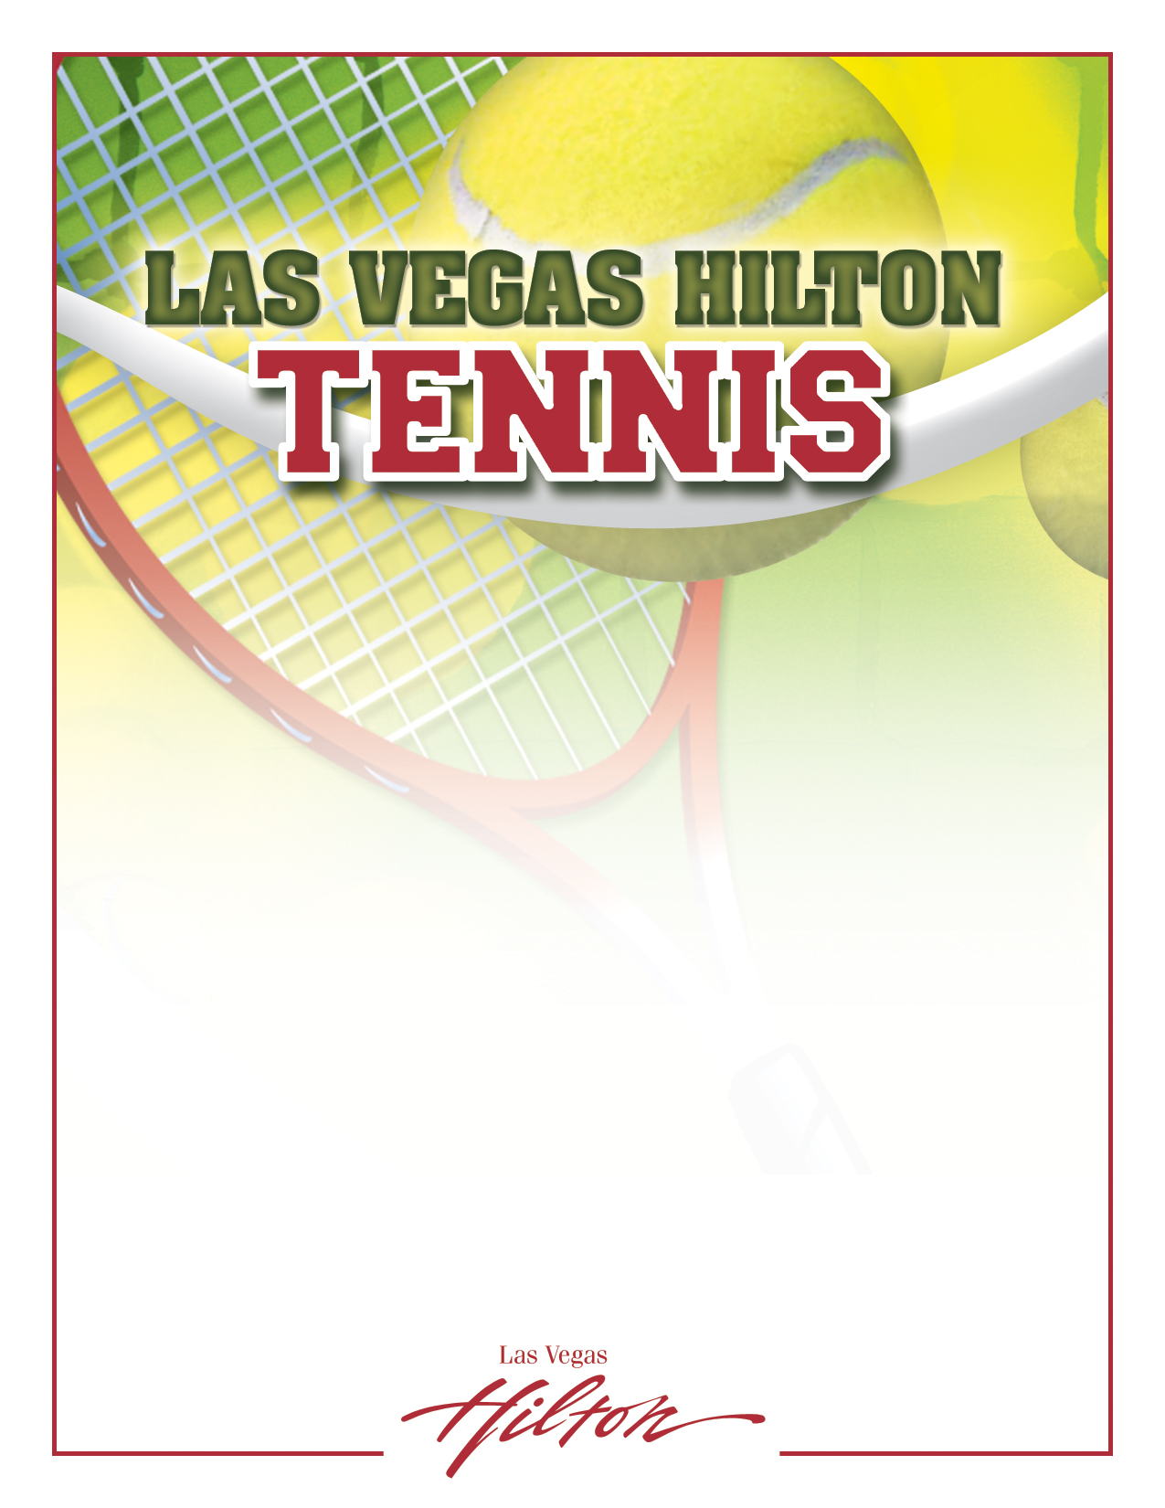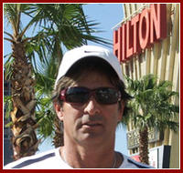

**ADULT GROUP LESSONS *JUNIOR GROUP LESSONS**

**\*PRIVATE LESSONS *BALL MACHINE RENTALS**

**PEE WEE AND JUNIOR GROUP LESSONS *CARDIO TENNIS**

**LEAGUES *MATCH PLAY**

**\*TENNIS WELCOME CENTER *TOURNAMENTS**

**\*VEGAS TENNIS VACATIONS!**

**Specialized Vacations available for Couples, Tennis Clubs, Conventions, Families, Ladies Trips, Men’s trips**

**\*STROKE OF THE DAY!**

**TENNIS FUNDAMENTALS, STRATEGY, TACTICS AND A FUN WORKOUT!**

**7 DAYS A WEEK!** 9:00 - 10:30 AM $25.00/PERSON

**PRIVATE LESSONS**

1 HOUR LESSON $85.00, HILTON GUESTS $75.00

**COURT RENTALS**

$25.00/HOUR, HILTON GUESTS $20.00

The Tennis Pro Shop is open Daily 9 AM – 5 PM

and is located just past the pool on our 3rd floor pool and recreation deck.

For more information contact Pro Shop at (702) 732-5009 or visit www.lvhilton.com

**HASSAN HUMAYUN**

**DIRECTOR OF TENNIS**

**CERTIFIED USPTA PRO 1 & PTR**

**Shop (702) 732-5009**

**Email: tennishassan@aol.com**

**www.lvhilton.com**

**BILLY DERANGO**

**TENNIS PROFESSIONAL**

**CERTIFIED USPTA**

**Shop (702) 732-5009**

**Email: tippyderango@yahoo.com**

**www.lvhilton.com**

