**Submission Form for Indie Games Area**

All applicants shall abide by the rules of Indie Games Area.

Please send this form by e-mail to [indie@nikkeibp.co.jp](mailto:indie@nikkeibp.co.jp) DEADLINE: Friday, June 14 <Japan Time>

**Exhibitor Name**

**Person in charge of submission *please check the applicable parenthesis**

**( )　As an individual**

**Name:**

**Address:**

**TEL:**

**e-mail：**

**( )　As a company**

**Name:**

**Title:**

**Company Name:**

**Address:**

**TEL：**

**e-mail：**

**Exhibit Period *please check the applicable parenthesis**

( ) 1day = Saturday, September 21 on Public Day (Exhibit Fee: 21,000 yen)

( ) 1day = Sunday, September 22 on Public Day (Exhibit Fee: 21,000 yen)

( ) 2days =September 21 and 22 on Public Days (Exhibit Fee: 31,500yen)

( ) 4days =September 19 through 22 on Business Days and Public Days (Exhibit Fee: 99,750yen)

**Past Record of Exhibiting at TOKYO GAME SHOW**

( ) No

( ) Yes 🡺 Year ( ) Exhibitor Name ( )

## What can be exhibited

## ・A completely original game (Derivative content cannot be exhibited regardless of whether or not it is licensed.) ・Created for a platform for which an applicant has the right to develop. ・Works that comply with the CESA Code of Ethics and the CERO Code of Ethics and do not fall under any of the following items:

1. An expression that conflicts with or that may conflict with Attached Table 3 “Prohibited Words and Phrases” of the CERO Code of Ethics is included.
2. Works for which an “Z” rating category was assigned by CERO or an expression equivalent to the“Z” rating category may be included.
3. Works that have already been released overseas and for which a “17+” (MATURE) rating category was assigned by an overseas examination body (e.g. ESRB).
4. Works planned to be released overseas for which a “17+” (MATURE) rating category is expected to be assigned by an overseas examination body (e.g., ESRB) (excessively bloody works that cannot be regarded as being equivalent to a “13+” (TEEN) rating category.

**Please complete followings:**

**◆Name of the game or content**

**◆URL of the movie of the game or content**

**(If the movie is not ready, please attach three screen shots of the game or content within 3MB.)**

**◆URL of the website where the game or content outline or an outline is posted.**

**◆Degree of completion**

**Current degree of completion: ( ) %**

**Estimated degree of completion at TGS2013: ( ) %**

**◆Record of exhibiting this game or content at other events (if exhibited, the event title)**

**★If you want to exhibit more than 2 titles, please submit for each game or content.**

**★Please read the information and rules from next page carefully before submission.**

**【Exhibit Area on Public Days】**

During Public Days (Saturday, 21 Sep / Sunday, 22 Sep), Indie Games Area will be located in Hall 9 where is a new venue for the TOKYO GAME SHOW this year. In Hall 9, there will be “Family Area”, “Cosplay Area”, “TGS Game Cinema Festa”, etc.

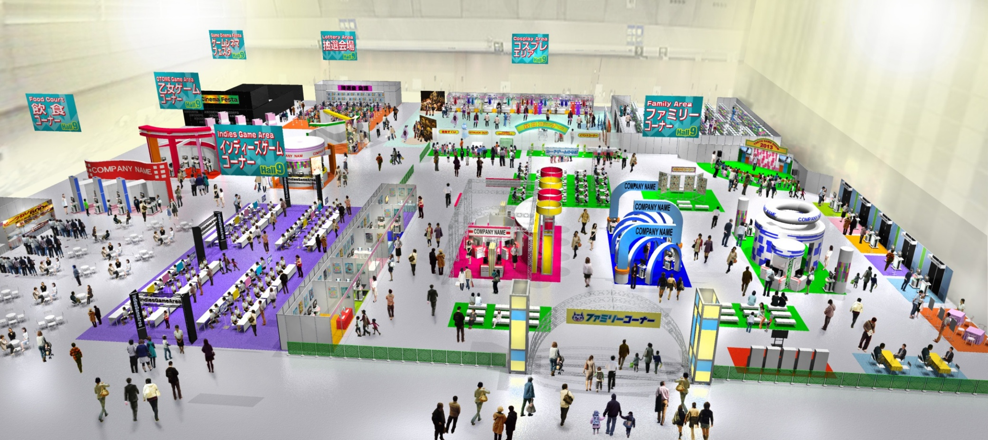

Hall 1-8

Hall 9

**【Exhibit Area on Business Days】**

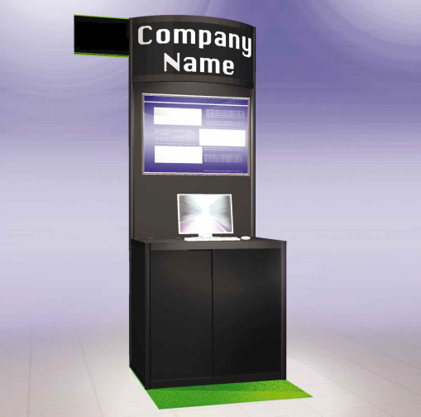During Business Days (Thursday, 19 Sep / Friday, 20 Sep), Indie Games Area will be located next to “Business Start-up Area” in Hall 1-8. Exhibitor will use an exclusive booth ( 1m X 1m) for this area. For details, please see the website:

<http://expo.nikkeibp.co.jp/tgs/2013/exhibition/english/exhibit/indie_games.html>

**Image of the booth🡺**

PC and Poster are not included.

**【Internet Line】**

Internet line is not provided. As a general rule, the exhibit game or content has need to run off-line.

**【Organizer’s right】**

Organizer has the right to cancel the exhibit during the show period due to false statements in application.

**Rules Governing Indie Games Area at TOKYO GAME SHOW**

■**Eligibility for Exhibiting in the Show**

・Exhibitors are limited to companies and other organizations supplying products and services consistent with the purpose of the Show as set by the organizer. The organizer has the right to determine if any product or service is consistent with the purpose of the Show.

■**Restriction of Exhibits**

・Exhibits are limited to those that meet the Ethical Rules of CESA and CERO. The exhibition of products related to software not in compliance with the Ethical Rules is prohibited.

・Products not handled by exhibitors cannot be exhibited at the Show.

■**Regulations for Exhibit**

・The decorating/exhibiting methods are described in the "Exhibitors Manual" to be supplied by the organizer, and all exhibitors are required to follow the guidelines in the Manual. There are limits to special structures, such as hanging structure and two-story booths, and the height of exhibition space, depending on the number of booths and location of booths.

・Each exhibitor must ensure that its exhibit does not interfere with those of adjacent exhibitors. The organizer will determine, based on the Exhibitors Manual, whether an exhibitor is interfering with another exhibit or whether there is violation of rules, and the exhibitor is to comply with the organizer's determination.

■**Exhibitor Name**

・The exhibitor name on the Submission Form must be the official name. Unless the organizer is informed of any changes in advance, the name on the form will be used for the exhibitors list in the Show advertisements, official web sites of the Show, guidebook, etc.

■**Determination of Booth Location**

・The booth location will be determined by the organizer.

■**Period**

・The exhibitor must decorate its booth space during the preparatory period to be defined by the organizer, and complete the work before the opening of the exhibit day.

・All exhibits and decorations shall be removed after 5:00 p.m. on the last day of the exhibit.

■**No Subleasing**

・Without the express permission of the organizer, an exhibitor may not transfer or sublease all or any part of its booth space (whether for payment or not).

■**Fire Safety**

・All exhibitors are required to adhere to all fire and safety rules and regulations that apply to the venue of TOKYO GAME SHOW 2013.

■**Application and payment**

1. Please e-mail the submission form to the organizer.

2. The selected applicants will be directly contacted by the organizer after the beginning of July 2013.  
3. After receiving payment of the exhibition fee by the end of July, the applicant will be formally accepted as an exhibitor.

■**Cancellation**

•If an exhibitor cancels an application for any reason, or reduces the number of booths applied for, the following cancellation charge (100%) must be paid.

■**Damage Compensation**

・The organizer, regardless of the reason, will not be responsible for any personal injury or property damage (including that to the venue's facilities and fixtures) resulting from the use of the venue by the exhibitor, its employees or any others involved.

・The exhibitor, its employee or any others involved must immediately compensate for all damages, either intentional or accidental, inflicted on the

venue's facilities and fixtures by its employees, representatives or any others involved.

・The organizer is not responsible for any typographical errors found in the promotional materials of TOKYO GAME SHOW 2013, including media

advertising, guidebook, etc.

■**Cancellation of the Show**

・In the event that the organizer cancels TOKYO GAME SHOW 2013 for its own reasons, making it impossible for the exhibitors to use their contracted booths, the organizer will reimburse the space fees to the exhibitors at a daily rate, calculated by the number of days left in the Show. Apart from the foregoing, the organizer will not bear any liability for cancellation of the Show.

・The organizer will not be responsible for any damages inflicted on the exhibitor, whether direct or indirect, through force majeur or by

command or instruction of a third party.