Attention Sands Exhibitors,

The following 2006 SES brochure contains information and order forms for a variety of services. Some of these services are exclusive to SES. These include telecommunications, Internet, electrical, catering, cleaning, hanging/rigging applications, video signal distribution, compressed air, water, and drainage.

Floral and audio-visual, computer, and office equipment are not exclusive to SES. The 2006 International CES official providers for these services are listed below. Their order forms may be found under tab 15, labeled “Supplemental Services” in your Exhibitor Manual.

Audio-Visual, Computer, and Office Equipment at the Sands Expo and Convention Center
Encore Productions  Las Vegas Convention Center  3150 S. Paradise Rd., Ste. 100  Las Vegas, NV 89109 | Joe Kenemore  (702) 943-6780 Phone  (702) 943-6781 Fax  jkenemore@encoreproductions.net  Or visit out website at:  www.clients.encoreprod.com/tradeshow | 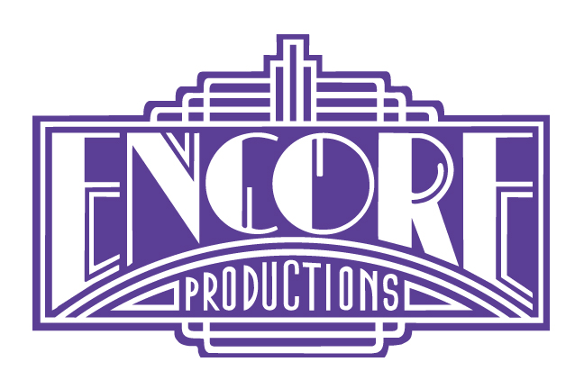

Floral
Spring Valley Floral  PO Box 760, 169 Route 303  Valley Cottage, NY 10989 | Howard Meyer  (845) 268-7555  (845) 268-6570 fax  www.springvalleyfloral.com | 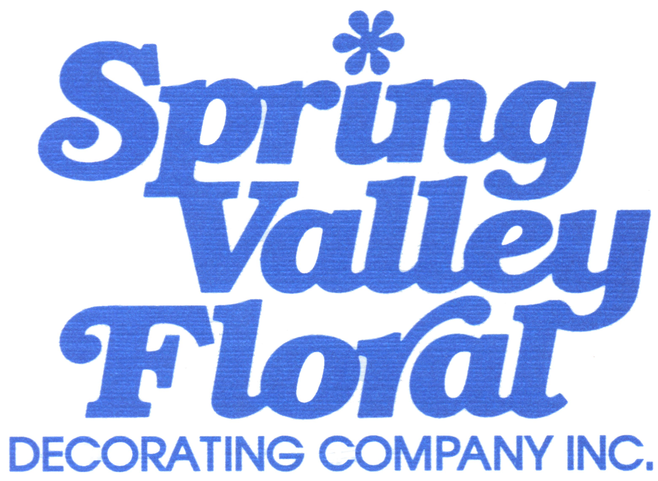

You may find a full list of exclusive and official contractors and their contact information located under tab 17, labeled “Key Contact Info” in your Exhibitor Manual.

