
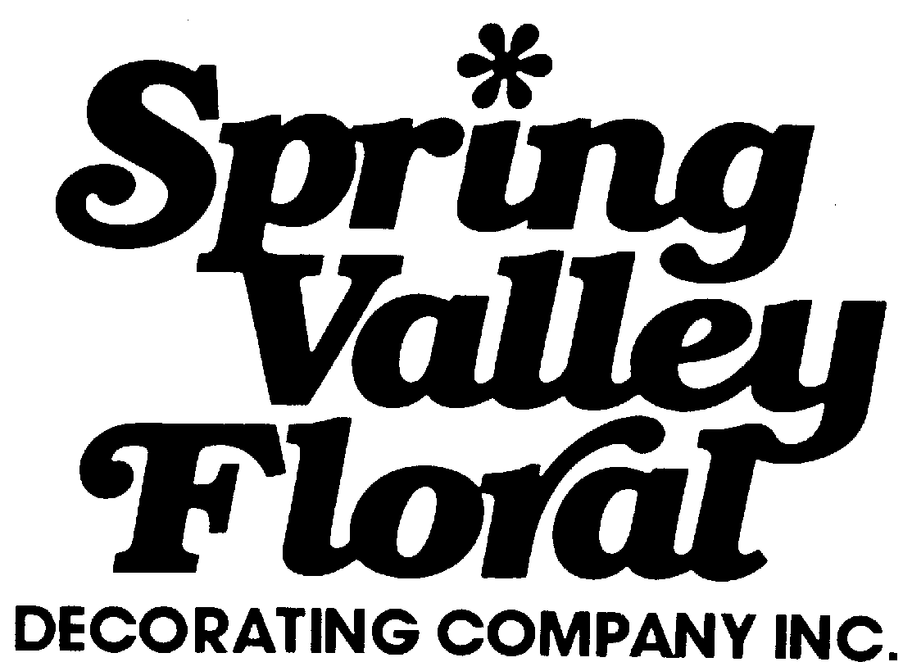
Mailing Address: PO Box 760
Street Address: 169 Route 303
Valley Cottage, NY 10989
TEL: 845 268-7555 FAX: 845 268-6570
Web Site: www.springvalleyfloral.com
FLORAL DECORATIONS

CUSTOM FLORAL SERVICES | Cost  Each | Quan. | Total
Fresh Floral Arrangement 12 - 14” High | 55.00
Fresh Floral Arrangement 15 - 18” High | 60.00
Exotic Floral Arrangement 14” High | 65.00
Exotic Floral Arrangement 24” High | 75.00
RENTAL Green & Flowering Plants

Mum Plants ___ yellow ___ white ___ lavender | 20.00
Azaleas | 25.00
Green Table Plant | 20.00
Regular Fern | 20.00
Large Fern | 25.00
3-foot Green Plant | 36.00
4-foot Green Plant | 46.00
5-foot Green Plant | 56.00
6-foot Green Plant | 66.00
8-foot Green Plant | 86.00

SUBTOTAL:__________
ADD 7.50% LAS VEGAS SALES TAX:__________
TOTAL:__________

ALL PRICES INCLUDE INSTALLATION, SERVICING, AND REMOVAL AT END OF SHOW

SPECIAL SERVICES AVAILABLE UPON REQUEST
- GARDEN AREAS
- FOUNTAINS
- HOSPITALITY SUITES
- LUNCHEONS
- BANQUETS

ON SITE ORDERS SUBJECT TO AVAILABILITY

__ PLEASE HAVE YOUR DESIGNER COME BY TO MAKE SUGGESTIONS
DATE/TIME____________

ALL PLANTS INCLUDE DECORATIVE CONTAINERS
PLEASE CHECK ONE
____WHITE ____BLACK

PAYMENT POLICY: ALL ORDERS MUST BE PAID IN ADVANCE
Enclose your check or credit card information as indicated below. Make checks payable to : Spring Valley Floral.

Credit Account Number Expiration Date MM/YY
 |  |  |  |  |  |  |  |  |  |  |  |  |  |  |  |  |  |  | _
1 | 2 | 3 | 4 | 5 | 6 | 7 | 8 | 9 | 10 | 11 | 12 | 13 | 14 | 15 | 16
❐ American Express (15 Digits)  Check
❐ MasterCard (16 Digits)  Visa (13 or 16 Digits)

_____________________________________________________________________________________
Authorized Signature Name on Card

RETURN THIS ORDER WITH PAYMENT TO SPRING VALLEY FLORAL
Company ________________________________________________ Phone ___________________
Address _________________________________________________ FAX _____________________
City, Zip, State ____________________________________________ E-mail____________________
Party in Charge ___________________________________________
Authorized Signature _______________________________________ BOOTH # _______________
PLEASE CHECK FACILITY: LVCC_______ LV Hilton_______ Alexis Park_______ Sands________

