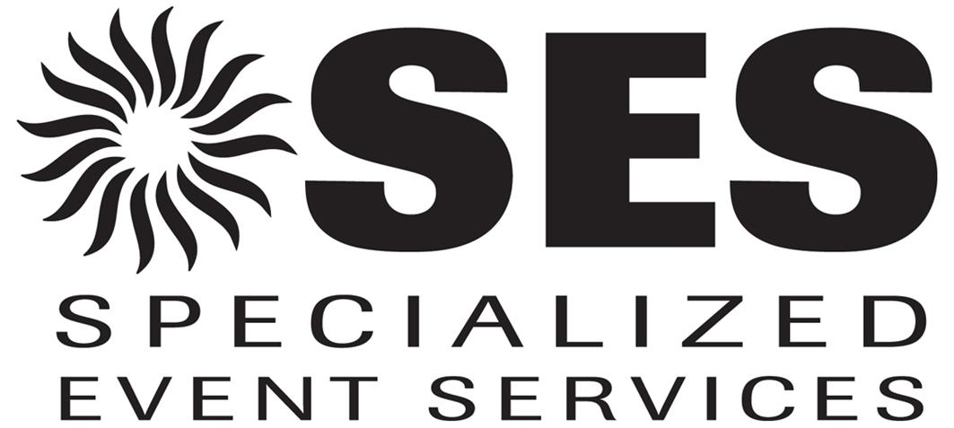

Lights Out Request Form
2006 International CES
January 5-8, 2006
(Sands Exhibitors Only – Applicable to island and
peninsula booths with 400 square feet or more)

- If your booth is at the Sands Expo and Convention Center, please use this form to request “Lights Out” service. Please NOTE: this service is available to exhibitors with 400 square feet or more.

- The Sands’ lighting system is set up in light banks, whereby, individual lights can not be turned off without turning off all the lights in the bank. It may be possible to unscrew or cover an individual light if it is easily accessible after booth set-up.

- An official order for this service (via this form) is required. Once on-site, it will be determined if your request can be met, how many lights can be turned off over your booth, and what the estimated charge for this service will be. Payment for all associated charges will be due on-site to Specialized Event Services (SES).

- All lights out orders are contingent upon approval by CES Show Management as they may affect neighboring exhibits.

- For questions regarding the Sands “Lights Out” service, please contact Gaiya Sims, CES Operations Manager at (703) 907-7685 or via email at gsims@CE.org. This form can be faxed into (703) 907-8130, ATTN: Gaiya Sims.

Company ____________________________________________________________________

Email Address__________________________________ Booth Number___________________

Authorized Contact – (please print)_________________________________________________

Authorized Contact Signature_____________________________________________________

Date_________________________________________________________________________

Description of What You’d Like Done________________________________________________

