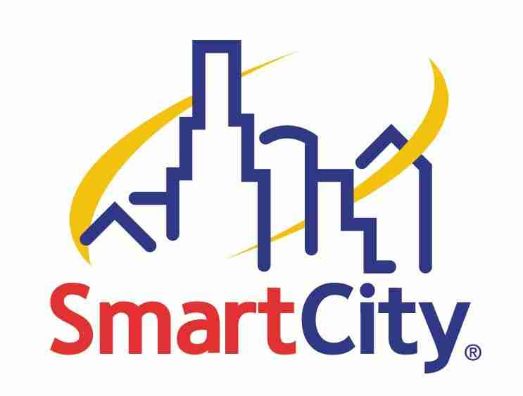

NETWORK SERVICES

AT THE LAS VEGAS CONVENTION CENTER

NEW THIS YEAR!
Feel free to contact our on site customer service team at our new
CES Hotline (702) 943-6CES or email servicedesklvcc@smartcity.com.
You may also contact our Data Manager, Danny Barnes, at (702) 943-6095 or
email him directly at dbarnes@smartcity.com.

For general billing or service questions you may also contact our national customer service team at (888) 446-6911.

FREQUENTLY ASKED QUESTIONS

- What type of Internet service should I order?
  - What type of Internet service you need will be dependent on how you intend to use the service. If you have questions regarding what service you need please call our CES Hotline at (702) 943-6237 or email ServicedeskLVCC@smartcity.com.

- What is the difference between a Public IP and a Private IP Address?
  - A Public IP is also referred to as a “real” IP commonly used in VPN connections and provides more robust capabilities than a Private IP. A Private IP allows the user to reach the World Wide Web and interact with web pages however, among its variety of limitations, connecting to servers outside of the Las Vegas Convention Center is not supported.

- What type of service does Basic EtherNat supply?
  - Basic EtherNat is the newest shared (Private IP) service provisioned by Smart City allowing a user to utilize uploads speeds of up to 128k and download speeds up to 512k. This service works with a username and password and can only support three computers per line. This service is only available in a limited quantity.

Q. What if I want to webcast or stream information to the Internet, what type of connection would I need?
  - Smart City can provide customized dedicated networks at speeds of 128k, 256k, 384k, 512k, and 1.5 Mbps and greater. You must order one of these private networks in order to stream information from your booth. A Rapid Data T-1 is a dedicated 1.5Mbps of bandwidth and includes 29 IP addresses.

- I have a router that I intend on using in my booth, will that be a problem?
- YES, routing devices are not allowed on our Shared Services, the use of routers can be very detrimental to performance when used on our network. Smart City reserves the right to disconnect service in any booth when devices attached to the Smart City provided connection (routers of any kind and access points) could possibly be disruptive. Smart City can usually allow most routing devices (programmed and functioning properly) on our customized dedicated networks.

