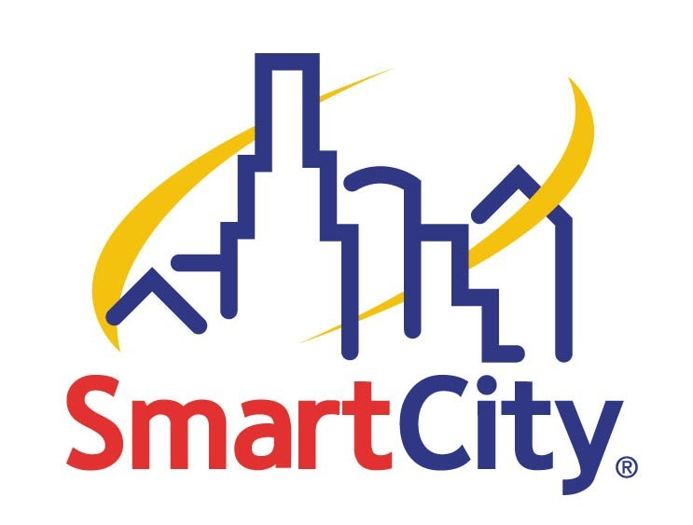

Smart City Wireless Policy Made Simple

We are proud to provide the technology that makes the Las Vegas Convention Center the largest wireless hotspot in the world! We provide one hundred Cisco Aironet access points throughout the facility to make this technology possible.

Our wireless technology allows us to provide our Instant Internet service to attendees as well as exhibitors. Hourly, daily and weekly services are available and can be ordered by anyone with a PC, laptop or PDA device that is configured with an 802.11b or g wireless card. The service can be ordered right from your wireless device connecting you to the web instantly.

In order to provide these services, Smart City has policies in place that help us to maintain the viability of our wireless network:

- Access points unauthorized by Smart City cause conflicts between the unauthorized access point and our access points. These conflicts affect everyone from exhibitors to attendees to show management. Many people can lose their signal and therefore, lose their Internet connectivity.
- If Smart City does not authorize an access point, then we do not know to coordinate this access point with ours until it is too late. We will be interfering with the unauthorized access point causing it to be intermittent or inoperable. For these reasons, we cannot allow unauthorized access points to be brought into the Las Vegas Convention Center.
- Wireless routers are also strictly prohibited.
- This service may not be used for any streaming video applications.
- No routers of any kind may be used with this service.

PLEASE NOTE: Cordless phones, remote controls, monitors and any other products operating in the 2.4 GHz wireless frequency easily interfere with one another and may not operate properly on site without prior coordination through Smart City.

Smart City and Air Magnet have been working to install a system that will protect the wireless environment and our Instant Internet users from conflicting wireless signals. For more detailed information about our wireless service, please review our Wireless Performance Declaration included with the Smart City order forms in your exhibitor manual or online at www.cesweb.org/exhibitors/manual (click on Show Utilities).

Are you showcasing wireless products? Want to bring your own access point? Not sure what the best solution may be for your exhibit? Call us! We can allow you to demonstrate wirelessly using our wireless system.

Smart City is proud to sponsor the Good Neighbor Program that you may join simply by calling us to discuss your wireless needs and allowing us to coordinate your services so that we can ensure that you, and all your neighbors, have a successful show. For joining this program, Smart City will provide you with a Good Neighbor Certificate of Appreciation and a small gift on site.

A Good Neighbor is a Smart Neighbor

