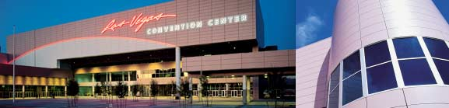
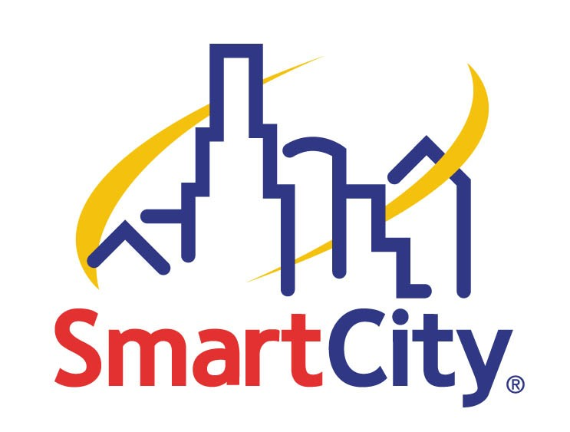
Smart City’s World of Wireless

The wireless infrastructure at the Las Vegas Convention Center supplies much more than just hourly, daily and weekly service. Our wireless backbone also supports dedicated wireless networks. This means that if an exhibitor needs to demonstrate wireless services, our backbone can be utilized for that purpose. These dedicated networks range from 128K to 512K, or can be customized up to T-1 speeds. Not sure what type of wireless network you need? No problem! Please call us at (702) 943-6080 and let us help you decide the best network option for your exhibit.

Exhibitors bringing wireless equipment to 2005 International CES run the risk of experiencing service outages due to the saturation of wireless services on the show floor.

Some tips to make sure that your wireless service operates flawlessly on the show floor:

- If you aren’t demonstrating wireless products don’t use wireless. As wireless service is “in the air” it is inherently vulnerable and could easily fail.

- If you must exhibit your product wirelessly, please call us and allow our Data Manager to coordinate a cohesive wireless network.

- If you must bring your own wireless equipment, please call us. Under certain circumstances we can coordinate your wireless equipment to exist in harmony without interference from the Smart City wireless network.

We’re here to help with your wireless needs.

