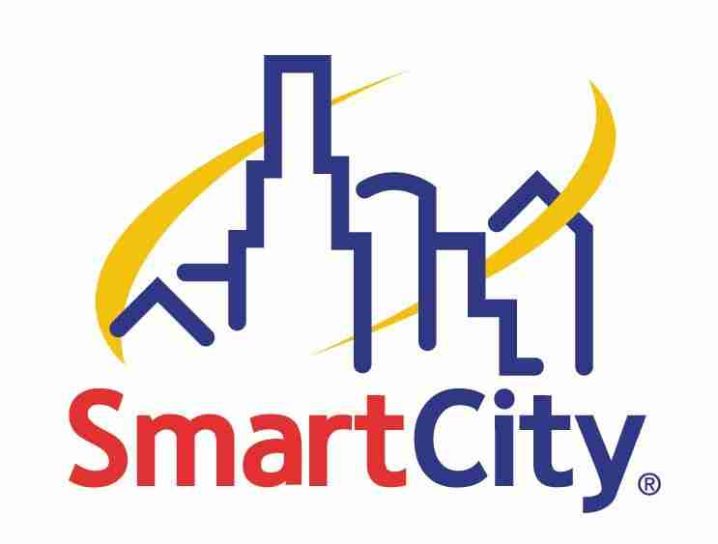

TELEPHONE SERVICE

AT THE LAS VEGAS CONVENTION CENTER

NEW THIS YEAR!
Feel free to contact our on site customer service team at our new
CES Hotline (702) 943-6CES or email servicedesklvcc@smartcity.com.

FREQUENTLY ASKED QUESTIONS

- Do I need to dial a “9” to dial outside the convention center?
  - Yes, if you order our standard line or our Multi line phone PBX Service. If you order a Dedicated Line you are not required to dial a “9” to call outside the building.

- What type of phone service should I order to use with a fax machine?
  - Our standard line would be the most appropriate service.

- Can I use an ISDN line to access the Internet?
  - Yes, but only if you have your own ISDN modem and your own ISP that has access for an ISDN dial-up account. This service is typically used for broadcasting and is not a recommended service for Internet connections.

- What is a dry pair (Category 4 on the Telephone Service order form)?
  - A “Dry Pair” is an extension of a circuit ordered through a 3rd party, like Sprint, and connected to equipment in the Smart City demarc. Smart City extends the circuit to the booth for the fee listed on the order form.

- How do I order my phone line restricted from long distance?
- All Smart City telephone lines are unrestricted for long distance unless requested otherwise. A line can be restricted as “CC”, allowing the line to make toll free and local calls, or “TLD” which allows the line to only call locally. To order your line with restricted access choose which type of restriction you require under line item 3b on our Telephone Services order form.

- I have my own multi line phone. Can I bring it with me to the show to use?
  - Smart City’s multi line service is one phone line delivered with a digital signal. Only Northern telecom 2000 series phones will work with this service. Smart City provides all the phones for this line.

