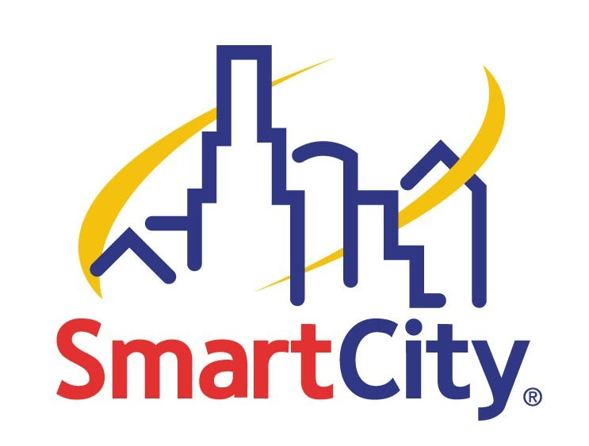

Smart City is proud to roll out our Good Neighbor program for the 2003 International CES! Exhibitors can enroll in our Good Neighbor program by calling Smart City at (702) 943-6080 or emailing mdworin@smartcity.com describing what, if any, wireless services they will be using in their booth for CES.

You wouldn’t test drive a Ferrari during rush hour traffic, right? Bringing wireless devices to the show floor of the largest technology show in the world, without first coordinating with Smart City, would be the same thing. Many wireless devices conflict with one another. Smart City would like the opportunity to make sure that the products utilized in your booth will not conflict with your neighbor’s product.

While Smart City does not allow exhibitors to supply their own wireless access points there are some special circumstances where this may be allowed. There are different wireless spectrums and while your product may not interfere with one neighbor it could easily interfere with another. We work hard to prevent these conflicts. Also, we try to ensure that all presentation and demonstrations on the show floor are successful. Advance coordination can help us achieve this goal.

Not running anything wirelessly? Great! We would still like to hear from you so that we may remove your booth name from the list of those who will need us to coordinate their services.

A Good Neighbor is a Smart Neighbor. For joining our good neighbor program we will provide you with a certificate of compliance as well as a gift as our way of thanking you for being a Good Neighbor.

