UGSM Architecture Rulebook (v2)

1. Purpose of UGSM
UGSM is designed to be a modular game server manager capable of supporting many games without requiring changes to the core application.

The system must allow:
• New game support by dropping a game module file into the Games folder
• Automatic game discovery
• Automatic UI population
• No modification of core files when adding new games

The application must remain cleanly layered, service-driven, and modular.

2. Core Design Philosophy
UGSM follows five architectural principles:

1. Modular Game System
Games are implemented as self-contained modules. A new game is added by placing a module file such as:

UGSM_Game_<GameName>.ps1

Example:
Games/
UGSM_Game_SCUM.ps1
UGSM_Game_ARKSE.ps1
UGSM_Game_Palworld.ps1

The application must automatically discover these modules at startup. No other file should need modification.

2. Single Source of Truth
Every shared concept must have one owning layer.

Example ownership:
Application runtime state → UGSM_Core_State.ps1
Game discovery/catalog → UGSM_Service_Games.ps1
Machine stats → UGSM_Service_MachineMonitor.ps1
Disk information → UGSM_Service_Disk.ps1
User settings → UGSM_Service_Settings.ps1
Instance management → UGSM_Service_Instances.ps1

Other files must read from the owner instead of recreating data.

3. Separation of Concerns
Architecture layers:

UI Layer
↓
Service Layer
↓
Core Layer
↓
Game Modules

4. Drop‑In Game Modules
Adding a new game must not require editing core files. A module dropped into the Games folder must automatically register itself.

5. Owner-Based Repairs
All bugs must be fixed at the layer that owns the data or behavior.

3. Layer Responsibilities
UI Layer
Files: UI/UGSM_UI_*.ps1

Responsibilities:
• Display information
• Trigger user actions
• Render models returned by services

UI must not contain business logic.
UI must not hardcode game data.
UI must not create new runtime state properties.

Service Layer
Files: UGSM_Service_*.ps1

Responsibilities:
• Provide business logic
• Provide data models for UI
• Coordinate between modules and core

Services must not contain UI rendering logic.

Core Layer
Files: UGSM_Core_*.ps1

Responsibilities:
• Runtime state
• Machine/system interaction
• File IO
• Process control
• Shared infrastructure

Core code must remain game‑agnostic.

Game Module Layer
Files: Games/UGSM_Game_<Game>.ps1

Responsibilities:
• Game metadata
• Install logic
• Start/Stop logic
• Validation logic
• Capability declaration

4. Game Module Contract
Each game module must expose a registration function.

Example:

function Register-UGSMGameSCUMModule {
return [pscustomobject]@{
Id = "SCUM"
Name = "SCUM"
SteamAppId = "3792580"

SupportsMods = $false
SupportsInstall = $true
SupportsStart = $true
SupportsStop = $true

SupportedTabs = @(
"Home","Games","Instances","Analytics",
"Tasks","Files","About","Settings"
)

Handlers = @{
Install = "Install-UGSMGameSCUM"
Start = "Start-UGSMGameSCUM"
Stop = "Stop-UGSMGameSCUM"
Validate= "Test-UGSMGameSCUMInstall"
}
}
}

5. Game Discovery
Startup process:

1. Scan Games folder
2. Load every UGSM_Game_*.ps1
3. Find Register‑UGSMGame*Module functions
4. Register returned module objects
5. Build the game catalog

Example discovery logic:

Get-ChildItem $GamesFolder -Filter "UGSM_Game_*.ps1" |
ForEach-Object { . $_.FullName }

Get-Command Register-UGSMGame*Module |
ForEach-Object {
$module = & $_
$GameCatalog[$module.Id] = $module
}

6. Global UI vs Game UI
UGSM uses two UI layers:

Left Sidebar (Global Navigation)
These tabs always exist:
Home
Games
Instances
Analytics
Tasks
Files
About
Settings

These are system-wide pages.

Center Workspace (Game Context Area)
When a game is selected, the center panel becomes a game workspace.

Each game module defines its own supported features.
Tabs that appear in the center workspace depend on the selected game.

Example:

SCUM supports:
Home
Instances
Files
Analytics
Tasks

SCUM does NOT support:
Mods

When SCUM is selected, the Mods tab will not appear in the center workspace.

The left sidebar remains unchanged.

7. Hardcoding Rules
Hardcoding is only allowed in game modules.

Game modules may hardcode:
• Game ID
• Steam App ID
• Default server executable
• Default install path
• Supported capabilities

Example:
SteamAppId = 3792580
ServerExe = "SCUMServer.exe"

The core application must never hardcode game lists.

8. Application State
Runtime state is defined in UGSM_Core_State.ps1.

Example properties:

SelectedGameId
SelectedInstanceId
SelectedInstance
GameDisplayMap
MachineStatus
AnalyticsHistory

Consumers may read and update existing properties but must never create new ones.

9. Bug Fixing Policy
UGSM uses Source‑Owner Repair.

Fix bugs at the layer that owns the data.

Example:

Missing AppState property → Fix UGSM_Core_State.ps1
Incorrect game list → Fix UGSM_Service_Games.ps1
Incorrect machine stats → Fix UGSM_Service_MachineMonitor.ps1

Never patch symptoms in random files.

10. Anti‑Patching Rule
The following are not acceptable first fixes:

• Adding Add-Member in random files
• Creating new runtime state in UI
• Hardcoding fallback values
• Copying default values across files
• Per‑page workaround fixes

These hide architectural problems.

11. Default Values
Defaults belong only in the owning layer.

Example:

Machine health thresholds → Machine Monitor
App state defaults → Core State
Game install defaults → Game Module

Consumers must not redefine defaults.

12. File Structure
Recommended layout:

UGSM/

Core/
UGSM_Core_State.ps1
UGSM_Core_IO.ps1
UGSM_Core_Process.ps1
UGSM_Core_Machine.ps1

Services/
UGSM_Service_Games.ps1
UGSM_Service_Instances.ps1
UGSM_Service_Files.ps1
UGSM_Service_Settings.ps1
UGSM_Service_MachineMonitor.ps1
UGSM_Service_SteamCMD.ps1

Games/
UGSM_Game_SCUM.ps1
UGSM_Game_ARKSE.ps1
More to come these are just examples

UI/
UGSM_UI_MainForm.ps1
UGSM_UI_Page_*.ps1

Edits

🧠 Recommended Terminology (lock this in now)
✅ Use this everywhere:
Concept Name
Saved server config Profile
Running server process Instance (later use)
Game install Installed / Not Installed

GAME Instance UI

Each game should produce its own UI to be displayed in the instance page according to the selected instance.

There is a section of the ui that has a big open area. See attached image. 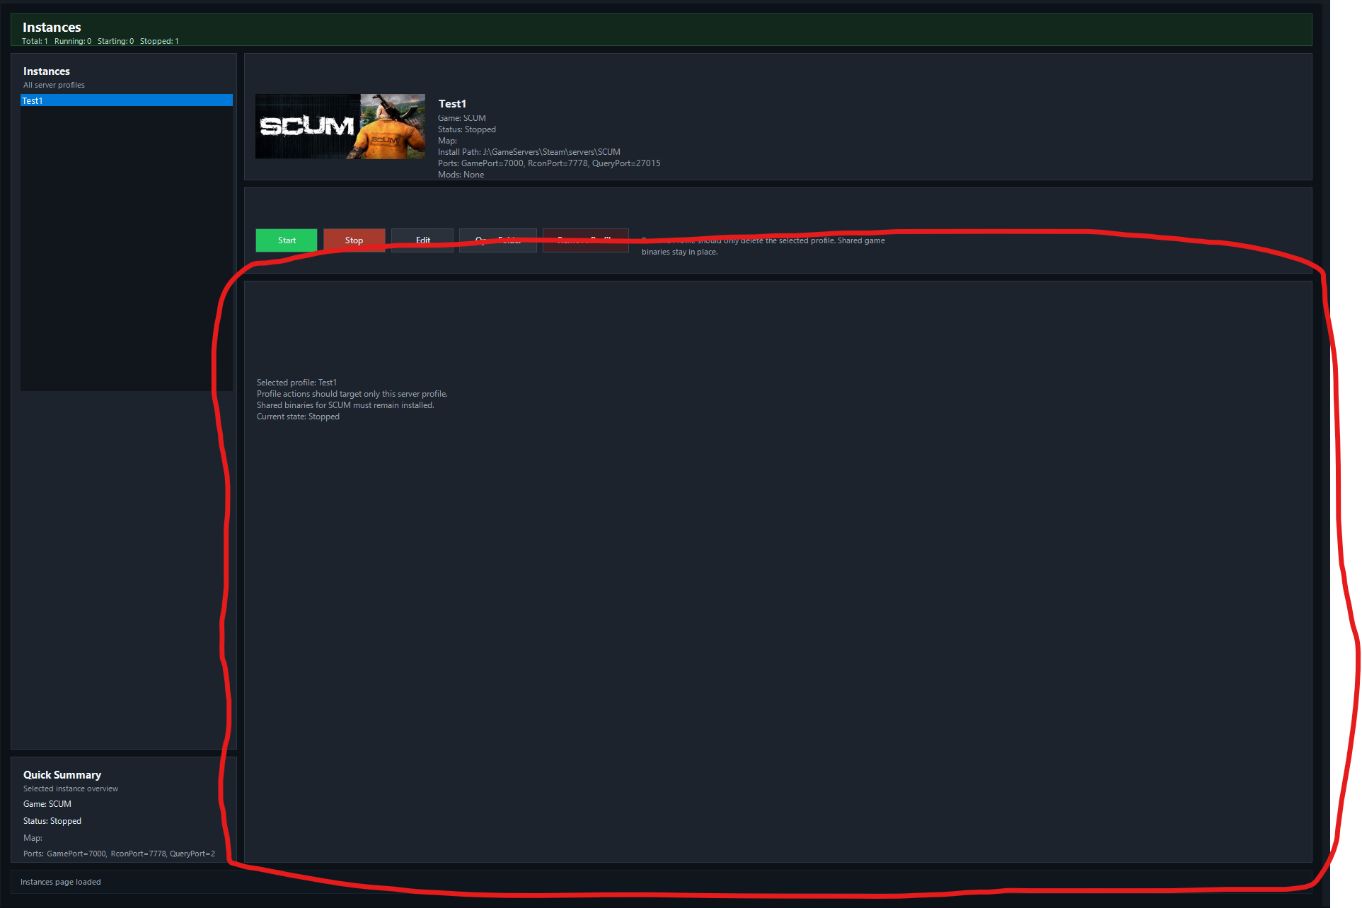
This is where game specific tabs should go. Organized in section and tabs according to what is being adjusted. Ie. Player, animal, environment, npc, admin. With text stating what that setting does. This is to make it more user friendly for new server owners.

