COS30045: Task from week 1 to week 3

Name: Khanh Toan Nguyen

ID: 104180605

**Task 1.1**

Fig 1: Task 1.1 Output

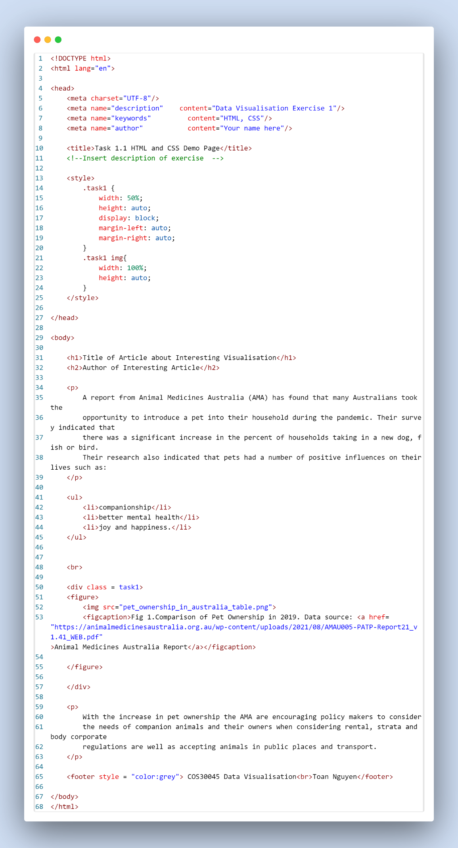

Fig 2: Task 1.1 HTML code

**Task 1.2**

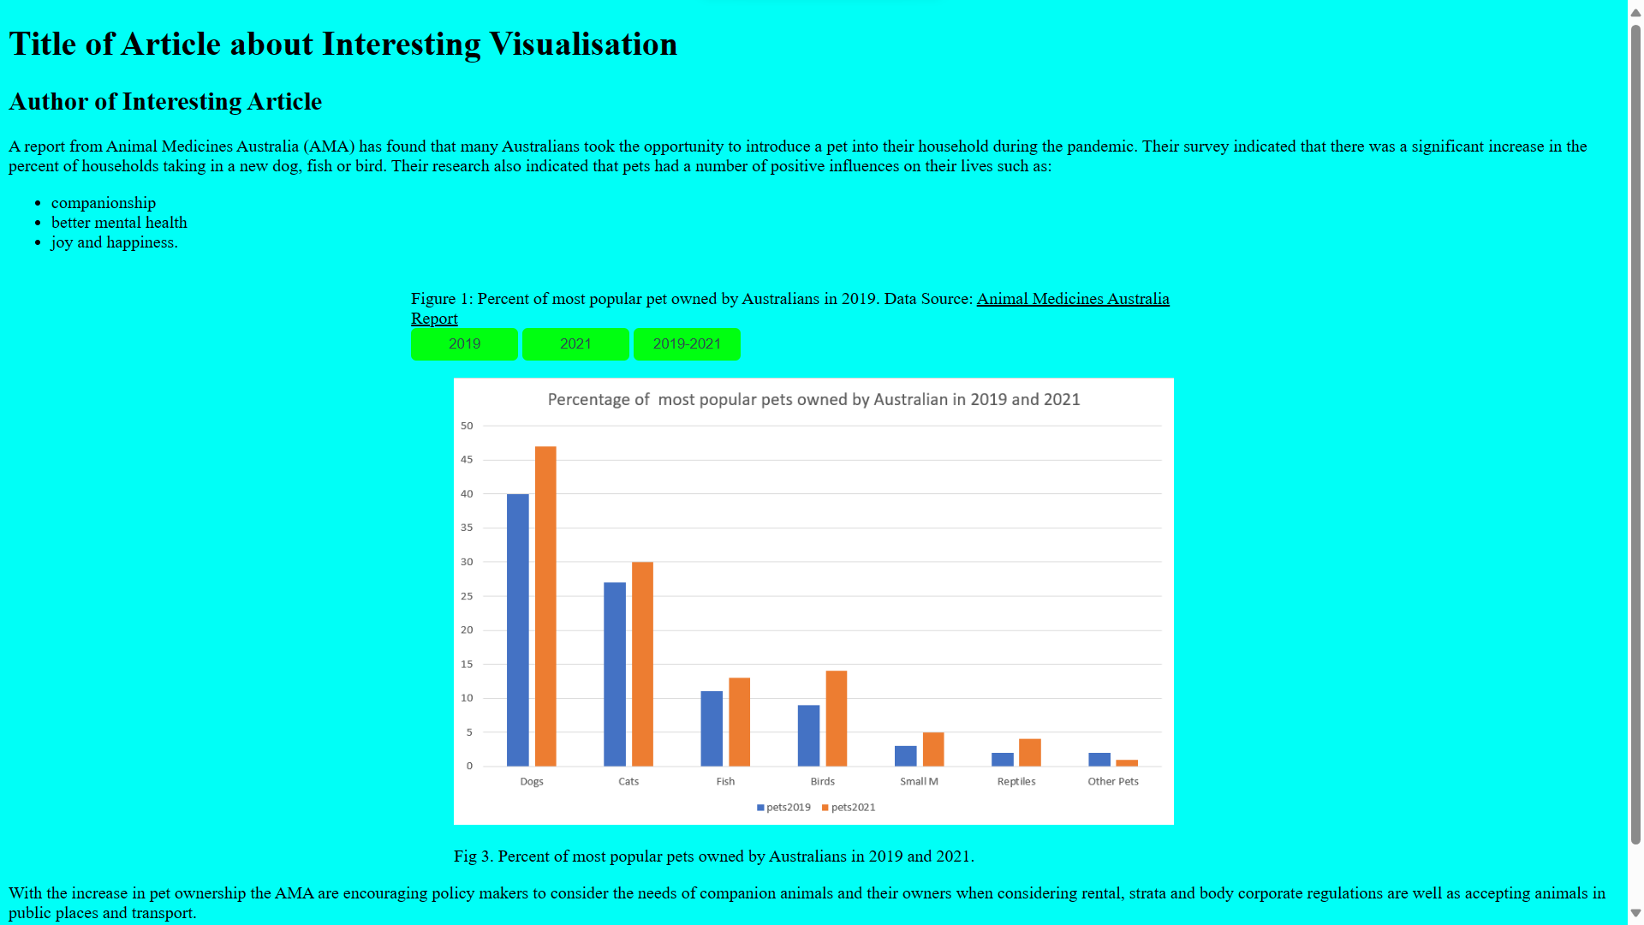

Fig 3: Task 1.2 Output

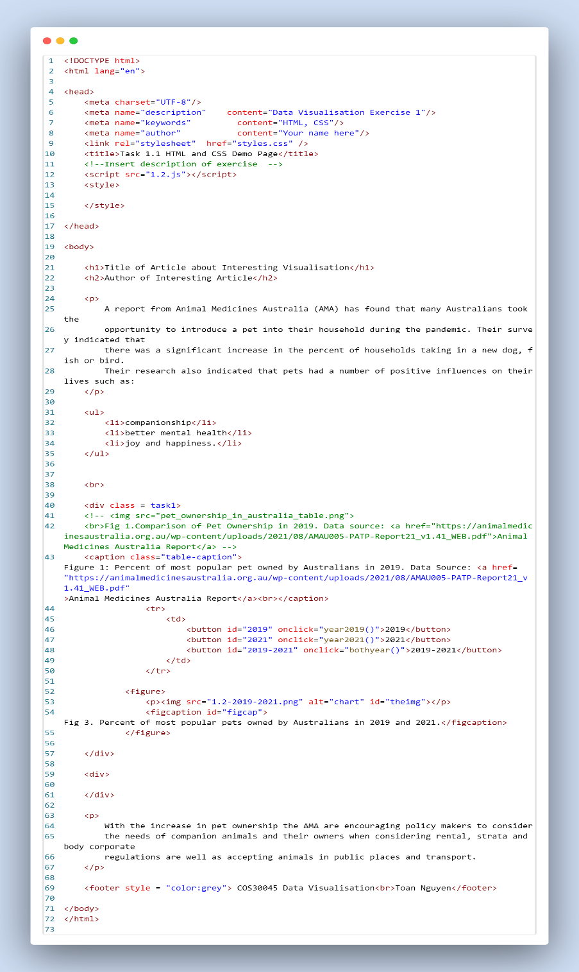

Fig 4: Task 1.2 HTML code

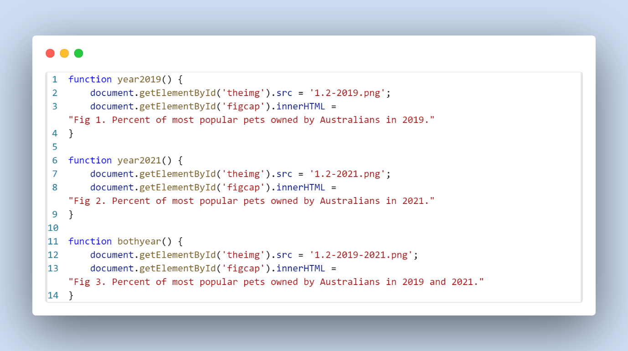

Fig 5: Task 1.2 JS code

**Task 1.3**

Fig 6: Task 1.3 Output

Fig 7: Task 1.3 HTML code

**Task 2.1**

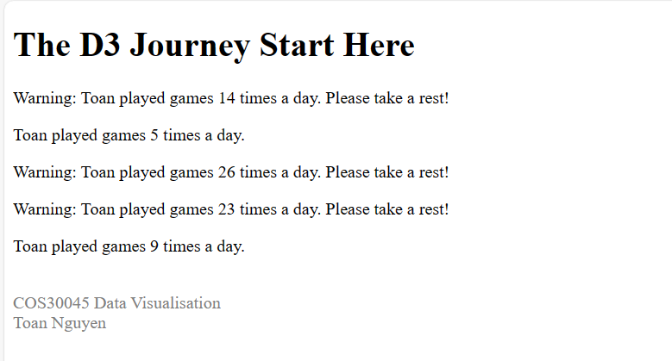

Fig 8: Task 2.1 Output

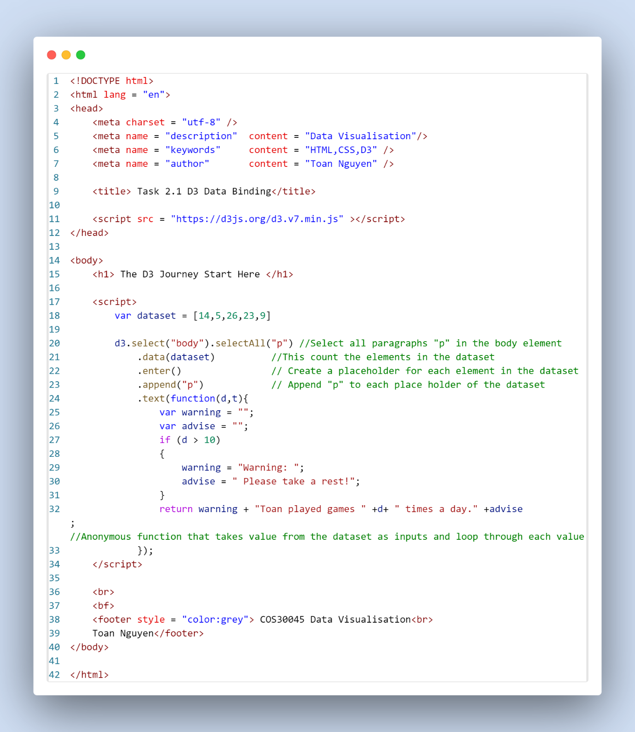

Fig 9: Task 2.1 HTML code

**Task 2.2**

Fig 10: Task 2.2 Output

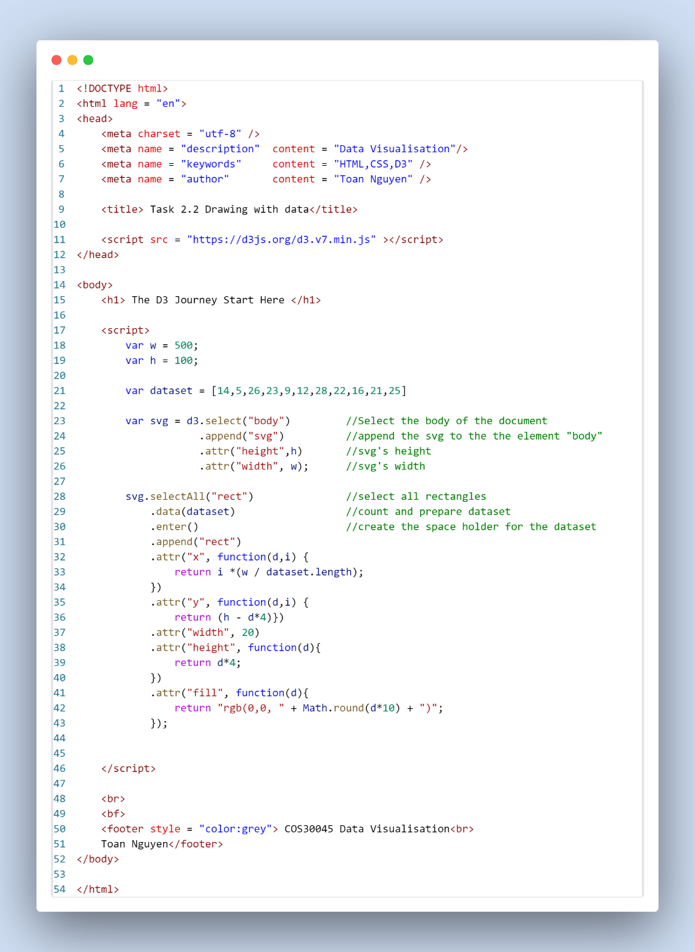

Fig 11: Task 2.2 HTML code

**Task 2.3**

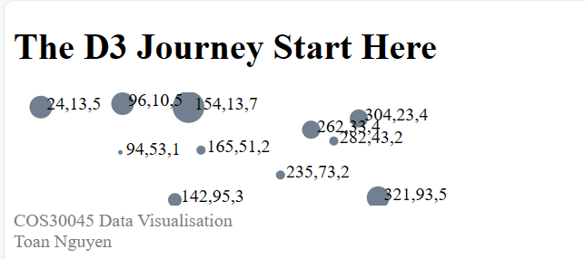

Fig 12: Task 2.3 Output

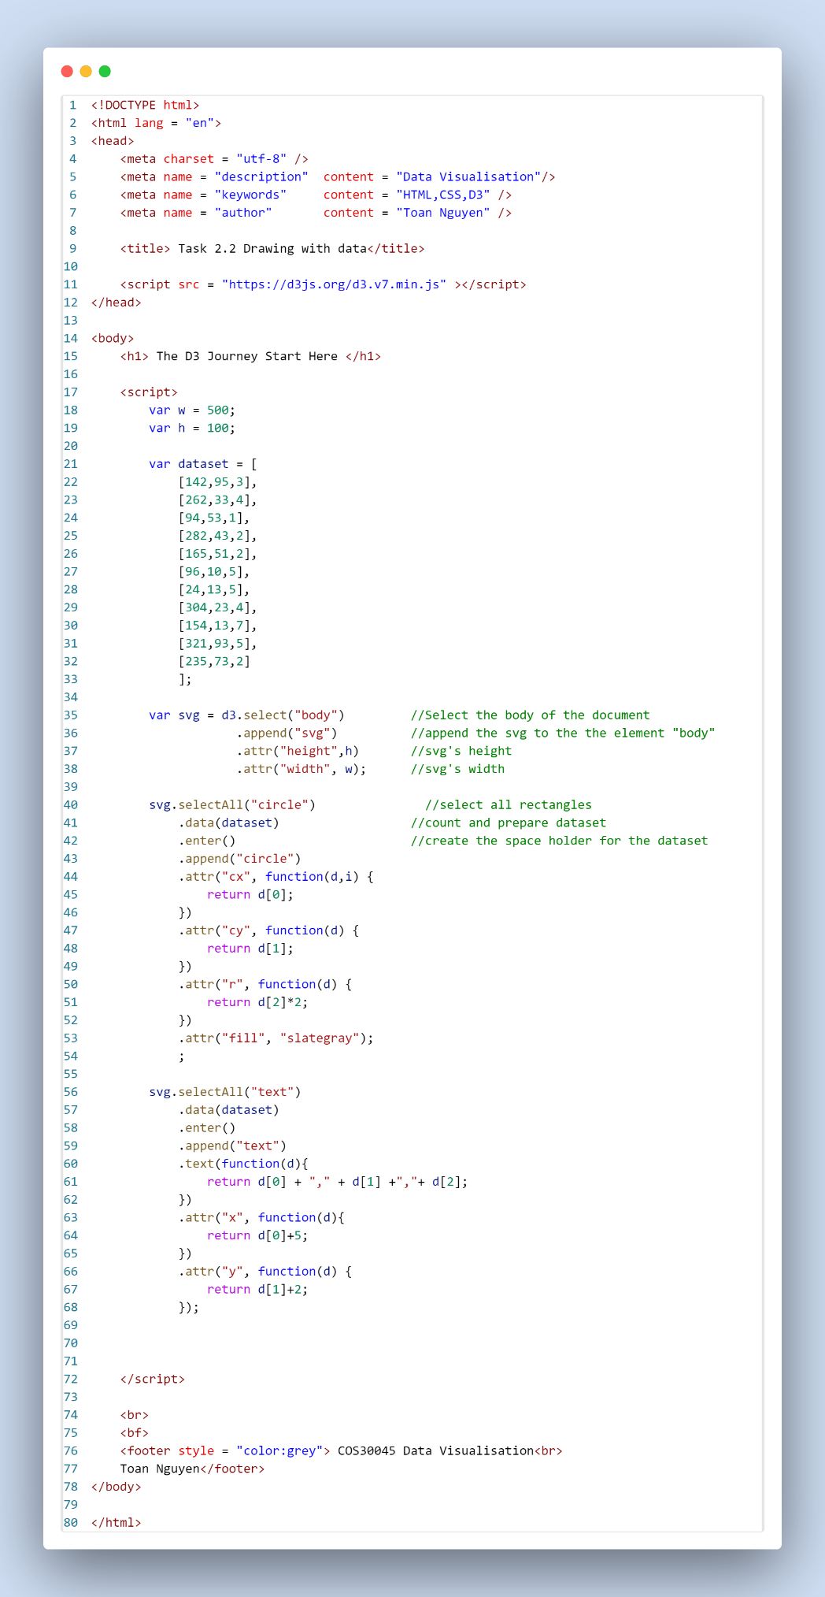

Fig 12: Task 2.3 HTML code

**Task 2.4**

Fig 13: Task 2.4 Output

Fig 14: Task 2.4 HTML code

Fig 15: Task 2.4 JS code