COS30045: Task 1.1

Name: Khanh Toan Nguyen

ID: 104180605

Figure 1: Webpage

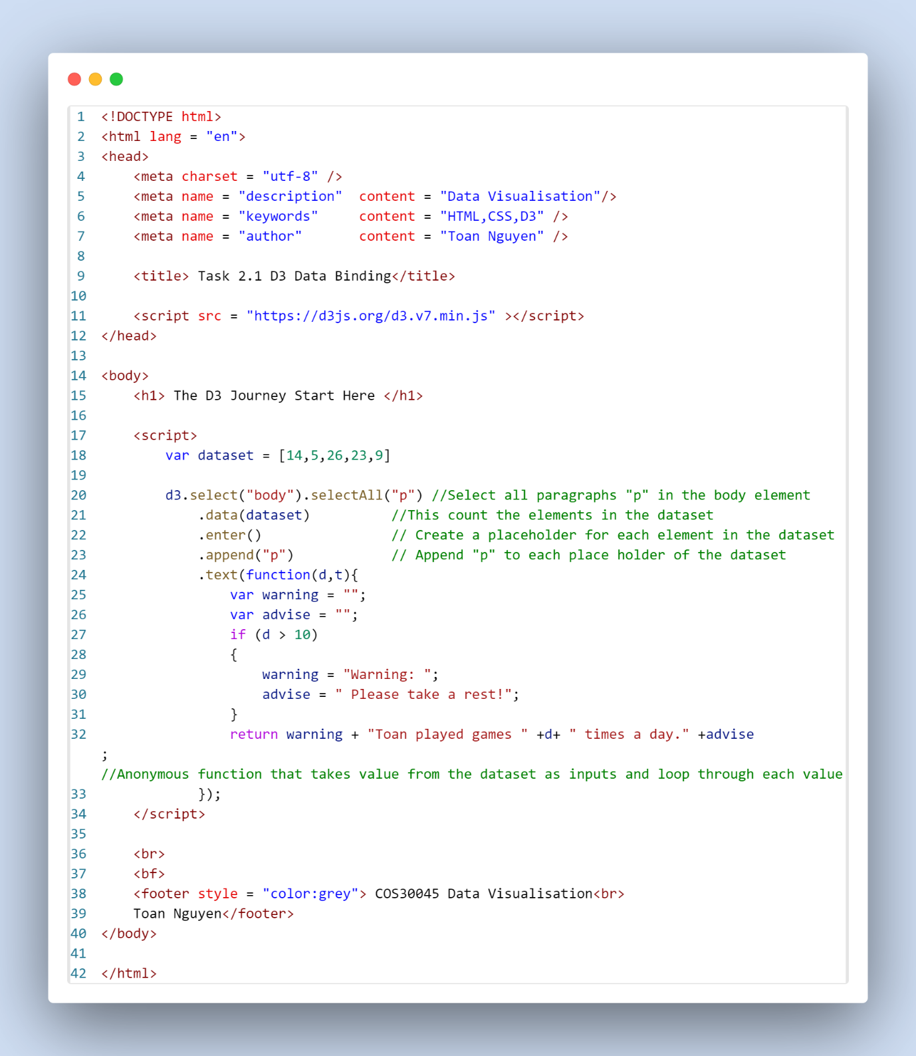

Figure 2: HTML Code