COS30045: Task 1.2

Name: Khanh Toan Nguyen

ID: 104180605

Figure 1: Web page

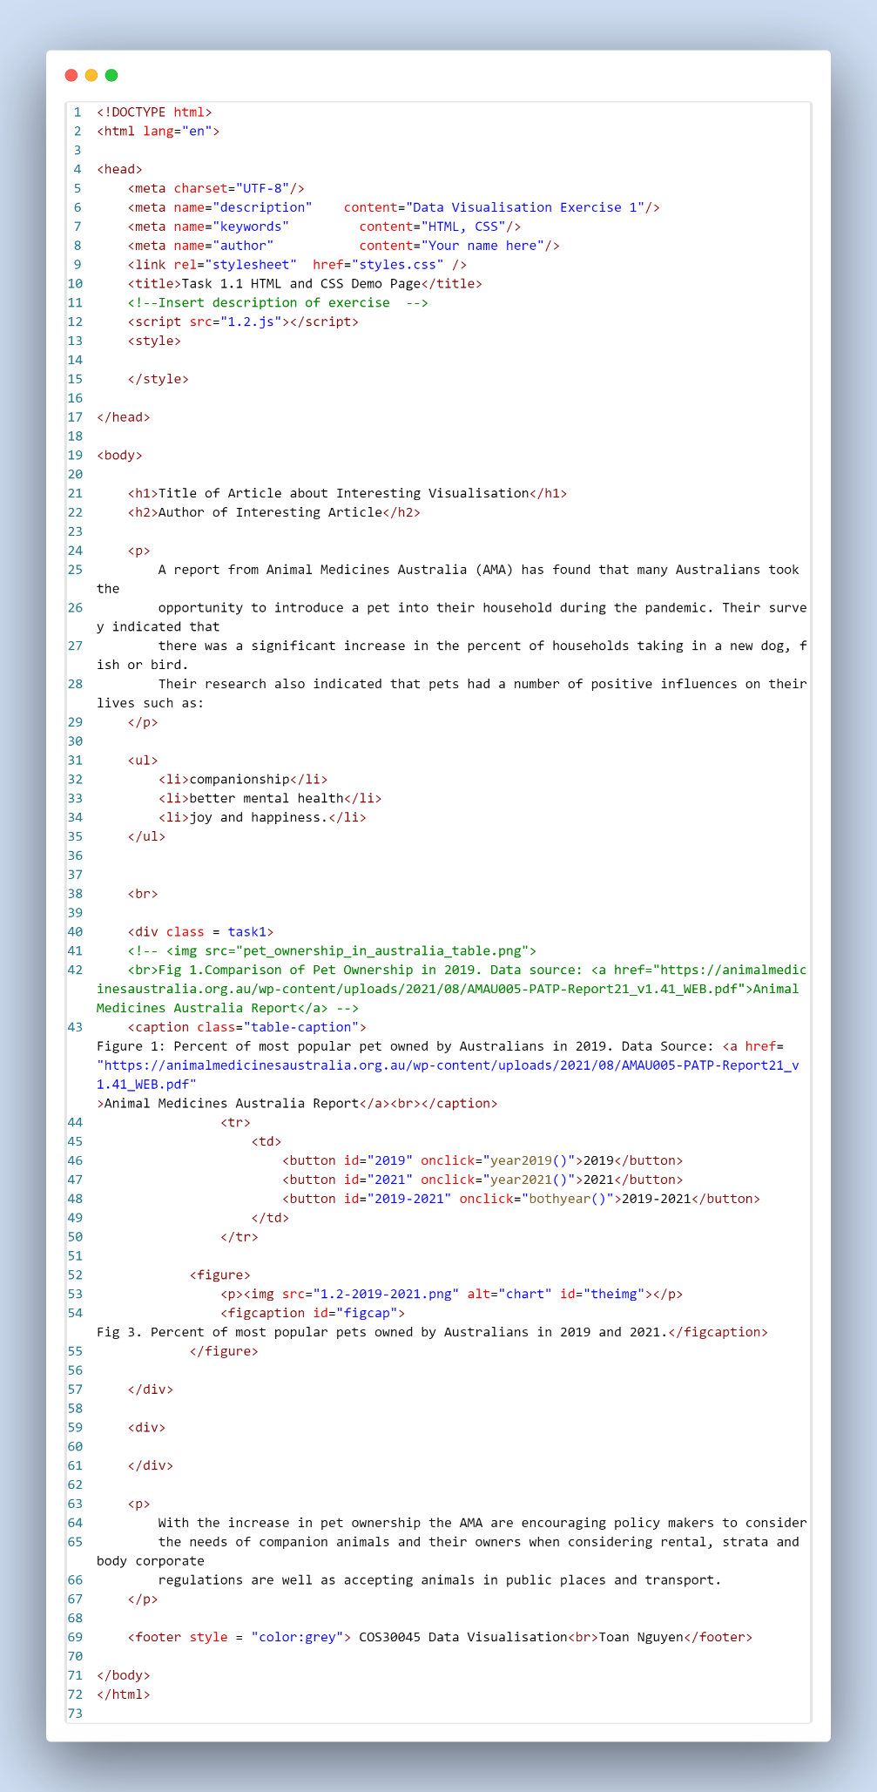

Figure 2: HTML Code

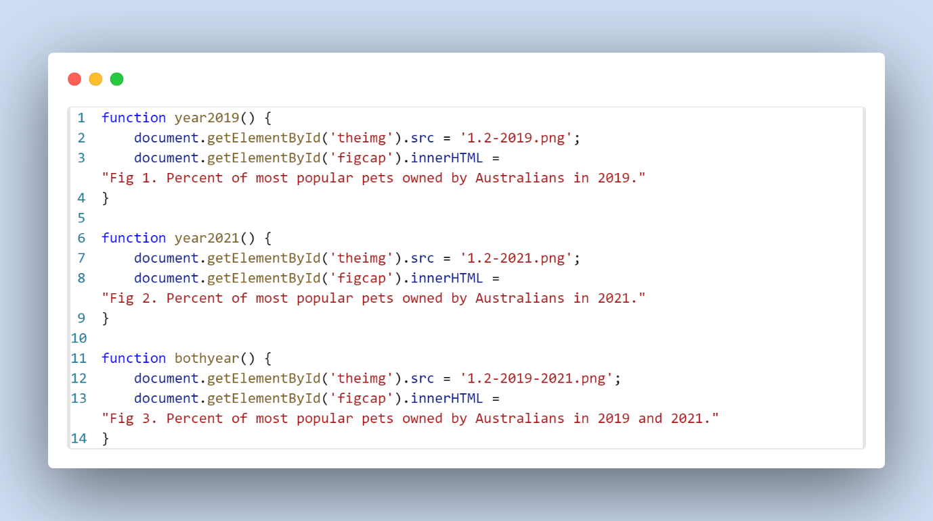

Figure 3: JS code