COS30045: Data Visualisation – Lab 3.1 – 4.1 Nguyen Khanh Toan – 104180605

# Task 3.1

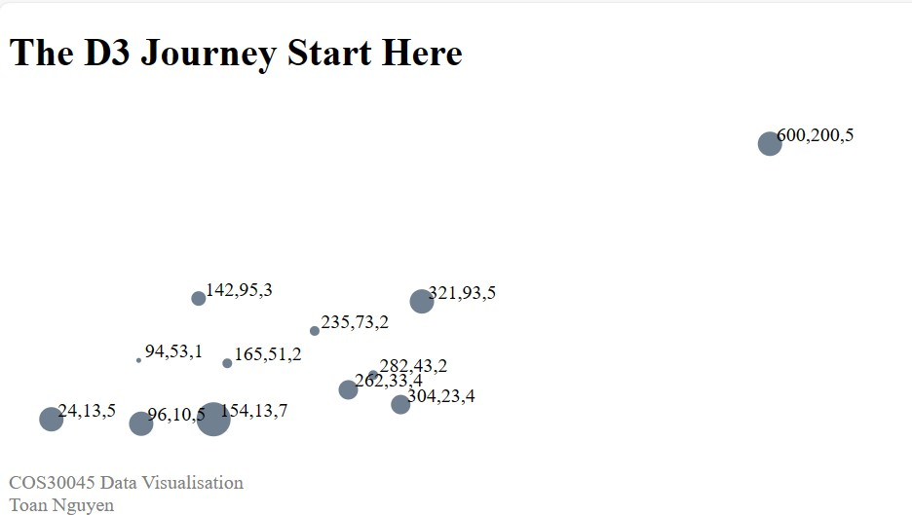

Fig1. Output

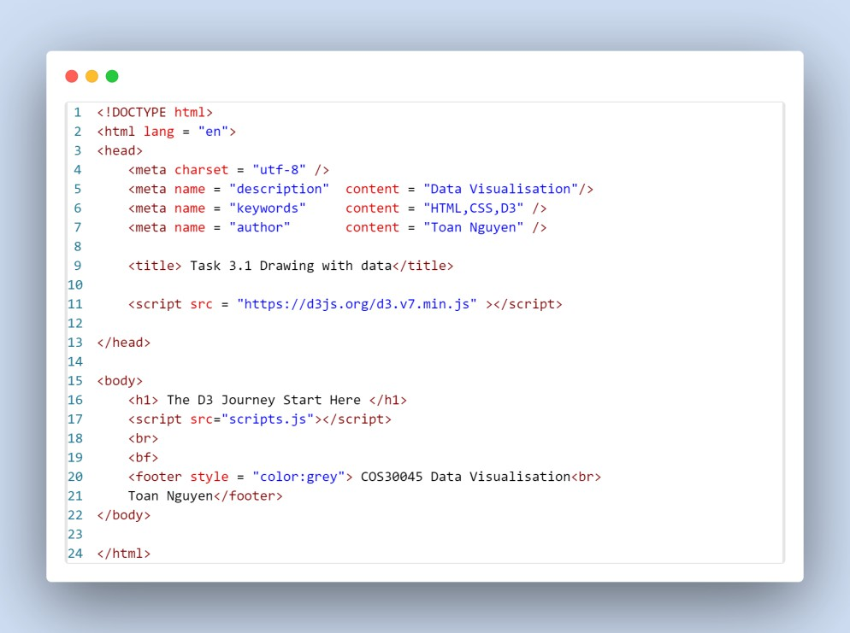

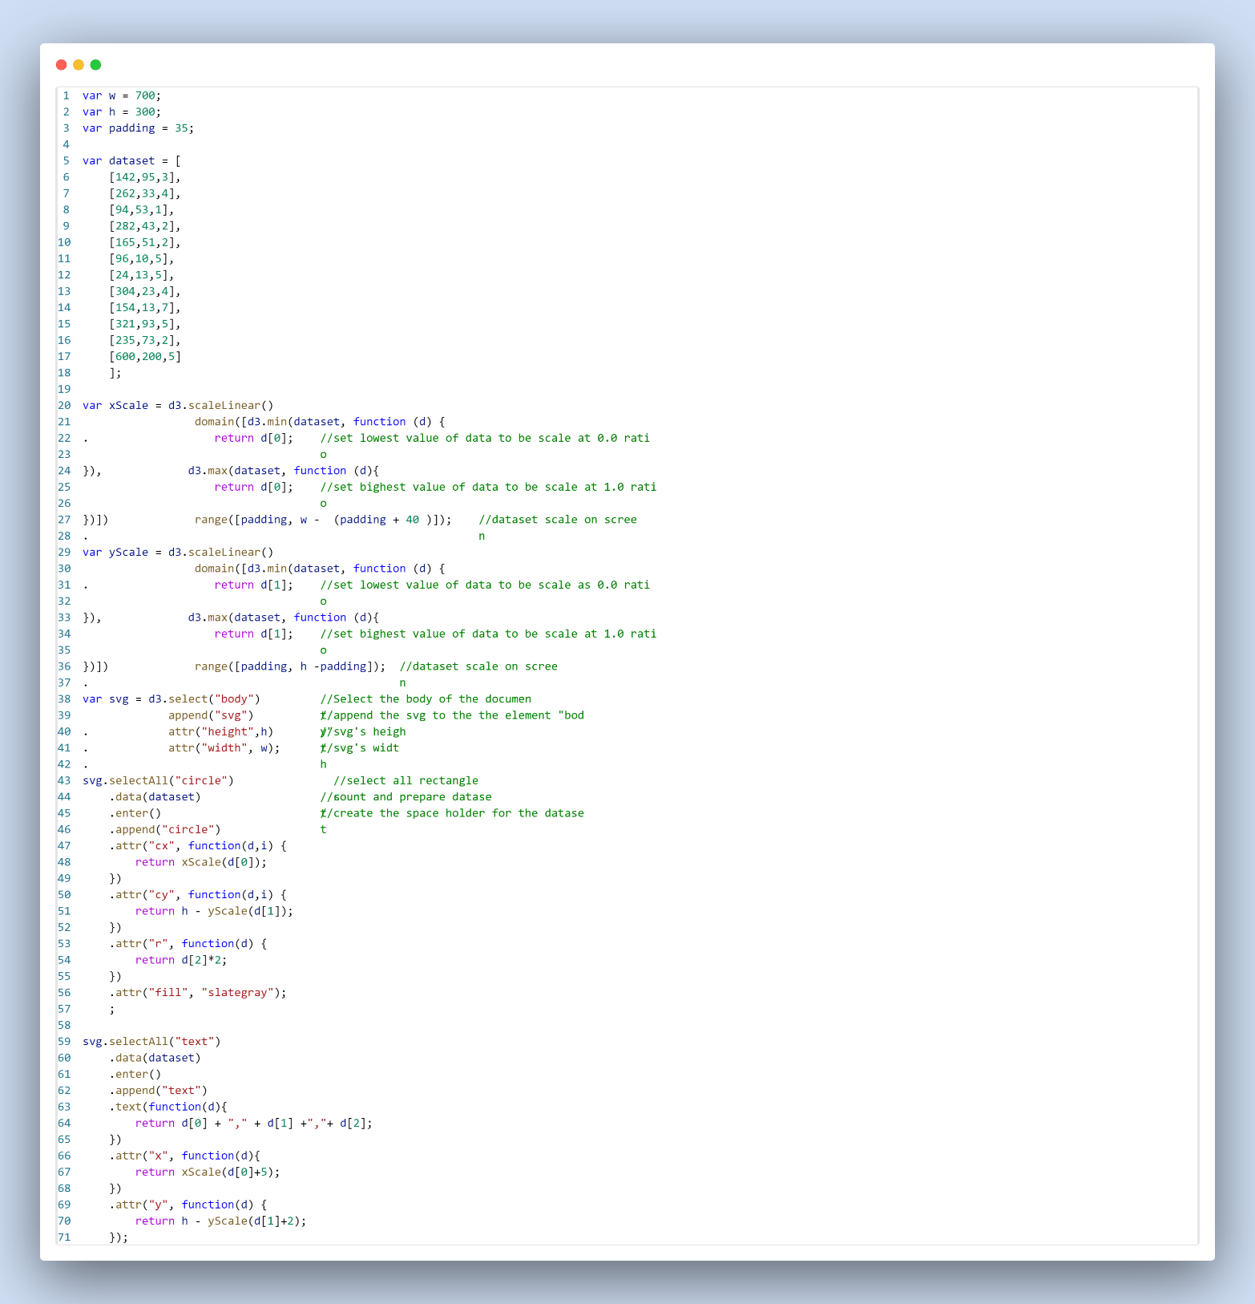

Fig 3: Task 3.1 JS code

# Task 3.2

Fig 4: Task 3.2 Output

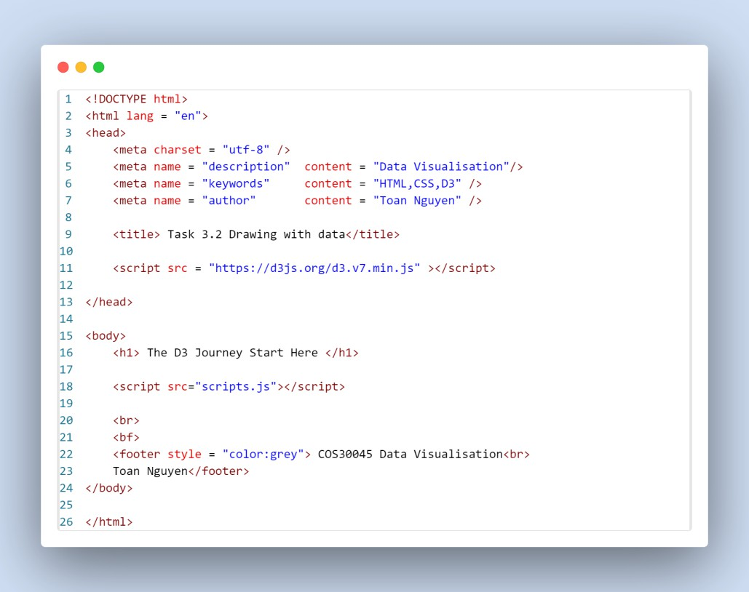

Fig 5: Task 3.2 HTML code

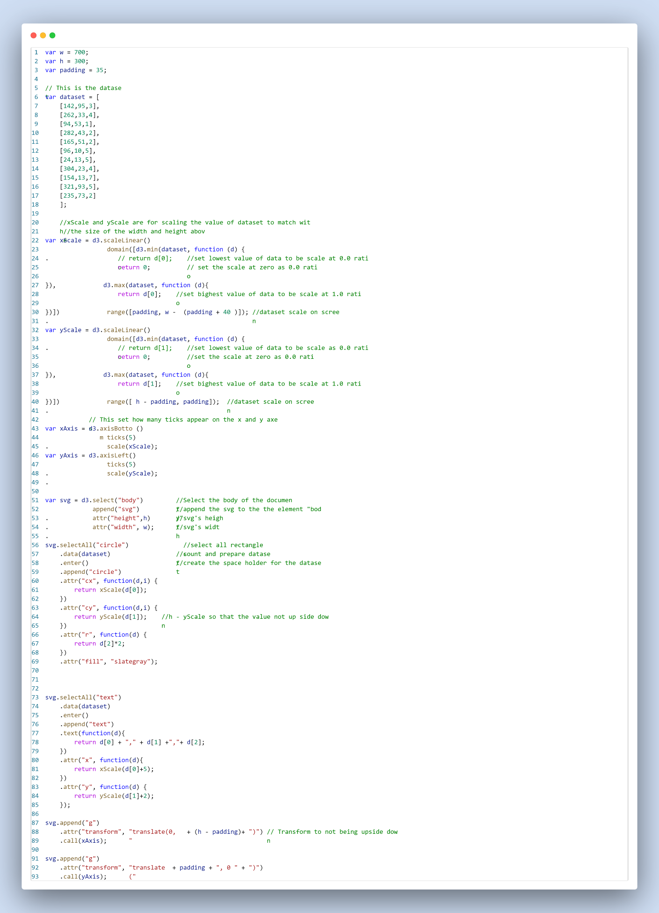

Fig 6: Task 3.2 JS code

School of Science, Computing and Engineering Technologies

COS30045

LAB 4.1 Design Studio

Overview

In this lab you will be given a sample data set and asked to identify the different data and attribute types. You will also think about some questions about this data set that might be answered by a visualisation.

ardd_fatalities_Jan2020_0.xlsx (download from Canvas)

Download and review this data set before attempting this exercise.

1 Interpreting the data set

Complete the LAB 4.1 Quiz.

2 Visualisation Design

1. Which is the age group which controlling vehicle and gender causing crash the most?

* The data attributes need to get to answer this question is Road User, Gender, and Age group. Road user used to identify if the person died in the crash, is the driver. Meanwhile the gender is to specify driver is male or female. And Age group is the main items as data type.
* The data need to transform for this task is Road User and Age Group, to only select the vehicle driver which means attribute match with “driver”, “motor cycle rider’,… and the Age group is to change the format “0_to_16’ to “0-16” or “0 to 16” for better recognition of viewer
* This transform of data does not change the data types which is string.
* The sketch graph:

1. Do Christmas period affects deaths.

* The data attributes need to get to answer this question is Christmas Period. This only need to count how many tuples of Yes or No appear in the attributes
* This data don’t need to transform because it already a string and the task only need to find string that match with “Yes” or “No”
* The sketch graph:

1. What is the trend of death by crash in Major cities of Australia over period 2015 to 2020?

* The data attributes need to get to answer this question is National Remoteness Areas and Year. The attribute National Remoteness Areas is to identify which place happened the death by crashed.
* The data need to transform for this task is National Remoteness Areas and Year, to only select the area in Australia major cities which means attribute match with “Major Cities of Australia”, and the Year is to include only year from 2015 to 2020.
* This transform of data could change the data types of year which from string to numeric, however it is not necessary since year in this case is an item and having the same gap between each year, but in the case the gap between each year is difference, we might consider to set the data type as numeric to not violate diso.
* The sketch graph:

