COS30045: Data Visualisation – Lab 7.1 – 8.2 Nguyen Khanh Toan – 104180605

# Task 7.1

# 

Fig 1: HTML code

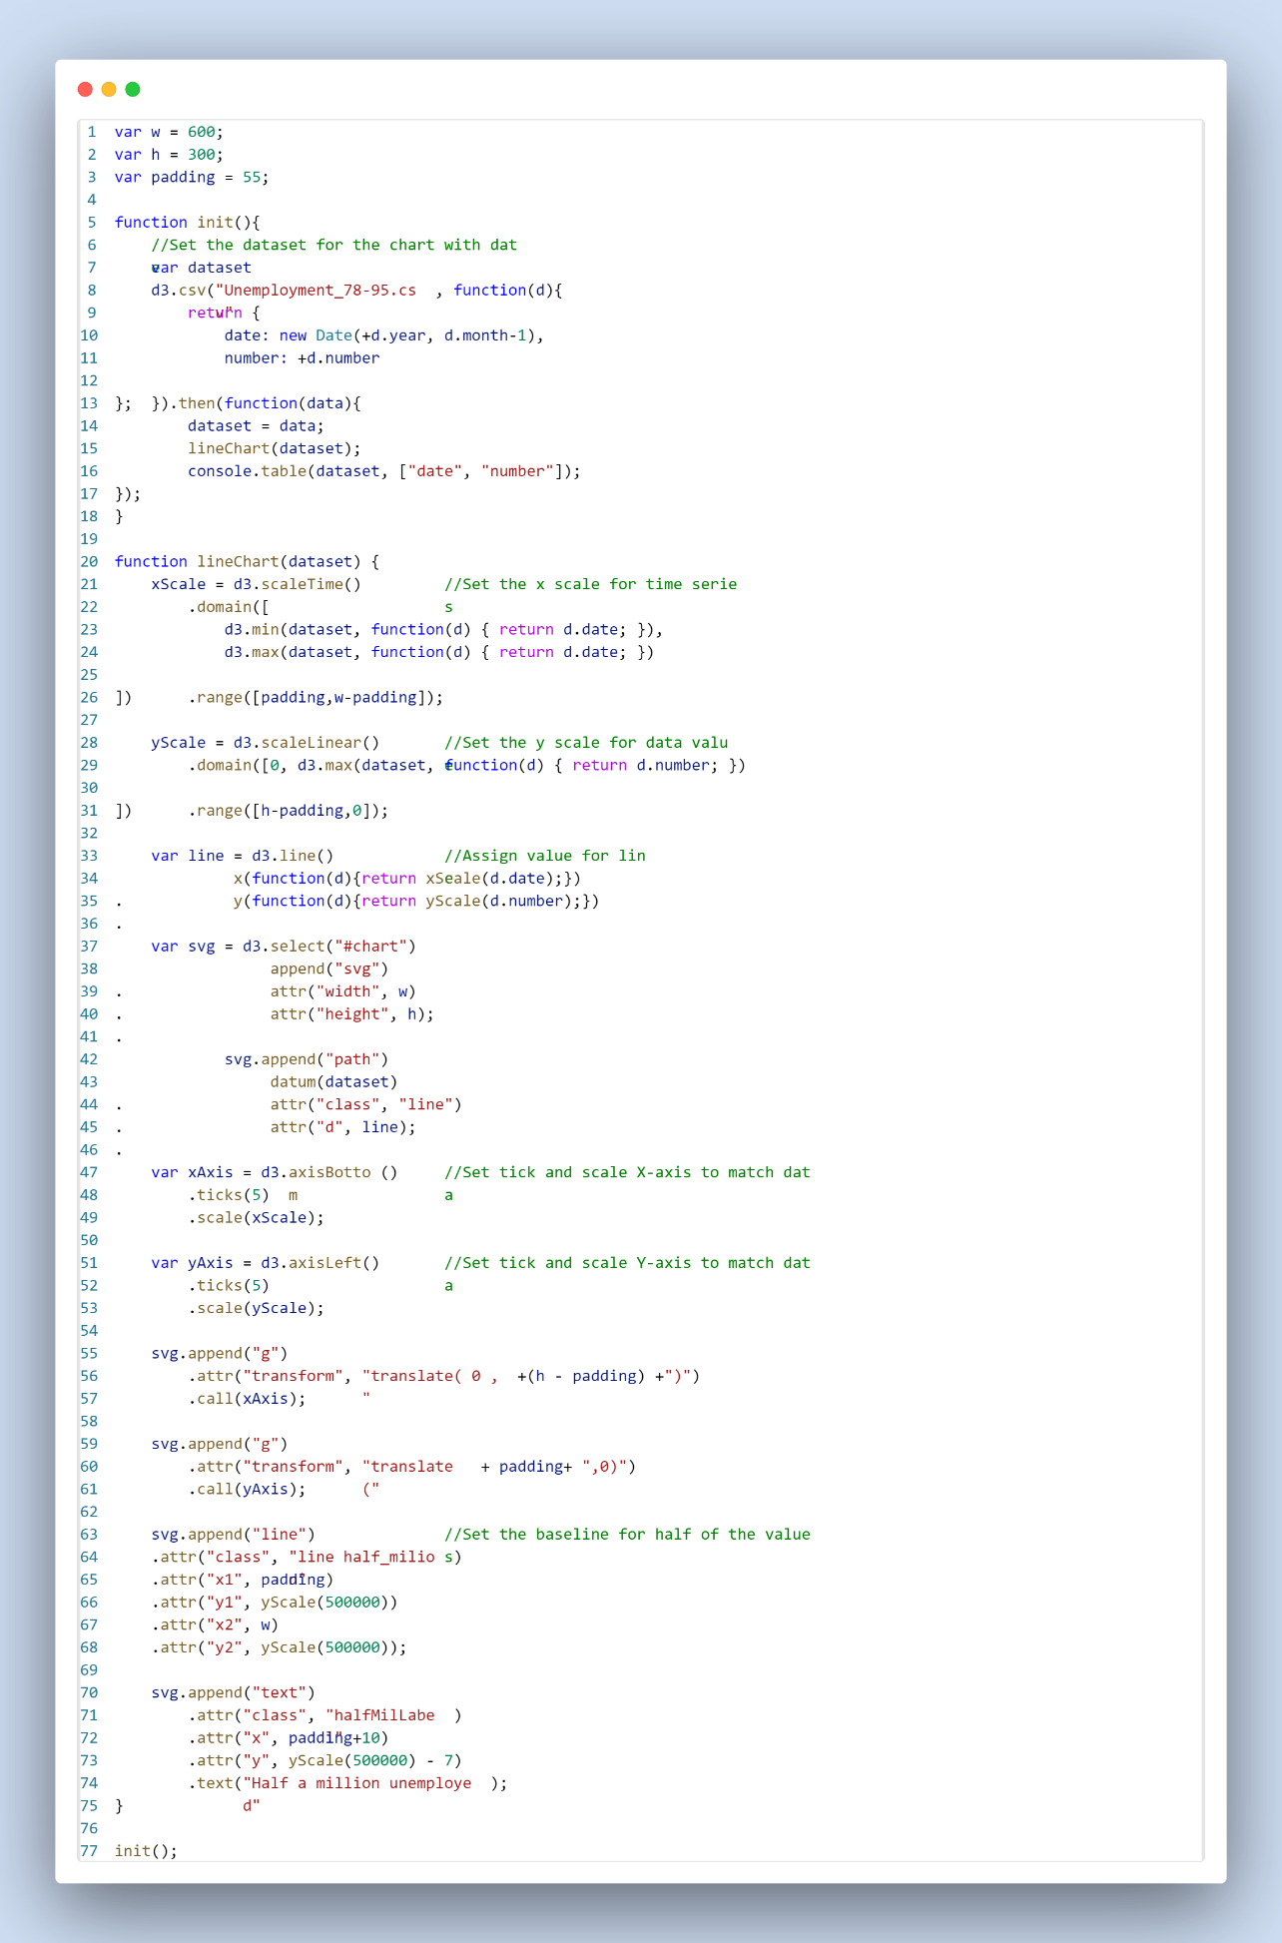

Fig2: JS code for Line chart

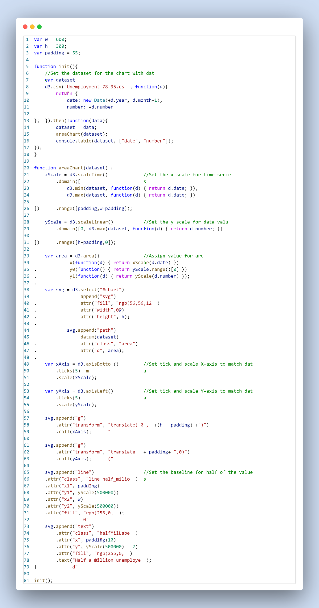

Fig 3: JS code for Area chart

# Task 7.2

# 

Fig 4: HTML code

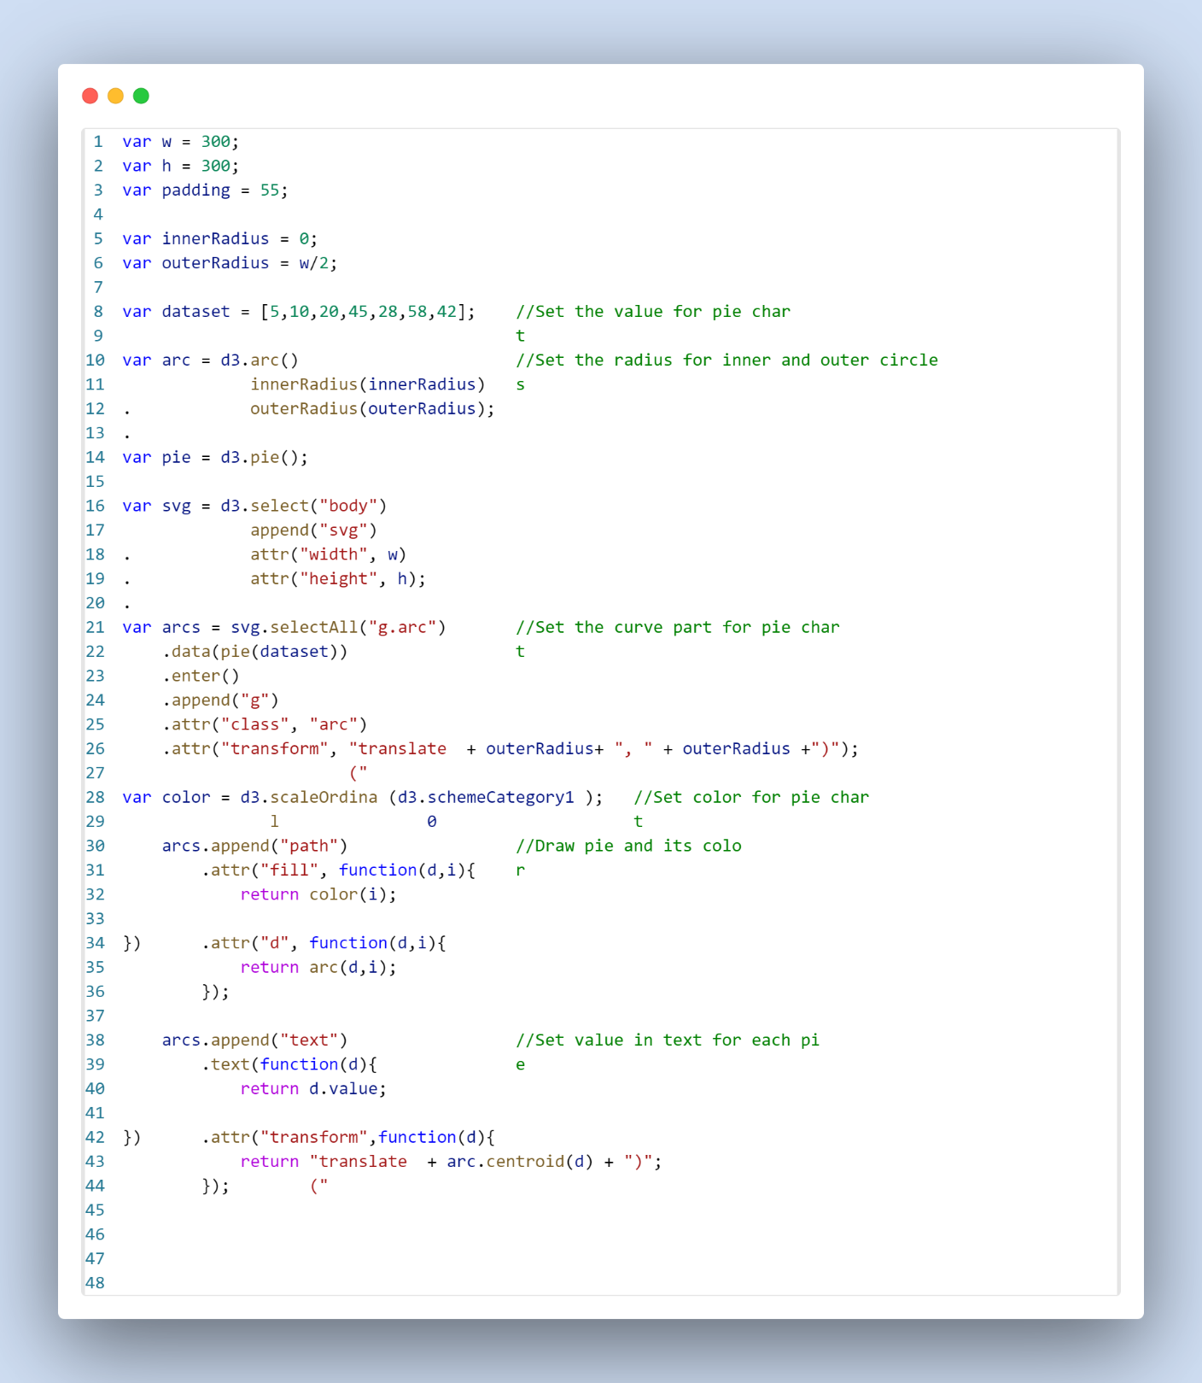

Fig 5: JS code

# Task 7.3

# 

Fig 6: HTML code

# 

Fig 7: JS code

# Task 8.1

# 

Fig 8: HTML code

# 

Fig 9: JS code

# Task 8.2

Fig 10: HTML code

# 

Fig 11: JS code