C Sc 335 Analysis and Design Artifacts for the Final Project, Spring 2013
Due Date: To be graded during your first PM meeting in the first week: 8- through 12-April
1. Team Name: ___AlphaSuperAwesomeCoolDynamiteWolfSquadron____
2. Team Members: __Kyle Almryde_____________ __Jimmy Chav_________________
__Joshua Fry _______________ __Vikrant Singhal_______________
3. Project Chosen: Circle your team's choice of final project
TRPG MUD Tower Defense

4. Classes: List the seven most important objects and the single responsibility of each.

Candidate Object | Single Responsibility in 1 or 2 sentences
1 Lobby | Holds the reference to the other ‘sub-dungeons’ objects
2 Item | An abstract class which characterizes any and all ‘physical/Inanimate objects’, such as weapons, potions, rocks, etc
3 Character | An abstract class which characterizes the basic functionality of the Player themselves, as well as MOBS. It also defines default behavior
4 Room | Is an abstract class that defines the basic structure and layout of a Room object. All rooms have 4 entrances/exits, all rooms contain items, and all rooms can hold MOBs and Players/
5 Warrior | Warrior extends the Character class, it defines behaviors specific to a warrior, such as a higher starting Health and Damage value
6 ItemInventory | Is a collection class that contains Item objects. Every Character (including MOBs) will have an ItemInventory as well as every Room object.
7 Weapon | Weapon extends the Item class. Weapons override the use method (inherent to all Item objects) by inflicting (or returning) damange

These Class and Sequence Diagrams may be written by hand, captured as a picture on a white board, or drawn with a UML editor such as Violet http://sourceforge.net/projects/violet/files/violetumleditor/

5. Class Diagram: Your team UML Class Diagram must show at least all of your candidate objects from above. Show any relationships between them the classes such as inheritance or interface implementation. Draw general associations such as dependency or aggregation. Label some to help explain things. Add any multiplicity adornments that seem appropriate. Use notes to explain things if you feel it will help. Each UML class must show the class name. For full credit, each class must have an average of at least one attribute per class. There must be an average of at least 2.0 methods per class, which may be implicit (no need to repeat methods) if the class implements a Java interface with methods shown there.

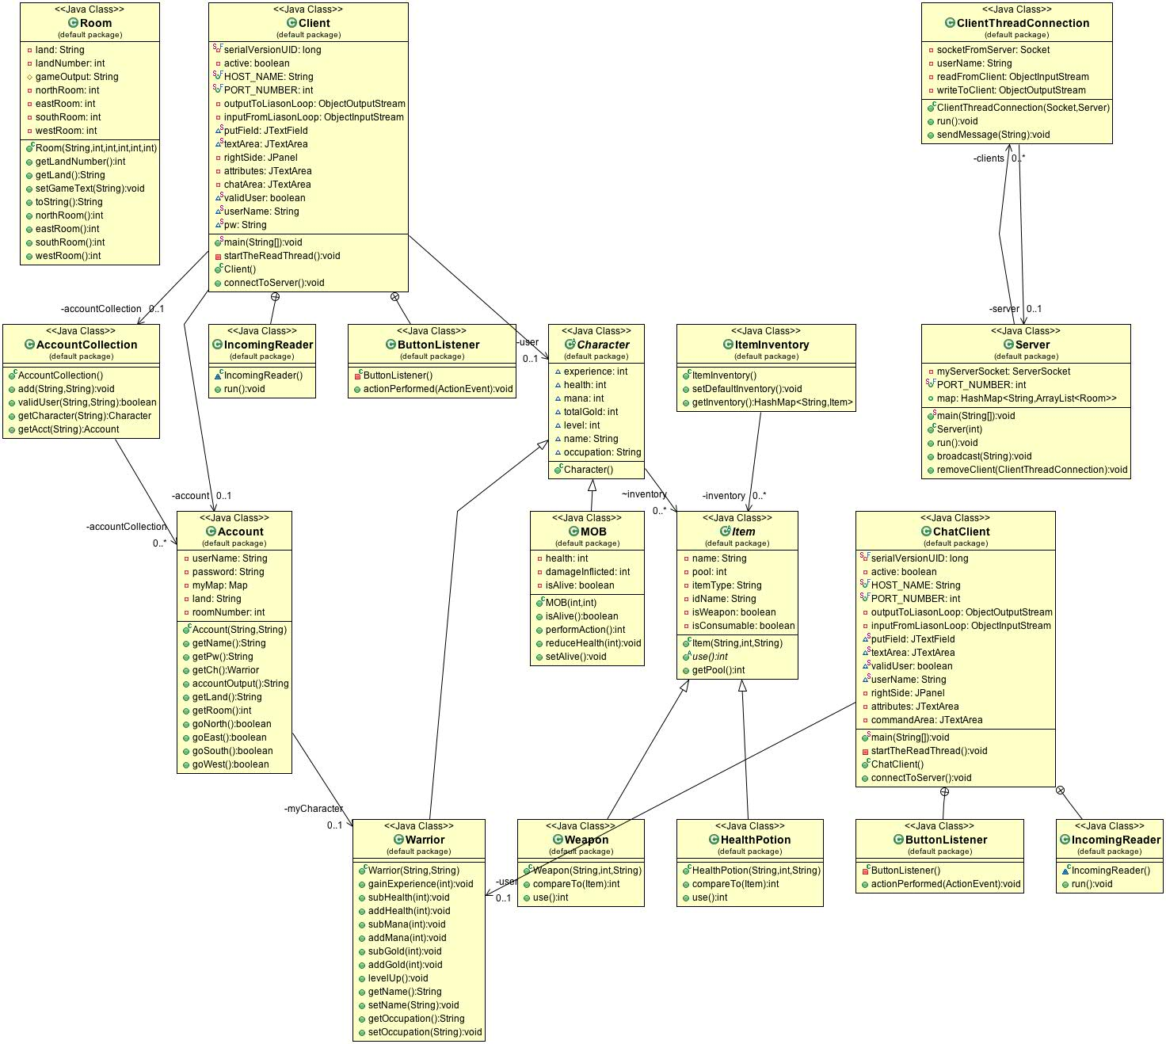

6. Sequence Diagram: Your team UML Sequence Diagram should show the most important scenario you can think of. Your sequence diagram should show most of your objects from above and how they communicate with each other.

