**Prerequisite for the Single Molecule Footprinting data analysis practical**

We will use R and R studio for data analysis.

You can find more information about R here: <https://www.r-project.org/about.html>

So, we have to install the following softwares:

(Don’t worry if you can’t make this, we can help you install them as well!)

1. Download and install R (Download R for Windows or R for macOS depending on your computer)

<https://cran.rstudio.com/>

1. Download and install R Studio (Download R Studio for Windows or R for macOS depending on your computer)

<https://posit.co/download/rstudio-desktop/>

1. Next, to install necessary packages, we will run commands from the provided file `install.R`.

Open R studio and click: file > Open File > install.R

Your R studio should look similar to this

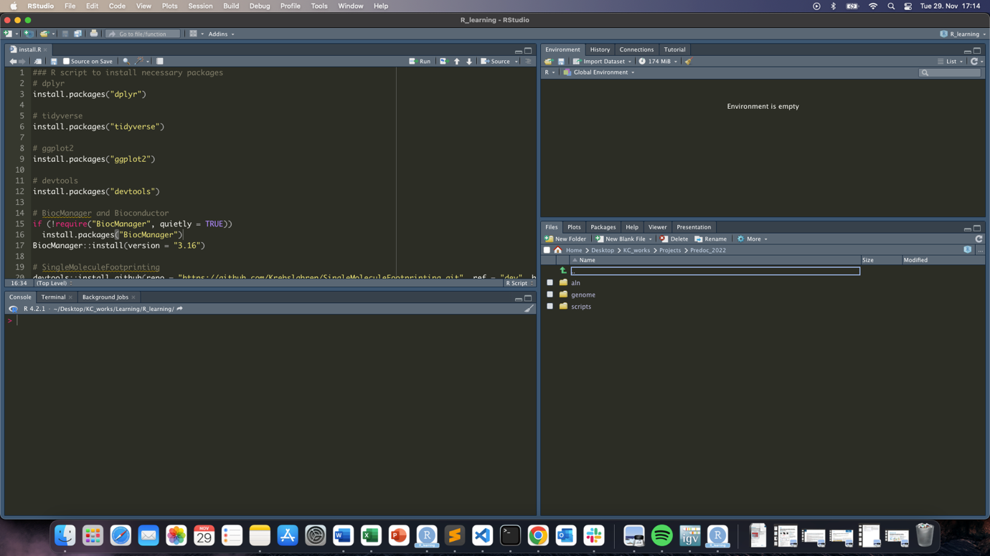

Then you select all texts in the script and click run like this

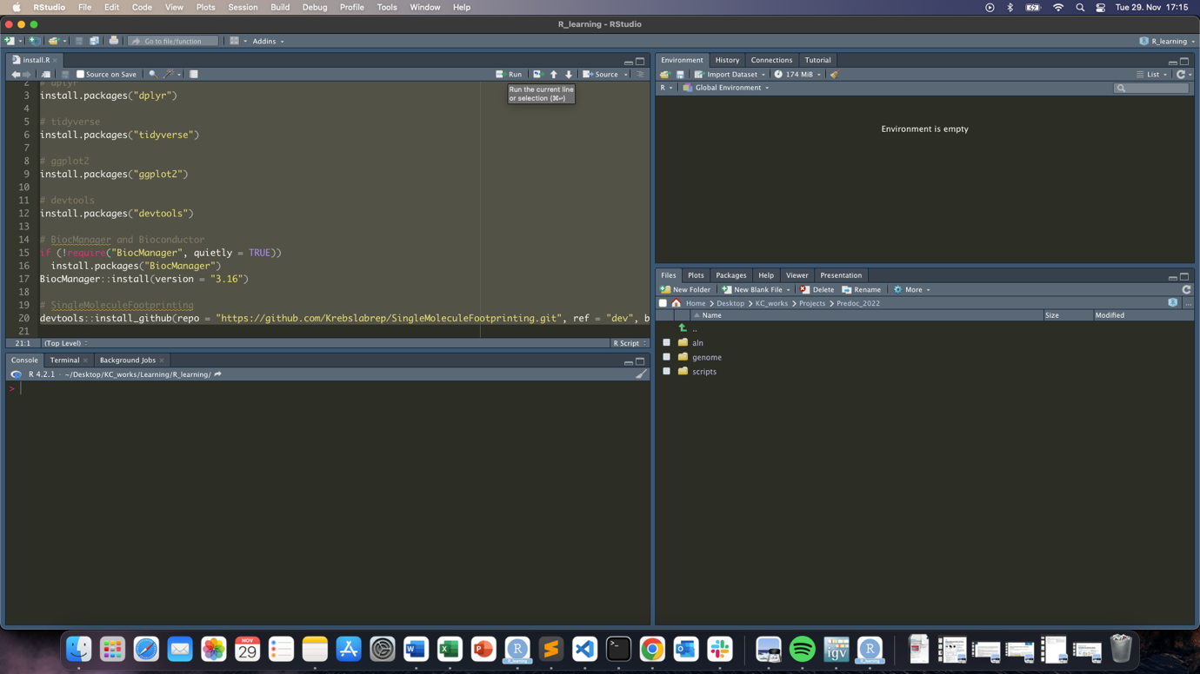



This should start installing the packages.

*** Again, don’t worry if this doesn’t work, we can help you do this ***