Handwritten Digit Recognition
Using Artificial Neural Networks
Task 2 | Implementation: Python 3.13, TensorFlow 2.21.0, Keras, Flask, NumPy, Matplotlib and scikit-learn

Abstract
This project designs and evaluates fully connected artificial neural networks (ANNs) for classifying handwritten digits (0–9). Four models were trained using the MNIST dataset and compared in terms of accuracy, cross-entropy loss, trainable parameters and generalization. The best-performing configuration, a two-hidden-layer ANN with dropout and early stopping, achieved 97.82% accuracy and 0.07340 loss on 10,000 unseen MNIST test images. A Flask and HTML5 Canvas application enabled live inference on manually drawn digits. The practical tests exposed occasional confident errors despite strong benchmark accuracy, highlighting the importance of input preprocessing and the difference between benchmark and user-generated handwriting. An additional refinement using intensity-weighted centering produced correct classifications in four new manual trials, although the small non-controlled sample does not establish a general accuracy improvement.

1. Objective and reference approach
The objective was to propose, train and evaluate an ANN capable of recognizing handwritten digits and to document experimental findings. The implementation takes inspiration from the provided TensorFlow handwritten-digit GitHub demonstration [1] and the deployment tutorial showing a Flask backend with an HTML5 drawing interface [2]. The four-architecture comparison, regularization experiment, detailed evaluation and improved crop/centering preprocessing were developed for this exercise; they are not claimed to be results from those sources.

2. Dataset and preprocessing
MNIST contains 60,000 labeled training images and 10,000 test images of 28 × 28 grayscale handwritten digits. Pixel intensities originally range from 0 to 255 and were divided by 255, producing normalized values in [0, 1]. Ten classes correspond to digits 0 through 9. For model comparison, 54,000 training images were used to update weights and 6,000 were reserved for validation; the separate 10,000-image test set was used for final evaluation.
The browser receives black pen strokes on a white 280 × 280 canvas. The backend decodes the PNG, converts to grayscale, inverts colors, crops to the non-background bounding box, preserves aspect ratio while resizing to fit within 20 × 20, centers the image on a black 28 × 28 canvas, normalizes intensities, and adds a batch dimension. This approximates, but does not exactly reproduce, all characteristics of MNIST preprocessing. A later implementation additionally shifts the image to its pixel-intensity center of mass; the new live results are described in Section 9.

3. Network design and training
All models are multilayer perceptrons (MLPs), not convolutional neural networks. The Flatten operation converts each 28 × 28 image into 784 inputs. Dense hidden layers use ReLU activation, and the 10-neuron output layer uses Softmax. Models were compiled with Adam (learning rate 0.001), sparse categorical cross-entropy, batch size 32 and up to 15 epochs. Random seeds were set to 42 for the comparison script; repeated runs may still vary slightly due to implementation details.
Model | Hidden units | Dropout | Stopping | Trainable parameters
ANN-1 | 64 | No | 15 epochs | 50,890
ANN-2 | 128, 64 | No | 15 epochs | 109,386
ANN-3 | 256, 128, 64 | No | 15 epochs | 242,762
ANN-4 | 128, 64 | 0.2 after each hidden layer | Early stopping, patience = 3 | 109,386
ANN-4 restores weights from its lowest validation-loss epoch when early stopping finishes. Dropout has no trainable weights, so ANN-2 and ANN-4 have the same parameter count. ANN-4 varies both dropout and stopping strategy, which limits causal attribution.

4. Baseline model training: learning curves
ANN-2 was first trained as the baseline network. The training accuracy increased from 92.49% in epoch 1 to 99.55% in epoch 15, while validation accuracy increased from 96.55% to 97.93%. Training loss decreased from 0.2557 to 0.0129, but validation loss increased from approximately 0.0959 at epoch 2 to 0.1373 by epoch 15.
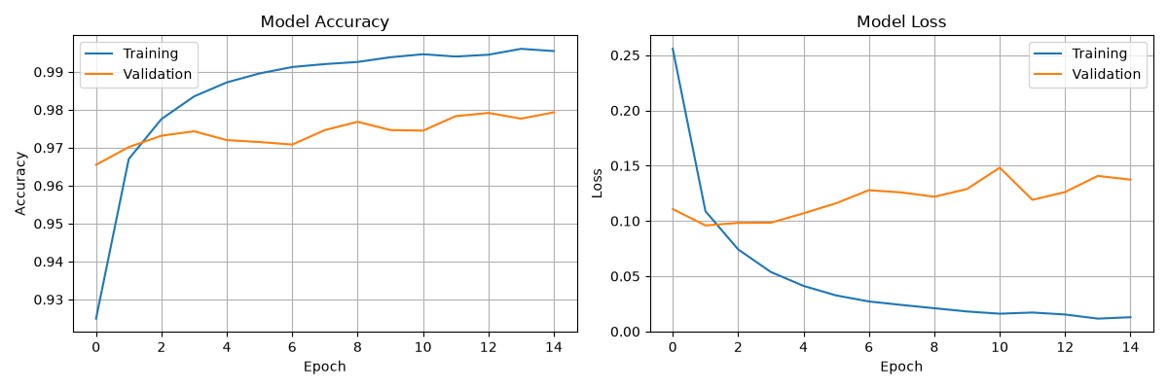
Figure 1. ANN-2 training and validation accuracy / loss across 15 epochs (user-generated experiment).
The divergence between decreasing training loss and generally rising validation loss after the early epochs is evidence of overfitting. Validation accuracy can still rise despite deterioration in cross-entropy because the latter penalizes increasingly confident mistakes.

5. Model comparison
Model | Epochs | Test accuracy | Test loss | Best val. loss
ANN-1 | 15 | 96.92% | 0.12820 | 0.09014
ANN-2 | 15 | 97.72% | 0.11438 | 0.09591
ANN-3 | 15 | 97.70% | 0.11021 | 0.07900
ANN-4 | 10 | 97.82% | 0.07340 | 0.06712
ANN-1 achieved 96.92% accuracy with fewer than half the trainable parameters of ANN-2. ANN-2 improved test accuracy by 0.80 percentage points relative to ANN-1. Increasing depth and width again (ANN-3) did not improve test accuracy over ANN-2, although it produced a slightly lower test loss. ANN-4 achieved the highest observed test accuracy (97.82%) and the lowest test loss (0.07340). The ANN-4 improvement over ANN-2 was 0.10 percentage points in accuracy and approximately 35.8% in test loss. Small accuracy differences on a single test set should not be overinterpreted without replication.
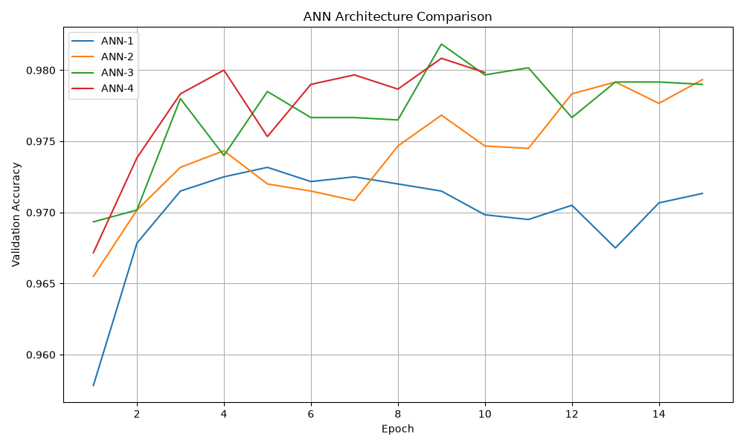
Figure 2. Validation accuracy during training for the four tested architectures (user-generated experiment).

6. Detailed test-set performance of ANN-2
The baseline network correctly classified 9,772 of 10,000 MNIST test digits (97.72% accuracy); 228 predictions were incorrect. The macro-average precision, recall and F1-score were 0.9771, 0.9769 and 0.9770 respectively. These per-class metrics were computed for ANN-2; they should not be presented as ANN-4 per-class metrics.
Digit | Precision | Recall | F1-score | Support
0 | 0.9798 | 0.9908 | 0.9853 | 980
1 | 0.9869 | 0.9947 | 0.9908 | 1,135
2 | 0.9665 | 0.9777 | 0.9721 | 1,032
3 | 0.9642 | 0.9871 | 0.9755 | 1,010
4 | 0.9866 | 0.9715 | 0.9790 | 982
5 | 0.9697 | 0.9697 | 0.9697 | 892
6 | 0.9862 | 0.9697 | 0.9779 | 958
7 | 0.9860 | 0.9601 | 0.9729 | 1,028
8 | 0.9724 | 0.9754 | 0.9739 | 974
9 | 0.9732 | 0.9722 | 0.9727 | 1,009
Digit 1 had the highest F1-score (0.9908), whereas digit 5 had the lowest F1-score (0.9697). Digit 7 had the lowest recall (0.9601), meaning that approximately 4% of the actual 7 examples were classified as a different class. The evaluation script generated a confusion matrix and misclassification examples, but these image files were not supplied in the available materials and therefore are not reproduced or reconstructed here.

7. Live browser application
The deployed prototype uses an HTML5 Canvas, JavaScript Fetch requests, a Flask /predict endpoint and a saved Keras model. The endpoint returns the predicted digit, maximum Softmax score and a vector of ten class scores. Users can draw and clear digits, request a prediction, and inspect probability bars for all classes. Softmax scores are reported as model confidence; they are not guaranteed to be statistically calibrated probabilities.
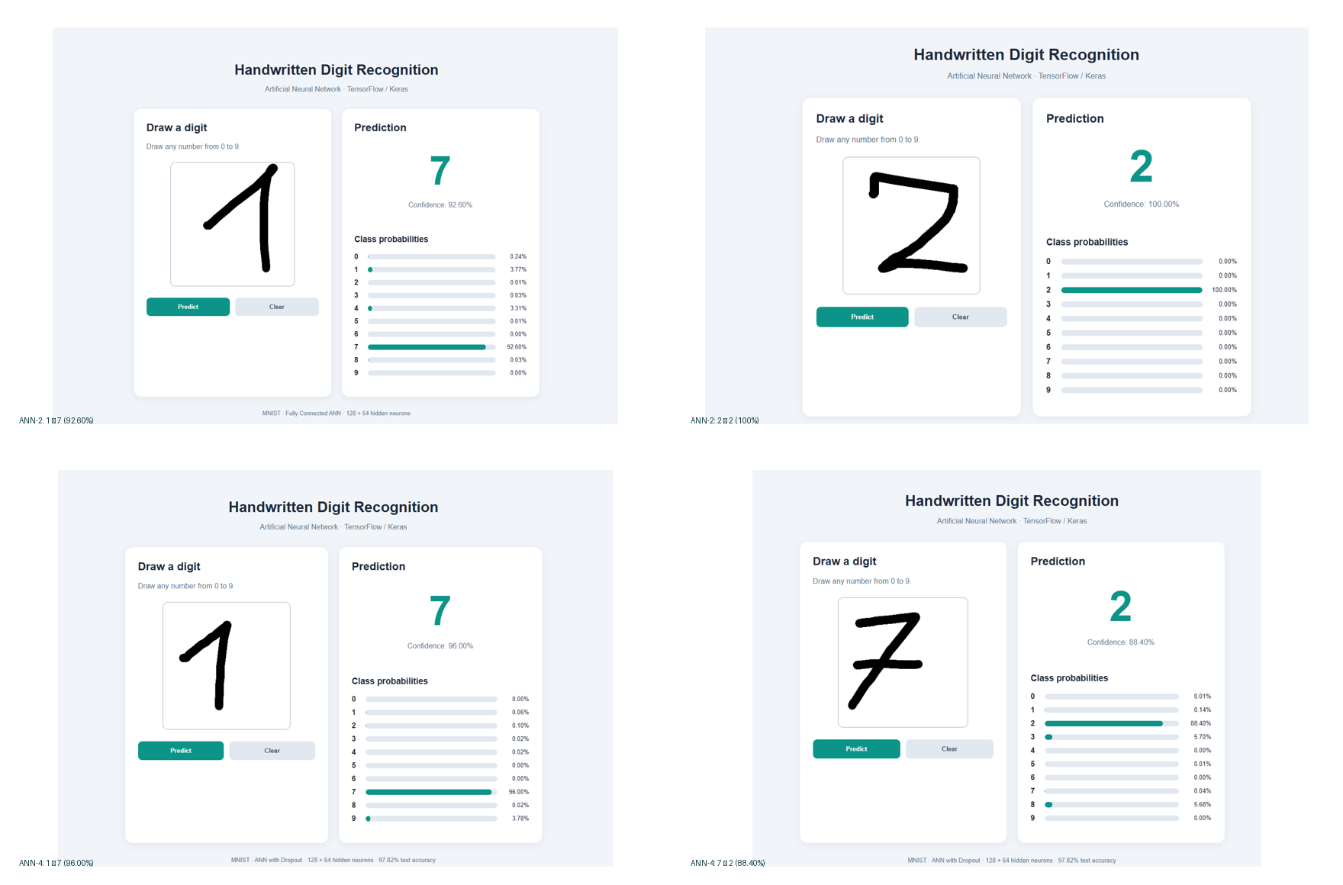
Figure 3. Representative live tests captured from the Flask drawing application (ANN-2 and ANN-4).

8. Manually drawn digit experiments
Model | Drawn digit | Predicted digit | Reported confidence | Outcome
ANN-2 | 7 | 7 | 99.15% | Correct
ANN-2 | 1 | 7 | 92.60% | Incorrect
ANN-2 | 2 | 2 | 100.00% | Correct
ANN-2 | 3 | 3 | 100.00% | Correct
ANN-4 | 1 | 7 | 96.00% | Incorrect
ANN-4 | 2 | 2 | 97.61% | Correct
ANN-4 | 3 | 3 | 100.00% | Correct
ANN-4 | 7 | 2 | 88.40% | Incorrect
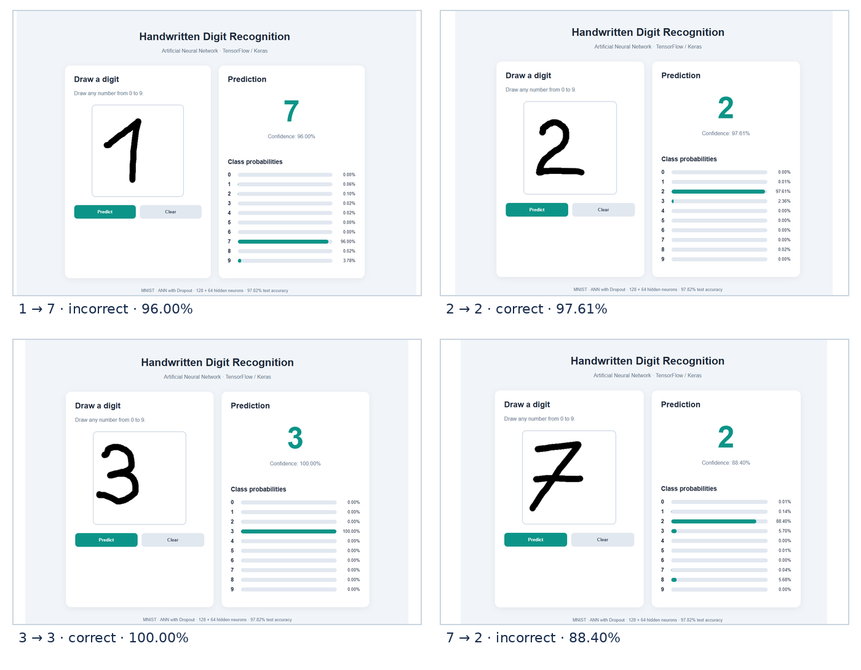
Figure 4. ANN-4 browser tests: original screenshots for handwritten 1, 2, 3 and 7. The model correctly predicted 2 and 3, but misclassified 1 as 7 and 7 as 2.
The four illustrated ANN-2 drawings yielded 3/4 correct predictions; the four illustrated ANN-4 drawings yielded 2/4. These are descriptive outcomes from a tiny convenience sample, not statistically meaningful estimates of real-world accuracy. In addition, the drawings were not saved and replayed identically between models, so the two sets do not support a controlled comparison of manual-input performance.
Two characteristic errors are informative. A handwritten 1 with an angled top stroke was read as 7 by both ANN-2 and ANN-4. ANN-4 also classified a crossed 7 as a 2 with 88.40% confidence. Such errors may reflect handwriting-style differences, stroke geometry and preprocessing mismatch between the browser inputs and the MNIST benchmark. No single explanation is confirmed by these observations alone.

9. Improved browser-image preprocessing
Following the initial live tests, image preprocessing was modified while retaining the trained ANN-4 weights. In addition to grayscale conversion, inversion, cropping, aspect-ratio-preserving resizing and placement on a 28 × 28 canvas, the updated pipeline calculated the intensity-weighted center of mass and translated the digit toward the image center. This was intended to better align browser inputs with MNIST-style samples.
In a new set of four manually drawn examples, the updated application correctly identified the digits 1, 2, 3 and 7. The earlier problematic writing styles for 1 and 7 were recognized correctly in these new trials. The drawings were recreated rather than replayed as identical saved images, so this observation suggests—but does not conclusively prove—that the preprocessing change caused the improvement.
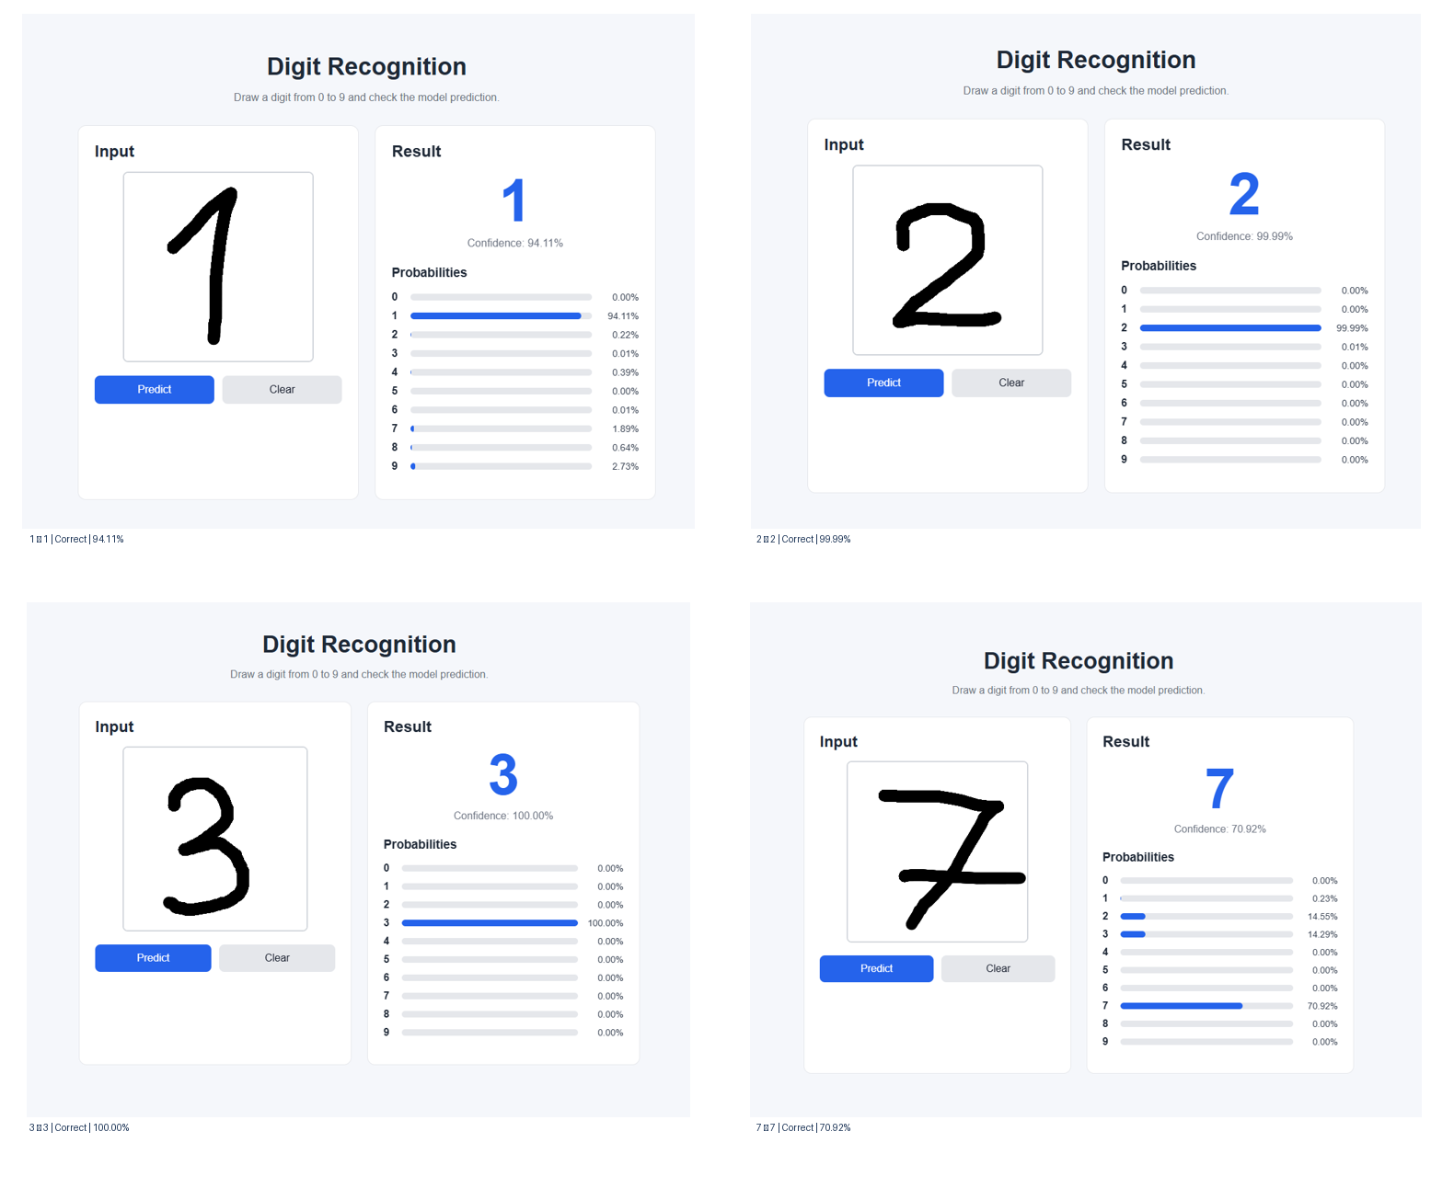
Figure 5. ANN-4 live predictions after intensity-weighted center-of-mass alignment: 1 (94.11%), 2 (99.99%), 3 (100.00%) and 7 (70.92%); all four correct.
These four examples constitute a small qualitative demonstration, not a reliable post-improvement accuracy estimate. The MNIST test result of 97.82% remains unchanged because the model was not retrained and the benchmark test pipeline was not modified.

10. Limitations and further improvements
The experiments used a single random seed and one test dataset. ANN-4 changed two training techniques simultaneously, so a dropout-only and early-stopping-only ablation would be needed to isolate their effects. The interface experiments have only four displayed examples per model and do not include standardized handwritten samples or a representative user population.
Further work should: (i) evaluate preprocessing variants on exactly the same saved canvas drawings; (ii) standardize stroke width and image centering; (iii) augment training samples with shifts, rotations and stroke variation; (iv) collect a larger labeled real-world test set; (v) consider calibration of Softmax scores; and (vi) optionally compare a convolutional neural network with the MLP baseline.

11. Conclusions
The project meets its core objective: a trained ANN can classify digits 0–9, and an integrated browser-based application can perform live inference. Among the four tested configurations, ANN-4 offered the best observed MNIST result: 97.82% accuracy and 0.07340 cross-entropy test loss with 109,386 trainable parameters. A larger architecture was not automatically better, while the combined dropout and early-stopping configuration reduced test loss. Nevertheless, manually drawn digits occasionally triggered highly confident misclassifications. Consequently, benchmark accuracy alone is insufficient to characterize user-facing reliability; representative input preprocessing and evaluation are important parts of model deployment. After introducing intensity-weighted centering at inference time, four additional browser drawings (1, 2, 3 and 7) were recognized correctly. This encouraging outcome requires controlled testing with saved, identical inputs before a quantitative gain can be claimed.

References
[1] agnivahp. Tensorflow-Handwritten-digit-recognition-demo. GitHub repository. https://github.com/agnivahp/Tensorflow-Handwritten-digit-recognition-demo (accessed 25 October 2026).
[2] Analytics Vidhya. How to Deploy Digit Recognition Model into Drawing App. https://medium.com/analytics-vidhya/how-to-deploy-digit-recognition-model-into-drawing-app-6e59f82a199c (accessed 25 October 2026).
[3] MNIST handwritten digit dataset, accessed through tensorflow.keras.datasets.mnist.

