WORKSHEET

Mapping your regulatory context
Data Centres and Large Loads Regulator Dialogues
Purpose
This worksheet helps your authority translate the dialogue into its own institutional and market context. It is designed to support a focused internal conversation between Sessions 1 and 2, and to prepare practical insights for the next dialogue.

How to use this worksheet
1. Bring together a small group. Where possible, complete the reflection with colleagues from relevant teams. A group of three to six people works well.
2. Set aside 30 to 45 minutes. Spend roughly 20 minutes on the Challenge Map and 15 minutes on the Regulatory Role Check. Capture conclusions, not perfect answers.
3. Choose a specific focus. Define the data centre or large-load issue you want to examine. Keep the scope narrow enough to discuss concretely.
4. Record different perspectives. Note areas of agreement, uncertainty, and divergence. Differences can reveal important dependencies or assumptions.
5. Bring your key insights to Session 2. You do not need to submit the full worksheet unless requested. Be ready to share one challenge, one point of regulatory agency, and one coordination need.
There are no right or wrong answers. The value lies in making assumptions visible and identifying where action or coordination may be possible.

Authority / organisation: _______________________________________________________
Participants: ___________________________________________________________________
Date: _____________________________________________________________________________

EXERCISE 1

Challenge Map
Build a shared view of what is driving the issue in your jurisdiction before discussing possible responses.

1. Define the issue
Write one clear issue statement. Describe the observed or anticipated challenge, who or what is affected, and the relevant timeframe. Avoid framing the issue as a predetermined solution.
Issue statement
Example structure: “Rapid growth in [type of large load] is creating [specific challenge] for [system or stakeholders] over [timeframe].”
________________________________________________________________________________
________________________________________________________________________________
________________________________________________________________________________

2. Identify contributing factors
Consider the categories below as prompts, not as a mandatory checklist. Add, combine, or remove categories to reflect your context. Record evidence where available and mark assumptions that require testing.

System planning and forecasting
Demand forecasts, location and timing uncertainty, generation and network planning, scenario assumptions.

Grid connection and infrastructure
Connection queues, capacity allocation, lead times, reinforcement, cost sharing, stranded-asset risk.

Tariffs and cost allocation
Network charges, connection costs, flexibility incentives, cross-subsidies, treatment of dedicated assets.

Technical and operational requirements
Reliability, power quality, ramping, backup generation, demand response, curtailment, data and visibility.

Consumer and public interest
Affordability, service quality, fairness, local impacts, environmental considerations, wider economic value.

Governance, policy and coordination
Legal mandate, permitting, government policy, institutional roles, information sharing, cross-border issues.

3. Find the pattern
Circle the three to five factors that most strongly drive the issue. Draw links between factors that reinforce one another. Then identify the factor that, if better understood or addressed, could change the overall picture most.

SYSTEMS-THINKING CANVAS

Challenge Map
Use the branches to move from the visible issue to its underlying and interconnected drivers.
How to map: Write the issue in the box. Add one contributing factor on each short line. Move outward to deeper causes, add branches where needed, and draw arrows between factors that reinforce or constrain one another. Look for the system, not a single root cause. The value lies in seeing how regulatory, technical, commercial, and institutional factors interact.

Grid Connection
Tariffs & Cost Allocation
Technical & Ops requirements
Governance, policy and coordination
Issue Statement
Risk of costs shifting to other customers
Unclear Cost Responsibility
WORK PAGE

Challenge Map synthesis
Move from a broad map to the few insights that matter most for the dialogue.
Three to five priority drivers
Which factors have the greatest influence on the issue? Note why.
Ex: Large-load connection requests are progressing faster than network reinforcement can be planned and delivered
________________________________________________________________________________
________________________________________________________________________________
________________________________________________________________________________
________________________________________________________________________________

Important relationships
Which factors reinforce, constrain, or depend on one another?
Ex: Uncertainty about whether proposed projects will proceed makes investment decisions difficult, which can further delay capacity expansion.
________________________________________________________________________________
________________________________________________________________________________
________________________________________________________________________________
________________________________________________________________________________

Evidence and uncertainty
What do you know? What are you assuming? What information is missing?
Ex: The regulator has data on submitted connection requests, but limited evidence on project maturity, expected commissioning dates, and actual future demand.
________________________________________________________________________________
________________________________________________________________________________
________________________________________________________________________________
________________________________________________________________________________

Key challenge to carry forward
Complete: “The regulatory challenge we most need to explore is…”
Ex: The regulatory challenge we most need to explore is how to enable timely network investment while protecting existing consumers from the cost of speculative or unrealised projects.
________________________________________________________________________________
________________________________________________________________________________

EXERCISE 2

Regulatory Role Check
Distinguish direct regulatory agency from matters that require coordination or sit outside the regulator’s remit.

Start from your Challenge Map
Select the priority drivers, decisions, or possible responses that now require attention. Place them in the nested zones according to how close they are to the regulator’s direct agency. Classify based on your authority’s actual legal mandate, powers, duties, and institutional arrangements, not on general expectations of what regulators should do.
1 | Within our authority’s role  The regulator can decide, require, approve, design, monitor, enforce, convene, or formally recommend action within its mandate.

2 | Requires coordination or shared action  Progress depends on government, system or market operators, utilities, planning bodies, other regulators, industry, or affected communities. The regulator may influence, advise, convene, or contribute evidence.

3 | Outside our direct remit  The matter is important to the outcome but another institution holds the relevant decision or implementation authority. The regulator should understand the dependency and its implications.

Discuss the boundaries
- Where is the classification clear, and where is it contested or uncertain?
- What can the regulator do now, using existing powers and processes?
- Where could the regulator influence outcomes without holding the final decision?
- Which relationships, protocols, or data-sharing arrangements would make coordination more effective?
- Does any issue expose a gap, overlap, or ambiguity in the institutional framework?
A matter can sit across more than one lens. If so, separate the specific decisions or actions and classify each one.

SYSTEMS-THINKING CANVAS

Regulatory Role Check
Use the nested zones to make the boundaries of regulatory agency visible and discussable.
How to map: Place each issue, decision, or action in the zone that best reflects the regulator’s role. Position uncertain items near a boundary. Use arrows to show dependencies and note the institutions involved in shared action.
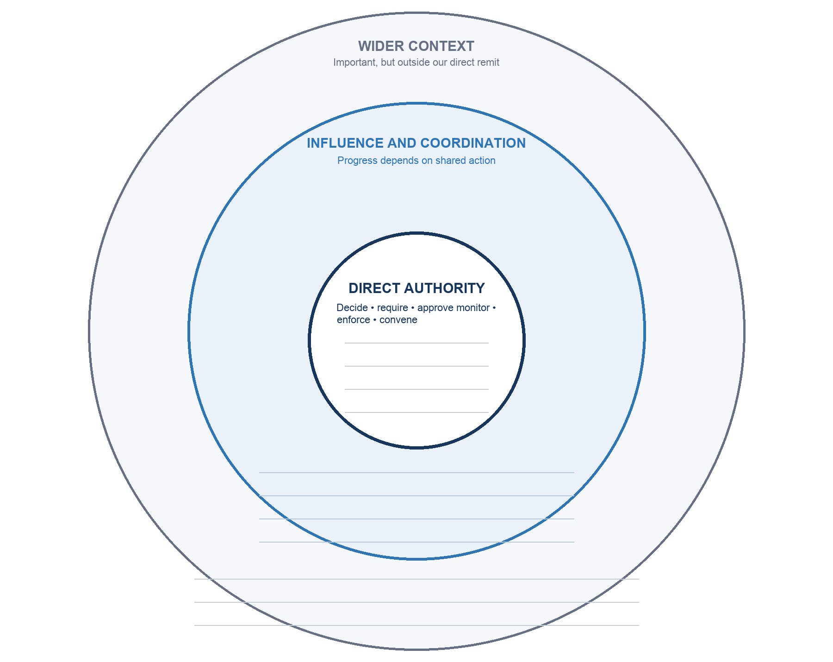

What this means for Session 2
Record one action within direct authority, one coordination need, and one question the dialogue should explore.
________________________________________________________________________________
________________________________________________________________________________
________________________________________________________________________________

