###### ML Experiment 1

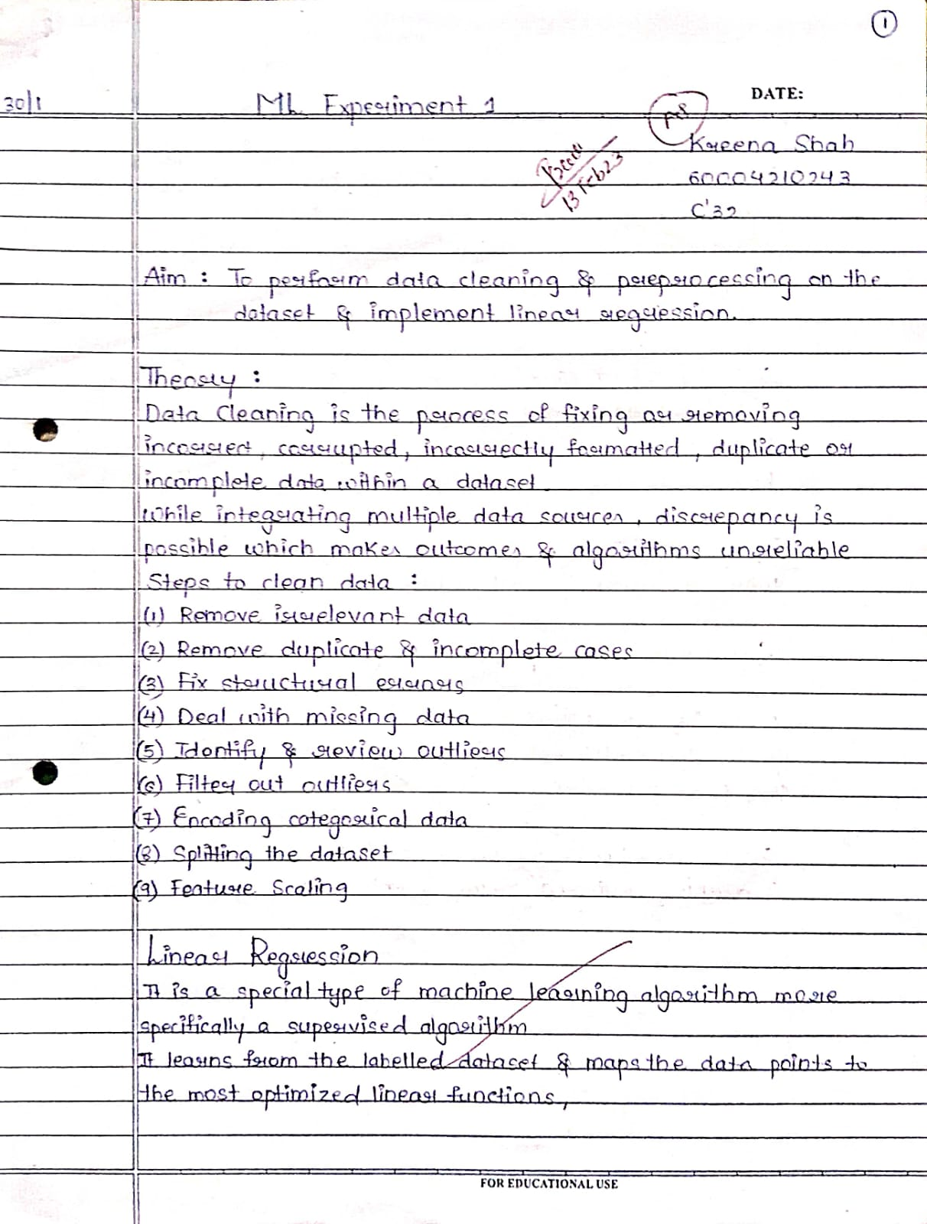

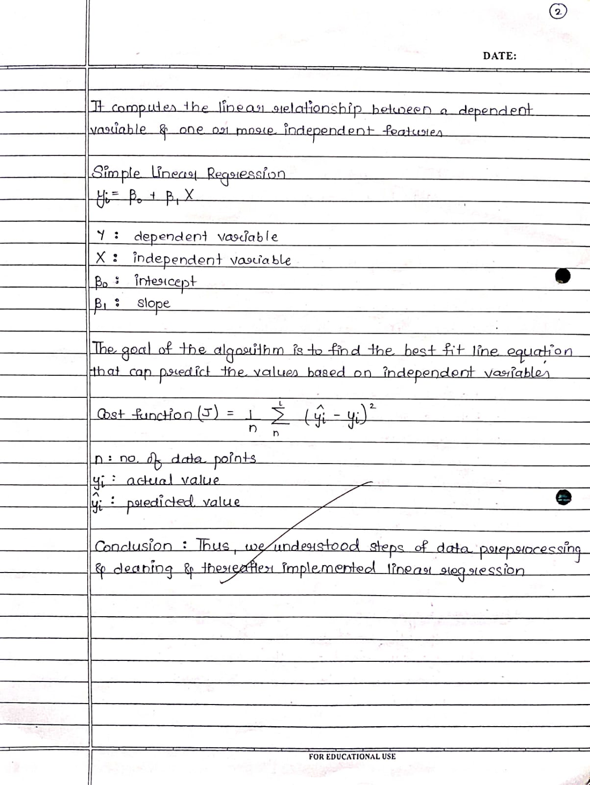

Using direct formulas.

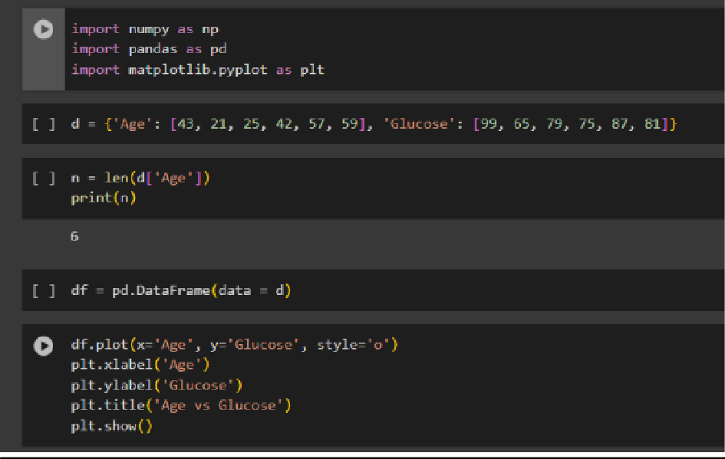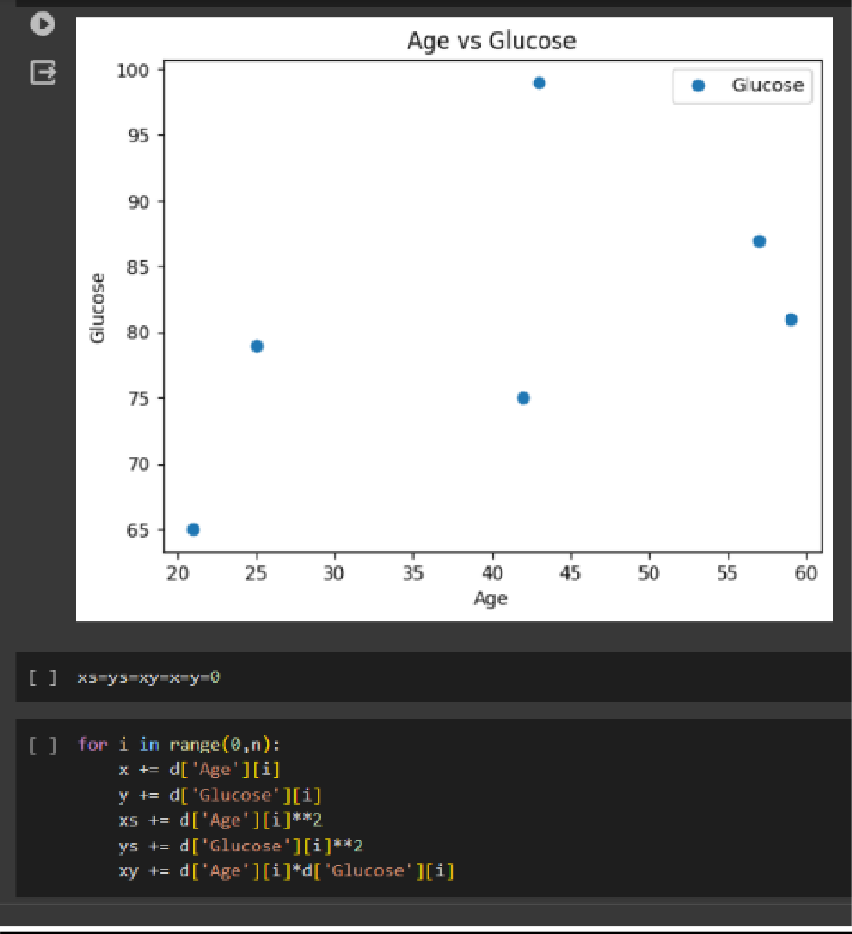

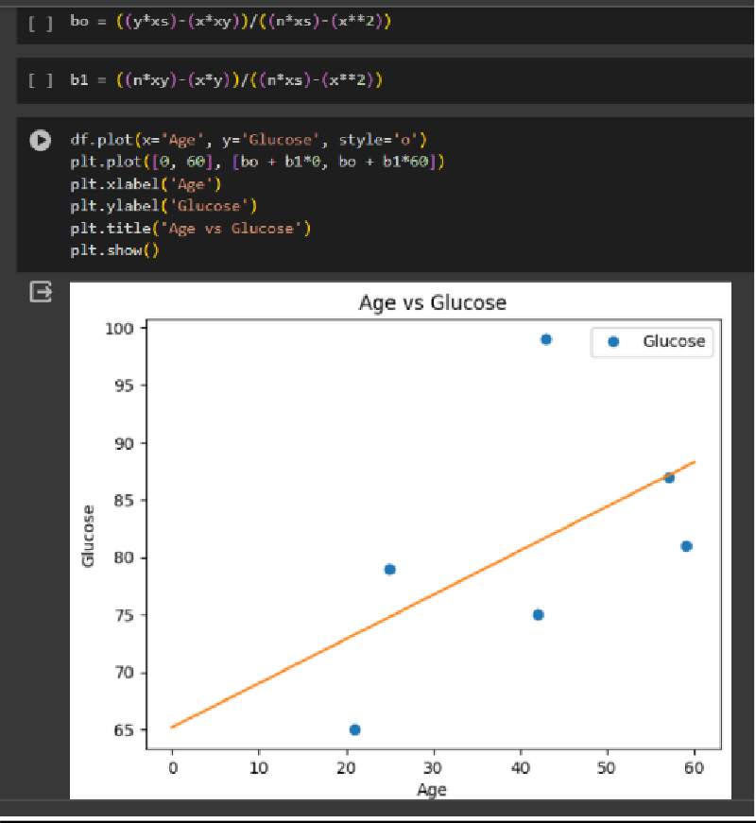

Then on an imported dataset using inbuilt functions and libraries

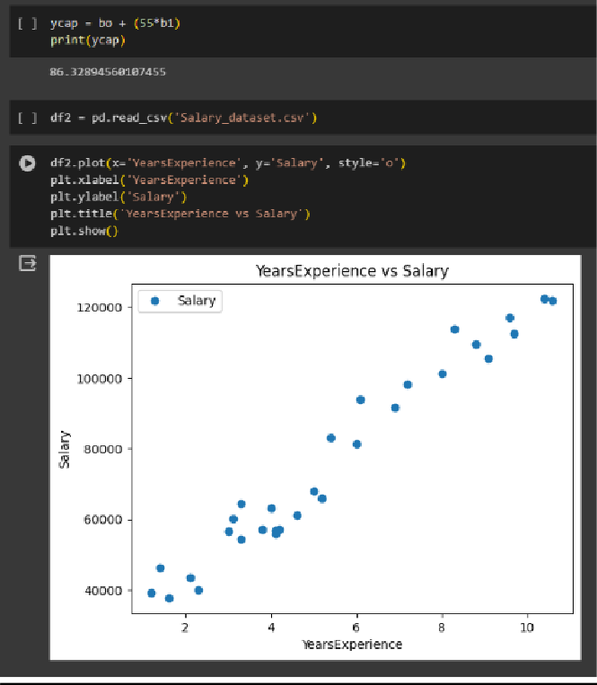

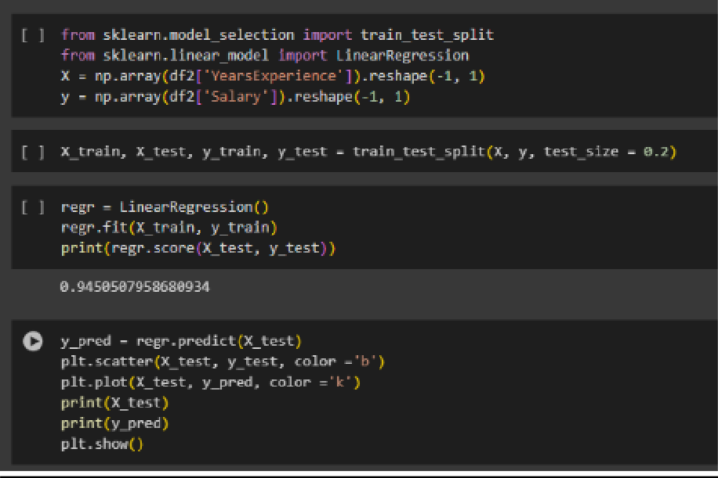

###### ML Experiment 2

Implementation: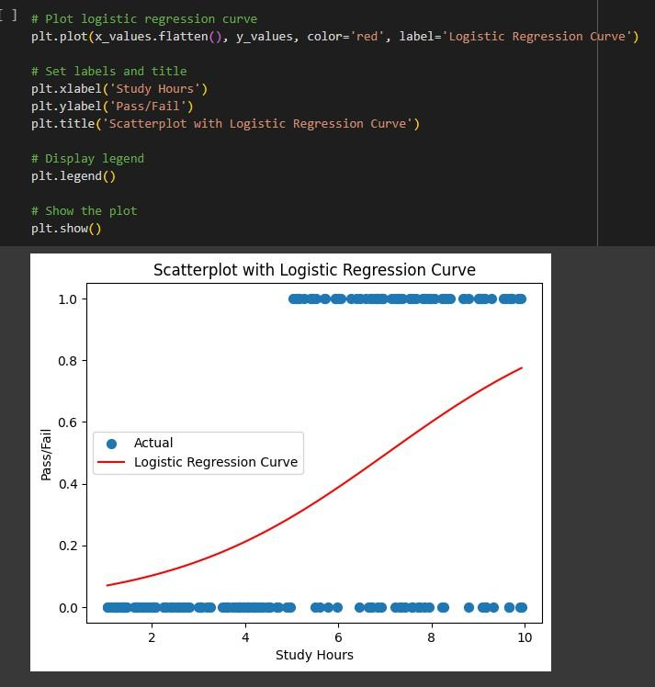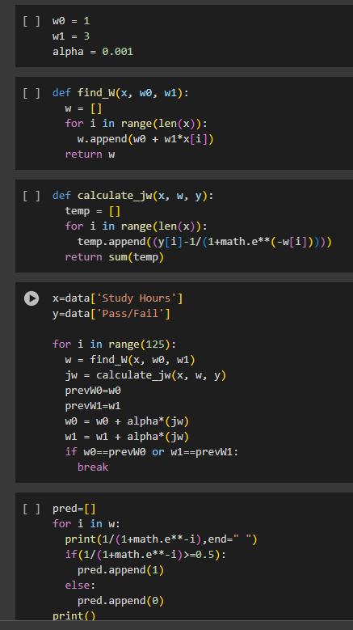

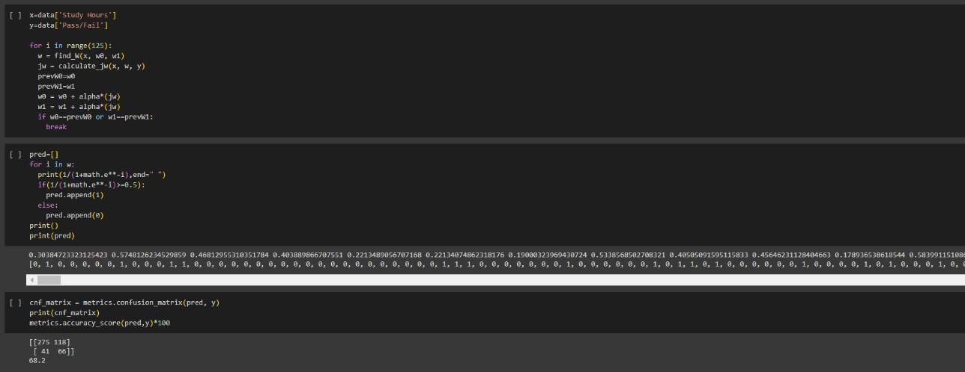

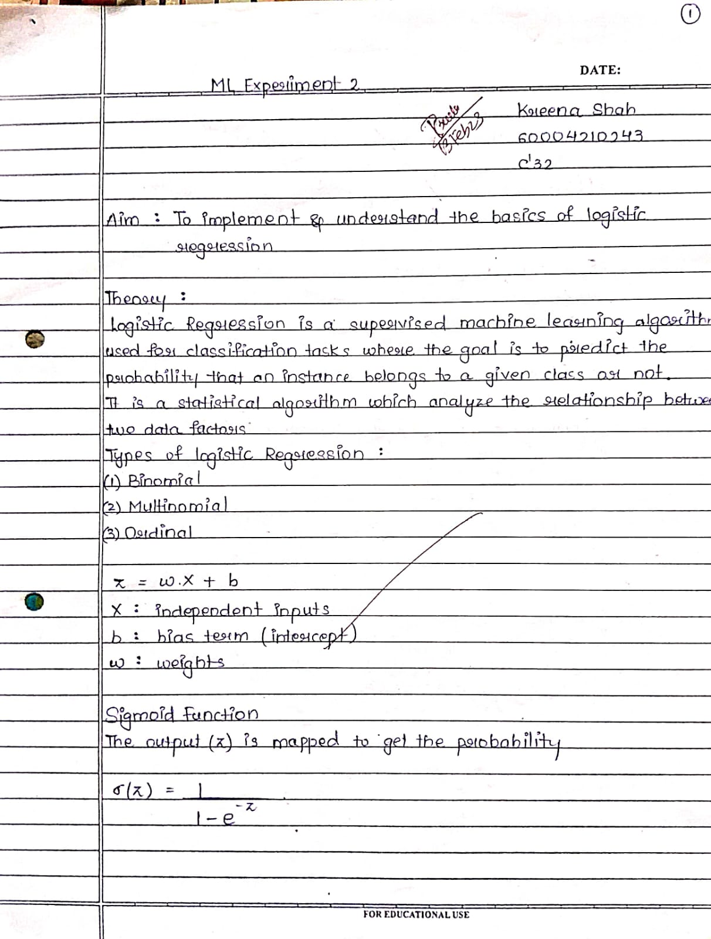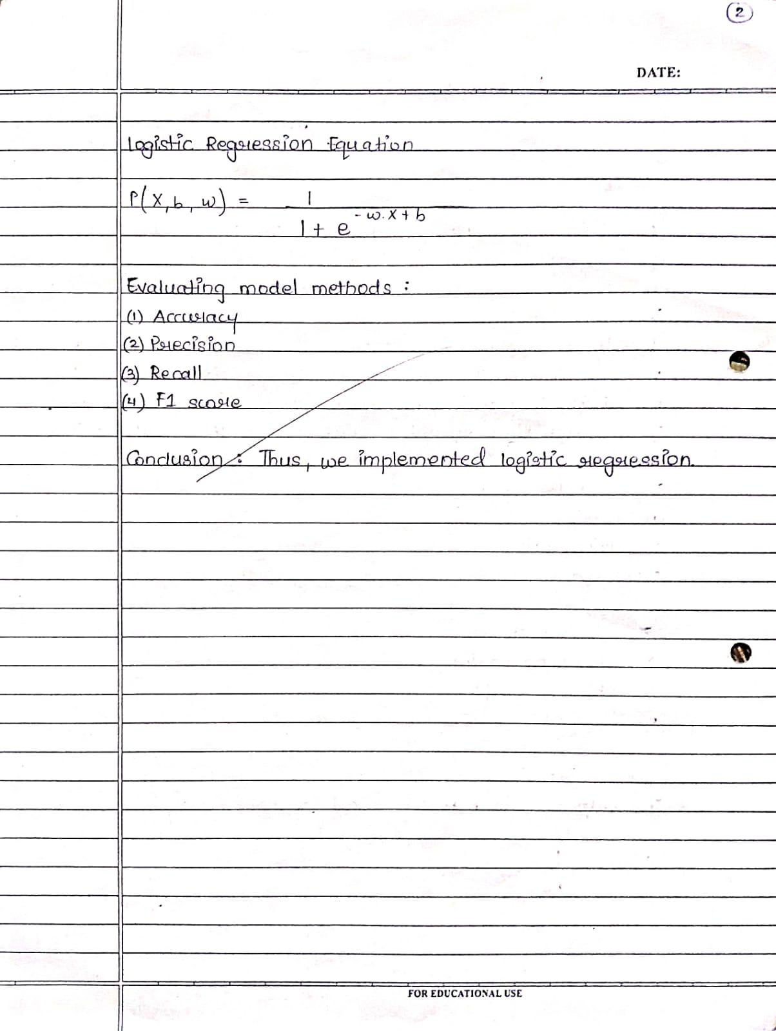

###### ML Experiment 3

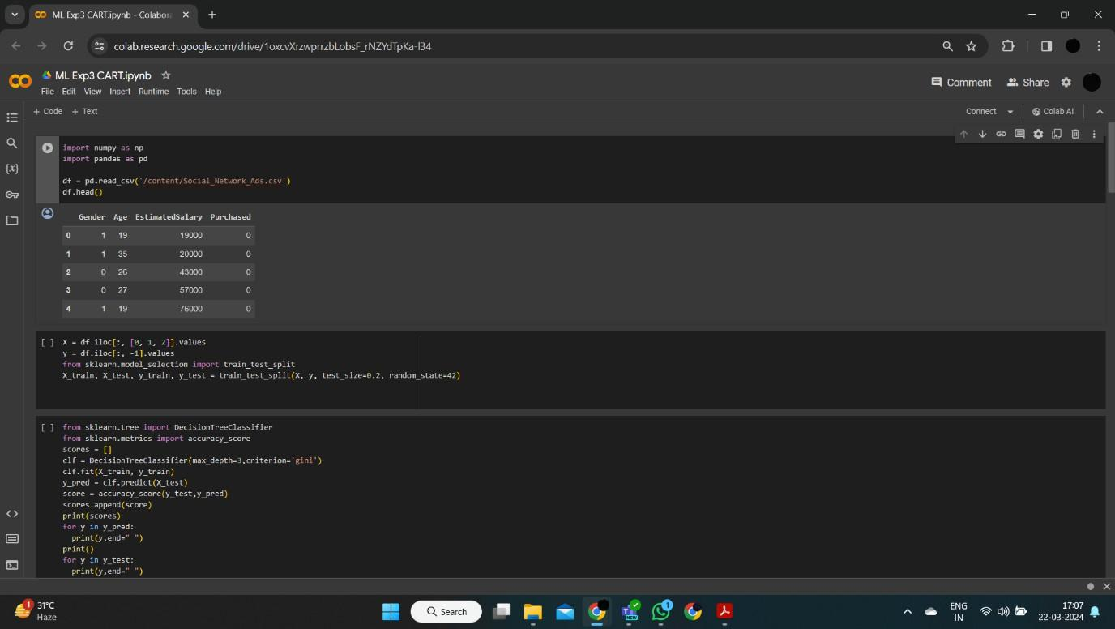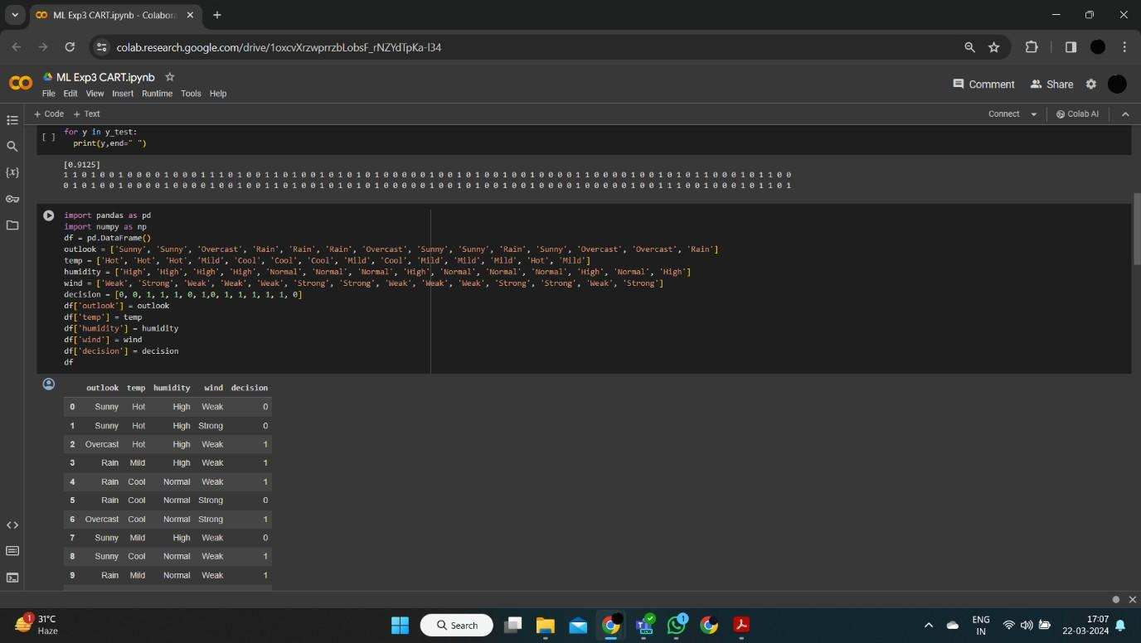

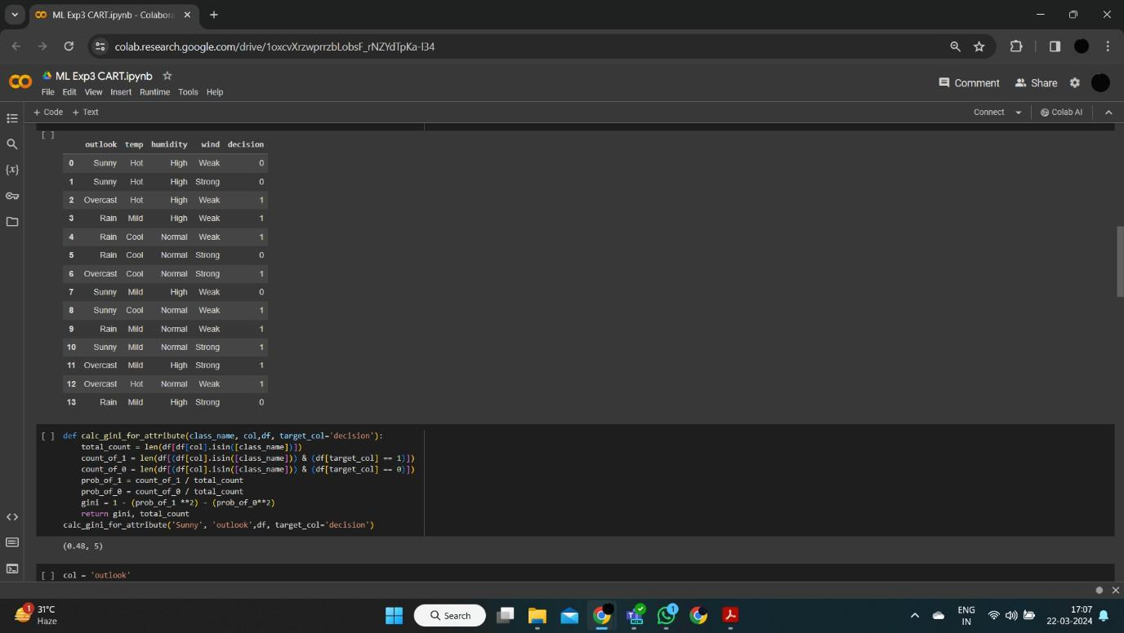

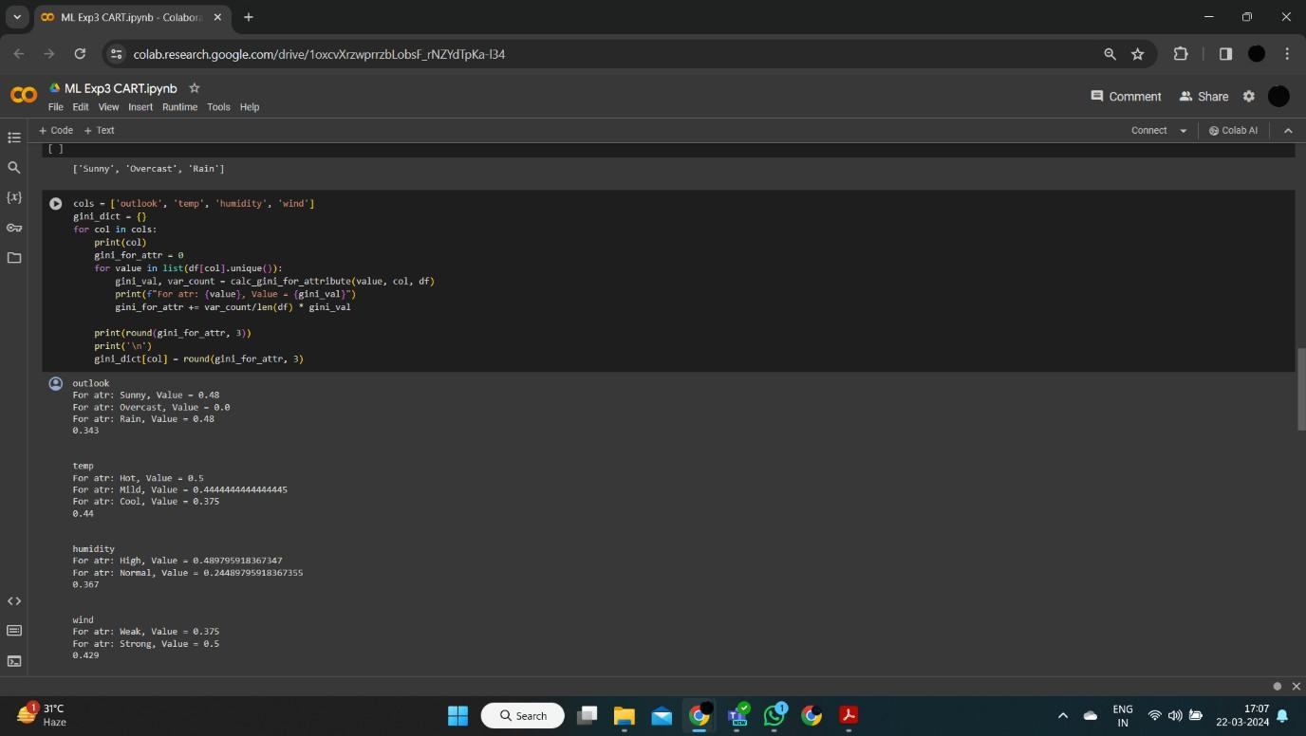

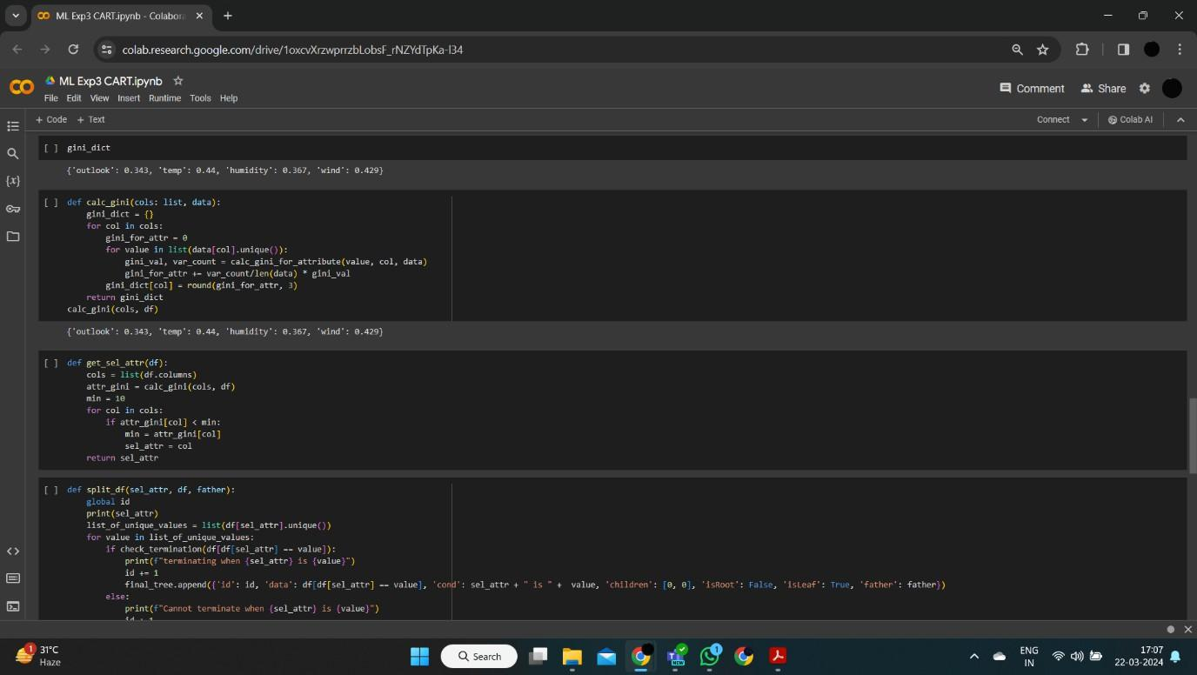

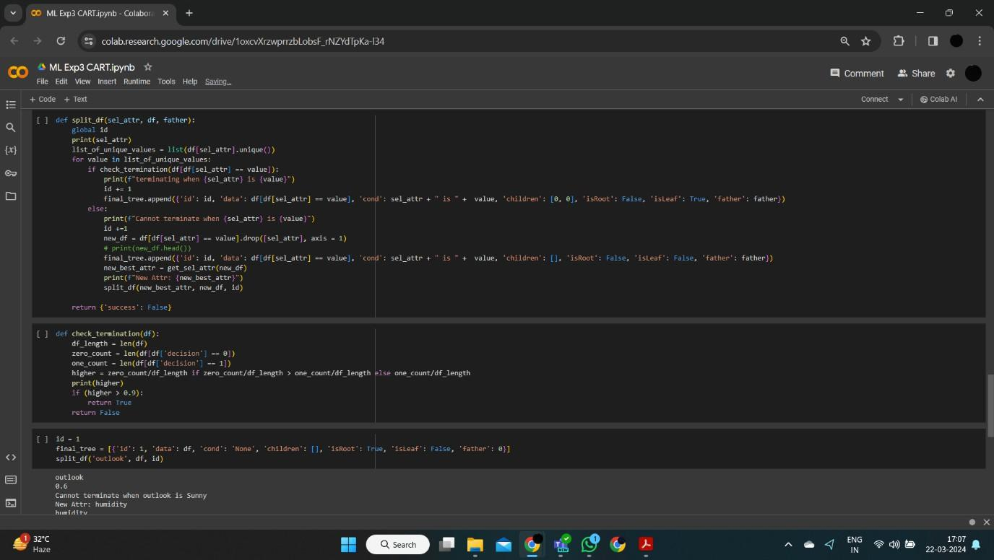

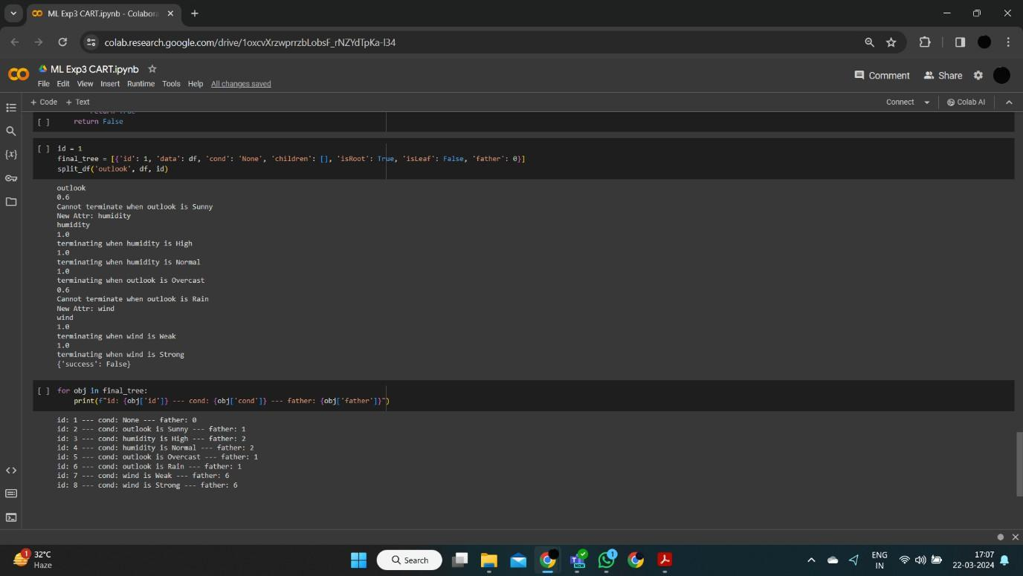

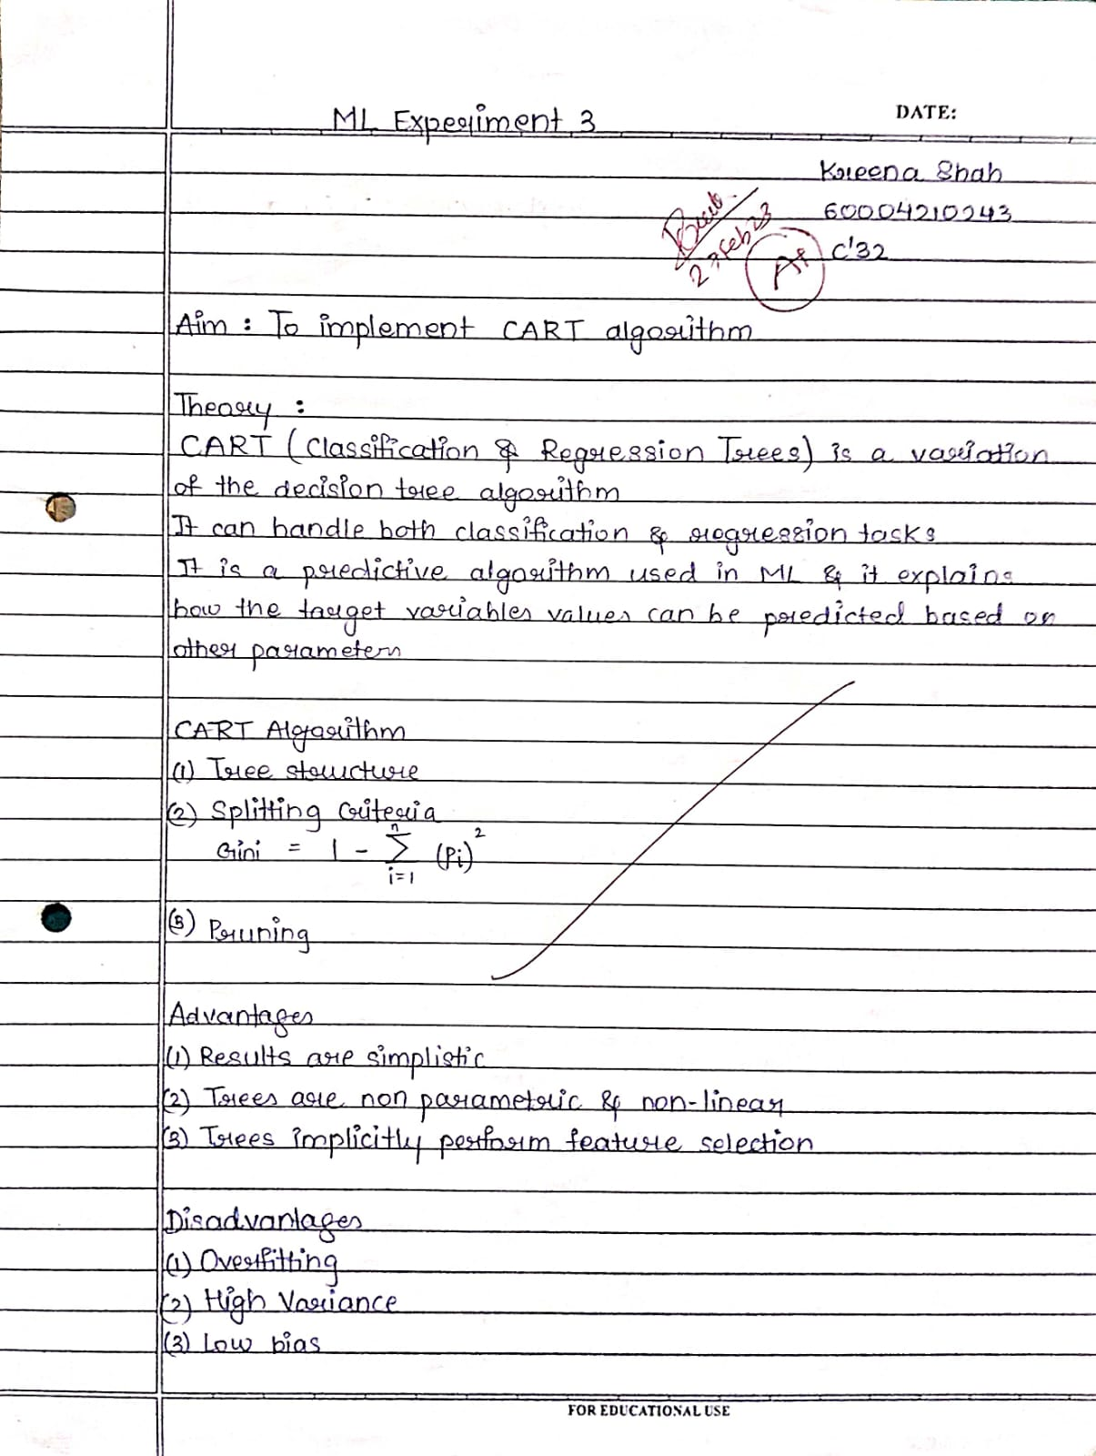

###### ML Experiment 4

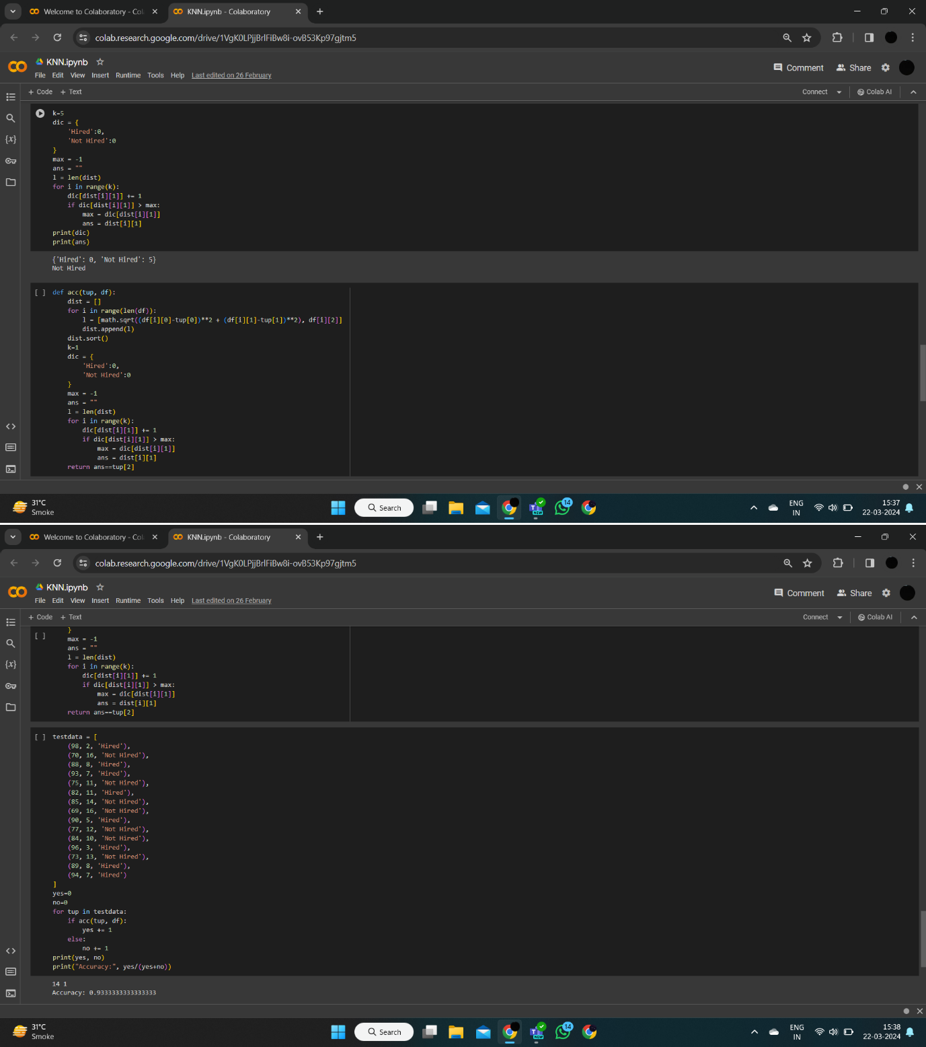

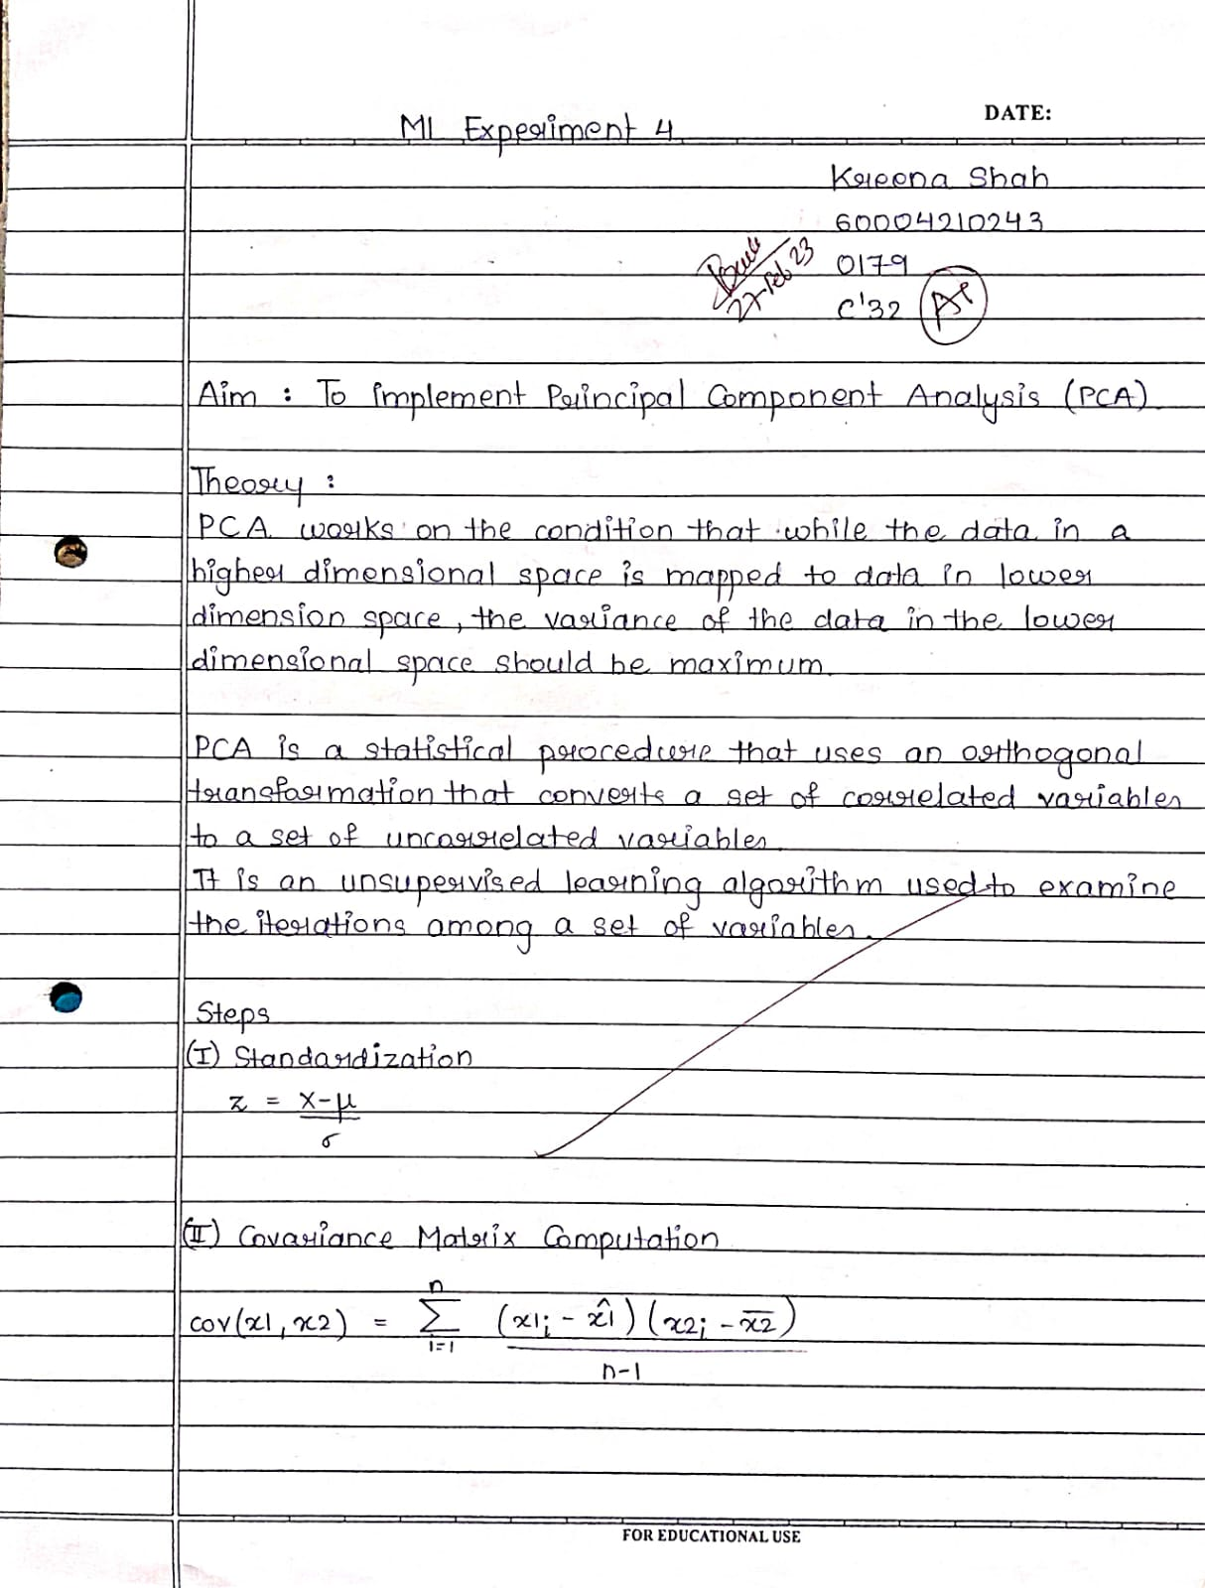

###### ML Experiment 5

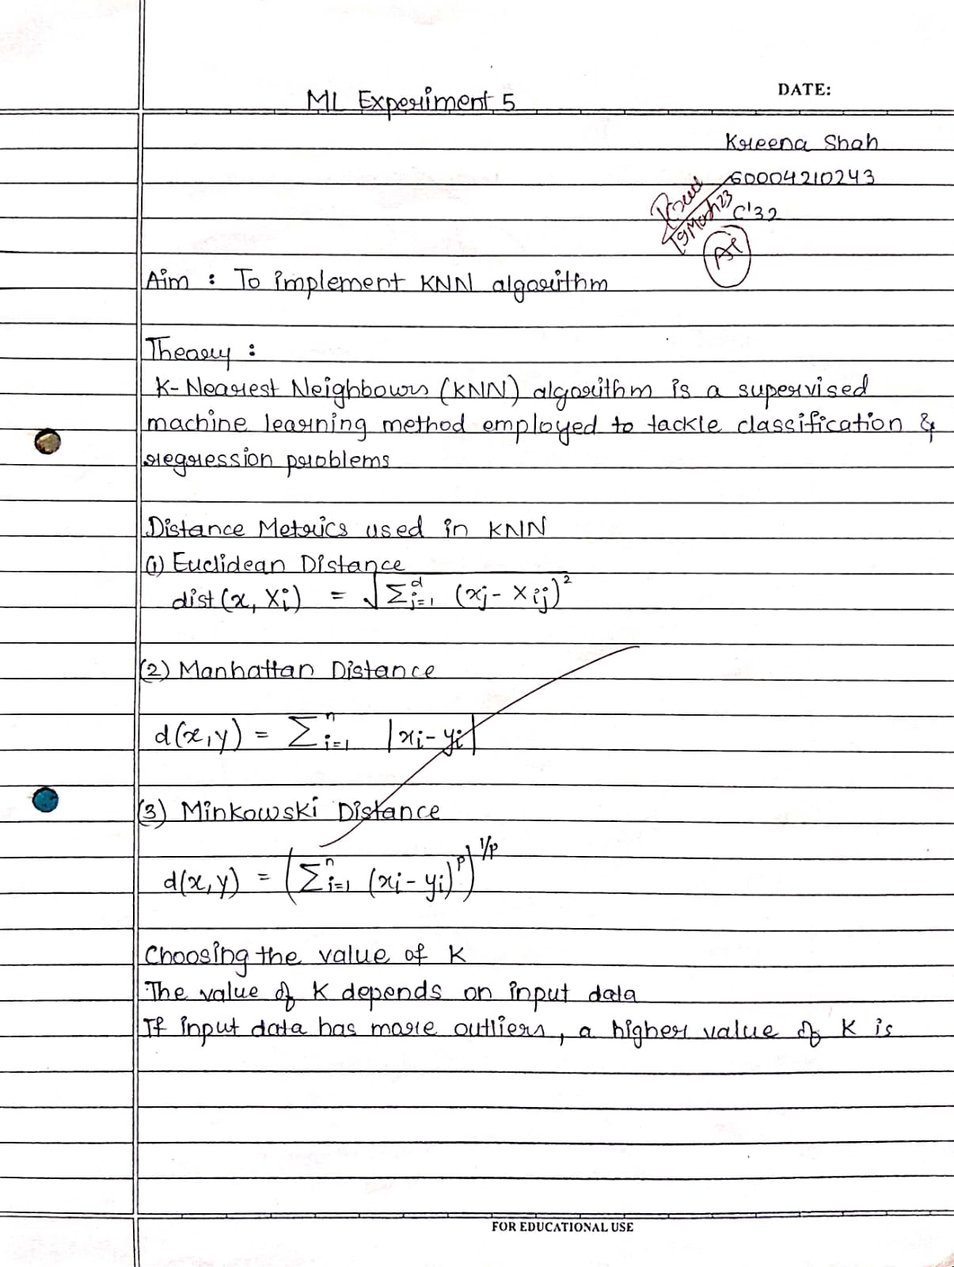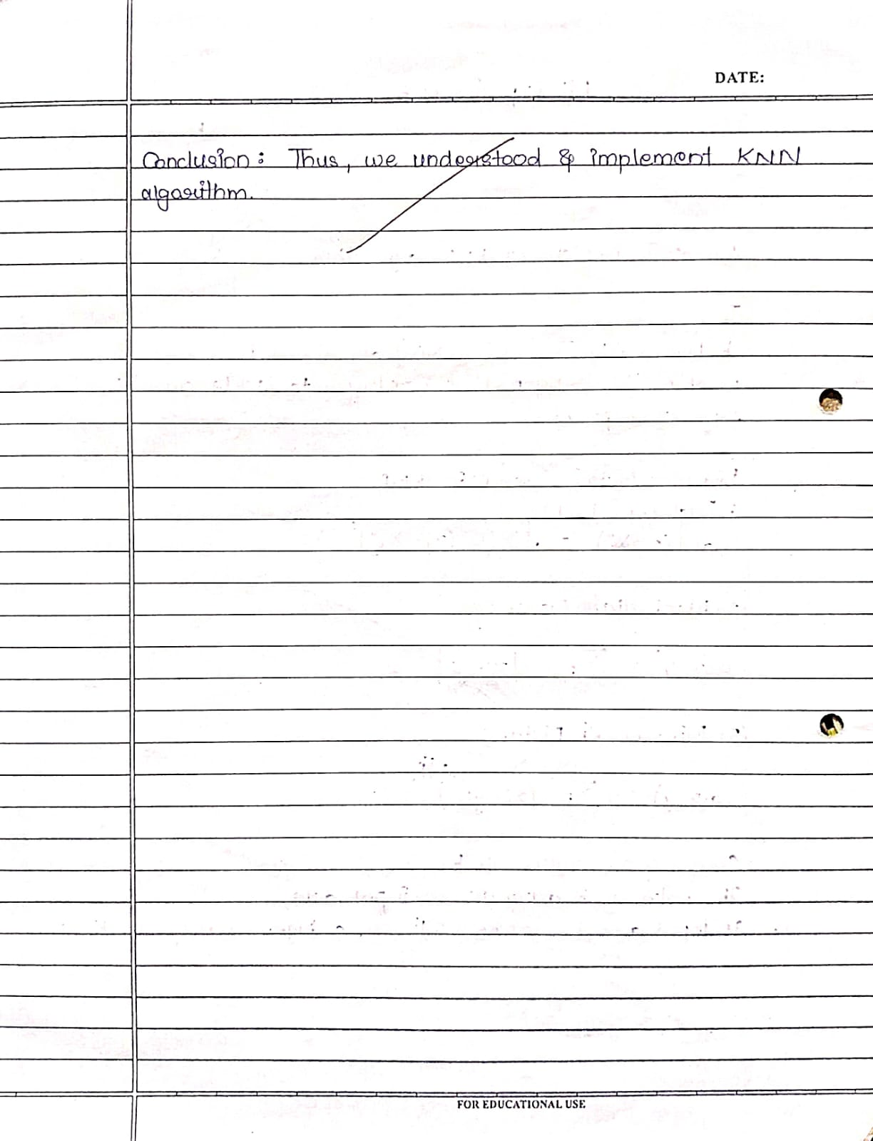

import numpy as np

import matplotlib.pyplot as plt import pandas as pd

from sklearn.datasets import load_digits from sklearn.decomposition import PCA

from sklearn.preprocessing import StandardScaler digits_data = load_digits()

X = digits_data.data scaler = StandardScaler()

X_scaled = scaler.fit_transform(X) pca = PCA()

X_pca = pca.fit_transform(X_scaled) eigenvalues = pca.explained_variance_ plt.figure(figsize=(10, 6))

plt.plot(range(1, len(eigenvalues) + 1), eigenvalues, marker='o', linestyle='-')

plt.title('Elbow Method for Optimal Number of Components') plt.xlabel('Number of Components') plt.ylabel('Eigenvalues (Explained Variance)') plt.grid(True)

plt.show() optimal_num_components = 10

X_reduced = X_pca[:, :optimal_num_components]

df_reduced = pd.DataFrame(X_reduced, columns=[f'PC{i}' for i in range(1, optimal_num_components + 1)])

df_reduced['target'] = digits_data.target df_reduced.to_csv('reduced_digits_dataset.csv', index=False) print("Digits Wine dataset saved successfully.")

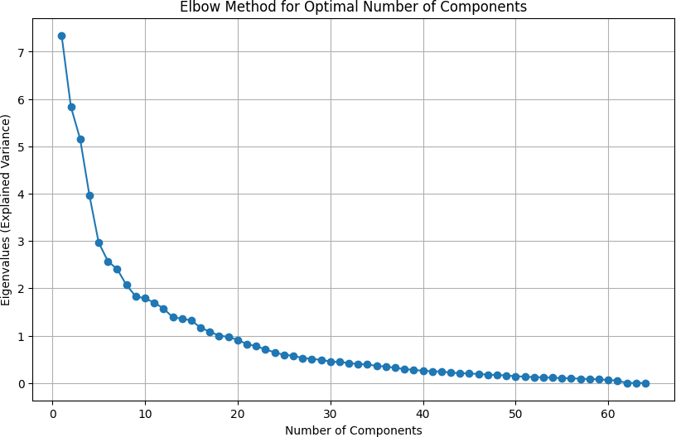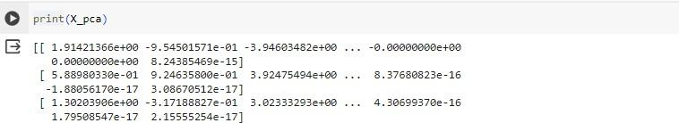

###### 

###### 

###### 

###### 

###### ML Experiment 6

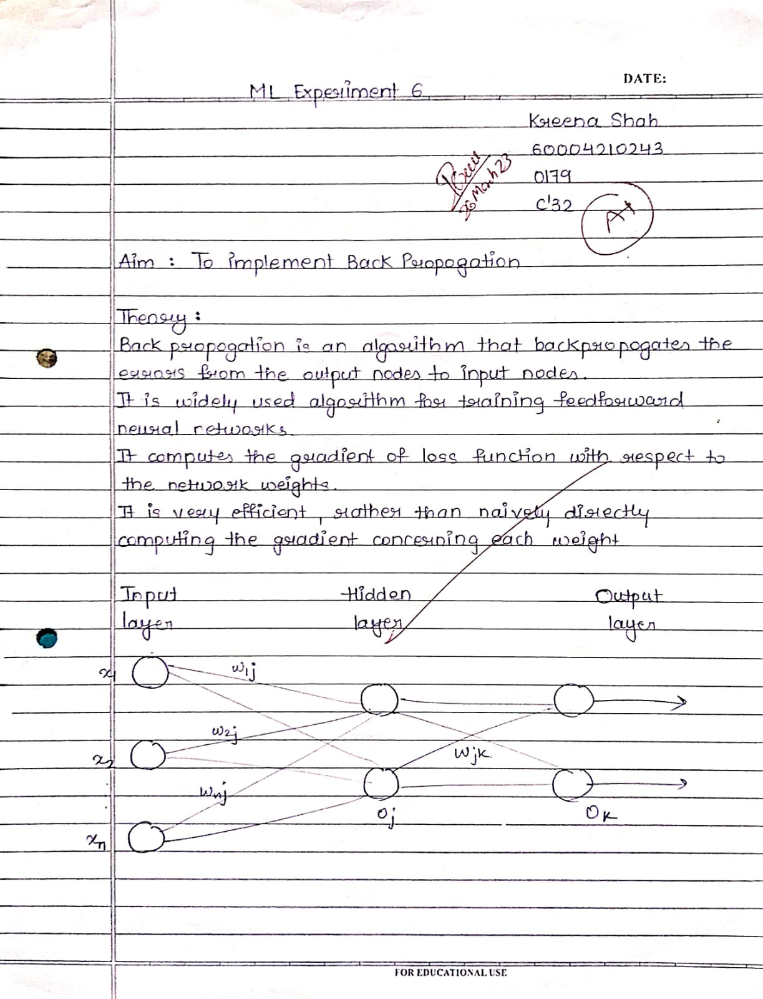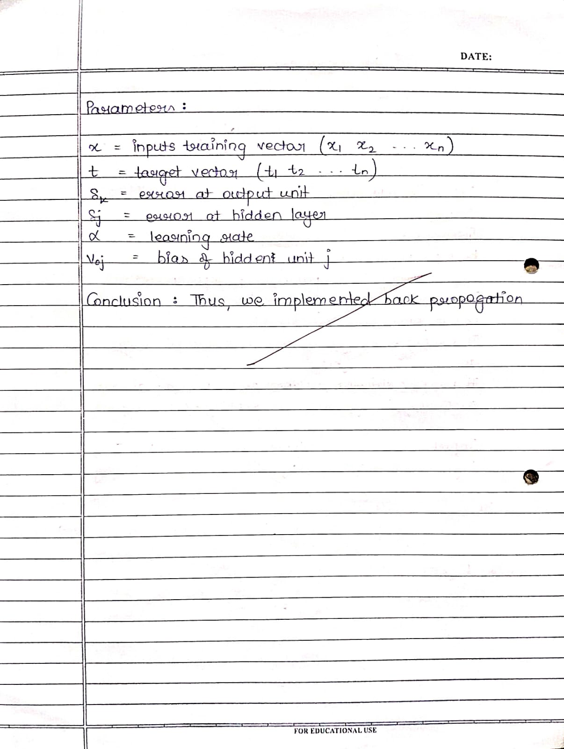

import numpy as np class NeuralNetwork:

def init (self, input_size, hidden_size, output_size):

self.input_size = input_size self.hidden_size = hidden_size self.output_size = output_size # Initialize weights and biases

self.weights_input_hidden = np.random.randn(self.input_size, self.hidden_size)

self.bias_input_hidden = np.random.randn(1, self.hidden_size) self.weights_hidden_output = np.random.randn(self.hidden_size, self.output_size)

self.bias_hidden_output = np.random.randn(1, self.output_size) def sigmoid(self, x):

return 1 / (1 + np.exp(-x))

def sigmoid_derivative(self, x):

return x * (1 - x)

def forward(self, inputs):

self.hidden_input = np.dot(inputs, self.weights_input_hidden) + self.bias_input_hidden

self.hidden_output = self.sigmoid(self.hidden_input) self.final_input = np.dot(self.hidden_output,

self.weights_hidden_output) + self.bias_hidden_output self.final_output = self.sigmoid(self.final_input)

return self.hidden_output, self.final_output

def backward(self, inputs, targets, learning_rate): error = targets - self.final_output

delta_output = error * self.sigmoid_derivative(self.final_output) delta_hidden = np.dot(delta_output, self.weights_hidden_output.T) * self.sigmoid_derivative(self.hidden_output)

self.weights_hidden_output += np.dot(self.hidden_output.T, delta_output) * learning_rate

self.bias_hidden_output += np.sum(delta_output, axis=0, keepdims=True) * learning_rate

self.weights_input_hidden += np.dot(inputs.T, delta_hidden) * learning_rate

self.bias_input_hidden += np.sum(delta_hidden, axis=0, keepdims=True) * learning_rate

return error

def train(self, inputs, targets, learning_rate): hidden_output, final_output = self.forward(inputs) error = self.backward(inputs, targets, learning_rate) print("Output of hidden layer:") print(hidden_output)

print("Output of output layer:")

print(final_output) print("Error found:") print(error)

print("Updated weights after 1 iteration:") print("Weights from input to hidden layer:") print(self.weights_input_hidden)

print("Weights from hidden to output layer:") print(self.weights_hidden_output)

dataset = pd.read_csv('reduced_digits_dataset.csv') inputs = dataset.drop(columns=['target']).values

targets = dataset['target'].values.reshape(-1, 1) input_size = inputs.shape[1]

output_size = len(np.unique(targets)) hidden_size = 3

nn = NeuralNetwork(input_size, hidden_size, output_size) nn.train(inputs, targets, learning_rate=0.1)

###### 

###### 

###### 

###### 

###### 

###### 

###### 

###### 

###### 

###### 

###### 

###### 

###### 

###### 

###### 

###### 

###### 

###### 

###### 

###### 

###### 

###### 

###### 

###### ML Experiment 7

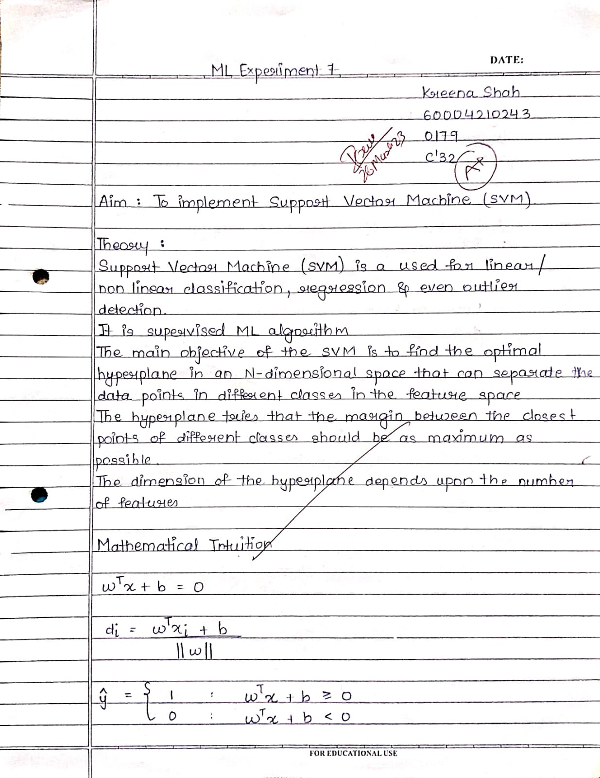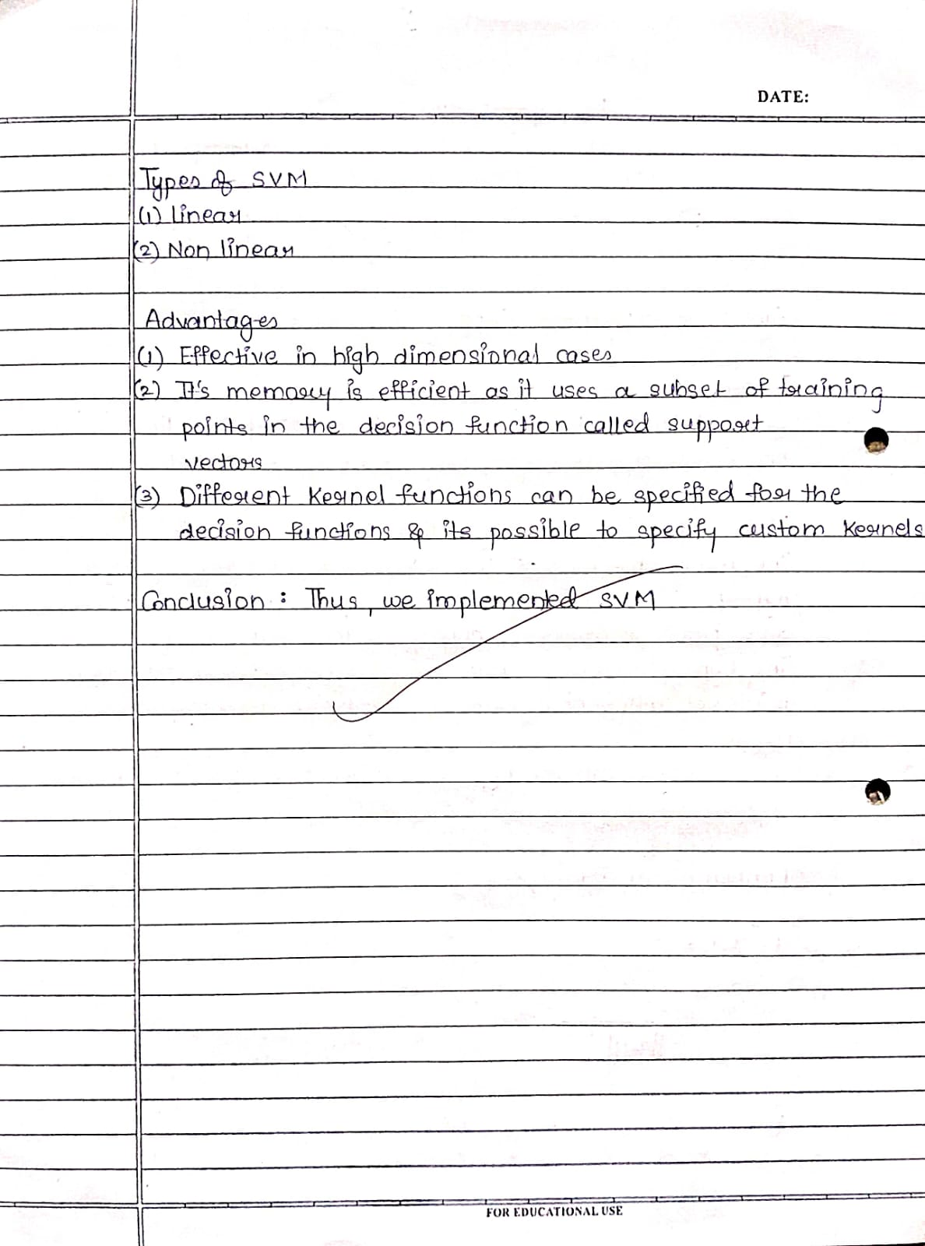

from sklearn.datasets import load_breast_cancer from sklearn.model_selection import train_test_split from sklearn.naive_bayes import GaussianNB

from sklearn.metrics import accuracy_score data = load_breast_cancer()

X = data.data y = data.target X

X_train, X_test, y_train, y_test = train_test_split(X, y, test_size=0.3, random_state=42)

classifier = GaussianNB() classifier.fit(X_train, y_train) y_pred = classifier.predict(X_test)

accuracy = accuracy_score(y_test, y_pred)

print(accuracy)

from sklearn.metrics import confusion_matrix

confusion_matrix(y_test, y_pred)

###### 

###### ML Experiment 8

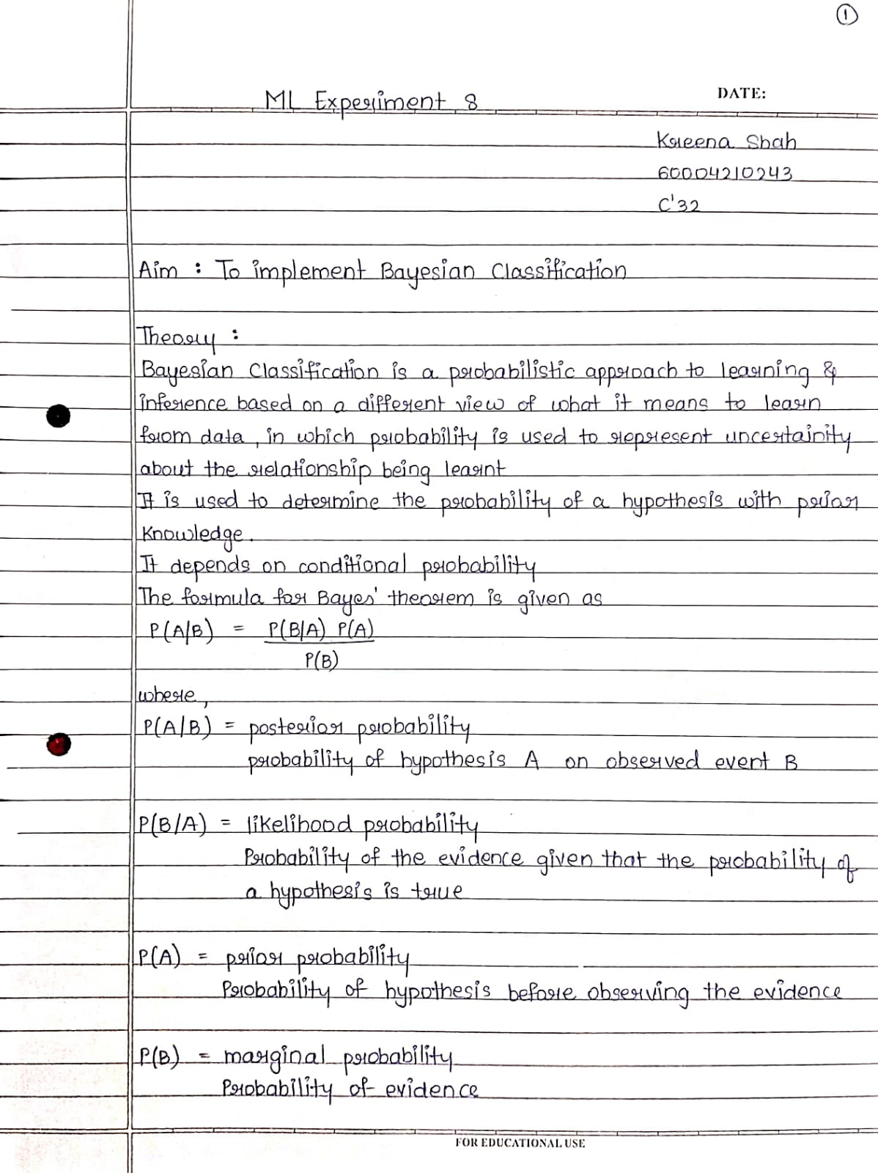

from sklearn.datasets import load_breast_cancer from sklearn.model_selection import train_test_split from sklearn.svm import SVC

from sklearn.metrics import accuracy_score data = load_breast_cancer()

X = data.data y = data.target X

X_train, X_test, Y_train, Y_test = train_test_split(X, y, test_size=0.3, random_state=42)

classifier = SVC(kernel=' ') classifier.fit(X_train, Y_train) Y_pred = classifier.predict(X_test)

accuracy = accuracy_score(Y_test, Y_pred)

print("Accuracy:", accuracy)

from sklearn.metrics import confusion_matrix

confusion_matrix(y_test, y_pred)