**Experiment No. 4**

**Aim:** Develop Activity diagram and DFD (up to 2 levels) for the project.

**Theory:**

**Activity Diagram**:

A UML activity diagram depicts the dynamic behavior of a system or part of a system through the flow of control between actions that the system performs. It is similar to a flowchart except that an activity diagram can show concurrent flows. The main component of an activity diagram is an action node, represented by a rounded rectangle, which corresponds to a task performed by the software system. Arrows from one action node to another indicate the flow of control. That is, an arrow between two action nodes means that after the first action is complete the second action begins. A solid black dot forms the initial node that indicates the starting point of the activity. A black dot surrounded by a black circle is the final node indicating the end of the activity. A fork represents the separation of activities into two or more concurrent activities. It is drawn as a horizontal black bar with one arrow pointing to it and two or more arrows pointing out from it. Each outgoing arrow represents a flow of control that can be executed concurrently with the flows corresponding to the other outgoing arrows. These concurrent activities can be performed on a computer using different threads or even using different computers.

|  |  |
| --- | --- |
|  |  |

To indicate how the actions are divided among the participants, one can decorate the activity diagram with swim lanes. Swim lanes are formed by dividing the diagram into strips or “lanes,” each of which corresponds to one of the participants. All actions in one lane are done by the corresponding participant.

**Data Flow Diagrams:**

The data flow diagram enables you to develop models of the information domain and functional domain. As the DFD is refined into greater levels of detail, you perform an implicit functional decomposition of the system. At the same time, the DFD refinement results in a corresponding refinement of data as it moves through the processes that embody the application.

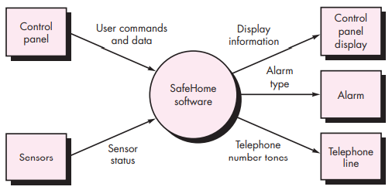

Data Flow Diagrams Level 0 and Level 1 for Security Home Function

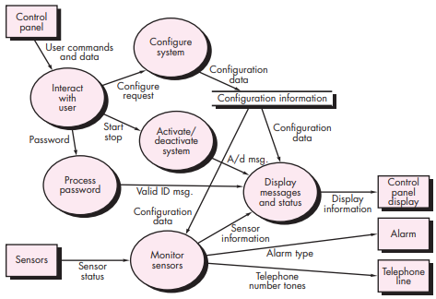

Guidelines for drawing a data flow diagram:

(1) the level 0 data flow diagram should depict the software/system as a single bubble;

(2) primary input and output should be carefully noted;

(3) refinement should begin by isolating candidate processes, data objects, and data stores to be represented at the next level;

(4) all arrows and bubbles should be labeled with meaningful names;

(5) information flow continuity must be maintained from level to level,2 and

(6) one bubble at a time should be refined.

**Practical:**

**For Activity diagram**

1. Identify any Use Case of your case study from Expt 3.
2. Draw Activity and Swimlane Activity diagram for that Use-case

**For DFD**

1. Draw a Context Level / Level 0 DFD to depict the data flow of your entire system.
2. Identify various processes in your case study and depict in the Level 1 DFD.
3. Refine the Level 1 DFD further to create Level 2. Refinement continues till each bubble performs only one function at a time.

**Conclusion:**

Thus, we are able to draw Activity and Swim lane diagram for our case study. We are also able to depict the flow of data through various processes through different level DFDs.