Hey!

[https://encrypted-tbn0.gstatic.com/images?q=tbn:ANd9GcT_HVnxWTPe9vnI0bsP_P19c-KojdRSznj-9g&s](https://encrypted-tbn0.gstatic.com/images?q=tbn:ANd9GcT_HVnxWTPe9vnI0bsP_P19c-KojdRSznj-9g&amp;s)

[https://encrypted-tbn0.gstatic.com/images?q=tbn:ANd9GcT_HVnxWTPe9vnI0bsP_P19c-KojdRSznj-9g&s](https://encrypted-tbn0.gstatic.com/images?q=tbn:ANd9GcT_HVnxWTPe9vnI0bsP_P19c-KojdRSznj-9g&amp;s)

added it via normal desktop word doc



using drag and drop

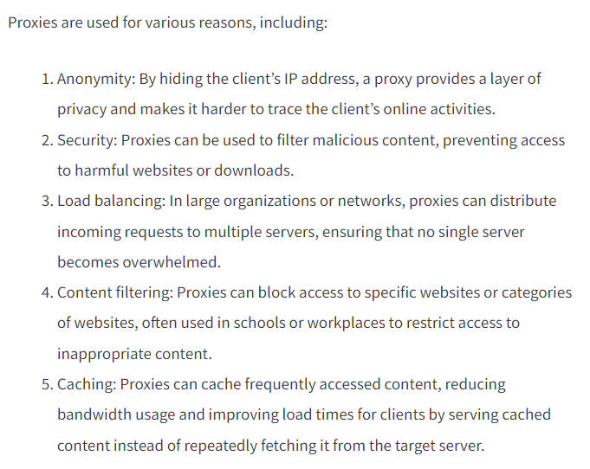

copy link address and added it via tinymce feature



copy paste image from browser

