Repo: https://github.com/Krefails/jk-csd-340.git
The original code with the error of no lang attribute:
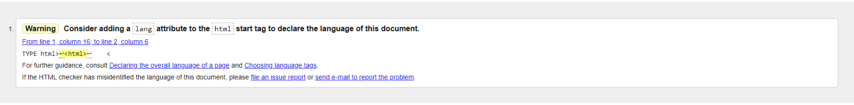
The updated code with no errors:
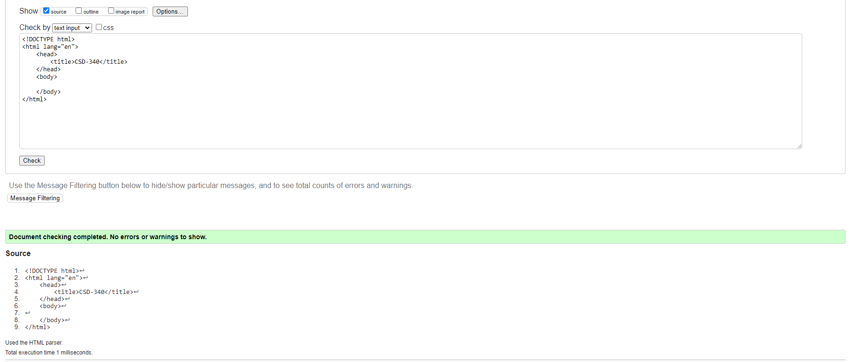
After adding an H1 to the code:
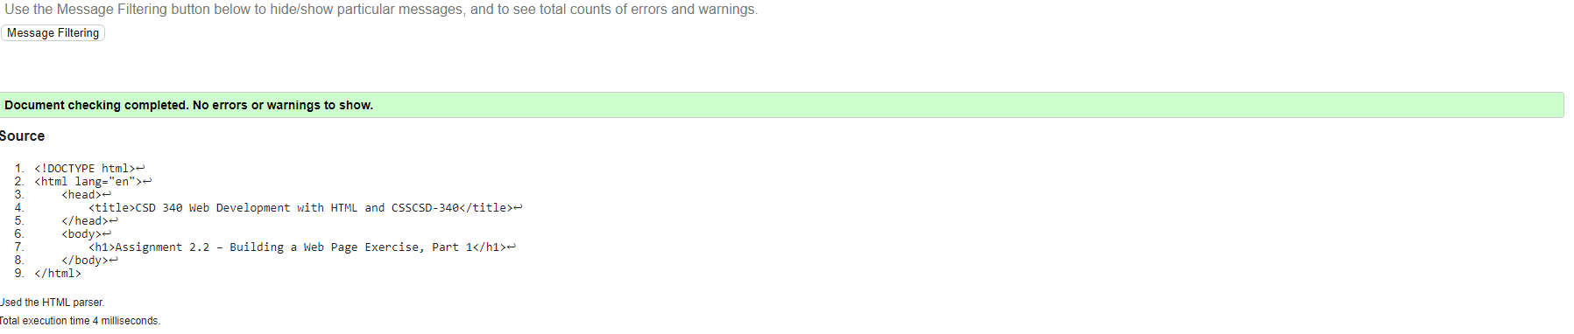
A picture of my localhost running the file:

