Volunteer Quick Guide: Praying for a Family
Open the Prayer Dashboard at /admin/prayer-list — for any volunteer whose record carries the Prayer Ambassador role.
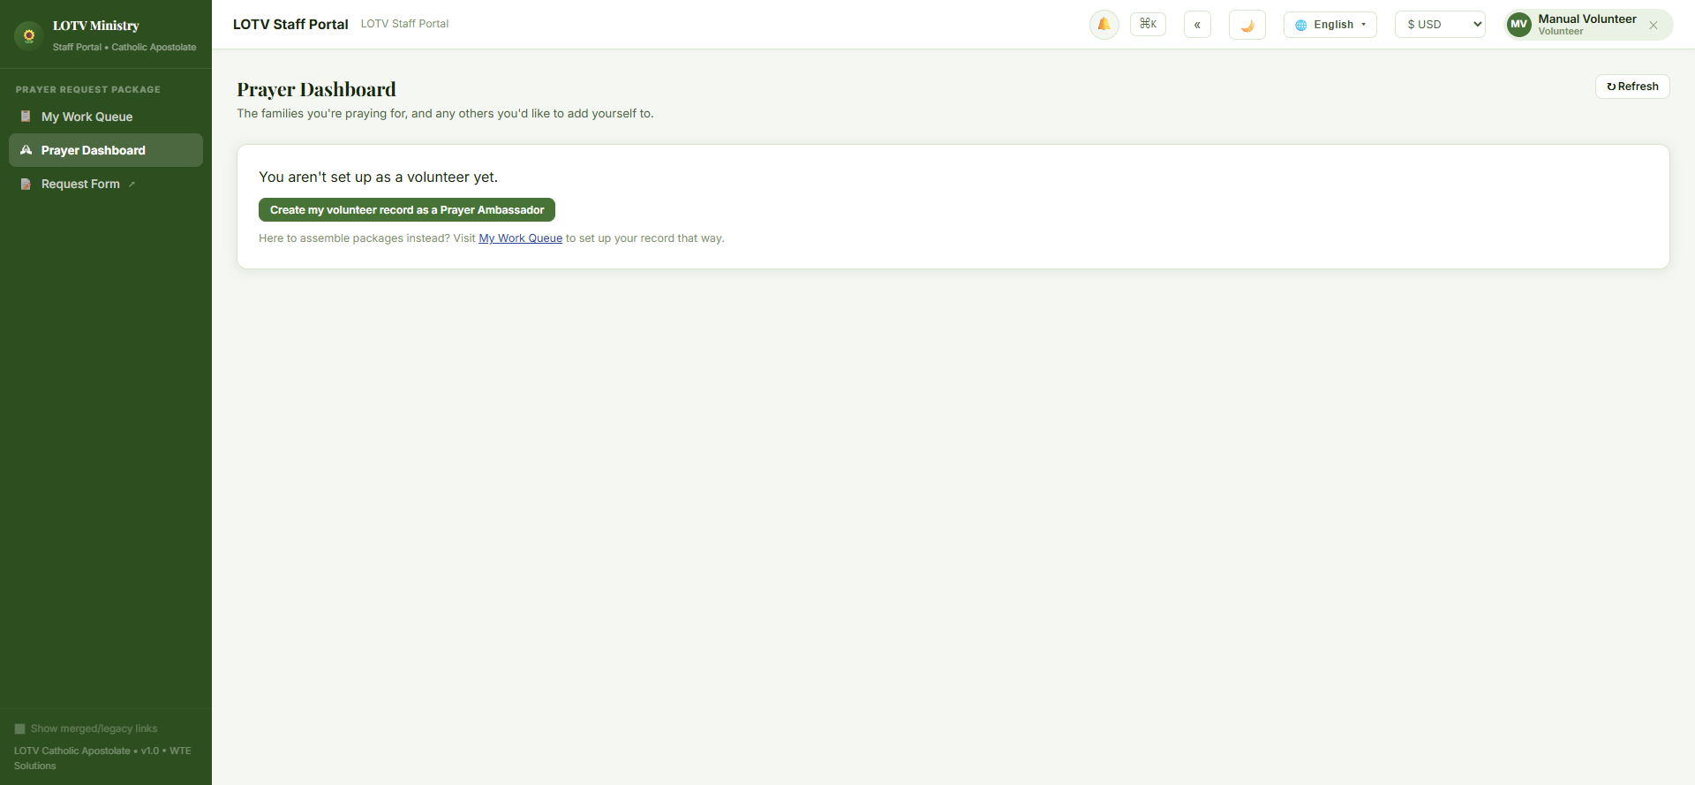
Steps:
- No volunteer record yet? Click "Create my volunteer record as a Prayer Ambassador" — one click sets it up.
- Under "Families You Could Join," pick any family and add yourself. There's no accept/decline step — you just join.
- That family now shows under "Praying For."
- Done praying for a family? Click "I'll stop praying for this family" next to their name, anytime.
Good to know:
- Many volunteers can pray for one family, and one volunteer can be on many families' teams at once — no limit either way.
- A case the requester marked "Package only" at intake never appears in "Families You Could Join" — they specifically asked not to involve the prayer team.
If something looks wrong: a family you expected to see missing from the list almost always means it was submitted as Package only — that's by design, not a bug.

