Staff Guide: The Cases Hub, Duplicates, and Queues

The Cases Hub
Open Cases at /admin/cases-hub — one page, 12 tabs, every way of looking at case data in one place. Each tab is the same page you'd reach individually elsewhere in the app; the Hub just puts them all behind one set of tab buttons.
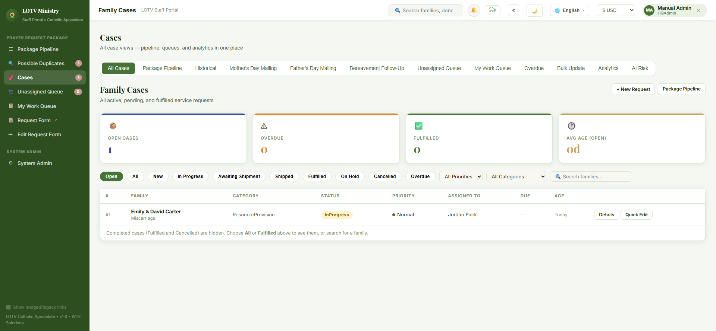

How a Possible Duplicate Gets Flagged
Open Possible Duplicates at /admin/families/duplicate-review — a sidebar link of its own, outside the Cases Hub tabs, with a live count badge.
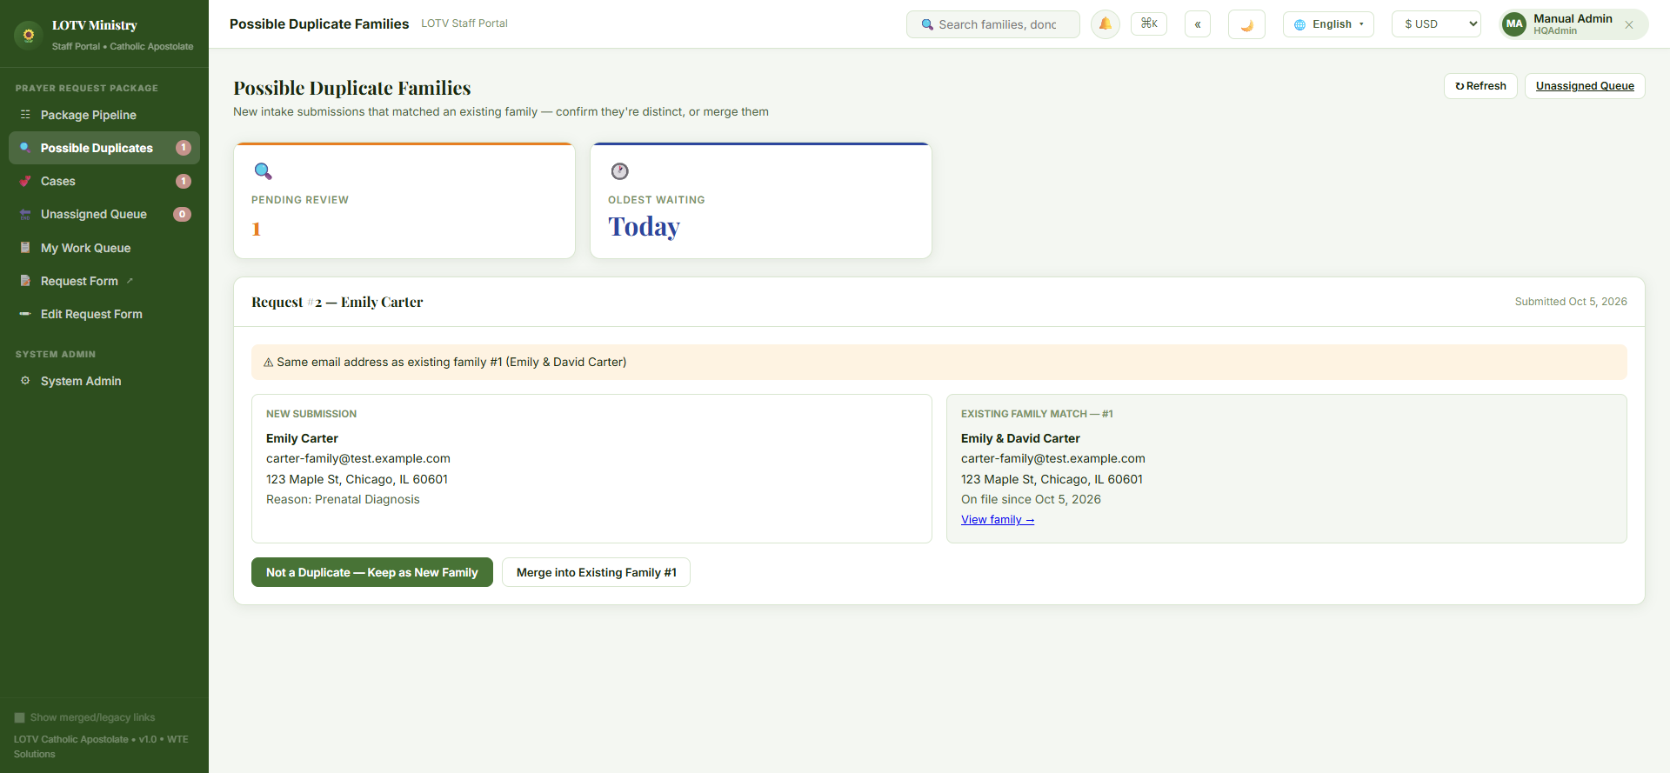

The Unassigned Queue
Open Unassigned Queue at /admin/queue — every New case with nobody on it yet, oldest first, with KPIs for how many are unassigned, how many of those are overdue, how many volunteers are available, and the oldest wait time.
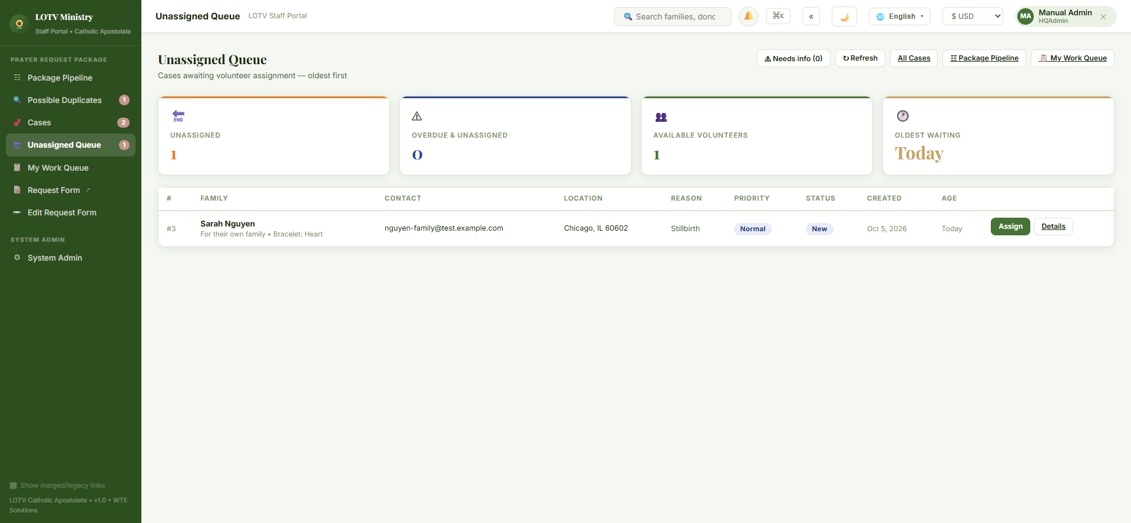

Assigning to yourself or to someone else
Click Assign on any case to open a drawer with the full family summary (contact, address, parish/diocese, faith tradition, date of loss) and:
- An Assign To dropdown listing every active volunteer, each with their current active-case count.
- Up to 5 suggested volunteers ranked by workload (a composite score) — click one to select it instantly.
There's no separate "assign to me" button — if you want a case for yourself, you pick your own name from the same dropdown everyone else uses. That only works once you have your own volunteer record (Package Assembler role); if you don't have one yet, create it first from My Work Queue ("Create my volunteer record"), then come back here and you'll appear in this same list.
Steps:
- Click Assign next to the case.
- Review the family summary that opens.
- Pick a volunteer from the Assign To dropdown — or click one of the ranked suggestions to select it instantly. To take it yourself, pick your own name.
- Click Confirm Assignment.
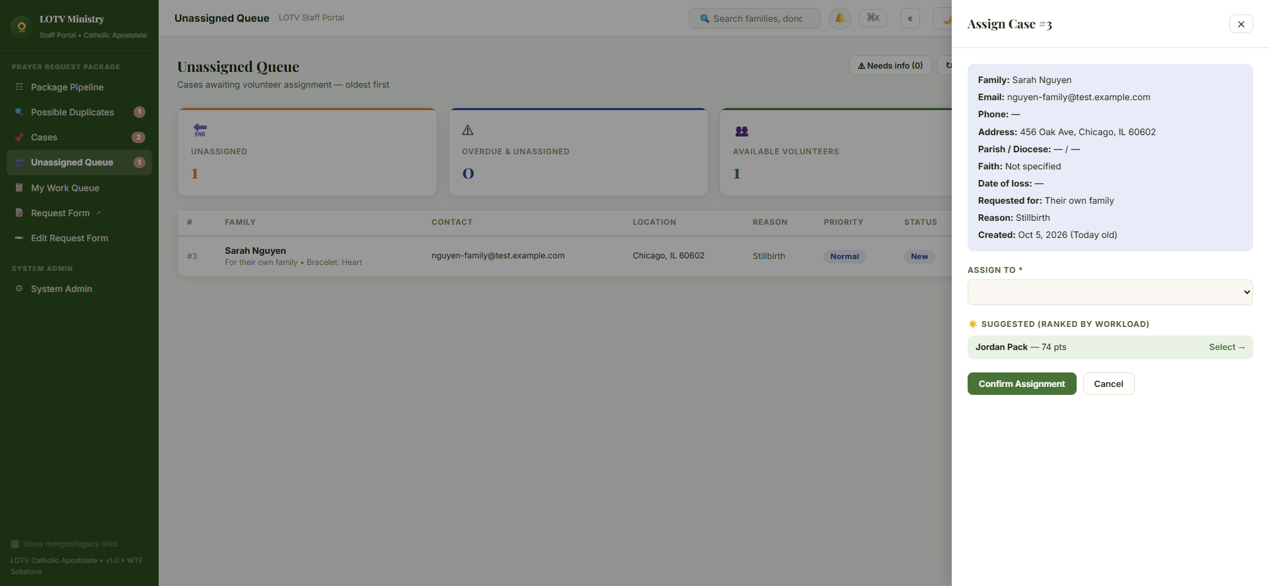

Then what?
Once assigned, the case moves to My Work Queue for whoever it's assigned to — see the Volunteer Quick Guide: Packing & Shipping a Package for what happens from there, and the Staff Guide: The Package Pipeline Board for the drag-and-drop view of the same case moving through its stages.
When someone submits the public request form, the system checks the new family against every existing family in the same chapter, in this order, and stops at the first hit:
- Same email address as an existing family.
- Same phone number (digits only — formatting doesn't matter).
- Same last name and ZIP code together.
If any of those match, the new submission is held out of the Unassigned Queue, auto-assignment, and the Package Pipeline entirely — it waits here instead, and staff see exactly which rule matched (e.g. "Same email address as existing family #2").

Resolving one
Each possible duplicate shows the new submission side by side with the existing family it matched, plus two buttons:
- Not a Duplicate — Keep as New Family — confirms they're different people; the case then enters the normal pipeline (Unassigned Queue, auto-assignment, etc.) like any other.
- Merge into Existing Family #X — folds the new request into the existing family's record instead of creating a second one.
Until you choose one, the case sits here and nowhere else — it won't show up in the Unassigned Queue, Package Pipeline, or case counts.
How to resolve one, step by step:
- Open Possible Duplicates — each entry shows the new submission next to the existing family it matched.
- Read the match reason (e.g. "Same email address as existing family #2") and compare the two sides.
- Decide: are these the same family, or genuinely different people?
- Click Not a Duplicate — Keep as New Family if they're different (the case then enters the normal pipeline), or Merge into Existing Family #X if they're the same (the new request folds into that family's existing record).
That's it — no undo step, so take a moment on step 3 if you're not sure; when genuinely unsure, it's safer to click through to the existing family's record first (via the link on that side) to compare more history before deciding.
Tab | What it's for
All Cases | Every active, pending, and fulfilled request, with filters and search.
Package Pipeline | The drag-and-drop Kanban board (see the separate Package Pipeline Board guide).
Historical | Read-only archive of closed-out requests from prior years — not part of the active pipeline.
Mother's Day Mailing | One card per mother for the current Mother's Day cycle; everyone with a request since last Mother's Day is on the list automatically.
Father's Day Mailing | Same idea for Father's Day; families with no father on record are left off.
Bereavement Follow-Up | Stephen's Ministry-style touchpoints at 3 weeks, 3 months, 6 months, and 11 months after loss.
Unassigned Queue | Cases awaiting a volunteer — see below.
My Work Queue | Cases assigned to you (see the Volunteer Quick Guide: Packing & Shipping).
Overdue | Open requests past 7 days with no resolution.
Bulk Update | Select several cases and change their status or priority in one action.
Analytics | Every case-analytics cut in one place — heat map, reason breakdown, timing, intake trend, geography, overdue queue.
At Risk | Overdue, unassigned, stalled, and urgent cases needing attention, all in one list.
"New Case" isn't a tab — it's its own button/sidebar link, always one click away rather than buried behind a tab switch.

