Volunteer Quick Guide: Packing & Shipping a Package
Open My Work Queue at /admin/my-queue — for any volunteer whose record carries the Package Assembler role (staff see it too, for cases assigned to them).
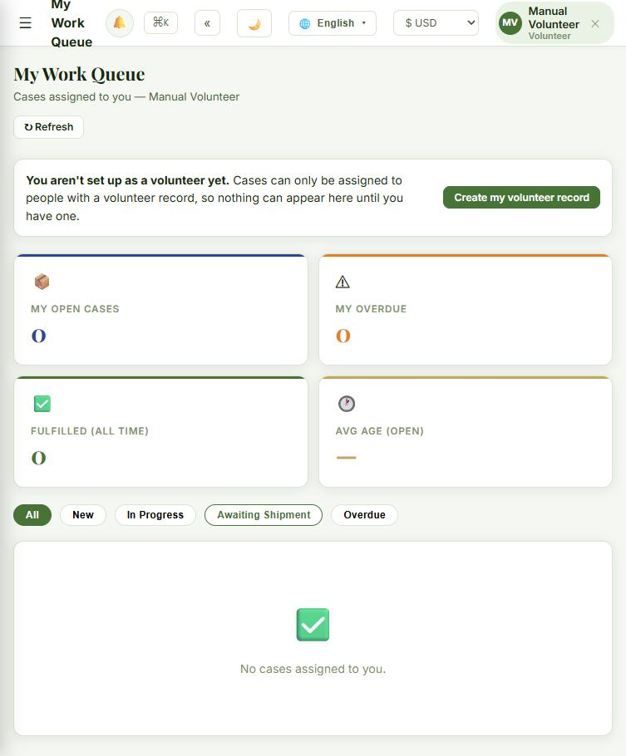
Steps:
- No volunteer record yet? Click "Create my volunteer record" first — cases can only be assigned to someone who has one.
- Your queue lists every case assigned to you, with KPIs for open cases, overdue cases (open more than 7 days), lifetime fulfilled count, and average age.
- Click "Quick Update" on any case to move it forward. Only the valid next statuses are offered — New → InProgress → AwaitingShipment → Shipped → Fulfilled.
- Moving to AwaitingShipment, Shipped, or Fulfilled also asks for a Tracking Number and a Shipped Date — fill those in before saving.
- Click "Details" instead of Quick Update to see the full case — packing checklist, family info, custom message, internal notes.
Good to know:
- Each chapter sets a cap on how many active cases one volunteer can carry at once (6 by default) — if you can't take a new case, you may be at that cap.
- Staff also see All Cases, Package Pipeline (a drag-and-drop board), and Unassigned Queue above the table — a plain volunteer doesn't, since those are chapter-wide views.
If something looks wrong: can't move a case to the status you expect? Only the next valid step is ever offered — check the Status table in the main dashboard reference manual.

