Staff Guide: Managing Cases
For: HQAdmin, ChapterAdmin, ChapterStaff, Director (Board can view everything below, read-only).

Case statuses
Every case has a Status, and only certain next steps are ever offered:
Status | Meaning
New | Just submitted, nobody assigned yet.
InProgress | Assigned to a volunteer and being worked.
AwaitingShipment | Packed, ready to ship.
Shipped | On its way — needs a tracking number.
Fulfilled | Delivered; the case is closed.
OnHold | Paused for any reason; can resume from here.
Cancelled | No longer happening.
A Prayer-only request skips every package status it doesn't need — it only ever waits on the Prayer Team, never on a Package Assembler.
How to change a case's status, from anywhere you see it:
- Find the Status dropdown (on the case's own page, in My Work Queue's Quick Update drawer, or in the Unassigned Queue's Assign drawer).
- Open it — only the statuses that are actually valid next steps from where the case is now are listed.
- Pick one. If you're choosing AwaitingShipment, Shipped, or Fulfilled, also fill in the Tracking Number and Shipped Date fields that appear.
- Click Save Changes (or Update Status, depending on the page).

The Unassigned Queue (/admin/queue)
Lists every New case with nobody assigned yet. New package requests are auto-assigned to a Package Assembler in the same chapter (when auto-assign is on), respecting that volunteer's maximum active cases (a chapter setting, 6 by default) and an acceptance window — 24 hours normally, 4 hours for an Urgent-priority case — before it moves to the next volunteer. Use this queue to assign or reassign by hand anytime.
How to assign a case from here:
- Find the case in the table and click Assign.
- Review the family summary that opens — contact info, address, reason, how long it's been waiting.
- Pick a volunteer from the Assign To dropdown, or click one of the up-to-5 suggested volunteers (ranked by workload) to select it instantly. To assign it to yourself, pick your own name — there's no separate "assign to me" button.
- Click Confirm Assignment.
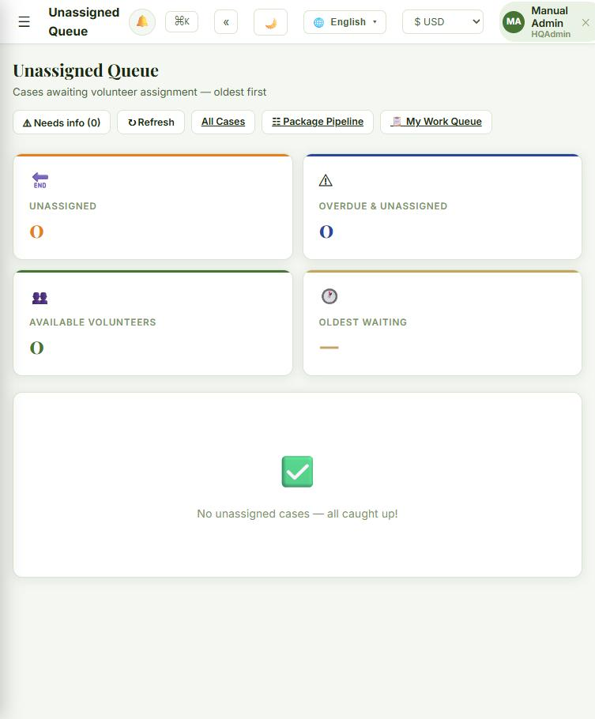

The Package Pipeline board (/admin/kanban)
A drag-and-drop view of every package case, organized into columns: Unassigned, Assigned, Confirmed ("Volunteer Accepted"), Packing, Notes, Shipping. Drag a card to a new column to move its status and process stage together. Moving a card into Packing now also auto-generates a placeholder shipping label behind the scenes (visible on the case's activity timeline) — carrier integration is a future phase.
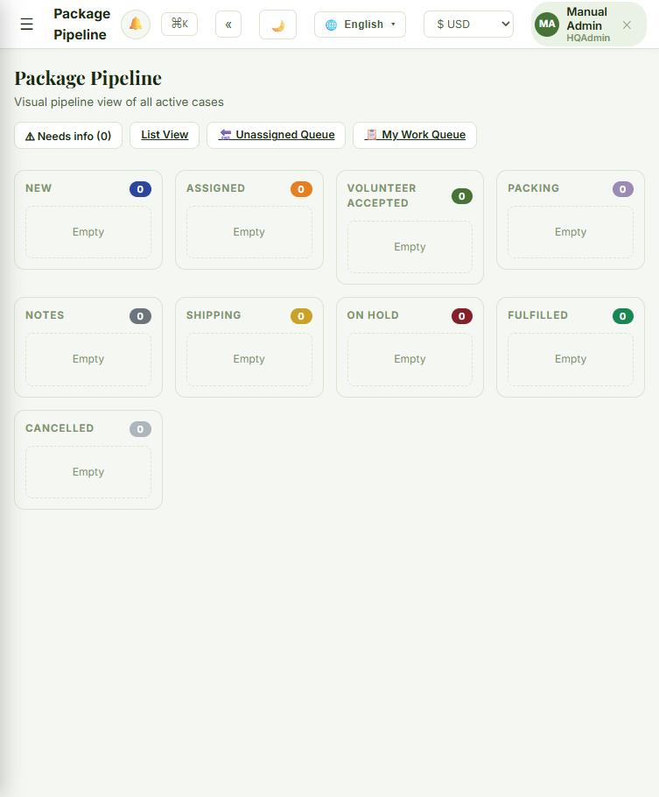
For the full rundown of every column, what each field on a card means, and how Quick Assign works: Staff Guide: The Package Pipeline Board.

The Case Detail Page — Every Field, and How to Change It
Open any case at /admin/cases/{id} — click Details from any list, or click anywhere on a card's body (not its buttons) on the Package Pipeline board. This is the one place that shows everything about a case and lets you change almost all of it.
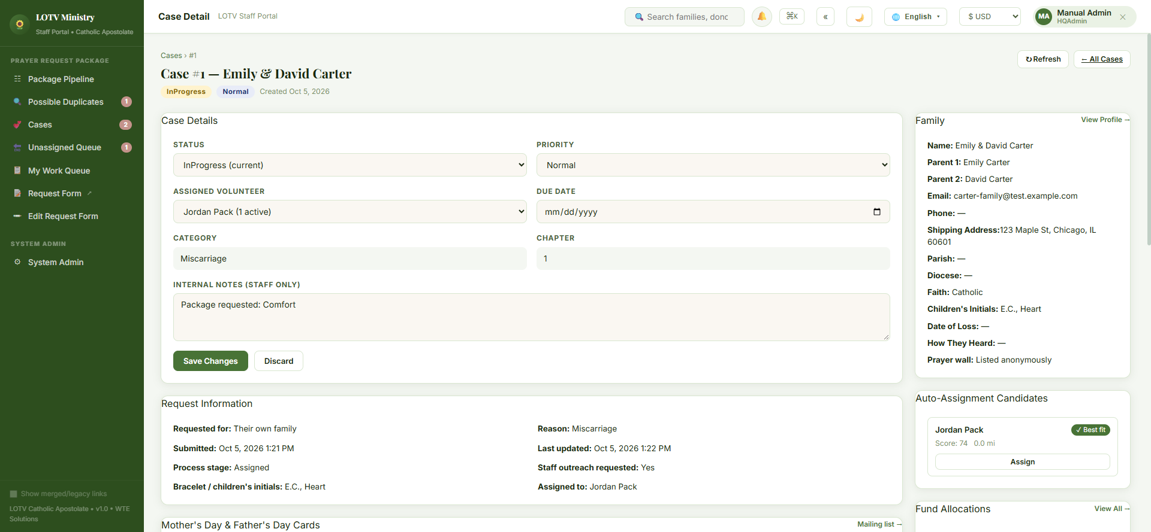

Case Details — the editable panel
Field | What it does
Status | Only the valid next steps are offered (same rules as everywhere else).
Priority | Urgent, High, Normal, or Low.
Assigned Volunteer | Any active volunteer, or — Unassigned —.
Due Date | Optional target date.
Category | Read-only — set automatically from the Reason given at intake.
Chapter | Read-only.
Tracking Number / Shipped Date | Only appear once Status is set to AwaitingShipment, Shipped, or Fulfilled.
Internal Notes | Staff-only free text, never shown to the family.
How to edit any of these fields:
- Change whatever you need directly in the panel — Status, Priority, Assigned Volunteer, Due Date, Internal Notes.
- If you set Status to AwaitingShipment, Shipped, or Fulfilled, the Tracking Number and Shipped Date fields appear — fill those in too.
- Click Save Changes to apply everything at once, or Discard to throw away your edits and reload what's saved.

Quick Actions — the one-click shortcuts
In the right-hand column, Quick Actions offers a button for every valid next status (e.g. "📦 Mark AwaitingShipment", "✅ Mark Fulfilled", "✖ Cancel Case") plus Unassign if someone's on it — same transition rules as the Status dropdown, just one click instead of picking-and-saving. + New Case for This Family starts a second request for the same family.

Auto-Assignment Candidates
A ranked list of volunteers for this specific case, with a ✓ Best fit tag on the top suggestion, a score, and distance in miles. Click Assign on any of them to hand the case off immediately — no drawer, no extra step.

Packing List
Add items from chapter inventory (with quantity), check them off as they're packed, or remove one. If you try to move toward Shipped with items still unchecked, a warning shows so nothing ships half-packed.
How to add an item: pick it from the — Select item — dropdown (only items with stock on hand are listed), set the quantity, and click Add. Check the box next to an item once it's packed; click Remove to take it back off the list.

Prayer Team
Add or remove Prayer Ambassadors for this family — completely separate from whoever's assembling the package; any number of people can be praying for one family at once.
How to add someone: pick them from the — Add a Prayer Ambassador — dropdown (only people with that role, not already on the team, are listed) and click Add. How to remove someone: click Remove next to their name.

Notes Thread
The family's own story from the intake form always leads the thread (read live from the family record, not copied — it stays current if the story is ever corrected). Add your own notes below it, optionally checking Internal only to keep a note hidden from the recipient.
How to add a note:
- Type it into the box at the bottom of the Notes Thread.
- Check Internal only if it shouldn't be visible to the recipient (staff only — this checkbox doesn't show for volunteers).
- Click Add Note.

Activity Log
A full timestamped history of everything that's happened to the case — who assigned it, who changed its status, when it was created — each entry attributed by name.

Family panel and Other Requests
The right-hand Family panel shows full contact info, address, parish/diocese, faith tradition, date of loss, how they heard about LOTV, and their prayer-wall privacy choice, with a View Profile → link for deeper family-level edits. All Requests from This Family lists every other case tied to the same family, so you can catch a possible repeat request before shipping a second package.

Possible duplicate families (/admin/families/duplicate-review)
If a new request looks like it might be the same family as an existing case, it's held out of the Unassigned Queue and auto-assignment, and shows here instead until staff confirm it's a new family or merge it.

A case's own page (/admin/cases/{id})
Assign or reassign a volunteer, change priority, add internal notes, and use the quick-action buttons to move through valid next statuses — the same rules as the Pipeline board, just one case at a time.

