Prayer Care Package Dashboard — Staff & Volunteer Manual
Oct 1, 2026 · prepared by @Eric Garrison

Welcome
The Prayer Care Package Dashboard is where every request submitted through the public intake form — for a comfort package, for prayer, or both — gets tracked from the moment a family asks for help until their case is closed.
Two kinds of people use it, and each sees a different slice of it:
- Staff (HQAdmin, ChapterAdmin, ChapterStaff, Director) manage every case, person, and setting.
- Volunteers see only their own work: cases assigned to them to pack and ship, and/or families they've joined to pray for.
This manual uses the exact page names, button labels, and URLs you'll see on screen, so you can follow along step by step.

Roles & Access
What you can see is set by your staff role, or by which volunteer role(s) are on your volunteer record — a volunteer can hold more than one role at once.
Staff role | Access
HQAdmin | Everything, every chapter. The only role that can use Login As or reach System Admin.
ChapterAdmin | Full case, volunteer, and donation access, can generate temp passwords, but not System Admin or Login As.
ChapterStaff | Same day-to-day case work as ChapterAdmin, without account-management screens.
Director | Same operational access as ChapterAdmin; never HQAdmin-only screens.
Board | Read-only across the same staff screens — can look, never change anything.
Volunteer | Only My Work Queue and the Prayer Dashboard, and only their own cases/families — nothing chapter-wide.
A volunteer record can carry one or more of these roles:
Volunteer role | What it's for
Package Assembler | Packs and ships comfort packages — shows up in My Work Queue.
Prayer Ambassador | Joins families' prayer teams — shows up in the Prayer Dashboard.
Parish Liaison, Event Helper, Driver, Admin | Other ministry roles — not used by this dashboard.

Logging In
Sign in with your email or username and password on the login page.
- First time, or locked out? An admin (HQAdmin, ChapterAdmin, or Director) can generate you a one-time temp password from User Management (see Admin Tools, below). The moment you log in with it, you're sent straight to Change Password — you can't use the rest of the dashboard until you set a password only you know.
- Forgot your password? Use "Forgot password" on the login screen, or ask an admin for a temp password.
- Where you land depends on how you got in. Logging in directly: staff go to the Dashboard, any Volunteer goes to My Work Queue. If an admin signed you in with Login As, or you're a Volunteer who opened a staff page you can't use: you're sent to My Work Queue if you're a Package Assembler (or hold both roles), or to the Prayer Dashboard if you're a Prayer Ambassador only, or have no volunteer record yet. (Tested 2026-10-01: these two paths don't currently agree for a brand-new volunteer account — worth a look if it matters which one a new volunteer lands on first.)
How to log in, step by step:
- Go to the login page.
- Type your username (or email) and password.
- Click Sign In.
- If you were given a temp password, you'll be sent straight to Change Password — set your own password there before doing anything else.
- You'll land on My Work Queue (Volunteer) or the staff Dashboard (everyone else) — see the note above for the one exception.

The Public Request Form
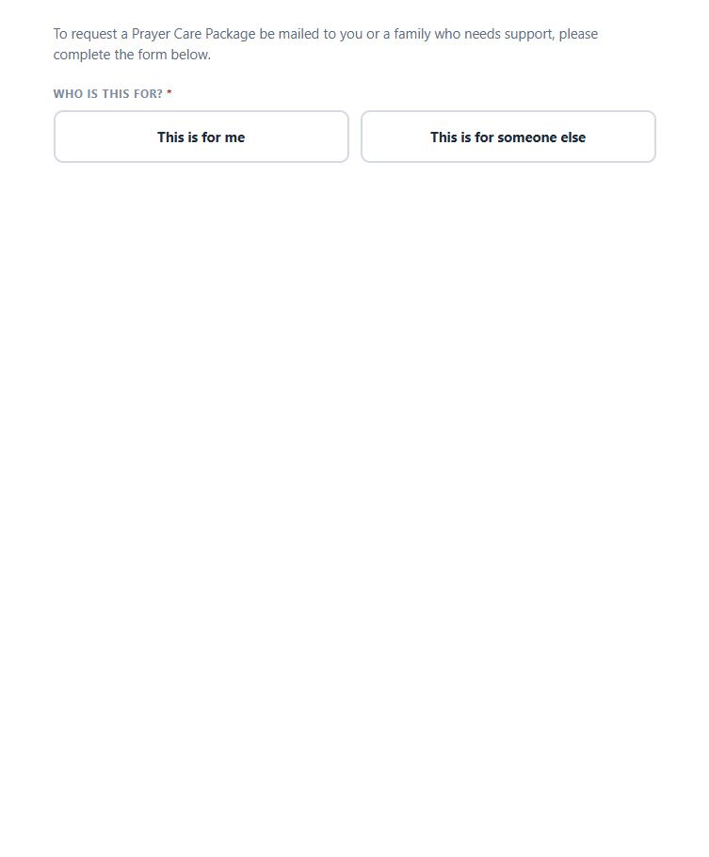
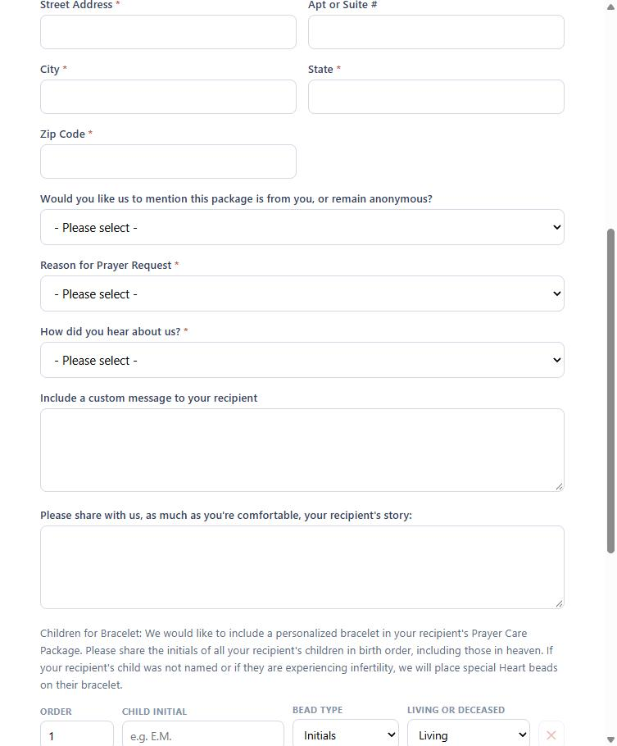
Every case on the dashboard starts here: a family or someone referring them fills out the public form (/request-prayer-care-package), and it becomes a case automatically — no staff step needed to create it.
The key question, "What would help most right now?", offers three choices in this order:
- A comfort package mailed to you/the family, plus ongoing prayer — the default; the case gets a package and sits in the Prayer Ambassadors' queue.
- Prayer only — no package needed — no package to pack or ship; never auto-assigned to a Package Assembler.
- A comfort package only — no prayer team needed — gets a package, but the requester explicitly opted out of the prayer team, so this case never appears in the Prayer Dashboard's queue.
Other things worth knowing:
- Reason for Prayer Request: Infertility, Prenatal Diagnosis, Miscarriage (before 20 weeks), Stillbirth (20 weeks or later), Infant Loss (after birth, up to age 1), or Postnatal Medical Concern.
- Children for Bracelet: only shown when a package was requested (either of the two package options above) — lists children in birth order for a personalized bracelet, with a Heart bead option for an unnamed child or for infertility.
- Whether the mention/anonymity and "reason" wording says "package" or "prayer request" automatically follows which option the requester picked.

Working a Case
Every case has a Status, shown everywhere on the dashboard, and only certain next steps are ever offered — you can't jump straight from New to Shipped.
Status | Meaning
New | Just submitted, nobody assigned yet.
InProgress | Assigned to a volunteer and being worked.
AwaitingShipment | Packed, ready to ship.
Shipped | On its way — needs a tracking number.
Fulfilled | Delivered; the case is closed.
OnHold | Paused for any reason; can resume from here.
Cancelled | No longer happening.
A Prayer only request skips every package status it doesn't need — nothing to pack or ship, so it's never auto-assigned to a Package Assembler; it only ever waits on the Prayer Team (next section).
How to assign an unassigned case:
- Open the Unassigned Queue (/admin/queue) and click Assign next to the case.
- Pick a volunteer from the dropdown, or click one of the ranked suggestions — pick your own name to take it yourself.
- Click Confirm Assignment.
How to change a case's status: open its Status dropdown (on its own page, or in a Quick Update/Assign drawer), pick one of the next steps offered, fill in Tracking Number/Shipped Date if asked, and save.
Full detail on both, plus the rest of the case detail page, lives in the Staff Guide: Managing Cases.
Getting assigned: new package requests are auto-assigned to a Package Assembler in the same chapter (when auto-assign is on), respecting that volunteer's maximum active cases (a chapter setting, 6 by default) and an acceptance window — 24 hours normally, 4 hours for an Urgent-priority case — before it's offered to someone else. Staff can always assign or reassign by hand from the Unassigned Queue (/admin/queue) or from a case's own page.
Possible duplicate families: if a new request looks like it might be the same family as an existing case, it's held out of the Unassigned Queue and auto-assignment, and shows instead on Families → Duplicate Review (/admin/families/duplicate-review) until staff confirm it's a new family or merge it.
The Package Pipeline board (/admin/kanban, staff only) shows package cases as drag-and-drop cards across columns — Unassigned, Assigned, Confirmed ("Volunteer Accepted"), Packing, Notes, Shipping — for a quick visual of where everything stands.

The Prayer Dashboard
Open Prayer Dashboard (/admin/prayer-list) — for any volunteer whose record carries the Prayer Ambassador role.
- No volunteer record yet? Click "Create my volunteer record as a Prayer Ambassador" — one click sets it up.
- Families You Could Join lists every open case that wasn't marked "package only" at intake. Pick any family and add yourself — there's no accept/decline step, you just join.
- Praying For lists the families you're already on. Click "I'll stop praying for this family" to leave anytime.
- Many volunteers can pray for one family, and one volunteer can be on many families' teams at once — no limit either way.
A request marked Package only at intake is the one case type that never appears here — the requester specifically asked not to involve the prayer team.

Assembling & Shipping a Package
Short, standalone guide for Package Assemblers: Volunteer Quick Guide: Packing & Shipping a Package — covers My Work Queue, moving a case through its statuses, and tracking numbers.

Admin Tools
Short, standalone guide for HQAdmin/ChapterAdmin/Director: Admin Quick Guide: Users, Temp Passwords & Login As — covers User Management, generating a one-time temp password, and signing in as another user.

Troubleshooting & FAQ
- The bracelet question isn't showing up. The requester picked Prayer only — it only appears when a package was requested.
- A case isn't showing in the Prayer Dashboard's queue. It was submitted as "Package only" — that's by design; the requester opted out of the prayer team.
- I can't move a case to a status I expect. Only the next valid step is ever offered — see the Status table under Working a Case.
- A volunteer can't take a new case. They may be at their chapter's Max Active Cases Per Volunteer cap (6 by default).
- I forgot my password. Use "Forgot password" on the login screen, or ask an HQAdmin/ChapterAdmin/Director for a temp password.
- I need to see exactly what a staff member or volunteer sees. An HQAdmin can use Login As — see the Admin Quick Guide.

Related guides
- Volunteer Quick Guide: Praying for a Family
- Volunteer Quick Guide: Packing & Shipping a Package
- Admin Quick Guide: Users, Temp Passwords & Login As
- Staff Guide: Managing Cases
- Board Member Guide
- Staff Guide: The Package Pipeline Board
- Staff Guide: The Cases Hub, Duplicates, and Queues

