Admin Quick Guide: Users, Temp Passwords & Login As
Open User Management at /admin/users — lists every staff account in your chapter (or every chapter, if you're HQAdmin).

Generating a temp password
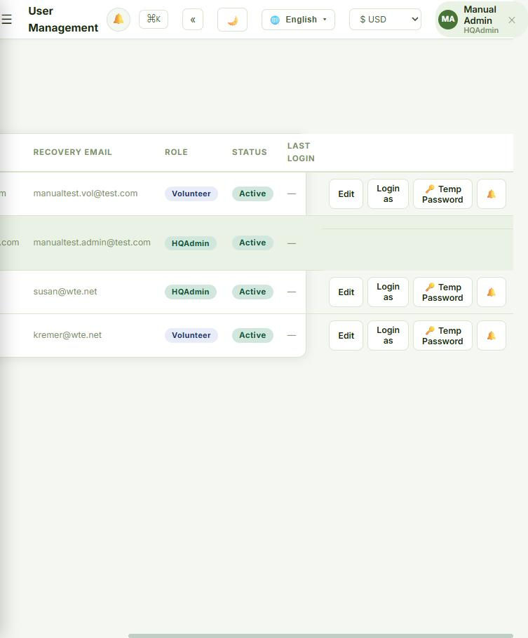
For: HQAdmin, ChapterAdmin, or Director.
- Find the person and click 🔑 Temp Password next to their name.
- Confirm — a random password is generated and shown once. Write it down or share it with them before closing the dialog; it can't be shown again.
- The moment they log in with it, they're sent straight to Change Password and can't do anything else until they set one only they know.
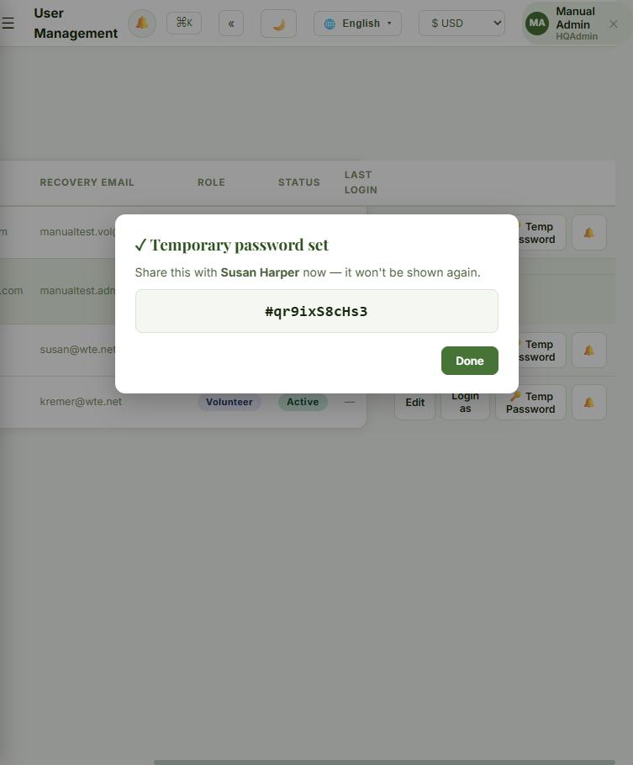
Nobody — including the person who generates it — can see a user's real password. This is the only way to help someone back into their account.

Login As
For: HQAdmin only.
- Click "Login as" next to any other user — even another HQAdmin, even a deactivated account.
- Confirm to sign in and see the portal exactly as they do. A banner stays on screen the whole time, naming whose account you're in.
- It lasts 30 minutes and can't be renewed — it ends itself, or click the banner to return to your own account early.
Rules: you can't use it on yourself, and you can't "Login As" while already signed in as someone else. Every start and end is logged, and anything done while impersonating is recorded under both names.

