Board Member Guide
Board access is read-only everywhere — you can look at anything described below, but every save, edit, or create action is refused by the system, not just hidden.

Sign in
- Go to the staff login page.
- Enter your username (or email) and password.
- Click Sign In.
- You'll land on the staff Dashboard.

Two ways to see the ministry's numbers
The Board Portal (/board/portal) — a separate, simpler page built just for governance oversight: Total Donations, Donations This Month, Families Served, Open Cases, Fulfilled Cases, Active Volunteers, and Dioceses Reached, all in one glance. This page isn't linked from the staff menu — go to it directly by typing or bookmarking the address above.
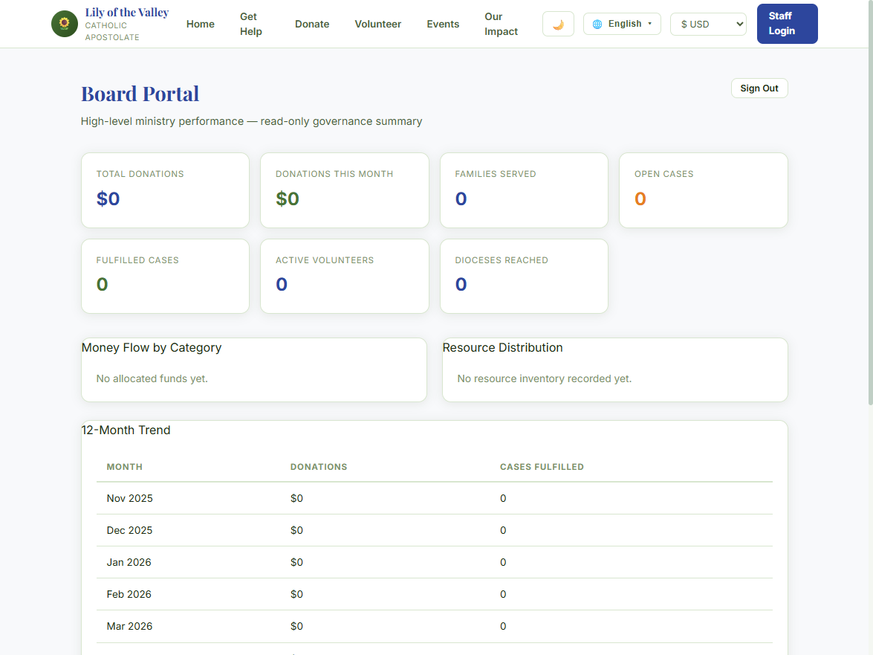
How to get there: after signing in, type or bookmark /board/portal and go to it directly — it isn't linked from the staff menu.
The regular staff area (/admin/...) — you can also browse Cases, Donations, and Volunteers the same way staff do, for more detail than the summary tiles give you. Anywhere you'd normally click Save, Edit, or Delete, the action is refused server-side — so nothing you click here can change ministry data, even by accident.

What's off-limits
System Admin, User Management, and other HQ-only screens are not reachable at all, read-only or otherwise.

