Staff Guide: The Package Pipeline Board
Open Package Pipeline at /admin/kanban — for staff (HQAdmin, ChapterAdmin, ChapterStaff, Director); Board can view it too, read-only. It's a drag-and-drop view of every active case, and it updates live when anyone else changes a case — no need to refresh.

The columns
Column | What's in it
New | Just submitted, nobody assigned yet.
Assigned | A volunteer is assigned but hasn't been marked as accepting it yet.
Volunteer Accepted | The assigned volunteer has confirmed they're on it.
Packing | Being packed. Moving a card here auto-generates a placeholder shipping label behind the scenes.
Notes | A packing note or hold-up is attached.
Shipping | Ready to ship or already shipped.
On Hold | Paused for any reason.
Fulfilled | Delivered and closed — shows only the last 3 months here; older ones are in List View.
Cancelled | No longer happening.
Drag a card into a new column to move it — this updates both its Status and its more detailed Process Stage together. You can only drop a card where that move is actually allowed (the same rules as everywhere else in the app); dragging to a column that isn't currently a valid next step for that card is blocked.
How to move a case to a new stage:
- Click and hold anywhere on the card (not its button).
- Drag it onto the column you want.
- Release. If that move isn't currently valid for this card, the drop is simply refused — nothing changes, and you can tell before you even let go: invalid columns are visually marked while you're dragging.
Click "⚠ Needs info" to filter the board down to only cases with a data problem on the family record (e.g. a missing field) — click it again to go back to everything.
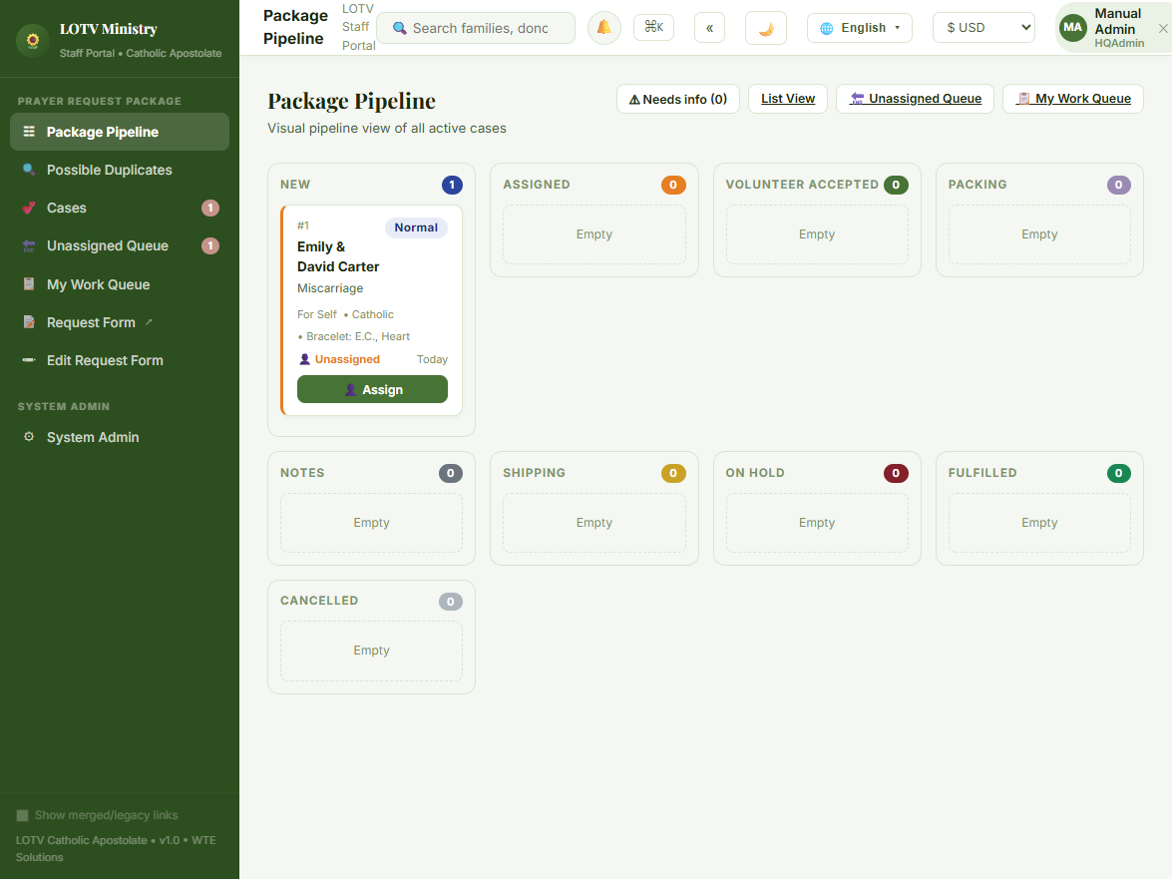

What's on a card
Each card shows, top to bottom:
- Case number and priority badge (top row) — Urgent, High, Normal, or Low. The card's left-edge color also reflects priority.
- Family name
- Reason for the request
- A meta line: whether it's for the requester themselves or someone else, their faith tradition if known, and a bracelet note if children's initials were given — whatever doesn't apply is simply left out.
- A tracking number, once one's been entered — shown with a 📦 icon.
- A ⚠ "Check family info" badge, only if something about the family record looks incomplete or inconsistent — hover it to see what's wrong.
- Assignee and age (bottom row) — "Unassigned" or the volunteer's name, and how long the case has been open; the age turns red once it's overdue.
- An action button: Assign if nobody's on it yet, or Unassign if someone is.
Clicking anywhere else on the card (not the button) opens that case's full detail page.

Assigning from the board
How to assign a card:
- Click Assign on any unassigned card.
- In the drawer that opens, either click one of the suggested volunteers ranked by workload, or pick manually from the Assign To dropdown (it flags anyone already at their chapter's case-load cap).
- Click Confirm Assignment.
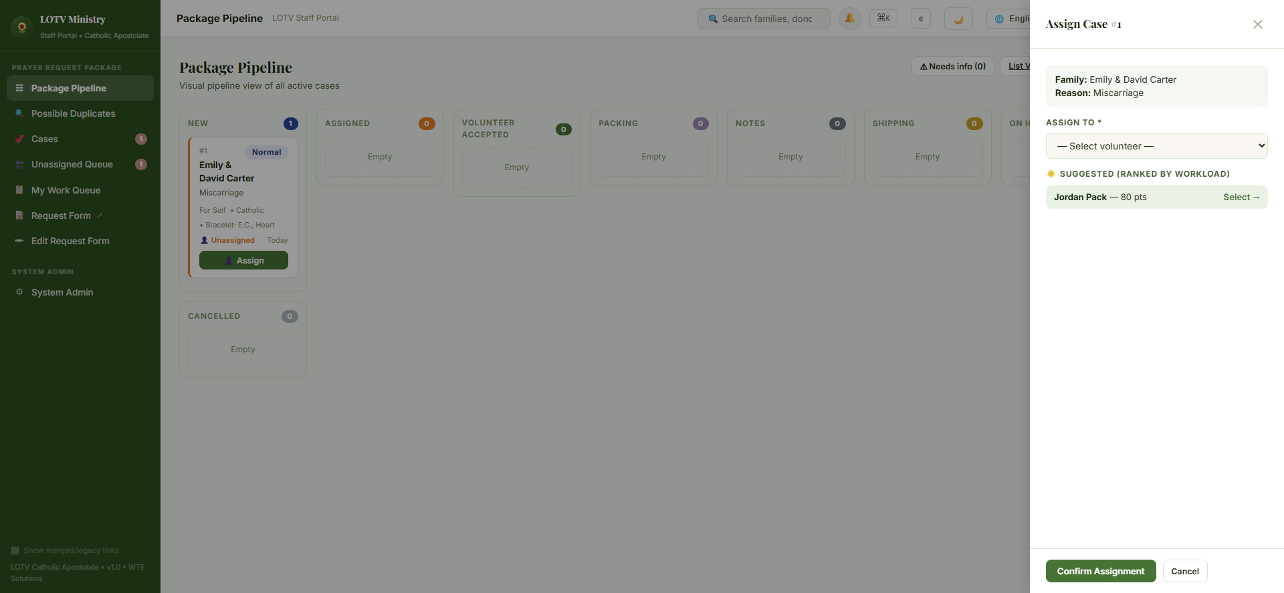
The same card right after confirming — now in the Assigned column, showing the volunteer's name on the bottom row and an Unassign button in place of Assign:
