Shri Vile Parle Kelavani Mandal’s

**SHRI BHAGUBHAI MAFATLAL POLYTECHNIC**

September 2020

Program: **Information Technology**

Course Name: **Programming in Java**

Course Code: **PRJ190901**

Semester: III

Academic Term: **15 June 2020 to 7 November 2020**

Mini Project Title: **Beauty products/Cosmetics**

**Student Name: Kresha Shah**

**Student Roll No: 1991050**

**Index**

|  |  |  |
| --- | --- | --- |
| **Sr. no** | **Topic Name** | **Page no.** |
| **1** | **Abstract and features** | **3** |
| **2** | **Hardware and Software Requirements** | **4** |
| **3** | **Module Implementation** | **5** |
| **4** | **Class diagram** | **6** |
| **5** | **Miniproject code and output** | **7-450** |
| **6** | **Future scope and Conclusion** | **451** |

**Abstract**

In this beauty product software, one will be able to login as either user or owner. If the login credentials are not appropriate then the software will not allow you to enter into the system. If someone logins as a user then there will be two options available for him/her i.e. they can either buy any product or can sell any product. If we click on the buy option there will be various buttons which describe what the available products are and there is also a table where all the products are displayed with their information. If one likes any product they can click n buy now enter the required credentials and at the end of the process a receipt will be generated of the product that was bought. If one wants to sell their product they can enter the details of the product and that product will be entered into the database. Now, for the owner part an owner can insert, delete or update any product they like but first they have to enter their login information then only they will be able to do so.

**Problem Statement & Features:**

**Description:** *This software is made in Java language using NetBeans .This IDE is easy to use and implement.*

Develop a Java Mini Project for Beauty products/Cosmetics which offers the following features:

* Insertion of a new product in the product list
* Displaying all the products from the product list
* Deletion of a product in the product list
* Updation of a product in the product list
* Login Form for user owner
* Buy any product from the product list
* Sell any product from the product list
* Receipt generation after buying any product.

Software requirements

1. Java: JDK1.8



Fig. 1 Oracle Java Logo

Java is a general-purpose programming language that is class- based object- oriented, and designed to have as few implementation dependencies as possible. Java is fast, reliable and se-cure. From desktop to web applications, scientific supercomputers to gaming consoles, cell phones to the Internet, Java

Is used in every nook and corner. Not only is Java the official programming language for Android app development (along with Kotlin), Java itself is used by Google for large parts of the Android internals.

MySQL, XAMPP, Netbeans.

HARDWARE REQUIREMENTS

• Windows 7 or higher (32bit or 64bit)

• Intel i3 processor (1.30 GHz)

• Minimum 4GB RAM

• 250GB Free Disk Space

Module Implementation

|  |  |  |  |
| --- | --- | --- | --- |
| Sr. no | Module Name | Description | Implementation date |
| 1 | Defining the requirements | Collecting all information  needed for implementation of  Beauty Product | 15-10-2020 |
| 2 | Designing on paper | Design the Frames using Java Swing on an IDE without implementation. | 18-10-2020 |
| 3 | Login Form implementation | Login Form enables the user to login to the Project and enables the connection to Database. | 25-10-2020 |
| 4 | Buy / Sell product implementation | It allows the user to buy or sell any product they want to with database connectivity | 30-10-2020 |
| 5 | Insert/delete/update data implementation | The Insert/ Delete/Update Data allows the user  To insert/delete/update data from the database  and store the information  in the database | 7-10-2020 |
| 6 | Payment and Receipt | It allows the customer to pay bill and after that generates a receipt | 15-11-2020 |

Class Diagram

User

Owner

Bill/ receipt generation

Payment information

Delete product

Insert/

Update

Product

Sell product

Buy product

Miniproject Source Code

1. SelectType.java

Code:

/*

* To change this license header, choose License Headers in Project Properties.

* To change this template file, choose Tools | Templates

* and open the template in the editor.

*/

package beautyproducts;

import javax.swing.JOptionPane;

import java.awt.Toolkit;

import java.awt.event.WindowEvent;

import beautyproducts.Login;

import beautyproducts.insertdelete;

/**

*

* @author js

*/

public class SelectType extends javax.swing.JFrame {

/**

* Creates new form SelectType

*/

public SelectType() {

initComponents();

}

/**

* This method is called from within the constructor to initialize the form.

* WARNING: Do NOT modify this code. The content of this method is always

* regenerated by the Form Editor.

*/

@SuppressWarnings("unchecked")

// <editor-fold defaultstate="collapsed" desc="Generated Code">

private void initComponents() {

jPanel1 = new javax.swing.JPanel();

exittxt = new javax.swing.JButton();

userbutton = new javax.swing.JButton();

ownerbutton = new javax.swing.JButton();

type = new javax.swing.JLabel();

setDefaultCloseOperation(javax.swing.WindowConstants.EXIT_ON_CLOSE);

exittxt.setText("Exit");

exittxt.addActionListener(new java.awt.event.ActionListener() {

public void actionPerformed(java.awt.event.ActionEvent evt) {

exittxtActionPerformed(evt);

}

});

userbutton.setText("USER");

userbutton.addActionListener(new java.awt.event.ActionListener() {

public void actionPerformed(java.awt.event.ActionEvent evt) {

userbuttonActionPerformed(evt);

}

});

ownerbutton.setText("OWNER");

ownerbutton.addActionListener(new java.awt.event.ActionListener() {

public void actionPerformed(java.awt.event.ActionEvent evt) {

ownerbuttonActionPerformed(evt);

}

});

javax.swing.GroupLayout jPanel1Layout = new javax.swing.GroupLayout(jPanel1);

jPanel1.setLayout(jPanel1Layout);

jPanel1Layout.setHorizontalGroup(

jPanel1Layout.createParallelGroup(javax.swing.GroupLayout.Alignment.LEADING)

.addGroup(jPanel1Layout.createSequentialGroup()

.addGap(216, 216, 216)

.addGroup(jPanel1Layout.createParallelGroup(javax.swing.GroupLayout.Alignment.TRAILING)

.addComponent(exittxt, javax.swing.GroupLayout.PREFERRED_SIZE, 196, javax.swing.GroupLayout.PREFERRED_SIZE)

.addGroup(jPanel1Layout.createParallelGroup(javax.swing.GroupLayout.Alignment.LEADING, false)

.addComponent(userbutton, javax.swing.GroupLayout.DEFAULT_SIZE, javax.swing.GroupLayout.DEFAULT_SIZE, Short.MAX_VALUE)

.addComponent(ownerbutton, javax.swing.GroupLayout.DEFAULT_SIZE, 199, Short.MAX_VALUE)))

.addContainerGap(249, Short.MAX_VALUE))

);

jPanel1Layout.setVerticalGroup(

jPanel1Layout.createParallelGroup(javax.swing.GroupLayout.Alignment.LEADING)

.addGroup(jPanel1Layout.createSequentialGroup()

.addGap(47, 47, 47)

.addComponent(userbutton, javax.swing.GroupLayout.PREFERRED_SIZE, 66, javax.swing.GroupLayout.PREFERRED_SIZE)

.addPreferredGap(javax.swing.LayoutStyle.ComponentPlacement.RELATED, 64, Short.MAX_VALUE)

.addComponent(ownerbutton, javax.swing.GroupLayout.PREFERRED_SIZE, 58, javax.swing.GroupLayout.PREFERRED_SIZE)

.addGap(79, 79, 79)

.addComponent(exittxt, javax.swing.GroupLayout.PREFERRED_SIZE, 40, javax.swing.GroupLayout.PREFERRED_SIZE))

);

type.setFont(new java.awt.Font("Tahoma", 1, 36)); // NOI18N

type.setText("Select Your Type");

type.setToolTipText("");

javax.swing.GroupLayout layout = new javax.swing.GroupLayout(getContentPane());

getContentPane().setLayout(layout);

layout.setHorizontalGroup(

layout.createParallelGroup(javax.swing.GroupLayout.Alignment.LEADING)

.addGroup(layout.createSequentialGroup()

.addGap(154, 154, 154)

.addComponent(type)

.addContainerGap(javax.swing.GroupLayout.DEFAULT_SIZE, Short.MAX_VALUE))

.addGroup(javax.swing.GroupLayout.Alignment.TRAILING, layout.createSequentialGroup()

.addContainerGap(javax.swing.GroupLayout.DEFAULT_SIZE, Short.MAX_VALUE)

.addComponent(jPanel1, javax.swing.GroupLayout.PREFERRED_SIZE, javax.swing.GroupLayout.DEFAULT_SIZE, javax.swing.GroupLayout.PREFERRED_SIZE)

.addGap(33, 33, 33))

);

layout.setVerticalGroup(

layout.createParallelGroup(javax.swing.GroupLayout.Alignment.LEADING)

.addGroup(layout.createSequentialGroup()

.addGap(29, 29, 29)

.addComponent(type)

.addGap(28, 28, 28)

.addComponent(jPanel1, javax.swing.GroupLayout.PREFERRED_SIZE, javax.swing.GroupLayout.DEFAULT_SIZE, javax.swing.GroupLayout.PREFERRED_SIZE)

.addContainerGap(43, Short.MAX_VALUE))

);

pack();

}// </editor-fold>

private void exittxtActionPerformed(java.awt.event.ActionEvent evt) {

System.exit(0);

}

private void userbuttonActionPerformed(java.awt.event.ActionEvent evt) {

new Login().setVisible(true);

this.setVisible(false);

}

private void ownerbuttonActionPerformed(java.awt.event.ActionEvent evt) {

new Login2().setVisible(true);

this.setVisible(false);

}

/**

* @param args the command line arguments

*/

public static void main(String args[]) {

/* Set the Nimbus look and feel */

//<editor-fold defaultstate="collapsed" desc=" Look and feel setting code (optional) ">

/* If Nimbus (introduced in Java SE 6) is not available, stay with the default look and feel.

* For details see http://download.oracle.com/javase/tutorial/uiswing/lookandfeel/plaf.html

*/

try {

for (javax.swing.UIManager.LookAndFeelInfo info : javax.swing.UIManager.getInstalledLookAndFeels()) {

if ("Nimbus".equals(info.getName())) {

javax.swing.UIManager.setLookAndFeel(info.getClassName());

break;

}

}

} catch (ClassNotFoundException ex) {

java.util.logging.Logger.getLogger(SelectType.class.getName()).log(java.util.logging.Level.SEVERE, null, ex);

} catch (InstantiationException ex) {

java.util.logging.Logger.getLogger(SelectType.class.getName()).log(java.util.logging.Level.SEVERE, null, ex);

} catch (IllegalAccessException ex) {

java.util.logging.Logger.getLogger(SelectType.class.getName()).log(java.util.logging.Level.SEVERE, null, ex);

} catch (javax.swing.UnsupportedLookAndFeelException ex) {

java.util.logging.Logger.getLogger(SelectType.class.getName()).log(java.util.logging.Level.SEVERE, null, ex);

}

//</editor-fold>

/* Create and display the form */

java.awt.EventQueue.invokeLater(new Runnable() {

public void run() {

new SelectType().setVisible(true);

}

});

}

// Variables declaration - do not modify

private javax.swing.JButton exittxt;

private javax.swing.JPanel jPanel1;

private javax.swing.JButton ownerbutton;

private javax.swing.JLabel type;

private javax.swing.JButton userbutton;

}

Output:

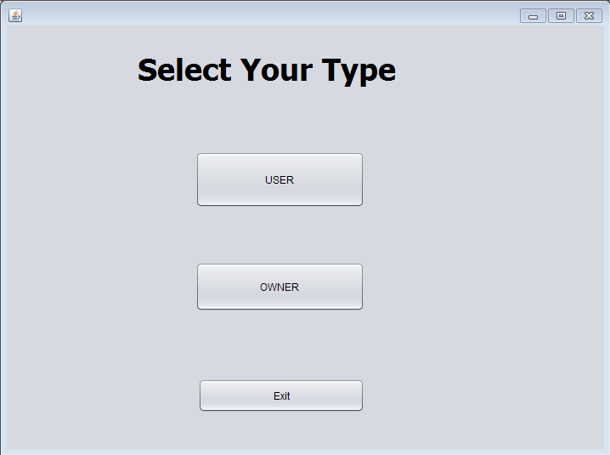

Login.java

Code:

/*

* To change this license header, choose License Headers in Project Properties.

* To change this template file, choose Tools | Templates

* and open the template in the editor.

*/

package beautyproducts;

import javax.swing.JOptionPane;

import java.awt.Toolkit;

import java.awt.event.WindowEvent;

import beautyproducts.BuySell;

/**

*

* @author js

*/

public class Login extends javax.swing.JFrame {

/**

* Creates new form Login

*/

public Login() {

initComponents();

}

/**

* This method is called from within the constructor to initialize the form.

* WARNING: Do NOT modify this code. The content of this method is always

* regenerated by the Form Editor.

*/

@SuppressWarnings("unchecked")

// <editor-fold defaultstate="collapsed" desc="Generated Code">

private void initComponents() {

jPanel1 = new javax.swing.JPanel();

jLabel2 = new javax.swing.JLabel();

jLabel3 = new javax.swing.JLabel();

jtxtUserName = new javax.swing.JTextField();

jPassword = new javax.swing.JPasswordField();

jbtnReset = new javax.swing.JButton();

jbtnExit = new javax.swing.JButton();

jbtnLogin = new javax.swing.JButton();

jLabel1 = new javax.swing.JLabel();

setDefaultCloseOperation(javax.swing.WindowConstants.EXIT_ON_CLOSE);

setPreferredSize(new java.awt.Dimension(400, 700));

jPanel1.setBorder(javax.swing.BorderFactory.createLineBorder(new java.awt.Color(0, 0, 0), 4));

jLabel2.setText("Username");

jLabel2.setBorder(javax.swing.BorderFactory.createEtchedBorder());

jLabel3.setText("Password");

jLabel3.setBorder(javax.swing.BorderFactory.createEtchedBorder());

jtxtUserName.setBorder(javax.swing.BorderFactory.createEtchedBorder());

jPassword.setBorder(javax.swing.BorderFactory.createEtchedBorder());

jbtnReset.setText("Reset");

jbtnReset.addActionListener(new java.awt.event.ActionListener() {

public void actionPerformed(java.awt.event.ActionEvent evt) {

jbtnResetActionPerformed(evt);

}

});

jbtnExit.setText("Exit");

jbtnExit.addActionListener(new java.awt.event.ActionListener() {

public void actionPerformed(java.awt.event.ActionEvent evt) {

jbtnExitActionPerformed(evt);

}

});

jbtnLogin.setText("Login");

jbtnLogin.setPreferredSize(new java.awt.Dimension(677, 527));

jbtnLogin.addActionListener(new java.awt.event.ActionListener() {

public void actionPerformed(java.awt.event.ActionEvent evt) {

jbtnLoginActionPerformed(evt);

}

});

javax.swing.GroupLayout jPanel1Layout = new javax.swing.GroupLayout(jPanel1);

jPanel1.setLayout(jPanel1Layout);

jPanel1Layout.setHorizontalGroup(

jPanel1Layout.createParallelGroup(javax.swing.GroupLayout.Alignment.LEADING)

.addGroup(jPanel1Layout.createSequentialGroup()

.addGap(122, 122, 122)

.addGroup(jPanel1Layout.createParallelGroup(javax.swing.GroupLayout.Alignment.TRAILING)

.addGroup(jPanel1Layout.createSequentialGroup()

.addGroup(jPanel1Layout.createParallelGroup(javax.swing.GroupLayout.Alignment.LEADING, false)

.addComponent(jLabel3, javax.swing.GroupLayout.DEFAULT_SIZE, javax.swing.GroupLayout.DEFAULT_SIZE, Short.MAX_VALUE)

.addComponent(jLabel2, javax.swing.GroupLayout.DEFAULT_SIZE, 84, Short.MAX_VALUE))

.addGap(184, 184, 184)

.addGroup(jPanel1Layout.createParallelGroup(javax.swing.GroupLayout.Alignment.LEADING, false)

.addComponent(jPassword, javax.swing.GroupLayout.DEFAULT_SIZE, 218, Short.MAX_VALUE)

.addComponent(jtxtUserName))

.addGap(197, 197, 197))

.addGroup(jPanel1Layout.createSequentialGroup()

.addComponent(jbtnLogin, javax.swing.GroupLayout.PREFERRED_SIZE, 160, javax.swing.GroupLayout.PREFERRED_SIZE)

.addGap(135, 135, 135)

.addComponent(jbtnReset, javax.swing.GroupLayout.PREFERRED_SIZE, 173, javax.swing.GroupLayout.PREFERRED_SIZE)

.addGap(161, 161, 161)))

.addComponent(jbtnExit, javax.swing.GroupLayout.PREFERRED_SIZE, 146, javax.swing.GroupLayout.PREFERRED_SIZE)

.addContainerGap(70, Short.MAX_VALUE))

);

jPanel1Layout.setVerticalGroup(

jPanel1Layout.createParallelGroup(javax.swing.GroupLayout.Alignment.LEADING)

.addGroup(jPanel1Layout.createSequentialGroup()

.addGroup(jPanel1Layout.createParallelGroup(javax.swing.GroupLayout.Alignment.LEADING)

.addGroup(jPanel1Layout.createSequentialGroup()

.addGap(346, 346, 346)

.addComponent(jbtnExit, javax.swing.GroupLayout.PREFERRED_SIZE, 58, javax.swing.GroupLayout.PREFERRED_SIZE))

.addGroup(jPanel1Layout.createSequentialGroup()

.addGroup(jPanel1Layout.createParallelGroup(javax.swing.GroupLayout.Alignment.LEADING)

.addGroup(jPanel1Layout.createSequentialGroup()

.addGap(39, 39, 39)

.addComponent(jLabel2, javax.swing.GroupLayout.PREFERRED_SIZE, 32, javax.swing.GroupLayout.PREFERRED_SIZE))

.addGroup(jPanel1Layout.createSequentialGroup()

.addGap(47, 47, 47)

.addComponent(jtxtUserName, javax.swing.GroupLayout.PREFERRED_SIZE, 33, javax.swing.GroupLayout.PREFERRED_SIZE)))

.addGap(77, 77, 77)

.addGroup(jPanel1Layout.createParallelGroup(javax.swing.GroupLayout.Alignment.BASELINE)

.addComponent(jLabel3, javax.swing.GroupLayout.PREFERRED_SIZE, 30, javax.swing.GroupLayout.PREFERRED_SIZE)

.addComponent(jPassword, javax.swing.GroupLayout.PREFERRED_SIZE, 30, javax.swing.GroupLayout.PREFERRED_SIZE))

.addGap(159, 159, 159)

.addGroup(jPanel1Layout.createParallelGroup(javax.swing.GroupLayout.Alignment.BASELINE)

.addComponent(jbtnLogin, javax.swing.GroupLayout.PREFERRED_SIZE, 58, javax.swing.GroupLayout.PREFERRED_SIZE)

.addComponent(jbtnReset, javax.swing.GroupLayout.PREFERRED_SIZE, 58, javax.swing.GroupLayout.PREFERRED_SIZE))))

.addContainerGap(javax.swing.GroupLayout.DEFAULT_SIZE, Short.MAX_VALUE))

);

jLabel1.setFont(new java.awt.Font("Calibri", 1, 48)); // NOI18N

jLabel1.setText("Login System");

javax.swing.GroupLayout layout = new javax.swing.GroupLayout(getContentPane());

getContentPane().setLayout(layout);

layout.setHorizontalGroup(

layout.createParallelGroup(javax.swing.GroupLayout.Alignment.LEADING)

.addGroup(layout.createSequentialGroup()

.addContainerGap(445, Short.MAX_VALUE)

.addGroup(layout.createParallelGroup(javax.swing.GroupLayout.Alignment.LEADING)

.addGroup(javax.swing.GroupLayout.Alignment.TRAILING, layout.createSequentialGroup()

.addComponent(jLabel1)

.addGap(357, 357, 357))

.addGroup(javax.swing.GroupLayout.Alignment.TRAILING, layout.createSequentialGroup()

.addComponent(jPanel1, javax.swing.GroupLayout.PREFERRED_SIZE, javax.swing.GroupLayout.DEFAULT_SIZE, javax.swing.GroupLayout.PREFERRED_SIZE)

.addGap(35, 35, 35))))

);

layout.setVerticalGroup(

layout.createParallelGroup(javax.swing.GroupLayout.Alignment.LEADING)

.addGroup(layout.createSequentialGroup()

.addGap(27, 27, 27)

.addComponent(jLabel1)

.addGap(18, 18, 18)

.addComponent(jPanel1, javax.swing.GroupLayout.PREFERRED_SIZE, javax.swing.GroupLayout.DEFAULT_SIZE, javax.swing.GroupLayout.PREFERRED_SIZE)

.addContainerGap(398, Short.MAX_VALUE))

);

pack();

}// </editor-fold>

private void jbtnExitActionPerformed(java.awt.event.ActionEvent evt) {

System.exit(0);

}

private void jbtnResetActionPerformed(java.awt.event.ActionEvent evt) {

jtxtUserName.setText(null);

jPassword.setText(null);

}

private void jbtnLoginActionPerformed(java.awt.event.ActionEvent evt) {

String password = jPassword.getText();

String username = jtxtUserName.getText();

if(password.contains("user1234")&& (username.contains("Kresha")))

{

jtxtUserName.setText(null);

jPassword.setText(null);

systemExit();

BuySell Info = new BuySell();

Info.setVisible(true);

}

else

{

JOptionPane.showMessageDialog(null,"Invalid Login Details","Login Error",JOptionPane.ERROR_MESSAGE);

jPassword.setText(null);

jtxtUserName.setText(null);

}

}

/**

* @param args the command line arguments

*/

public static void main(String args[]) {

/* Set the Nimbus look and feel */

//<editor-fold defaultstate="collapsed" desc=" Look and feel setting code (optional) ">

/* If Nimbus (introduced in Java SE 6) is not available, stay with the default look and feel.

* For details see http://download.oracle.com/javase/tutorial/uiswing/lookandfeel/plaf.html

*/

try {

for (javax.swing.UIManager.LookAndFeelInfo info : javax.swing.UIManager.getInstalledLookAndFeels()) {

if ("Nimbus".equals(info.getName())) {

javax.swing.UIManager.setLookAndFeel(info.getClassName());

break;

}

}

} catch (ClassNotFoundException ex) {

java.util.logging.Logger.getLogger(Login.class.getName()).log(java.util.logging.Level.SEVERE, null, ex);

} catch (InstantiationException ex) {

java.util.logging.Logger.getLogger(Login.class.getName()).log(java.util.logging.Level.SEVERE, null, ex);

} catch (IllegalAccessException ex) {

java.util.logging.Logger.getLogger(Login.class.getName()).log(java.util.logging.Level.SEVERE, null, ex);

} catch (javax.swing.UnsupportedLookAndFeelException ex) {

java.util.logging.Logger.getLogger(Login.class.getName()).log(java.util.logging.Level.SEVERE, null, ex);

}

//</editor-fold>

/* Create and display the form */

java.awt.EventQueue.invokeLater(new Runnable() {

public void run() {

new Login().setVisible(true);

}

});

}

// Variables declaration - do not modify

private javax.swing.JLabel jLabel1;

private javax.swing.JLabel jLabel2;

private javax.swing.JLabel jLabel3;

private javax.swing.JPanel jPanel1;

private javax.swing.JPasswordField jPassword;

private javax.swing.JButton jbtnExit;

private javax.swing.JButton jbtnLogin;

private javax.swing.JButton jbtnReset;

private javax.swing.JTextField jtxtUserName;

// End of variables declaration

private void systemExit()

{

WindowEvent winCloseing = new WindowEvent(this,WindowEvent.WINDOW_CLOSING);

}

}

Output:

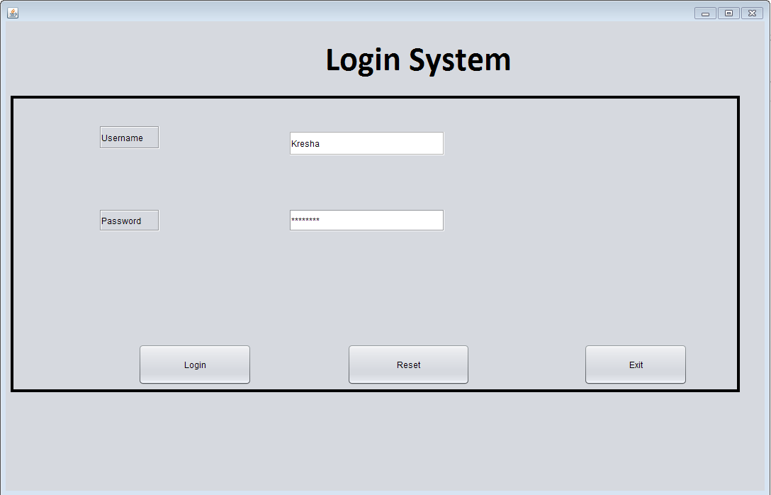

BuySell.java

Code:

/*

* To change this license header, choose License Headers in Project Properties.

* To change this template file, choose Tools | Templates

* and open the template in the editor.

*/

package beautyproducts;

import javax.swing.JOptionPane;

import java.awt.Toolkit;

import java.awt.event.WindowEvent;

import beautyproducts.BuyProduct;

import beautyproducts.SellProduct;

/**

*

* @author js

*/

public class BuySell extends javax.swing.JFrame {

/**

* Creates new form BuySell

*/

public BuySell() {

initComponents();

}

/**

* This method is called from within the constructor to initialize the form.

* WARNING: Do NOT modify this code. The content of this method is always

* regenerated by the Form Editor.

*/

@SuppressWarnings("unchecked")

// <editor-fold defaultstate="collapsed" desc="Generated Code">

private void initComponents() {

jScrollPane1 = new javax.swing.JScrollPane();

jList1 = new javax.swing.JList();

jButton1 = new javax.swing.JButton();

jButton2 = new javax.swing.JButton();

jButton3 = new javax.swing.JButton();

jLabel3 = new javax.swing.JLabel();

jLabel4 = new javax.swing.JLabel();

jList1.setModel(new javax.swing.AbstractListModel() {

String[] strings = { "Item 1", "Item 2", "Item 3", "Item 4", "Item 5" };

public int getSize() { return strings.length; }

public Object getElementAt(int i) { return strings[i]; }

});

jScrollPane1.setViewportView(jList1);

setDefaultCloseOperation(javax.swing.WindowConstants.EXIT_ON_CLOSE);

jButton1.setText("Buy product");

jButton1.addActionListener(new java.awt.event.ActionListener() {

public void actionPerformed(java.awt.event.ActionEvent evt) {

jButton1ActionPerformed(evt);

}

});

jButton2.setText("Sell product");

jButton2.addActionListener(new java.awt.event.ActionListener() {

public void actionPerformed(java.awt.event.ActionEvent evt) {

jButton2ActionPerformed(evt);

}

});

jButton3.setText("Exit");

jButton3.addActionListener(new java.awt.event.ActionListener() {

public void actionPerformed(java.awt.event.ActionEvent evt) {

jButton3ActionPerformed(evt);

}

});

jLabel3.setText("Displays the product list");

jLabel4.setText("Displays the condition of the product");

javax.swing.GroupLayout layout = new javax.swing.GroupLayout(getContentPane());

getContentPane().setLayout(layout);

layout.setHorizontalGroup(

layout.createParallelGroup(javax.swing.GroupLayout.Alignment.LEADING)

.addGroup(layout.createSequentialGroup()

.addGap(0, 290, Short.MAX_VALUE)

.addGroup(layout.createParallelGroup(javax.swing.GroupLayout.Alignment.LEADING)

.addGroup(javax.swing.GroupLayout.Alignment.TRAILING, layout.createSequentialGroup()

.addGroup(layout.createParallelGroup(javax.swing.GroupLayout.Alignment.LEADING)

.addComponent(jButton3, javax.swing.GroupLayout.PREFERRED_SIZE, 134, javax.swing.GroupLayout.PREFERRED_SIZE)

.addComponent(jLabel3, javax.swing.GroupLayout.PREFERRED_SIZE, 128, javax.swing.GroupLayout.PREFERRED_SIZE)

.addComponent(jButton1, javax.swing.GroupLayout.PREFERRED_SIZE, 128, javax.swing.GroupLayout.PREFERRED_SIZE)

.addComponent(jButton2, javax.swing.GroupLayout.PREFERRED_SIZE, 129, javax.swing.GroupLayout.PREFERRED_SIZE))

.addGap(298, 298, 298))

.addGroup(javax.swing.GroupLayout.Alignment.TRAILING, layout.createSequentialGroup()

.addComponent(jLabel4)

.addGap(275, 275, 275))))

);

layout.setVerticalGroup(

layout.createParallelGroup(javax.swing.GroupLayout.Alignment.LEADING)

.addGroup(layout.createSequentialGroup()

.addGap(51, 51, 51)

.addComponent(jButton1, javax.swing.GroupLayout.PREFERRED_SIZE, 35, javax.swing.GroupLayout.PREFERRED_SIZE)

.addGap(18, 18, 18)

.addComponent(jLabel3)

.addGap(124, 124, 124)

.addComponent(jButton2, javax.swing.GroupLayout.PREFERRED_SIZE, 35, javax.swing.GroupLayout.PREFERRED_SIZE)

.addPreferredGap(javax.swing.LayoutStyle.ComponentPlacement.UNRELATED)

.addComponent(jLabel4)

.addPreferredGap(javax.swing.LayoutStyle.ComponentPlacement.RELATED, 127, Short.MAX_VALUE)

.addComponent(jButton3, javax.swing.GroupLayout.PREFERRED_SIZE, 45, javax.swing.GroupLayout.PREFERRED_SIZE)

.addGap(20, 20, 20))

);

pack();

}// </editor-fold>

private void jButton3ActionPerformed(java.awt.event.ActionEvent evt) {

System.exit(0);

}

private void jButton1ActionPerformed(java.awt.event.ActionEvent evt) {

new BuyProduct().setVisible(true);

this.setVisible(false);

}

private void jButton2ActionPerformed(java.awt.event.ActionEvent evt) {

new SellProduct().setVisible(true);

this.setVisible(false);

}

/**

* @param args the command line arguments

*/

public static void main(String args[]) {

/* Set the Nimbus look and feel */

//<editor-fold defaultstate="collapsed" desc=" Look and feel setting code (optional) ">

/* If Nimbus (introduced in Java SE 6) is not available, stay with the default look and feel.

* For details see http://download.oracle.com/javase/tutorial/uiswing/lookandfeel/plaf.html

*/

try {

for (javax.swing.UIManager.LookAndFeelInfo info : javax.swing.UIManager.getInstalledLookAndFeels()) {

if ("Nimbus".equals(info.getName())) {

javax.swing.UIManager.setLookAndFeel(info.getClassName());

break;

}

}

} catch (ClassNotFoundException ex) {

java.util.logging.Logger.getLogger(BuySell.class.getName()).log(java.util.logging.Level.SEVERE, null, ex);

} catch (InstantiationException ex) {

java.util.logging.Logger.getLogger(BuySell.class.getName()).log(java.util.logging.Level.SEVERE, null, ex);

} catch (IllegalAccessException ex) {

java.util.logging.Logger.getLogger(BuySell.class.getName()).log(java.util.logging.Level.SEVERE, null, ex);

} catch (javax.swing.UnsupportedLookAndFeelException ex) {

java.util.logging.Logger.getLogger(BuySell.class.getName()).log(java.util.logging.Level.SEVERE, null, ex);

}

//</editor-fold>

/* Create and display the form */

java.awt.EventQueue.invokeLater(new Runnable() {

public void run() {

new BuySell().setVisible(true);

}

});

}

// Variables declaration - do not modify

private javax.swing.JButton jButton1;

private javax.swing.JButton jButton2;

private javax.swing.JButton jButton3;

private javax.swing.JLabel jLabel3;

private javax.swing.JLabel jLabel4;

private javax.swing.JList jList1;

private javax.swing.JScrollPane jScrollPane1;

// End of variables declaration

private void systemExit()

{

WindowEvent winCloseing = new WindowEvent(this,WindowEvent.WINDOW_CLOSING);

}

}

Output:

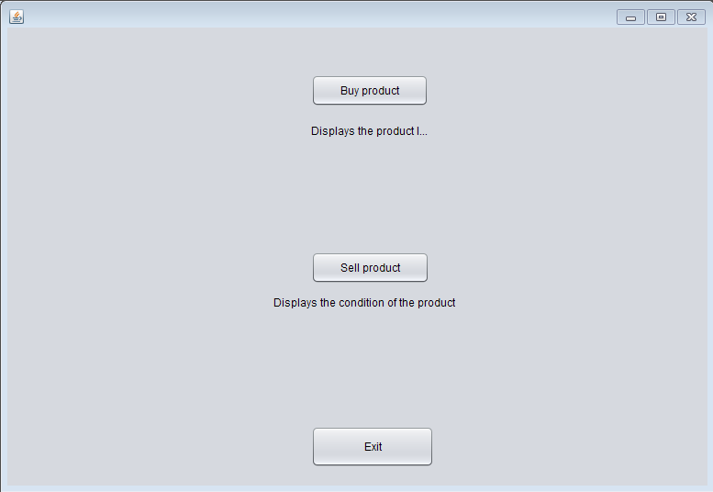

BuyProduct.java

Code:

/*

* To change this license header, choose License Headers in Project Properties.

* To change this template file, choose Tools | Templates

* and open the template in the editor.

*/

package beautyproducts;

import com.mysql.jdbc.Connection;

import com.mysql.jdbc.PreparedStatement;

import java.sql.DriverManager;

import java.sql.ResultSet;

import javax.swing.JOptionPane;

import net.proteanit.sql.DbUtils;

/**

*

* @author js

*/

public class BuyProduct extends javax.swing.JFrame {

Connection con = null;

PreparedStatement pst = null;

ResultSet rs = null;

public BuyProduct() {

initComponents();

showTableData();

}

public void showTableData()

{

try

{

con = (Connection) DriverManager.getConnection("jdbc:mysql://localhost/beauty_products","root","");

String sql = "SELECT * FROM products";

pst = (PreparedStatement) con.prepareStatement(sql);

rs = pst.executeQuery();

jTable1.setModel(DbUtils.resultSetToTableModel(rs));

}

catch(Exception ex)

{

JOptionPane.showMessageDialog(null, ex);

}

}

/**

* This method is called from within the constructor to initialize the form.

* WARNING: Do NOT modify this code. The content of this method is always

* regenerated by the Form Editor.

*/

@SuppressWarnings("unchecked")

// <editor-fold defaultstate="collapsed" desc="Generated Code">

private void initComponents() {

jButton1 = new javax.swing.JButton();

jButton2 = new javax.swing.JButton();

jButton3 = new javax.swing.JButton();

jButton4 = new javax.swing.JButton();

jButton5 = new javax.swing.JButton();

jButton6 = new javax.swing.JButton();

jButton7 = new javax.swing.JButton();

jButton8 = new javax.swing.JButton();

jButton9 = new javax.swing.JButton();

jButton10 = new javax.swing.JButton();

jScrollPane1 = new javax.swing.JScrollPane();

jTable1 = new javax.swing.JTable();

jLabel1 = new javax.swing.JLabel();

setDefaultCloseOperation(javax.swing.WindowConstants.EXIT_ON_CLOSE);

jButton1.setText("Foundation");

jButton1.addActionListener(new java.awt.event.ActionListener() {

public void actionPerformed(java.awt.event.ActionEvent evt) {

jButton1ActionPerformed(evt);

}

});

jButton2.setText("Eyeshadow");

jButton2.addActionListener(new java.awt.event.ActionListener() {

public void actionPerformed(java.awt.event.ActionEvent evt) {

jButton2ActionPerformed(evt);

}

});

jButton3.setText("Lipstick");

jButton3.addActionListener(new java.awt.event.ActionListener() {

public void actionPerformed(java.awt.event.ActionEvent evt) {

jButton3ActionPerformed(evt);

}

});

jButton4.setText("Blush");

jButton4.addActionListener(new java.awt.event.ActionListener() {

public void actionPerformed(java.awt.event.ActionEvent evt) {

jButton4ActionPerformed(evt);

}

});

jButton5.setText("Highlighter");

jButton5.addActionListener(new java.awt.event.ActionListener() {

public void actionPerformed(java.awt.event.ActionEvent evt) {

jButton5ActionPerformed(evt);

}

});

jButton6.setText("Concealer");

jButton6.addActionListener(new java.awt.event.ActionListener() {

public void actionPerformed(java.awt.event.ActionEvent evt) {

jButton6ActionPerformed(evt);

}

});

jButton7.setText("Compact");

jButton7.addActionListener(new java.awt.event.ActionListener() {

public void actionPerformed(java.awt.event.ActionEvent evt) {

jButton7ActionPerformed(evt);

}

});

jButton8.setText("Loose Powder");

jButton8.addActionListener(new java.awt.event.ActionListener() {

public void actionPerformed(java.awt.event.ActionEvent evt) {

jButton8ActionPerformed(evt);

}

});

jButton9.setText("Eye liner");

jButton9.addActionListener(new java.awt.event.ActionListener() {

public void actionPerformed(java.awt.event.ActionEvent evt) {

jButton9ActionPerformed(evt);

}

});

jButton10.setText("Kajal");

jButton10.addActionListener(new java.awt.event.ActionListener() {

public void actionPerformed(java.awt.event.ActionEvent evt) {

jButton10ActionPerformed(evt);

}

});

jTable1.setModel(new javax.swing.table.DefaultTableModel(

new Object [][] {

{null, null, null, null},

{null, null, null, null},

{null, null, null, null},

{null, null, null, null}

},

new String [] {

"Title 1", "Title 2", "Title 3", "Title 4"

}

));

jScrollPane1.setViewportView(jTable1);

jLabel1.setFont(new java.awt.Font("Tahoma", 0, 24)); // NOI18N

jLabel1.setText("Click on the product you want to buy");

javax.swing.GroupLayout layout = new javax.swing.GroupLayout(getContentPane());

getContentPane().setLayout(layout);

layout.setHorizontalGroup(

layout.createParallelGroup(javax.swing.GroupLayout.Alignment.LEADING)

.addGroup(layout.createSequentialGroup()

.addGroup(layout.createParallelGroup(javax.swing.GroupLayout.Alignment.LEADING)

.addGroup(layout.createSequentialGroup()

.addGap(19, 19, 19)

.addGroup(layout.createParallelGroup(javax.swing.GroupLayout.Alignment.LEADING, false)

.addGroup(layout.createSequentialGroup()

.addComponent(jButton5, javax.swing.GroupLayout.PREFERRED_SIZE, 87, javax.swing.GroupLayout.PREFERRED_SIZE)

.addPreferredGap(javax.swing.LayoutStyle.ComponentPlacement.RELATED, 111, Short.MAX_VALUE)

.addComponent(jButton10, javax.swing.GroupLayout.PREFERRED_SIZE, 99, javax.swing.GroupLayout.PREFERRED_SIZE))

.addGroup(layout.createSequentialGroup()

.addComponent(jButton1)

.addPreferredGap(javax.swing.LayoutStyle.ComponentPlacement.RELATED, 111, Short.MAX_VALUE)

.addComponent(jButton6, javax.swing.GroupLayout.PREFERRED_SIZE, 99, javax.swing.GroupLayout.PREFERRED_SIZE))

.addGroup(layout.createSequentialGroup()

.addComponent(jButton2)

.addPreferredGap(javax.swing.LayoutStyle.ComponentPlacement.RELATED, javax.swing.GroupLayout.DEFAULT_SIZE, Short.MAX_VALUE)

.addComponent(jButton7, javax.swing.GroupLayout.PREFERRED_SIZE, 99, javax.swing.GroupLayout.PREFERRED_SIZE))

.addGroup(layout.createSequentialGroup()

.addComponent(jButton3, javax.swing.GroupLayout.PREFERRED_SIZE, 87, javax.swing.GroupLayout.PREFERRED_SIZE)

.addPreferredGap(javax.swing.LayoutStyle.ComponentPlacement.RELATED, javax.swing.GroupLayout.DEFAULT_SIZE, Short.MAX_VALUE)

.addComponent(jButton8))

.addGroup(layout.createSequentialGroup()

.addComponent(jButton4, javax.swing.GroupLayout.PREFERRED_SIZE, 87, javax.swing.GroupLayout.PREFERRED_SIZE)

.addPreferredGap(javax.swing.LayoutStyle.ComponentPlacement.RELATED, javax.swing.GroupLayout.DEFAULT_SIZE, Short.MAX_VALUE)

.addComponent(jButton9, javax.swing.GroupLayout.PREFERRED_SIZE, 99, javax.swing.GroupLayout.PREFERRED_SIZE)))

.addGap(40, 40, 40)

.addComponent(jScrollPane1, javax.swing.GroupLayout.PREFERRED_SIZE, 368, javax.swing.GroupLayout.PREFERRED_SIZE))

.addGroup(layout.createSequentialGroup()

.addGap(159, 159, 159)

.addComponent(jLabel1)))

.addContainerGap(60, Short.MAX_VALUE))

);

layout.setVerticalGroup(

layout.createParallelGroup(javax.swing.GroupLayout.Alignment.LEADING)

.addGroup(layout.createSequentialGroup()

.addGap(19, 19, 19)

.addComponent(jLabel1)

.addGap(47, 47, 47)

.addGroup(layout.createParallelGroup(javax.swing.GroupLayout.Alignment.LEADING)

.addComponent(jScrollPane1, javax.swing.GroupLayout.Alignment.TRAILING, javax.swing.GroupLayout.PREFERRED_SIZE, 0, Short.MAX_VALUE)

.addGroup(javax.swing.GroupLayout.Alignment.TRAILING, layout.createSequentialGroup()

.addGroup(layout.createParallelGroup(javax.swing.GroupLayout.Alignment.BASELINE)

.addComponent(jButton6)

.addComponent(jButton1))

.addPreferredGap(javax.swing.LayoutStyle.ComponentPlacement.RELATED, 66, Short.MAX_VALUE)

.addGroup(layout.createParallelGroup(javax.swing.GroupLayout.Alignment.BASELINE)

.addComponent(jButton7)

.addComponent(jButton2))

.addGap(65, 65, 65)

.addGroup(layout.createParallelGroup(javax.swing.GroupLayout.Alignment.BASELINE)

.addComponent(jButton8)

.addComponent(jButton3))

.addGap(76, 76, 76)

.addGroup(layout.createParallelGroup(javax.swing.GroupLayout.Alignment.BASELINE)

.addComponent(jButton9)

.addComponent(jButton4))

.addGap(67, 67, 67)

.addGroup(layout.createParallelGroup(javax.swing.GroupLayout.Alignment.BASELINE)

.addComponent(jButton5)

.addComponent(jButton10))))

.addContainerGap())

);

pack();

}// </editor-fold>

private void jButton5ActionPerformed(java.awt.event.ActionEvent evt) {

new Highlighter().setVisible(true);

this.setVisible(false);

}

private void jButton1ActionPerformed(java.awt.event.ActionEvent evt) {

new Foundation().setVisible(true);

this.setVisible(false);

}

private void jButton2ActionPerformed(java.awt.event.ActionEvent evt) {

new EyeShadow().setVisible(true);

this.setVisible(false);

}

private void jButton3ActionPerformed(java.awt.event.ActionEvent evt) {

new Lipstick().setVisible(true);

this.setVisible(false);

}

private void jButton4ActionPerformed(java.awt.event.ActionEvent evt) {

new Blush().setVisible(true);

this.setVisible(false);

}

private void jButton6ActionPerformed(java.awt.event.ActionEvent evt) {

new Concealer().setVisible(true);

this.setVisible(false);

}

private void jButton7ActionPerformed(java.awt.event.ActionEvent evt) {

new Compact().setVisible(true);

this.setVisible(false);

}

private void jButton8ActionPerformed(java.awt.event.ActionEvent evt) {

new Powder().setVisible(true);

this.setVisible(false);

}

private void jButton9ActionPerformed(java.awt.event.ActionEvent evt) {

new Eyeliner().setVisible(true);

this.setVisible(false);

}

private void jButton10ActionPerformed(java.awt.event.ActionEvent evt) {

new Kajal().setVisible(true);

this.setVisible(false);

}

/**

* @param args the command line arguments

*/

public static void main(String args[]) {

/* Set the Nimbus look and feel */

//<editor-fold defaultstate="collapsed" desc=" Look and feel setting code (optional) ">

/* If Nimbus (introduced in Java SE 6) is not available, stay with the default look and feel.

* For details see http://download.oracle.com/javase/tutorial/uiswing/lookandfeel/plaf.html

*/

try {

for (javax.swing.UIManager.LookAndFeelInfo info : javax.swing.UIManager.getInstalledLookAndFeels()) {

if ("Nimbus".equals(info.getName())) {

javax.swing.UIManager.setLookAndFeel(info.getClassName());

break;

}

}

} catch (ClassNotFoundException ex) {

java.util.logging.Logger.getLogger(BuyProduct.class.getName()).log(java.util.logging.Level.SEVERE, null, ex);

} catch (InstantiationException ex) {

java.util.logging.Logger.getLogger(BuyProduct.class.getName()).log(java.util.logging.Level.SEVERE, null, ex);

} catch (IllegalAccessException ex) {

java.util.logging.Logger.getLogger(BuyProduct.class.getName()).log(java.util.logging.Level.SEVERE, null, ex);

} catch (javax.swing.UnsupportedLookAndFeelException ex) {

java.util.logging.Logger.getLogger(BuyProduct.class.getName()).log(java.util.logging.Level.SEVERE, null, ex);

}

//</editor-fold>

/* Create and display the form */

java.awt.EventQueue.invokeLater(new Runnable() {

public void run() {

new BuyProduct().setVisible(true);

}

});

}

// Variables declaration - do not modify

private javax.swing.JButton jButton1;

private javax.swing.JButton jButton10;

private javax.swing.JButton jButton2;

private javax.swing.JButton jButton3;

private javax.swing.JButton jButton4;

private javax.swing.JButton jButton5;

private javax.swing.JButton jButton6;

private javax.swing.JButton jButton7;

private javax.swing.JButton jButton8;

private javax.swing.JButton jButton9;

private javax.swing.JLabel jLabel1;

private javax.swing.JScrollPane jScrollPane1;

private javax.swing.JTable jTable1;

// End of variables declaration

}

Output:

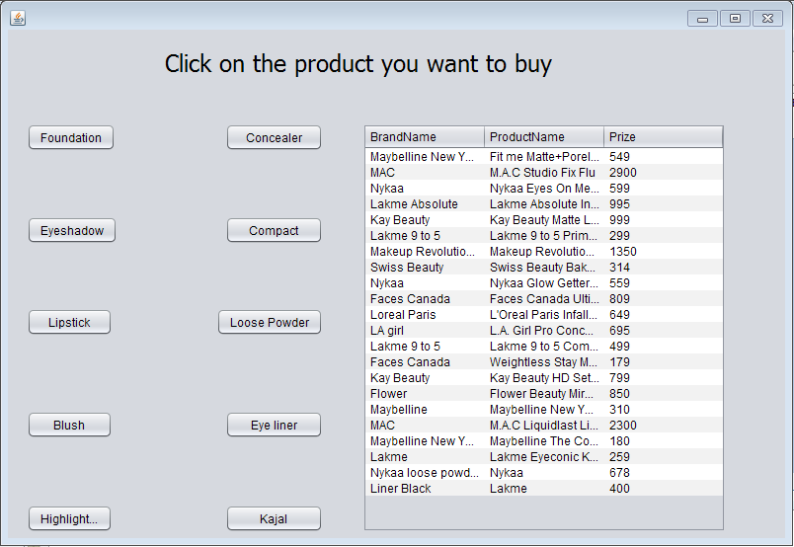

Foundation.java

Code:

/*

* To change this license header, choose License Headers in Project Properties.

* To change this template file, choose Tools | Templates

* and open the template in the editor.

*/

package beautyproducts;

/**

*

* @author js

*/

public class Foundation extends javax.swing.JFrame {

/**

* Creates new form Foundation

*/

public Foundation() {

initComponents();

}

/**

* This method is called from within the constructor to initialize the form.

* WARNING: Do NOT modify this code. The content of this method is always

* regenerated by the Form Editor.

*/

@SuppressWarnings("unchecked")

// <editor-fold defaultstate="collapsed" desc="Generated Code">

private void initComponents() {

jLabel1 = new javax.swing.JLabel();

jLabel2 = new javax.swing.JLabel();

jLabel5 = new javax.swing.JLabel();

jLabel3 = new javax.swing.JLabel();

jLabel4 = new javax.swing.JLabel();

jLabel6 = new javax.swing.JLabel();

jButton2 = new javax.swing.JButton();

jButton3 = new javax.swing.JButton();

setDefaultCloseOperation(javax.swing.WindowConstants.EXIT_ON_CLOSE);

jLabel1.setIcon(new javax.swing.ImageIcon("C:\\Users\\js\\Desktop\\1.PNG")); // NOI18N

jLabel5.setFont(new java.awt.Font("Tahoma", 3, 12)); // NOI18N

jLabel5.setText("Company name: Maybelline New York");

jLabel3.setFont(new java.awt.Font("Tahoma", 3, 11)); // NOI18N

jLabel3.setText("Product name: Fit me Matte+Poreless liquid Foundation with pump ");

jLabel4.setFont(new java.awt.Font("Tahoma", 3, 12)); // NOI18N

jLabel4.setText("Size :30 ml");

jLabel6.setFont(new java.awt.Font("Tahoma", 3, 12)); // NOI18N

jLabel6.setText("MRP: rs.549");

jButton2.setText("Buy Now");

jButton2.addActionListener(new java.awt.event.ActionListener() {

public void actionPerformed(java.awt.event.ActionEvent evt) {

jButton2ActionPerformed(evt);

}

});

jButton3.setText("Back");

jButton3.addActionListener(new java.awt.event.ActionListener() {

public void actionPerformed(java.awt.event.ActionEvent evt) {

jButton3ActionPerformed(evt);

}

});

javax.swing.GroupLayout layout = new javax.swing.GroupLayout(getContentPane());

getContentPane().setLayout(layout);

layout.setHorizontalGroup(

layout.createParallelGroup(javax.swing.GroupLayout.Alignment.LEADING)

.addGroup(layout.createSequentialGroup()

.addGap(29, 29, 29)

.addComponent(jLabel1, javax.swing.GroupLayout.PREFERRED_SIZE, 267, javax.swing.GroupLayout.PREFERRED_SIZE)

.addGap(18, 18, 18)

.addGroup(layout.createParallelGroup(javax.swing.GroupLayout.Alignment.LEADING)

.addGroup(layout.createSequentialGroup()

.addComponent(jLabel5, javax.swing.GroupLayout.PREFERRED_SIZE, 235, javax.swing.GroupLayout.PREFERRED_SIZE)

.addGap(320, 320, 320)

.addComponent(jLabel2, javax.swing.GroupLayout.PREFERRED_SIZE, 0, javax.swing.GroupLayout.PREFERRED_SIZE))

.addComponent(jLabel3)

.addComponent(jLabel4, javax.swing.GroupLayout.PREFERRED_SIZE, 87, javax.swing.GroupLayout.PREFERRED_SIZE)

.addGroup(layout.createSequentialGroup()

.addGroup(layout.createParallelGroup(javax.swing.GroupLayout.Alignment.TRAILING)

.addComponent(jButton3, javax.swing.GroupLayout.PREFERRED_SIZE, 67, javax.swing.GroupLayout.PREFERRED_SIZE)

.addComponent(jLabel6, javax.swing.GroupLayout.PREFERRED_SIZE, 97, javax.swing.GroupLayout.PREFERRED_SIZE))

.addGap(66, 66, 66)

.addComponent(jButton2)))

.addContainerGap(166, Short.MAX_VALUE))

);

layout.setVerticalGroup(

layout.createParallelGroup(javax.swing.GroupLayout.Alignment.LEADING)

.addGroup(layout.createSequentialGroup()

.addGroup(layout.createParallelGroup(javax.swing.GroupLayout.Alignment.LEADING)

.addGroup(layout.createSequentialGroup()

.addGap(27, 27, 27)

.addComponent(jLabel2))

.addGroup(layout.createSequentialGroup()

.addContainerGap()

.addGroup(layout.createParallelGroup(javax.swing.GroupLayout.Alignment.LEADING)

.addGroup(layout.createSequentialGroup()

.addGap(5, 5, 5)

.addComponent(jLabel5, javax.swing.GroupLayout.PREFERRED_SIZE, 43, javax.swing.GroupLayout.PREFERRED_SIZE)

.addPreferredGap(javax.swing.LayoutStyle.ComponentPlacement.RELATED)

.addComponent(jLabel3)

.addGap(18, 18, 18)

.addComponent(jLabel4)

.addGap(18, 18, 18)

.addComponent(jLabel6)

.addGap(34, 34, 34)

.addGroup(layout.createParallelGroup(javax.swing.GroupLayout.Alignment.BASELINE)

.addComponent(jButton2)

.addComponent(jButton3)))

.addComponent(jLabel1, javax.swing.GroupLayout.PREFERRED_SIZE, 300, javax.swing.GroupLayout.PREFERRED_SIZE))))

.addContainerGap(536, Short.MAX_VALUE))

);

pack();

}// </editor-fold>

private void jButton2ActionPerformed(java.awt.event.ActionEvent evt) {

new Pay1().setVisible(true);

this.setVisible(false);

}

private void jButton3ActionPerformed(java.awt.event.ActionEvent evt) {

new BuyProduct().setVisible(true);

this.setVisible(false);

}

/**

* @param args the command line arguments

*/

public static void main(String args[]) {

/* Set the Nimbus look and feel */

//<editor-fold defaultstate="collapsed" desc=" Look and feel setting code (optional) ">

/* If Nimbus (introduced in Java SE 6) is not available, stay with the default look and feel.

* For details see http://download.oracle.com/javase/tutorial/uiswing/lookandfeel/plaf.html

*/

try {

for (javax.swing.UIManager.LookAndFeelInfo info : javax.swing.UIManager.getInstalledLookAndFeels()) {

if ("Nimbus".equals(info.getName())) {

javax.swing.UIManager.setLookAndFeel(info.getClassName());

break;

}

}

} catch (ClassNotFoundException ex) {

java.util.logging.Logger.getLogger(Foundation.class.getName()).log(java.util.logging.Level.SEVERE, null, ex);

} catch (InstantiationException ex) {

java.util.logging.Logger.getLogger(Foundation.class.getName()).log(java.util.logging.Level.SEVERE, null, ex);

} catch (IllegalAccessException ex) {

java.util.logging.Logger.getLogger(Foundation.class.getName()).log(java.util.logging.Level.SEVERE, null, ex);

} catch (javax.swing.UnsupportedLookAndFeelException ex) {

java.util.logging.Logger.getLogger(Foundation.class.getName()).log(java.util.logging.Level.SEVERE, null, ex);

}

//</editor-fold>

/* Create and display the form */

java.awt.EventQueue.invokeLater(new Runnable() {

public void run() {

new Foundation().setVisible(true);

}

});

}

// Variables declaration - do not modify

private javax.swing.JButton jButton2;

private javax.swing.JButton jButton3;

private javax.swing.JLabel jLabel1;

private javax.swing.JLabel jLabel2;

private javax.swing.JLabel jLabel3;

private javax.swing.JLabel jLabel4;

private javax.swing.JLabel jLabel5;

private javax.swing.JLabel jLabel6;

// End of variables declaration

}

Output:

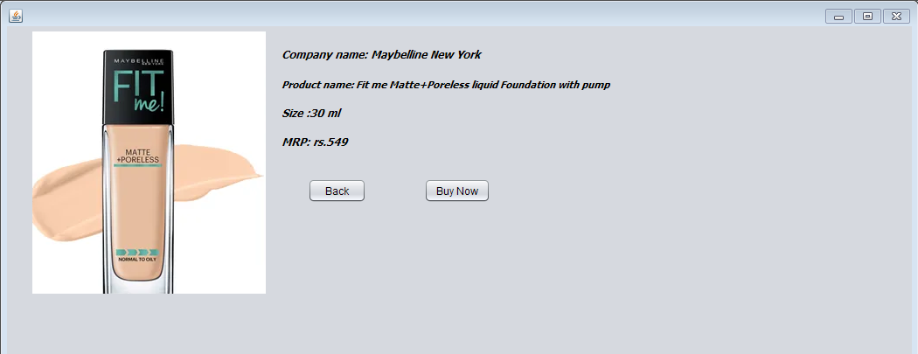

Pay1.java

/*

* To change this license header, choose License Headers in Project Properties.

* To change this template file, choose Tools | Templates

* and open the template in the editor.

*/

package beautyproducts;

import javax.swing.JOptionPane;

/**

*

* @author js

*/

public class Pay1 extends javax.swing.JFrame {

/**

* Creates new form Pay1

*/

public Pay1() {

initComponents();

}

/**

* This method is called from within the constructor to initialize the form.

* WARNING: Do NOT modify this code. The content of this method is always

* regenerated by the Form Editor.

*/

@SuppressWarnings("unchecked")

// <editor-fold defaultstate="collapsed" desc="Generated Code">

private void initComponents() {

jLabel3 = new javax.swing.JLabel();

jTextField3 = new javax.swing.JTextField();

jLabel4 = new javax.swing.JLabel();

jTextField4 = new javax.swing.JTextField();

jLabel1 = new javax.swing.JLabel();

jLabel2 = new javax.swing.JLabel();

jplaceorder = new javax.swing.JButton();

jexit = new javax.swing.JButton();

jTextField1 = new javax.swing.JTextField();

jTextField2 = new javax.swing.JTextField();

setDefaultCloseOperation(javax.swing.WindowConstants.EXIT_ON_CLOSE);

jLabel3.setText("Year of expiry");

jLabel4.setText("Total amount");

jLabel1.setText("Name");

jLabel2.setText("Card No");

jplaceorder.setText("Place Order");

jplaceorder.addActionListener(new java.awt.event.ActionListener() {

public void actionPerformed(java.awt.event.ActionEvent evt) {

jplaceorderActionPerformed(evt);

}

});

jexit.setText("Exit");

jexit.addActionListener(new java.awt.event.ActionListener() {

public void actionPerformed(java.awt.event.ActionEvent evt) {

jexitActionPerformed(evt);

}

});

javax.swing.GroupLayout layout = new javax.swing.GroupLayout(getContentPane());

getContentPane().setLayout(layout);

layout.setHorizontalGroup(

layout.createParallelGroup(javax.swing.GroupLayout.Alignment.LEADING)

.addGroup(layout.createSequentialGroup()

.addGap(125, 125, 125)

.addGroup(layout.createParallelGroup(javax.swing.GroupLayout.Alignment.LEADING)

.addGroup(layout.createSequentialGroup()

.addComponent(jplaceorder)

.addGap(127, 127, 127)

.addComponent(jexit, javax.swing.GroupLayout.PREFERRED_SIZE, 93, javax.swing.GroupLayout.PREFERRED_SIZE)

.addGap(0, 164, Short.MAX_VALUE))

.addGroup(layout.createSequentialGroup()

.addComponent(jLabel2)

.addContainerGap(javax.swing.GroupLayout.DEFAULT_SIZE, Short.MAX_VALUE))

.addGroup(javax.swing.GroupLayout.Alignment.TRAILING, layout.createSequentialGroup()

.addGroup(layout.createParallelGroup(javax.swing.GroupLayout.Alignment.LEADING)

.addComponent(jLabel3)

.addComponent(jLabel1, javax.swing.GroupLayout.PREFERRED_SIZE, 39, javax.swing.GroupLayout.PREFERRED_SIZE)

.addComponent(jLabel4))

.addPreferredGap(javax.swing.LayoutStyle.ComponentPlacement.RELATED, javax.swing.GroupLayout.DEFAULT_SIZE, Short.MAX_VALUE)

.addGroup(layout.createParallelGroup(javax.swing.GroupLayout.Alignment.TRAILING, false)

.addComponent(jTextField4)

.addComponent(jTextField1, javax.swing.GroupLayout.Alignment.LEADING, javax.swing.GroupLayout.DEFAULT_SIZE, 179, Short.MAX_VALUE)

.addComponent(jTextField2, javax.swing.GroupLayout.Alignment.LEADING, javax.swing.GroupLayout.DEFAULT_SIZE, 179, Short.MAX_VALUE)

.addComponent(jTextField3, javax.swing.GroupLayout.Alignment.LEADING))

.addGap(222, 222, 222))))

);

layout.setVerticalGroup(

layout.createParallelGroup(javax.swing.GroupLayout.Alignment.LEADING)

.addGroup(layout.createSequentialGroup()

.addGap(83, 83, 83)

.addGroup(layout.createParallelGroup(javax.swing.GroupLayout.Alignment.BASELINE)

.addComponent(jTextField1, javax.swing.GroupLayout.PREFERRED_SIZE, javax.swing.GroupLayout.DEFAULT_SIZE, javax.swing.GroupLayout.PREFERRED_SIZE)

.addComponent(jLabel1))

.addGap(34, 34, 34)

.addGroup(layout.createParallelGroup(javax.swing.GroupLayout.Alignment.BASELINE)

.addComponent(jTextField2, javax.swing.GroupLayout.PREFERRED_SIZE, javax.swing.GroupLayout.DEFAULT_SIZE, javax.swing.GroupLayout.PREFERRED_SIZE)

.addComponent(jLabel2))

.addGap(36, 36, 36)

.addGroup(layout.createParallelGroup(javax.swing.GroupLayout.Alignment.BASELINE)

.addComponent(jLabel3)

.addComponent(jTextField3, javax.swing.GroupLayout.PREFERRED_SIZE, javax.swing.GroupLayout.DEFAULT_SIZE, javax.swing.GroupLayout.PREFERRED_SIZE))

.addGap(45, 45, 45)

.addGroup(layout.createParallelGroup(javax.swing.GroupLayout.Alignment.BASELINE)

.addComponent(jLabel4)

.addComponent(jTextField4, javax.swing.GroupLayout.PREFERRED_SIZE, javax.swing.GroupLayout.DEFAULT_SIZE, javax.swing.GroupLayout.PREFERRED_SIZE))

.addPreferredGap(javax.swing.LayoutStyle.ComponentPlacement.RELATED, 54, Short.MAX_VALUE)

.addGroup(layout.createParallelGroup(javax.swing.GroupLayout.Alignment.BASELINE)

.addComponent(jplaceorder)

.addComponent(jexit))

.addGap(32, 32, 32))

);

pack();

}// </editor-fold>

private void jplaceorderActionPerformed(java.awt.event.ActionEvent evt) {

new Fou_bill().setVisible(true);

this.setVisible(false);

}

private void jexitActionPerformed(java.awt.event.ActionEvent evt) {

System.exit(0);

}

/**

* @param args the command line arguments

*/

public static void main(String args[]) {

/* Set the Nimbus look and feel */

//<editor-fold defaultstate="collapsed" desc=" Look and feel setting code (optional) ">

/* If Nimbus (introduced in Java SE 6) is not available, stay with the default look and feel.

* For details see http://download.oracle.com/javase/tutorial/uiswing/lookandfeel/plaf.html

*/

try {

for (javax.swing.UIManager.LookAndFeelInfo info : javax.swing.UIManager.getInstalledLookAndFeels()) {

if ("Nimbus".equals(info.getName())) {

javax.swing.UIManager.setLookAndFeel(info.getClassName());

break;

}

}

} catch (ClassNotFoundException ex) {

java.util.logging.Logger.getLogger(Pay1.class.getName()).log(java.util.logging.Level.SEVERE, null, ex);

} catch (InstantiationException ex) {

java.util.logging.Logger.getLogger(Pay1.class.getName()).log(java.util.logging.Level.SEVERE, null, ex);

} catch (IllegalAccessException ex) {

java.util.logging.Logger.getLogger(Pay1.class.getName()).log(java.util.logging.Level.SEVERE, null, ex);

} catch (javax.swing.UnsupportedLookAndFeelException ex) {

java.util.logging.Logger.getLogger(Pay1.class.getName()).log(java.util.logging.Level.SEVERE, null, ex);

}

//</editor-fold>

/* Create and display the form */

java.awt.EventQueue.invokeLater(new Runnable() {

public void run() {

new Pay1().setVisible(true);

}

});

}

// Variables declaration - do not modify

private javax.swing.JLabel jLabel1;

private javax.swing.JLabel jLabel2;

private javax.swing.JLabel jLabel3;

private javax.swing.JLabel jLabel4;

private javax.swing.JTextField jTextField1;

private javax.swing.JTextField jTextField2;

private javax.swing.JTextField jTextField3;

private javax.swing.JTextField jTextField4;

private javax.swing.JButton jexit;

private javax.swing.JButton jplaceorder;

// End of variables declaration

}

Output:

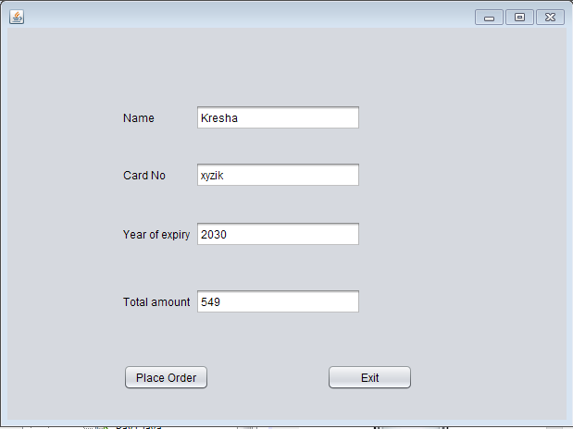

Fou_bill.java

Code:

/*

* To change this license header, choose License Headers in Project Properties.

* To change this template file, choose Tools | Templates

* and open the template in the editor.

*/

package beautyproducts;

import com.mysql.jdbc.Connection;

import com.mysql.jdbc.PreparedStatement;

import java.sql.DriverManager;

import java.sql.ResultSet;

import java.sql.SQLException;

import java.util.logging.Level;

import java.util.logging.Logger;

import javax.swing.JOptionPane;

import net.proteanit.sql.DbUtils;

/**

*

* @author js

*/

public class Fou_bill extends javax.swing.JFrame {

/**

* Creates new form Fou_bill

*/

Connection con = null;

PreparedStatement pst = null;

ResultSet rs = null;

public Fou_bill() {

initComponents();

String name,number,address;

}

public void Print(){

String name=txtname.getText();

String number=txtnumber.getText();

String address=txtaddress.getText();

txtbill.setText("\t"+"The Cosmetic Shop"+"\n"+"\n"

+"Brand:- Maybelline New York"+"\n"

+"Product Name:- Fit me Matte+Poreless liquid Foundation with pump " +"\n"

+"Price:- 549"+"\n"

+"\n"+"********************");

txtbill.setText(txtbill.getText() +"\n"+"Coustomer name:- "+name);

txtbill.setText(txtbill.getText()+"\n"+"\n"+"Contact number:-"+number);

txtbill.setText(txtbill.getText() +"\n"+"\n"+"Address:-"+address);

txtbill.setText(txtbill.getText()+"\n"+"\n"+"\n"+"\n"+"\n"+"\n"+"\n"+"\t"+"**Thanks For Shopping**");

}

/**

* This method is called from within the constructor to initialize the form.

* WARNING: Do NOT modify this code. The content of this method is always

* regenerated by the Form Editor.

*/

@SuppressWarnings("unchecked")

// <editor-fold defaultstate="collapsed" desc="Generated Code">

private void initComponents() {

txtaddress = new javax.swing.JTextField();

jScrollPane1 = new javax.swing.JScrollPane();

txtbill = new javax.swing.JTextArea();

jButton1 = new javax.swing.JButton();

jButton2 = new javax.swing.JButton();

jLabel1 = new javax.swing.JLabel();

jLabel2 = new javax.swing.JLabel();

jLabel3 = new javax.swing.JLabel();

txtname = new javax.swing.JTextField();

txtnumber = new javax.swing.JTextField();

setDefaultCloseOperation(javax.swing.WindowConstants.EXIT_ON_CLOSE);

txtaddress.addActionListener(new java.awt.event.ActionListener() {

public void actionPerformed(java.awt.event.ActionEvent evt) {

txtaddressActionPerformed(evt);

}

});

txtbill.setColumns(20);

txtbill.setRows(5);

jScrollPane1.setViewportView(txtbill);

jButton1.setText("Ok");

jButton1.addActionListener(new java.awt.event.ActionListener() {

public void actionPerformed(java.awt.event.ActionEvent evt) {

jButton1ActionPerformed(evt);

}

});

jButton2.setText("Done");

jButton2.addActionListener(new java.awt.event.ActionListener() {

public void actionPerformed(java.awt.event.ActionEvent evt) {

jButton2ActionPerformed(evt);

}

});

jLabel1.setText("Customer Name:");

jLabel2.setText("Contact Number:");

jLabel3.setText("Address:");

javax.swing.GroupLayout layout = new javax.swing.GroupLayout(getContentPane());

getContentPane().setLayout(layout);

layout.setHorizontalGroup(

layout.createParallelGroup(javax.swing.GroupLayout.Alignment.LEADING)

.addGroup(layout.createSequentialGroup()

.addGap(37, 37, 37)

.addGroup(layout.createParallelGroup(javax.swing.GroupLayout.Alignment.TRAILING)

.addGroup(layout.createSequentialGroup()

.addGroup(layout.createParallelGroup(javax.swing.GroupLayout.Alignment.LEADING)

.addComponent(jLabel1)

.addComponent(jLabel2)

.addComponent(jLabel3))

.addGap(69, 69, 69)

.addGroup(layout.createParallelGroup(javax.swing.GroupLayout.Alignment.LEADING, false)

.addComponent(txtname, javax.swing.GroupLayout.DEFAULT_SIZE, 161, Short.MAX_VALUE)

.addComponent(txtnumber)

.addComponent(txtaddress)))

.addComponent(jButton1))

.addPreferredGap(javax.swing.LayoutStyle.ComponentPlacement.RELATED, 51, Short.MAX_VALUE)

.addComponent(jScrollPane1, javax.swing.GroupLayout.PREFERRED_SIZE, 309, javax.swing.GroupLayout.PREFERRED_SIZE)

.addGap(22, 22, 22))

.addGroup(javax.swing.GroupLayout.Alignment.TRAILING, layout.createSequentialGroup()

.addContainerGap(javax.swing.GroupLayout.DEFAULT_SIZE, Short.MAX_VALUE)

.addComponent(jButton2)

.addGap(126, 126, 126))

);

layout.setVerticalGroup(

layout.createParallelGroup(javax.swing.GroupLayout.Alignment.LEADING)

.addGroup(layout.createSequentialGroup()

.addGap(52, 52, 52)

.addGroup(layout.createParallelGroup(javax.swing.GroupLayout.Alignment.BASELINE)

.addComponent(jLabel1)

.addComponent(txtname, javax.swing.GroupLayout.PREFERRED_SIZE, javax.swing.GroupLayout.DEFAULT_SIZE, javax.swing.GroupLayout.PREFERRED_SIZE))

.addGap(29, 29, 29)

.addGroup(layout.createParallelGroup(javax.swing.GroupLayout.Alignment.BASELINE)

.addComponent(jLabel2)

.addComponent(txtnumber, javax.swing.GroupLayout.PREFERRED_SIZE, javax.swing.GroupLayout.DEFAULT_SIZE, javax.swing.GroupLayout.PREFERRED_SIZE))

.addGap(40, 40, 40)

.addGroup(layout.createParallelGroup(javax.swing.GroupLayout.Alignment.BASELINE)

.addComponent(jLabel3)

.addComponent(txtaddress, javax.swing.GroupLayout.PREFERRED_SIZE, 109, javax.swing.GroupLayout.PREFERRED_SIZE))

.addGap(67, 67, 67)

.addComponent(jButton1)

.addContainerGap(javax.swing.GroupLayout.DEFAULT_SIZE, Short.MAX_VALUE))

.addGroup(javax.swing.GroupLayout.Alignment.TRAILING, layout.createSequentialGroup()

.addContainerGap(57, Short.MAX_VALUE)

.addComponent(jScrollPane1, javax.swing.GroupLayout.PREFERRED_SIZE, 418, javax.swing.GroupLayout.PREFERRED_SIZE)

.addGap(18, 18, 18)

.addComponent(jButton2)

.addGap(10, 10, 10))

);

pack();

}// </editor-fold>

private void txtaddressActionPerformed(java.awt.event.ActionEvent evt) {

// TODO add your handling code here:

}

private void jButton1ActionPerformed(java.awt.event.ActionEvent evt) {

Print();

}

private void jButton2ActionPerformed(java.awt.event.ActionEvent evt) {

try

{

String sql = "INSERT INTO customer_details"

+"(CustomerName,CustomerNumber,Address)"

+"VALUES (?,?,?)";

con = (Connection) DriverManager.getConnection("jdbc:mysql://localhost/details","root","");

pst = (PreparedStatement) con.prepareStatement(sql);

pst.setString(1,txtname.getText());

pst.setString(2,txtnumber.getText());

pst.setString(3,txtaddress.getText());

pst.executeUpdate();

JOptionPane.showMessageDialog(null, "Thank you for shopping!!");

txtname.setText(null);

txtnumber.setText(null);

txtaddress.setText(null);

}

catch(Exception ex)

{

JOptionPane.showMessageDialog(null, ex);

}

}

/**

* @param args the command line arguments

*/

public static void main(String args[]) {

/* Set the Nimbus look and feel */

//<editor-fold defaultstate="collapsed" desc=" Look and feel setting code (optional) ">

/* If Nimbus (introduced in Java SE 6) is not available, stay with the default look and feel.

* For details see http://download.oracle.com/javase/tutorial/uiswing/lookandfeel/plaf.html

*/

try {

for (javax.swing.UIManager.LookAndFeelInfo info : javax.swing.UIManager.getInstalledLookAndFeels()) {

if ("Nimbus".equals(info.getName())) {

javax.swing.UIManager.setLookAndFeel(info.getClassName());

break;

}

}

} catch (ClassNotFoundException ex) {

java.util.logging.Logger.getLogger(Fou_bill.class.getName()).log(java.util.logging.Level.SEVERE, null, ex);

} catch (InstantiationException ex) {

java.util.logging.Logger.getLogger(Fou_bill.class.getName()).log(java.util.logging.Level.SEVERE, null, ex);

} catch (IllegalAccessException ex) {

java.util.logging.Logger.getLogger(Fou_bill.class.getName()).log(java.util.logging.Level.SEVERE, null, ex);

} catch (javax.swing.UnsupportedLookAndFeelException ex) {

java.util.logging.Logger.getLogger(Fou_bill.class.getName()).log(java.util.logging.Level.SEVERE, null, ex);

}

//</editor-fold>

/* Create and display the form */

java.awt.EventQueue.invokeLater(new Runnable() {

public void run() {

new Fou_bill().setVisible(true);

}

});

}

// Variables declaration - do not modify

private javax.swing.JButton jButton1;

private javax.swing.JButton jButton2;

private javax.swing.JLabel jLabel1;

private javax.swing.JLabel jLabel2;

private javax.swing.JLabel jLabel3;

private javax.swing.JScrollPane jScrollPane1;

private javax.swing.JTextField txtaddress;

private javax.swing.JTextArea txtbill;

private javax.swing.JTextField txtname;

private javax.swing.JTextField txtnumber;

// End of variables declaration

}

Output:

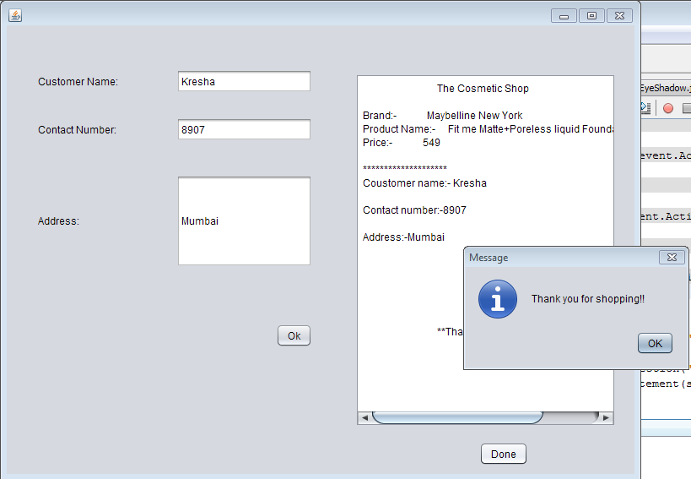

EyeShadow.java

Code:

/*

* To change this license header, choose License Headers in Project Properties.

* To change this template file, choose Tools | Templates

* and open the template in the editor.

*/

package beautyproducts;

/**

*

* @author js

*/

public class EyeShadow extends javax.swing.JFrame {

/**

* Creates new form EyeShadow

*/

public EyeShadow() {

initComponents();

}

/**

* This method is called from within the constructor to initialize the form.

* WARNING: Do NOT modify this code. The content of this method is always

* regenerated by the Form Editor.

*/

@SuppressWarnings("unchecked")

// <editor-fold defaultstate="collapsed" desc="Generated Code">

private void initComponents() {

jLabel1 = new javax.swing.JLabel();

jLabel2 = new javax.swing.JLabel();

jLabel3 = new javax.swing.JLabel();

jLabel4 = new javax.swing.JLabel();

jLabel5 = new javax.swing.JLabel();

jButton1 = new javax.swing.JButton();

jButton3 = new javax.swing.JButton();

setDefaultCloseOperation(javax.swing.WindowConstants.EXIT_ON_CLOSE);

jLabel1.setIcon(new javax.swing.ImageIcon("C:\\Users\\js\\Desktop\\3.PNG")); // NOI18N

jLabel1.setText("jLabel1");

jLabel2.setFont(new java.awt.Font("Tahoma", 3, 12)); // NOI18N

jLabel2.setText("Company Name: Nykaa");

jLabel3.setFont(new java.awt.Font("Tahoma", 3, 10)); // NOI18N

jLabel3.setText("Product Name:Nykaa Eyes On Me! 10-in-1 Eyeshadow Palette - Smokey at 8!");

jLabel4.setFont(new java.awt.Font("Tahoma", 3, 12)); // NOI18N

jLabel4.setText("Size:12 gm");

jLabel5.setFont(new java.awt.Font("Tahoma", 3, 12)); // NOI18N

jLabel5.setText("Prize: rs.599");

jButton1.setText("Buy Now");

jButton1.addActionListener(new java.awt.event.ActionListener() {

public void actionPerformed(java.awt.event.ActionEvent evt) {

jButton1ActionPerformed(evt);

}

});

jButton3.setText("Back");

jButton3.addActionListener(new java.awt.event.ActionListener() {

public void actionPerformed(java.awt.event.ActionEvent evt) {

jButton3ActionPerformed(evt);

}

});

javax.swing.GroupLayout layout = new javax.swing.GroupLayout(getContentPane());

getContentPane().setLayout(layout);

layout.setHorizontalGroup(

layout.createParallelGroup(javax.swing.GroupLayout.Alignment.LEADING)

.addGroup(layout.createSequentialGroup()

.addContainerGap()

.addComponent(jLabel1, javax.swing.GroupLayout.PREFERRED_SIZE, 293, javax.swing.GroupLayout.PREFERRED_SIZE)

.addGap(38, 38, 38)

.addGroup(layout.createParallelGroup(javax.swing.GroupLayout.Alignment.LEADING)

.addComponent(jLabel3, javax.swing.GroupLayout.DEFAULT_SIZE, 433, Short.MAX_VALUE)

.addGroup(layout.createSequentialGroup()

.addGroup(layout.createParallelGroup(javax.swing.GroupLayout.Alignment.LEADING)

.addComponent(jLabel2, javax.swing.GroupLayout.PREFERRED_SIZE, 165, javax.swing.GroupLayout.PREFERRED_SIZE)

.addGroup(layout.createParallelGroup(javax.swing.GroupLayout.Alignment.TRAILING, false)

.addComponent(jLabel4, javax.swing.GroupLayout.Alignment.LEADING, javax.swing.GroupLayout.DEFAULT_SIZE, javax.swing.GroupLayout.DEFAULT_SIZE, Short.MAX_VALUE)

.addComponent(jLabel5, javax.swing.GroupLayout.Alignment.LEADING, javax.swing.GroupLayout.DEFAULT_SIZE, 90, Short.MAX_VALUE)))

.addGap(0, 0, Short.MAX_VALUE))

.addGroup(layout.createSequentialGroup()

.addComponent(jButton3, javax.swing.GroupLayout.PREFERRED_SIZE, 67, javax.swing.GroupLayout.PREFERRED_SIZE)

.addPreferredGap(javax.swing.LayoutStyle.ComponentPlacement.RELATED, javax.swing.GroupLayout.DEFAULT_SIZE, Short.MAX_VALUE)

.addComponent(jButton1)

.addGap(126, 126, 126))))

);

layout.setVerticalGroup(

layout.createParallelGroup(javax.swing.GroupLayout.Alignment.LEADING)

.addGroup(layout.createSequentialGroup()

.addGroup(layout.createParallelGroup(javax.swing.GroupLayout.Alignment.LEADING)

.addGroup(layout.createSequentialGroup()

.addContainerGap()

.addComponent(jLabel1))

.addGroup(layout.createSequentialGroup()

.addGap(21, 21, 21)

.addComponent(jLabel2)

.addGap(18, 18, 18)

.addComponent(jLabel3)

.addGap(18, 18, 18)

.addComponent(jLabel4)

.addGap(18, 18, 18)

.addComponent(jLabel5)

.addGap(33, 33, 33)

.addGroup(layout.createParallelGroup(javax.swing.GroupLayout.Alignment.BASELINE)

.addComponent(jButton1)

.addComponent(jButton3))))

.addContainerGap(270, Short.MAX_VALUE))

);

pack();

}// </editor-fold>

private void jButton1ActionPerformed(java.awt.event.ActionEvent evt) {

new Pay2().setVisible(true);

this.setVisible(false);

}

private void jButton3ActionPerformed(java.awt.event.ActionEvent evt) {

new BuyProduct().setVisible(true);

this.setVisible(false);

}

/**

* @param args the command line arguments

*/

public static void main(String args[]) {

/* Set the Nimbus look and feel */

//<editor-fold defaultstate="collapsed" desc=" Look and feel setting code (optional) ">

/* If Nimbus (introduced in Java SE 6) is not available, stay with the default look and feel.

* For details see http://download.oracle.com/javase/tutorial/uiswing/lookandfeel/plaf.html

*/

try {

for (javax.swing.UIManager.LookAndFeelInfo info : javax.swing.UIManager.getInstalledLookAndFeels()) {

if ("Nimbus".equals(info.getName())) {

javax.swing.UIManager.setLookAndFeel(info.getClassName());

break;

}

}

} catch (ClassNotFoundException ex) {

java.util.logging.Logger.getLogger(EyeShadow.class.getName()).log(java.util.logging.Level.SEVERE, null, ex);

} catch (InstantiationException ex) {

java.util.logging.Logger.getLogger(EyeShadow.class.getName()).log(java.util.logging.Level.SEVERE, null, ex);

} catch (IllegalAccessException ex) {

java.util.logging.Logger.getLogger(EyeShadow.class.getName()).log(java.util.logging.Level.SEVERE, null, ex);

} catch (javax.swing.UnsupportedLookAndFeelException ex) {

java.util.logging.Logger.getLogger(EyeShadow.class.getName()).log(java.util.logging.Level.SEVERE, null, ex);

}

//</editor-fold>

/* Create and display the form */

java.awt.EventQueue.invokeLater(new Runnable() {

public void run() {

new EyeShadow().setVisible(true);

}

});

}

// Variables declaration - do not modify

private javax.swing.JButton jButton1;

private javax.swing.JButton jButton3;

private javax.swing.JLabel jLabel1;

private javax.swing.JLabel jLabel2;

private javax.swing.JLabel jLabel3;

private javax.swing.JLabel jLabel4;

private javax.swing.JLabel jLabel5;

// End of variables declaration

}

Output:

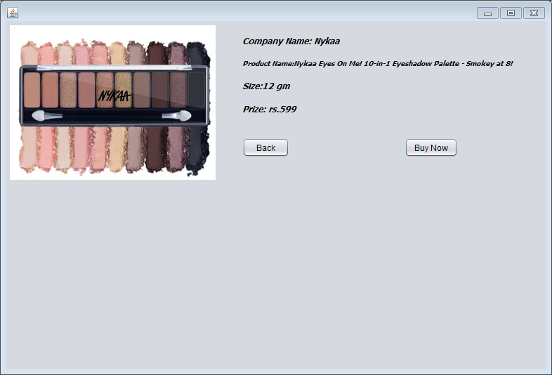

Pay2.java

/*

* To change this license header, choose License Headers in Project Properties.

* To change this template file, choose Tools | Templates

* and open the template in the editor.

*/

package beautyproducts;

/**

*

* @author js

*/

public class Pay2 extends javax.swing.JFrame {

/**

* Creates new form Pay2

*/

public Pay2() {

initComponents();

}

/**

* This method is called from within the constructor to initialize the form.

* WARNING: Do NOT modify this code. The content of this method is always

* regenerated by the Form Editor.

*/

@SuppressWarnings("unchecked")

// <editor-fold defaultstate="collapsed" desc="Generated Code">

private void initComponents() {

jLabel3 = new javax.swing.JLabel();

jTextField3 = new javax.swing.JTextField();

jLabel4 = new javax.swing.JLabel();

jTextField4 = new javax.swing.JTextField();

jLabel1 = new javax.swing.JLabel();

jLabel2 = new javax.swing.JLabel();

jplaceorder = new javax.swing.JButton();

jexit = new javax.swing.JButton();

jTextField1 = new javax.swing.JTextField();

jTextField2 = new javax.swing.JTextField();

setDefaultCloseOperation(javax.swing.WindowConstants.EXIT_ON_CLOSE);

jLabel3.setText("Year of expiry");

jLabel4.setText("Total amount");

jLabel1.setText("Name");

jLabel2.setText("Card No");

jplaceorder.setText("Place Order");

jplaceorder.addActionListener(new java.awt.event.ActionListener() {

public void actionPerformed(java.awt.event.ActionEvent evt) {

jplaceorderActionPerformed(evt);

}

});

jexit.setText("Exit");

jexit.addActionListener(new java.awt.event.ActionListener() {

public void actionPerformed(java.awt.event.ActionEvent evt) {

jexitActionPerformed(evt);

}

});

javax.swing.GroupLayout layout = new javax.swing.GroupLayout(getContentPane());

getContentPane().setLayout(layout);

layout.setHorizontalGroup(

layout.createParallelGroup(javax.swing.GroupLayout.Alignment.LEADING)

.addGroup(layout.createSequentialGroup()

.addGap(127, 127, 127)

.addGroup(layout.createParallelGroup(javax.swing.GroupLayout.Alignment.LEADING)

.addGroup(layout.createSequentialGroup()

.addComponent(jplaceorder)

.addGap(127, 127, 127)

.addComponent(jexit, javax.swing.GroupLayout.PREFERRED_SIZE, 93, javax.swing.GroupLayout.PREFERRED_SIZE))

.addGroup(layout.createSequentialGroup()

.addComponent(jLabel2)

.addPreferredGap(javax.swing.LayoutStyle.ComponentPlacement.RELATED, 270, javax.swing.GroupLayout.PREFERRED_SIZE))

.addGroup(javax.swing.GroupLayout.Alignment.TRAILING, layout.createSequentialGroup()

.addGroup(layout.createParallelGroup(javax.swing.GroupLayout.Alignment.LEADING)

.addComponent(jLabel3)

.addComponent(jLabel1, javax.swing.GroupLayout.PREFERRED_SIZE, 39, javax.swing.GroupLayout.PREFERRED_SIZE)

.addComponent(jLabel4))

.addPreferredGap(javax.swing.LayoutStyle.ComponentPlacement.RELATED, 88, Short.MAX_VALUE)

.addGroup(layout.createParallelGroup(javax.swing.GroupLayout.Alignment.TRAILING, false)

.addComponent(jTextField4)

.addComponent(jTextField1, javax.swing.GroupLayout.Alignment.LEADING)

.addComponent(jTextField2, javax.swing.GroupLayout.Alignment.LEADING)

.addComponent(jTextField3, javax.swing.GroupLayout.Alignment.LEADING, javax.swing.GroupLayout.PREFERRED_SIZE, 179, javax.swing.GroupLayout.PREFERRED_SIZE))

.addGap(58, 58, 58)))

.addGap(162, 162, 162))

);

layout.setVerticalGroup(

layout.createParallelGroup(javax.swing.GroupLayout.Alignment.LEADING)

.addGroup(layout.createSequentialGroup()

.addGap(74, 74, 74)

.addGroup(layout.createParallelGroup(javax.swing.GroupLayout.Alignment.BASELINE)

.addComponent(jTextField1, javax.swing.GroupLayout.PREFERRED_SIZE, javax.swing.GroupLayout.DEFAULT_SIZE, javax.swing.GroupLayout.PREFERRED_SIZE)

.addComponent(jLabel1))

.addGap(34, 34, 34)

.addGroup(layout.createParallelGroup(javax.swing.GroupLayout.Alignment.BASELINE)

.addComponent(jTextField2, javax.swing.GroupLayout.PREFERRED_SIZE, javax.swing.GroupLayout.DEFAULT_SIZE, javax.swing.GroupLayout.PREFERRED_SIZE)

.addComponent(jLabel2))

.addGap(36, 36, 36)

.addGroup(layout.createParallelGroup(javax.swing.GroupLayout.Alignment.BASELINE)

.addComponent(jLabel3)

.addComponent(jTextField3, javax.swing.GroupLayout.PREFERRED_SIZE, javax.swing.GroupLayout.DEFAULT_SIZE, javax.swing.GroupLayout.PREFERRED_SIZE))

.addGap(45, 45, 45)

.addGroup(layout.createParallelGroup(javax.swing.GroupLayout.Alignment.BASELINE)

.addComponent(jLabel4)

.addComponent(jTextField4, javax.swing.GroupLayout.PREFERRED_SIZE, javax.swing.GroupLayout.DEFAULT_SIZE, javax.swing.GroupLayout.PREFERRED_SIZE))

.addPreferredGap(javax.swing.LayoutStyle.ComponentPlacement.RELATED, 131, Short.MAX_VALUE)

.addGroup(layout.createParallelGroup(javax.swing.GroupLayout.Alignment.BASELINE)

.addComponent(jplaceorder)

.addComponent(jexit))

.addGap(41, 41, 41))

);

pack();

}// </editor-fold>

private void jplaceorderActionPerformed(java.awt.event.ActionEvent evt) {

new Eye_bill().setVisible(true);

this.setVisible(false);

}

private void jexitActionPerformed(java.awt.event.ActionEvent evt) {

System.exit(0);

}

/**

* @param args the command line arguments

*/

public static void main(String args[]) {

/* Set the Nimbus look and feel */

//<editor-fold defaultstate="collapsed" desc=" Look and feel setting code (optional) ">

/* If Nimbus (introduced in Java SE 6) is not available, stay with the default look and feel.

* For details see http://download.oracle.com/javase/tutorial/uiswing/lookandfeel/plaf.html

*/

try {

for (javax.swing.UIManager.LookAndFeelInfo info : javax.swing.UIManager.getInstalledLookAndFeels()) {

if ("Nimbus".equals(info.getName())) {

javax.swing.UIManager.setLookAndFeel(info.getClassName());

break;

}

}

} catch (ClassNotFoundException ex) {

java.util.logging.Logger.getLogger(Pay2.class.getName()).log(java.util.logging.Level.SEVERE, null, ex);

} catch (InstantiationException ex) {

java.util.logging.Logger.getLogger(Pay2.class.getName()).log(java.util.logging.Level.SEVERE, null, ex);

} catch (IllegalAccessException ex) {

java.util.logging.Logger.getLogger(Pay2.class.getName()).log(java.util.logging.Level.SEVERE, null, ex);

} catch (javax.swing.UnsupportedLookAndFeelException ex) {

java.util.logging.Logger.getLogger(Pay2.class.getName()).log(java.util.logging.Level.SEVERE, null, ex);

}

//</editor-fold>

/* Create and display the form */

java.awt.EventQueue.invokeLater(new Runnable() {

public void run() {

new Pay2().setVisible(true);

}

});

}

// Variables declaration - do not modify

private javax.swing.JLabel jLabel1;

private javax.swing.JLabel jLabel2;

private javax.swing.JLabel jLabel3;

private javax.swing.JLabel jLabel4;

private javax.swing.JTextField jTextField1;

private javax.swing.JTextField jTextField2;

private javax.swing.JTextField jTextField3;

private javax.swing.JTextField jTextField4;

private javax.swing.JButton jexit;

private javax.swing.JButton jplaceorder;

// End of variables declaration

}

Output:

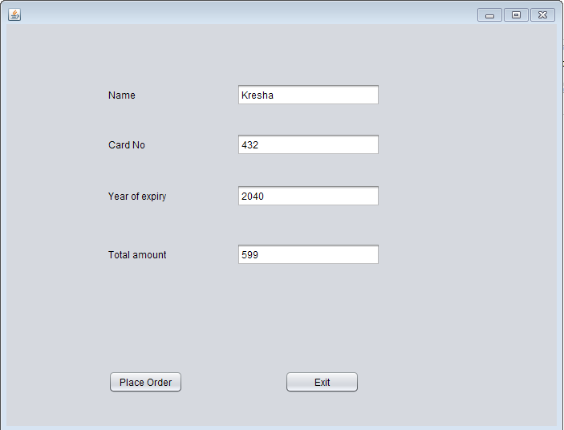

Eye_bill.java

Code:

/*

* To change this license header, choose License Headers in Project Properties.

* To change this template file, choose Tools | Templates

* and open the template in the editor.

*/

package beautyproducts;

import com.mysql.jdbc.Connection;

import com.mysql.jdbc.PreparedStatement;

import java.sql.DriverManager;

import java.sql.ResultSet;

import java.sql.SQLException;

import java.util.logging.Level;

import java.util.logging.Logger;

import javax.swing.JOptionPane;

import net.proteanit.sql.DbUtils;

/**

*

* @author js

*/

public class Eye_bill extends javax.swing.JFrame {

/**

* Creates new form Eye_bill

*/

Connection con = null;

PreparedStatement pst = null;

ResultSet rs = null;

public Eye_bill() {

initComponents();

String name,number,address;

}

public void Print(){

String name=txtname.getText();

String number=txtnumber.getText();

String address=txtaddress.getText();

txtbill.setText("\t"+"The Cosmetic Shop"+"\n"+"\n"

+"Brand:- Nykaa"+"\n"

+"Product Name:- Nykaa Eyes On Me! 10-in-1 Eyeshadow Palette - Smokey at 8! " +"\n"

+"Price:- 599"+"\n"

+"\n"+"********************");

txtbill.setText(txtbill.getText() +"\n"+"Coustomer name:- "+name);

txtbill.setText(txtbill.getText()+"\n"+"\n"+"Contact number:-"+number);

txtbill.setText(txtbill.getText() +"\n"+"\n"+"Address:-"+address);

txtbill.setText(txtbill.getText()+"\n"+"\n"+"\n"+"\n"+"\n"+"\n"+"\n"+"\t"+"**Thanks For Shopping**");

}

/**

* This method is called from within the constructor to initialize the form.

* WARNING: Do NOT modify this code. The content of this method is always

* regenerated by the Form Editor.

*/

@SuppressWarnings("unchecked")

// <editor-fold defaultstate="collapsed" desc="Generated Code">

private void initComponents() {

jLabel3 = new javax.swing.JLabel();

txtname = new javax.swing.JTextField();

txtnumber = new javax.swing.JTextField();

txtaddress = new javax.swing.JTextField();

jScrollPane1 = new javax.swing.JScrollPane();

txtbill = new javax.swing.JTextArea();

jButton1 = new javax.swing.JButton();

jButton2 = new javax.swing.JButton();

jLabel1 = new javax.swing.JLabel();

jLabel2 = new javax.swing.JLabel();

setDefaultCloseOperation(javax.swing.WindowConstants.EXIT_ON_CLOSE);

jLabel3.setText("Address:");

txtaddress.addActionListener(new java.awt.event.ActionListener() {

public void actionPerformed(java.awt.event.ActionEvent evt) {

txtaddressActionPerformed(evt);

}

});

txtbill.setColumns(20);

txtbill.setRows(5);

jScrollPane1.setViewportView(txtbill);

jButton1.setText("Ok");

jButton1.addActionListener(new java.awt.event.ActionListener() {

public void actionPerformed(java.awt.event.ActionEvent evt) {

jButton1ActionPerformed(evt);

}

});

jButton2.setText("Done");

jButton2.addActionListener(new java.awt.event.ActionListener() {

public void actionPerformed(java.awt.event.ActionEvent evt) {

jButton2ActionPerformed(evt);

}

});

jLabel1.setText("Customer Name:");

jLabel2.setText("Contact Number:");

javax.swing.GroupLayout layout = new javax.swing.GroupLayout(getContentPane());

getContentPane().setLayout(layout);

layout.setHorizontalGroup(

layout.createParallelGroup(javax.swing.GroupLayout.Alignment.LEADING)

.addGroup(layout.createSequentialGroup()

.addGap(37, 37, 37)

.addGroup(layout.createParallelGroup(javax.swing.GroupLayout.Alignment.TRAILING)

.addGroup(layout.createSequentialGroup()

.addGroup(layout.createParallelGroup(javax.swing.GroupLayout.Alignment.LEADING)

.addComponent(jLabel1)

.addComponent(jLabel2)

.addComponent(jLabel3))

.addGap(69, 69, 69)

.addGroup(layout.createParallelGroup(javax.swing.GroupLayout.Alignment.LEADING, false)

.addComponent(txtname, javax.swing.GroupLayout.DEFAULT_SIZE, 161, Short.MAX_VALUE)

.addComponent(txtnumber)

.addComponent(txtaddress)))

.addComponent(jButton1))

.addPreferredGap(javax.swing.LayoutStyle.ComponentPlacement.RELATED, 64, Short.MAX_VALUE)

.addComponent(jScrollPane1, javax.swing.GroupLayout.PREFERRED_SIZE, 309, javax.swing.GroupLayout.PREFERRED_SIZE)

.addGap(22, 22, 22))

.addGroup(javax.swing.GroupLayout.Alignment.TRAILING, layout.createSequentialGroup()

.addContainerGap(javax.swing.GroupLayout.DEFAULT_SIZE, Short.MAX_VALUE)

.addComponent(jButton2)

.addGap(126, 126, 126))

);

layout.setVerticalGroup(

layout.createParallelGroup(javax.swing.GroupLayout.Alignment.LEADING)

.addGroup(layout.createSequentialGroup()

.addGap(52, 52, 52)

.addGroup(layout.createParallelGroup(javax.swing.GroupLayout.Alignment.BASELINE)

.addComponent(jLabel1)

.addComponent(txtname, javax.swing.GroupLayout.PREFERRED_SIZE, javax.swing.GroupLayout.DEFAULT_SIZE, javax.swing.GroupLayout.PREFERRED_SIZE))

.addGap(29, 29, 29)

.addGroup(layout.createParallelGroup(javax.swing.GroupLayout.Alignment.BASELINE)

.addComponent(jLabel2)

.addComponent(txtnumber, javax.swing.GroupLayout.PREFERRED_SIZE, javax.swing.GroupLayout.DEFAULT_SIZE, javax.swing.GroupLayout.PREFERRED_SIZE))

.addGap(40, 40, 40)

.addGroup(layout.createParallelGroup(javax.swing.GroupLayout.Alignment.BASELINE)

.addComponent(jLabel3)

.addComponent(txtaddress, javax.swing.GroupLayout.PREFERRED_SIZE, 109, javax.swing.GroupLayout.PREFERRED_SIZE))

.addGap(67, 67, 67)

.addComponent(jButton1)

.addContainerGap(javax.swing.GroupLayout.DEFAULT_SIZE, Short.MAX_VALUE))

.addGroup(javax.swing.GroupLayout.Alignment.TRAILING, layout.createSequentialGroup()

.addContainerGap(13, Short.MAX_VALUE)

.addComponent(jScrollPane1, javax.swing.GroupLayout.PREFERRED_SIZE, 418, javax.swing.GroupLayout.PREFERRED_SIZE)

.addGap(18, 18, 18)

.addComponent(jButton2)

.addGap(10, 10, 10))

);

pack();

}// </editor-fold>

private void txtaddressActionPerformed(java.awt.event.ActionEvent evt) {

// TODO add your handling code here:

}

private void jButton1ActionPerformed(java.awt.event.ActionEvent evt) {

Print();

}

private void jButton2ActionPerformed(java.awt.event.ActionEvent evt) {

try

{

String sql = "INSERT INTO customer_details"

+"(CustomerName,CustomerNumber,Address)"

+"VALUES (?,?,?)";

con = (Connection) DriverManager.getConnection("jdbc:mysql://localhost/details","root","");

pst = (PreparedStatement) con.prepareStatement(sql);

pst.setString(1,txtname.getText());

pst.setString(2,txtnumber.getText());

pst.setString(3,txtaddress.getText());

pst.executeUpdate();

JOptionPane.showMessageDialog(null, "Thank you for shopping!!");

txtname.setText(null);

txtnumber.setText(null);

txtaddress.setText(null);

}

catch(Exception ex)

{

JOptionPane.showMessageDialog(null, ex);

}

}

/**

* @param args the command line arguments

*/

public static void main(String args[]) {

/* Set the Nimbus look and feel */

//<editor-fold defaultstate="collapsed" desc=" Look and feel setting code (optional) ">

/* If Nimbus (introduced in Java SE 6) is not available, stay with the default look and feel.

* For details see http://download.oracle.com/javase/tutorial/uiswing/lookandfeel/plaf.html

*/

try {

for (javax.swing.UIManager.LookAndFeelInfo info : javax.swing.UIManager.getInstalledLookAndFeels()) {

if ("Nimbus".equals(info.getName())) {

javax.swing.UIManager.setLookAndFeel(info.getClassName());

break;

}

}

} catch (ClassNotFoundException ex) {

java.util.logging.Logger.getLogger(Eye_bill.class.getName()).log(java.util.logging.Level.SEVERE, null, ex);

} catch (InstantiationException ex) {

java.util.logging.Logger.getLogger(Eye_bill.class.getName()).log(java.util.logging.Level.SEVERE, null, ex);

} catch (IllegalAccessException ex) {

java.util.logging.Logger.getLogger(Eye_bill.class.getName()).log(java.util.logging.Level.SEVERE, null, ex);

} catch (javax.swing.UnsupportedLookAndFeelException ex) {

java.util.logging.Logger.getLogger(Eye_bill.class.getName()).log(java.util.logging.Level.SEVERE, null, ex);

}

//</editor-fold>

/* Create and display the form */

java.awt.EventQueue.invokeLater(new Runnable() {

public void run() {

new Eye_bill().setVisible(true);

}

});

}

// Variables declaration - do not modify

private javax.swing.JButton jButton1;

private javax.swing.JButton jButton2;

private javax.swing.JLabel jLabel1;

private javax.swing.JLabel jLabel2;

private javax.swing.JLabel jLabel3;

private javax.swing.JScrollPane jScrollPane1;

private javax.swing.JTextField txtaddress;

private javax.swing.JTextArea txtbill;

private javax.swing.JTextField txtname;

private javax.swing.JTextField txtnumber;

// End of variables declaration

}

Output:

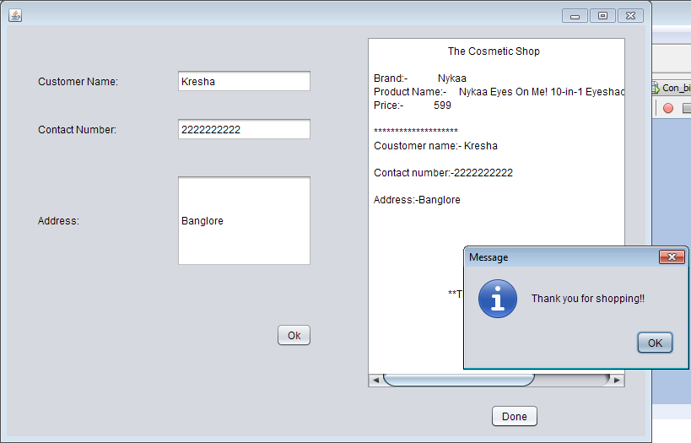

Lipstick.java

Code:

/*

* To change this license header, choose License Headers in Project Properties.

* To change this template file, choose Tools | Templates

* and open the template in the editor.

*/

package beautyproducts;

/**

*

* @author js

*/

public class Lipstick extends javax.swing.JFrame {

/**

* Creates new form Lipstick

*/

public Lipstick() {

initComponents();

}

/**

* This method is called from within the constructor to initialize the form.

* WARNING: Do NOT modify this code. The content of this method is always

* regenerated by the Form Editor.

*/

@SuppressWarnings("unchecked")

// <editor-fold defaultstate="collapsed" desc="Generated Code">

private void initComponents() {

jLabel1 = new javax.swing.JLabel();

jLabel2 = new javax.swing.JLabel();

jLabel3 = new javax.swing.JLabel();

jLabel4 = new javax.swing.JLabel();

jLabel5 = new javax.swing.JLabel();

jButton1 = new javax.swing.JButton();

jButton3 = new javax.swing.JButton();

setDefaultCloseOperation(javax.swing.WindowConstants.EXIT_ON_CLOSE);

jLabel1.setIcon(new javax.swing.ImageIcon("C:\\Users\\js\\Desktop\\5.PNG")); // NOI18N

jLabel1.setText("jLabel1");

jLabel2.setFont(new java.awt.Font("Tahoma", 3, 12)); // NOI18N

jLabel2.setText("Company Name: Kay Beauty");

jLabel3.setFont(new java.awt.Font("Tahoma", 3, 12)); // NOI18N

jLabel3.setText("Product Name:Kay Beauty Matte Lipstick - Red Carpet");

jLabel4.setFont(new java.awt.Font("Tahoma", 3, 12)); // NOI18N

jLabel4.setText("Size:4.2 gm");

jLabel5.setFont(new java.awt.Font("Tahoma", 3, 12)); // NOI18N

jLabel5.setText("MRP: rs.999");

jButton1.setText("Buy Now");

jButton1.addActionListener(new java.awt.event.ActionListener() {

public void actionPerformed(java.awt.event.ActionEvent evt) {

jButton1ActionPerformed(evt);

}

});

jButton3.setText("Back");

jButton3.addActionListener(new java.awt.event.ActionListener() {

public void actionPerformed(java.awt.event.ActionEvent evt) {

jButton3ActionPerformed(evt);

}

});

javax.swing.GroupLayout layout = new javax.swing.GroupLayout(getContentPane());

getContentPane().setLayout(layout);

layout.setHorizontalGroup(

layout.createParallelGroup(javax.swing.GroupLayout.Alignment.LEADING)

.addGroup(layout.createSequentialGroup()

.addContainerGap()

.addComponent(jLabel1, javax.swing.GroupLayout.PREFERRED_SIZE, 267, javax.swing.GroupLayout.PREFERRED_SIZE)

.addGroup(layout.createParallelGroup(javax.swing.GroupLayout.Alignment.LEADING)

.addGroup(layout.createSequentialGroup()

.addGap(123, 123, 123)

.addGroup(layout.createParallelGroup(javax.swing.GroupLayout.Alignment.LEADING)

.addComponent(jLabel2, javax.swing.GroupLayout.PREFERRED_SIZE, 192, javax.swing.GroupLayout.PREFERRED_SIZE)

.addComponent(jLabel3, javax.swing.GroupLayout.PREFERRED_SIZE, 348, javax.swing.GroupLayout.PREFERRED_SIZE)

.addComponent(jLabel4, javax.swing.GroupLayout.PREFERRED_SIZE, 83, javax.swing.GroupLayout.PREFERRED_SIZE)

.addComponent(jLabel5, javax.swing.GroupLayout.PREFERRED_SIZE, 83, javax.swing.GroupLayout.PREFERRED_SIZE)))

.addGroup(layout.createSequentialGroup()

.addGap(74, 74, 74)

.addComponent(jButton3, javax.swing.GroupLayout.PREFERRED_SIZE, 67, javax.swing.GroupLayout.PREFERRED_SIZE)

.addGap(158, 158, 158)

.addComponent(jButton1)))

.addGap(0, 247, Short.MAX_VALUE))

);

layout.setVerticalGroup(

layout.createParallelGroup(javax.swing.GroupLayout.Alignment.LEADING)

.addGroup(layout.createSequentialGroup()

.addComponent(jLabel1, javax.swing.GroupLayout.PREFERRED_SIZE, 307, javax.swing.GroupLayout.PREFERRED_SIZE)

.addGap(109, 331, Short.MAX_VALUE))

.addGroup(layout.createSequentialGroup()

.addGap(21, 21, 21)

.addComponent(jLabel2)

.addGap(11, 11, 11)

.addComponent(jLabel3)

.addGap(13, 13, 13)

.addComponent(jLabel4)

.addPreferredGap(javax.swing.LayoutStyle.ComponentPlacement.UNRELATED)

.addComponent(jLabel5)

.addGap(40, 40, 40)

.addGroup(layout.createParallelGroup(javax.swing.GroupLayout.Alignment.BASELINE)

.addComponent(jButton1)

.addComponent(jButton3))

.addGap(22, 459, Short.MAX_VALUE))

);

pack();

}// </editor-fold>

private void jButton1ActionPerformed(java.awt.event.ActionEvent evt) {

new Pay3().setVisible(true);

this.setVisible(false);

}

private void jButton3ActionPerformed(java.awt.event.ActionEvent evt) {

new BuyProduct().setVisible(true);

this.setVisible(false);

}

/**

* @param args the command line arguments

*/

public static void main(String args[]) {

/* Set the Nimbus look and feel */

//<editor-fold defaultstate="collapsed" desc=" Look and feel setting code (optional) ">

/* If Nimbus (introduced in Java SE 6) is not available, stay with the default look and feel.

* For details see http://download.oracle.com/javase/tutorial/uiswing/lookandfeel/plaf.html

*/

try {

for (javax.swing.UIManager.LookAndFeelInfo info : javax.swing.UIManager.getInstalledLookAndFeels()) {

if ("Nimbus".equals(info.getName())) {

javax.swing.UIManager.setLookAndFeel(info.getClassName());

break;

}

}

} catch (ClassNotFoundException ex) {

java.util.logging.Logger.getLogger(Lipstick.class.getName()).log(java.util.logging.Level.SEVERE, null, ex);

} catch (InstantiationException ex) {

java.util.logging.Logger.getLogger(Lipstick.class.getName()).log(java.util.logging.Level.SEVERE, null, ex);

} catch (IllegalAccessException ex) {

java.util.logging.Logger.getLogger(Lipstick.class.getName()).log(java.util.logging.Level.SEVERE, null, ex);

} catch (javax.swing.UnsupportedLookAndFeelException ex) {

java.util.logging.Logger.getLogger(Lipstick.class.getName()).log(java.util.logging.Level.SEVERE, null, ex);

}

//</editor-fold>

/* Create and display the form */

java.awt.EventQueue.invokeLater(new Runnable() {

public void run() {

new Lipstick().setVisible(true);

}

});

}

// Variables declaration - do not modify

private javax.swing.JButton jButton1;

private javax.swing.JButton jButton3;

private javax.swing.JLabel jLabel1;

private javax.swing.JLabel jLabel2;

private javax.swing.JLabel jLabel3;

private javax.swing.JLabel jLabel4;

private javax.swing.JLabel jLabel5;

// End of variables declaration

}

Output:

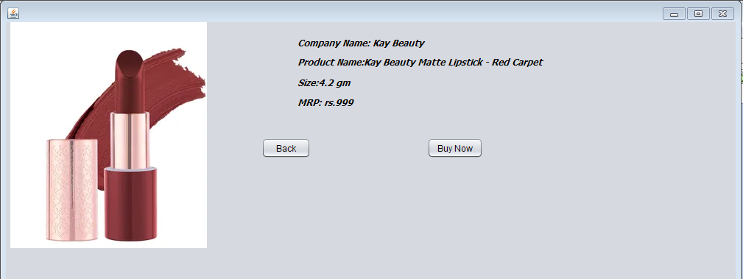

Pay3.java

Code:

/*

* To change this license header, choose License Headers in Project Properties.

* To change this template file, choose Tools | Templates

* and open the template in the editor.

*/

package beautyproducts;

/**

*

* @author js

*/

public class Pay3 extends javax.swing.JFrame {

/**

* Creates new form Pay3

*/

public Pay3() {

initComponents();

}

/**

* This method is called from within the constructor to initialize the form.

* WARNING: Do NOT modify this code. The content of this method is always

* regenerated by the Form Editor.

*/

@SuppressWarnings("unchecked")

// <editor-fold defaultstate="collapsed" desc="Generated Code">

private void initComponents() {

jLabel3 = new javax.swing.JLabel();

jTextField3 = new javax.swing.JTextField();

jLabel4 = new javax.swing.JLabel();

jTextField4 = new javax.swing.JTextField();

jLabel1 = new javax.swing.JLabel();

jLabel2 = new javax.swing.JLabel();

jplaceorder = new javax.swing.JButton();

jexit = new javax.swing.JButton();

jTextField1 = new javax.swing.JTextField();

jTextField2 = new javax.swing.JTextField();

setDefaultCloseOperation(javax.swing.WindowConstants.EXIT_ON_CLOSE);

jLabel3.setText("Year of expiry");

jLabel4.setText("Total amount");

jLabel1.setText("Name");

jLabel2.setText("Card No");

jplaceorder.setText("Place Order");

jplaceorder.addActionListener(new java.awt.event.ActionListener() {

public void actionPerformed(java.awt.event.ActionEvent evt) {

jplaceorderActionPerformed(evt);

}

});

jexit.setText("Exit");

jexit.addActionListener(new java.awt.event.ActionListener() {

public void actionPerformed(java.awt.event.ActionEvent evt) {

jexitActionPerformed(evt);

}

});

javax.swing.GroupLayout layout = new javax.swing.GroupLayout(getContentPane());

getContentPane().setLayout(layout);

layout.setHorizontalGroup(

layout.createParallelGroup(javax.swing.GroupLayout.Alignment.LEADING)

.addGroup(layout.createSequentialGroup()

.addGap(127, 127, 127)

.addGroup(layout.createParallelGroup(javax.swing.GroupLayout.Alignment.LEADING)

.addGroup(layout.createSequentialGroup()

.addComponent(jplaceorder)

.addGap(127, 127, 127)

.addComponent(jexit, javax.swing.GroupLayout.PREFERRED_SIZE, 93, javax.swing.GroupLayout.PREFERRED_SIZE))

.addGroup(layout.createSequentialGroup()

.addComponent(jLabel2)

.addPreferredGap(javax.swing.LayoutStyle.ComponentPlacement.RELATED, 270, javax.swing.GroupLayout.PREFERRED_SIZE))

.addGroup(javax.swing.GroupLayout.Alignment.TRAILING, layout.createSequentialGroup()

.addGroup(layout.createParallelGroup(javax.swing.GroupLayout.Alignment.LEADING)

.addComponent(jLabel3)

.addComponent(jLabel1, javax.swing.GroupLayout.PREFERRED_SIZE, 39, javax.swing.GroupLayout.PREFERRED_SIZE)

.addComponent(jLabel4))

.addPreferredGap(javax.swing.LayoutStyle.ComponentPlacement.RELATED, 106, Short.MAX_VALUE)

.addGroup(layout.createParallelGroup(javax.swing.GroupLayout.Alignment.TRAILING, false)

.addComponent(jTextField4)

.addComponent(jTextField1, javax.swing.GroupLayout.Alignment.LEADING)

.addComponent(jTextField2, javax.swing.GroupLayout.Alignment.LEADING)

.addComponent(jTextField3, javax.swing.GroupLayout.Alignment.LEADING, javax.swing.GroupLayout.PREFERRED_SIZE, 179, javax.swing.GroupLayout.PREFERRED_SIZE))

.addGap(58, 58, 58)))

.addGap(162, 162, 162))

);

layout.setVerticalGroup(

layout.createParallelGroup(javax.swing.GroupLayout.Alignment.LEADING)

.addGroup(layout.createSequentialGroup()

.addGap(74, 74, 74)

.addGroup(layout.createParallelGroup(javax.swing.GroupLayout.Alignment.BASELINE)

.addComponent(jTextField1, javax.swing.GroupLayout.PREFERRED_SIZE, javax.swing.GroupLayout.DEFAULT_SIZE, javax.swing.GroupLayout.PREFERRED_SIZE)

.addComponent(jLabel1))

.addGap(34, 34, 34)

.addGroup(layout.createParallelGroup(javax.swing.GroupLayout.Alignment.BASELINE)

.addComponent(jTextField2, javax.swing.GroupLayout.PREFERRED_SIZE, javax.swing.GroupLayout.DEFAULT_SIZE, javax.swing.GroupLayout.PREFERRED_SIZE)

.addComponent(jLabel2))

.addGap(36, 36, 36)

.addGroup(layout.createParallelGroup(javax.swing.GroupLayout.Alignment.BASELINE)

.addComponent(jLabel3)

.addComponent(jTextField3, javax.swing.GroupLayout.PREFERRED_SIZE, javax.swing.GroupLayout.DEFAULT_SIZE, javax.swing.GroupLayout.PREFERRED_SIZE))

.addGap(45, 45, 45)

.addGroup(layout.createParallelGroup(javax.swing.GroupLayout.Alignment.BASELINE)

.addComponent(jLabel4)

.addComponent(jTextField4, javax.swing.GroupLayout.PREFERRED_SIZE, javax.swing.GroupLayout.DEFAULT_SIZE, javax.swing.GroupLayout.PREFERRED_SIZE))

.addPreferredGap(javax.swing.LayoutStyle.ComponentPlacement.RELATED, 130, Short.MAX_VALUE)

.addGroup(layout.createParallelGroup(javax.swing.GroupLayout.Alignment.BASELINE)

.addComponent(jplaceorder)

.addComponent(jexit))

.addGap(41, 41, 41))

);

pack();

}// </editor-fold>

private void jplaceorderActionPerformed(java.awt.event.ActionEvent evt) {

new Lips_bill().setVisible(true);

this.setVisible(false);

}

private void jexitActionPerformed(java.awt.event.ActionEvent evt) {

System.exit(0);

}

/**

* @param args the command line arguments

*/

public static void main(String args[]) {

/* Set the Nimbus look and feel */

//<editor-fold defaultstate="collapsed" desc=" Look and feel setting code (optional) ">

/* If Nimbus (introduced in Java SE 6) is not available, stay with the default look and feel.

* For details see http://download.oracle.com/javase/tutorial/uiswing/lookandfeel/plaf.html

*/

try {

for (javax.swing.UIManager.LookAndFeelInfo info : javax.swing.UIManager.getInstalledLookAndFeels()) {

if ("Nimbus".equals(info.getName())) {

javax.swing.UIManager.setLookAndFeel(info.getClassName());

break;

}

}

} catch (ClassNotFoundException ex) {

java.util.logging.Logger.getLogger(Pay3.class.getName()).log(java.util.logging.Level.SEVERE, null, ex);

} catch (InstantiationException ex) {

java.util.logging.Logger.getLogger(Pay3.class.getName()).log(java.util.logging.Level.SEVERE, null, ex);

} catch (IllegalAccessException ex) {

java.util.logging.Logger.getLogger(Pay3.class.getName()).log(java.util.logging.Level.SEVERE, null, ex);

} catch (javax.swing.UnsupportedLookAndFeelException ex) {

java.util.logging.Logger.getLogger(Pay3.class.getName()).log(java.util.logging.Level.SEVERE, null, ex);

}

//</editor-fold>

/* Create and display the form */

java.awt.EventQueue.invokeLater(new Runnable() {

public void run() {

new Pay3().setVisible(true);

}

});

}

// Variables declaration - do not modify

private javax.swing.JLabel jLabel1;

private javax.swing.JLabel jLabel2;

private javax.swing.JLabel jLabel3;

private javax.swing.JLabel jLabel4;

private javax.swing.JTextField jTextField1;

private javax.swing.JTextField jTextField2;

private javax.swing.JTextField jTextField3;

private javax.swing.JTextField jTextField4;

private javax.swing.JButton jexit;

private javax.swing.JButton jplaceorder;

// End of variables declaration

}

Output:

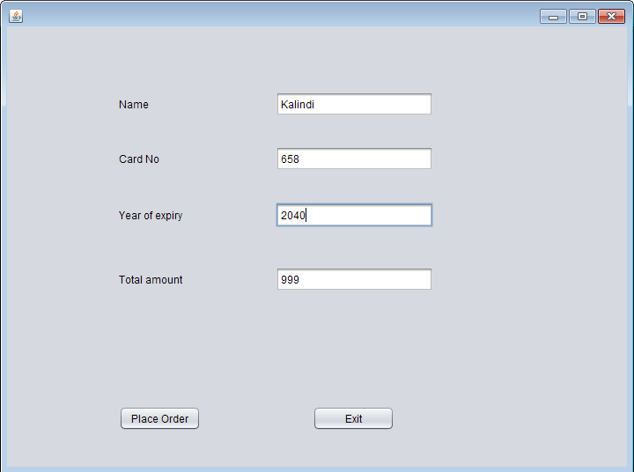

Lips_bill.java

Code:

/*

* To change this license header, choose License Headers in Project Properties.

* To change this template file, choose Tools | Templates

* and open the template in the editor.

*/

package beautyproducts;

import com.mysql.jdbc.Connection;

import com.mysql.jdbc.PreparedStatement;

import java.sql.DriverManager;

import java.sql.ResultSet;

import java.sql.SQLException;

import java.util.logging.Level;

import java.util.logging.Logger;

import javax.swing.JOptionPane;

import net.proteanit.sql.DbUtils;

/**

*

* @author js

*/

public class Lips_bill extends javax.swing.JFrame {

/**

* Creates new form Lips_bill

*/

Connection con = null;

PreparedStatement pst = null;

ResultSet rs = null;

public Lips_bill() {

initComponents();

String name,number,address;

}

public void Print(){

String name=txtname.getText();

String number=txtnumber.getText();

String address=txtaddress.getText();

txtbill.setText("\t"+"The Cosmetic Shop"+"\n"+"\n"

+"Brand:- Kay Beauty"+"\n"

+"Product Name:- Kay Beauty Matte Lipstick - Red Carpet " +"\n"

+"Price:- 999"+"\n"

+"\n"+"********************");

txtbill.setText(txtbill.getText() +"\n"+"Coustomer name:- "+name);

txtbill.setText(txtbill.getText()+"\n"+"\n"+"Contact number:-"+number);

txtbill.setText(txtbill.getText() +"\n"+"\n"+"Address:-"+address);

txtbill.setText(txtbill.getText()+"\n"+"\n"+"\n"+"\n"+"\n"+"\n"+"\n"+"\t"+"**Thanks For Shopping**");

}

/**

* This method is called from within the constructor to initialize the form.

* WARNING: Do NOT modify this code. The content of this method is always

* regenerated by the Form Editor.

*/

@SuppressWarnings("unchecked")

// <editor-fold defaultstate="collapsed" desc="Generated Code">

private void initComponents() {

jLabel3 = new javax.swing.JLabel();

txtname = new javax.swing.JTextField();

txtnumber = new javax.swing.JTextField();

txtaddress = new javax.swing.JTextField();

jScrollPane1 = new javax.swing.JScrollPane();

txtbill = new javax.swing.JTextArea();

jButton1 = new javax.swing.JButton();

jButton2 = new javax.swing.JButton();

jLabel1 = new javax.swing.JLabel();

jLabel2 = new javax.swing.JLabel();

setDefaultCloseOperation(javax.swing.WindowConstants.EXIT_ON_CLOSE);

jLabel3.setText("Address:");

txtaddress.addActionListener(new java.awt.event.ActionListener() {

public void actionPerformed(java.awt.event.ActionEvent evt) {

txtaddressActionPerformed(evt);

}

});

txtbill.setColumns(20);

txtbill.setRows(5);

jScrollPane1.setViewportView(txtbill);

jButton1.setText("Ok");

jButton1.addActionListener(new java.awt.event.ActionListener() {

public void actionPerformed(java.awt.event.ActionEvent evt) {

jButton1ActionPerformed(evt);

}

});

jButton2.setText("Done");

jButton2.addActionListener(new java.awt.event.ActionListener() {

public void actionPerformed(java.awt.event.ActionEvent evt) {

jButton2ActionPerformed(evt);

}

});

jLabel1.setText("Customer Name:");

jLabel2.setText("Contact Number:");

javax.swing.GroupLayout layout = new javax.swing.GroupLayout(getContentPane());

getContentPane().setLayout(layout);

layout.setHorizontalGroup(

layout.createParallelGroup(javax.swing.GroupLayout.Alignment.LEADING)

.addGroup(layout.createSequentialGroup()

.addGap(37, 37, 37)

.addGroup(layout.createParallelGroup(javax.swing.GroupLayout.Alignment.TRAILING)

.addGroup(layout.createSequentialGroup()

.addGroup(layout.createParallelGroup(javax.swing.GroupLayout.Alignment.LEADING)

.addComponent(jLabel1)

.addComponent(jLabel2)

.addComponent(jLabel3))

.addGap(69, 69, 69)

.addGroup(layout.createParallelGroup(javax.swing.GroupLayout.Alignment.LEADING, false)

.addComponent(txtname, javax.swing.GroupLayout.DEFAULT_SIZE, 161, Short.MAX_VALUE)

.addComponent(txtnumber)

.addComponent(txtaddress)))

.addComponent(jButton1))

.addPreferredGap(javax.swing.LayoutStyle.ComponentPlacement.RELATED, javax.swing.GroupLayout.DEFAULT_SIZE, Short.MAX_VALUE)

.addComponent(jScrollPane1, javax.swing.GroupLayout.PREFERRED_SIZE, 309, javax.swing.GroupLayout.PREFERRED_SIZE)

.addGap(22, 22, 22))

.addGroup(javax.swing.GroupLayout.Alignment.TRAILING, layout.createSequentialGroup()

.addContainerGap(javax.swing.GroupLayout.DEFAULT_SIZE, Short.MAX_VALUE)

.addComponent(jButton2)

.addGap(126, 126, 126))

);

layout.setVerticalGroup(

layout.createParallelGroup(javax.swing.GroupLayout.Alignment.LEADING)

.addGroup(layout.createSequentialGroup()

.addGap(52, 52, 52)

.addGroup(layout.createParallelGroup(javax.swing.GroupLayout.Alignment.BASELINE)

.addComponent(jLabel1)

.addComponent(txtname, javax.swing.GroupLayout.PREFERRED_SIZE, javax.swing.GroupLayout.DEFAULT_SIZE, javax.swing.GroupLayout.PREFERRED_SIZE))

.addGap(29, 29, 29)

.addGroup(layout.createParallelGroup(javax.swing.GroupLayout.Alignment.BASELINE)

.addComponent(jLabel2)

.addComponent(txtnumber, javax.swing.GroupLayout.PREFERRED_SIZE, javax.swing.GroupLayout.DEFAULT_SIZE, javax.swing.GroupLayout.PREFERRED_SIZE))

.addGap(40, 40, 40)

.addGroup(layout.createParallelGroup(javax.swing.GroupLayout.Alignment.BASELINE)

.addComponent(jLabel3)

.addComponent(txtaddress, javax.swing.GroupLayout.PREFERRED_SIZE, 109, javax.swing.GroupLayout.PREFERRED_SIZE))

.addGap(67, 67, 67)

.addComponent(jButton1)

.addContainerGap(javax.swing.GroupLayout.DEFAULT_SIZE, Short.MAX_VALUE))

.addGroup(javax.swing.GroupLayout.Alignment.TRAILING, layout.createSequentialGroup()

.addContainerGap(javax.swing.GroupLayout.DEFAULT_SIZE, Short.MAX_VALUE)

.addComponent(jScrollPane1, javax.swing.GroupLayout.PREFERRED_SIZE, 418, javax.swing.GroupLayout.PREFERRED_SIZE)

.addGap(18, 18, 18)

.addComponent(jButton2)

.addGap(10, 10, 10))

);

pack();

}// </editor-fold>

private void txtaddressActionPerformed(java.awt.event.ActionEvent evt) {

// TODO add your handling code here:

}

private void jButton1ActionPerformed(java.awt.event.ActionEvent evt) {

Print();

}

private void jButton2ActionPerformed(java.awt.event.ActionEvent evt) {

try

{

String sql = "INSERT INTO customer_details"

+"(CustomerName,CustomerNumber,Address)"

+"VALUES (?,?,?)";

con = (Connection) DriverManager.getConnection("jdbc:mysql://localhost/details","root","");

pst = (PreparedStatement) con.prepareStatement(sql);

pst.setString(1,txtname.getText());

pst.setString(2,txtnumber.getText());

pst.setString(3,txtaddress.getText());

pst.executeUpdate();

JOptionPane.showMessageDialog(null, "Thank you for shopping!!");

txtname.setText(null);

txtnumber.setText(null);

txtaddress.setText(null);

}

catch(Exception ex)

{

JOptionPane.showMessageDialog(null, ex);

}

}

/**

* @param args the command line arguments

*/

public static void main(String args[]) {

/* Set the Nimbus look and feel */

//<editor-fold defaultstate="collapsed" desc=" Look and feel setting code (optional) ">

/* If Nimbus (introduced in Java SE 6) is not available, stay with the default look and feel.

* For details see http://download.oracle.com/javase/tutorial/uiswing/lookandfeel/plaf.html

*/

try {

for (javax.swing.UIManager.LookAndFeelInfo info : javax.swing.UIManager.getInstalledLookAndFeels()) {

if ("Nimbus".equals(info.getName())) {

javax.swing.UIManager.setLookAndFeel(info.getClassName());

break;

}

}

} catch (ClassNotFoundException ex) {

java.util.logging.Logger.getLogger(Lips_bill.class.getName()).log(java.util.logging.Level.SEVERE, null, ex);

} catch (InstantiationException ex) {

java.util.logging.Logger.getLogger(Lips_bill.class.getName()).log(java.util.logging.Level.SEVERE, null, ex);

} catch (IllegalAccessException ex) {

java.util.logging.Logger.getLogger(Lips_bill.class.getName()).log(java.util.logging.Level.SEVERE, null, ex);

} catch (javax.swing.UnsupportedLookAndFeelException ex) {

java.util.logging.Logger.getLogger(Lips_bill.class.getName()).log(java.util.logging.Level.SEVERE, null, ex);

}

//</editor-fold>

/* Create and display the form */

java.awt.EventQueue.invokeLater(new Runnable() {

public void run() {

new Lips_bill().setVisible(true);

}

});

}

// Variables declaration - do not modify

private javax.swing.JButton jButton1;

private javax.swing.JButton jButton2;

private javax.swing.JLabel jLabel1;

private javax.swing.JLabel jLabel2;

private javax.swing.JLabel jLabel3;

private javax.swing.JScrollPane jScrollPane1;

private javax.swing.JTextField txtaddress;

private javax.swing.JTextArea txtbill;

private javax.swing.JTextField txtname;

private javax.swing.JTextField txtnumber;

// End of variables declaration

}

Output:

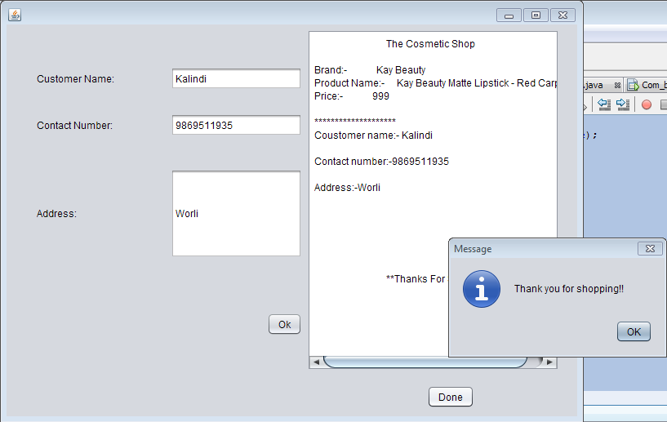

Blush.java

Code:

/*

* To change this license header, choose License Headers in Project Properties.

* To change this template file, choose Tools | Templates

* and open the template in the editor.

*/

package beautyproducts;

/**

*

* @author js

*/

public class Blush extends javax.swing.JFrame {

/**

* Creates new form Blush

*/

public Blush() {

initComponents();

}

/**

* This method is called from within the constructor to initialize the form.

* WARNING: Do NOT modify this code. The content of this method is always

* regenerated by the Form Editor.

*/

@SuppressWarnings("unchecked")

// <editor-fold defaultstate="collapsed" desc="Generated Code">

private void initComponents() {

jLabel1 = new javax.swing.JLabel();

jLabel2 = new javax.swing.JLabel();

jLabel3 = new javax.swing.JLabel();

jLabel4 = new javax.swing.JLabel();

jLabel5 = new javax.swing.JLabel();

jButton1 = new javax.swing.JButton();

jButton3 = new javax.swing.JButton();

setDefaultCloseOperation(javax.swing.WindowConstants.EXIT_ON_CLOSE);

jLabel1.setFont(new java.awt.Font("Tahoma", 3, 12)); // NOI18N

jLabel1.setIcon(new javax.swing.ImageIcon("C:\\Users\\js\\Desktop\\7.PNG")); // NOI18N

jLabel1.setText("jLabel1");

jLabel2.setFont(new java.awt.Font("Tahoma", 3, 12)); // NOI18N

jLabel2.setText("Brand Name:Makeup Revolution London");

jLabel3.setFont(new java.awt.Font("Tahoma", 3, 11)); // NOI18N

jLabel3.setText("Product Name:Makeup Revolution Ultra Blush - Sugar And Spice ");

jLabel4.setFont(new java.awt.Font("Tahoma", 3, 12)); // NOI18N

jLabel4.setText("Size:12.8 gm");

jLabel5.setFont(new java.awt.Font("Tahoma", 3, 12)); // NOI18N

jLabel5.setText("MRP:rs.1350");

jButton1.setText("Buy Now");

jButton1.addActionListener(new java.awt.event.ActionListener() {

public void actionPerformed(java.awt.event.ActionEvent evt) {

jButton1ActionPerformed(evt);

}

});

jButton3.setText("Back");

jButton3.addActionListener(new java.awt.event.ActionListener() {

public void actionPerformed(java.awt.event.ActionEvent evt) {

jButton3ActionPerformed(evt);

}

});

javax.swing.GroupLayout layout = new javax.swing.GroupLayout(getContentPane());

getContentPane().setLayout(layout);

layout.setHorizontalGroup(

layout.createParallelGroup(javax.swing.GroupLayout.Alignment.LEADING)

.addGroup(layout.createSequentialGroup()

.addGap(22, 22, 22)

.addComponent(jLabel1, javax.swing.GroupLayout.PREFERRED_SIZE, 327, javax.swing.GroupLayout.PREFERRED_SIZE)

.addPreferredGap(javax.swing.LayoutStyle.ComponentPlacement.UNRELATED)

.addGroup(layout.createParallelGroup(javax.swing.GroupLayout.Alignment.LEADING)

.addGroup(layout.createSequentialGroup()

.addGroup(layout.createParallelGroup(javax.swing.GroupLayout.Alignment.LEADING)

.addComponent(jLabel3)

.addComponent(jLabel2, javax.swing.GroupLayout.PREFERRED_SIZE, 276, javax.swing.GroupLayout.PREFERRED_SIZE)

.addGroup(layout.createParallelGroup(javax.swing.GroupLayout.Alignment.TRAILING, false)

.addComponent(jLabel5, javax.swing.GroupLayout.Alignment.LEADING, javax.swing.GroupLayout.DEFAULT_SIZE, 89, Short.MAX_VALUE)

.addComponent(jLabel4, javax.swing.GroupLayout.Alignment.LEADING, javax.swing.GroupLayout.DEFAULT_SIZE, javax.swing.GroupLayout.DEFAULT_SIZE, Short.MAX_VALUE)))

.addContainerGap(72, Short.MAX_VALUE))

.addGroup(layout.createSequentialGroup()

.addGap(41, 41, 41)

.addComponent(jButton3, javax.swing.GroupLayout.PREFERRED_SIZE, 67, javax.swing.GroupLayout.PREFERRED_SIZE)

.addPreferredGap(javax.swing.LayoutStyle.ComponentPlacement.RELATED, javax.swing.GroupLayout.DEFAULT_SIZE, Short.MAX_VALUE)

.addComponent(jButton1)

.addGap(115, 115, 115))))

);

layout.setVerticalGroup(

layout.createParallelGroup(javax.swing.GroupLayout.Alignment.LEADING)

.addGroup(layout.createSequentialGroup()

.addGroup(layout.createParallelGroup(javax.swing.GroupLayout.Alignment.LEADING)

.addGroup(layout.createSequentialGroup()

.addContainerGap()

.addComponent(jLabel1, javax.swing.GroupLayout.PREFERRED_SIZE, 328, javax.swing.GroupLayout.PREFERRED_SIZE))

.addGroup(layout.createSequentialGroup()

.addGap(36, 36, 36)

.addComponent(jLabel2)

.addPreferredGap(javax.swing.LayoutStyle.ComponentPlacement.RELATED)

.addComponent(jLabel3)

.addPreferredGap(javax.swing.LayoutStyle.ComponentPlacement.RELATED)

.addComponent(jLabel4)

.addPreferredGap(javax.swing.LayoutStyle.ComponentPlacement.UNRELATED)

.addComponent(jLabel5)

.addGap(85, 85, 85)

.addGroup(layout.createParallelGroup(javax.swing.GroupLayout.Alignment.BASELINE)

.addComponent(jButton1)

.addComponent(jButton3))))

.addContainerGap(308, Short.MAX_VALUE))

);

pack();

}// </editor-fold>

private void jButton1ActionPerformed(java.awt.event.ActionEvent evt) {

new Pay4().setVisible(true);

this.setVisible(false);

}

private void jButton3ActionPerformed(java.awt.event.ActionEvent evt) {

new BuyProduct().setVisible(true);

this.setVisible(false);

}

/**

* @param args the command line arguments

*/

public static void main(String args[]) {

/* Set the Nimbus look and feel */

//<editor-fold defaultstate="collapsed" desc=" Look and feel setting code (optional) ">

/* If Nimbus (introduced in Java SE 6) is not available, stay with the default look and feel.

* For details see http://download.oracle.com/javase/tutorial/uiswing/lookandfeel/plaf.html

*/

try {

for (javax.swing.UIManager.LookAndFeelInfo info : javax.swing.UIManager.getInstalledLookAndFeels()) {

if ("Nimbus".equals(info.getName())) {

javax.swing.UIManager.setLookAndFeel(info.getClassName());

break;

}

}

} catch (ClassNotFoundException ex) {

java.util.logging.Logger.getLogger(Blush.class.getName()).log(java.util.logging.Level.SEVERE, null, ex);

} catch (InstantiationException ex) {

java.util.logging.Logger.getLogger(Blush.class.getName()).log(java.util.logging.Level.SEVERE, null, ex);

} catch (IllegalAccessException ex) {

java.util.logging.Logger.getLogger(Blush.class.getName()).log(java.util.logging.Level.SEVERE, null, ex);

} catch (javax.swing.UnsupportedLookAndFeelException ex) {

java.util.logging.Logger.getLogger(Blush.class.getName()).log(java.util.logging.Level.SEVERE, null, ex);

}

//</editor-fold>

/* Create and display the form */

java.awt.EventQueue.invokeLater(new Runnable() {

public void run() {

new Blush().setVisible(true);

}

});

}

// Variables declaration - do not modify

private javax.swing.JButton jButton1;

private javax.swing.JButton jButton3;

private javax.swing.JLabel jLabel1;

private javax.swing.JLabel jLabel2;

private javax.swing.JLabel jLabel3;

private javax.swing.JLabel jLabel4;

private javax.swing.JLabel jLabel5;

// End of variables declaration

}

Output:

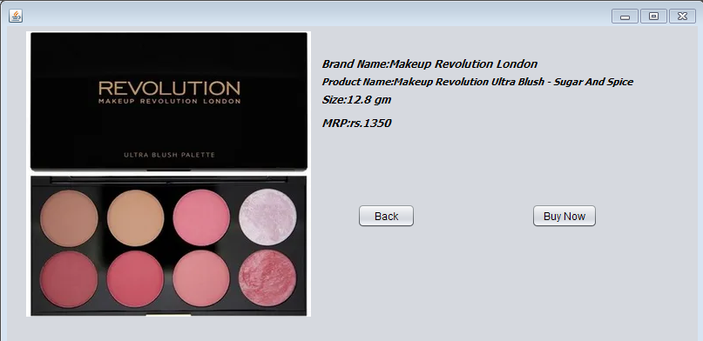

Pay4.java

Code:

/*

* To change this license header, choose License Headers in Project Properties.

* To change this template file, choose Tools | Templates

* and open the template in the editor.

*/

package beautyproducts;

/**

*

* @author js

*/

public class Pay4 extends javax.swing.JFrame {

/**

* Creates new form Pay4

*/

public Pay4() {

initComponents();

}

/**

* This method is called from within the constructor to initialize the form.

* WARNING: Do NOT modify this code. The content of this method is always

* regenerated by the Form Editor.

*/

@SuppressWarnings("unchecked")

// <editor-fold defaultstate="collapsed" desc="Generated Code">

private void initComponents() {

jLabel3 = new javax.swing.JLabel();

jTextField3 = new javax.swing.JTextField();

jLabel4 = new javax.swing.JLabel();

jTextField4 = new javax.swing.JTextField();

jLabel1 = new javax.swing.JLabel();

jLabel2 = new javax.swing.JLabel();

jplaceorder = new javax.swing.JButton();

jexit = new javax.swing.JButton();

jTextField1 = new javax.swing.JTextField();

jTextField2 = new javax.swing.JTextField();

jLabel5 = new javax.swing.JLabel();

jTextField5 = new javax.swing.JTextField();

jLabel6 = new javax.swing.JLabel();

jTextField6 = new javax.swing.JTextField();

jLabel7 = new javax.swing.JLabel();

jLabel8 = new javax.swing.JLabel();

jplaceorder1 = new javax.swing.JButton();

jexit1 = new javax.swing.JButton();

jTextField7 = new javax.swing.JTextField();

jTextField8 = new javax.swing.JTextField();

jLabel3.setText("Year of expiry");

jLabel4.setText("Total amount");

jLabel1.setText("Name");

jLabel2.setText("Card No");

jplaceorder.setText("Place Order");

jplaceorder.addActionListener(new java.awt.event.ActionListener() {

public void actionPerformed(java.awt.event.ActionEvent evt) {

jplaceorderActionPerformed(evt);

}

});

jexit.setText("Exit");

jexit.addActionListener(new java.awt.event.ActionListener() {

public void actionPerformed(java.awt.event.ActionEvent evt) {

jexitActionPerformed(evt);

}

});

setDefaultCloseOperation(javax.swing.WindowConstants.EXIT_ON_CLOSE);

jLabel5.setText("Year of expiry");

jLabel6.setText("Total amount");

jLabel7.setText("Name");

jLabel8.setText("Card No");

jplaceorder1.setText("Place Order");

jplaceorder1.addActionListener(new java.awt.event.ActionListener() {

public void actionPerformed(java.awt.event.ActionEvent evt) {

jplaceorder1ActionPerformed(evt);

}

});

jexit1.setText("Exit");

jexit1.addActionListener(new java.awt.event.ActionListener() {

public void actionPerformed(java.awt.event.ActionEvent evt) {

jexit1ActionPerformed(evt);

}

});

javax.swing.GroupLayout layout = new javax.swing.GroupLayout(getContentPane());

getContentPane().setLayout(layout);

layout.setHorizontalGroup(

layout.createParallelGroup(javax.swing.GroupLayout.Alignment.LEADING)

.addGroup(layout.createSequentialGroup()

.addGap(127, 127, 127)

.addGroup(layout.createParallelGroup(javax.swing.GroupLayout.Alignment.LEADING)

.addGroup(layout.createSequentialGroup()

.addComponent(jplaceorder1)

.addGap(127, 127, 127)

.addComponent(jexit1, javax.swing.GroupLayout.PREFERRED_SIZE, 93, javax.swing.GroupLayout.PREFERRED_SIZE))

.addGroup(layout.createSequentialGroup()

.addComponent(jLabel8)

.addPreferredGap(javax.swing.LayoutStyle.ComponentPlacement.RELATED, 270, javax.swing.GroupLayout.PREFERRED_SIZE))

.addGroup(javax.swing.GroupLayout.Alignment.TRAILING, layout.createSequentialGroup()

.addGroup(layout.createParallelGroup(javax.swing.GroupLayout.Alignment.LEADING)

.addComponent(jLabel5)

.addComponent(jLabel7, javax.swing.GroupLayout.PREFERRED_SIZE, 39, javax.swing.GroupLayout.PREFERRED_SIZE)

.addComponent(jLabel6))

.addPreferredGap(javax.swing.LayoutStyle.ComponentPlacement.RELATED, 150, Short.MAX_VALUE)

.addGroup(layout.createParallelGroup(javax.swing.GroupLayout.Alignment.TRAILING, false)

.addComponent(jTextField6)

.addComponent(jTextField7, javax.swing.GroupLayout.Alignment.LEADING)

.addComponent(jTextField8, javax.swing.GroupLayout.Alignment.LEADING)

.addComponent(jTextField5, javax.swing.GroupLayout.Alignment.LEADING, javax.swing.GroupLayout.PREFERRED_SIZE, 179, javax.swing.GroupLayout.PREFERRED_SIZE))

.addGap(58, 58, 58)))

.addGap(162, 162, 162))

);

layout.setVerticalGroup(

layout.createParallelGroup(javax.swing.GroupLayout.Alignment.LEADING)

.addGroup(layout.createSequentialGroup()

.addGap(74, 74, 74)

.addGroup(layout.createParallelGroup(javax.swing.GroupLayout.Alignment.BASELINE)

.addComponent(jTextField7, javax.swing.GroupLayout.PREFERRED_SIZE, javax.swing.GroupLayout.DEFAULT_SIZE, javax.swing.GroupLayout.PREFERRED_SIZE)

.addComponent(jLabel7))

.addGap(34, 34, 34)

.addGroup(layout.createParallelGroup(javax.swing.GroupLayout.Alignment.BASELINE)

.addComponent(jTextField8, javax.swing.GroupLayout.PREFERRED_SIZE, javax.swing.GroupLayout.DEFAULT_SIZE, javax.swing.GroupLayout.PREFERRED_SIZE)

.addComponent(jLabel8))

.addGap(36, 36, 36)

.addGroup(layout.createParallelGroup(javax.swing.GroupLayout.Alignment.BASELINE)

.addComponent(jLabel5)

.addComponent(jTextField5, javax.swing.GroupLayout.PREFERRED_SIZE, javax.swing.GroupLayout.DEFAULT_SIZE, javax.swing.GroupLayout.PREFERRED_SIZE))

.addGap(45, 45, 45)

.addGroup(layout.createParallelGroup(javax.swing.GroupLayout.Alignment.BASELINE)

.addComponent(jLabel6)

.addComponent(jTextField6, javax.swing.GroupLayout.PREFERRED_SIZE, javax.swing.GroupLayout.DEFAULT_SIZE, javax.swing.GroupLayout.PREFERRED_SIZE))

.addPreferredGap(javax.swing.LayoutStyle.ComponentPlacement.RELATED, 154, Short.MAX_VALUE)

.addGroup(layout.createParallelGroup(javax.swing.GroupLayout.Alignment.BASELINE)

.addComponent(jplaceorder1)

.addComponent(jexit1))

.addGap(41, 41, 41))

);

pack();

}// </editor-fold>

private void jplaceorderActionPerformed(java.awt.event.ActionEvent evt) {

}

private void jexitActionPerformed(java.awt.event.ActionEvent evt) {

System.exit(0);

}

private void jplaceorder1ActionPerformed(java.awt.event.ActionEvent evt) {

new Blush_bill().setVisible(true);

this.setVisible(false);

}

private void jexit1ActionPerformed(java.awt.event.ActionEvent evt) {

System.exit(0);

}

/**

* @param args the command line arguments

*/

public static void main(String args[]) {

/* Set the Nimbus look and feel */

//<editor-fold defaultstate="collapsed" desc=" Look and feel setting code (optional) ">

/* If Nimbus (introduced in Java SE 6) is not available, stay with the default look and feel.

* For details see http://download.oracle.com/javase/tutorial/uiswing/lookandfeel/plaf.html

*/

try {

for (javax.swing.UIManager.LookAndFeelInfo info : javax.swing.UIManager.getInstalledLookAndFeels()) {

if ("Nimbus".equals(info.getName())) {

javax.swing.UIManager.setLookAndFeel(info.getClassName());

break;

}

}

} catch (ClassNotFoundException ex) {

java.util.logging.Logger.getLogger(Pay4.class.getName()).log(java.util.logging.Level.SEVERE, null, ex);

} catch (InstantiationException ex) {

java.util.logging.Logger.getLogger(Pay4.class.getName()).log(java.util.logging.Level.SEVERE, null, ex);

} catch (IllegalAccessException ex) {

java.util.logging.Logger.getLogger(Pay4.class.getName()).log(java.util.logging.Level.SEVERE, null, ex);

} catch (javax.swing.UnsupportedLookAndFeelException ex) {

java.util.logging.Logger.getLogger(Pay4.class.getName()).log(java.util.logging.Level.SEVERE, null, ex);

}

//</editor-fold>

/* Create and display the form */

java.awt.EventQueue.invokeLater(new Runnable() {

public void run() {

new Pay4().setVisible(true);

}

});

}

// Variables declaration - do not modify

private javax.swing.JLabel jLabel1;

private javax.swing.JLabel jLabel2;

private javax.swing.JLabel jLabel3;

private javax.swing.JLabel jLabel4;

private javax.swing.JLabel jLabel5;

private javax.swing.JLabel jLabel6;

private javax.swing.JLabel jLabel7;

private javax.swing.JLabel jLabel8;

private javax.swing.JTextField jTextField1;

private javax.swing.JTextField jTextField2;

private javax.swing.JTextField jTextField3;

private javax.swing.JTextField jTextField4;

private javax.swing.JTextField jTextField5;

private javax.swing.JTextField jTextField6;

private javax.swing.JTextField jTextField7;

private javax.swing.JTextField jTextField8;

private javax.swing.JButton jexit;

private javax.swing.JButton jexit1;

private javax.swing.JButton jplaceorder;

private javax.swing.JButton jplaceorder1;

// End of variables declaration

}

Output:

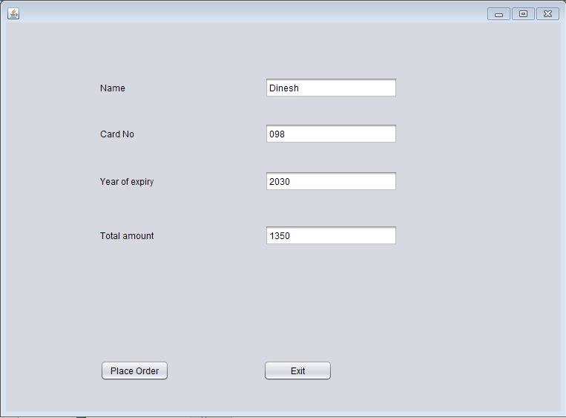

Blush_bill.java

Code:

/*

* To change this license header, choose License Headers in Project Properties.

* To change this template file, choose Tools | Templates

* and open the template in the editor.

*/

package beautyproducts;

import com.mysql.jdbc.Connection;

import com.mysql.jdbc.PreparedStatement;

import java.sql.DriverManager;

import java.sql.ResultSet;

import java.sql.SQLException;

import java.util.logging.Level;

import java.util.logging.Logger;

import javax.swing.JOptionPane;

import net.proteanit.sql.DbUtils;

/**

*

* @author js

*/

public class Blush_bill extends javax.swing.JFrame {

/**

* Creates new form Blush_bill

*/

Connection con = null;

PreparedStatement pst = null;

ResultSet rs = null;

public Blush_bill() {

initComponents();

String name,number,address;

}

public void Print(){

String name=txtname.getText();

String number=txtnumber.getText();

String address=txtaddress.getText();

txtbill.setText("\t"+"The Cosmetic Shop"+"\n"+"\n"

+"Brand:- Makeup Revolution London"+"\n"

+"Product Name:- Makeup Revolution Ultra Blush - Sugar And Spice" +"\n"

+"Price:- 1350"+"\n"

+"\n"+"********************");

txtbill.setText(txtbill.getText() +"\n"+"Coustomer name:- "+name);

txtbill.setText(txtbill.getText()+"\n"+"\n"+"Contact number:-"+number);

txtbill.setText(txtbill.getText() +"\n"+"\n"+"Address:-"+address);

txtbill.setText(txtbill.getText()+"\n"+"\n"+"\n"+"\n"+"\n"+"\n"+"\n"+"\t"+"**Thanks For Shopping**");

}

/**

* This method is called from within the constructor to initialize the form.

* WARNING: Do NOT modify this code. The content of this method is always

* regenerated by the Form Editor.

*/

@SuppressWarnings("unchecked")

// <editor-fold defaultstate="collapsed" desc="Generated Code">

private void initComponents() {

jLabel3 = new javax.swing.JLabel();

txtname = new javax.swing.JTextField();

txtnumber = new javax.swing.JTextField();

txtaddress = new javax.swing.JTextField();

jScrollPane1 = new javax.swing.JScrollPane();

txtbill = new javax.swing.JTextArea();

jButton1 = new javax.swing.JButton();

jButton2 = new javax.swing.JButton();

jLabel1 = new javax.swing.JLabel();

jLabel2 = new javax.swing.JLabel();

setDefaultCloseOperation(javax.swing.WindowConstants.EXIT_ON_CLOSE);

jLabel3.setText("Address:");

txtaddress.addActionListener(new java.awt.event.ActionListener() {

public void actionPerformed(java.awt.event.ActionEvent evt) {

txtaddressActionPerformed(evt);

}

});

txtbill.setColumns(20);

txtbill.setRows(5);

jScrollPane1.setViewportView(txtbill);

jButton1.setText("Ok");

jButton1.addActionListener(new java.awt.event.ActionListener() {

public void actionPerformed(java.awt.event.ActionEvent evt) {

jButton1ActionPerformed(evt);

}

});

jButton2.setText("Done");

jButton2.addActionListener(new java.awt.event.ActionListener() {

public void actionPerformed(java.awt.event.ActionEvent evt) {

jButton2ActionPerformed(evt);

}

});

jLabel1.setText("Customer Name:");

jLabel2.setText("Contact Number:");

javax.swing.GroupLayout layout = new javax.swing.GroupLayout(getContentPane());

getContentPane().setLayout(layout);

layout.setHorizontalGroup(

layout.createParallelGroup(javax.swing.GroupLayout.Alignment.LEADING)

.addGroup(layout.createSequentialGroup()

.addGap(37, 37, 37)

.addGroup(layout.createParallelGroup(javax.swing.GroupLayout.Alignment.TRAILING)

.addGroup(layout.createSequentialGroup()

.addGroup(layout.createParallelGroup(javax.swing.GroupLayout.Alignment.LEADING)

.addComponent(jLabel1)

.addComponent(jLabel2)

.addComponent(jLabel3))

.addGap(69, 69, 69)

.addGroup(layout.createParallelGroup(javax.swing.GroupLayout.Alignment.LEADING, false)

.addComponent(txtname, javax.swing.GroupLayout.DEFAULT_SIZE, 161, Short.MAX_VALUE)

.addComponent(txtnumber)

.addComponent(txtaddress)))

.addComponent(jButton1))

.addPreferredGap(javax.swing.LayoutStyle.ComponentPlacement.RELATED, 62, Short.MAX_VALUE)

.addComponent(jScrollPane1, javax.swing.GroupLayout.PREFERRED_SIZE, 309, javax.swing.GroupLayout.PREFERRED_SIZE)

.addGap(22, 22, 22))

.addGroup(javax.swing.GroupLayout.Alignment.TRAILING, layout.createSequentialGroup()

.addContainerGap(javax.swing.GroupLayout.DEFAULT_SIZE, Short.MAX_VALUE)

.addComponent(jButton2)

.addGap(126, 126, 126))

);

layout.setVerticalGroup(

layout.createParallelGroup(javax.swing.GroupLayout.Alignment.LEADING)

.addGroup(layout.createSequentialGroup()

.addGap(52, 52, 52)

.addGroup(layout.createParallelGroup(javax.swing.GroupLayout.Alignment.BASELINE)

.addComponent(jLabel1)

.addComponent(txtname, javax.swing.GroupLayout.PREFERRED_SIZE, javax.swing.GroupLayout.DEFAULT_SIZE, javax.swing.GroupLayout.PREFERRED_SIZE))

.addGap(29, 29, 29)

.addGroup(layout.createParallelGroup(javax.swing.GroupLayout.Alignment.BASELINE)

.addComponent(jLabel2)

.addComponent(txtnumber, javax.swing.GroupLayout.PREFERRED_SIZE, javax.swing.GroupLayout.DEFAULT_SIZE, javax.swing.GroupLayout.PREFERRED_SIZE))

.addGap(40, 40, 40)

.addGroup(layout.createParallelGroup(javax.swing.GroupLayout.Alignment.BASELINE)

.addComponent(jLabel3)

.addComponent(txtaddress, javax.swing.GroupLayout.PREFERRED_SIZE, 109, javax.swing.GroupLayout.PREFERRED_SIZE))

.addGap(67, 67, 67)

.addComponent(jButton1)

.addContainerGap(javax.swing.GroupLayout.DEFAULT_SIZE, Short.MAX_VALUE))

.addGroup(javax.swing.GroupLayout.Alignment.TRAILING, layout.createSequentialGroup()

.addContainerGap(javax.swing.GroupLayout.DEFAULT_SIZE, Short.MAX_VALUE)

.addComponent(jScrollPane1, javax.swing.GroupLayout.PREFERRED_SIZE, 418, javax.swing.GroupLayout.PREFERRED_SIZE)

.addGap(18, 18, 18)

.addComponent(jButton2)

.addGap(10, 10, 10))

);

pack();

}// </editor-fold>

private void txtaddressActionPerformed(java.awt.event.ActionEvent evt) {

// TODO add your handling code here:

}

private void jButton1ActionPerformed(java.awt.event.ActionEvent evt) {

Print();

}

private void jButton2ActionPerformed(java.awt.event.ActionEvent evt) {

try

{

String sql = "INSERT INTO customer_details"

+"(CustomerName,CustomerNumber,Address)"

+"VALUES (?,?,?)";

con = (Connection) DriverManager.getConnection("jdbc:mysql://localhost/details","root","");

pst = (PreparedStatement) con.prepareStatement(sql);

pst.setString(1,txtname.getText());

pst.setString(2,txtnumber.getText());

pst.setString(3,txtaddress.getText());

pst.executeUpdate();

JOptionPane.showMessageDialog(null, "Thank you for shopping!!");

txtname.setText(null);

txtnumber.setText(null);

txtaddress.setText(null);

}

catch(Exception ex)

{

JOptionPane.showMessageDialog(null, ex);

}

}

/**

* @param args the command line arguments

*/

public static void main(String args[]) {

/* Set the Nimbus look and feel */

//<editor-fold defaultstate="collapsed" desc=" Look and feel setting code (optional) ">

/* If Nimbus (introduced in Java SE 6) is not available, stay with the default look and feel.

* For details see http://download.oracle.com/javase/tutorial/uiswing/lookandfeel/plaf.html

*/

try {

for (javax.swing.UIManager.LookAndFeelInfo info : javax.swing.UIManager.getInstalledLookAndFeels()) {

if ("Nimbus".equals(info.getName())) {

javax.swing.UIManager.setLookAndFeel(info.getClassName());

break;

}

}

} catch (ClassNotFoundException ex) {

java.util.logging.Logger.getLogger(Blush_bill.class.getName()).log(java.util.logging.Level.SEVERE, null, ex);

} catch (InstantiationException ex) {

java.util.logging.Logger.getLogger(Blush_bill.class.getName()).log(java.util.logging.Level.SEVERE, null, ex);

} catch (IllegalAccessException ex) {

java.util.logging.Logger.getLogger(Blush_bill.class.getName()).log(java.util.logging.Level.SEVERE, null, ex);

} catch (javax.swing.UnsupportedLookAndFeelException ex) {

java.util.logging.Logger.getLogger(Blush_bill.class.getName()).log(java.util.logging.Level.SEVERE, null, ex);

}

//</editor-fold>

/* Create and display the form */

java.awt.EventQueue.invokeLater(new Runnable() {

public void run() {

new Blush_bill().setVisible(true);

}

});

}

// Variables declaration - do not modify

private javax.swing.JButton jButton1;

private javax.swing.JButton jButton2;

private javax.swing.JLabel jLabel1;

private javax.swing.JLabel jLabel2;

private javax.swing.JLabel jLabel3;

private javax.swing.JScrollPane jScrollPane1;

private javax.swing.JTextField txtaddress;

private javax.swing.JTextArea txtbill;

private javax.swing.JTextField txtname;

private javax.swing.JTextField txtnumber;

// End of variables declaration

}

Output:

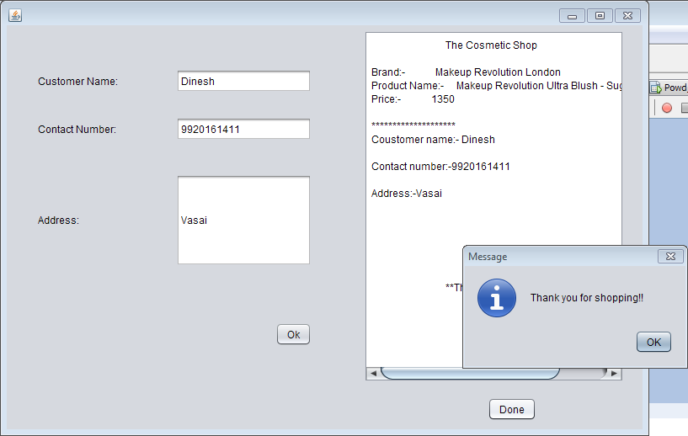

Highlighter.java

Code:

/*

* To change this license header, choose License Headers in Project Properties.

* To change this template file, choose Tools | Templates

* and open the template in the editor.

*/

package beautyproducts;

/**

*

* @author js

*/

public class Highlighter extends javax.swing.JFrame {

/**

* Creates new form Highlighter

*/

public Highlighter() {

initComponents();

}

/**

* This method is called from within the constructor to initialize the form.

* WARNING: Do NOT modify this code. The content of this method is always

* regenerated by the Form Editor.

*/

@SuppressWarnings("unchecked")

// <editor-fold defaultstate="collapsed" desc="Generated Code">

private void initComponents() {

jLabel1 = new javax.swing.JLabel();

jLabel2 = new javax.swing.JLabel();

jLabel3 = new javax.swing.JLabel();

jLabel4 = new javax.swing.JLabel();

jLabel5 = new javax.swing.JLabel();

jButton1 = new javax.swing.JButton();

jButton3 = new javax.swing.JButton();

setDefaultCloseOperation(javax.swing.WindowConstants.EXIT_ON_CLOSE);

jLabel1.setIcon(new javax.swing.ImageIcon("C:\\Users\\js\\Desktop\\9.PNG")); // NOI18N

jLabel1.setText("jLabel1");

jLabel2.setFont(new java.awt.Font("Tahoma", 3, 12)); // NOI18N

jLabel2.setText("Company Name:Nykaa");

jLabel3.setFont(new java.awt.Font("Tahoma", 3, 10)); // NOI18N

jLabel3.setText("Product Name:Nykaa Glow Getter Highlighting Duo Palette-Gliterrati 02");

jLabel4.setFont(new java.awt.Font("Tahoma", 3, 12)); // NOI18N

jLabel4.setText("Size:9 gm");

jLabel5.setFont(new java.awt.Font("Tahoma", 3, 12)); // NOI18N

jLabel5.setText("MRP:rs.559");

jButton1.setText("Buy Now");

jButton1.addActionListener(new java.awt.event.ActionListener() {

public void actionPerformed(java.awt.event.ActionEvent evt) {

jButton1ActionPerformed(evt);

}

});

jButton3.setText("Back");

jButton3.addActionListener(new java.awt.event.ActionListener() {

public void actionPerformed(java.awt.event.ActionEvent evt) {

jButton3ActionPerformed(evt);

}

});

javax.swing.GroupLayout layout = new javax.swing.GroupLayout(getContentPane());

getContentPane().setLayout(layout);

layout.setHorizontalGroup(

layout.createParallelGroup(javax.swing.GroupLayout.Alignment.LEADING)

.addGroup(layout.createSequentialGroup()

.addContainerGap()

.addComponent(jLabel1, javax.swing.GroupLayout.PREFERRED_SIZE, 336, javax.swing.GroupLayout.PREFERRED_SIZE)

.addGroup(layout.createParallelGroup(javax.swing.GroupLayout.Alignment.LEADING)

.addGroup(layout.createSequentialGroup()

.addGap(20, 20, 20)

.addGroup(layout.createParallelGroup(javax.swing.GroupLayout.Alignment.LEADING)

.addComponent(jLabel3, javax.swing.GroupLayout.PREFERRED_SIZE, 386, javax.swing.GroupLayout.PREFERRED_SIZE)

.addComponent(jLabel2, javax.swing.GroupLayout.PREFERRED_SIZE, 142, javax.swing.GroupLayout.PREFERRED_SIZE)))

.addGroup(layout.createSequentialGroup()

.addGap(18, 18, 18)

.addComponent(jLabel4, javax.swing.GroupLayout.PREFERRED_SIZE, 71, javax.swing.GroupLayout.PREFERRED_SIZE))

.addGroup(layout.createSequentialGroup()

.addGap(18, 18, 18)

.addGroup(layout.createParallelGroup(javax.swing.GroupLayout.Alignment.LEADING)

.addGroup(layout.createSequentialGroup()

.addComponent(jButton3, javax.swing.GroupLayout.PREFERRED_SIZE, 67, javax.swing.GroupLayout.PREFERRED_SIZE)

.addGap(144, 144, 144)

.addComponent(jButton1))

.addComponent(jLabel5, javax.swing.GroupLayout.PREFERRED_SIZE, 82, javax.swing.GroupLayout.PREFERRED_SIZE))))

.addContainerGap(67, Short.MAX_VALUE))

);

layout.setVerticalGroup(

layout.createParallelGroup(javax.swing.GroupLayout.Alignment.LEADING)

.addGroup(layout.createSequentialGroup()

.addGroup(layout.createParallelGroup(javax.swing.GroupLayout.Alignment.LEADING)

.addGroup(layout.createSequentialGroup()

.addContainerGap()

.addComponent(jLabel1, javax.swing.GroupLayout.PREFERRED_SIZE, 250, javax.swing.GroupLayout.PREFERRED_SIZE))

.addGroup(layout.createSequentialGroup()

.addGap(25, 25, 25)

.addComponent(jLabel2)

.addPreferredGap(javax.swing.LayoutStyle.ComponentPlacement.UNRELATED)

.addComponent(jLabel3)

.addPreferredGap(javax.swing.LayoutStyle.ComponentPlacement.RELATED)

.addComponent(jLabel4)

.addGap(11, 11, 11)

.addComponent(jLabel5)

.addGap(31, 31, 31)

.addGroup(layout.createParallelGroup(javax.swing.GroupLayout.Alignment.BASELINE)

.addComponent(jButton1)

.addComponent(jButton3))))

.addContainerGap(265, Short.MAX_VALUE))

);

pack();

}// </editor-fold>

private void jButton1ActionPerformed(java.awt.event.ActionEvent evt) {

new Pay5().setVisible(true);

this.setVisible(false);

}

private void jButton3ActionPerformed(java.awt.event.ActionEvent evt) {

new BuyProduct().setVisible(true);

this.setVisible(false);

}

/**

* @param args the command line arguments

*/

public static void main(String args[]) {

/* Set the Nimbus look and feel */

//<editor-fold defaultstate="collapsed" desc=" Look and feel setting code (optional) ">

/* If Nimbus (introduced in Java SE 6) is not available, stay with the default look and feel.

* For details see http://download.oracle.com/javase/tutorial/uiswing/lookandfeel/plaf.html

*/

try { for (javax.swing.UIManager.LookAndFeelInfo info : javax.swing.UIManager.getInstalledLookAndFeels()) {

if ("Nimbus".equals(info.getName())) {

javax.swing.UIManager.setLookAndFeel(info.getClassName());

break;

}

}

} catch (ClassNotFoundException ex) {

java.util.logging.Logger.getLogger(Highlighter.class.getName()).log(java.util.logging.Level.SEVERE, null, ex);

} catch (InstantiationException ex) {

java.util.logging.Logger.getLogger(Highlighter.class.getName()).log(java.util.logging.Level.SEVERE, null, ex);

} catch (IllegalAccessException ex) {

java.util.logging.Logger.getLogger(Highlighter.class.getName()).log(java.util.logging.Level.SEVERE, null, ex);

} catch (javax.swing.UnsupportedLookAndFeelException ex) {

java.util.logging.Logger.getLogger(Highlighter.class.getName()).log(java.util.logging.Level.SEVERE, null, ex);

}

//</editor-fold> /* Create and display the form */

java.awt.EventQueue.invokeLater(new Runnable() {

public void run() {

new Highlighter().setVisible(true);

}

});

} // Variables declaration - do not modify

private javax.swing.JButton jButton1;

private javax.swing.JButton jButton3;

private javax.swing.JLabel jLabel1;

private javax.swing.JLabel jLabel2;

private javax.swing.JLabel jLabel3;

private javax.swing.JLabel jLabel4;

private javax.swing.JLabel jLabel5;

// End of variables declaration

}

Output:

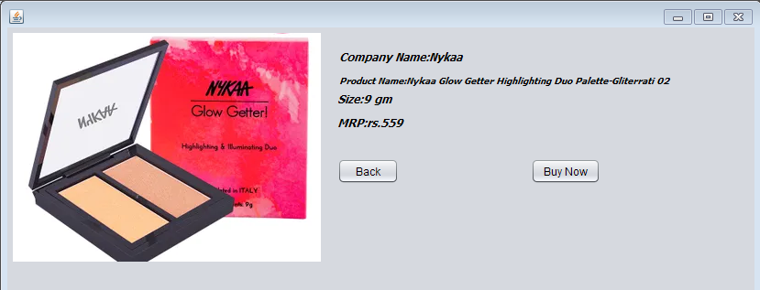

Pay5.java

Code:

/*

* To change this license header, choose License Headers in Project Properties.

* To change this template file, choose Tools | Templates

* and open the template in the editor.

*/

package beautyproducts;

/**

*

* @author js

*/

public class Pay5 extends javax.swing.JFrame {

/**

* Creates new form Pay5

*/

public Pay5() {

initComponents();

}

/**

* This method is called from within the constructor to initialize the form.

* WARNING: Do NOT modify this code. The content of this method is always

* regenerated by the Form Editor.

*/

@SuppressWarnings("unchecked")

// <editor-fold defaultstate="collapsed" desc="Generated Code">

private void initComponents() {

jLabel5 = new javax.swing.JLabel();

jTextField5 = new javax.swing.JTextField();

jLabel6 = new javax.swing.JLabel();

jTextField6 = new javax.swing.JTextField();

jLabel7 = new javax.swing.JLabel();

jLabel8 = new javax.swing.JLabel();

jplaceorder1 = new javax.swing.JButton();

jexit1 = new javax.swing.JButton();

jTextField7 = new javax.swing.JTextField();

jTextField8 = new javax.swing.JTextField();

setDefaultCloseOperation(javax.swing.WindowConstants.EXIT_ON_CLOSE);

jLabel5.setText("Year of expiry");

jLabel6.setText("Total amount");

jLabel7.setText("Name");

jLabel8.setText("Card No");

jplaceorder1.setText("Place Order");

jplaceorder1.addActionListener(new java.awt.event.ActionListener() {

public void actionPerformed(java.awt.event.ActionEvent evt) {

jplaceorder1ActionPerformed(evt);

}

});

jexit1.setText("Exit");

jexit1.addActionListener(new java.awt.event.ActionListener() {

public void actionPerformed(java.awt.event.ActionEvent evt) {

jexit1ActionPerformed(evt);

}

});

javax.swing.GroupLayout layout = new javax.swing.GroupLayout(getContentPane());

getContentPane().setLayout(layout);

layout.setHorizontalGroup(

layout.createParallelGroup(javax.swing.GroupLayout.Alignment.LEADING)

.addGroup(layout.createSequentialGroup()

.addGap(127, 127, 127)

.addGroup(layout.createParallelGroup(javax.swing.GroupLayout.Alignment.LEADING)

.addGroup(layout.createSequentialGroup()

.addComponent(jplaceorder1)

.addGap(127, 127, 127)

.addComponent(jexit1, javax.swing.GroupLayout.PREFERRED_SIZE, 93, javax.swing.GroupLayout.PREFERRED_SIZE))

.addGroup(layout.createSequentialGroup()

.addComponent(jLabel8)

.addPreferredGap(javax.swing.LayoutStyle.ComponentPlacement.RELATED, 270, javax.swing.GroupLayout.PREFERRED_SIZE))

.addGroup(javax.swing.GroupLayout.Alignment.TRAILING, layout.createSequentialGroup()

.addGroup(layout.createParallelGroup(javax.swing.GroupLayout.Alignment.LEADING)

.addComponent(jLabel5)

.addComponent(jLabel7, javax.swing.GroupLayout.PREFERRED_SIZE, 39, javax.swing.GroupLayout.PREFERRED_SIZE)

.addComponent(jLabel6))

.addPreferredGap(javax.swing.LayoutStyle.ComponentPlacement.RELATED, javax.swing.GroupLayout.DEFAULT_SIZE, Short.MAX_VALUE)

.addGroup(layout.createParallelGroup(javax.swing.GroupLayout.Alignment.TRAILING, false)

.addComponent(jTextField6)

.addComponent(jTextField7, javax.swing.GroupLayout.Alignment.LEADING)

.addComponent(jTextField8, javax.swing.GroupLayout.Alignment.LEADING)

.addComponent(jTextField5, javax.swing.GroupLayout.Alignment.LEADING, javax.swing.GroupLayout.PREFERRED_SIZE, 179, javax.swing.GroupLayout.PREFERRED_SIZE))

.addGap(58, 58, 58)))

.addGap(162, 162, 162))

);

layout.setVerticalGroup(

layout.createParallelGroup(javax.swing.GroupLayout.Alignment.LEADING)

.addGroup(layout.createSequentialGroup()

.addGap(74, 74, 74)

.addGroup(layout.createParallelGroup(javax.swing.GroupLayout.Alignment.BASELINE)

.addComponent(jTextField7, javax.swing.GroupLayout.PREFERRED_SIZE, javax.swing.GroupLayout.DEFAULT_SIZE, javax.swing.GroupLayout.PREFERRED_SIZE)

.addComponent(jLabel7))

.addGap(34, 34, 34)

.addGroup(layout.createParallelGroup(javax.swing.GroupLayout.Alignment.BASELINE)

.addComponent(jTextField8, javax.swing.GroupLayout.PREFERRED_SIZE, javax.swing.GroupLayout.DEFAULT_SIZE, javax.swing.GroupLayout.PREFERRED_SIZE)

.addComponent(jLabel8))

.addGap(36, 36, 36)

.addGroup(layout.createParallelGroup(javax.swing.GroupLayout.Alignment.BASELINE)

.addComponent(jLabel5)

.addComponent(jTextField5, javax.swing.GroupLayout.PREFERRED_SIZE, javax.swing.GroupLayout.DEFAULT_SIZE, javax.swing.GroupLayout.PREFERRED_SIZE))

.addGap(45, 45, 45)

.addGroup(layout.createParallelGroup(javax.swing.GroupLayout.Alignment.BASELINE)

.addComponent(jLabel6)

.addComponent(jTextField6, javax.swing.GroupLayout.PREFERRED_SIZE, javax.swing.GroupLayout.DEFAULT_SIZE, javax.swing.GroupLayout.PREFERRED_SIZE))

.addPreferredGap(javax.swing.LayoutStyle.ComponentPlacement.RELATED, javax.swing.GroupLayout.DEFAULT_SIZE, Short.MAX_VALUE)

.addGroup(layout.createParallelGroup(javax.swing.GroupLayout.Alignment.BASELINE)

.addComponent(jplaceorder1)

.addComponent(jexit1))

.addGap(41, 41, 41))

);

pack();

}// </editor-fold>

private void jplaceorder1ActionPerformed(java.awt.event.ActionEvent evt) {

new High_bill().setVisible(true);

this.setVisible(false);

}

private void jexit1ActionPerformed(java.awt.event.ActionEvent evt) {

System.exit(0);

}

/**

* @param args the command line arguments

*/

public static void main(String args[]) {

/* Set the Nimbus look and feel */

//<editor-fold defaultstate="collapsed" desc=" Look and feel setting code (optional) ">

/* If Nimbus (introduced in Java SE 6) is not available, stay with the default look and feel.

* For details see http://download.oracle.com/javase/tutorial/uiswing/lookandfeel/plaf.html

*/

try {

for (javax.swing.UIManager.LookAndFeelInfo info : javax.swing.UIManager.getInstalledLookAndFeels()) {

if ("Nimbus".equals(info.getName())) {

javax.swing.UIManager.setLookAndFeel(info.getClassName());

break;

}

}

} catch (ClassNotFoundException ex) {

java.util.logging.Logger.getLogger(Pay5.class.getName()).log(java.util.logging.Level.SEVERE, null, ex);

} catch (InstantiationException ex) {

java.util.logging.Logger.getLogger(Pay5.class.getName()).log(java.util.logging.Level.SEVERE, null, ex);

} catch (IllegalAccessException ex) {

java.util.logging.Logger.getLogger(Pay5.class.getName()).log(java.util.logging.Level.SEVERE, null, ex);

} catch (javax.swing.UnsupportedLookAndFeelException ex) {

java.util.logging.Logger.getLogger(Pay5.class.getName()).log(java.util.logging.Level.SEVERE, null, ex);

}

//</editor-fold>

/* Create and display the form */

java.awt.EventQueue.invokeLater(new Runnable() {

public void run() {

new Pay5().setVisible(true);

}

});

}

// Variables declaration - do not modify

private javax.swing.JLabel jLabel5;

private javax.swing.JLabel jLabel6;

private javax.swing.JLabel jLabel7;

private javax.swing.JLabel jLabel8;

private javax.swing.JTextField jTextField5;

private javax.swing.JTextField jTextField6;

private javax.swing.JTextField jTextField7;

private javax.swing.JTextField jTextField8;

private javax.swing.JButton jexit1;

private javax.swing.JButton jplaceorder1;

// End of variables declaration

}

Output:

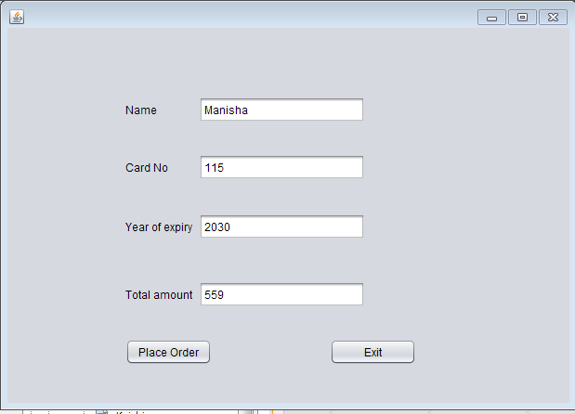

High_bill.java

Code:

/*

* To change this license header, choose License Headers in Project Properties.

* To change this template file, choose Tools | Templates

* and open the template in the editor.

*/

package beautyproducts;

import com.mysql.jdbc.Connection;

import com.mysql.jdbc.PreparedStatement;

import java.sql.DriverManager;

import java.sql.ResultSet;

import java.sql.SQLException;

import java.util.logging.Level;

import java.util.logging.Logger;

import javax.swing.JOptionPane;

import net.proteanit.sql.DbUtils;

/**

*

* @author js

*/

public class High_bill extends javax.swing.JFrame {

/**

* Creates new form High_bill

*/

Connection con = null;

PreparedStatement pst = null;

ResultSet rs = null;

public High_bill() {

initComponents();

String name,number,address;

}

public void Print(){

String name=txtname.getText();

String number=txtnumber.getText();

String address=txtaddress.getText();

txtbill.setText("\t"+"The Cosmetic Shop"+"\n"+"\n"

+"Brand:- Nykaa"+"\n"

+"Product Name:- Nykaa Glow Getter Highlighting Duo Palette-Gliterrati 02" +"\n"

+"Price:- 559"+"\n"

+"\n"+"********************");

txtbill.setText(txtbill.getText() +"\n"+"Coustomer name:- "+name);

txtbill.setText(txtbill.getText()+"\n"+"\n"+"Contact number:-"+number);

txtbill.setText(txtbill.getText() +"\n"+"\n"+"Address:-"+address);

txtbill.setText(txtbill.getText()+"\n"+"\n"+"\n"+"\n"+"\n"+"\n"+"\n"+"\t"+"**Thanks For Shopping**");

}

/**

* This method is called from within the constructor to initialize the form.

* WARNING: Do NOT modify this code. The content of this method is always

* regenerated by the Form Editor.

*/

@SuppressWarnings("unchecked")

// <editor-fold defaultstate="collapsed" desc="Generated Code">

private void initComponents() {

jLabel3 = new javax.swing.JLabel();

txtname = new javax.swing.JTextField();

txtnumber = new javax.swing.JTextField();

txtaddress = new javax.swing.JTextField();

jScrollPane1 = new javax.swing.JScrollPane();

txtbill = new javax.swing.JTextArea();

jButton1 = new javax.swing.JButton();

jButton2 = new javax.swing.JButton();

jLabel1 = new javax.swing.JLabel();

jLabel2 = new javax.swing.JLabel();

setDefaultCloseOperation(javax.swing.WindowConstants.EXIT_ON_CLOSE);

jLabel3.setText("Address:");

txtaddress.addActionListener(new java.awt.event.ActionListener() {

public void actionPerformed(java.awt.event.ActionEvent evt) {

txtaddressActionPerformed(evt);

}

});

txtbill.setColumns(20);

txtbill.setRows(5);

jScrollPane1.setViewportView(txtbill);

jButton1.setText("Ok");

jButton1.addActionListener(new java.awt.event.ActionListener() {

public void actionPerformed(java.awt.event.ActionEvent evt) {

jButton1ActionPerformed(evt);

}

});

jButton2.setText("Done");

jButton2.addActionListener(new java.awt.event.ActionListener() {

public void actionPerformed(java.awt.event.ActionEvent evt) {

jButton2ActionPerformed(evt);

}

});

jLabel1.setText("Customer Name:");

jLabel2.setText("Contact Number:");

javax.swing.GroupLayout layout = new javax.swing.GroupLayout(getContentPane());

getContentPane().setLayout(layout);

layout.setHorizontalGroup(

layout.createParallelGroup(javax.swing.GroupLayout.Alignment.LEADING)

.addGroup(layout.createSequentialGroup()

.addGap(37, 37, 37)

.addGroup(layout.createParallelGroup(javax.swing.GroupLayout.Alignment.TRAILING)

.addGroup(layout.createSequentialGroup()

.addGroup(layout.createParallelGroup(javax.swing.GroupLayout.Alignment.LEADING)

.addComponent(jLabel1)

.addComponent(jLabel2)

.addComponent(jLabel3))

.addGap(69, 69, 69)

.addGroup(layout.createParallelGroup(javax.swing.GroupLayout.Alignment.LEADING, false)

.addComponent(txtname, javax.swing.GroupLayout.DEFAULT_SIZE, 161, Short.MAX_VALUE)

.addComponent(txtnumber)

.addComponent(txtaddress)))

.addComponent(jButton1))

.addPreferredGap(javax.swing.LayoutStyle.ComponentPlacement.RELATED, 66, Short.MAX_VALUE)

.addComponent(jScrollPane1, javax.swing.GroupLayout.PREFERRED_SIZE, 309, javax.swing.GroupLayout.PREFERRED_SIZE)

.addGap(22, 22, 22))

.addGroup(javax.swing.GroupLayout.Alignment.TRAILING, layout.createSequentialGroup()

.addContainerGap(javax.swing.GroupLayout.DEFAULT_SIZE, Short.MAX_VALUE)

.addComponent(jButton2)

.addGap(126, 126, 126))

);

layout.setVerticalGroup(

layout.createParallelGroup(javax.swing.GroupLayout.Alignment.LEADING)

.addGroup(layout.createSequentialGroup()

.addGap(52, 52, 52)

.addGroup(layout.createParallelGroup(javax.swing.GroupLayout.Alignment.BASELINE)

.addComponent(jLabel1)

.addComponent(txtname, javax.swing.GroupLayout.PREFERRED_SIZE, javax.swing.GroupLayout.DEFAULT_SIZE, javax.swing.GroupLayout.PREFERRED_SIZE))

.addGap(29, 29, 29)

.addGroup(layout.createParallelGroup(javax.swing.GroupLayout.Alignment.BASELINE)

.addComponent(jLabel2)

.addComponent(txtnumber, javax.swing.GroupLayout.PREFERRED_SIZE, javax.swing.GroupLayout.DEFAULT_SIZE, javax.swing.GroupLayout.PREFERRED_SIZE))

.addGap(40, 40, 40)

.addGroup(layout.createParallelGroup(javax.swing.GroupLayout.Alignment.BASELINE)

.addComponent(jLabel3)

.addComponent(txtaddress, javax.swing.GroupLayout.PREFERRED_SIZE, 109, javax.swing.GroupLayout.PREFERRED_SIZE))

.addGap(67, 67, 67)

.addComponent(jButton1)

.addContainerGap(javax.swing.GroupLayout.DEFAULT_SIZE, Short.MAX_VALUE))

.addGroup(javax.swing.GroupLayout.Alignment.TRAILING, layout.createSequentialGroup()

.addContainerGap(19, Short.MAX_VALUE)

.addComponent(jScrollPane1, javax.swing.GroupLayout.PREFERRED_SIZE, 418, javax.swing.GroupLayout.PREFERRED_SIZE)

.addGap(18, 18, 18)

.addComponent(jButton2)

.addGap(10, 10, 10))

);

pack();

}// </editor-fold>

private void txtaddressActionPerformed(java.awt.event.ActionEvent evt) {

// TODO add your handling code here:

}

private void jButton1ActionPerformed(java.awt.event.ActionEvent evt) {

Print();

}

private void jButton2ActionPerformed(java.awt.event.ActionEvent evt) {

try

{

String sql = "INSERT INTO customer_details"

+"(CustomerName,CustomerNumber,Address)"

+"VALUES (?,?,?)";

con = (Connection) DriverManager.getConnection("jdbc:mysql://localhost/details","root","");

pst = (PreparedStatement) con.prepareStatement(sql);

pst.setString(1,txtname.getText());

pst.setString(2,txtnumber.getText());

pst.setString(3,txtaddress.getText());

pst.executeUpdate();

JOptionPane.showMessageDialog(null, "Thank you for shopping!!");

txtname.setText(null);

txtnumber.setText(null);

txtaddress.setText(null);

}

catch(Exception ex)

{

JOptionPane.showMessageDialog(null, ex);

}

}

/**

* @param args the command line arguments

*/

public static void main(String args[]) {

/* Set the Nimbus look and feel */

//<editor-fold defaultstate="collapsed" desc=" Look and feel setting code (optional) ">

/* If Nimbus (introduced in Java SE 6) is not available, stay with the default look and feel.

* For details see http://download.oracle.com/javase/tutorial/uiswing/lookandfeel/plaf.html

*/

try {

for (javax.swing.UIManager.LookAndFeelInfo info : javax.swing.UIManager.getInstalledLookAndFeels()) {

if ("Nimbus".equals(info.getName())) {

javax.swing.UIManager.setLookAndFeel(info.getClassName());

break;

}

}

} catch (ClassNotFoundException ex) {

java.util.logging.Logger.getLogger(High_bill.class.getName()).log(java.util.logging.Level.SEVERE, null, ex);

} catch (InstantiationException ex) {

java.util.logging.Logger.getLogger(High_bill.class.getName()).log(java.util.logging.Level.SEVERE, null, ex);

} catch (IllegalAccessException ex) {

java.util.logging.Logger.getLogger(High_bill.class.getName()).log(java.util.logging.Level.SEVERE, null, ex);

} catch (javax.swing.UnsupportedLookAndFeelException ex) {

java.util.logging.Logger.getLogger(High_bill.class.getName()).log(java.util.logging.Level.SEVERE, null, ex);

}

//</editor-fold>

/* Create and display the form */

java.awt.EventQueue.invokeLater(new Runnable() {

public void run() {

new High_bill().setVisible(true);

}

});

}

// Variables declaration - do not modify

private javax.swing.JButton jButton1;

private javax.swing.JButton jButton2;

private javax.swing.JLabel jLabel1;

private javax.swing.JLabel jLabel2;

private javax.swing.JLabel jLabel3;

private javax.swing.JScrollPane jScrollPane1;

private javax.swing.JTextField txtaddress;

private javax.swing.JTextArea txtbill;

private javax.swing.JTextField txtname;

private javax.swing.JTextField txtnumber;

// End of variables declaration

}

Output:

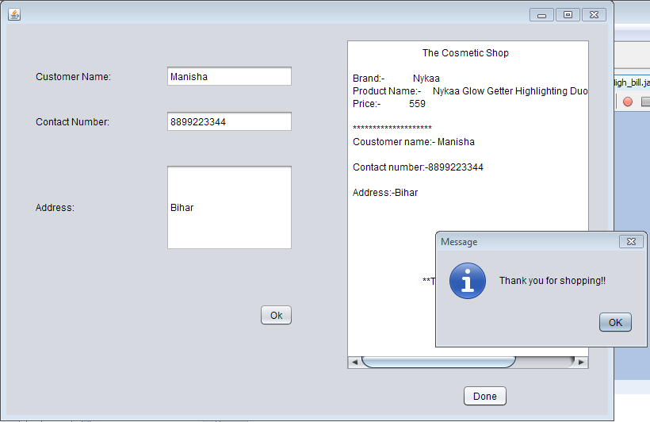

Concealer.java

Code:

/*

* To change this license header, choose License Headers in Project Properties.

* To change this template file, choose Tools | Templates

* and open the template in the editor.

*/

package beautyproducts;

/**

*

* @author js

*/

public class Concealer extends javax.swing.JFrame {

/**

* Creates new form Concealer

*/

public Concealer() {

initComponents();

}

/**

* This method is called from within the constructor to initialize the form.

* WARNING: Do NOT modify this code. The content of this method is always

* regenerated by the Form Editor.

*/

@SuppressWarnings("unchecked")

// <editor-fold defaultstate="collapsed" desc="Generated Code">

private void initComponents() {

jLabel1 = new javax.swing.JLabel();

jLabel2 = new javax.swing.JLabel();

jLabel3 = new javax.swing.JLabel();

jLabel4 = new javax.swing.JLabel();

jLabel5 = new javax.swing.JLabel();

jButton1 = new javax.swing.JButton();

jButton3 = new javax.swing.JButton();

setDefaultCloseOperation(javax.swing.WindowConstants.EXIT_ON_CLOSE);

jLabel1.setIcon(new javax.swing.ImageIcon("C:\\Users\\js\\Desktop\\11.PNG")); // NOI18N

jLabel1.setText("jLabel1");

jLabel2.setFont(new java.awt.Font("Tahoma", 3, 12)); // NOI18N

jLabel2.setText("Company Name: Loreal Paris ");

jLabel3.setFont(new java.awt.Font("Tahoma", 3, 12)); // NOI18N

jLabel3.setText("Product Name: L'Oreal Paris Infallible Full Wear Concealer - 314");

jLabel4.setFont(new java.awt.Font("Tahoma", 3, 12)); // NOI18N

jLabel4.setText("Size:10 ml");

jLabel5.setFont(new java.awt.Font("Tahoma", 3, 12)); // NOI18N

jLabel5.setText("MRP:rs.649");

jButton1.setText("Buy Now");

jButton1.addActionListener(new java.awt.event.ActionListener() {

public void actionPerformed(java.awt.event.ActionEvent evt) {

jButton1ActionPerformed(evt);

}

});

jButton3.setText("Back");

jButton3.addActionListener(new java.awt.event.ActionListener() {

public void actionPerformed(java.awt.event.ActionEvent evt) {

jButton3ActionPerformed(evt);

}

});

javax.swing.GroupLayout layout = new javax.swing.GroupLayout(getContentPane());

getContentPane().setLayout(layout);

layout.setHorizontalGroup(

layout.createParallelGroup(javax.swing.GroupLayout.Alignment.LEADING)

.addGroup(layout.createSequentialGroup()

.addContainerGap()

.addComponent(jLabel1, javax.swing.GroupLayout.PREFERRED_SIZE, 250, javax.swing.GroupLayout.PREFERRED_SIZE)

.addGap(54, 54, 54)

.addGroup(layout.createParallelGroup(javax.swing.GroupLayout.Alignment.LEADING)

.addGroup(layout.createSequentialGroup()

.addGroup(layout.createParallelGroup(javax.swing.GroupLayout.Alignment.LEADING)

.addComponent(jLabel2)

.addComponent(jLabel3, javax.swing.GroupLayout.PREFERRED_SIZE, 397, javax.swing.GroupLayout.PREFERRED_SIZE)

.addGroup(layout.createParallelGroup(javax.swing.GroupLayout.Alignment.TRAILING, false)

.addComponent(jLabel5, javax.swing.GroupLayout.Alignment.LEADING, javax.swing.GroupLayout.DEFAULT_SIZE, 76, Short.MAX_VALUE)

.addComponent(jLabel4, javax.swing.GroupLayout.Alignment.LEADING, javax.swing.GroupLayout.DEFAULT_SIZE, javax.swing.GroupLayout.DEFAULT_SIZE, Short.MAX_VALUE)))

.addContainerGap(30, Short.MAX_VALUE))

.addGroup(layout.createSequentialGroup()

.addComponent(jButton3)

.addPreferredGap(javax.swing.LayoutStyle.ComponentPlacement.RELATED, javax.swing.GroupLayout.DEFAULT_SIZE, Short.MAX_VALUE)

.addComponent(jButton1)

.addGap(118, 118, 118))))

);

layout.setVerticalGroup(

layout.createParallelGroup(javax.swing.GroupLayout.Alignment.LEADING)

.addGroup(layout.createSequentialGroup()

.addGroup(layout.createParallelGroup(javax.swing.GroupLayout.Alignment.LEADING)

.addGroup(layout.createSequentialGroup()

.addContainerGap()

.addComponent(jLabel1))

.addGroup(layout.createSequentialGroup()

.addGap(20, 20, 20)

.addComponent(jLabel2)

.addPreferredGap(javax.swing.LayoutStyle.ComponentPlacement.UNRELATED)

.addComponent(jLabel3)

.addPreferredGap(javax.swing.LayoutStyle.ComponentPlacement.UNRELATED)

.addComponent(jLabel4)

.addPreferredGap(javax.swing.LayoutStyle.ComponentPlacement.UNRELATED)

.addComponent(jLabel5)

.addGap(49, 49, 49)

.addGroup(layout.createParallelGroup(javax.swing.GroupLayout.Alignment.BASELINE)

.addComponent(jButton1)

.addComponent(jButton3))))

.addContainerGap(486, Short.MAX_VALUE))

);

pack();

}// </editor-fold>

private void jButton1ActionPerformed(java.awt.event.ActionEvent evt) {

new Pay6().setVisible(true);

this.setVisible(false);

}

private void jButton3ActionPerformed(java.awt.event.ActionEvent evt) {

new BuyProduct().setVisible(true);

this.setVisible(false);

}

/**

* @param args the command line arguments

*/

public static void main(String args[]) {

/* Set the Nimbus look and feel */

//<editor-fold defaultstate="collapsed" desc=" Look and feel setting code (optional) ">

/* If Nimbus (introduced in Java SE 6) is not available, stay with the default look and feel.

* For details see http://download.oracle.com/javase/tutorial/uiswing/lookandfeel/plaf.html

*/

try {

for (javax.swing.UIManager.LookAndFeelInfo info : javax.swing.UIManager.getInstalledLookAndFeels()) {

if ("Nimbus".equals(info.getName())) {

javax.swing.UIManager.setLookAndFeel(info.getClassName());

break;

}

}

} catch (ClassNotFoundException ex) {

java.util.logging.Logger.getLogger(Concealer.class.getName()).log(java.util.logging.Level.SEVERE, null, ex);

} catch (InstantiationException ex) {

java.util.logging.Logger.getLogger(Concealer.class.getName()).log(java.util.logging.Level.SEVERE, null, ex);

} catch (IllegalAccessException ex) {

java.util.logging.Logger.getLogger(Concealer.class.getName()).log(java.util.logging.Level.SEVERE, null, ex);

} catch (javax.swing.UnsupportedLookAndFeelException ex) {

java.util.logging.Logger.getLogger(Concealer.class.getName()).log(java.util.logging.Level.SEVERE, null, ex);

}

//</editor-fold>

/* Create and display the form */

java.awt.EventQueue.invokeLater(new Runnable() {

public void run() {

new Concealer().setVisible(true);

}

});

}

// Variables declaration - do not modify

private javax.swing.JButton jButton1;

private javax.swing.JButton jButton3;

private javax.swing.JLabel jLabel1;

private javax.swing.JLabel jLabel2;

private javax.swing.JLabel jLabel3;

private javax.swing.JLabel jLabel4;

private javax.swing.JLabel jLabel5;

// End of variables declaration

}

Output:

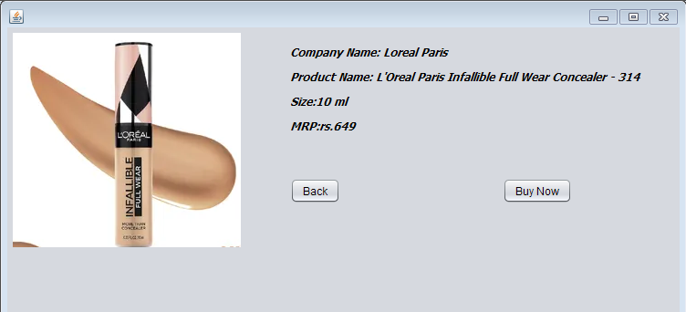

Pay6.java

Code:

/*

* To change this license header, choose License Headers in Project Properties.

* To change this template file, choose Tools | Templates

* and open the template in the editor.

*/

package beautyproducts;

/**

*

* @author js

*/

public class Pay6 extends javax.swing.JFrame {

/**

* Creates new form Pay6

*/

public Pay6() {

initComponents();

}

/**

* This method is called from within the constructor to initialize the form.

* WARNING: Do NOT modify this code. The content of this method is always

* regenerated by the Form Editor.

*/

@SuppressWarnings("unchecked")

// <editor-fold defaultstate="collapsed" desc="Generated Code">

private void initComponents() {

jLabel5 = new javax.swing.JLabel();

jTextField5 = new javax.swing.JTextField();

jLabel6 = new javax.swing.JLabel();

jTextField6 = new javax.swing.JTextField();

jLabel7 = new javax.swing.JLabel();

jLabel8 = new javax.swing.JLabel();

jplaceorder1 = new javax.swing.JButton();

jexit1 = new javax.swing.JButton();

jTextField7 = new javax.swing.JTextField();

jTextField8 = new javax.swing.JTextField();

setDefaultCloseOperation(javax.swing.WindowConstants.EXIT_ON_CLOSE);

jLabel5.setText("Year of expiry");

jLabel6.setText("Total amount");

jLabel7.setText("Name");

jLabel8.setText("Card No");

jplaceorder1.setText("Place Order");

jplaceorder1.addActionListener(new java.awt.event.ActionListener() {

public void actionPerformed(java.awt.event.ActionEvent evt) {

jplaceorder1ActionPerformed(evt);

}

});

jexit1.setText("Exit");

jexit1.addActionListener(new java.awt.event.ActionListener() {

public void actionPerformed(java.awt.event.ActionEvent evt) {

jexit1ActionPerformed(evt);

}

});

javax.swing.GroupLayout layout = new javax.swing.GroupLayout(getContentPane());

getContentPane().setLayout(layout);

layout.setHorizontalGroup(

layout.createParallelGroup(javax.swing.GroupLayout.Alignment.LEADING)

.addGroup(layout.createSequentialGroup()

.addGap(127, 127, 127)

.addGroup(layout.createParallelGroup(javax.swing.GroupLayout.Alignment.LEADING)

.addGroup(layout.createSequentialGroup()

.addComponent(jplaceorder1)

.addGap(127, 127, 127)

.addComponent(jexit1, javax.swing.GroupLayout.PREFERRED_SIZE, 93, javax.swing.GroupLayout.PREFERRED_SIZE))

.addComponent(jLabel8)

.addGroup(javax.swing.GroupLayout.Alignment.TRAILING, layout.createSequentialGroup()

.addGroup(layout.createParallelGroup(javax.swing.GroupLayout.Alignment.LEADING)

.addComponent(jLabel5)

.addComponent(jLabel7, javax.swing.GroupLayout.PREFERRED_SIZE, 39, javax.swing.GroupLayout.PREFERRED_SIZE)

.addComponent(jLabel6))

.addPreferredGap(javax.swing.LayoutStyle.ComponentPlacement.RELATED, 136, Short.MAX_VALUE)

.addGroup(layout.createParallelGroup(javax.swing.GroupLayout.Alignment.TRAILING, false)

.addComponent(jTextField6)

.addComponent(jTextField7, javax.swing.GroupLayout.Alignment.LEADING)

.addComponent(jTextField8, javax.swing.GroupLayout.Alignment.LEADING)

.addComponent(jTextField5, javax.swing.GroupLayout.Alignment.LEADING, javax.swing.GroupLayout.PREFERRED_SIZE, 179, javax.swing.GroupLayout.PREFERRED_SIZE))

.addGap(58, 58, 58)))

.addGap(162, 162, 162))

);

layout.setVerticalGroup(

layout.createParallelGroup(javax.swing.GroupLayout.Alignment.LEADING)

.addGroup(layout.createSequentialGroup()

.addGap(74, 74, 74)

.addGroup(layout.createParallelGroup(javax.swing.GroupLayout.Alignment.BASELINE)

.addComponent(jTextField7, javax.swing.GroupLayout.PREFERRED_SIZE, javax.swing.GroupLayout.DEFAULT_SIZE, javax.swing.GroupLayout.PREFERRED_SIZE)

.addComponent(jLabel7))

.addGap(34, 34, 34)

.addGroup(layout.createParallelGroup(javax.swing.GroupLayout.Alignment.BASELINE)

.addComponent(jTextField8, javax.swing.GroupLayout.PREFERRED_SIZE, javax.swing.GroupLayout.DEFAULT_SIZE, javax.swing.GroupLayout.PREFERRED_SIZE)

.addComponent(jLabel8))

.addGap(36, 36, 36)

.addGroup(layout.createParallelGroup(javax.swing.GroupLayout.Alignment.BASELINE)

.addComponent(jLabel5)

.addComponent(jTextField5, javax.swing.GroupLayout.PREFERRED_SIZE, javax.swing.GroupLayout.DEFAULT_SIZE, javax.swing.GroupLayout.PREFERRED_SIZE))

.addGap(45, 45, 45)

.addGroup(layout.createParallelGroup(javax.swing.GroupLayout.Alignment.BASELINE)

.addComponent(jLabel6)

.addComponent(jTextField6, javax.swing.GroupLayout.PREFERRED_SIZE, javax.swing.GroupLayout.DEFAULT_SIZE, javax.swing.GroupLayout.PREFERRED_SIZE))

.addPreferredGap(javax.swing.LayoutStyle.ComponentPlacement.RELATED, 186, Short.MAX_VALUE)

.addGroup(layout.createParallelGroup(javax.swing.GroupLayout.Alignment.BASELINE)

.addComponent(jplaceorder1)

.addComponent(jexit1))

.addGap(41, 41, 41))

);

pack();

}// </editor-fold>

private void jplaceorder1ActionPerformed(java.awt.event.ActionEvent evt) {

new Con_bill().setVisible(true);

this.setVisible(false);

}

private void jexit1ActionPerformed(java.awt.event.ActionEvent evt) {

System.exit(0);

}

/**

* @param args the command line arguments

*/

public static void main(String args[]) {

/* Set the Nimbus look and feel */

//<editor-fold defaultstate="collapsed" desc=" Look and feel setting code (optional) ">

/* If Nimbus (introduced in Java SE 6) is not available, stay with the default look and feel.

* For details see http://download.oracle.com/javase/tutorial/uiswing/lookandfeel/plaf.html

*/

try {

for (javax.swing.UIManager.LookAndFeelInfo info : javax.swing.UIManager.getInstalledLookAndFeels()) {

if ("Nimbus".equals(info.getName())) {

javax.swing.UIManager.setLookAndFeel(info.getClassName());

break;

}

}

} catch (ClassNotFoundException ex) {

java.util.logging.Logger.getLogger(Pay6.class.getName()).log(java.util.logging.Level.SEVERE, null, ex);

} catch (InstantiationException ex) {

java.util.logging.Logger.getLogger(Pay6.class.getName()).log(java.util.logging.Level.SEVERE, null, ex);

} catch (IllegalAccessException ex) {

java.util.logging.Logger.getLogger(Pay6.class.getName()).log(java.util.logging.Level.SEVERE, null, ex);

} catch (javax.swing.UnsupportedLookAndFeelException ex) {

java.util.logging.Logger.getLogger(Pay6.class.getName()).log(java.util.logging.Level.SEVERE, null, ex);

}

//</editor-fold>

/* Create and display the form */

java.awt.EventQueue.invokeLater(new Runnable() {

public void run() {

new Pay6().setVisible(true);

}

});

}

// Variables declaration - do not modify

private javax.swing.JLabel jLabel5;

private javax.swing.JLabel jLabel6;

private javax.swing.JLabel jLabel7;

private javax.swing.JLabel jLabel8;

private javax.swing.JTextField jTextField5;

private javax.swing.JTextField jTextField6;

private javax.swing.JTextField jTextField7;

private javax.swing.JTextField jTextField8;

private javax.swing.JButton jexit1;

private javax.swing.JButton jplaceorder1;

// End of variables declaration

}

Output:

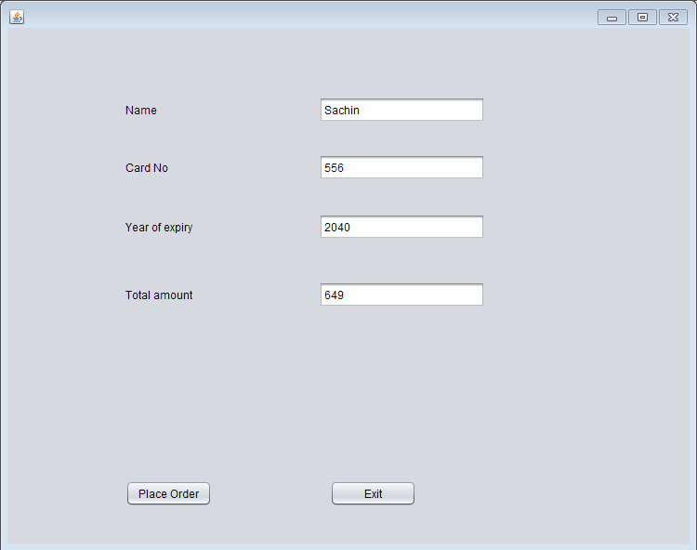

Con_bill.java

Code:

/*

* To change this license header, choose License Headers in Project Properties.

* To change this template file, choose Tools | Templates

* and open the template in the editor.

*/

package beautyproducts;

import com.mysql.jdbc.Connection;

import com.mysql.jdbc.PreparedStatement;

import java.sql.DriverManager;

import java.sql.ResultSet;

import java.sql.SQLException;

import java.util.logging.Level;

import java.util.logging.Logger;

import javax.swing.JOptionPane;

import net.proteanit.sql.DbUtils;

/**

*

* @author js

*/

public class Con_bill extends javax.swing.JFrame {

/**

* Creates new form Con_bill

*/

Connection con = null;

PreparedStatement pst = null;

ResultSet rs = null;

public Con_bill() {

initComponents();

String name,number,address;

}

public void Print()

{

String name=txtname.getText();

String number=txtnumber.getText();

String address=txtaddress.getText();

txtbill.setText("\t"+"The Cosmetic Shop"+"\n"+"\n"

+"Brand:- Loreal Paris"+"\n"

+"Product Name:- L'Oreal Paris Infallible Full Wear Concealer - 314" +"\n"

+"Price:- 649"+"\n"

+"\n"+"********************");

txtbill.setText(txtbill.getText() +"\n"+"Coustomer name:- "+name);

txtbill.setText(txtbill.getText()+"\n"+"\n"+"Contact number:-"+number);

txtbill.setText(txtbill.getText() +"\n"+"\n"+"Address:-"+address);

txtbill.setText(txtbill.getText()+"\n"+"\n"+"\n"+"\n"+"\n"+"\n"+"\n"+"\t"+"**Thanks For Shopping**");

}

/**

* This method is called from within the constructor to initialize the form.

* WARNING: Do NOT modify this code. The content of this method is always

* regenerated by the Form Editor.

*/

@SuppressWarnings("unchecked")

// <editor-fold defaultstate="collapsed" desc="Generated Code">

private void initComponents() {

jLabel3 = new javax.swing.JLabel();

txtname = new javax.swing.JTextField();

txtnumber = new javax.swing.JTextField();

txtaddress = new javax.swing.JTextField();

jScrollPane1 = new javax.swing.JScrollPane();

txtbill = new javax.swing.JTextArea();

jButton1 = new javax.swing.JButton();

jButton2 = new javax.swing.JButton();

jLabel1 = new javax.swing.JLabel();

jLabel2 = new javax.swing.JLabel();

setDefaultCloseOperation(javax.swing.WindowConstants.EXIT_ON_CLOSE);

jLabel3.setText("Address:");

txtaddress.addActionListener(new java.awt.event.ActionListener() {

public void actionPerformed(java.awt.event.ActionEvent evt) {

txtaddressActionPerformed(evt);

}

});

txtbill.setColumns(20);

txtbill.setRows(5);

jScrollPane1.setViewportView(txtbill);

jButton1.setText("Ok");

jButton1.addActionListener(new java.awt.event.ActionListener() {

public void actionPerformed(java.awt.event.ActionEvent evt) {

jButton1ActionPerformed(evt);

}

});

jButton2.setText("Done");

jButton2.addActionListener(new java.awt.event.ActionListener() {

public void actionPerformed(java.awt.event.ActionEvent evt) {

jButton2ActionPerformed(evt);

}

});

jLabel1.setText("Customer Name:");

jLabel2.setText("Contact Number:");

javax.swing.GroupLayout layout = new javax.swing.GroupLayout(getContentPane());

getContentPane().setLayout(layout);

layout.setHorizontalGroup(

layout.createParallelGroup(javax.swing.GroupLayout.Alignment.LEADING)

.addGroup(layout.createSequentialGroup()

.addGap(37, 37, 37)

.addGroup(layout.createParallelGroup(javax.swing.GroupLayout.Alignment.TRAILING)

.addGroup(layout.createSequentialGroup()

.addGroup(layout.createParallelGroup(javax.swing.GroupLayout.Alignment.LEADING)

.addComponent(jLabel1)

.addComponent(jLabel2)

.addComponent(jLabel3))

.addGap(69, 69, 69)

.addGroup(layout.createParallelGroup(javax.swing.GroupLayout.Alignment.LEADING, false)

.addComponent(txtname, javax.swing.GroupLayout.DEFAULT_SIZE, 161, Short.MAX_VALUE)

.addComponent(txtnumber)

.addComponent(txtaddress)))

.addComponent(jButton1))

.addPreferredGap(javax.swing.LayoutStyle.ComponentPlacement.RELATED, 59, Short.MAX_VALUE)

.addComponent(jScrollPane1, javax.swing.GroupLayout.PREFERRED_SIZE, 309, javax.swing.GroupLayout.PREFERRED_SIZE)

.addGap(22, 22, 22))

.addGroup(javax.swing.GroupLayout.Alignment.TRAILING, layout.createSequentialGroup()

.addContainerGap(javax.swing.GroupLayout.DEFAULT_SIZE, Short.MAX_VALUE)

.addComponent(jButton2)

.addGap(126, 126, 126))

);

layout.setVerticalGroup(

layout.createParallelGroup(javax.swing.GroupLayout.Alignment.LEADING)

.addGroup(layout.createSequentialGroup()

.addGap(52, 52, 52)

.addGroup(layout.createParallelGroup(javax.swing.GroupLayout.Alignment.BASELINE)

.addComponent(jLabel1)

.addComponent(txtname, javax.swing.GroupLayout.PREFERRED_SIZE, javax.swing.GroupLayout.DEFAULT_SIZE, javax.swing.GroupLayout.PREFERRED_SIZE))

.addGap(29, 29, 29)

.addGroup(layout.createParallelGroup(javax.swing.GroupLayout.Alignment.BASELINE)

.addComponent(jLabel2)

.addComponent(txtnumber, javax.swing.GroupLayout.PREFERRED_SIZE, javax.swing.GroupLayout.DEFAULT_SIZE, javax.swing.GroupLayout.PREFERRED_SIZE))

.addGap(40, 40, 40)

.addGroup(layout.createParallelGroup(javax.swing.GroupLayout.Alignment.BASELINE)

.addComponent(jLabel3)

.addComponent(txtaddress, javax.swing.GroupLayout.PREFERRED_SIZE, 109, javax.swing.GroupLayout.PREFERRED_SIZE))

.addGap(67, 67, 67)

.addComponent(jButton1)

.addContainerGap(javax.swing.GroupLayout.DEFAULT_SIZE, Short.MAX_VALUE))

.addGroup(javax.swing.GroupLayout.Alignment.TRAILING, layout.createSequentialGroup()

.addContainerGap(javax.swing.GroupLayout.DEFAULT_SIZE, Short.MAX_VALUE)

.addComponent(jScrollPane1, javax.swing.GroupLayout.PREFERRED_SIZE, 418, javax.swing.GroupLayout.PREFERRED_SIZE)

.addGap(18, 18, 18)

.addComponent(jButton2)

.addGap(10, 10, 10))

);

pack();

}// </editor-fold>

private void txtaddressActionPerformed(java.awt.event.ActionEvent evt) {

// TODO add your handling code here:

}

private void jButton1ActionPerformed(java.awt.event.ActionEvent evt) {

Print();

}

private void jButton2ActionPerformed(java.awt.event.ActionEvent evt) {

try

{

String sql = "INSERT INTO customer_details"

+"(CustomerName,CustomerNumber,Address)"

+"VALUES (?,?,?)";

con = (Connection) DriverManager.getConnection("jdbc:mysql://localhost/details","root","");

pst = (PreparedStatement) con.prepareStatement(sql);

pst.setString(1,txtname.getText());

pst.setString(2,txtnumber.getText());

pst.setString(3,txtaddress.getText());

pst.executeUpdate();

JOptionPane.showMessageDialog(null, "Thank you for shopping!!");

txtname.setText(null);

txtnumber.setText(null);

txtaddress.setText(null);

}

catch(Exception ex)

{

JOptionPane.showMessageDialog(null, ex);

}

}

/**

* @param args the command line arguments

*/

public static void main(String args[]) {

/* Set the Nimbus look and feel */

//<editor-fold defaultstate="collapsed" desc=" Look and feel setting code (optional) ">

/* If Nimbus (introduced in Java SE 6) is not available, stay with the default look and feel.

* For details see http://download.oracle.com/javase/tutorial/uiswing/lookandfeel/plaf.html

*/

try {

for (javax.swing.UIManager.LookAndFeelInfo info : javax.swing.UIManager.getInstalledLookAndFeels()) {

if ("Nimbus".equals(info.getName())) {

javax.swing.UIManager.setLookAndFeel(info.getClassName());

break;

}

}

} catch (ClassNotFoundException ex) {

java.util.logging.Logger.getLogger(Con_bill.class.getName()).log(java.util.logging.Level.SEVERE, null, ex);

} catch (InstantiationException ex) {

java.util.logging.Logger.getLogger(Con_bill.class.getName()).log(java.util.logging.Level.SEVERE, null, ex);

} catch (IllegalAccessException ex) {

java.util.logging.Logger.getLogger(Con_bill.class.getName()).log(java.util.logging.Level.SEVERE, null, ex);

} catch (javax.swing.UnsupportedLookAndFeelException ex) {

java.util.logging.Logger.getLogger(Con_bill.class.getName()).log(java.util.logging.Level.SEVERE, null, ex);

}

//</editor-fold>

/* Create and display the form */

java.awt.EventQueue.invokeLater(new Runnable() {

public void run() {

new Con_bill().setVisible(true);

}

});

}

// Variables declaration - do not modify

private javax.swing.JButton jButton1;

private javax.swing.JButton jButton2;

private javax.swing.JLabel jLabel1;

private javax.swing.JLabel jLabel2;

private javax.swing.JLabel jLabel3;

private javax.swing.JScrollPane jScrollPane1;

private javax.swing.JTextField txtaddress;

private javax.swing.JTextArea txtbill;

private javax.swing.JTextField txtname;

private javax.swing.JTextField txtnumber;

// End of variables declaration

}

Output:

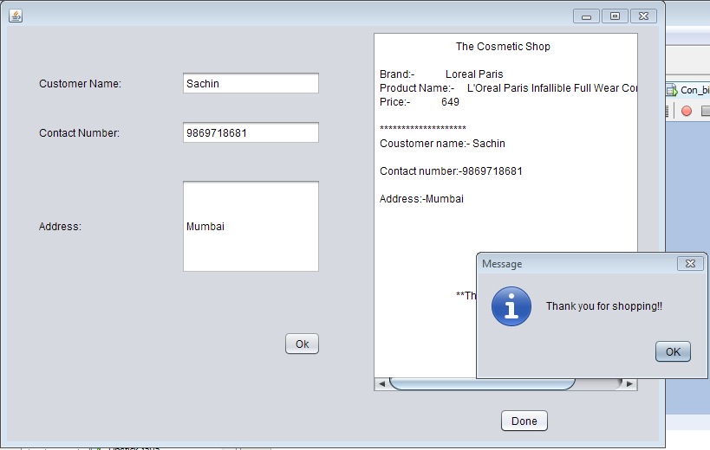

Compact.java

Code:

/*

* To change this license header, choose License Headers in Project Properties.

* To change this template file, choose Tools | Templates

* and open the template in the editor.

*/

package beautyproducts;

/**

*

* @author js

*/

public class Compact extends javax.swing.JFrame {

/**

* Creates new form Compact

*/

public Compact() {

initComponents();

}

/**

* This method is called from within the constructor to initialize the form.

* WARNING: Do NOT modify this code. The content of this method is always

* regenerated by the Form Editor.

*/

@SuppressWarnings("unchecked")

// <editor-fold defaultstate="collapsed" desc="Generated Code">

private void initComponents() {

jLabel1 = new javax.swing.JLabel();

jLabel2 = new javax.swing.JLabel();

jLabel3 = new javax.swing.JLabel();

jLabel4 = new javax.swing.JLabel();

jLabel5 = new javax.swing.JLabel();

jButton1 = new javax.swing.JButton();

jButton3 = new javax.swing.JButton();

setDefaultCloseOperation(javax.swing.WindowConstants.EXIT_ON_CLOSE);

jLabel1.setIcon(new javax.swing.ImageIcon("C:\\Users\\js\\Desktop\\13.PNG")); // NOI18N

jLabel1.setText("jLabel1");

jLabel2.setFont(new java.awt.Font("Tahoma", 3, 12)); // NOI18N

jLabel2.setText("Brand Name: Lakme 9 to 5");

jLabel3.setFont(new java.awt.Font("Tahoma", 3, 12)); // NOI18N

jLabel3.setText("Product Name:Lakme 9 to 5 Compact - Silky Golden");

jLabel4.setFont(new java.awt.Font("Tahoma", 3, 12)); // NOI18N

jLabel4.setText("Size:9 gm");

jLabel5.setFont(new java.awt.Font("Tahoma", 3, 12)); // NOI18N

jLabel5.setText("MRP: rs.499");

jButton1.setText("Buy Now");

jButton1.addActionListener(new java.awt.event.ActionListener() {

public void actionPerformed(java.awt.event.ActionEvent evt) {

jButton1ActionPerformed(evt);

}

});

jButton3.setText("Back");

jButton3.addActionListener(new java.awt.event.ActionListener() {

public void actionPerformed(java.awt.event.ActionEvent evt) {

jButton3ActionPerformed(evt);

}

});

javax.swing.GroupLayout layout = new javax.swing.GroupLayout(getContentPane());

getContentPane().setLayout(layout);

layout.setHorizontalGroup(

layout.createParallelGroup(javax.swing.GroupLayout.Alignment.LEADING)

.addGroup(layout.createSequentialGroup()

.addComponent(jLabel1, javax.swing.GroupLayout.PREFERRED_SIZE, 276, javax.swing.GroupLayout.PREFERRED_SIZE)

.addGap(56, 56, 56)

.addGroup(layout.createParallelGroup(javax.swing.GroupLayout.Alignment.LEADING)

.addGroup(layout.createSequentialGroup()

.addGroup(layout.createParallelGroup(javax.swing.GroupLayout.Alignment.LEADING)

.addComponent(jLabel2, javax.swing.GroupLayout.PREFERRED_SIZE, 179, javax.swing.GroupLayout.PREFERRED_SIZE)

.addComponent(jLabel3, javax.swing.GroupLayout.PREFERRED_SIZE, 325, javax.swing.GroupLayout.PREFERRED_SIZE)

.addGroup(layout.createParallelGroup(javax.swing.GroupLayout.Alignment.TRAILING, false)

.addComponent(jLabel5, javax.swing.GroupLayout.Alignment.LEADING, javax.swing.GroupLayout.DEFAULT_SIZE, 78, Short.MAX_VALUE)

.addComponent(jLabel4, javax.swing.GroupLayout.Alignment.LEADING, javax.swing.GroupLayout.DEFAULT_SIZE, javax.swing.GroupLayout.DEFAULT_SIZE, Short.MAX_VALUE)))

.addGap(0, 208, Short.MAX_VALUE))

.addGroup(layout.createSequentialGroup()

.addComponent(jButton3)

.addPreferredGap(javax.swing.LayoutStyle.ComponentPlacement.RELATED, javax.swing.GroupLayout.DEFAULT_SIZE, Short.MAX_VALUE)

.addComponent(jButton1)

.addGap(184, 184, 184))))

);

layout.setVerticalGroup(

layout.createParallelGroup(javax.swing.GroupLayout.Alignment.LEADING)

.addGroup(layout.createSequentialGroup()

.addGroup(layout.createParallelGroup(javax.swing.GroupLayout.Alignment.LEADING)

.addGroup(layout.createSequentialGroup()

.addContainerGap()

.addComponent(jLabel1))

.addGroup(layout.createSequentialGroup()

.addGap(22, 22, 22)

.addComponent(jLabel2)

.addPreferredGap(javax.swing.LayoutStyle.ComponentPlacement.UNRELATED)

.addComponent(jLabel3)

.addPreferredGap(javax.swing.LayoutStyle.ComponentPlacement.UNRELATED)

.addComponent(jLabel4)

.addPreferredGap(javax.swing.LayoutStyle.ComponentPlacement.UNRELATED)

.addComponent(jLabel5)

.addGap(34, 34, 34)

.addGroup(layout.createParallelGroup(javax.swing.GroupLayout.Alignment.BASELINE)

.addComponent(jButton1)

.addComponent(jButton3))))

.addContainerGap(396, Short.MAX_VALUE))

);

pack();

}// </editor-fold>

private void jButton1ActionPerformed(java.awt.event.ActionEvent evt) {

new Pay7().setVisible(true);

this.setVisible(false);

}

private void jButton3ActionPerformed(java.awt.event.ActionEvent evt) {

new BuyProduct().setVisible(true);

this.setVisible(false);

}

/**

* @param args the command line arguments

*/

public static void main(String args[]) {

/* Set the Nimbus look and feel */

//<editor-fold defaultstate="collapsed" desc=" Look and feel setting code (optional) ">

/* If Nimbus (introduced in Java SE 6) is not available, stay with the default look and feel.

* For details see http://download.oracle.com/javase/tutorial/uiswing/lookandfeel/plaf.html

*/

try {

for (javax.swing.UIManager.LookAndFeelInfo info : javax.swing.UIManager.getInstalledLookAndFeels()) {

if ("Nimbus".equals(info.getName())) {

javax.swing.UIManager.setLookAndFeel(info.getClassName());

break;

}

}

} catch (ClassNotFoundException ex) {

java.util.logging.Logger.getLogger(Compact.class.getName()).log(java.util.logging.Level.SEVERE, null, ex);

} catch (InstantiationException ex) {

java.util.logging.Logger.getLogger(Compact.class.getName()).log(java.util.logging.Level.SEVERE, null, ex);

} catch (IllegalAccessException ex) {

java.util.logging.Logger.getLogger(Compact.class.getName()).log(java.util.logging.Level.SEVERE, null, ex);

} catch (javax.swing.UnsupportedLookAndFeelException ex) {

java.util.logging.Logger.getLogger(Compact.class.getName()).log(java.util.logging.Level.SEVERE, null, ex);

}

//</editor-fold>

/* Create and display the form */

java.awt.EventQueue.invokeLater(new Runnable() {

public void run() {

new Compact().setVisible(true);

}

});

}

// Variables declaration - do not modify

private javax.swing.JButton jButton1;

private javax.swing.JButton jButton3;

private javax.swing.JLabel jLabel1;

private javax.swing.JLabel jLabel2;

private javax.swing.JLabel jLabel3;

private javax.swing.JLabel jLabel4;

private javax.swing.JLabel jLabel5;

// End of variables declaration

}

Output:

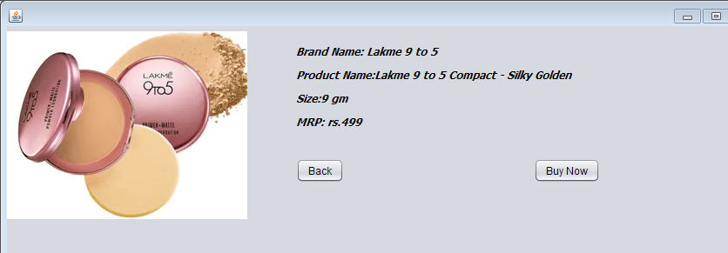

Pay7.java

Code:

/*

* To change this license header, choose License Headers in Project Properties.

* To change this template file, choose Tools | Templates

* and open the template in the editor.

*/

package beautyproducts;

/**

*

* @author js

*/

public class Pay7 extends javax.swing.JFrame {

/**

* Creates new form Pay7

*/

public Pay7() {

initComponents();

}

/**

* This method is called from within the constructor to initialize the form.

* WARNING: Do NOT modify this code. The content of this method is always

* regenerated by the Form Editor.

*/

@SuppressWarnings("unchecked")

// <editor-fold defaultstate="collapsed" desc="Generated Code">

private void initComponents() {

jLabel5 = new javax.swing.JLabel();

jTextField5 = new javax.swing.JTextField();

jLabel6 = new javax.swing.JLabel();

jTextField6 = new javax.swing.JTextField();

jLabel7 = new javax.swing.JLabel();

jLabel8 = new javax.swing.JLabel();

jplaceorder1 = new javax.swing.JButton();

jexit1 = new javax.swing.JButton();

jTextField7 = new javax.swing.JTextField();

jTextField8 = new javax.swing.JTextField();

setDefaultCloseOperation(javax.swing.WindowConstants.EXIT_ON_CLOSE);

jLabel5.setText("Year of expiry");

jLabel6.setText("Total amount");

jLabel7.setText("Name");

jLabel8.setText("Card No");

jplaceorder1.setText("Place Order");

jplaceorder1.addActionListener(new java.awt.event.ActionListener() {

public void actionPerformed(java.awt.event.ActionEvent evt) {

jplaceorder1ActionPerformed(evt);

}

});

jexit1.setText("Exit");

jexit1.addActionListener(new java.awt.event.ActionListener() {

public void actionPerformed(java.awt.event.ActionEvent evt) {

jexit1ActionPerformed(evt);

}

});

javax.swing.GroupLayout layout = new javax.swing.GroupLayout(getContentPane());

getContentPane().setLayout(layout);

layout.setHorizontalGroup(

layout.createParallelGroup(javax.swing.GroupLayout.Alignment.LEADING)

.addGroup(layout.createSequentialGroup()

.addGap(127, 127, 127)

.addGroup(layout.createParallelGroup(javax.swing.GroupLayout.Alignment.LEADING)

.addGroup(layout.createSequentialGroup()

.addComponent(jplaceorder1)

.addGap(127, 127, 127)

.addComponent(jexit1, javax.swing.GroupLayout.PREFERRED_SIZE, 93, javax.swing.GroupLayout.PREFERRED_SIZE))

.addGroup(layout.createSequentialGroup()

.addComponent(jLabel8)

.addPreferredGap(javax.swing.LayoutStyle.ComponentPlacement.RELATED, 270, javax.swing.GroupLayout.PREFERRED_SIZE))

.addGroup(javax.swing.GroupLayout.Alignment.TRAILING, layout.createSequentialGroup()

.addGroup(layout.createParallelGroup(javax.swing.GroupLayout.Alignment.LEADING)

.addComponent(jLabel5)

.addComponent(jLabel7, javax.swing.GroupLayout.PREFERRED_SIZE, 39, javax.swing.GroupLayout.PREFERRED_SIZE)

.addComponent(jLabel6))

.addPreferredGap(javax.swing.LayoutStyle.ComponentPlacement.RELATED, javax.swing.GroupLayout.DEFAULT_SIZE, Short.MAX_VALUE)

.addGroup(layout.createParallelGroup(javax.swing.GroupLayout.Alignment.TRAILING, false)

.addComponent(jTextField6)

.addComponent(jTextField7, javax.swing.GroupLayout.Alignment.LEADING)

.addComponent(jTextField8, javax.swing.GroupLayout.Alignment.LEADING)

.addComponent(jTextField5, javax.swing.GroupLayout.Alignment.LEADING, javax.swing.GroupLayout.PREFERRED_SIZE, 179, javax.swing.GroupLayout.PREFERRED_SIZE))

.addGap(58, 58, 58)))

.addGap(162, 162, 162))

);

layout.setVerticalGroup(

layout.createParallelGroup(javax.swing.GroupLayout.Alignment.LEADING)

.addGroup(layout.createSequentialGroup()

.addGap(74, 74, 74)

.addGroup(layout.createParallelGroup(javax.swing.GroupLayout.Alignment.BASELINE)

.addComponent(jTextField7, javax.swing.GroupLayout.PREFERRED_SIZE, javax.swing.GroupLayout.DEFAULT_SIZE, javax.swing.GroupLayout.PREFERRED_SIZE)

.addComponent(jLabel7))

.addGap(34, 34, 34)

.addGroup(layout.createParallelGroup(javax.swing.GroupLayout.Alignment.BASELINE)

.addComponent(jTextField8, javax.swing.GroupLayout.PREFERRED_SIZE, javax.swing.GroupLayout.DEFAULT_SIZE, javax.swing.GroupLayout.PREFERRED_SIZE)

.addComponent(jLabel8))

.addGap(36, 36, 36)

.addGroup(layout.createParallelGroup(javax.swing.GroupLayout.Alignment.BASELINE)

.addComponent(jLabel5)

.addComponent(jTextField5, javax.swing.GroupLayout.PREFERRED_SIZE, javax.swing.GroupLayout.DEFAULT_SIZE, javax.swing.GroupLayout.PREFERRED_SIZE))

.addGap(45, 45, 45)

.addGroup(layout.createParallelGroup(javax.swing.GroupLayout.Alignment.BASELINE)

.addComponent(jLabel6)

.addComponent(jTextField6, javax.swing.GroupLayout.PREFERRED_SIZE, javax.swing.GroupLayout.DEFAULT_SIZE, javax.swing.GroupLayout.PREFERRED_SIZE))

.addPreferredGap(javax.swing.LayoutStyle.ComponentPlacement.RELATED, javax.swing.GroupLayout.DEFAULT_SIZE, Short.MAX_VALUE)

.addGroup(layout.createParallelGroup(javax.swing.GroupLayout.Alignment.BASELINE)

.addComponent(jplaceorder1)

.addComponent(jexit1))

.addGap(41, 41, 41))

);

pack();

}// </editor-fold>

private void jplaceorder1ActionPerformed(java.awt.event.ActionEvent evt) {

new Com_bill().setVisible(true);

this.setVisible(false);

}

private void jexit1ActionPerformed(java.awt.event.ActionEvent evt) {

System.exit(0);

}

/**

* @param args the command line arguments

*/

public static void main(String args[]) {

/* Set the Nimbus look and feel */

//<editor-fold defaultstate="collapsed" desc=" Look and feel setting code (optional) ">

/* If Nimbus (introduced in Java SE 6) is not available, stay with the default look and feel.

* For details see http://download.oracle.com/javase/tutorial/uiswing/lookandfeel/plaf.html

*/

try {

for (javax.swing.UIManager.LookAndFeelInfo info : javax.swing.UIManager.getInstalledLookAndFeels()) {

if ("Nimbus".equals(info.getName())) {

javax.swing.UIManager.setLookAndFeel(info.getClassName());

break;

}

}

} catch (ClassNotFoundException ex) {

java.util.logging.Logger.getLogger(Pay7.class.getName()).log(java.util.logging.Level.SEVERE, null, ex);

} catch (InstantiationException ex) {

java.util.logging.Logger.getLogger(Pay7.class.getName()).log(java.util.logging.Level.SEVERE, null, ex);

} catch (IllegalAccessException ex) {

java.util.logging.Logger.getLogger(Pay7.class.getName()).log(java.util.logging.Level.SEVERE, null, ex);

} catch (javax.swing.UnsupportedLookAndFeelException ex) {

java.util.logging.Logger.getLogger(Pay7.class.getName()).log(java.util.logging.Level.SEVERE, null, ex);

}

//</editor-fold>

/* Create and display the form */

java.awt.EventQueue.invokeLater(new Runnable() {

public void run() {

new Pay7().setVisible(true);

}

});

}

// Variables declaration - do not modify

private javax.swing.JLabel jLabel5;

private javax.swing.JLabel jLabel6;

private javax.swing.JLabel jLabel7;

private javax.swing.JLabel jLabel8;

private javax.swing.JTextField jTextField5;

private javax.swing.JTextField jTextField6;

private javax.swing.JTextField jTextField7;

private javax.swing.JTextField jTextField8;

private javax.swing.JButton jexit1;

private javax.swing.JButton jplaceorder1;

// End of variables declaration

}

Output:

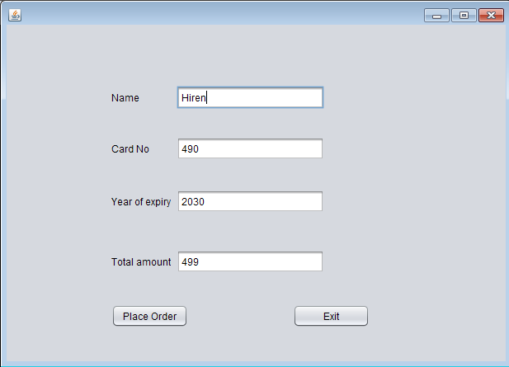

Com_bill.java

/*

* To change this license header, choose License Headers in Project Properties.

* To change this template file, choose Tools | Templates

* and open the template in the editor.

*/

package beautyproducts;

import com.mysql.jdbc.Connection;

import com.mysql.jdbc.PreparedStatement;

import java.sql.DriverManager;

import java.sql.ResultSet;

import java.sql.SQLException;

import java.util.logging.Level;

import java.util.logging.Logger;

import javax.swing.JOptionPane;

import net.proteanit.sql.DbUtils;

/**

*

* @author js

*/

public class Com_bill extends javax.swing.JFrame {

/**

* Creates new form Com_bill

*/

Connection con = null;

PreparedStatement pst = null;

ResultSet rs = null;

public Com_bill() {

initComponents();

String name,number,address;

}

public void Print()

{

String name=txtname.getText();

String number=txtnumber.getText();

String address=txtaddress.getText();

txtbill.setText("\t"+"The Cosmetic Shop"+"\n"+"\n"

+"Brand:- Lakme 9 to 5 "+"\n"

+"Product Name:- Lakme 9 to 5 Compact - Silky Golden" +"\n"

+"Price:- 499"+"\n"

+"\n"+"********************");

txtbill.setText(txtbill.getText() +"\n"+"Coustomer name:- "+name);

txtbill.setText(txtbill.getText()+"\n"+"\n"+"Contact number:-"+number);

txtbill.setText(txtbill.getText() +"\n"+"\n"+"Address:-"+address);

txtbill.setText(txtbill.getText()+"\n"+"\n"+"\n"+"\n"+"\n"+"\n"+"\n"+"\t"+"**Thanks For Shopping**");

}

/**

* This method is called from within the constructor to initialize the form.

* WARNING: Do NOT modify this code. The content of this method is always

* regenerated by the Form Editor.

*/

@SuppressWarnings("unchecked")

// <editor-fold defaultstate="collapsed" desc="Generated Code">

private void initComponents() {

jLabel3 = new javax.swing.JLabel();

txtname = new javax.swing.JTextField();

txtnumber = new javax.swing.JTextField();

txtaddress = new javax.swing.JTextField();

jScrollPane1 = new javax.swing.JScrollPane();

txtbill = new javax.swing.JTextArea();

jButton1 = new javax.swing.JButton();

jButton2 = new javax.swing.JButton();

jLabel1 = new javax.swing.JLabel();

jLabel2 = new javax.swing.JLabel();

setDefaultCloseOperation(javax.swing.WindowConstants.EXIT_ON_CLOSE);

jLabel3.setText("Address:");

txtaddress.addActionListener(new java.awt.event.ActionListener() {

public void actionPerformed(java.awt.event.ActionEvent evt) {

txtaddressActionPerformed(evt);

}

});

txtbill.setColumns(20);

txtbill.setRows(5);

jScrollPane1.setViewportView(txtbill);

jButton1.setText("Ok");

jButton1.addActionListener(new java.awt.event.ActionListener() {

public void actionPerformed(java.awt.event.ActionEvent evt) {

jButton1ActionPerformed(evt);

}

});

jButton2.setText("Done");

jButton2.addActionListener(new java.awt.event.ActionListener() {

public void actionPerformed(java.awt.event.ActionEvent evt) {

jButton2ActionPerformed(evt);

}

});

jLabel1.setText("Customer Name:");

jLabel2.setText("Contact Number:");

javax.swing.GroupLayout layout = new javax.swing.GroupLayout(getContentPane());

getContentPane().setLayout(layout);

layout.setHorizontalGroup(

layout.createParallelGroup(javax.swing.GroupLayout.Alignment.LEADING)

.addGroup(layout.createSequentialGroup()

.addGap(37, 37, 37)

.addGroup(layout.createParallelGroup(javax.swing.GroupLayout.Alignment.TRAILING)

.addGroup(layout.createSequentialGroup()

.addGroup(layout.createParallelGroup(javax.swing.GroupLayout.Alignment.LEADING)

.addComponent(jLabel1)

.addComponent(jLabel2)

.addComponent(jLabel3))

.addGap(69, 69, 69)

.addGroup(layout.createParallelGroup(javax.swing.GroupLayout.Alignment.LEADING, false)

.addComponent(txtname, javax.swing.GroupLayout.DEFAULT_SIZE, 161, Short.MAX_VALUE)

.addComponent(txtnumber)

.addComponent(txtaddress)))

.addComponent(jButton1))

.addPreferredGap(javax.swing.LayoutStyle.ComponentPlacement.RELATED, 49, Short.MAX_VALUE)

.addComponent(jScrollPane1, javax.swing.GroupLayout.PREFERRED_SIZE, 309, javax.swing.GroupLayout.PREFERRED_SIZE)

.addGap(22, 22, 22))

.addGroup(javax.swing.GroupLayout.Alignment.TRAILING, layout.createSequentialGroup()

.addContainerGap(javax.swing.GroupLayout.DEFAULT_SIZE, Short.MAX_VALUE)

.addComponent(jButton2)

.addGap(126, 126, 126))

);

layout.setVerticalGroup(

layout.createParallelGroup(javax.swing.GroupLayout.Alignment.LEADING)

.addGroup(layout.createSequentialGroup()

.addGap(52, 52, 52)

.addGroup(layout.createParallelGroup(javax.swing.GroupLayout.Alignment.BASELINE)

.addComponent(jLabel1)

.addComponent(txtname, javax.swing.GroupLayout.PREFERRED_SIZE, javax.swing.GroupLayout.DEFAULT_SIZE, javax.swing.GroupLayout.PREFERRED_SIZE))

.addGap(29, 29, 29)

.addGroup(layout.createParallelGroup(javax.swing.GroupLayout.Alignment.BASELINE)

.addComponent(jLabel2)

.addComponent(txtnumber, javax.swing.GroupLayout.PREFERRED_SIZE, javax.swing.GroupLayout.DEFAULT_SIZE, javax.swing.GroupLayout.PREFERRED_SIZE))

.addGap(40, 40, 40)

.addGroup(layout.createParallelGroup(javax.swing.GroupLayout.Alignment.BASELINE)

.addComponent(jLabel3)

.addComponent(txtaddress, javax.swing.GroupLayout.PREFERRED_SIZE, 109, javax.swing.GroupLayout.PREFERRED_SIZE))

.addGap(67, 67, 67)

.addComponent(jButton1)

.addContainerGap(javax.swing.GroupLayout.DEFAULT_SIZE, Short.MAX_VALUE))

.addGroup(javax.swing.GroupLayout.Alignment.TRAILING, layout.createSequentialGroup()

.addContainerGap(javax.swing.GroupLayout.DEFAULT_SIZE, Short.MAX_VALUE)

.addComponent(jScrollPane1, javax.swing.GroupLayout.PREFERRED_SIZE, 418, javax.swing.GroupLayout.PREFERRED_SIZE)

.addGap(18, 18, 18)

.addComponent(jButton2)

.addGap(10, 10, 10))

);

pack();

}// </editor-fold>

private void txtaddressActionPerformed(java.awt.event.ActionEvent evt) {

// TODO add your handling code here:

}

private void jButton1ActionPerformed(java.awt.event.ActionEvent evt) {

Print();

}

private void jButton2ActionPerformed(java.awt.event.ActionEvent evt) {

try

{

String sql = "INSERT INTO customer_details"

+"(CustomerName,CustomerNumber,Address)"

+"VALUES (?,?,?)";

con = (Connection) DriverManager.getConnection("jdbc:mysql://localhost/details","root","");

pst = (PreparedStatement) con.prepareStatement(sql);

pst.setString(1,txtname.getText());

pst.setString(2,txtnumber.getText());

pst.setString(3,txtaddress.getText());

pst.executeUpdate();

JOptionPane.showMessageDialog(null, "Thank you for shopping!!");

txtname.setText(null);

txtnumber.setText(null);

txtaddress.setText(null);

}

catch(Exception ex)

{

JOptionPane.showMessageDialog(null, ex);

}

}

/**

* @param args the command line arguments

*/

public static void main(String args[]) {

/* Set the Nimbus look and feel */

//<editor-fold defaultstate="collapsed" desc=" Look and feel setting code (optional) ">

/* If Nimbus (introduced in Java SE 6) is not available, stay with the default look and feel.

* For details see http://download.oracle.com/javase/tutorial/uiswing/lookandfeel/plaf.html

*/

try {

for (javax.swing.UIManager.LookAndFeelInfo info : javax.swing.UIManager.getInstalledLookAndFeels()) {

if ("Nimbus".equals(info.getName())) {

javax.swing.UIManager.setLookAndFeel(info.getClassName());

break;

}

}

} catch (ClassNotFoundException ex) {

java.util.logging.Logger.getLogger(Com_bill.class.getName()).log(java.util.logging.Level.SEVERE, null, ex);

} catch (InstantiationException ex) {

java.util.logging.Logger.getLogger(Com_bill.class.getName()).log(java.util.logging.Level.SEVERE, null, ex);

} catch (IllegalAccessException ex) {

java.util.logging.Logger.getLogger(Com_bill.class.getName()).log(java.util.logging.Level.SEVERE, null, ex);

} catch (javax.swing.UnsupportedLookAndFeelException ex) {

java.util.logging.Logger.getLogger(Com_bill.class.getName()).log(java.util.logging.Level.SEVERE, null, ex);

}

//</editor-fold>

/* Create and display the form */

java.awt.EventQueue.invokeLater(new Runnable() {

public void run() {

new Com_bill().setVisible(true);

}

});

}

// Variables declaration - do not modify

private javax.swing.JButton jButton1;

private javax.swing.JButton jButton2;

private javax.swing.JLabel jLabel1;

private javax.swing.JLabel jLabel2;

private javax.swing.JLabel jLabel3;

private javax.swing.JScrollPane jScrollPane1;

private javax.swing.JTextField txtaddress;

private javax.swing.JTextArea txtbill;

private javax.swing.JTextField txtname;

private javax.swing.JTextField txtnumber;

// End of variables declaration

}

Output:

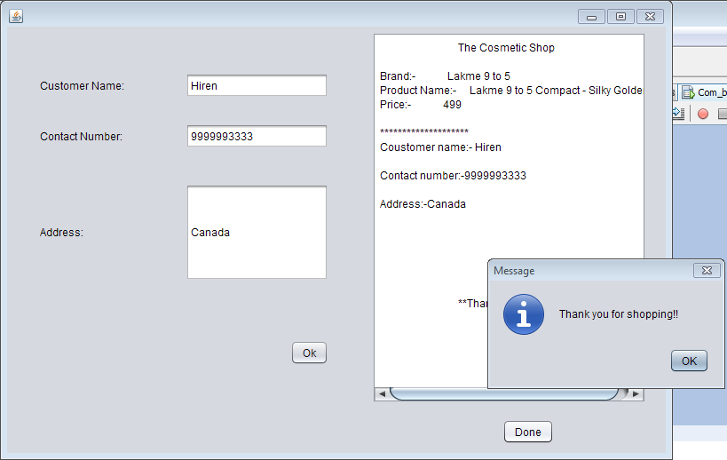

Powder.java

Code:

/*

* To change this license header, choose License Headers in Project Properties.

* To change this template file, choose Tools | Templates

* and open the template in the editor.

*/

package beautyproducts;

/**

*

* @author js

*/

public class Powder extends javax.swing.JFrame {

/**

* Creates new form Powder

*/

public Powder() {

initComponents();

}

/**

* This method is called from within the constructor to initialize the form.

* WARNING: Do NOT modify this code. The content of this method is always

* regenerated by the Form Editor.

*/

@SuppressWarnings("unchecked")

// <editor-fold defaultstate="collapsed" desc="Generated Code">

private void initComponents() {

jLabel1 = new javax.swing.JLabel();

jLabel2 = new javax.swing.JLabel();

jLabel3 = new javax.swing.JLabel();

jLabel4 = new javax.swing.JLabel();

jLabel5 = new javax.swing.JLabel();

jButton1 = new javax.swing.JButton();

jButton3 = new javax.swing.JButton();

setDefaultCloseOperation(javax.swing.WindowConstants.EXIT_ON_CLOSE);

jLabel1.setIcon(new javax.swing.ImageIcon("C:\\Users\\js\\Desktop\\15.PNG")); // NOI18N

jLabel1.setText("jLabel1");

jLabel2.setFont(new java.awt.Font("Tahoma", 3, 12)); // NOI18N

jLabel2.setText("Brand Name: Kay Beauty");

jLabel3.setFont(new java.awt.Font("Tahoma", 3, 10)); // NOI18N

jLabel3.setText("Product Name: Kay Beauty HD Setting Loose Powder - Almond 03");

jLabel4.setFont(new java.awt.Font("Tahoma", 3, 12)); // NOI18N

jLabel4.setText("Size: 10 gm");

jLabel5.setFont(new java.awt.Font("Tahoma", 3, 12)); // NOI18N

jLabel5.setText("MRP:rs.799");

jButton1.setText("Buy Now");

jButton1.addActionListener(new java.awt.event.ActionListener() {

public void actionPerformed(java.awt.event.ActionEvent evt) {

jButton1ActionPerformed(evt);

}

});

jButton3.setText("Back");

jButton3.addActionListener(new java.awt.event.ActionListener() {

public void actionPerformed(java.awt.event.ActionEvent evt) {

jButton3ActionPerformed(evt);

}

});

javax.swing.GroupLayout layout = new javax.swing.GroupLayout(getContentPane());

getContentPane().setLayout(layout);

layout.setHorizontalGroup(

layout.createParallelGroup(javax.swing.GroupLayout.Alignment.LEADING)

.addGroup(layout.createSequentialGroup()

.addContainerGap()

.addGroup(layout.createParallelGroup(javax.swing.GroupLayout.Alignment.LEADING)

.addGroup(layout.createSequentialGroup()

.addComponent(jLabel1, javax.swing.GroupLayout.PREFERRED_SIZE, 334, javax.swing.GroupLayout.PREFERRED_SIZE)

.addPreferredGap(javax.swing.LayoutStyle.ComponentPlacement.UNRELATED)

.addGroup(layout.createParallelGroup(javax.swing.GroupLayout.Alignment.LEADING)

.addComponent(jLabel2, javax.swing.GroupLayout.PREFERRED_SIZE, 167, javax.swing.GroupLayout.PREFERRED_SIZE)

.addGroup(layout.createParallelGroup(javax.swing.GroupLayout.Alignment.TRAILING, false)

.addGroup(layout.createSequentialGroup()

.addGroup(layout.createParallelGroup(javax.swing.GroupLayout.Alignment.TRAILING, false)

.addComponent(jLabel5, javax.swing.GroupLayout.Alignment.LEADING, javax.swing.GroupLayout.DEFAULT_SIZE, 80, Short.MAX_VALUE)

.addComponent(jLabel4, javax.swing.GroupLayout.Alignment.LEADING, javax.swing.GroupLayout.DEFAULT_SIZE, javax.swing.GroupLayout.DEFAULT_SIZE, Short.MAX_VALUE))

.addPreferredGap(javax.swing.LayoutStyle.ComponentPlacement.RELATED, javax.swing.GroupLayout.DEFAULT_SIZE, Short.MAX_VALUE)

.addComponent(jButton1))

.addComponent(jLabel3)))

.addContainerGap(137, Short.MAX_VALUE))

.addGroup(javax.swing.GroupLayout.Alignment.TRAILING, layout.createSequentialGroup()

.addGap(0, 0, Short.MAX_VALUE)

.addComponent(jButton3)

.addGap(368, 368, 368))))

);

layout.setVerticalGroup(

layout.createParallelGroup(javax.swing.GroupLayout.Alignment.LEADING)

.addGroup(layout.createSequentialGroup()

.addGap(19, 19, 19)

.addGroup(layout.createParallelGroup(javax.swing.GroupLayout.Alignment.LEADING)

.addGroup(layout.createSequentialGroup()

.addGap(5, 5, 5)

.addComponent(jLabel2)

.addPreferredGap(javax.swing.LayoutStyle.ComponentPlacement.RELATED)

.addComponent(jLabel3)

.addPreferredGap(javax.swing.LayoutStyle.ComponentPlacement.UNRELATED)

.addComponent(jLabel4)

.addPreferredGap(javax.swing.LayoutStyle.ComponentPlacement.UNRELATED)

.addComponent(jLabel5)

.addGap(25, 25, 25)

.addGroup(layout.createParallelGroup(javax.swing.GroupLayout.Alignment.BASELINE)

.addComponent(jButton1)

.addComponent(jButton3)))

.addComponent(jLabel1))

.addContainerGap(450, Short.MAX_VALUE))

);

pack();

}// </editor-fold>

private void jButton1ActionPerformed(java.awt.event.ActionEvent evt) {

new Pay8().setVisible(true);

this.setVisible(false);

}

private void jButton3ActionPerformed(java.awt.event.ActionEvent evt) {

new BuyProduct().setVisible(true);

this.setVisible(false);

}

/**

* @param args the command line arguments

*/

public static void main(String args[]) {

/* Set the Nimbus look and feel */

//<editor-fold defaultstate="collapsed" desc=" Look and feel setting code (optional) ">

/* If Nimbus (introduced in Java SE 6) is not available, stay with the default look and feel.

* For details see http://download.oracle.com/javase/tutorial/uiswing/lookandfeel/plaf.html

*/

try {

for (javax.swing.UIManager.LookAndFeelInfo info : javax.swing.UIManager.getInstalledLookAndFeels()) {

if ("Nimbus".equals(info.getName())) {

javax.swing.UIManager.setLookAndFeel(info.getClassName());

break;

}

}

} catch (ClassNotFoundException ex) {

java.util.logging.Logger.getLogger(Powder.class.getName()).log(java.util.logging.Level.SEVERE, null, ex);

} catch (InstantiationException ex) {

java.util.logging.Logger.getLogger(Powder.class.getName()).log(java.util.logging.Level.SEVERE, null, ex);

} catch (IllegalAccessException ex) {

java.util.logging.Logger.getLogger(Powder.class.getName()).log(java.util.logging.Level.SEVERE, null, ex);

} catch (javax.swing.UnsupportedLookAndFeelException ex) {

java.util.logging.Logger.getLogger(Powder.class.getName()).log(java.util.logging.Level.SEVERE, null, ex);

}

//</editor-fold>

/* Create and display the form */

java.awt.EventQueue.invokeLater(new Runnable() {

public void run() {

new Powder().setVisible(true);

}

});

}

// Variables declaration - do not modify

private javax.swing.JButton jButton1;

private javax.swing.JButton jButton3;

private javax.swing.JLabel jLabel1;

private javax.swing.JLabel jLabel2;

private javax.swing.JLabel jLabel3;

private javax.swing.JLabel jLabel4;

private javax.swing.JLabel jLabel5;

// End of variables declaration

}

Output:

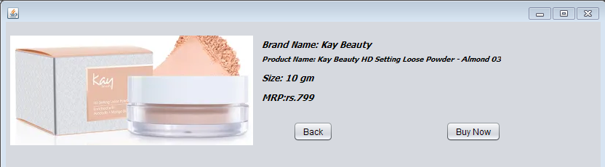

Pay8.java

Code:

/*

* To change this license header, choose License Headers in Project Properties.

* To change this template file, choose Tools | Templates

* and open the template in the editor.

*/

package beautyproducts;

/**

*

* @author js

*/

public class Pay8 extends javax.swing.JFrame {

/**

* Creates new form Pay8

*/

public Pay8() {

initComponents();

}

/**

* This method is called from within the constructor to initialize the form.

* WARNING: Do NOT modify this code. The content of this method is always

* regenerated by the Form Editor.

*/

@SuppressWarnings("unchecked")

// <editor-fold defaultstate="collapsed" desc="Generated Code">

private void initComponents() {

jLabel5 = new javax.swing.JLabel();

jTextField5 = new javax.swing.JTextField();

jLabel6 = new javax.swing.JLabel();

jTextField6 = new javax.swing.JTextField();

jLabel7 = new javax.swing.JLabel();

jLabel8 = new javax.swing.JLabel();

jplaceorder1 = new javax.swing.JButton();

jexit1 = new javax.swing.JButton();

jTextField7 = new javax.swing.JTextField();

jTextField8 = new javax.swing.JTextField();

setDefaultCloseOperation(javax.swing.WindowConstants.EXIT_ON_CLOSE);

jLabel5.setText("Year of expiry");

jLabel6.setText("Total amount");

jLabel7.setText("Name");

jLabel8.setText("Card No");

jplaceorder1.setText("Place Order");

jplaceorder1.addActionListener(new java.awt.event.ActionListener() {

public void actionPerformed(java.awt.event.ActionEvent evt) {

jplaceorder1ActionPerformed(evt);

}

});

jexit1.setText("Exit");

jexit1.addActionListener(new java.awt.event.ActionListener() {

public void actionPerformed(java.awt.event.ActionEvent evt) {

jexit1ActionPerformed(evt);

}

});

javax.swing.GroupLayout layout = new javax.swing.GroupLayout(getContentPane());

getContentPane().setLayout(layout);

layout.setHorizontalGroup(

layout.createParallelGroup(javax.swing.GroupLayout.Alignment.LEADING)

.addGroup(layout.createSequentialGroup()

.addGap(127, 127, 127)

.addGroup(layout.createParallelGroup(javax.swing.GroupLayout.Alignment.LEADING)

.addGroup(layout.createSequentialGroup()

.addComponent(jplaceorder1)

.addGap(127, 127, 127)

.addComponent(jexit1, javax.swing.GroupLayout.PREFERRED_SIZE, 93, javax.swing.GroupLayout.PREFERRED_SIZE))

.addGroup(layout.createSequentialGroup()

.addComponent(jLabel8)

.addPreferredGap(javax.swing.LayoutStyle.ComponentPlacement.RELATED, 270, javax.swing.GroupLayout.PREFERRED_SIZE))

.addGroup(javax.swing.GroupLayout.Alignment.TRAILING, layout.createSequentialGroup()

.addGroup(layout.createParallelGroup(javax.swing.GroupLayout.Alignment.LEADING)

.addComponent(jLabel5)

.addComponent(jLabel7, javax.swing.GroupLayout.PREFERRED_SIZE, 39, javax.swing.GroupLayout.PREFERRED_SIZE)

.addComponent(jLabel6))

.addPreferredGap(javax.swing.LayoutStyle.ComponentPlacement.RELATED, javax.swing.GroupLayout.DEFAULT_SIZE, Short.MAX_VALUE)

.addGroup(layout.createParallelGroup(javax.swing.GroupLayout.Alignment.TRAILING, false)

.addComponent(jTextField6)

.addComponent(jTextField7, javax.swing.GroupLayout.Alignment.LEADING)

.addComponent(jTextField8, javax.swing.GroupLayout.Alignment.LEADING)

.addComponent(jTextField5, javax.swing.GroupLayout.Alignment.LEADING, javax.swing.GroupLayout.PREFERRED_SIZE, 179, javax.swing.GroupLayout.PREFERRED_SIZE))

.addGap(58, 58, 58)))

.addGap(162, 162, 162))

);

layout.setVerticalGroup(

layout.createParallelGroup(javax.swing.GroupLayout.Alignment.LEADING)

.addGroup(layout.createSequentialGroup()

.addGap(74, 74, 74)

.addGroup(layout.createParallelGroup(javax.swing.GroupLayout.Alignment.BASELINE)

.addComponent(jTextField7, javax.swing.GroupLayout.PREFERRED_SIZE, javax.swing.GroupLayout.DEFAULT_SIZE, javax.swing.GroupLayout.PREFERRED_SIZE)

.addComponent(jLabel7))

.addGap(34, 34, 34)

.addGroup(layout.createParallelGroup(javax.swing.GroupLayout.Alignment.BASELINE)

.addComponent(jTextField8, javax.swing.GroupLayout.PREFERRED_SIZE, javax.swing.GroupLayout.DEFAULT_SIZE, javax.swing.GroupLayout.PREFERRED_SIZE)

.addComponent(jLabel8))

.addGap(36, 36, 36)

.addGroup(layout.createParallelGroup(javax.swing.GroupLayout.Alignment.BASELINE)

.addComponent(jLabel5)

.addComponent(jTextField5, javax.swing.GroupLayout.PREFERRED_SIZE, javax.swing.GroupLayout.DEFAULT_SIZE, javax.swing.GroupLayout.PREFERRED_SIZE))

.addGap(45, 45, 45)

.addGroup(layout.createParallelGroup(javax.swing.GroupLayout.Alignment.BASELINE)

.addComponent(jLabel6)

.addComponent(jTextField6, javax.swing.GroupLayout.PREFERRED_SIZE, javax.swing.GroupLayout.DEFAULT_SIZE, javax.swing.GroupLayout.PREFERRED_SIZE))

.addPreferredGap(javax.swing.LayoutStyle.ComponentPlacement.RELATED, javax.swing.GroupLayout.DEFAULT_SIZE, Short.MAX_VALUE)

.addGroup(layout.createParallelGroup(javax.swing.GroupLayout.Alignment.BASELINE)

.addComponent(jplaceorder1)

.addComponent(jexit1))

.addGap(41, 41, 41))

);

pack();

}// </editor-fold>

private void jplaceorder1ActionPerformed(java.awt.event.ActionEvent evt) {

new Powd_bill().setVisible(true);

this.setVisible(false);

}

private void jexit1ActionPerformed(java.awt.event.ActionEvent evt) {

System.exit(0);

}

/**

* @param args the command line arguments

*/

public static void main(String args[]) {

/* Set the Nimbus look and feel */

//<editor-fold defaultstate="collapsed" desc=" Look and feel setting code (optional) ">

/* If Nimbus (introduced in Java SE 6) is not available, stay with the default look and feel.

* For details see http://download.oracle.com/javase/tutorial/uiswing/lookandfeel/plaf.html

*/

try {

for (javax.swing.UIManager.LookAndFeelInfo info : javax.swing.UIManager.getInstalledLookAndFeels()) {

if ("Nimbus".equals(info.getName())) {

javax.swing.UIManager.setLookAndFeel(info.getClassName());

break;

}

}

} catch (ClassNotFoundException ex) {

java.util.logging.Logger.getLogger(Pay8.class.getName()).log(java.util.logging.Level.SEVERE, null, ex);

} catch (InstantiationException ex) {

java.util.logging.Logger.getLogger(Pay8.class.getName()).log(java.util.logging.Level.SEVERE, null, ex);

} catch (IllegalAccessException ex) {

java.util.logging.Logger.getLogger(Pay8.class.getName()).log(java.util.logging.Level.SEVERE, null, ex);

} catch (javax.swing.UnsupportedLookAndFeelException ex) {

java.util.logging.Logger.getLogger(Pay8.class.getName()).log(java.util.logging.Level.SEVERE, null, ex);

}

//</editor-fold>

/* Create and display the form */

java.awt.EventQueue.invokeLater(new Runnable() {

public void run() {

new Pay8().setVisible(true);

}

});

}

// Variables declaration - do not modify

private javax.swing.JLabel jLabel5;

private javax.swing.JLabel jLabel6;

private javax.swing.JLabel jLabel7;

private javax.swing.JLabel jLabel8;

private javax.swing.JTextField jTextField5;

private javax.swing.JTextField jTextField6;

private javax.swing.JTextField jTextField7;

private javax.swing.JTextField jTextField8;

private javax.swing.JButton jexit1;

private javax.swing.JButton jplaceorder1;

// End of variables declaration

}

Output:

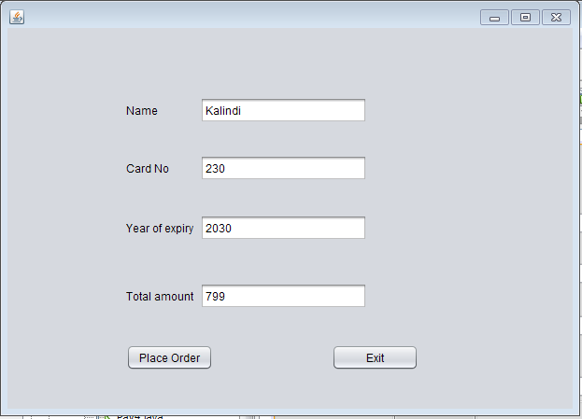

Powd_bill.java

Code:

/*

* To change this license header, choose License Headers in Project Properties.

* To change this template file, choose Tools | Templates

* and open the template in the editor.

*/

package beautyproducts;

import com.mysql.jdbc.Connection;

import com.mysql.jdbc.PreparedStatement;

import java.sql.DriverManager;

import java.sql.ResultSet;

import java.sql.SQLException;

import java.util.logging.Level;

import java.util.logging.Logger;

import javax.swing.JOptionPane;

import net.proteanit.sql.DbUtils;

/**

*

* @author js

*/

public class Powd_bill extends javax.swing.JFrame {

/**

* Creates new form Powd_bill

*/

Connection con = null;

PreparedStatement pst = null;

ResultSet rs = null;

public Powd_bill() {

initComponents();

String name,number,address;

}

public void Print(){

String name=txtname.getText();

String number=txtnumber.getText();

String address=txtaddress.getText();

txtbill.setText("\t"+"The Cosmetic Shop"+"\n"+"\n"

+"Brand:- Kay Beauty"+"\n"

+"Product Name:- Kay Beauty HD Setting Loose Powder - Almond 03 " +"\n"

+"Price:- 799"+"\n"

+"\n"+"********************");

txtbill.setText(txtbill.getText() +"\n"+"Coustomer name:- "+name);

txtbill.setText(txtbill.getText()+"\n"+"\n"+"Contact number:-"+number);

txtbill.setText(txtbill.getText() +"\n"+"\n"+"Address:-"+address);

txtbill.setText(txtbill.getText()+"\n"+"\n"+"\n"+"\n"+"\n"+"\n"+"\n"+"\t"+"**Thanks For Shopping**");

}

/**

* This method is called from within the constructor to initialize the form.

* WARNING: Do NOT modify this code. The content of this method is always

* regenerated by the Form Editor.

*/

@SuppressWarnings("unchecked")

// <editor-fold defaultstate="collapsed" desc="Generated Code">

private void initComponents() {

jLabel3 = new javax.swing.JLabel();

txtname = new javax.swing.JTextField();

txtnumber = new javax.swing.JTextField();

txtaddress = new javax.swing.JTextField();

jScrollPane1 = new javax.swing.JScrollPane();

txtbill = new javax.swing.JTextArea();

jButton1 = new javax.swing.JButton();

jButton2 = new javax.swing.JButton();

jLabel1 = new javax.swing.JLabel();

jLabel2 = new javax.swing.JLabel();

setDefaultCloseOperation(javax.swing.WindowConstants.EXIT_ON_CLOSE);

jLabel3.setText("Address:");

txtaddress.addActionListener(new java.awt.event.ActionListener() {

public void actionPerformed(java.awt.event.ActionEvent evt) {

txtaddressActionPerformed(evt);

}

});

txtbill.setColumns(20);

txtbill.setRows(5);

jScrollPane1.setViewportView(txtbill);

jButton1.setText("Ok");

jButton1.addActionListener(new java.awt.event.ActionListener() {

public void actionPerformed(java.awt.event.ActionEvent evt) {

jButton1ActionPerformed(evt);

}

});

jButton2.setText("Done");

jButton2.addActionListener(new java.awt.event.ActionListener() {

public void actionPerformed(java.awt.event.ActionEvent evt) {

jButton2ActionPerformed(evt);

}

});

jLabel1.setText("Customer Name:");

jLabel2.setText("Contact Number:");

javax.swing.GroupLayout layout = new javax.swing.GroupLayout(getContentPane());

getContentPane().setLayout(layout);

layout.setHorizontalGroup(

layout.createParallelGroup(javax.swing.GroupLayout.Alignment.LEADING)

.addGroup(layout.createSequentialGroup()

.addGap(37, 37, 37)

.addGroup(layout.createParallelGroup(javax.swing.GroupLayout.Alignment.TRAILING)

.addGroup(layout.createSequentialGroup()

.addGroup(layout.createParallelGroup(javax.swing.GroupLayout.Alignment.LEADING)

.addComponent(jLabel1)

.addComponent(jLabel2)

.addComponent(jLabel3))

.addGap(69, 69, 69)

.addGroup(layout.createParallelGroup(javax.swing.GroupLayout.Alignment.LEADING, false)

.addComponent(txtname, javax.swing.GroupLayout.DEFAULT_SIZE, 161, Short.MAX_VALUE)

.addComponent(txtnumber)

.addComponent(txtaddress)))

.addComponent(jButton1))

.addPreferredGap(javax.swing.LayoutStyle.ComponentPlacement.RELATED, javax.swing.GroupLayout.DEFAULT_SIZE, Short.MAX_VALUE)

.addComponent(jScrollPane1, javax.swing.GroupLayout.PREFERRED_SIZE, 309, javax.swing.GroupLayout.PREFERRED_SIZE)

.addGap(22, 22, 22))

.addGroup(javax.swing.GroupLayout.Alignment.TRAILING, layout.createSequentialGroup()

.addContainerGap(javax.swing.GroupLayout.DEFAULT_SIZE, Short.MAX_VALUE)

.addComponent(jButton2)

.addGap(126, 126, 126))

);

layout.setVerticalGroup(

layout.createParallelGroup(javax.swing.GroupLayout.Alignment.LEADING)

.addGroup(layout.createSequentialGroup()

.addGap(52, 52, 52)

.addGroup(layout.createParallelGroup(javax.swing.GroupLayout.Alignment.BASELINE)

.addComponent(jLabel1)

.addComponent(txtname, javax.swing.GroupLayout.PREFERRED_SIZE, javax.swing.GroupLayout.DEFAULT_SIZE, javax.swing.GroupLayout.PREFERRED_SIZE))

.addGap(29, 29, 29)

.addGroup(layout.createParallelGroup(javax.swing.GroupLayout.Alignment.BASELINE)

.addComponent(jLabel2)

.addComponent(txtnumber, javax.swing.GroupLayout.PREFERRED_SIZE, javax.swing.GroupLayout.DEFAULT_SIZE, javax.swing.GroupLayout.PREFERRED_SIZE))

.addGap(40, 40, 40)

.addGroup(layout.createParallelGroup(javax.swing.GroupLayout.Alignment.BASELINE)

.addComponent(jLabel3)

.addComponent(txtaddress, javax.swing.GroupLayout.PREFERRED_SIZE, 109, javax.swing.GroupLayout.PREFERRED_SIZE))

.addGap(67, 67, 67)

.addComponent(jButton1)

.addContainerGap(javax.swing.GroupLayout.DEFAULT_SIZE, Short.MAX_VALUE))

.addGroup(javax.swing.GroupLayout.Alignment.TRAILING, layout.createSequentialGroup()

.addContainerGap(javax.swing.GroupLayout.DEFAULT_SIZE, Short.MAX_VALUE)

.addComponent(jScrollPane1, javax.swing.GroupLayout.PREFERRED_SIZE, 418, javax.swing.GroupLayout.PREFERRED_SIZE)

.addGap(18, 18, 18)

.addComponent(jButton2)

.addGap(10, 10, 10))

);

pack();

}// </editor-fold>

private void txtaddressActionPerformed(java.awt.event.ActionEvent evt) {

// TODO add your handling code here:

}

private void jButton1ActionPerformed(java.awt.event.ActionEvent evt) {

Print();

}

private void jButton2ActionPerformed(java.awt.event.ActionEvent evt) {

try

{

String sql = "INSERT INTO customer_details"

+"(CustomerName,CustomerNumber,Address)"

+"VALUES (?,?,?)";

con = (Connection) DriverManager.getConnection("jdbc:mysql://localhost/details","root","");

pst = (PreparedStatement) con.prepareStatement(sql);

pst.setString(1,txtname.getText());

pst.setString(2,txtnumber.getText());

pst.setString(3,txtaddress.getText());

pst.executeUpdate();

JOptionPane.showMessageDialog(null, "Thank you for shopping!!");

txtname.setText(null);

txtnumber.setText(null);

txtaddress.setText(null);

}

catch(Exception ex)

{

JOptionPane.showMessageDialog(null, ex);

}

}

/**

* @param args the command line arguments

*/

public static void main(String args[]) {

/* Set the Nimbus look and feel */

//<editor-fold defaultstate="collapsed" desc=" Look and feel setting code (optional) ">

/* If Nimbus (introduced in Java SE 6) is not available, stay with the default look and feel.

* For details see http://download.oracle.com/javase/tutorial/uiswing/lookandfeel/plaf.html

*/

try {

for (javax.swing.UIManager.LookAndFeelInfo info : javax.swing.UIManager.getInstalledLookAndFeels()) {

if ("Nimbus".equals(info.getName())) {

javax.swing.UIManager.setLookAndFeel(info.getClassName());

break;

}

}

} catch (ClassNotFoundException ex) {

java.util.logging.Logger.getLogger(Powd_bill.class.getName()).log(java.util.logging.Level.SEVERE, null, ex);

} catch (InstantiationException ex) {

java.util.logging.Logger.getLogger(Powd_bill.class.getName()).log(java.util.logging.Level.SEVERE, null, ex);

} catch (IllegalAccessException ex) {

java.util.logging.Logger.getLogger(Powd_bill.class.getName()).log(java.util.logging.Level.SEVERE, null, ex);

} catch (javax.swing.UnsupportedLookAndFeelException ex) {

java.util.logging.Logger.getLogger(Powd_bill.class.getName()).log(java.util.logging.Level.SEVERE, null, ex);

}

//</editor-fold>

/* Create and display the form */

java.awt.EventQueue.invokeLater(new Runnable() {

public void run() {

new Powd_bill().setVisible(true);

}

});

}

// Variables declaration - do not modify

private javax.swing.JButton jButton1;

private javax.swing.JButton jButton2;

private javax.swing.JLabel jLabel1;

private javax.swing.JLabel jLabel2;

private javax.swing.JLabel jLabel3;

private javax.swing.JScrollPane jScrollPane1;

private javax.swing.JTextField txtaddress;

private javax.swing.JTextArea txtbill;

private javax.swing.JTextField txtname;

private javax.swing.JTextField txtnumber;

// End of variables declaration

}

Output:

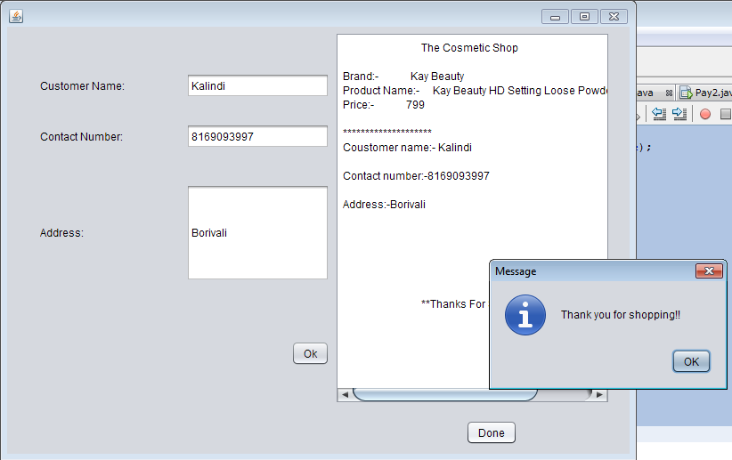

Eyeliner.java

Code:

/*

* To change this license header, choose License Headers in Project Properties.

* To change this template file, choose Tools | Templates

* and open the template in the editor.

*/

package beautyproducts;

/**

*

* @author js

*/

public class Eyeliner extends javax.swing.JFrame {

/**

* Creates new form Eyeliner

*/

public Eyeliner() {

initComponents();

}

/**

* This method is called from within the constructor to initialize the form.

* WARNING: Do NOT modify this code. The content of this method is always

* regenerated by the Form Editor.

*/

@SuppressWarnings("unchecked")

// <editor-fold defaultstate="collapsed" desc="Generated Code">

private void initComponents() {

jLabel1 = new javax.swing.JLabel();

jLabel2 = new javax.swing.JLabel();

jLabel3 = new javax.swing.JLabel();

jLabel4 = new javax.swing.JLabel();

jLabel5 = new javax.swing.JLabel();

jButton1 = new javax.swing.JButton();

jButton3 = new javax.swing.JButton();

setDefaultCloseOperation(javax.swing.WindowConstants.EXIT_ON_CLOSE);

jLabel1.setIcon(new javax.swing.ImageIcon("C:\\Users\\js\\Desktop\\17.PNG")); // NOI18N

jLabel1.setText("jLabel1");

jLabel2.setFont(new java.awt.Font("Tahoma", 3, 12)); // NOI18N

jLabel2.setText("Brand Name: Maybelline");

jLabel3.setFont(new java.awt.Font("Tahoma", 3, 12)); // NOI18N

jLabel3.setText("Product Name: Maybelline New York Hyper Glossy Liquid Liner - Black ");

jLabel4.setFont(new java.awt.Font("Tahoma", 3, 12)); // NOI18N

jLabel4.setText("Size: 3 gm");

jLabel5.setFont(new java.awt.Font("Tahoma", 3, 12)); // NOI18N

jLabel5.setText("MRP: rs.310");

jButton1.setText("Buy Now");

jButton1.addActionListener(new java.awt.event.ActionListener() {

public void actionPerformed(java.awt.event.ActionEvent evt) {

jButton1ActionPerformed(evt);

}

});

jButton3.setText("Back");

jButton3.addActionListener(new java.awt.event.ActionListener() {

public void actionPerformed(java.awt.event.ActionEvent evt) {

jButton3ActionPerformed(evt);

}

});

javax.swing.GroupLayout layout = new javax.swing.GroupLayout(getContentPane());

getContentPane().setLayout(layout);

layout.setHorizontalGroup(

layout.createParallelGroup(javax.swing.GroupLayout.Alignment.LEADING)

.addGroup(layout.createSequentialGroup()

.addContainerGap()

.addComponent(jLabel1, javax.swing.GroupLayout.PREFERRED_SIZE, 221, javax.swing.GroupLayout.PREFERRED_SIZE)

.addGap(145, 145, 145)

.addGroup(layout.createParallelGroup(javax.swing.GroupLayout.Alignment.LEADING)

.addGroup(layout.createSequentialGroup()

.addPreferredGap(javax.swing.LayoutStyle.ComponentPlacement.RELATED, 96, Short.MAX_VALUE)

.addGroup(layout.createParallelGroup(javax.swing.GroupLayout.Alignment.LEADING)

.addComponent(jLabel2, javax.swing.GroupLayout.PREFERRED_SIZE, 163, javax.swing.GroupLayout.PREFERRED_SIZE)

.addComponent(jLabel3)

.addComponent(jLabel4, javax.swing.GroupLayout.PREFERRED_SIZE, 75, javax.swing.GroupLayout.PREFERRED_SIZE)

.addComponent(jLabel5, javax.swing.GroupLayout.PREFERRED_SIZE, 88, javax.swing.GroupLayout.PREFERRED_SIZE)))

.addGroup(layout.createSequentialGroup()

.addGap(6, 6, 6)

.addComponent(jButton3)

.addGap(173, 173, 173)

.addComponent(jButton1)))

.addContainerGap(javax.swing.GroupLayout.DEFAULT_SIZE, Short.MAX_VALUE))

);

layout.setVerticalGroup(

layout.createParallelGroup(javax.swing.GroupLayout.Alignment.LEADING)

.addGroup(layout.createSequentialGroup()

.addGroup(layout.createParallelGroup(javax.swing.GroupLayout.Alignment.LEADING)

.addGroup(layout.createSequentialGroup()

.addContainerGap()

.addComponent(jLabel1))

.addGroup(layout.createSequentialGroup()

.addGap(21, 21, 21)

.addComponent(jLabel2)

.addPreferredGap(javax.swing.LayoutStyle.ComponentPlacement.UNRELATED)

.addComponent(jLabel3)

.addPreferredGap(javax.swing.LayoutStyle.ComponentPlacement.UNRELATED)

.addComponent(jLabel4)

.addPreferredGap(javax.swing.LayoutStyle.ComponentPlacement.UNRELATED)

.addComponent(jLabel5)

.addGap(85, 85, 85)

.addGroup(layout.createParallelGroup(javax.swing.GroupLayout.Alignment.BASELINE)

.addComponent(jButton1)

.addComponent(jButton3))))

.addContainerGap(364, Short.MAX_VALUE))

);

pack();

}// </editor-fold>

private void jButton1ActionPerformed(java.awt.event.ActionEvent evt) {

new Pay9().setVisible(true);

this.setVisible(false);

}

private void jButton3ActionPerformed(java.awt.event.ActionEvent evt) {

new BuyProduct().setVisible(true);

this.setVisible(false);

}

/**

* @param args the command line arguments

*/

public static void main(String args[]) {

/* Set the Nimbus look and feel */

//<editor-fold defaultstate="collapsed" desc=" Look and feel setting code (optional) ">

/* If Nimbus (introduced in Java SE 6) is not available, stay with the default look and feel.

* For details see http://download.oracle.com/javase/tutorial/uiswing/lookandfeel/plaf.html

*/

try {

for (javax.swing.UIManager.LookAndFeelInfo info : javax.swing.UIManager.getInstalledLookAndFeels()) {

if ("Nimbus".equals(info.getName())) {

javax.swing.UIManager.setLookAndFeel(info.getClassName());

break;

}

}

} catch (ClassNotFoundException ex) {

java.util.logging.Logger.getLogger(Eyeliner.class.getName()).log(java.util.logging.Level.SEVERE, null, ex);

} catch (InstantiationException ex) {

java.util.logging.Logger.getLogger(Eyeliner.class.getName()).log(java.util.logging.Level.SEVERE, null, ex);

} catch (IllegalAccessException ex) {

java.util.logging.Logger.getLogger(Eyeliner.class.getName()).log(java.util.logging.Level.SEVERE, null, ex);

} catch (javax.swing.UnsupportedLookAndFeelException ex) {

java.util.logging.Logger.getLogger(Eyeliner.class.getName()).log(java.util.logging.Level.SEVERE, null, ex);

}

//</editor-fold>

/* Create and display the form */

java.awt.EventQueue.invokeLater(new Runnable() {

public void run() {

new Eyeliner().setVisible(true);

}

});

}

// Variables declaration - do not modify

private javax.swing.JButton jButton1;

private javax.swing.JButton jButton3;

private javax.swing.JLabel jLabel1;

private javax.swing.JLabel jLabel2;

private javax.swing.JLabel jLabel3;

private javax.swing.JLabel jLabel4;

private javax.swing.JLabel jLabel5;

// End of variables declaration

}

Output:

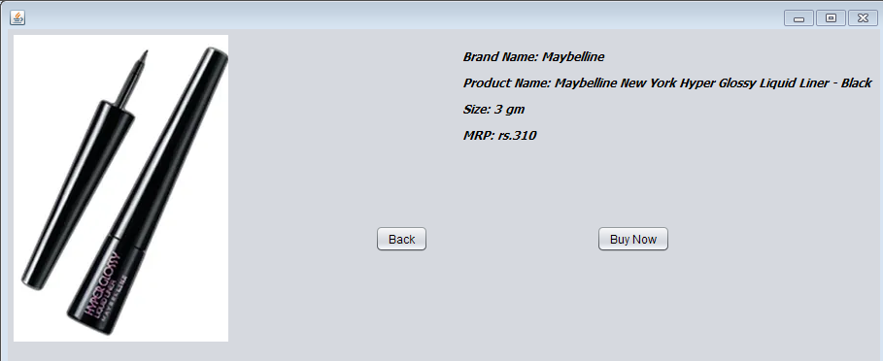

Pay9.java

Code:

/*

* To change this license header, choose License Headers in Project Properties.

* To change this template file, choose Tools | Templates

* and open the template in the editor.

*/

package beautyproducts;

/**

*

* @author js

*/

public class Pay9 extends javax.swing.JFrame {

/**

* Creates new form Pay9

*/

public Pay9() {

initComponents();

}

/**

* This method is called from within the constructor to initialize the form.

* WARNING: Do NOT modify this code. The content of this method is always

* regenerated by the Form Editor.

*/

@SuppressWarnings("unchecked")

// <editor-fold defaultstate="collapsed" desc="Generated Code">

private void initComponents() {

jLabel5 = new javax.swing.JLabel();

jTextField5 = new javax.swing.JTextField();

jLabel6 = new javax.swing.JLabel();

jTextField6 = new javax.swing.JTextField();

jLabel7 = new javax.swing.JLabel();

jLabel8 = new javax.swing.JLabel();

jplaceorder1 = new javax.swing.JButton();

jexit1 = new javax.swing.JButton();

jTextField7 = new javax.swing.JTextField();

jTextField8 = new javax.swing.JTextField();

setDefaultCloseOperation(javax.swing.WindowConstants.EXIT_ON_CLOSE);

jLabel5.setText("Year of expiry");

jLabel6.setText("Total amount");

jLabel7.setText("Name");

jLabel8.setText("Card No");

jplaceorder1.setText("Place Order");

jplaceorder1.addActionListener(new java.awt.event.ActionListener() {

public void actionPerformed(java.awt.event.ActionEvent evt) {

jplaceorder1ActionPerformed(evt);

}

});

jexit1.setText("Exit");

jexit1.addActionListener(new java.awt.event.ActionListener() {

public void actionPerformed(java.awt.event.ActionEvent evt) {

jexit1ActionPerformed(evt);

}

});

javax.swing.GroupLayout layout = new javax.swing.GroupLayout(getContentPane());

getContentPane().setLayout(layout);

layout.setHorizontalGroup(

layout.createParallelGroup(javax.swing.GroupLayout.Alignment.LEADING)

.addGroup(layout.createSequentialGroup()

.addGap(127, 127, 127)

.addGroup(layout.createParallelGroup(javax.swing.GroupLayout.Alignment.LEADING)

.addGroup(layout.createSequentialGroup()

.addComponent(jplaceorder1)

.addGap(127, 127, 127)

.addComponent(jexit1, javax.swing.GroupLayout.PREFERRED_SIZE, 93, javax.swing.GroupLayout.PREFERRED_SIZE))

.addGroup(layout.createSequentialGroup()

.addComponent(jLabel8)

.addPreferredGap(javax.swing.LayoutStyle.ComponentPlacement.RELATED, 270, javax.swing.GroupLayout.PREFERRED_SIZE))

.addGroup(javax.swing.GroupLayout.Alignment.TRAILING, layout.createSequentialGroup()

.addGroup(layout.createParallelGroup(javax.swing.GroupLayout.Alignment.LEADING)

.addComponent(jLabel5)

.addComponent(jLabel7, javax.swing.GroupLayout.PREFERRED_SIZE, 39, javax.swing.GroupLayout.PREFERRED_SIZE)

.addComponent(jLabel6))

.addPreferredGap(javax.swing.LayoutStyle.ComponentPlacement.RELATED, javax.swing.GroupLayout.DEFAULT_SIZE, Short.MAX_VALUE)

.addGroup(layout.createParallelGroup(javax.swing.GroupLayout.Alignment.TRAILING, false)

.addComponent(jTextField6)

.addComponent(jTextField7, javax.swing.GroupLayout.Alignment.LEADING)

.addComponent(jTextField8, javax.swing.GroupLayout.Alignment.LEADING)

.addComponent(jTextField5, javax.swing.GroupLayout.Alignment.LEADING, javax.swing.GroupLayout.PREFERRED_SIZE, 179, javax.swing.GroupLayout.PREFERRED_SIZE))

.addGap(58, 58, 58)))

.addGap(162, 162, 162))

);

layout.setVerticalGroup(

layout.createParallelGroup(javax.swing.GroupLayout.Alignment.LEADING)

.addGroup(layout.createSequentialGroup()

.addGap(74, 74, 74)

.addGroup(layout.createParallelGroup(javax.swing.GroupLayout.Alignment.BASELINE)

.addComponent(jTextField7, javax.swing.GroupLayout.PREFERRED_SIZE, javax.swing.GroupLayout.DEFAULT_SIZE, javax.swing.GroupLayout.PREFERRED_SIZE)

.addComponent(jLabel7))

.addGap(34, 34, 34)

.addGroup(layout.createParallelGroup(javax.swing.GroupLayout.Alignment.BASELINE)

.addComponent(jTextField8, javax.swing.GroupLayout.PREFERRED_SIZE, javax.swing.GroupLayout.DEFAULT_SIZE, javax.swing.GroupLayout.PREFERRED_SIZE)

.addComponent(jLabel8))

.addGap(36, 36, 36)

.addGroup(layout.createParallelGroup(javax.swing.GroupLayout.Alignment.BASELINE)

.addComponent(jLabel5)

.addComponent(jTextField5, javax.swing.GroupLayout.PREFERRED_SIZE, javax.swing.GroupLayout.DEFAULT_SIZE, javax.swing.GroupLayout.PREFERRED_SIZE))

.addGap(45, 45, 45)

.addGroup(layout.createParallelGroup(javax.swing.GroupLayout.Alignment.BASELINE)

.addComponent(jLabel6)

.addComponent(jTextField6, javax.swing.GroupLayout.PREFERRED_SIZE, javax.swing.GroupLayout.DEFAULT_SIZE, javax.swing.GroupLayout.PREFERRED_SIZE))

.addPreferredGap(javax.swing.LayoutStyle.ComponentPlacement.RELATED, javax.swing.GroupLayout.DEFAULT_SIZE, Short.MAX_VALUE)

.addGroup(layout.createParallelGroup(javax.swing.GroupLayout.Alignment.BASELINE)

.addComponent(jplaceorder1)

.addComponent(jexit1))

.addGap(41, 41, 41))

);

pack();

}// </editor-fold>

private void jplaceorder1ActionPerformed(java.awt.event.ActionEvent evt) {

new Liner_bill().setVisible(true);

this.setVisible(false);

}

private void jexit1ActionPerformed(java.awt.event.ActionEvent evt) {

System.exit(0);

}

/**

* @param args the command line arguments

*/

public static void main(String args[]) {

/* Set the Nimbus look and feel */

//<editor-fold defaultstate="collapsed" desc=" Look and feel setting code (optional) ">

/* If Nimbus (introduced in Java SE 6) is not available, stay with the default look and feel.

* For details see http://download.oracle.com/javase/tutorial/uiswing/lookandfeel/plaf.html

*/

try {

for (javax.swing.UIManager.LookAndFeelInfo info : javax.swing.UIManager.getInstalledLookAndFeels()) {

if ("Nimbus".equals(info.getName())) {

javax.swing.UIManager.setLookAndFeel(info.getClassName());

break;

}

}

} catch (ClassNotFoundException ex) {

java.util.logging.Logger.getLogger(Pay9.class.getName()).log(java.util.logging.Level.SEVERE, null, ex);

} catch (InstantiationException ex) {

java.util.logging.Logger.getLogger(Pay9.class.getName()).log(java.util.logging.Level.SEVERE, null, ex);

} catch (IllegalAccessException ex) {

java.util.logging.Logger.getLogger(Pay9.class.getName()).log(java.util.logging.Level.SEVERE, null, ex);

} catch (javax.swing.UnsupportedLookAndFeelException ex) {

java.util.logging.Logger.getLogger(Pay9.class.getName()).log(java.util.logging.Level.SEVERE, null, ex);

}

//</editor-fold>

/* Create and display the form */

java.awt.EventQueue.invokeLater(new Runnable() {

public void run() {

new Pay9().setVisible(true);

}

});

}

// Variables declaration - do not modify

private javax.swing.JLabel jLabel5;

private javax.swing.JLabel jLabel6;

private javax.swing.JLabel jLabel7;

private javax.swing.JLabel jLabel8;

private javax.swing.JTextField jTextField5;

private javax.swing.JTextField jTextField6;

private javax.swing.JTextField jTextField7;

private javax.swing.JTextField jTextField8;

private javax.swing.JButton jexit1;

private javax.swing.JButton jplaceorder1;

// End of variables declaration

}

Output:

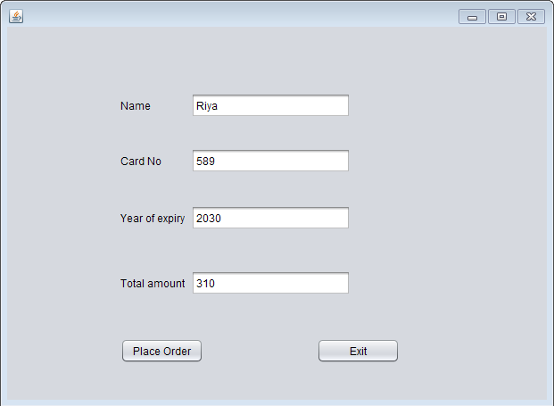

Liner_bill.java

Code:

/*

* To change this license header, choose License Headers in Project Properties.

* To change this template file, choose Tools | Templates

* and open the template in the editor.

*/

package beautyproducts;

import com.mysql.jdbc.Connection;

import com.mysql.jdbc.PreparedStatement;

import java.sql.DriverManager;

import java.sql.ResultSet;

import java.sql.SQLException;

import java.util.logging.Level;

import java.util.logging.Logger;

import javax.swing.JOptionPane;

import net.proteanit.sql.DbUtils;

/**

*

* @author js

*/

public class Liner_bill extends javax.swing.JFrame {

/**

* Creates new form Liner_bill

*/

Connection con = null;

PreparedStatement pst = null;

ResultSet rs = null;

public Liner_bill() {

initComponents();

String name,number,address;

}

public void Print(){

String name=txtname.getText();

String number=txtnumber.getText();

String address=txtaddress.getText();

txtbill.setText("\t"+"The Cosmetic Shop"+"\n"+"\n"

+"Brand:- Maybelline New York "+"\n"

+"Product Name:- Maybelline New York Hyper Glossy Liquid Liner - Black" +"\n"

+"Price:- 310"+"\n"

+"\n"+"********************");

txtbill.setText(txtbill.getText() +"\n"+"Coustomer name:- "+name);

txtbill.setText(txtbill.getText()+"\n"+"\n"+"Contact number:-"+number);

txtbill.setText(txtbill.getText() +"\n"+"\n"+"Address:-"+address);

txtbill.setText(txtbill.getText()+"\n"+"\n"+"\n"+"\n"+"\n"+"\n"+"\n"+"\t"+"**Thanks For Shopping**");

}

/**

* This method is called from within the constructor to initialize the form.

* WARNING: Do NOT modify this code. The content of this method is always

* regenerated by the Form Editor.

*/

@SuppressWarnings("unchecked")

// <editor-fold defaultstate="collapsed" desc="Generated Code">

private void initComponents() {

jLabel3 = new javax.swing.JLabel();

txtname = new javax.swing.JTextField();

txtnumber = new javax.swing.JTextField();

txtaddress = new javax.swing.JTextField();

jScrollPane1 = new javax.swing.JScrollPane();

txtbill = new javax.swing.JTextArea();

jButton1 = new javax.swing.JButton();

jButton2 = new javax.swing.JButton();

jLabel1 = new javax.swing.JLabel();

jLabel2 = new javax.swing.JLabel();

setDefaultCloseOperation(javax.swing.WindowConstants.EXIT_ON_CLOSE);

jLabel3.setText("Address:");

txtaddress.addActionListener(new java.awt.event.ActionListener() {

public void actionPerformed(java.awt.event.ActionEvent evt) {

txtaddressActionPerformed(evt);

}

});

txtbill.setColumns(20);

txtbill.setRows(5);

jScrollPane1.setViewportView(txtbill);

jButton1.setText("Ok");

jButton1.addActionListener(new java.awt.event.ActionListener() {

public void actionPerformed(java.awt.event.ActionEvent evt) {

jButton1ActionPerformed(evt);

}

});

jButton2.setText("Done");

jButton2.addActionListener(new java.awt.event.ActionListener() {

public void actionPerformed(java.awt.event.ActionEvent evt) {

jButton2ActionPerformed(evt);

}

});

jLabel1.setText("Customer Name:");

jLabel2.setText("Contact Number:");

javax.swing.GroupLayout layout = new javax.swing.GroupLayout(getContentPane());

getContentPane().setLayout(layout);

layout.setHorizontalGroup(

layout.createParallelGroup(javax.swing.GroupLayout.Alignment.LEADING)

.addGroup(layout.createSequentialGroup()

.addGap(37, 37, 37)

.addGroup(layout.createParallelGroup(javax.swing.GroupLayout.Alignment.TRAILING)

.addGroup(layout.createSequentialGroup()

.addGroup(layout.createParallelGroup(javax.swing.GroupLayout.Alignment.LEADING)

.addComponent(jLabel1)

.addComponent(jLabel2)

.addComponent(jLabel3))

.addGap(69, 69, 69)

.addGroup(layout.createParallelGroup(javax.swing.GroupLayout.Alignment.LEADING, false)

.addComponent(txtname, javax.swing.GroupLayout.DEFAULT_SIZE, 161, Short.MAX_VALUE)

.addComponent(txtnumber)

.addComponent(txtaddress)))

.addComponent(jButton1))

.addPreferredGap(javax.swing.LayoutStyle.ComponentPlacement.RELATED, javax.swing.GroupLayout.DEFAULT_SIZE, Short.MAX_VALUE)

.addComponent(jScrollPane1, javax.swing.GroupLayout.PREFERRED_SIZE, 309, javax.swing.GroupLayout.PREFERRED_SIZE)

.addGap(22, 22, 22))

.addGroup(javax.swing.GroupLayout.Alignment.TRAILING, layout.createSequentialGroup()

.addContainerGap(javax.swing.GroupLayout.DEFAULT_SIZE, Short.MAX_VALUE)

.addComponent(jButton2)

.addGap(126, 126, 126))

);

layout.setVerticalGroup(

layout.createParallelGroup(javax.swing.GroupLayout.Alignment.LEADING)

.addGroup(layout.createSequentialGroup()

.addGap(52, 52, 52)

.addGroup(layout.createParallelGroup(javax.swing.GroupLayout.Alignment.BASELINE)

.addComponent(jLabel1)

.addComponent(txtname, javax.swing.GroupLayout.PREFERRED_SIZE, javax.swing.GroupLayout.DEFAULT_SIZE, javax.swing.GroupLayout.PREFERRED_SIZE))

.addGap(29, 29, 29)

.addGroup(layout.createParallelGroup(javax.swing.GroupLayout.Alignment.BASELINE)

.addComponent(jLabel2)

.addComponent(txtnumber, javax.swing.GroupLayout.PREFERRED_SIZE, javax.swing.GroupLayout.DEFAULT_SIZE, javax.swing.GroupLayout.PREFERRED_SIZE))

.addGap(40, 40, 40)

.addGroup(layout.createParallelGroup(javax.swing.GroupLayout.Alignment.BASELINE)

.addComponent(jLabel3)

.addComponent(txtaddress, javax.swing.GroupLayout.PREFERRED_SIZE, 109, javax.swing.GroupLayout.PREFERRED_SIZE))

.addGap(67, 67, 67)

.addComponent(jButton1)

.addContainerGap(javax.swing.GroupLayout.DEFAULT_SIZE, Short.MAX_VALUE))

.addGroup(javax.swing.GroupLayout.Alignment.TRAILING, layout.createSequentialGroup()

.addContainerGap(javax.swing.GroupLayout.DEFAULT_SIZE, Short.MAX_VALUE)

.addComponent(jScrollPane1, javax.swing.GroupLayout.PREFERRED_SIZE, 418, javax.swing.GroupLayout.PREFERRED_SIZE)

.addGap(18, 18, 18)

.addComponent(jButton2)

.addGap(10, 10, 10))

);

pack();

}// </editor-fold>

private void txtaddressActionPerformed(java.awt.event.ActionEvent evt) {

// TODO add your handling code here:

}

private void jButton1ActionPerformed(java.awt.event.ActionEvent evt) {

Print();

}

private void jButton2ActionPerformed(java.awt.event.ActionEvent evt) {

try

{

String sql = "INSERT INTO customer_details"

+"(CustomerName,CustomerNumber,Address)"

+"VALUES (?,?,?)";

con = (Connection) DriverManager.getConnection("jdbc:mysql://localhost/details","root","");

pst = (PreparedStatement) con.prepareStatement(sql);

pst.setString(1,txtname.getText());

pst.setString(2,txtnumber.getText());

pst.setString(3,txtaddress.getText());

pst.executeUpdate();

JOptionPane.showMessageDialog(null, "Thank you for shopping!!");

txtname.setText(null);

txtnumber.setText(null);

txtaddress.setText(null);

}

catch(Exception ex)

{

JOptionPane.showMessageDialog(null, ex);

}

}

/**

* @param args the command line arguments

*/

public static void main(String args[]) {

/* Set the Nimbus look and feel */

//<editor-fold defaultstate="collapsed" desc=" Look and feel setting code (optional) ">

/* If Nimbus (introduced in Java SE 6) is not available, stay with the default look and feel.

* For details see http://download.oracle.com/javase/tutorial/uiswing/lookandfeel/plaf.html

*/

try {

for (javax.swing.UIManager.LookAndFeelInfo info : javax.swing.UIManager.getInstalledLookAndFeels()) {

if ("Nimbus".equals(info.getName())) {

javax.swing.UIManager.setLookAndFeel(info.getClassName());

break;

}

}

} catch (ClassNotFoundException ex) {

java.util.logging.Logger.getLogger(Liner_bill.class.getName()).log(java.util.logging.Level.SEVERE, null, ex);

} catch (InstantiationException ex) {

java.util.logging.Logger.getLogger(Liner_bill.class.getName()).log(java.util.logging.Level.SEVERE, null, ex);

} catch (IllegalAccessException ex) {

java.util.logging.Logger.getLogger(Liner_bill.class.getName()).log(java.util.logging.Level.SEVERE, null, ex);

} catch (javax.swing.UnsupportedLookAndFeelException ex) {

java.util.logging.Logger.getLogger(Liner_bill.class.getName()).log(java.util.logging.Level.SEVERE, null, ex);

}

//</editor-fold>

/* Create and display the form */

java.awt.EventQueue.invokeLater(new Runnable() {

public void run() {

new Liner_bill().setVisible(true);

}

});

}

// Variables declaration - do not modify

private javax.swing.JButton jButton1;

private javax.swing.JButton jButton2;

private javax.swing.JLabel jLabel1;

private javax.swing.JLabel jLabel2;

private javax.swing.JLabel jLabel3;

private javax.swing.JScrollPane jScrollPane1;

private javax.swing.JTextField txtaddress;

private javax.swing.JTextArea txtbill;

private javax.swing.JTextField txtname;

private javax.swing.JTextField txtnumber;

// End of variables declaration

}

Output:

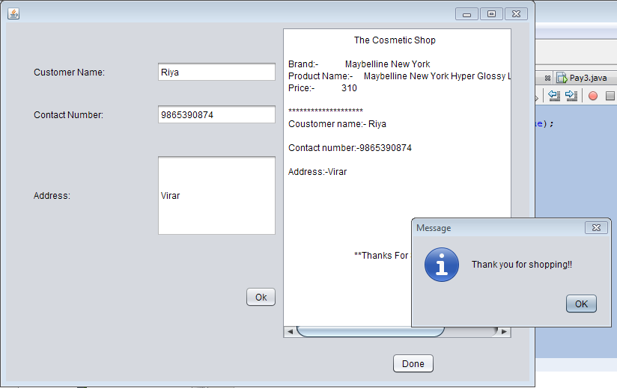

Kajal.java

Code:

/*

* To change this license header, choose License Headers in Project Properties.

* To change this template file, choose Tools | Templates

* and open the template in the editor.

*/

package beautyproducts;

/**

*

* @author js

*/

public class Kajal extends javax.swing.JFrame {

/**

* Creates new form Kajal

*/

public Kajal() {

initComponents();

}

/**

* This method is called from within the constructor to initialize the form.

* WARNING: Do NOT modify this code. The content of this method is always

* regenerated by the Form Editor.

*/

@SuppressWarnings("unchecked")

// <editor-fold defaultstate="collapsed" desc="Generated Code">

private void initComponents() {

jLabel1 = new javax.swing.JLabel();

jLabel2 = new javax.swing.JLabel();

jLabel3 = new javax.swing.JLabel();

jLabel4 = new javax.swing.JLabel();

jLabel5 = new javax.swing.JLabel();

jButton2 = new javax.swing.JButton();

jButton3 = new javax.swing.JButton();

setDefaultCloseOperation(javax.swing.WindowConstants.EXIT_ON_CLOSE);

jLabel1.setIcon(new javax.swing.ImageIcon("C:\\Users\\js\\Desktop\\19.PNG")); // NOI18N

jLabel1.setText("jLabel1");

jLabel2.setFont(new java.awt.Font("Tahoma", 3, 12)); // NOI18N

jLabel2.setText("Brand Name: Maybelline New York");

jLabel3.setFont(new java.awt.Font("Tahoma", 3, 12)); // NOI18N

jLabel3.setText("Product Name: Maybelline The Colossal Kajal 24Hour Smudge Proof - Deep Black");

jLabel4.setFont(new java.awt.Font("Tahoma", 3, 12)); // NOI18N

jLabel4.setText("Size:0.35 gm");

jLabel5.setFont(new java.awt.Font("Tahoma", 3, 12)); // NOI18N

jLabel5.setText("MRP: rs.180");

jButton2.setText("Back");

jButton2.addActionListener(new java.awt.event.ActionListener() {

public void actionPerformed(java.awt.event.ActionEvent evt) {

jButton2ActionPerformed(evt);

}

});

jButton3.setText("Buy Now");

jButton3.addActionListener(new java.awt.event.ActionListener() {

public void actionPerformed(java.awt.event.ActionEvent evt) {

jButton3ActionPerformed(evt);

}

});

javax.swing.GroupLayout layout = new javax.swing.GroupLayout(getContentPane());

getContentPane().setLayout(layout);

layout.setHorizontalGroup(

layout.createParallelGroup(javax.swing.GroupLayout.Alignment.LEADING)

.addGroup(layout.createSequentialGroup()

.addContainerGap()

.addComponent(jLabel1, javax.swing.GroupLayout.PREFERRED_SIZE, 198, javax.swing.GroupLayout.PREFERRED_SIZE)

.addGap(35, 35, 35)

.addGroup(layout.createParallelGroup(javax.swing.GroupLayout.Alignment.LEADING)

.addGroup(layout.createSequentialGroup()

.addGroup(layout.createParallelGroup(javax.swing.GroupLayout.Alignment.LEADING)

.addComponent(jLabel2)

.addComponent(jLabel3)

.addComponent(jLabel4, javax.swing.GroupLayout.PREFERRED_SIZE, 94, javax.swing.GroupLayout.PREFERRED_SIZE))

.addContainerGap(71, Short.MAX_VALUE))

.addGroup(layout.createSequentialGroup()

.addGroup(layout.createParallelGroup(javax.swing.GroupLayout.Alignment.TRAILING)

.addComponent(jButton2)

.addComponent(jLabel5, javax.swing.GroupLayout.PREFERRED_SIZE, 85, javax.swing.GroupLayout.PREFERRED_SIZE))

.addPreferredGap(javax.swing.LayoutStyle.ComponentPlacement.RELATED, javax.swing.GroupLayout.DEFAULT_SIZE, Short.MAX_VALUE)

.addComponent(jButton3)

.addGap(173, 173, 173))))

);

layout.setVerticalGroup(

layout.createParallelGroup(javax.swing.GroupLayout.Alignment.LEADING)

.addGroup(layout.createSequentialGroup()

.addGroup(layout.createParallelGroup(javax.swing.GroupLayout.Alignment.LEADING)

.addGroup(layout.createSequentialGroup()

.addContainerGap()

.addComponent(jLabel1))

.addGroup(layout.createSequentialGroup()

.addGap(28, 28, 28)

.addComponent(jLabel2)

.addPreferredGap(javax.swing.LayoutStyle.ComponentPlacement.UNRELATED)

.addComponent(jLabel3)

.addPreferredGap(javax.swing.LayoutStyle.ComponentPlacement.UNRELATED)

.addComponent(jLabel4)

.addPreferredGap(javax.swing.LayoutStyle.ComponentPlacement.UNRELATED)

.addComponent(jLabel5)

.addGap(74, 74, 74)

.addGroup(layout.createParallelGroup(javax.swing.GroupLayout.Alignment.BASELINE)

.addComponent(jButton3)

.addComponent(jButton2))))

.addContainerGap(385, Short.MAX_VALUE))

);

pack();

}// </editor-fold>

private void jButton3ActionPerformed(java.awt.event.ActionEvent evt) {

new Payment().setVisible(true);

this.setVisible(false);

}

private void jButton2ActionPerformed(java.awt.event.ActionEvent evt) {

new BuyProduct().setVisible(true);

this.setVisible(false);

}

/**

* @param args the command line arguments

*/

public static void main(String args[]) {

/* Set the Nimbus look and feel */

//<editor-fold defaultstate="collapsed" desc=" Look and feel setting code (optional) ">

/* If Nimbus (introduced in Java SE 6) is not available, stay with the default look and feel.

* For details see http://download.oracle.com/javase/tutorial/uiswing/lookandfeel/plaf.html

*/

try {

for (javax.swing.UIManager.LookAndFeelInfo info : javax.swing.UIManager.getInstalledLookAndFeels()) {

if ("Nimbus".equals(info.getName())) {

javax.swing.UIManager.setLookAndFeel(info.getClassName());

break;

}

}

} catch (ClassNotFoundException ex) {

java.util.logging.Logger.getLogger(Kajal.class.getName()).log(java.util.logging.Level.SEVERE, null, ex);

} catch (InstantiationException ex) {

java.util.logging.Logger.getLogger(Kajal.class.getName()).log(java.util.logging.Level.SEVERE, null, ex);

} catch (IllegalAccessException ex) {

java.util.logging.Logger.getLogger(Kajal.class.getName()).log(java.util.logging.Level.SEVERE, null, ex);

} catch (javax.swing.UnsupportedLookAndFeelException ex) {

java.util.logging.Logger.getLogger(Kajal.class.getName()).log(java.util.logging.Level.SEVERE, null, ex);

}

//</editor-fold>

/* Create and display the form */

java.awt.EventQueue.invokeLater(new Runnable() {

public void run() {

new Kajal().setVisible(true);

}

});

}

// Variables declaration - do not modify

private javax.swing.JButton jButton2;

private javax.swing.JButton jButton3;

private javax.swing.JLabel jLabel1;

private javax.swing.JLabel jLabel2;

private javax.swing.JLabel jLabel3;

private javax.swing.JLabel jLabel4;

private javax.swing.JLabel jLabel5;

// End of variables declaration

}

Output:

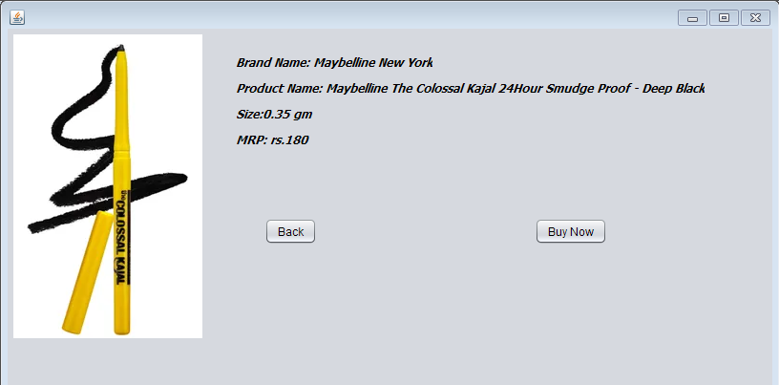

Payment.java

Code:

/*

* To change this license header, choose License Headers in Project Properties.

* To change this template file, choose Tools | Templates

* and open the template in the editor.

*/

package beautyproducts;

import javax.swing.JOptionPane;

import java.awt.Toolkit;

import java.awt.event.WindowEvent;

/**

*

* @author js

*/

public class Payment extends javax.swing.JFrame {

/**

* Creates new form Payment

*/

public Payment() {

initComponents();

}

/**

* This method is called from within the constructor to initialize the form.

* WARNING: Do NOT modify this code. The content of this method is always

* regenerated by the Form Editor.

*/

@SuppressWarnings("unchecked")

// <editor-fold defaultstate="collapsed" desc="Generated Code">

private void initComponents() {

jLabel1 = new javax.swing.JLabel();

jLabel2 = new javax.swing.JLabel();

jplaceorder = new javax.swing.JButton();

jexit = new javax.swing.JButton();

jTextField1 = new javax.swing.JTextField();

jTextField2 = new javax.swing.JTextField();

jLabel3 = new javax.swing.JLabel();

jTextField3 = new javax.swing.JTextField();

jLabel4 = new javax.swing.JLabel();

jTextField4 = new javax.swing.JTextField();

setDefaultCloseOperation(javax.swing.WindowConstants.EXIT_ON_CLOSE);

jLabel1.setText("Name");

jLabel2.setText("Card No");

jplaceorder.setText("Place Order");

jplaceorder.addActionListener(new java.awt.event.ActionListener() {

public void actionPerformed(java.awt.event.ActionEvent evt) {

jplaceorderActionPerformed(evt);

}

});

jexit.setText("Exit");

jexit.addActionListener(new java.awt.event.ActionListener() {

public void actionPerformed(java.awt.event.ActionEvent evt) {

jexitActionPerformed(evt);

}

});

jLabel3.setText("Year of expiry");

jLabel4.setText("Total amount");

javax.swing.GroupLayout layout = new javax.swing.GroupLayout(getContentPane());

getContentPane().setLayout(layout);

layout.setHorizontalGroup(

layout.createParallelGroup(javax.swing.GroupLayout.Alignment.LEADING)

.addGroup(layout.createSequentialGroup()

.addGap(161, 161, 161)

.addComponent(jplaceorder)

.addPreferredGap(javax.swing.LayoutStyle.ComponentPlacement.RELATED, 237, Short.MAX_VALUE)

.addComponent(jexit, javax.swing.GroupLayout.PREFERRED_SIZE, 93, javax.swing.GroupLayout.PREFERRED_SIZE)

.addGap(167, 167, 167))

.addGroup(layout.createSequentialGroup()

.addGap(125, 125, 125)

.addGroup(layout.createParallelGroup(javax.swing.GroupLayout.Alignment.LEADING)

.addGroup(layout.createSequentialGroup()

.addComponent(jLabel2)

.addContainerGap(javax.swing.GroupLayout.DEFAULT_SIZE, Short.MAX_VALUE))

.addGroup(javax.swing.GroupLayout.Alignment.TRAILING, layout.createSequentialGroup()

.addGroup(layout.createParallelGroup(javax.swing.GroupLayout.Alignment.LEADING)

.addComponent(jLabel3)

.addComponent(jLabel1, javax.swing.GroupLayout.PREFERRED_SIZE, 39, javax.swing.GroupLayout.PREFERRED_SIZE)

.addComponent(jLabel4))

.addPreferredGap(javax.swing.LayoutStyle.ComponentPlacement.RELATED, javax.swing.GroupLayout.DEFAULT_SIZE, Short.MAX_VALUE)

.addGroup(layout.createParallelGroup(javax.swing.GroupLayout.Alignment.TRAILING, false)

.addComponent(jTextField4)

.addComponent(jTextField1, javax.swing.GroupLayout.Alignment.LEADING, javax.swing.GroupLayout.DEFAULT_SIZE, 179, Short.MAX_VALUE)

.addComponent(jTextField2, javax.swing.GroupLayout.Alignment.LEADING, javax.swing.GroupLayout.DEFAULT_SIZE, 179, Short.MAX_VALUE)

.addComponent(jTextField3, javax.swing.GroupLayout.Alignment.LEADING))

.addGap(222, 222, 222))))

);

layout.setVerticalGroup(

layout.createParallelGroup(javax.swing.GroupLayout.Alignment.LEADING)

.addGroup(layout.createSequentialGroup()

.addGap(83, 83, 83)

.addGroup(layout.createParallelGroup(javax.swing.GroupLayout.Alignment.BASELINE)

.addComponent(jTextField1, javax.swing.GroupLayout.PREFERRED_SIZE, javax.swing.GroupLayout.DEFAULT_SIZE, javax.swing.GroupLayout.PREFERRED_SIZE)

.addComponent(jLabel1))

.addGap(34, 34, 34)

.addGroup(layout.createParallelGroup(javax.swing.GroupLayout.Alignment.BASELINE)

.addComponent(jTextField2, javax.swing.GroupLayout.PREFERRED_SIZE, javax.swing.GroupLayout.DEFAULT_SIZE, javax.swing.GroupLayout.PREFERRED_SIZE)

.addComponent(jLabel2))

.addGap(36, 36, 36)

.addGroup(layout.createParallelGroup(javax.swing.GroupLayout.Alignment.BASELINE)

.addComponent(jLabel3)

.addComponent(jTextField3, javax.swing.GroupLayout.PREFERRED_SIZE, javax.swing.GroupLayout.DEFAULT_SIZE, javax.swing.GroupLayout.PREFERRED_SIZE))

.addGap(45, 45, 45)

.addGroup(layout.createParallelGroup(javax.swing.GroupLayout.Alignment.BASELINE)

.addComponent(jLabel4)

.addComponent(jTextField4, javax.swing.GroupLayout.PREFERRED_SIZE, javax.swing.GroupLayout.DEFAULT_SIZE, javax.swing.GroupLayout.PREFERRED_SIZE))

.addPreferredGap(javax.swing.LayoutStyle.ComponentPlacement.RELATED, 117, Short.MAX_VALUE)

.addGroup(layout.createParallelGroup(javax.swing.GroupLayout.Alignment.BASELINE)

.addComponent(jplaceorder)

.addComponent(jexit))

.addGap(80, 80, 80))

);

pack();

}// </editor-fold>

private void jexitActionPerformed(java.awt.event.ActionEvent evt) {

System.exit(0);

}

private void jplaceorderActionPerformed(java.awt.event.ActionEvent evt) {

new Kajal_bill().setVisible(true);

this.setVisible(false);

}

/**

* @param args the command line arguments

*/

public static void main(String args[]) {

/* Set the Nimbus look and feel */

//<editor-fold defaultstate="collapsed" desc=" Look and feel setting code (optional) ">

/* If Nimbus (introduced in Java SE 6) is not available, stay with the default look and feel.

* For details see http://download.oracle.com/javase/tutorial/uiswing/lookandfeel/plaf.html

*/

try {

for (javax.swing.UIManager.LookAndFeelInfo info : javax.swing.UIManager.getInstalledLookAndFeels()) {

if ("Nimbus".equals(info.getName())) {

javax.swing.UIManager.setLookAndFeel(info.getClassName());

break;

}

}

} catch (ClassNotFoundException ex) {

java.util.logging.Logger.getLogger(Payment.class.getName()).log(java.util.logging.Level.SEVERE, null, ex);

} catch (InstantiationException ex) {

java.util.logging.Logger.getLogger(Payment.class.getName()).log(java.util.logging.Level.SEVERE, null, ex);

} catch (IllegalAccessException ex) {

java.util.logging.Logger.getLogger(Payment.class.getName()).log(java.util.logging.Level.SEVERE, null, ex);

} catch (javax.swing.UnsupportedLookAndFeelException ex) {

java.util.logging.Logger.getLogger(Payment.class.getName()).log(java.util.logging.Level.SEVERE, null, ex);

}

//</editor-fold>

/* Create and display the form */

java.awt.EventQueue.invokeLater(new Runnable() {

public void run() {

new Payment().setVisible(true);

}

});

}

// Variables declaration - do not modify

private javax.swing.JLabel jLabel1;

private javax.swing.JLabel jLabel2;

private javax.swing.JLabel jLabel3;

private javax.swing.JLabel jLabel4;

private javax.swing.JTextField jTextField1;

private javax.swing.JTextField jTextField2;

private javax.swing.JTextField jTextField3;

private javax.swing.JTextField jTextField4;

private javax.swing.JButton jexit;

private javax.swing.JButton jplaceorder;

// End of variables declaration

private void systemExit()

{

WindowEvent winCloseing = new WindowEvent(this,WindowEvent.WINDOW_CLOSING);

}

}

Output:

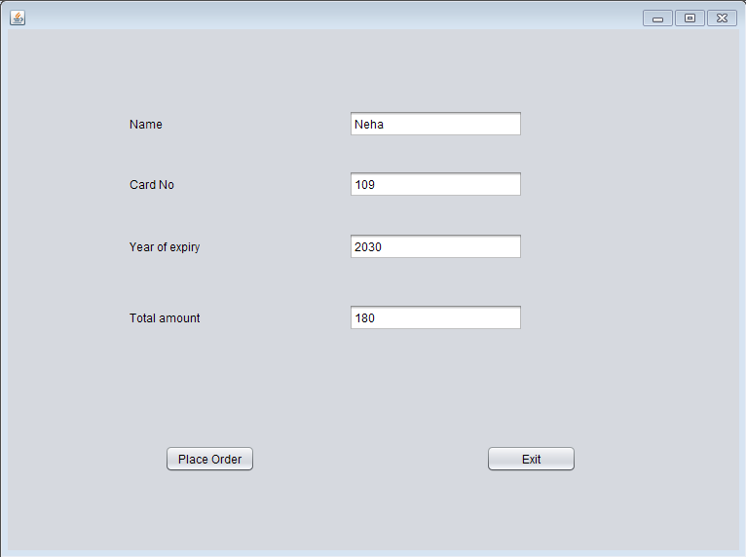

Kajal_bill.java

Code:

/*

* To change this license header, choose License Headers in Project Properties.

* To change this template file, choose Tools | Templates

* and open the template in the editor.

*/

package beautyproducts;

import com.mysql.jdbc.Connection;

import com.mysql.jdbc.PreparedStatement;

import java.sql.DriverManager;

import java.sql.ResultSet;

import java.sql.SQLException;

import java.util.logging.Level;

import java.util.logging.Logger;

import javax.swing.JOptionPane;

import net.proteanit.sql.DbUtils;

/**

*

* @author js

*/

public class Kajal_bill extends javax.swing.JFrame {

/**

* Creates new form Kajal_bill

*/

Connection con = null;

PreparedStatement pst = null;

ResultSet rs = null;

public Kajal_bill() {

initComponents();

String name,number,address;

}

public void Print(){

String name=txtname.getText();

String number=txtnumber.getText();

String address=txtaddress.getText();

txtbill.setText("\t"+"The Cosmetic Shop"+"\n"+"\n"

+"Brand:- Maybelline New York "+"\n"

+"Product Name:- Maybelline The Colossal Kajal 24Hour Smudge Proof - Deep Black" +"\n"

+"Price:- 180"+"\n"

+"\n"+"********************");

txtbill.setText(txtbill.getText() +"\n"+"Coustomer name:- "+name);

txtbill.setText(txtbill.getText()+"\n"+"\n"+"Contact number:-"+number);

txtbill.setText(txtbill.getText() +"\n"+"\n"+"Address:-"+address);

txtbill.setText(txtbill.getText()+"\n"+"\n"+"\n"+"\n"+"\n"+"\n"+"\n"+"\t"+"**Thanks For Shopping**");

}

/**

* This method is called from within the constructor to initialize the form.

* WARNING: Do NOT modify this code. The content of this method is always

* regenerated by the Form Editor.

*/

@SuppressWarnings("unchecked")

// <editor-fold defaultstate="collapsed" desc="Generated Code">

private void initComponents() {

jLabel3 = new javax.swing.JLabel();

txtname = new javax.swing.JTextField();

txtnumber = new javax.swing.JTextField();

txtaddress = new javax.swing.JTextField();

jScrollPane1 = new javax.swing.JScrollPane();

txtbill = new javax.swing.JTextArea();

jButton1 = new javax.swing.JButton();

jButton2 = new javax.swing.JButton();

jLabel1 = new javax.swing.JLabel();

jLabel2 = new javax.swing.JLabel();

setDefaultCloseOperation(javax.swing.WindowConstants.EXIT_ON_CLOSE);

jLabel3.setText("Address:");

txtaddress.addActionListener(new java.awt.event.ActionListener() {

public void actionPerformed(java.awt.event.ActionEvent evt) {

txtaddressActionPerformed(evt);

}

});

txtbill.setColumns(20);

txtbill.setRows(5);

jScrollPane1.setViewportView(txtbill);

jButton1.setText("Ok");

jButton1.addActionListener(new java.awt.event.ActionListener() {

public void actionPerformed(java.awt.event.ActionEvent evt) {

jButton1ActionPerformed(evt);

}

});

jButton2.setText("Done");

jButton2.addActionListener(new java.awt.event.ActionListener() {

public void actionPerformed(java.awt.event.ActionEvent evt) {

jButton2ActionPerformed(evt);

}

});

jLabel1.setText("Customer Name:");

jLabel2.setText("Contact Number:");

javax.swing.GroupLayout layout = new javax.swing.GroupLayout(getContentPane());

getContentPane().setLayout(layout);

layout.setHorizontalGroup(

layout.createParallelGroup(javax.swing.GroupLayout.Alignment.LEADING)

.addGroup(layout.createSequentialGroup()

.addGap(37, 37, 37)

.addGroup(layout.createParallelGroup(javax.swing.GroupLayout.Alignment.TRAILING)

.addGroup(layout.createSequentialGroup()

.addGroup(layout.createParallelGroup(javax.swing.GroupLayout.Alignment.LEADING)

.addComponent(jLabel1)

.addComponent(jLabel2)

.addComponent(jLabel3))

.addGap(69, 69, 69)

.addGroup(layout.createParallelGroup(javax.swing.GroupLayout.Alignment.LEADING, false)

.addComponent(txtname, javax.swing.GroupLayout.DEFAULT_SIZE, 161, Short.MAX_VALUE)

.addComponent(txtnumber)

.addComponent(txtaddress)))

.addComponent(jButton1))

.addPreferredGap(javax.swing.LayoutStyle.ComponentPlacement.RELATED, 59, Short.MAX_VALUE)

.addComponent(jScrollPane1, javax.swing.GroupLayout.PREFERRED_SIZE, 309, javax.swing.GroupLayout.PREFERRED_SIZE)

.addGap(22, 22, 22))

.addGroup(javax.swing.GroupLayout.Alignment.TRAILING, layout.createSequentialGroup()

.addContainerGap(javax.swing.GroupLayout.DEFAULT_SIZE, Short.MAX_VALUE)

.addComponent(jButton2)

.addGap(126, 126, 126))

);

layout.setVerticalGroup(

layout.createParallelGroup(javax.swing.GroupLayout.Alignment.LEADING)

.addGroup(layout.createSequentialGroup()

.addGap(52, 52, 52)

.addGroup(layout.createParallelGroup(javax.swing.GroupLayout.Alignment.BASELINE)

.addComponent(jLabel1)

.addComponent(txtname, javax.swing.GroupLayout.PREFERRED_SIZE, javax.swing.GroupLayout.DEFAULT_SIZE, javax.swing.GroupLayout.PREFERRED_SIZE))

.addGap(29, 29, 29)

.addGroup(layout.createParallelGroup(javax.swing.GroupLayout.Alignment.BASELINE)

.addComponent(jLabel2)

.addComponent(txtnumber, javax.swing.GroupLayout.PREFERRED_SIZE, javax.swing.GroupLayout.DEFAULT_SIZE, javax.swing.GroupLayout.PREFERRED_SIZE))

.addGap(40, 40, 40)

.addGroup(layout.createParallelGroup(javax.swing.GroupLayout.Alignment.BASELINE)

.addComponent(jLabel3)

.addComponent(txtaddress, javax.swing.GroupLayout.PREFERRED_SIZE, 109, javax.swing.GroupLayout.PREFERRED_SIZE))

.addGap(67, 67, 67)

.addComponent(jButton1)

.addContainerGap(javax.swing.GroupLayout.DEFAULT_SIZE, Short.MAX_VALUE))

.addGroup(javax.swing.GroupLayout.Alignment.TRAILING, layout.createSequentialGroup()

.addContainerGap(javax.swing.GroupLayout.DEFAULT_SIZE, Short.MAX_VALUE)

.addComponent(jScrollPane1, javax.swing.GroupLayout.PREFERRED_SIZE, 418, javax.swing.GroupLayout.PREFERRED_SIZE)

.addGap(18, 18, 18)

.addComponent(jButton2)

.addGap(10, 10, 10))

);

pack();

}// </editor-fold>

private void txtaddressActionPerformed(java.awt.event.ActionEvent evt) {

// TODO add your handling code here:

}

private void jButton1ActionPerformed(java.awt.event.ActionEvent evt) {

Print();

}

private void jButton2ActionPerformed(java.awt.event.ActionEvent evt) {

try

{

String sql = "INSERT INTO customer_details"

+"(CustomerName,CustomerNumber,Address)"

+"VALUES (?,?,?)";

con = (Connection) DriverManager.getConnection("jdbc:mysql://localhost/details","root","");

pst = (PreparedStatement) con.prepareStatement(sql);

pst.setString(1,txtname.getText());

pst.setString(2,txtnumber.getText());

pst.setString(3,txtaddress.getText());

pst.executeUpdate();

JOptionPane.showMessageDialog(null, "Thank you for shopping!!");

txtname.setText(null);

txtnumber.setText(null);

txtaddress.setText(null);

}

catch(Exception ex)

{

JOptionPane.showMessageDialog(null, ex);

}

}

/**

* @param args the command line arguments

*/

public static void main(String args[]) {

/* Set the Nimbus look and feel */

//<editor-fold defaultstate="collapsed" desc=" Look and feel setting code (optional) ">

/* If Nimbus (introduced in Java SE 6) is not available, stay with the default look and feel.

* For details see http://download.oracle.com/javase/tutorial/uiswing/lookandfeel/plaf.html

*/

try {

for (javax.swing.UIManager.LookAndFeelInfo info : javax.swing.UIManager.getInstalledLookAndFeels()) {

if ("Nimbus".equals(info.getName())) {

javax.swing.UIManager.setLookAndFeel(info.getClassName());

break;

}

}

} catch (ClassNotFoundException ex) {

java.util.logging.Logger.getLogger(Kajal_bill.class.getName()).log(java.util.logging.Level.SEVERE, null, ex);

} catch (InstantiationException ex) {

java.util.logging.Logger.getLogger(Kajal_bill.class.getName()).log(java.util.logging.Level.SEVERE, null, ex);

} catch (IllegalAccessException ex) {

java.util.logging.Logger.getLogger(Kajal_bill.class.getName()).log(java.util.logging.Level.SEVERE, null, ex);

} catch (javax.swing.UnsupportedLookAndFeelException ex) {

java.util.logging.Logger.getLogger(Kajal_bill.class.getName()).log(java.util.logging.Level.SEVERE, null, ex);

}

//</editor-fold>

/* Create and display the form */

java.awt.EventQueue.invokeLater(new Runnable() {

public void run() {

new Kajal_bill().setVisible(true);

}

});

}

// Variables declaration - do not modify

private javax.swing.JButton jButton1;

private javax.swing.JButton jButton2;

private javax.swing.JLabel jLabel1;

private javax.swing.JLabel jLabel2;

private javax.swing.JLabel jLabel3;

private javax.swing.JScrollPane jScrollPane1;

private javax.swing.JTextField txtaddress;

private javax.swing.JTextArea txtbill;

private javax.swing.JTextField txtname;

private javax.swing.JTextField txtnumber;

// End of variables declaration

}

Output:

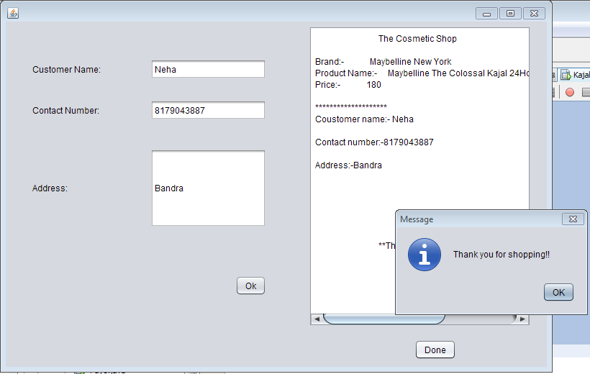

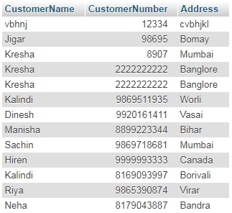

All the customer details are also added into the database

Login2.java

Code:

/*

* To change this license header, choose License Headers in Project Properties.

* To change this template file, choose Tools | Templates

* and open the template in the editor.

*/

package beautyproducts;

import javax.swing.JOptionPane;

import java.awt.Toolkit;

import java.awt.event.WindowEvent;

import beautyproducts.insertdelete;

/**

*

* @author js

*/

public class Login2 extends javax.swing.JFrame {

/**

* Creates new form Login2

*/

public Login2() {

initComponents();

}

/**

* This method is called from within the constructor to initialize the form.

* WARNING: Do NOT modify this code. The content of this method is always

* regenerated by the Form Editor.

*/

@SuppressWarnings("unchecked")

// <editor-fold defaultstate="collapsed" desc="Generated Code">

private void initComponents() {

jPanel1 = new javax.swing.JPanel();

jLabel2 = new javax.swing.JLabel();

jLabel3 = new javax.swing.JLabel();

jtxtUserName = new javax.swing.JTextField();

jPassword = new javax.swing.JPasswordField();

jbtnLogin = new javax.swing.JButton();

jbtnReset = new javax.swing.JButton();

jbtnExit = new javax.swing.JButton();

jLabel1 = new javax.swing.JLabel();

setDefaultCloseOperation(javax.swing.WindowConstants.EXIT_ON_CLOSE);

jPanel1.setBorder(javax.swing.BorderFactory.createLineBorder(new java.awt.Color(0, 0, 0), 4));

jLabel2.setText("Owner Name");

jLabel2.setBorder(javax.swing.BorderFactory.createEtchedBorder());

jLabel3.setText("Password");

jLabel3.setBorder(javax.swing.BorderFactory.createEtchedBorder());

jtxtUserName.setBorder(javax.swing.BorderFactory.createEtchedBorder());

jPassword.setBorder(javax.swing.BorderFactory.createEtchedBorder());

jbtnLogin.setText("Login");

jbtnLogin.addActionListener(new java.awt.event.ActionListener() {

public void actionPerformed(java.awt.event.ActionEvent evt) {

jbtnLoginActionPerformed(evt);

}

});

jbtnReset.setText("Reset");

jbtnReset.addActionListener(new java.awt.event.ActionListener() {

public void actionPerformed(java.awt.event.ActionEvent evt) {

jbtnResetActionPerformed(evt);

}

});

jbtnExit.setText("Exit");

jbtnExit.addActionListener(new java.awt.event.ActionListener() {

public void actionPerformed(java.awt.event.ActionEvent evt) {

jbtnExitActionPerformed(evt);

}

});

javax.swing.GroupLayout jPanel1Layout = new javax.swing.GroupLayout(jPanel1);

jPanel1.setLayout(jPanel1Layout);

jPanel1Layout.setHorizontalGroup(

jPanel1Layout.createParallelGroup(javax.swing.GroupLayout.Alignment.LEADING)

.addGroup(jPanel1Layout.createSequentialGroup()

.addGap(74, 74, 74)

.addGroup(jPanel1Layout.createParallelGroup(javax.swing.GroupLayout.Alignment.LEADING, false)

.addComponent(jLabel3, javax.swing.GroupLayout.DEFAULT_SIZE, javax.swing.GroupLayout.DEFAULT_SIZE, Short.MAX_VALUE)

.addComponent(jLabel2, javax.swing.GroupLayout.DEFAULT_SIZE, 140, Short.MAX_VALUE))

.addPreferredGap(javax.swing.LayoutStyle.ComponentPlacement.RELATED, javax.swing.GroupLayout.DEFAULT_SIZE, Short.MAX_VALUE)

.addGroup(jPanel1Layout.createParallelGroup(javax.swing.GroupLayout.Alignment.LEADING, false)

.addComponent(jtxtUserName, javax.swing.GroupLayout.DEFAULT_SIZE, 173, Short.MAX_VALUE)

.addComponent(jPassword))

.addContainerGap(javax.swing.GroupLayout.DEFAULT_SIZE, Short.MAX_VALUE))

.addGroup(jPanel1Layout.createSequentialGroup()

.addGap(39, 39, 39)

.addComponent(jbtnLogin, javax.swing.GroupLayout.PREFERRED_SIZE, 102, javax.swing.GroupLayout.PREFERRED_SIZE)

.addGap(119, 119, 119)

.addComponent(jbtnReset, javax.swing.GroupLayout.PREFERRED_SIZE, 95, javax.swing.GroupLayout.PREFERRED_SIZE)

.addPreferredGap(javax.swing.LayoutStyle.ComponentPlacement.RELATED, 123, Short.MAX_VALUE)

.addComponent(jbtnExit, javax.swing.GroupLayout.PREFERRED_SIZE, 79, javax.swing.GroupLayout.PREFERRED_SIZE)

.addGap(78, 78, 78))

);

jPanel1Layout.setVerticalGroup(

jPanel1Layout.createParallelGroup(javax.swing.GroupLayout.Alignment.LEADING)

.addGroup(jPanel1Layout.createSequentialGroup()

.addGap(41, 41, 41)

.addGroup(jPanel1Layout.createParallelGroup(javax.swing.GroupLayout.Alignment.BASELINE)

.addComponent(jLabel2, javax.swing.GroupLayout.PREFERRED_SIZE, 37, javax.swing.GroupLayout.PREFERRED_SIZE)

.addComponent(jtxtUserName, javax.swing.GroupLayout.PREFERRED_SIZE, 37, javax.swing.GroupLayout.PREFERRED_SIZE))

.addGap(90, 90, 90)

.addGroup(jPanel1Layout.createParallelGroup(javax.swing.GroupLayout.Alignment.LEADING, false)

.addComponent(jPassword, javax.swing.GroupLayout.DEFAULT_SIZE, 40, Short.MAX_VALUE)

.addComponent(jLabel3, javax.swing.GroupLayout.DEFAULT_SIZE, javax.swing.GroupLayout.DEFAULT_SIZE, Short.MAX_VALUE))

.addPreferredGap(javax.swing.LayoutStyle.ComponentPlacement.RELATED, 115, Short.MAX_VALUE)

.addGroup(jPanel1Layout.createParallelGroup(javax.swing.GroupLayout.Alignment.BASELINE)

.addComponent(jbtnLogin, javax.swing.GroupLayout.PREFERRED_SIZE, 40, javax.swing.GroupLayout.PREFERRED_SIZE)

.addComponent(jbtnReset, javax.swing.GroupLayout.PREFERRED_SIZE, 40, javax.swing.GroupLayout.PREFERRED_SIZE)

.addComponent(jbtnExit, javax.swing.GroupLayout.PREFERRED_SIZE, 40, javax.swing.GroupLayout.PREFERRED_SIZE))

.addGap(36, 36, 36))

);

jLabel1.setFont(new java.awt.Font("Tahoma", 1, 36)); // NOI18N

jLabel1.setText("Login system");

javax.swing.GroupLayout layout = new javax.swing.GroupLayout(getContentPane());

getContentPane().setLayout(layout);

layout.setHorizontalGroup(

layout.createParallelGroup(javax.swing.GroupLayout.Alignment.LEADING)

.addGroup(layout.createSequentialGroup()

.addGroup(layout.createParallelGroup(javax.swing.GroupLayout.Alignment.LEADING)

.addGroup(layout.createSequentialGroup()

.addGap(188, 188, 188)

.addComponent(jLabel1))

.addGroup(layout.createSequentialGroup()

.addGap(24, 24, 24)

.addComponent(jPanel1, javax.swing.GroupLayout.PREFERRED_SIZE, javax.swing.GroupLayout.DEFAULT_SIZE, javax.swing.GroupLayout.PREFERRED_SIZE)))

.addContainerGap(javax.swing.GroupLayout.DEFAULT_SIZE, Short.MAX_VALUE))

);

layout.setVerticalGroup(

layout.createParallelGroup(javax.swing.GroupLayout.Alignment.LEADING)

.addGroup(layout.createSequentialGroup()

.addGap(47, 47, 47)

.addComponent(jLabel1)

.addGap(18, 18, 18)

.addComponent(jPanel1, javax.swing.GroupLayout.PREFERRED_SIZE, javax.swing.GroupLayout.DEFAULT_SIZE, javax.swing.GroupLayout.PREFERRED_SIZE)

.addContainerGap(javax.swing.GroupLayout.DEFAULT_SIZE, Short.MAX_VALUE))

);

pack();

}// </editor-fold>

private void jbtnExitActionPerformed(java.awt.event.ActionEvent evt) {

System.exit(0);

}

private void jbtnResetActionPerformed(java.awt.event.ActionEvent evt) {

jtxtUserName.setText(null);

jPassword.setText(null);

}

private void jbtnLoginActionPerformed(java.awt.event.ActionEvent evt) {

String password = jPassword.getText();

String username = jtxtUserName.getText();

if(password.contains("owner1234")&& (username.contains("Kresha")))

{

jtxtUserName.setText(null);

jPassword.setText(null);

systemExit();

insertdelete Info = new insertdelete();

Info.setVisible(true);

}

else

{

JOptionPane.showMessageDialog(null,"Invalid Login Details","Login Error",JOptionPane.ERROR_MESSAGE);

jPassword.setText(null);

jtxtUserName.setText(null);

}

}

/**

* @param args the command line arguments

*/

public static void main(String args[]) {

/* Set the Nimbus look and feel */

//<editor-fold defaultstate="collapsed" desc=" Look and feel setting code (optional) ">

/* If Nimbus (introduced in Java SE 6) is not available, stay with the default look and feel.

* For details see http://download.oracle.com/javase/tutorial/uiswing/lookandfeel/plaf.html

*/

try {

for (javax.swing.UIManager.LookAndFeelInfo info : javax.swing.UIManager.getInstalledLookAndFeels()) {

if ("Nimbus".equals(info.getName())) {

javax.swing.UIManager.setLookAndFeel(info.getClassName());

break;

}

}

} catch (ClassNotFoundException ex) {

java.util.logging.Logger.getLogger(Login2.class.getName()).log(java.util.logging.Level.SEVERE, null, ex);

} catch (InstantiationException ex) {

java.util.logging.Logger.getLogger(Login2.class.getName()).log(java.util.logging.Level.SEVERE, null, ex);

} catch (IllegalAccessException ex) {

java.util.logging.Logger.getLogger(Login2.class.getName()).log(java.util.logging.Level.SEVERE, null, ex);

} catch (javax.swing.UnsupportedLookAndFeelException ex) {

java.util.logging.Logger.getLogger(Login2.class.getName()).log(java.util.logging.Level.SEVERE, null, ex);

}

//</editor-fold>

/* Create and display the form */

java.awt.EventQueue.invokeLater(new Runnable() {

public void run() {

new Login2().setVisible(true);

}

});

}

// Variables declaration - do not modify

private javax.swing.JLabel jLabel1;

private javax.swing.JLabel jLabel2;

private javax.swing.JLabel jLabel3;

private javax.swing.JPanel jPanel1;

private javax.swing.JPasswordField jPassword;

private javax.swing.JButton jbtnExit;

private javax.swing.JButton jbtnLogin;

private javax.swing.JButton jbtnReset;

private javax.swing.JTextField jtxtUserName;

// End of variables declaration

private void systemExit()

{

WindowEvent winCloseing = new WindowEvent(this,WindowEvent.WINDOW_CLOSING);

}

}

Output:

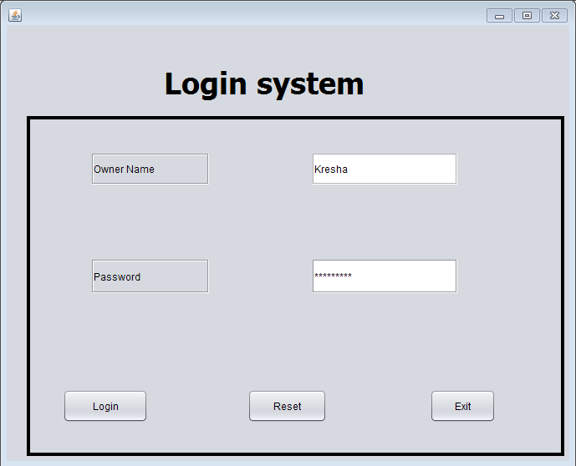

Insertdelete.java

Code:

/*

* To change this license header, choose License Headers in Project Properties.

* To change this template file, choose Tools | Templates

* and open the template in the editor.

*/

package beautyproducts;

import javax.swing.JOptionPane;

import java.awt.Toolkit;

import java.awt.event.WindowEvent;

import beautyproducts.insert;

import beautyproducts.delete;

/**

*

* @author js

*/

public class insertdelete extends javax.swing.JFrame {

/**

* Creates new form insertdelete

*/

public insertdelete() {

initComponents();

}

/**

* This method is called from within the constructor to initialize the form.

* WARNING: Do NOT modify this code. The content of this method is always

* regenerated by the Form Editor.

*/

@SuppressWarnings("unchecked")

// <editor-fold defaultstate="collapsed" desc="Generated Code">

private void initComponents() {

insertbtn = new javax.swing.JButton();

deletebtn = new javax.swing.JButton();

exitbtn = new javax.swing.JButton();

jButton1 = new javax.swing.JButton();

setDefaultCloseOperation(javax.swing.WindowConstants.EXIT_ON_CLOSE);

insertbtn.setText("Insert product");

insertbtn.addActionListener(new java.awt.event.ActionListener() {

public void actionPerformed(java.awt.event.ActionEvent evt) {

insertbtnActionPerformed(evt);

}

});

deletebtn.setText("Delete product");

deletebtn.addActionListener(new java.awt.event.ActionListener() {

public void actionPerformed(java.awt.event.ActionEvent evt) {

deletebtnActionPerformed(evt);

}

});

exitbtn.setText("Exit");

exitbtn.addActionListener(new java.awt.event.ActionListener() {

public void actionPerformed(java.awt.event.ActionEvent evt) {

exitbtnActionPerformed(evt);

}

});

jButton1.setText("Update product");

jButton1.addActionListener(new java.awt.event.ActionListener() {

public void actionPerformed(java.awt.event.ActionEvent evt) {

jButton1ActionPerformed(evt);

}

});

javax.swing.GroupLayout layout = new javax.swing.GroupLayout(getContentPane());

getContentPane().setLayout(layout);

layout.setHorizontalGroup(

layout.createParallelGroup(javax.swing.GroupLayout.Alignment.LEADING)

.addGroup(javax.swing.GroupLayout.Alignment.TRAILING, layout.createSequentialGroup()

.addContainerGap(320, Short.MAX_VALUE)

.addGroup(layout.createParallelGroup(javax.swing.GroupLayout.Alignment.TRAILING, false)

.addComponent(exitbtn, javax.swing.GroupLayout.DEFAULT_SIZE, 133, Short.MAX_VALUE)

.addComponent(deletebtn, javax.swing.GroupLayout.DEFAULT_SIZE, 133, Short.MAX_VALUE)

.addComponent(insertbtn, javax.swing.GroupLayout.DEFAULT_SIZE, javax.swing.GroupLayout.DEFAULT_SIZE, Short.MAX_VALUE)

.addComponent(jButton1, javax.swing.GroupLayout.DEFAULT_SIZE, javax.swing.GroupLayout.DEFAULT_SIZE, Short.MAX_VALUE))

.addGap(314, 314, 314))

);

layout.setVerticalGroup(

layout.createParallelGroup(javax.swing.GroupLayout.Alignment.LEADING)

.addGroup(layout.createSequentialGroup()

.addGap(21, 21, 21)

.addComponent(insertbtn, javax.swing.GroupLayout.PREFERRED_SIZE, 47, javax.swing.GroupLayout.PREFERRED_SIZE)

.addGap(64, 64, 64)

.addComponent(deletebtn, javax.swing.GroupLayout.PREFERRED_SIZE, 51, javax.swing.GroupLayout.PREFERRED_SIZE)

.addGap(65, 65, 65)

.addComponent(jButton1, javax.swing.GroupLayout.PREFERRED_SIZE, 47, javax.swing.GroupLayout.PREFERRED_SIZE)

.addPreferredGap(javax.swing.LayoutStyle.ComponentPlacement.RELATED, 120, Short.MAX_VALUE)

.addComponent(exitbtn, javax.swing.GroupLayout.PREFERRED_SIZE, 44, javax.swing.GroupLayout.PREFERRED_SIZE)

.addGap(32, 32, 32))

);

pack();

}// </editor-fold>

private void exitbtnActionPerformed(java.awt.event.ActionEvent evt) {

System.exit(0);

}

private void insertbtnActionPerformed(java.awt.event.ActionEvent evt) {

new insert().setVisible(true);

this.setVisible(false);

}

private void deletebtnActionPerformed(java.awt.event.ActionEvent evt) {

new delete().setVisible(true);

this.setVisible(false);

}

private void jButton1ActionPerformed(java.awt.event.ActionEvent evt) {

new insert().setVisible(true);

this.setVisible(false);

}

/**

* @param args the command line arguments

*/

public static void main(String args[]) {

/* Set the Nimbus look and feel */

//<editor-fold defaultstate="collapsed" desc=" Look and feel setting code (optional) ">

/* If Nimbus (introduced in Java SE 6) is not available, stay with the default look and feel.

* For details see http://download.oracle.com/javase/tutorial/uiswing/lookandfeel/plaf.html

*/

try {

for (javax.swing.UIManager.LookAndFeelInfo info : javax.swing.UIManager.getInstalledLookAndFeels()) {

if ("Nimbus".equals(info.getName())) {

javax.swing.UIManager.setLookAndFeel(info.getClassName());

break;

}

}

} catch (ClassNotFoundException ex) {

java.util.logging.Logger.getLogger(insertdelete.class.getName()).log(java.util.logging.Level.SEVERE, null, ex);

} catch (InstantiationException ex) {

java.util.logging.Logger.getLogger(insertdelete.class.getName()).log(java.util.logging.Level.SEVERE, null, ex);

} catch (IllegalAccessException ex) {

java.util.logging.Logger.getLogger(insertdelete.class.getName()).log(java.util.logging.Level.SEVERE, null, ex);

} catch (javax.swing.UnsupportedLookAndFeelException ex) {

java.util.logging.Logger.getLogger(insertdelete.class.getName()).log(java.util.logging.Level.SEVERE, null, ex);

}

//</editor-fold>

/* Create and display the form */

java.awt.EventQueue.invokeLater(new Runnable() {

public void run() {

new insertdelete().setVisible(true);

}

});

}

// Variables declaration - do not modify

private javax.swing.JButton deletebtn;

private javax.swing.JButton exitbtn;

private javax.swing.JButton insertbtn;

private javax.swing.JButton jButton1;

// End of variables declaration

}

Output:

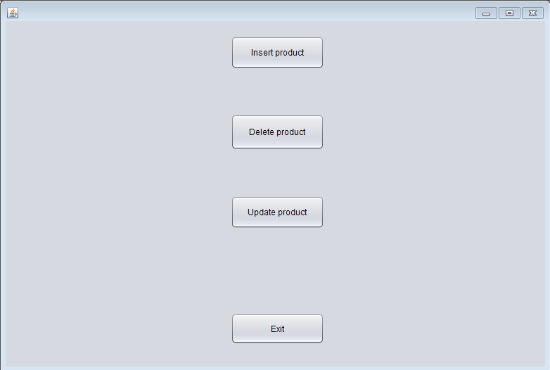insert.java

/*

* To change this license header, choose License Headers in Project Properties.

* To change this template file, choose Tools | Templates

* and open the template in the editor.

*/

package beautyproducts;

import com.mysql.jdbc.Connection;

import com.mysql.jdbc.PreparedStatement;

import java.sql.DriverManager;

import java.sql.ResultSet;

import java.sql.SQLException;

import java.util.logging.Level;

import java.util.logging.Logger;

import javax.swing.JOptionPane;

import net.proteanit.sql.DbUtils;

/**

*

* @author js

*/

public class insert extends javax.swing.JFrame {

Connection con = null;

PreparedStatement pst = null;

ResultSet rs = null;

public insert() {

initComponents();

showTableData();

}

/**

* This method is called from within the constructor to initialize the form.

* WARNING: Do NOT modify this code. The content of this method is always

* regenerated by the Form Editor.

*/

@SuppressWarnings("unchecked")

// <editor-fold defaultstate="collapsed" desc="Generated Code">

private void initComponents() {

jLabel1 = new javax.swing.JLabel();

jLabel2 = new javax.swing.JLabel();

jLabel3 = new javax.swing.JLabel();

jSubmit = new javax.swing.JButton();

jExit = new javax.swing.JButton();

jLabel4 = new javax.swing.JLabel();

jLabel5 = new javax.swing.JLabel();

jLabel6 = new javax.swing.JLabel();

jProductName = new javax.swing.JLabel();

JPName = new javax.swing.JTextField();

jBName = new javax.swing.JTextField();

jPrize = new javax.swing.JTextField();

jUpdate = new javax.swing.JButton();

jScrollPane1 = new javax.swing.JScrollPane();

jTable1 = new javax.swing.JTable();

setDefaultCloseOperation(javax.swing.WindowConstants.EXIT_ON_CLOSE);

jLabel1.setText("Product Name");

jLabel2.setText("Brand Name");

jLabel3.setText("Prize");

jSubmit.setText("Insert ");

jSubmit.addActionListener(new java.awt.event.ActionListener() {

public void actionPerformed(java.awt.event.ActionEvent evt) {

jSubmitActionPerformed(evt);

}

});

jExit.setText("Exit");

jExit.addActionListener(new java.awt.event.ActionListener() {

public void actionPerformed(java.awt.event.ActionEvent evt) {

jExitActionPerformed(evt);

}

});

jUpdate.setText("Update");

jUpdate.addActionListener(new java.awt.event.ActionListener() {

public void actionPerformed(java.awt.event.ActionEvent evt) {

jUpdateActionPerformed(evt);

}

});

jTable1.setModel(new javax.swing.table.DefaultTableModel(

new Object [][] {

{null, null, null, null},

{null, null, null, null},

{null, null, null, null},

{null, null, null, null}

},

new String [] {

"Title 1", "Title 2", "Title 3", "Title 4"

}

));

jScrollPane1.setViewportView(jTable1);

javax.swing.GroupLayout layout = new javax.swing.GroupLayout(getContentPane());

getContentPane().setLayout(layout);

layout.setHorizontalGroup(

layout.createParallelGroup(javax.swing.GroupLayout.Alignment.LEADING)

.addGroup(layout.createSequentialGroup()

.addGap(41, 41, 41)

.addGroup(layout.createParallelGroup(javax.swing.GroupLayout.Alignment.TRAILING)

.addGroup(layout.createParallelGroup(javax.swing.GroupLayout.Alignment.LEADING)

.addComponent(jLabel1)

.addComponent(jLabel2)

.addComponent(jLabel3))

.addGroup(layout.createSequentialGroup()

.addComponent(jSubmit)

.addGap(9, 9, 9)))

.addGroup(layout.createParallelGroup(javax.swing.GroupLayout.Alignment.LEADING)

.addGroup(layout.createSequentialGroup()

.addGroup(layout.createParallelGroup(javax.swing.GroupLayout.Alignment.TRAILING)

.addGroup(layout.createParallelGroup(javax.swing.GroupLayout.Alignment.TRAILING)

.addComponent(jLabel6, javax.swing.GroupLayout.Alignment.LEADING)

.addGroup(layout.createSequentialGroup()

.addComponent(jLabel5)

.addGap(175, 175, 175)))

.addGroup(javax.swing.GroupLayout.Alignment.LEADING, layout.createSequentialGroup()

.addGap(178, 178, 178)

.addGroup(layout.createParallelGroup(javax.swing.GroupLayout.Alignment.LEADING)

.addComponent(jPrize, javax.swing.GroupLayout.PREFERRED_SIZE, 171, javax.swing.GroupLayout.PREFERRED_SIZE)

.addComponent(jBName, javax.swing.GroupLayout.PREFERRED_SIZE, 171, javax.swing.GroupLayout.PREFERRED_SIZE)

.addComponent(JPName, javax.swing.GroupLayout.PREFERRED_SIZE, 171, javax.swing.GroupLayout.PREFERRED_SIZE))

.addPreferredGap(javax.swing.LayoutStyle.ComponentPlacement.RELATED, 11, Short.MAX_VALUE)

.addComponent(jLabel4)))

.addGap(30, 30, 30)

.addComponent(jScrollPane1, javax.swing.GroupLayout.PREFERRED_SIZE, 476, javax.swing.GroupLayout.PREFERRED_SIZE)

.addPreferredGap(javax.swing.LayoutStyle.ComponentPlacement.RELATED, 474, Short.MAX_VALUE))

.addGroup(layout.createSequentialGroup()

.addGap(194, 194, 194)

.addComponent(jUpdate)

.addGap(173, 173, 173)

.addComponent(jExit, javax.swing.GroupLayout.PREFERRED_SIZE, 62, javax.swing.GroupLayout.PREFERRED_SIZE)

.addPreferredGap(javax.swing.LayoutStyle.ComponentPlacement.RELATED, javax.swing.GroupLayout.DEFAULT_SIZE, Short.MAX_VALUE)))

.addComponent(jProductName, javax.swing.GroupLayout.PREFERRED_SIZE, 294, javax.swing.GroupLayout.PREFERRED_SIZE))

);

layout.setVerticalGroup(

layout.createParallelGroup(javax.swing.GroupLayout.Alignment.LEADING)

.addGroup(layout.createSequentialGroup()

.addGroup(layout.createParallelGroup(javax.swing.GroupLayout.Alignment.LEADING)

.addGroup(layout.createSequentialGroup()

.addGap(59, 59, 59)

.addGroup(layout.createParallelGroup(javax.swing.GroupLayout.Alignment.BASELINE)

.addComponent(jLabel1)

.addComponent(jLabel4)

.addComponent(jProductName)

.addComponent(JPName, javax.swing.GroupLayout.PREFERRED_SIZE, javax.swing.GroupLayout.DEFAULT_SIZE, javax.swing.GroupLayout.PREFERRED_SIZE))

.addGap(91, 91, 91)

.addGroup(layout.createParallelGroup(javax.swing.GroupLayout.Alignment.BASELINE)

.addComponent(jLabel2)

.addComponent(jBName, javax.swing.GroupLayout.PREFERRED_SIZE, javax.swing.GroupLayout.DEFAULT_SIZE, javax.swing.GroupLayout.PREFERRED_SIZE))

.addGap(11, 11, 11)

.addComponent(jLabel5)

.addPreferredGap(javax.swing.LayoutStyle.ComponentPlacement.RELATED, javax.swing.GroupLayout.DEFAULT_SIZE, Short.MAX_VALUE)

.addGroup(layout.createParallelGroup(javax.swing.GroupLayout.Alignment.BASELINE)

.addComponent(jLabel3)

.addComponent(jPrize, javax.swing.GroupLayout.PREFERRED_SIZE, javax.swing.GroupLayout.DEFAULT_SIZE, javax.swing.GroupLayout.PREFERRED_SIZE)))

.addGroup(layout.createSequentialGroup()

.addContainerGap(39, Short.MAX_VALUE)

.addComponent(jScrollPane1, javax.swing.GroupLayout.PREFERRED_SIZE, 265, javax.swing.GroupLayout.PREFERRED_SIZE)))

.addGap(76, 76, 76)

.addComponent(jLabel6)

.addGap(43, 43, 43)

.addGroup(layout.createParallelGroup(javax.swing.GroupLayout.Alignment.BASELINE)

.addComponent(jExit)

.addComponent(jSubmit)

.addComponent(jUpdate))

.addContainerGap(63, Short.MAX_VALUE))

);

pack();

}// </editor-fold>

private void jSubmitActionPerformed(java.awt.event.ActionEvent evt) {

try

{

String sql = "INSERT INTO products"

+"(BrandName, ProductName, Prize)"

+"VALUES (?,?,?)";

con = (Connection) DriverManager.getConnection("jdbc:mysql://localhost/beauty_products","root","");

pst = (PreparedStatement) con.prepareStatement(sql);

pst.setString(1,JPName.getText());

pst.setString(2,jBName.getText());

pst.setString(3,jPrize.getText());

pst.executeUpdate();

JOptionPane.showMessageDialog(null, "Product inserted successfully!!");

JPName.setText(null);

jBName.setText(null);

jPrize.setText(null);

}

catch(Exception ex)

{

JOptionPane.showMessageDialog(null, ex);

}

showTableData();

}

private void jExitActionPerformed(java.awt.event.ActionEvent evt) {

System.exit(0);

}

private void jUpdateActionPerformed(java.awt.event.ActionEvent evt) {

try

{

String sql = "UPDATE products SET ProductName=?,BrandName=?,Prize=? WHERE 1";

con = (Connection) DriverManager.getConnection("jdbc:mysql://localhost/beauty_products","root","");

pst = (PreparedStatement) con.prepareStatement(sql);

pst.setString(1,JPName.getText());

pst.setString(2,jBName.getText());

pst.setString(3,jPrize.getText());

pst.executeUpdate();

JOptionPane.showMessageDialog(null, "Product Updated successfully!!");

JPName.setText(null);

jBName.setText(null);

jPrize.setText(null);

}

catch(Exception ex)

{

JOptionPane.showMessageDialog(null, ex);

}

showTableData();

}

public void showTableData()

{

try

{

con = (Connection) DriverManager.getConnection("jdbc:mysql://localhost/beauty_products","root","");

String sql = "SELECT * FROM products";

pst = (PreparedStatement) con.prepareStatement(sql);

rs = pst.executeQuery();

jTable1.setModel(DbUtils.resultSetToTableModel(rs));

}

catch(Exception ex)

{

JOptionPane.showMessageDialog(null, ex);

}

}

/**

* @param args the command line arguments

*/

public static void main(String args[]) {

/* Set the Nimbus look and feel */

//<editor-fold defaultstate="collapsed" desc=" Look and feel setting code (optional) ">

/* If Nimbus (introduced in Java SE 6) is not available, stay with the default look and feel.

* For details see http://download.oracle.com/javase/tutorial/uiswing/lookandfeel/plaf.html

*/

try {

for (javax.swing.UIManager.LookAndFeelInfo info : javax.swing.UIManager.getInstalledLookAndFeels()) {

if ("Nimbus".equals(info.getName())) {

javax.swing.UIManager.setLookAndFeel(info.getClassName());

break;

}

}

} catch (ClassNotFoundException ex) {

java.util.logging.Logger.getLogger(insert.class.getName()).log(java.util.logging.Level.SEVERE, null, ex);

} catch (InstantiationException ex) {

java.util.logging.Logger.getLogger(insert.class.getName()).log(java.util.logging.Level.SEVERE, null, ex);

} catch (IllegalAccessException ex) {

java.util.logging.Logger.getLogger(insert.class.getName()).log(java.util.logging.Level.SEVERE, null, ex);

} catch (javax.swing.UnsupportedLookAndFeelException ex) {

java.util.logging.Logger.getLogger(insert.class.getName()).log(java.util.logging.Level.SEVERE, null, ex);

}

//</editor-fold>

/* Create and display the form */

java.awt.EventQueue.invokeLater(new Runnable() {

public void run() {

new insert().setVisible(true);

}

});

}

// Variables declaration - do not modify

private javax.swing.JTextField JPName;

private javax.swing.JTextField jBName;

private javax.swing.JButton jExit;

private javax.swing.JLabel jLabel1;

private javax.swing.JLabel jLabel2;

private javax.swing.JLabel jLabel3;

private javax.swing.JLabel jLabel4;

private javax.swing.JLabel jLabel5;

private javax.swing.JLabel jLabel6;

private javax.swing.JTextField jPrize;

private javax.swing.JLabel jProductName;

private javax.swing.JScrollPane jScrollPane1;

private javax.swing.JButton jSubmit;

private javax.swing.JTable jTable1;

private javax.swing.JButton jUpdate;

// End of variables declaration

}

Output:

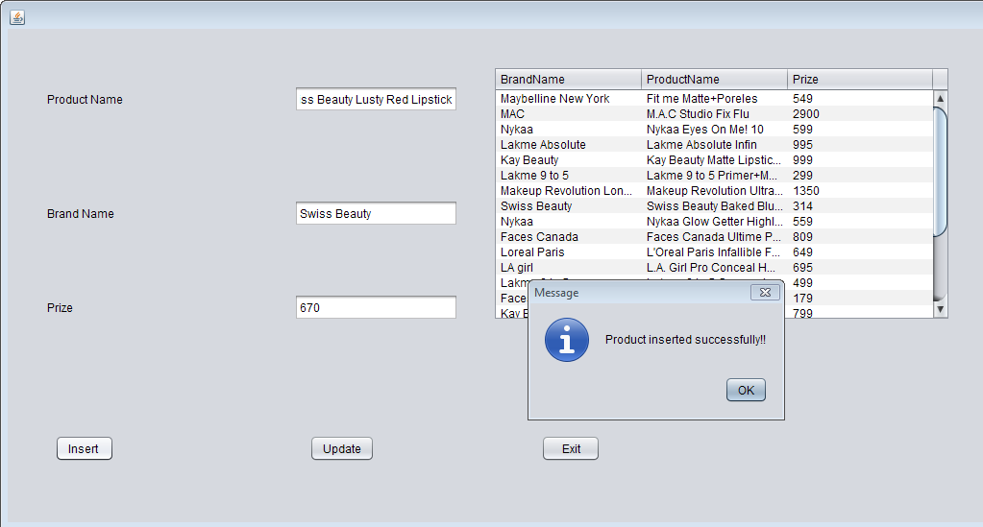

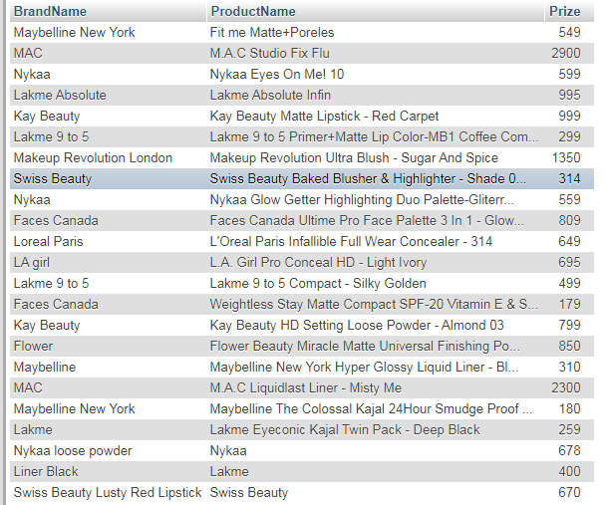

Inserted in the table besides it as well as in the database

Update

Output:

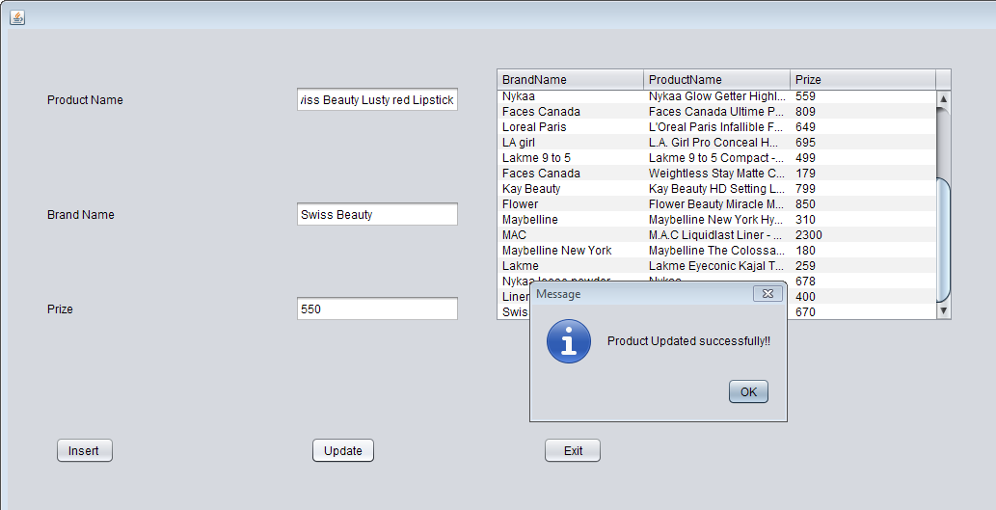

Updated here as well as in the database

Delete.java

Code:

/*

* To change this license header, choose License Headers in Project Properties.

* To change this template file, choose Tools | Templates

* and open the template in the editor.

*/

package beautyproducts;

import com.mysql.jdbc.Connection;

import javax.swing.JOptionPane;

import java.awt.Toolkit;

import java.awt.event.WindowEvent;

import java.sql.DriverManager;

import java.sql.PreparedStatement;

import java.sql.ResultSet;

import net.proteanit.sql.DbUtils;

/**

*

* @author js

*/

public class delete extends javax.swing.JFrame {

Connection con = null;

com.mysql.jdbc.PreparedStatement pst = null;

ResultSet rs = null;

public delete() {

initComponents();

showTableData();

}

/**

* This method is called from within the constructor to initialize the form.

* WARNING: Do NOT modify this code. The content of this method is always

* regenerated by the Form Editor.

*/

@SuppressWarnings("unchecked")

// <editor-fold defaultstate="collapsed" desc="Generated Code">

private void initComponents() {

jButton3 = new javax.swing.JButton();

jLabel1 = new javax.swing.JLabel();

jLabel2 = new javax.swing.JLabel();

jLabel3 = new javax.swing.JLabel();

jProductName = new javax.swing.JTextField();

jBrandName = new javax.swing.JTextField();

jPrize = new javax.swing.JTextField();

jsubmit = new javax.swing.JButton();

jReset = new javax.swing.JButton();

jExit = new javax.swing.JButton();

jScrollPane1 = new javax.swing.JScrollPane();

jTable1 = new javax.swing.JTable();

jButton3.setText("jButton3");

setDefaultCloseOperation(javax.swing.WindowConstants.EXIT_ON_CLOSE);

jLabel1.setText("Product Name");

jLabel2.setText("Brand Name");

jLabel3.setText("Prize");

jsubmit.setText("Submit");

jsubmit.addActionListener(new java.awt.event.ActionListener() {

public void actionPerformed(java.awt.event.ActionEvent evt) {

jsubmitActionPerformed(evt);

}

});

jReset.setText("Reset");

jReset.addActionListener(new java.awt.event.ActionListener() {

public void actionPerformed(java.awt.event.ActionEvent evt) {

jResetActionPerformed(evt);

}

});

jExit.setText("Exit");

jExit.addActionListener(new java.awt.event.ActionListener() {

public void actionPerformed(java.awt.event.ActionEvent evt) {

jExitActionPerformed(evt);

}

});

jTable1.setModel(new javax.swing.table.DefaultTableModel(

new Object [][] {

{null, null, null, null},

{null, null, null, null},

{null, null, null, null},

{null, null, null, null}

},

new String [] {

"Title 1", "Title 2", "Title 3", "Title 4"

}

));

jScrollPane1.setViewportView(jTable1);

javax.swing.GroupLayout layout = new javax.swing.GroupLayout(getContentPane());

getContentPane().setLayout(layout);

layout.setHorizontalGroup(

layout.createParallelGroup(javax.swing.GroupLayout.Alignment.LEADING)

.addGroup(layout.createSequentialGroup()

.addGap(64, 64, 64)

.addGroup(layout.createParallelGroup(javax.swing.GroupLayout.Alignment.LEADING)

.addGroup(layout.createSequentialGroup()

.addGroup(layout.createParallelGroup(javax.swing.GroupLayout.Alignment.LEADING, false)

.addComponent(jLabel3, javax.swing.GroupLayout.DEFAULT_SIZE, javax.swing.GroupLayout.DEFAULT_SIZE, Short.MAX_VALUE)

.addComponent(jLabel1, javax.swing.GroupLayout.DEFAULT_SIZE, 149, Short.MAX_VALUE)

.addComponent(jLabel2, javax.swing.GroupLayout.DEFAULT_SIZE, javax.swing.GroupLayout.DEFAULT_SIZE, Short.MAX_VALUE))

.addGap(57, 57, 57)

.addGroup(layout.createParallelGroup(javax.swing.GroupLayout.Alignment.LEADING)

.addComponent(jBrandName, javax.swing.GroupLayout.PREFERRED_SIZE, 163, javax.swing.GroupLayout.PREFERRED_SIZE)

.addComponent(jProductName, javax.swing.GroupLayout.PREFERRED_SIZE, 163, javax.swing.GroupLayout.PREFERRED_SIZE)

.addComponent(jPrize, javax.swing.GroupLayout.PREFERRED_SIZE, 163, javax.swing.GroupLayout.PREFERRED_SIZE))

.addGap(75, 75, 75)

.addComponent(jScrollPane1, javax.swing.GroupLayout.PREFERRED_SIZE, 383, javax.swing.GroupLayout.PREFERRED_SIZE))

.addGroup(layout.createSequentialGroup()

.addComponent(jsubmit, javax.swing.GroupLayout.PREFERRED_SIZE, 128, javax.swing.GroupLayout.PREFERRED_SIZE)

.addGap(117, 117, 117)

.addComponent(jReset, javax.swing.GroupLayout.PREFERRED_SIZE, 113, javax.swing.GroupLayout.PREFERRED_SIZE)

.addGap(103, 103, 103)

.addComponent(jExit, javax.swing.GroupLayout.PREFERRED_SIZE, 115, javax.swing.GroupLayout.PREFERRED_SIZE)))

.addContainerGap(javax.swing.GroupLayout.DEFAULT_SIZE, Short.MAX_VALUE))

);

layout.setVerticalGroup(

layout.createParallelGroup(javax.swing.GroupLayout.Alignment.LEADING)

.addGroup(layout.createSequentialGroup()

.addGap(57, 57, 57)

.addGroup(layout.createParallelGroup(javax.swing.GroupLayout.Alignment.TRAILING)

.addGroup(layout.createSequentialGroup()

.addGroup(layout.createParallelGroup(javax.swing.GroupLayout.Alignment.BASELINE)

.addComponent(jLabel1, javax.swing.GroupLayout.PREFERRED_SIZE, 45, javax.swing.GroupLayout.PREFERRED_SIZE)

.addComponent(jProductName, javax.swing.GroupLayout.PREFERRED_SIZE, 45, javax.swing.GroupLayout.PREFERRED_SIZE))

.addGap(130, 130, 130))

.addGroup(layout.createParallelGroup(javax.swing.GroupLayout.Alignment.BASELINE)

.addComponent(jBrandName, javax.swing.GroupLayout.PREFERRED_SIZE, 45, javax.swing.GroupLayout.PREFERRED_SIZE)

.addComponent(jLabel2, javax.swing.GroupLayout.PREFERRED_SIZE, 45, javax.swing.GroupLayout.PREFERRED_SIZE)))

.addPreferredGap(javax.swing.LayoutStyle.ComponentPlacement.RELATED, 93, Short.MAX_VALUE)

.addGroup(layout.createParallelGroup(javax.swing.GroupLayout.Alignment.BASELINE)

.addComponent(jPrize, javax.swing.GroupLayout.PREFERRED_SIZE, 40, javax.swing.GroupLayout.PREFERRED_SIZE)

.addComponent(jLabel3, javax.swing.GroupLayout.PREFERRED_SIZE, 40, javax.swing.GroupLayout.PREFERRED_SIZE))

.addGap(79, 79, 79)

.addGroup(layout.createParallelGroup(javax.swing.GroupLayout.Alignment.LEADING, false)

.addComponent(jExit, javax.swing.GroupLayout.DEFAULT_SIZE, 43, Short.MAX_VALUE)

.addComponent(jsubmit, javax.swing.GroupLayout.DEFAULT_SIZE, javax.swing.GroupLayout.DEFAULT_SIZE, Short.MAX_VALUE)

.addComponent(jReset, javax.swing.GroupLayout.DEFAULT_SIZE, javax.swing.GroupLayout.DEFAULT_SIZE, Short.MAX_VALUE))

.addContainerGap())

.addGroup(layout.createSequentialGroup()

.addGap(48, 48, 48)

.addComponent(jScrollPane1, javax.swing.GroupLayout.PREFERRED_SIZE, 328, javax.swing.GroupLayout.PREFERRED_SIZE)

.addContainerGap(javax.swing.GroupLayout.DEFAULT_SIZE, Short.MAX_VALUE))

);

pack();

}// </editor-fold>

private void jExitActionPerformed(java.awt.event.ActionEvent evt) {

System.exit(0);

}

private void jResetActionPerformed(java.awt.event.ActionEvent evt) {

jProductName.setText(null);

jBrandName.setText(null);

jPrize.setText(null);

}

private void jsubmitActionPerformed(java.awt.event.ActionEvent evt) {

try

{

String sql = "DELETE FROM products WHERE ProductName=?";

Connection con = (Connection) DriverManager.getConnection("jdbc:mysql://localhost/beauty_products","root","");

@SuppressWarnings("LocalVariableHidesMemberVariable")

PreparedStatement pst = con.prepareStatement(sql);

pst.setString(1,jProductName.getText());

pst.executeUpdate();

JOptionPane.showMessageDialog(this,"Product Deleted");

}

catch(Exception ex)

{

JOptionPane.showMessageDialog(null, ex);

}

showTableData();

}

public void showTableData()

{

try

{

con = (Connection) DriverManager.getConnection("jdbc:mysql://localhost/beauty_products","root","");

String sql = "SELECT * FROM products";

pst = (com.mysql.jdbc.PreparedStatement) con.prepareStatement(sql);

rs = pst.executeQuery();

jTable1.setModel(DbUtils.resultSetToTableModel(rs));

}

catch(Exception ex)

{

JOptionPane.showMessageDialog(null, ex);

}

}

/**

* @param args the command line arguments

*/

public static void main(String args[]) {

/* Set the Nimbus look and feel */

//<editor-fold defaultstate="collapsed" desc=" Look and feel setting code (optional) ">

/* If Nimbus (introduced in Java SE 6) is not available, stay with the default look and feel.

* For details see http://download.oracle.com/javase/tutorial/uiswing/lookandfeel/plaf.html

*/

try {

for (javax.swing.UIManager.LookAndFeelInfo info : javax.swing.UIManager.getInstalledLookAndFeels()) {

if ("Nimbus".equals(info.getName())) {

javax.swing.UIManager.setLookAndFeel(info.getClassName());

break;

}

}

} catch (ClassNotFoundException ex) {

java.util.logging.Logger.getLogger(delete.class.getName()).log(java.util.logging.Level.SEVERE, null, ex);

} catch (InstantiationException ex) {

java.util.logging.Logger.getLogger(delete.class.getName()).log(java.util.logging.Level.SEVERE, null, ex);

} catch (IllegalAccessException ex) {

java.util.logging.Logger.getLogger(delete.class.getName()).log(java.util.logging.Level.SEVERE, null, ex);

} catch (javax.swing.UnsupportedLookAndFeelException ex) {

java.util.logging.Logger.getLogger(delete.class.getName()).log(java.util.logging.Level.SEVERE, null, ex);

}

//</editor-fold>

/* Create and display the form */

java.awt.EventQueue.invokeLater(new Runnable() {

public void run() {

new delete().setVisible(true);

}

});

}

// Variables declaration - do not modify

private javax.swing.JTextField jBrandName;

private javax.swing.JButton jButton3;

private javax.swing.JButton jExit;

private javax.swing.JLabel jLabel1;

private javax.swing.JLabel jLabel2;

private javax.swing.JLabel jLabel3;

private javax.swing.JTextField jPrize;

private javax.swing.JTextField jProductName;

private javax.swing.JButton jReset;

private javax.swing.JScrollPane jScrollPane1;

private javax.swing.JTable jTable1;

private javax.swing.JButton jsubmit;

// End of variables declaration

}

Output:

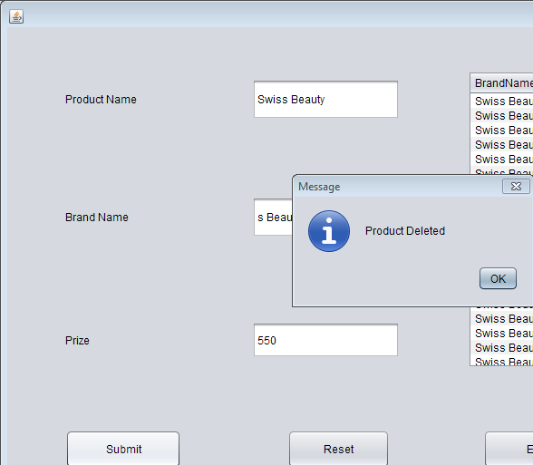

Future Scope

In this project we can further implement add to cart option for buying various products at the same time also we can add more products in the database and we can add comments and review/rating section too.

Conclusion

In my mini project I have used mainly java swing forms and

database connectivity.To add security to my project i have first

made a login form for both user as well as the owner , if the

password entered is incorrect they won't be able to make any

further changes ahead. In this beauty product project, a user

can either sell or buy any of the beauty product and an owner

can insert or delete any item from the database.while buying

any of the product one must enter their card details for the

transaction to be completed.