# Image Processing and Computer Vision I (DJ19DSL603)

## Lab 3: Image Enhancement in Spatial Domain using Point Processing Techniques

Name: Kresha Shah

SAP ID: 60009220080

**Aim:** To perform image enhancement in spatial domain using point processing techniques: contrast stretching, log transformation, power law transformation

**Theory:**

**1. Contrast Stretching:**

Contrast stretching (often called normalization) is a simple image enhancement technique that attempts to improve the contrast in an image by 'stretching' the range of intensity values it contains to span a desired range of values, e.g. the the full range of pixel values that the image type concerned allows. It differs from the more sophisticated histogram equalization in that it can only apply a linear scaling function to the image pixel values. As a result the 'enhancement' is less harsh.

Below figure shows a typical transformation function used for Contrast

Stretching.

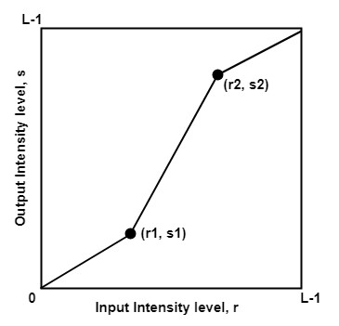

By changing the location of points (r1, s1) and (r2, s2), we can control the shape of the transformation function. For example,

1. When r1 =s1 and r2=s2, transformation becomes a **Linear function**.
2. When r1=r2, s1=0 and s2=L-1, transformation becomes a **thresholding function**.
3. When (r1, s1) = (rmin, 0) and (r2, s2) = (rmax, L-1), this is known as **Min-Max Stretching.**
4. When (r1, s1) = (rmin + c, 0) and (r2, s2) = (rmax – c, L-1), this is known as **Percentile Stretching**.

# Image Processing and Computer Vision I (DJ19DSL603)

## Lab 3: Image Enhancement in Spatial Domain using Point Processing Techniques

**2. Log Transformation:**

The log transformations can be defined by this formula:

## s = c log(r + 1)

Where s and r are the pixel values of the output and the input image and c is a constant. The value 1 is added to each of the pixel value of the input image because if there is a pixel intensity of 0 in the image, then log (0) is equal to infinity. So 1 is added, to make the minimum value at least 1.

During log transformation, the dark pixels in an image are expanded as compare to the higher pixel values. The higher pixel values are kind of compressed in log transformation.

**3. Power Law Transformation:**

The power law transformation, also called gamma transformation is a technique that uses a power-law function to adjust the pixel values of an image. It is versatile, as it allows the emphasis on certain intensity ranges or enhancing specific details in an image.

Formula of the gamma transformation equation is given as:

## O = cIγ

In this context, the symbol c is used to represent the scaling factor, γ denotes the gamma correction value, and I and O respectively stand for the input and output pixel values.

If the value of gamma is greater than one, it stretches contrast in brighter areas and compresses the pixel values in the darker areas. If the value of gamma is smaller than one, it enhances contrast in dim areas and compresses the pixel values in the bright areas.The graphical representation of the function is given below:

# Image Processing and Computer Vision I (DJ19DSL603)

## Lab 3: Image Enhancement in Spatial Domain using Point Processing Techniques

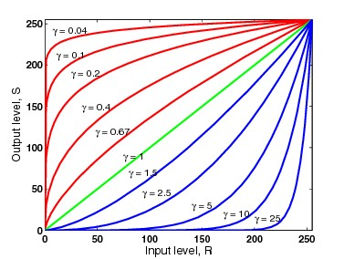

Here, the x-axis and y-axis represent the input and output pixel values respectively and the shape of the graph varies with the gamma values.

**Lab Assignments to complete in this session**

**Problem Statement:** Develop a Python program utilizing the OpenCV library to enhance the images in spatial domain. The program should address the following tasks:

1. Read any low contrast image of your choice or generate one.
2. Display the before & after image(s) used in every task below.
3. Apply contrast stretching.
4. Apply Log transformation.
5. Apply Power law tranformation
6. Perform all the task for black and white images and on coloured RGB Images on

all the three chanels.

The solution to the operations performed must be produced by scratch coding without the use of built in OpenCV methods.

import cv2

import numpy as np

from matplotlib import pyplot as plt

def display_images(before, after, title_before, title_after):

    plt.subplot(1, 2, 1)

    plt.imshow(before, cmap='gray')

    plt.title(title_before)

    plt.axis('off')

    plt.subplot(1, 2, 2)

    plt.imshow(after, cmap='gray')

    plt.title(title_after)

    plt.axis('off')

    plt.show()

def contrast_stretching(img):

    min_val = np.min(img)

    max_val = np.max(img)

    stretched_img = ((img - min_val) / (max_val - min_val)) * 255

    stretched_img = stretched_img.astype(np.uint8)

    return stretched_img

def log_transformation(img):

    c = 255 / np.log(1 + np.max(img))

    log_transformed_img = c * np.log(1 + img + 1e-10)

    log_transformed_img = log_transformed_img.astype(np.uint8)

    return log_transformed_img

def power_law_transformation(img, gamma):

    power_law_img = np.power(img, gamma)

    power_law_img = power_law_img / np.max(power_law_img) * 255

    power_law_img = power_law_img.astype(np.uint8)

    return power_law_img

def enhance_image(img_path, gamma_values=[0.5, 1.5, 2.5]):

    original_img = cv2.imread(img_path, cv2.IMREAD_GRAYSCALE)

    plt.imshow(original_img, cmap='gray')

    plt.title("Original Image")

    plt.axis('off')

    plt.show()

    stretched_img = contrast_stretching(original_img)

    display_images(original_img, stretched_img, "Original", "Contrast Stretched")

    log_transformed_img = log_transformation(original_img)

    display_images(original_img, log_transformed_img, "Original", "Log Transformed")

    for gamma in gamma_values:

        power_law_img = power_law_transformation(original_img, gamma)

        display_images(original_img, power_law_img, f"Original (gamma={gamma})", f"Power Law Transformed (gamma={gamma})")

if __name__ == "__main__":

    image_path = "/content/drive/MyDrive/Colab Notebooks/gurushots-mostly-white-contest-winners-32.jpg"

    enhance_image(image_path)

