**Experiment 7**

**Name: Kresha Shah**

**SAP ID: 60009220080**

**Aim:** To perform morphological operations on image (erosion, dilation, opening, closing and hit and miss transform) **Theory:**

1. **Erosion:**

Morphological expressions are written in terms of structuring elements and a set, A, of foreground pixels, or in terms of structuring elements and an image, I, that contains A. We consider the former approach first. Erosion of A by B is defined as:



In words, this equation indicates that the erosion of A by B is the set of all points z such that B, translated by z, is contained in A. (Remember, displacement is defined with respect to the origin of B. The result of erosion is controlled by the shape of the structuring element. The image is eroded by two different structuring elements (B) giving the outputs as seen:

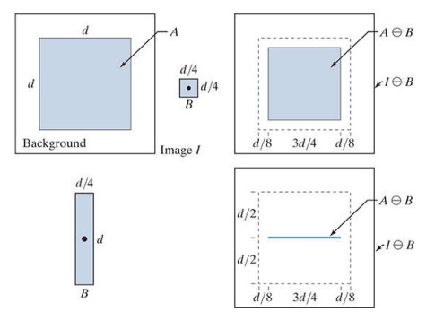

1. **Dilation:**

Dilation of A by B is defined as:



The dilation of A by B then is the set of all displacements, z, such that the foreground elements of overlap at least one element of A. (Remember, z is the displacement of the origin of 𝐵̂. The image is dilated by two different structuring elements (B) giving the outputs as seen:

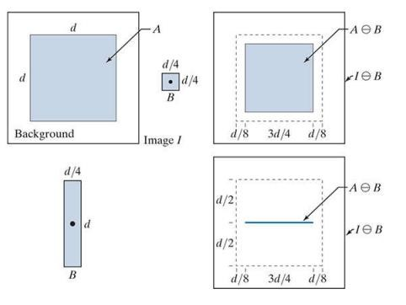

1. **Opening:**

Opening generally smoothens the contour of an object, breaks narrow isthmuses, and eliminates thin protrusions. The opening of set A by structuring element B is defined as:



Thus, the opening A by B is the erosion of A by B, followed by a dilation of the result by B. The opening of A by B is the union of all the translations of B so that B fits entirely in A

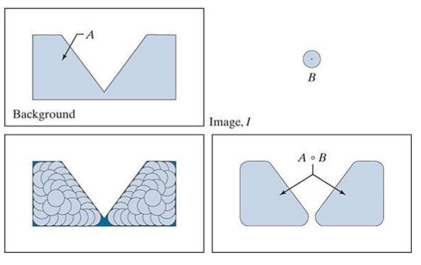

1. **Closing:**

The closing of set A by structuring element B is defined as:



The closing of A by B is simply the dilation of A by B, followed by erosion of the result by B. The opening of A by B is the union of all the translations of B so that B fits entirely in A.

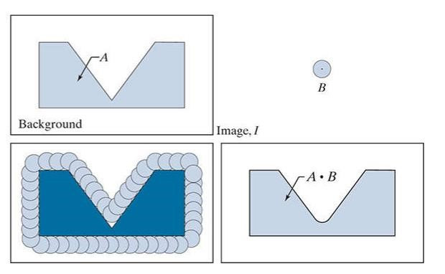

1. **Hit and miss transform:**

The morphological hit-or-miss transform (HMT) is a basic tool for shape detection. Let I be a binary image composed of foreground (A) and background pixels, respectively. Unlike the morphological methods discussed thus far, the HMT utilizes two structuring elements: B1 for detecting shapes in the foreground, and B2 for detecting shapes in the background. The HMT of image I is defined as

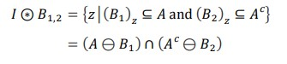

In words, this equation says that the morphological HMT is the set of translations, z, of structuring elements B1 and B2 such that, simultaneously, B1 found a match in the foreground (i.e., is contained in A) and B2 found a match in the background (i.e., is contained in Ac).

**Lab Assignments to complete in this session**

**Problem Statement:** Develop a Python program utilizing the OpenCV library to morph the images in spatial domain using the morphological operations explained. The program should address the following tasks:

1. Read any image from COVID 19 Image Dataset. Take it as object **Dataset Link:** [**Covid-19 Image Dataset**](https://www.kaggle.com/datasets/pranavraikokte/covid19-image-dataset/code)
2. Create a structuring element of any form that is much smaller in size than the image considered in step 1.
3. Display the before & after image(s) used in every task below:
   1. Apply erosion and show the before and after image
   2. Apply dilation and show the before and after image
   3. Apply opening and show the before and after image
   4. Apply closing and show the before and after image
   5. Apply hit and miss transformation and show the before and after image. Take the structuring element to be negation of the one used till now.

The solution to the operations performed must be produced by scratch coding without the use of built in OpenCV methods.

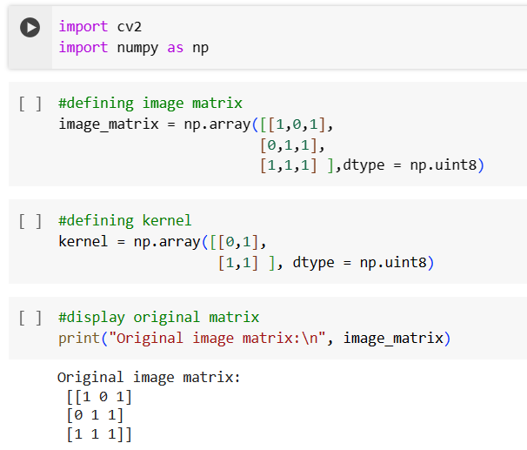

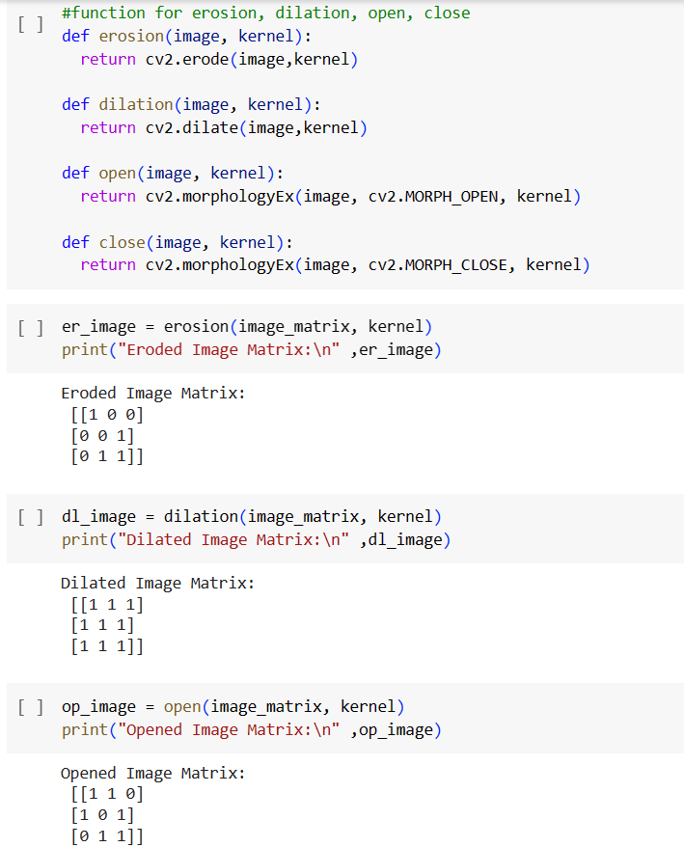

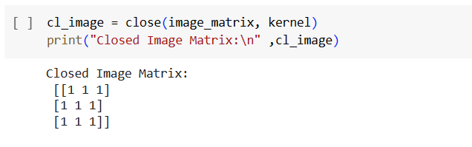

import cv2

import numpy as np

import os

import matplotlib.pyplot as plt

# Function to perform erosion

def erosion(image, kernel):

    eroded_image = np.zeros_like(image)

    rows, cols = image.shape

    krows, kcols = kernel.shape

    for i in range(rows - krows):

        for j in range(cols - kcols):

            if np.all(image[i:i+krows, j:j+kcols] == kernel):

                eroded_image[i+krows//2, j+kcols//2] = 255

    return eroded_image

# Function to perform dilation

def dilation(image, kernel):

    dilated_image = np.zeros_like(image)

    rows, cols = image.shape

    krows, kcols = kernel.shape

    for i in range(rows - krows):

        for j in range(cols - kcols):

            if np.any(image[i:i+krows, j:j+kcols] == 255):

                dilated_image[i+krows//2, j+kcols//2] = 255

    return dilated_image

# Function to perform opening

def opening(image, kernel):

    opened_image = erosion(image, kernel)

    opened_image = dilation(opened_image, kernel)

    return opened_image

# Function to perform closing

def closing(image, kernel):

    closed_image = dilation(image, kernel)

    closed_image = erosion(closed_image, kernel)

    return closed_image

# Function to perform hit and miss transformation

def hit_and_miss(image, kernel):

    neg_kernel = 255 - kernel

    hit_image = erosion(image, kernel)

    miss_image = erosion(255 - image, neg_kernel)

    hit_miss_image = np.bitwise_and(hit_image, miss_image)

    return hit_miss_image

# Read the COVID-19 Image Dataset

dataset_path = "/content/drive/MyDrive/datasets/Covid19-dataset/train/Covid/078.jpeg"

if os.path.exists(dataset_path):

    # Read the image

    original_image = cv2.imread(dataset_path, cv2.IMREAD_GRAYSCALE)

    # Create a structuring element (3x3 kernel)

    structuring_element = np.ones((3, 3), dtype=np.uint8)

    # Display original image

    plt.imshow(original_image, cmap='gray')

    plt.title("Original Image")

    plt.axis('off')

    plt.show()

    # Apply erosion

    eroded_image = erosion(original_image, structuring_element)

    plt.imshow(eroded_image, cmap='gray')

    plt.title("Eroded Image")

    plt.axis('off')

    plt.show()

    # Apply dilation

    dilated_image = dilation(original_image, structuring_element)

    plt.imshow(dilated_image, cmap='gray')

    plt.title("Dilated Image")

    plt.axis('off')

    plt.show()

    # Apply opening

    opened_image = opening(original_image, structuring_element)

    plt.imshow(opened_image, cmap='gray')

    plt.title("Opened Image")

    plt.axis('off')

    plt.show()

    # Apply closing

    closed_image = closing(original_image, structuring_element)

    plt.imshow(closed_image, cmap='gray')

    plt.title("Closed Image")

    plt.axis('off')

    plt.show()

    # Apply hit and miss transformation

    hit_miss_image = hit_and_miss(original_image, structuring_element)

    plt.imshow(hit_miss_image, cmap='gray')

    plt.title("Hit and Miss Image")

    plt.axis('off')

    plt.show()

else:

    print("Specified image file does not exist.")

