**AIM: To implement frequency domain filters on an image**

**Name: Kresha Shah**

**SAP ID: 60009220080**

**THEORY:**

# 1. Ideal Low Pass Filter

This filter cuts off all high frequency components of the Fourier transform that are at a distance greater than a specified distance D0.

H(u,v) = 1; if D(u,v)< D0

= 0; if D(u,v)> D0

Where,

D

0

is

the

specified

non

negative

distance.



H(u,v)



1



D

0



D(u,v)

Response of Ideal Low Pass Filter

D(u,v) is the distance from the point (u,v) to the origin of the frequency rectangle for an M X N image.

D(u,v)=[(u-M/2)² + (v-N/2)²]^ ½

Therefore ,

For an image, when u=M/2 , v=N/2

D(u,v)=0

This formula centers our H(u,v).

D(u,v) gives us concentric rings with each ring having a fixed value.

When an ideal low-pass filter is applied to an image, the high-frequency components (i.e., the high-frequency information, such as edges and details) are removed, and only the low-frequency components (i.e., the smooth areas and large details) are retained. This results in a blurring or smoothing effect on the image.

Observations:

1. The image appears smoother or less sharp, as high-frequency details are removed.
2. Edges and other high-contrast features may appear blurred or softened.
3. Noise and other high-frequency artifacts may be reduced, resulting in a cleaner appearance.
4. The overall contrast of the image may be reduced, especially in areas with fine details.
5. The filter may introduce ringing artifacts around edges or high-contrast areas, due to the ideal filter’s inherent characteristics.

# 2. Ideal High Pass Filter

When an ideal high-pass filter is applied to an image, the low-frequency components (i.e., the smooth areas and large details) are removed, and only the high-frequency components (i.e., the edges and fine details) are retained. This results in an image with enhanced edges and details, but with reduced low-frequency content.

Observations:

1. The image appears sharper, as high-frequency details are enhanced.
2. Edges and other high-contrast features appear more prominent and welldefined.
3. The overall contrast of the image may be increased, especially in areas with fine details.
4. Low-frequency content, such as smooth areas or large features, may appear blurred or reduced in prominence.

The filter may introduce ringing artifacts around edges or high-contrast areas, due to the ideal filter’s inherent characteristics.

This filter cuts off all high frequency components of the Fourier transform that are at a distance greater than a specified distance D0.



H(u,v)



D

0



D(u,v)

Where, H(u,v) = 0; if D(u,v)< D0

= 1; if D(u,v)> D0

D0 is the specified non negative distance.

D(u,v) is the distance from the point (u,v) to the origin of the frequency rectangle for an M X N image.

**3. Gaussian Low Pass Filter** Gaussian LPF is given by:

H(u,v) = e-D² (u,v)/2σ²

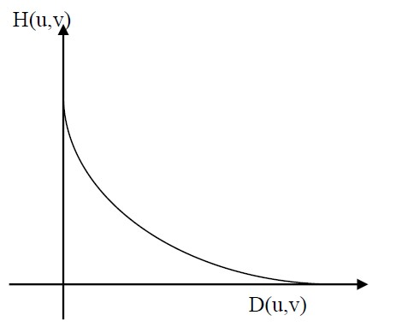

Where, σ is the standard deviation and is a measure of spread of the Gaussian curve. If we put σ =D0 we get, H(u,v) = e-D² (u,v)/2D0²

The response of the Gaussian LPF is similar to that of BLPF but there are no ringing effects.

# 4. Gaussian High Pass Filter

The basic formula is, Hhp(u,v) = 1- Hlp(u,v)

# Therefore,

HGaussian hp(u,v) = 1- H Gaussian lp (u,v)

H GHPF = 1- e-D² (u,v)/2D0²

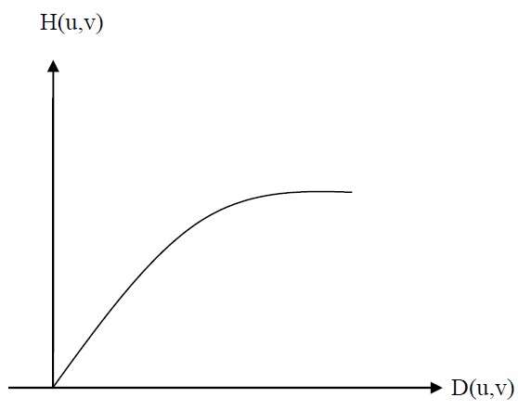

The results of Gaussian high pass filter are smoother and cleaner

## Lab Assignments to complete in this session

**Problem Statement:** Develop a Python program utilizing the OpenCV library to manipulate images from the Fashion MNIST digits dataset. The program should address the following tasks:

1. Importing libraries
2. Read random image(s) from the MNIST fashion dataset.
3. **Dataset Link:** [Fashion MNIST Github](https://github.com/zalandoresearch/fashion-mnist)
4. Getting the Fourier Transform
5. Ideal Low Pass Filtering
6. Multiplication between the Fourier Transformed input image and the filtering mask
7. Taking Inverse Fourier Transform of the convoluted image
8. Ideal High Pass Filtering
9. Multiplication between the Fourier Transformed input image and the filtering mask
10. Taking Inverse Fourier Transform of the convoluted image
11. Gaussian Low Pass Filtering
12. Multiplication between the Fourier Transformed input image and the filtering mask
13. Taking Inverse Fourier Transform of the convoluted image
14. Gaussian High Pass Filtering
15. Multiplication between the Fourier Transformed input image and the filtering mask
16. Taking Inverse Fourier Transform of the convoluted image

The solution to the operations performed must be produced by scratch coding without the use of built in OpenCV methods.

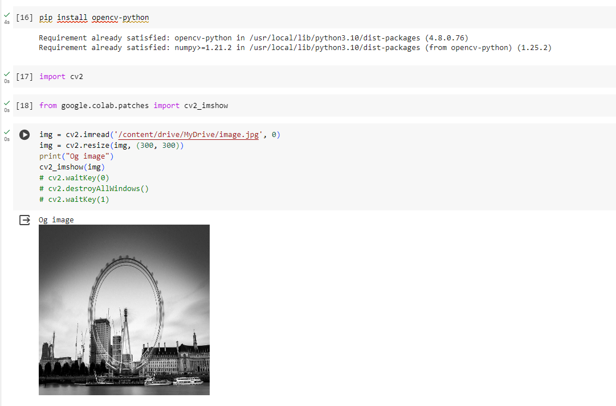

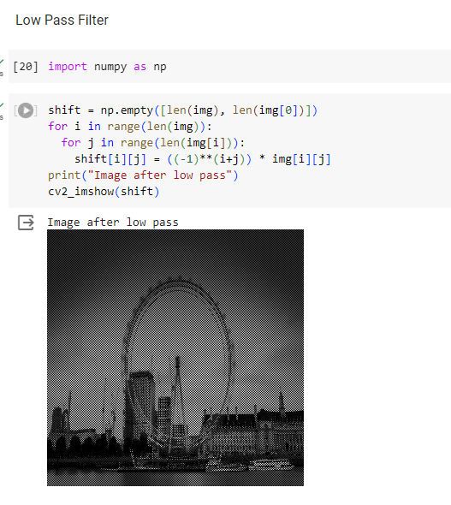

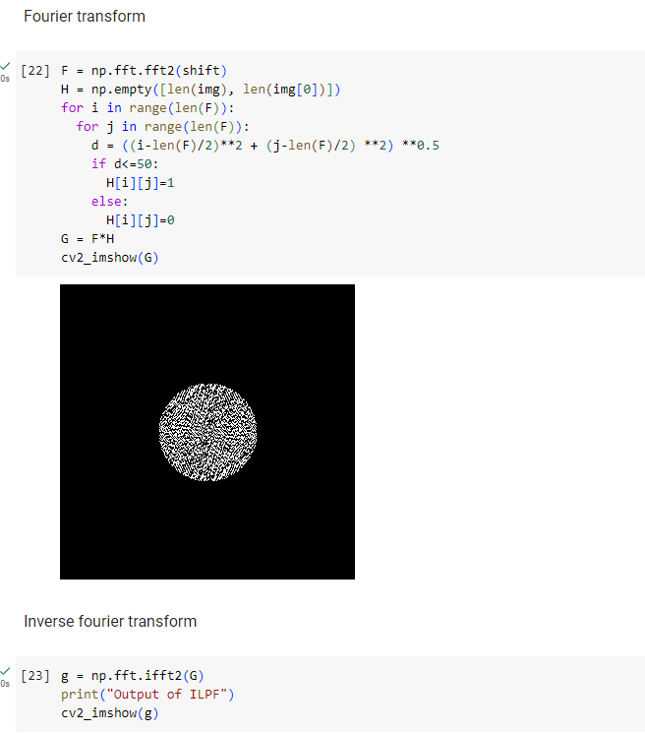

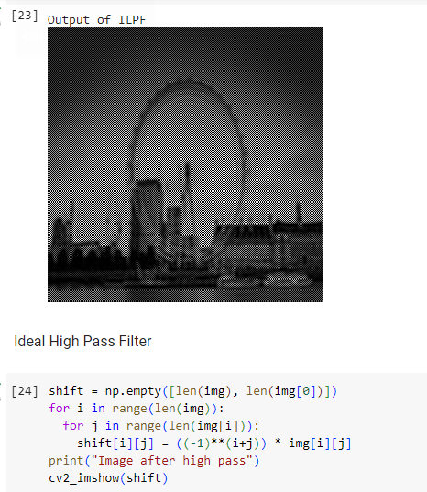

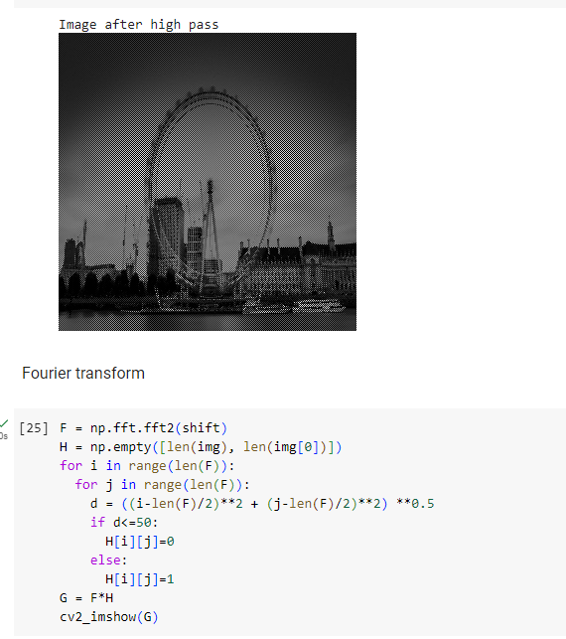

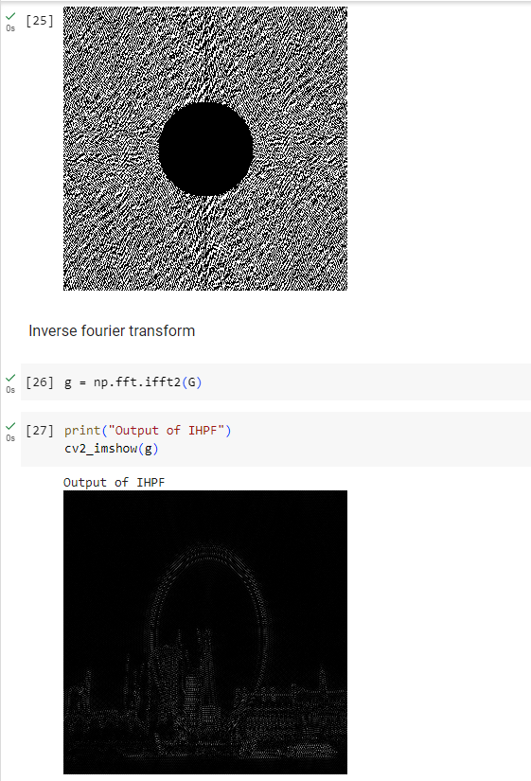

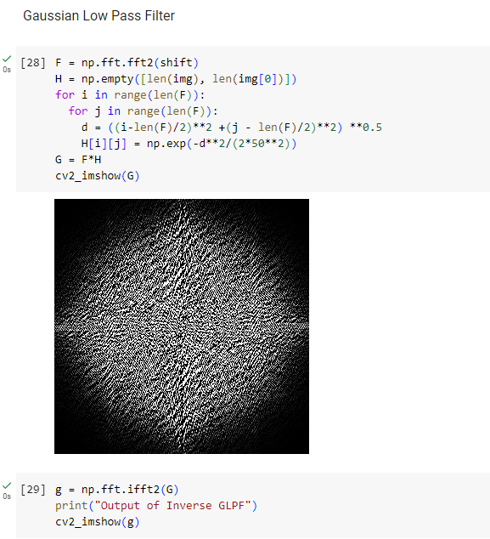

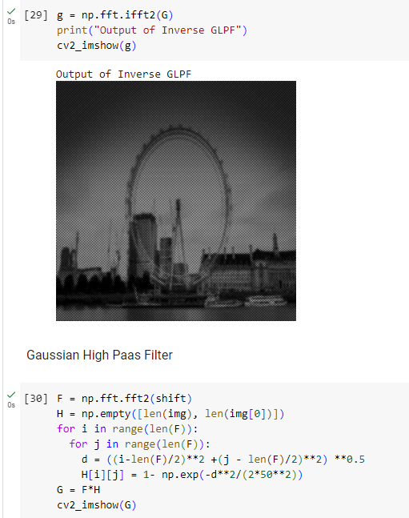

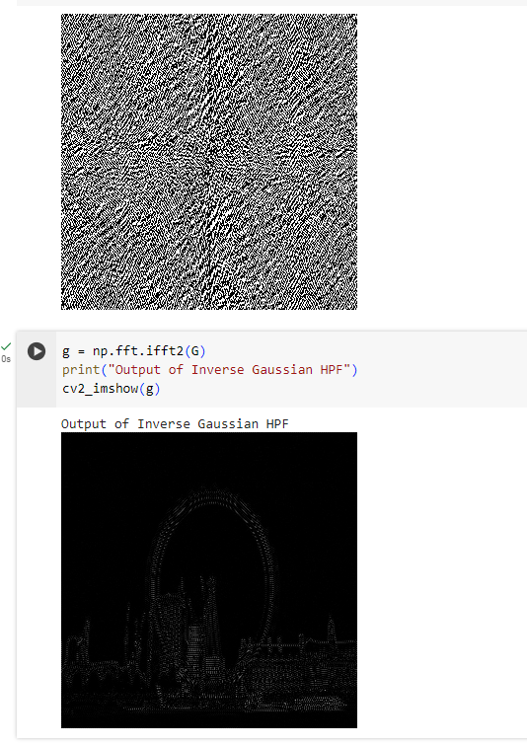

import numpy as np

import cv2

from tensorflow.keras.datasets import fashion_mnist

from google.colab.patches import cv2_imshow

# Load Fashion MNIST dataset

(train_images, _), (_, _) = fashion_mnist.load_data()

# Select a random sample image

idx = np.random.randint(0, len(train_images))

img = train_images[idx]

# Resize image to 300x300

img = cv2.resize(img, (300, 300))

# Display original image

print("Original Image")

cv2_imshow(img)

# Apply low pass filter

shift = np.empty_like(img)

for i in range(len(img)):

    for j in range(len(img[i])):

        shift[i][j] = ((-1) ** (i + j)) * img[i][j]

# Display image after low pass

print("Image after low pass")

cv2_imshow(shift)

# Perform FFT

F = np.fft.fft2(shift)

# Define low pass filter

H = np.empty_like(F)

for i in range(len(F)):

    for j in range(len(F[i])):

        d = ((i - len(F) / 2) ** 2 + (j - len(F[i]) / 2) ** 2) ** 0.5

        if d <= 50:

            H[i][j] = 1

        else:

            H[i][j] = 0

# Apply low pass filter in frequency domain

G = F * H

# Inverse FFT

g = np.fft.ifft2(G)

# Display output of ILPF

print("Output of ILPF")

cv2_imshow(g.real.astype(np.uint8))

# Apply high pass filter

shift = np.empty_like(img)

for i in range(len(img)):

    for j in range(len(img[i])):

        shift[i][j] = ((-1) ** (i + j)) * img[i][j]

# Display image after high pass

print("Image after high pass")

cv2_imshow(shift)

# Perform FFT

F = np.fft.fft2(shift)

# Define high pass filter

H = np.empty_like(F)

for i in range(len(F)):

    for j in range(len(F[i])):

        d = ((i - len(F) / 2) ** 2 + (j - len(F[i]) / 2) ** 2) ** 0.5

        if d <= 50:

            H[i][j] = 0

        else:

            H[i][j] = 1

# Apply high pass filter in frequency domain

G = F * H

# Inverse FFT

g = np.fft.ifft2(G)

# Display output of IHPF

print("Output of IHPF")

cv2_imshow(g.real.astype(np.uint8))

# Gaussian low pass filter

F = np.fft.fft2(shift)

H = np.empty_like(F)

for i in range(len(F)):

    for j in range(len(F[i])):

        d = ((i - len(F) / 2) ** 2 + (j - len(F[i]) / 2) ** 2) ** 0.5

        H[i][j] = np.exp(-d ** 2 / (2 * 50 ** 2))

# Apply Gaussian low pass filter in frequency domain

G = F * H

# Inverse FFT

g = np.fft.ifft2(G)

# Display output of Inverse GLPF

print("Output of Inverse GLPF")

cv2_imshow(g.real.astype(np.uint8))

# Gaussian high pass filter

F = np.fft.fft2(shift)

H = np.empty_like(F)

for i in range(len(F)):

    for j in range(len(F[i])):

        d = ((i - len(F) / 2) ** 2 + (j - len(F[i]) / 2) ** 2) ** 0.5

        H[i][j] = 1 - np.exp(-d ** 2 / (2 * 50 ** 2))

# Apply Gaussian high pass filter in frequency domain

G = F * H

# Inverse FFT

g = np.fft.ifft2(G)

# Display output of Inverse Gaussian HPF

print("Output of Inverse Gaussian HPF")

cv2_imshow(g.real.astype(np.uint8))

**Output:**

