***CHAPTER 1*. *The Machine Learning Landscape***

**Machine Learning is great for:**

* ***Problems for which existing solutions require a lot of fine-tuning or long lists of rules***: one Machine Learning algorithm can often simplify code and perform better than the traditional approach.
* ***Complex problems for which using a traditional approach yields no good solution***: the best Machine Learning techniques can perhaps find a solution.
* ***Fluctuating environments***: a Machine Learning system can adapt to new data.
* ***Getting insights about complex problems and large amounts of data***.

**Examples of Machine Learning Applications**

Some concrete examples of Machine Learning tasks, along with the techniques that can tackle them:

* ***Analysing images of products on a production line to automatically classify them*.**
  + this is **image classification**, typically performed using convolutional neural networks (CNNs; see Chapter 14).
* ***Detecting tumours in brain scans***
  + This is **semantic segmentation**, where each pixel in the image is classified (as we want to determine the exact location and shape of tumors), typically using CNNs as well.
* ***Automatically classifying news articles***
  + This is **natural language processing (NLP)**, and more specifically **text classification**, which can be tackled using recurrent neural networks (RNNs), CNNs, or Transformers (see Chapter 16).
* ***Automatically flagging offensive comments on discussion forums***
  + This is also **text classification**, using the same NLP tools.
* ***Summarizing long documents automatically***
  + This is a branch of NLP called **text summarization**, again using the same tools.
* ***Creating a chatbot or a personal assistant***
  + This involves many NLP components, including **natural language understanding (NLU)** and **question-answering modules**.
* ***Forecasting your company’s revenue next year, based on many performance metrics.***
  + This is a **regression task** (i.e., predicting values) that may be tackled using any regression model, such as a *Linear Regression* or *Polynomial Regression model* (see Chapter 4), a *regression SVM* (see Chapter 5), a *regression Random Forest* (see Chapter 7), or an *artificial neural network* (see Chapter 10). If you want to take into account sequences of past performance metrics, you may want to use RNNs, CNNs, or Transformers (see Chapters 15 and 16).
* ***Making your app react to voice commands.***
  + This is **speech recognition**, which requires processing audio samples: since they are long and complex sequences, they are typically processed using RNNs, CNNs, or Transformers (see Chapters 15 and 16).
* ***Detecting credit card fraud***
  + This is **anomaly detection** (see Chapter 9).
* ***Segmenting clients based on their purchases so that you can design a different marketing strategy for each segment.***
  + This is **clustering** (see Chapter 9).
* ***Representing a complex, high-dimensional dataset in a clear and insightful diagram***
  + This is **data visualization**, often involving **dimensionality reduction** techniques (see Chapter 8).
* ***Recommending a product that a client may be interested in, based on past purchases.***
  + This is a **recommender system**. One approach is to feed past purchases (and other information about the client) to an *artificial neural network* (see Chapter 10) and get it to output the most likely next purchase. This neural net would typically be trained on past sequences of purchases across all clients.
* ***Building an intelligent bot for a game***
  + This is often tackled using **Reinforcement Learning** (RL; see Chapter 18), which is a branch of Machine Learning that trains agents (such as bots) to pick the actions that will maximize their rewards over time (e.g., a bot may get a reward every time the player loses some life points), within a given environment (such as the game). The famous AlphaGo program that beat the world champion at the game of Go was built using RL.

**Types of Machine Learning Systems**

There are so many different types of Machine Learning systems that it is useful to classify them in broad categories, based on the following criteria[1]:

* **According to the amount and type of (human) supervision they get during training)**
  + Supervised Learning,
  + Unsupervised Learning,
  + Semisupervised Learning, and
  + Reinforcement Learning
* **Whether or not they can learn incrementally (on the fly) from a stream of incoming data**
  + Online Learning
  + Batch learning
* **How they generalize**
  + Whether they work by simply comparing new data points to known data points, or instead by detecting patterns in the training data and building a predictive model
    - Instance-based learning
    - Model-based learning

Let’s look at each of these criteria a bit more closely.

|  |
| --- |
| In Machine Learning an *attribute* is a data type (e.g., “mileage”), while a *feature* has several meanings, depending on the context, but generally means an attribute plus its value (e.g., “mileage = 15,000”). Many people use the words *attribute* and *feature* interchangeably. |

**Supervised learning**

Supervised learning is where you have input variables (x) and an output variable (Y) and you use an algorithm to learn the mapping function from the input to the output. Y = f(X). The goal is to approximate the mapping function so well that when you have new input data (x) that you can predict the output variables (Y) for that data. It is called supervised learning because the process of an algorithm learning from the training dataset can be thought of as a teacher supervising the learning process. We know the correct answers, the algorithm iteratively makes predictions on the training data and is corrected by the teacher. Learning stops when the algorithm achieves an acceptable level of performance. The typical supervised learning tasks and some of the most important supervised learning algorithms:

* ***Classification task***
  + A classification problem is when the output variable is a category, such as “red” or “blue” or “disease” and “no disease”.
* ***Regression task***
  + A regression problem is when the output variable is a numeric value, such as “dollars” or “weight”.
* ***Algorithms***
  + k-Nearest Neighbors
  + Linear Regression
  + Logistic Regression
  + Support Vector Machines (SVMs)
  + Decision Trees and Random Forests
  + Neural networks[2]

**Unsupervised learning**

In unsupervised learning, as you might guess, the training data is unlabelled and the algorithms learn to inherent structure from the input data, somehow the system tries to learn without a teacher.

* **Clustering**
  + K-Means
  + DBSCAN
  + Hierarchical Cluster Analysis (HCA)
* **Anomaly detection and novelty detection**
  + ***Anomaly detection task*** — for example, detecting unusual credit card transactions to prevent fraud, catching manufacturing defects, or automatically removing outliers from a dataset before feeding it to another learning algorithm. The system is shown mostly normal instances during training, so it learns to recognize them; then, when it sees a new instance, it can tell whether it looks like a normal one or whether it is likely an anomaly.
  + A very similar task is ***novelty detection***: it aims to detect new instances that look different from all instances in the training set. This requires having a very “clean” training set, devoid of any instance that you would like the algorithm to detect. For example, if you have thousands of pictures of dogs, and 1% of these pictures represent Chihuahuas, then a novelty detection algorithm should not treat new pictures of Chihuahuas as novelties. On the other hand, anomaly detection algorithms may consider these dogs as so rare and so different from other dogs that they would likely classify them as anomalies.
  + ***Algorithms***
    - One-class SVM
    - Isolation Forest
* **Visualization and dimensionality reduction**
  + **Visualization** algorithms are also good examples of unsupervised learning algorithms: you feed them a lot of complex and unlabelled data, and they output a 2D or 3D representation of your data that can easily be plotted (Figure 1-9). These algorithms try to preserve as much structure as they can (e.g., trying to keep separate clusters in the input space from overlapping in the visualization) so that you can understand how the data is organized and perhaps identify unsuspected patterns.
  + A related **task is dimensionality reduction**, in which the goal is to simplify the data without losing too much information. One way to do this is to merge several correlated features into one. For example, a car’s mileage may be strongly correlated with its age, so the dimensionality reduction algorithm will merge them into one feature that represents the car’s wear and tear. This is called feature extraction.
  + ***Algorithms***
    - Principal Component Analysis (PCA)
    - Kernel PCA
    - Locally Linear Embedding (LLE)
    - t-Distributed Stochastic Neighbor Embedding (t-SNE)
* **Association rule learning**
  + The goal of *association rule learning task* is to dig into large amounts of data and discover interesting relations between attributes. For example, suppose you own a supermarket. Running an association rule on your sales logs may reveal that people who purchase barbecue sauce and potato chips also tend to buy steak. Thus, you may want to place these items close to one another.
  + ***Algorithms***
    - Apriori
    - Eclat

|  |
| --- |
| It is often a good idea to try to **reduce the dimension** of your training data using a dimensionality reduction algorithm before you feed it to another Machine Learning algorithm (such as a supervised learning algorithm). It will run much faster, the data will take up less disk and memory space, and in some cases it may also perform better. |

**Semisupervised learning**

Since labelling data is usually time-consuming and costly, you will often have large number of unlabelled instances and only some of the data is labelled. Some algorithms can deal with data that’s partially labelled. This is called *semisupervised learning.*

Some photo-hosting services, such as Google Photos, are good examples of this. Once you upload all your family photos to the service, it automatically recognizes that the same person A shows up in photos 1, 5, and 11, while another person B shows up in photos 2, 5, and 7. This is the unsupervised part of the algorithm (clustering). Now all the system needs is for you to tell it who these people are. Just add one label per person[3] and it is able to name everyone in every photo, which is useful for searching photos.

Most semisupervised learning algorithms are combinations of unsupervised and supervised algorithms. For example

* D*eep belief networks* (DBNs) are based on unsupervised components called *restricted Boltzmann machines* (RBMs) stacked on top of one another. RBMs are trained sequentially in an unsupervised manner, and then the whole system is fine-tuned using supervised learning techniques.

**Reinforcement Learning**

The learning system, called an agent in this context, can observe the environment, select, and perform actions, and get rewards in return (or penalties in the form of negative rewards). It must then learn by itself what is the best strategy, called a policy, to get the most reward over time. A policy defines what action the agent should choose when it is in a given situation. For example, many robots implement Reinforcement Learning algorithms to learn how to walk.

**Batch learning**

In batch learning, the system is incapable of learning incrementally. If you want a batch learning system to know about new data

* you need to train a new version of the system from scratch on the full dataset (not just the new data, but also the old data)
* then stop the old system and launched (replace it with) the new one into production and runs without learning anymore; it just applies what it has learned.

This will generally take a lot of time and computing resources, so it is typically done offline, and it is called ***offline learning***. Fortunately, the whole process of training, evaluating, and launching a Machine Learning system can be automated easily.

**Disadvantages of Batch learning**

* Training on the full set of data requires a lot of computing resources (CPU, memory space, disk space, disk I/O, network I/O, etc.).
  + if your system needs to be able to learn autonomously and it has limited resources (e.g., a smartphone application or a rover on Mars) then carrying around large amounts of training data and taking up a lot of resources to train for hours every day is a showstopper.
  + If you have a lot of data and you automate your system to train from scratch every day, it will end up costing you a lot of money.
  + If the amount of data is huge, it may even be impossible to use a batch learning algorithm.
* If your system needs to adapt to rapidly changing data (e.g., to predict stock prices), then you need a more reactive solution.

**Online learning**

In online learning, you train the system incrementally by feeding it data instances sequentially, either individually or in small groups called ***mini-batches***. Each learning step is fast and cheap, so the system can learn about new data on the fly, as it arrives.

**Advantages**

* Online learning is great for systems that receive data as a continuous flow (e.g., stock prices) and need to adapt to change rapidly or autonomously.
* It is also a good option if you have limited computing resources: once an online learning system has learned about new data instances, it does not need them anymore, so you can discard them (unless you want to be able to roll back to a previous state and “replay” the data). This can save a huge amount of space.
* Online learning algorithms can also be used to train systems on huge datasets that cannot fit in one machine’s main memory (this is called *out-of-core* learning).
  + The algorithm loads part of the data, runs a training step on that data, and repeats the process until it has run on all the data.

**Disadvantages**

* A big challenge with online learning is that if bad data is fed to the system, the system’s performance will gradually decline. If it’s a live system, your clients will notice.
  + For example, bad data could come from a malfunctioning sensor on a robot, or from someone spamming a search engine to try to rank high in search results.
  + **To reduce this risk**, you need to monitor your system closely and promptly switch learning off (and possibly revert to a previously working state) if you detect a drop in performance. You may also want to monitor the input data and react to abnormal data (e.g., using an anomaly detection algorithm).

**Instance-based learning**

Instance-based learning system learns the examples by heart, then generalizes to new cases by using a similarity measure to compare them to the learned examples (or a subset of them).



**Model-based learning**

Another way to generalize from a set of examples is to build a model (based on - defining some parameters) of these examples and then use that model to make predictions. This is called ***model-based learning***. Before using the model, we need to specify a performance measure. We can either define a *utility function (or fitness function)* that measures how good your model is, or we can define a *cost function* that measures how bad it is.

For *Linear Regression problems*, people typically use a cost function that measures the distance between the linear model’s predictions and the training examples; the objective is to minimize this distance.

**Example:** suppose you want to know if money makes people happy, so you download the Better Life Index data from the OECD’s website and stats about gross domestic product (GDP) per capita from the IMF’s website. Then you join the tables and sort by GDP per capita.

Let’s plot the data for these countries.

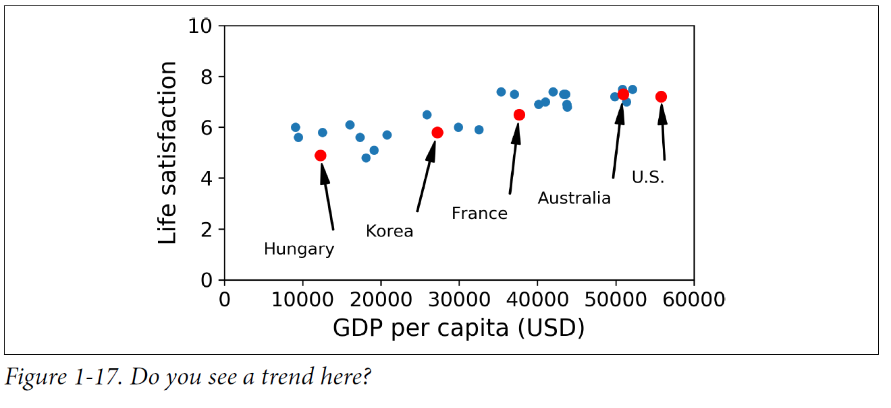

There does seem to be a trend here! Although the data is noisy (i.e., partly random), it looks like life satisfaction goes up more or less linearly as the country’s GDP per capita increases. So, you decide to model life satisfaction as a linear function of GDP per capita. This step is called model selection: you selected a linear model of life satisfaction with just one attribute, GDP per capita.

You feed it your training examples, and it finds the parameters that make the linear model fit best to your data. This is called *training* the model. In our case, the algorithm finds that the optimal parameter values are ***θ*0** = 4.85 and ***θ*1** = 4.91 × 10–5.

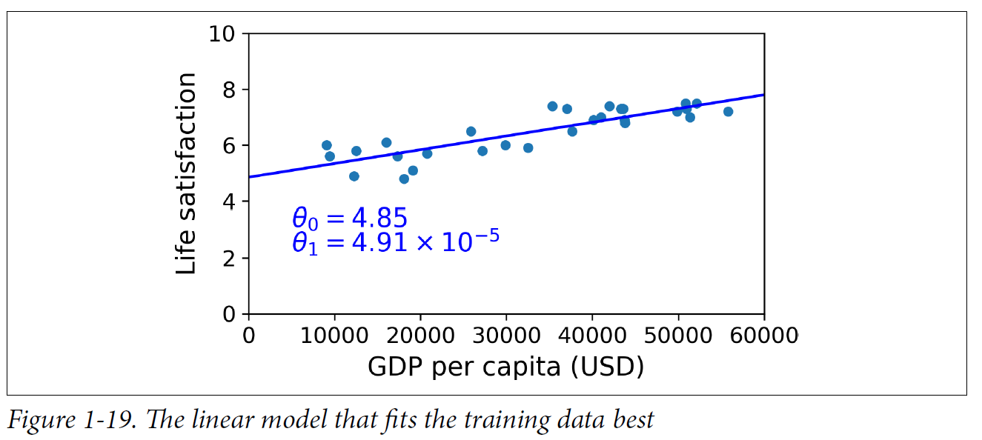

You are finally ready to run the model to make predictions.

**Main Challenges of Machine Learning**

In short, since your main task is to select a learning algorithm and train it on some data, the two things that can go wrong are **“bad algorithm”** and **“bad data.”**

**“BAD DATA”**

* **Insufficient Quantity of Training Data** – For many years researchers have proved thatdata matters more than algorithms for complex problems. Very different Machine Learning algorithms, including fairly simple ones, performed almost identically well on a complex problem of natural language disambiguation once they were given enough data.

* **Nonrepresentative Training Data –** whether you use instance-based learning or model-based learning, in order to generalize well, It is crucial to use a training set that is representative of the (new) cases you want to generalize to. This is often harder than it sounds:
  + if the sample is too small, you will have ***sampling noise*** (i.e., nonrepresentative data as a result of chance),
  + but even very large samples can be non-representative if the sampling method is flawed. This is called ***sampling bias***.
* **Poor-Quality Data –** Obviously, if your training data is full of errors, outliers, and noise (e.g., due to poor quality measurements), it will make it harder for the system to detect the underlying patterns, so your system is less likely to perform well.
  + Most data scientists spend a significant part of their time cleaning up your training data. A couple of examples of when you'd want to clean up training data:
    - If some instances are clearly outliers, it may help to simply discard them or try to fix the errors manually.
    - If some instances are missing a few features (e.g., 5% of your customers did not specify their age), you must decide whether you want to ignore this attribute altogether, ignore these instances, fill in the missing values (e.g., with the median age), or train one model with the feature and one model without it.
* **Irrelevant Features –** Your system will only be capable of learning if the training data contains enough relevant features and not too many irrelevant ones. A critical part of the success of a Machine Learning project is coming up with a good set of features to train on. This process, called *feature engineering*, involves the following steps:
  + *Feature selection* (selecting the most useful features to train on among existing features)
  + *Feature extraction* (combining existing features to produce a more useful one—as we saw earlier, dimensionality reduction algorithms can help)
  + Creating new features by gathering new data

**“BAD ALGORITHM”**

* **Overfitting the Training Data –** Overfitting happens when the model is too complex relative to the amount and noisiness of the training data. Here are some possible solutions.
  + Simplify the model by selecting one with fewer parameters (e.g., a linear model rather than a high-degree polynomial model), by reducing the number of attributes in the training data, or by constraining the model.
  + Gather more training data.
  + Reduce the noise in the training data (e.g., fix data errors and remove outliers).
  + Constraining a model to make it simpler and reduce the risk of overfitting is called *regularization*. The amount of regularization to apply during learning can be controlled by a *hyperparameter*. A hyperparameter is a parameter of a learning algorithm (not of the model). As such, it is not affected by the learning algorithm itself; it must be set prior to training and remains constant during training. If you set the regularization hyperparameter to a very large value, you will get an almost flat model (a slope close to zero); the learning algorithm will almost certainly not overfit the training data, but it will be less likely to find a good solution. Tuning hyperparameters is an important part of building a Machine Learning system (you will see a detailed example in the next chapter).
* **Underfitting the Training Data –***underfitting* is the opposite of overfitting: it occurs when your ***model is too simple to learn the underlying structure of the data***. Rreality is just more complex than the model, so its predictions are bound to be inaccurate, even on the training examples. Here are the main options for fixing this problem:
  + Select a more powerful model, with more parameters.
  + Feed better features to the learning algorithm (feature engineering).
  + Reduce the constraints on the model (e.g., reduce the regularization hyperparameter).

There’s just one last important topic to cover: once you have trained a model, you don’t want to just “hope” it generalizes to new cases. You want to evaluate it and finetune it if necessary. Let’s see how to do that.

**Testing and Validating**

A better option is to split your data into two sets:

* *training set –* you train your model using the training set.
* *test set* – you test it using the test set.

The error rate on new cases is called the *generalization error* (or *out of sample error*), and by evaluating your model on the test set, you get an estimate of this error. This value tells you how well your model will perform on instances it has never seen before. ***If the training error is low (i.e., your model makes few mistakes on the training set), but the generalization error is high, it means that your model is overfitting the training data.***

|  |
| --- |
| It is common to use 80% of the data for training and *hold out* 20% for testing. However, this depends on the size of the dataset: if it contains 10 million instances, then holding out 1% means your test set will contain 100,000 instances, probably more than enough to get a good estimate of the generalization error. |

**Hyperparameter Tuning and Model Selection**

Suppose you are hesitating between two types of models (say, a *linear model* and a *polynomial model*):

* ***How can you decide between them?*** 
  + One option is to train both and compare how well they generalize using the test set.

Now suppose that the linear model generalizes better, but you want to apply some regularization to avoid overfitting.

The question is,

* ***how do you choose the value of the regularization hyperparameter?***
  + One option is to train 100 different models using 100 different values for this hyperparameter.

Suppose you find the best hyperparameter value that produces a model with the lowest generalization error—say, just 5% error. You launch this model into production, but unfortunately it does not perform as well as expected and produces 15% errors.

* ***What just happened?***
  + The problem is that you measured the generalization error multiple times on the test set, and you adapted the model and hyperparameters to produce the best model *for that particular set*. This means that the model is unlikely to perform as well on new data.
* ***Holdout validation*** – is a **common solution** to this problem.
  + You simply hold out part of the training set to evaluate several candidate models and select the best one. The new held-out set is called the *validation set* (or sometimes the *development set*, or *dev set*). More specifically,
    - you train multiple models with various hyperparameters on the reduced training set.
      * (i.e., the full training set minus the validation set), and
    - you select the model that performs best on the validation set.
    - After this holdout validation process,
    - you train the best model on the full training set (including the ***validation set***), and this gives you the final model.
    - Lastly, you evaluate this final model on the ***test set*** to get an estimate of the generalization error.

The Holdout validation solution usually works quite well. However, if the validation set is too small, then model evaluations will be imprecise: ***you may end up selecting a suboptimal model by mistake***.

Conversely, if the validation set is too large, then the remaining training set will be much smaller than the full training set.

* **Why is this bad?**
  + Since the final model will be trained on the full training set, it is not ideal to compare candidate models trained on a much smaller training set. It would be like selecting the fastest sprinter to participate in a marathon.
* **One way to solve this problem** is to perform repeated *cross-validation*, using many small validation sets. Each model is evaluated once per validation set after it is trained on the rest of the data. By averaging out all the evaluations of a model, you get a much more accurate measure of its performance.
  + **There is a drawback**, however: the training time is multiplied by the number of validation sets.

**Data Mismatch**

In some cases, it’s easy to get a large amount of data for training, but this data probably won’t be perfectly representative of the data that will be used in production. For example, suppose you want to create a mobile app to take pictures of flowers and automatically determine their species. You can easily download millions of pictures of flowers on the web, but they won’t be perfectly representative of the pictures that will actually be taken using the app on a mobile device.

Perhaps you only have 10,000 representative pictures (i.e., actually taken with the app). In this case, ***the most important rule to remember is that the validation set and the test set must be as representative as possible of the data you expect to use in production.***

So they should be composed exclusively of representative pictures: You can shuffle the data and put half in the validation set and half in the test set (putting together with web pictures, and making sure that no duplicates or near-duplicates end up in both sets).

But after training your model on the web pictures, if you observe that the performance of the model on the validation set is disappointing, you will not know

* whether this is because your model has overfit the training set, or
* whether this is just due to the mismatch between the web pictures and the mobile app pictures.

One solution is to hold out some of the training pictures (from the web) in yet another set that Andrew Ng calls the ***train-dev set*.**

* After the model is trained (on the *training set*, *not* on the *train-dev set*), you can evaluate it on the *train-dev set*.
* If it performs well, then the model is not overfitting the *training set*.
* If it performs poorly on the *validation set*, the problem must be coming from the data mismatch.
  + You can try to tackle this problem by preprocessing the web images to make them look more like the pictures that will be taken by the mobile app, and then retraining the model.
* Conversely, if the model performs poorly on the *train-dev set*, then it must have overfit the training set, so you should try to simplify or regularize the model, get more training data, and clean up the training data.

**No Free Lunch Theorem**

A model is a ***simplified version*** of the ***observations***. The ***simplifications*** are meant to discard the superfluous details that are unlikely to generalize to new instances.

To decide what data to discard and what data to keep, you must make *assumptions*. For example, a linear model makes the assumption that the data is fundamentally linear and that the distance between the instances and the straight line is just noise, which can safely be ignored.

In a famous 1996 paper[4] David Wolpert demonstrated that if you make absolutely no assumption about the data, then there is no reason to prefer one model over any other. This is called the *No Free Lunch* (NFL) theorem.

For some datasets the best model is a ***linear model***, while for other datasets it is a ***neural network***.

***There is no model that is a priori guaranteed to work better (hence the name of the theorem).***

The only way to know for sure which model is best is to evaluate them all. Since this is not possible, in practice you make some reasonable assumptions about the data and evaluate only a few reasonable models. For example,

* for simple tasks you may evaluate linear models with various levels of regularization, and
* for a complex problem you may evaluate various neural networks.

|  |  |  |  |  |
| --- | --- | --- | --- | --- |
| Machine  Learning | **Learning Type** | Tasks |  |  |
| Supervised | *Classification* | A classification problem is when the output variable is a category, such as “red” or “blue” or “disease” and “no disease”. |  |
| *Regression* | A regression problem is when the output variable is a numeric value, such as “dollars” or “weight”. |  |
| Unsupervised | Clustering |  |  |
| Anomaly detection & Novelty detection |  |  |
| Visualization & Dimensionality reduction |  |  |
| Association rule learning |  |  |
| Semisupervised |  |  |  |
| Reinforcement |  |  |  |

**Exercises**

In this chapter we have covered some of the most important concepts in Machine Learning. In the next chapters we will dive deeper and write more code, but before we do, make sure you know how to answer the following questions:

1. How would you define Machine Learning?
2. Can you name four types of problems where it shines?
3. What is a labelled training set?
4. What are the two most common supervised tasks?
5. Can you name four common unsupervised tasks?
6. What type of Machine Learning algorithm would you use to allow a robot to walk in various unknown terrains?
7. What type of algorithm would you use to segment your customers into multiple groups?
8. Would you frame the problem of spam detection as a supervised learning problem or an unsupervised learning problem?
9. What is an online learning system?
10. What is out-of-core learning?
11. What type of learning algorithm relies on a similarity measure to make predictions?
12. What is the difference between a model parameter and a learning algorithm’s hyperparameter?
13. What do model-based learning algorithms search for? What is the most common strategy they use to succeed? How do they make predictions?
14. Can you name four of the main challenges in Machine Learning?
15. If your model performs great on the training data but generalizes poorly to new instances, what is happening? Can you name three possible solutions?
16. What is a test set, and why would you want to use it?
17. What is the purpose of a validation set?
18. What is the train-dev set, when do you need it, and how do you use it?
19. What can go wrong if you tune hyperparameters using the test set?

1. These criteria are not exclusive; you can combine them in any way you like. For example, a state-of-the-art spam filter may learn on the fly using a deep neural network model trained using examples of spam and ham; this makes it an online, model based, supervised learning system.
2. Some neural network architectures can be unsupervised, such as autoencoders and restricted Boltzmann machines. They can also be semisupervised, such as in deep belief networks and unsupervised pretraining.
3. That’s when the system works perfectly. In practice it often creates a few clusters per person, and sometimes mixes up two people who look alike, so you may need to provide a few labels per person and manually clean up some clusters.
4. David Wolpert, “The Lack of A Priori Distinctions Between Learning Algorithms,” *Neural Computation* 8, no. 7 (1996): 1341–1390.