FA7 - APM1111

This data set, "Horizontal Eye Movements", provides the number of recalled words by two groups of participants - during the retention inverval, one group was isntructed to fixate on a centrally presented dot; the other group was instraucted to execute horizontal saccades. Specifically,

"Participants were presented with a list of neutral study words for a subsequent free recall test. Prior to recall, participants were requested to perform - depending on the experimental condition - either horizontal, vertical, or no eye movements (i.e., looking at a central fixation point). The type of eye movement was thus manipulated between subjects. As the effect of eye movement on episodic memory has been reported to be influenced by handedness, we tested only strong right-handed individuals. The dependent variable of interest was the number of correctly recalled words.'' (Matzke et al, 2015, p. 3)

This data set contains only data from participants assigned to the horizontal and no eye movements condition.

Variables:

*ParticipantNumber* - Participant's identification number.

*Condition* - Experimental condition (Fixed = fixed gaze, Horizontal = horizontal eye movements).

*CriticalRecall* - The number of Recalled words after the memory retrieval task.

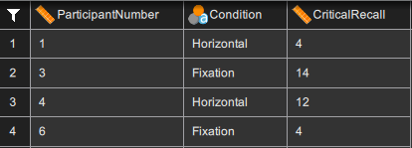

*Screenshot of the first four rows of the Horizontal Eye Movements data*

Independent Samples T-Test:

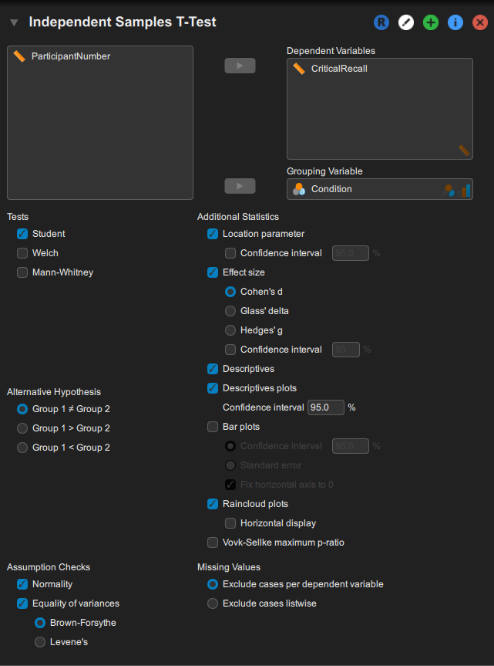

*Screenshot of the JASP input panel for the analysis of the Horizonal Eye Movements data (Matzke et al. 2015) using independent samples t-test.*

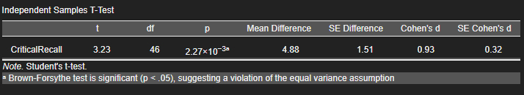*JASP output for the Horizontal Eye Movements data (Matzke et al. 2015): independent samples t-test and descriptive.*

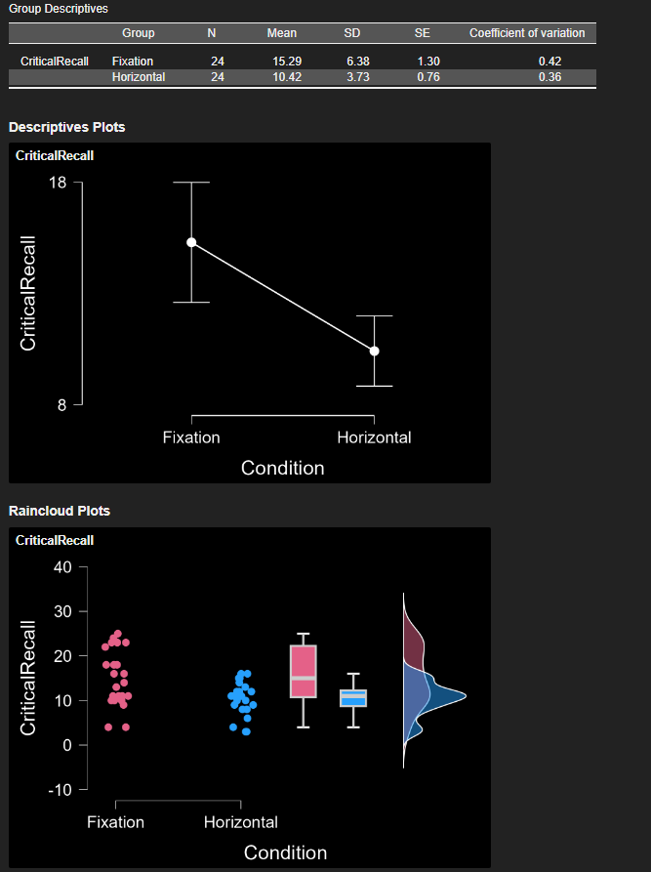

*The descriptive plot of the sample means with 95% credible intervals.*