|  |  |  |
| --- | --- | --- |
| **Name:** Krestel Ann P. Esplana |  | **Course:** SDF 104 |
| **Program:** BS Computer Science III |  | **Quarter:** Preliminary |

**I.** Basic programming problems or exercises in arithmetic operations, input/output, data manipulation, and variable manipulation. (Part 1)

1. Write a program that prompts the user to input a value in feet and then displays its equivalent in centimeters using the conversion factor 1 ft. = 30.48 cm.

Code:



Output:

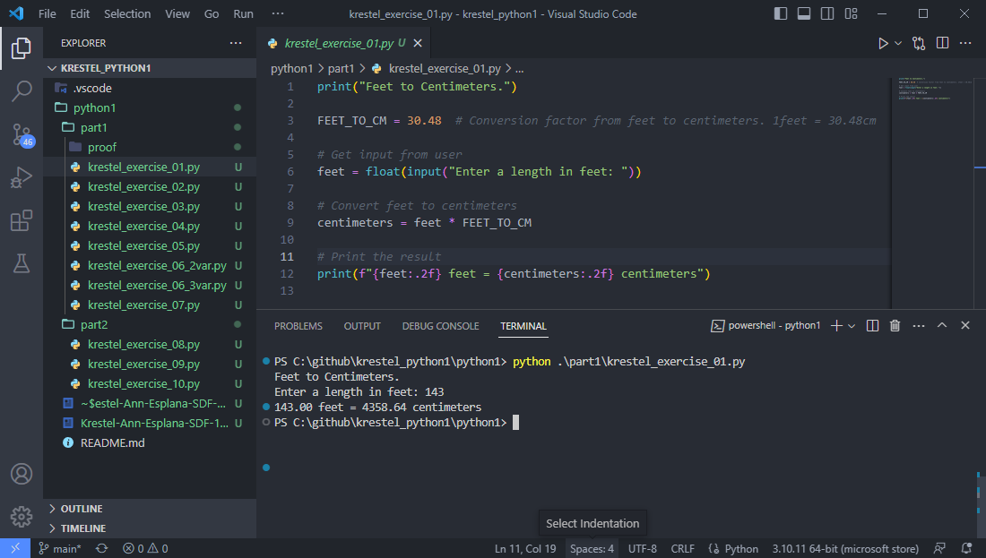

1. Create a program that accepts a Fahrenheit temperature value from the user and converts it to Celsius using the formula C = (9/5) * (F - 32).

Code:

  
Output:

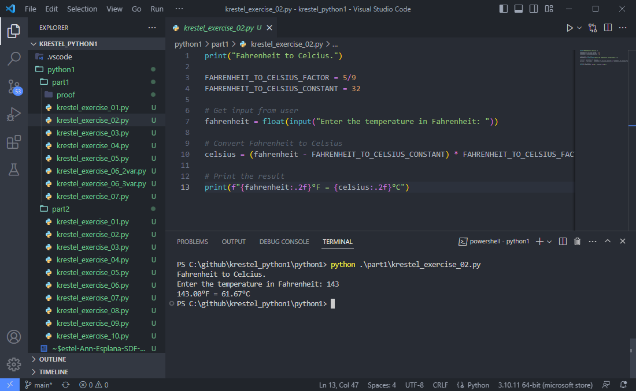

1. Develop a program that reads the length and width of a rectangle from the user, calculates its area using the formula A = L * W, and then displays the result.

Code:

  
Output:

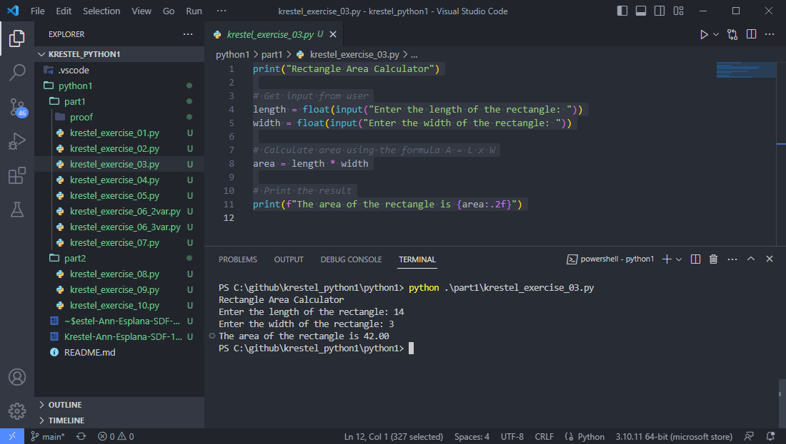

1. Build a program that prompts the user to enter two numbers, computes and displays their sum, difference, product, and quotient.

Code:

  
Output:

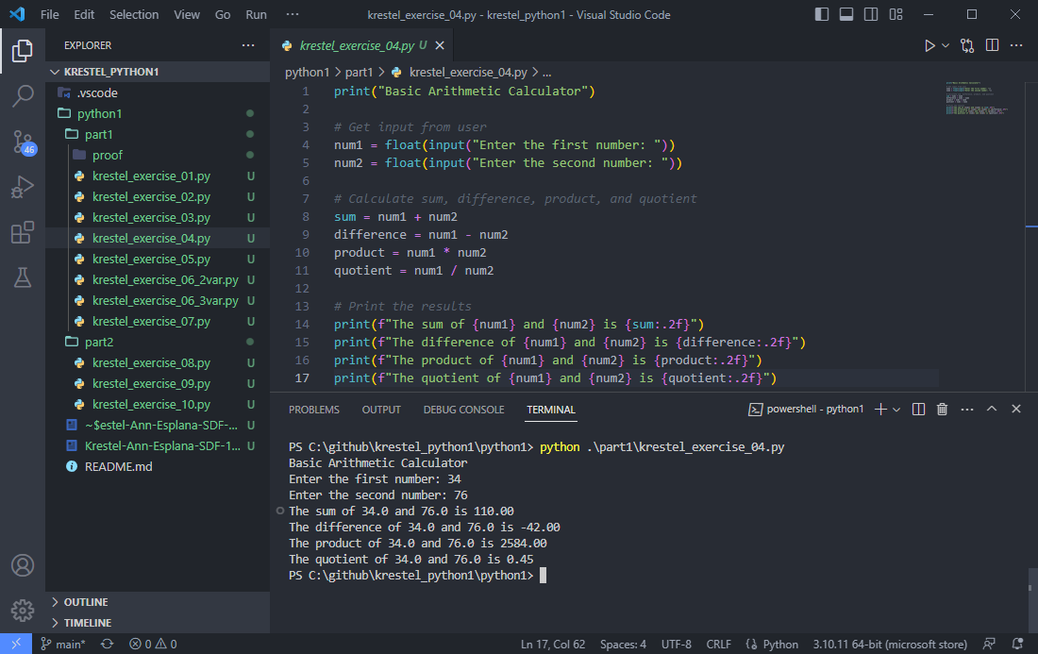

1. Write a program that accepts four input numbers as grades, calculates their average, and displays the result.

Code:

  
Output:

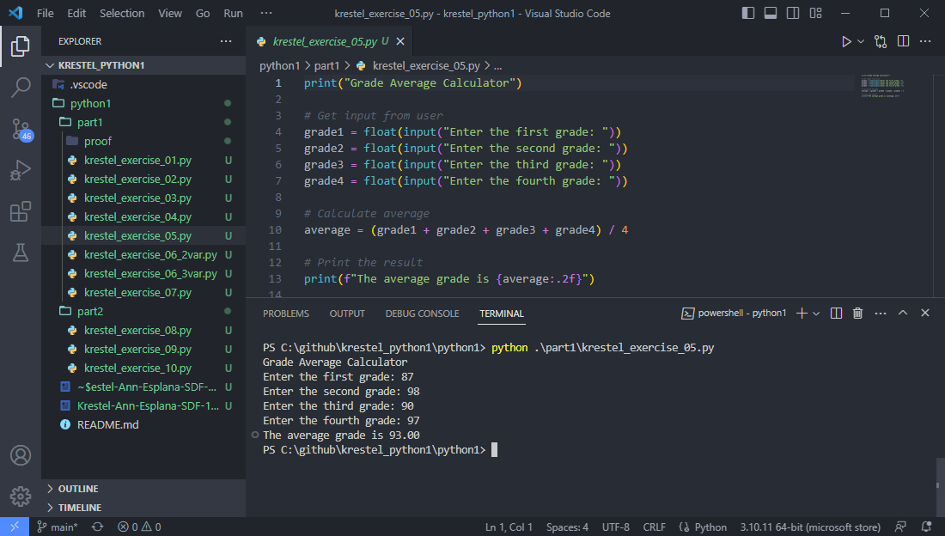

1. Implement a program that swaps the values of two variables x and y, such that the value of x becomes the value of y and vice versa.
   1. Using 3 Variables

Code:

  
Output:

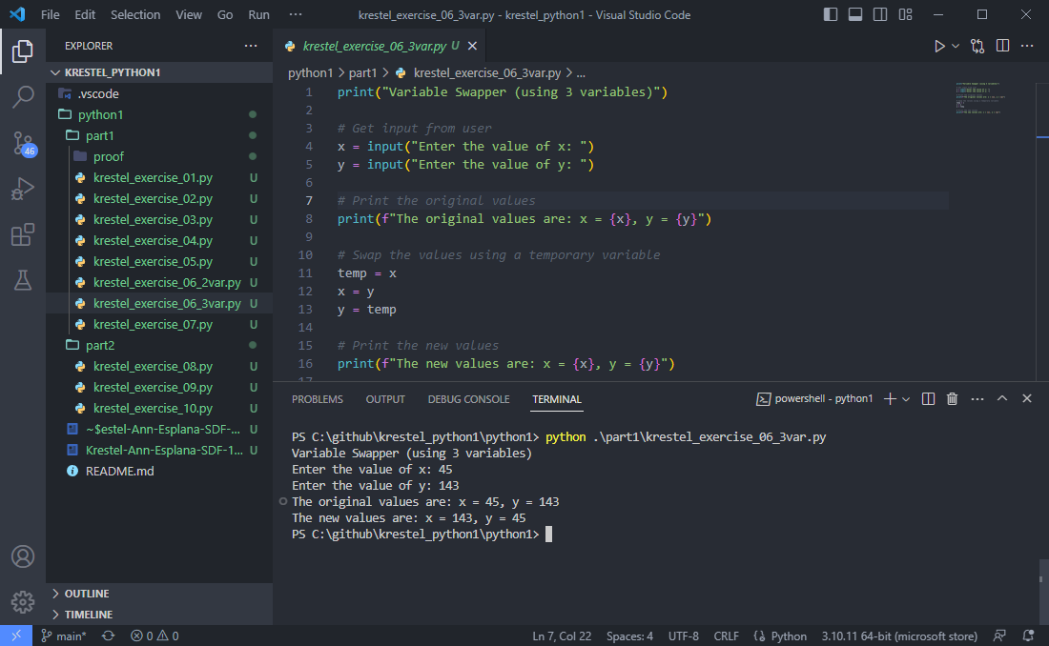

1. Implement a program that swaps the values of two variables x and y, such that the value of x becomes the value of y and vice versa.
   1. Using 2 Variables

Code:

  
Output:

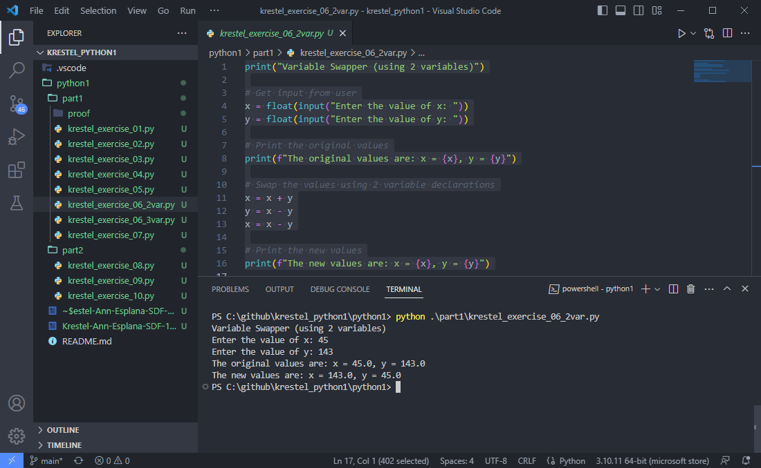

1. Develop a program that takes as inputs the purchase price of an item (P), its expected number of years of service (Y), and its expected salvage value (S), and then calculates and outputs the yearly depreciation for the item using the formula D = (P - S)/Y.

Code:

  
Output:

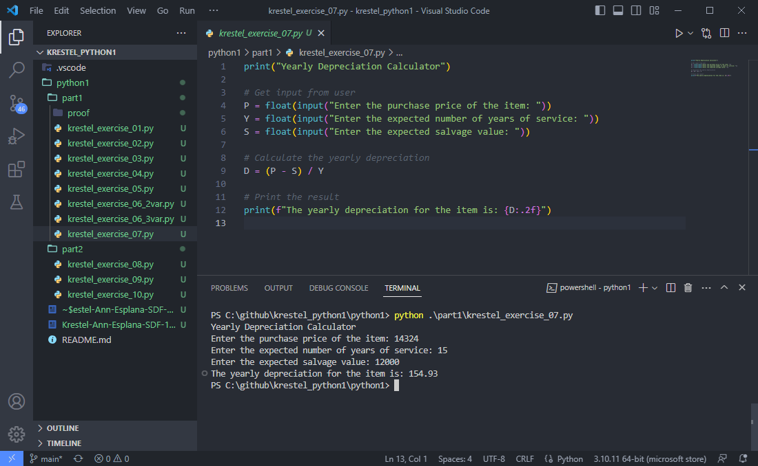

**II.** Basic programming problems or exercises in arithmetic operations, input/output, data manipulation, and variable manipulation. (Part 2)

1. Create a program that identifies whether a given letter is a vowel or consonant, regardless of its case.

Code:



Output:

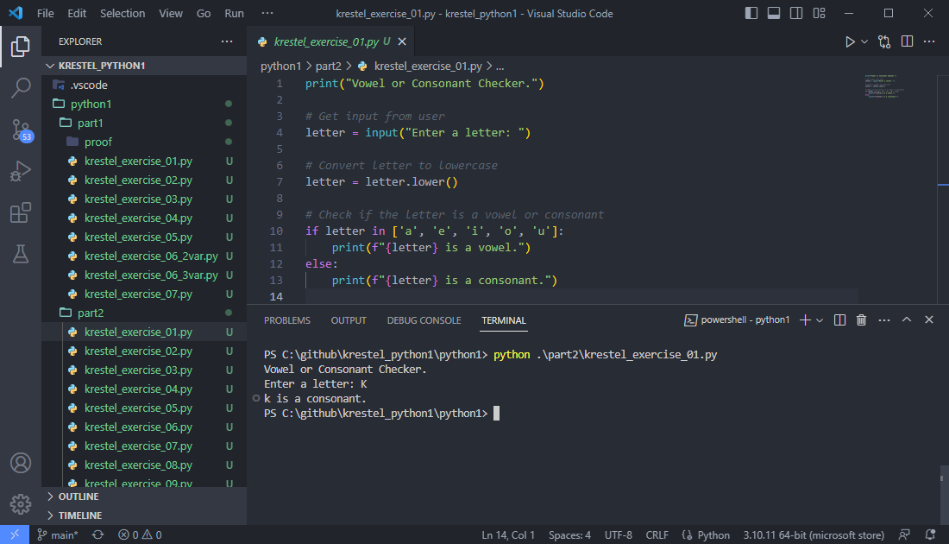

1. Write a program that takes numerical dates as input and outputs the complete form of the date.

Code:



Output:

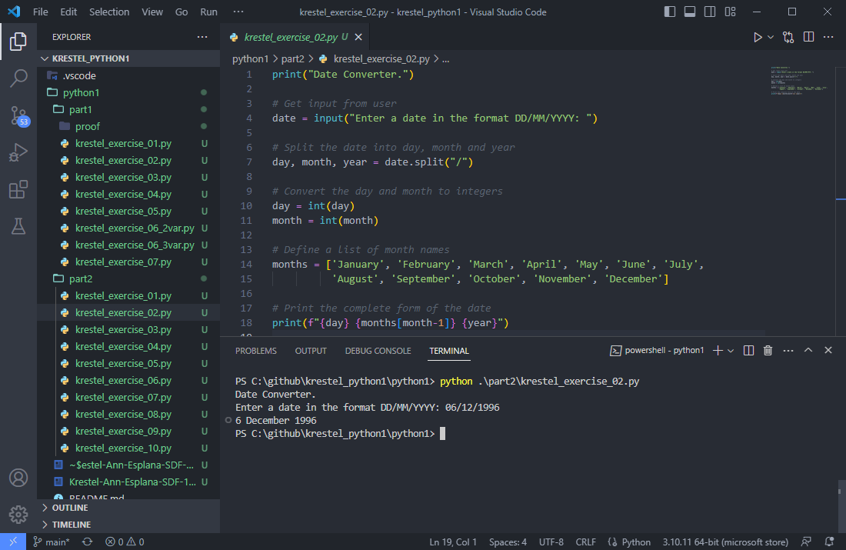

1. Create a program that checks the value of a variable called "temp" and displays a message based on its value.

Code:



Output:

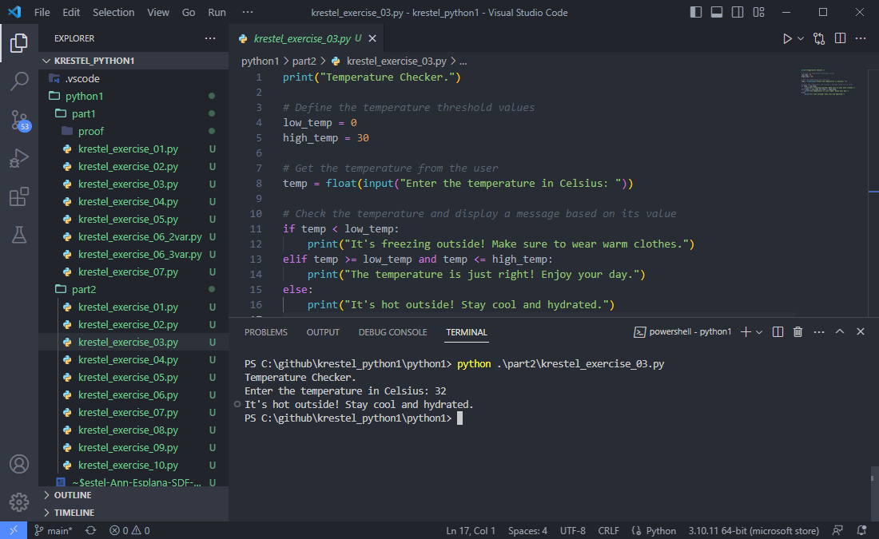

1. Design a program for the Aircraft Force that determines if a given aircraft is military or civilian, based on its observed speed in km/h and estimated length in meters.

Code:



Output:

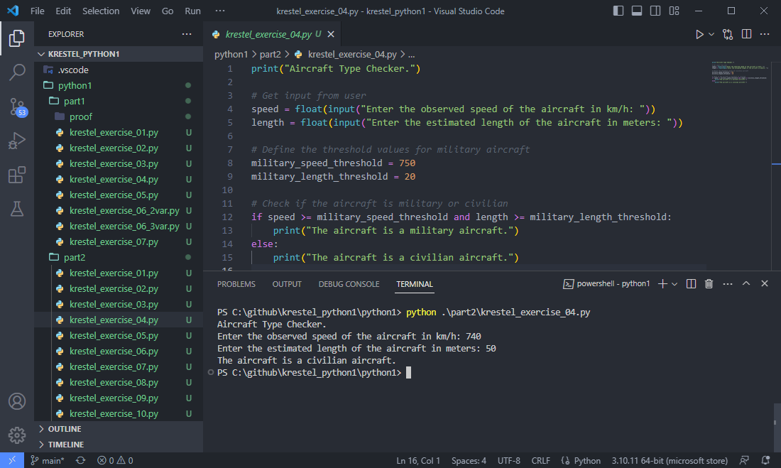

1. Write a program that identifies the class of a ship based on its class ID.

Code:



Output:

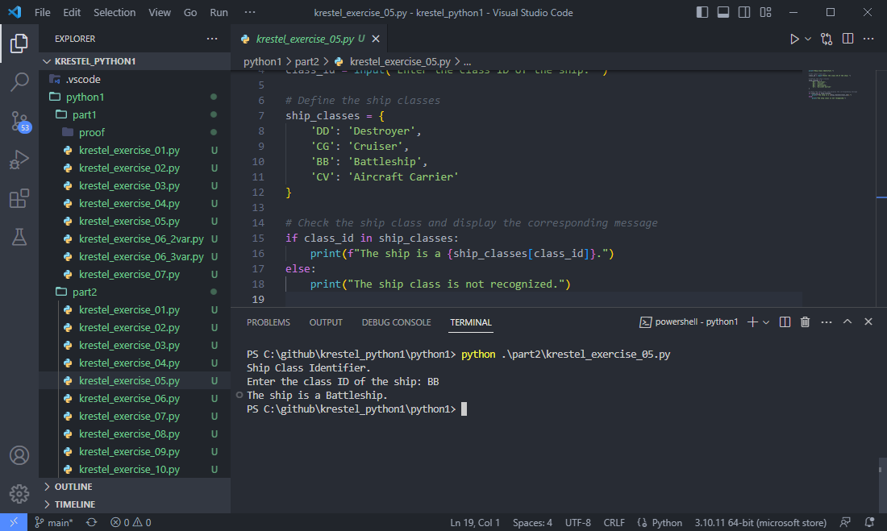

1. The National Earthquake Information Center has a set of criteria for determining earthquake damage. Create a program that follows these criteria to determine the extent of damage.

Code:



Output:

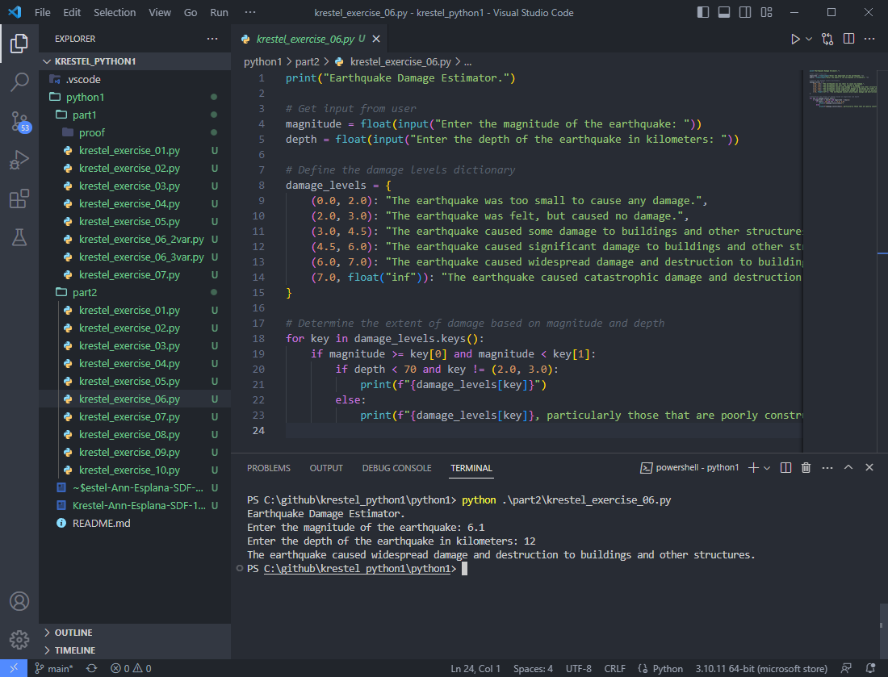

1. Develop a program that takes a number as input and outputs its word form.

Code:





Output:

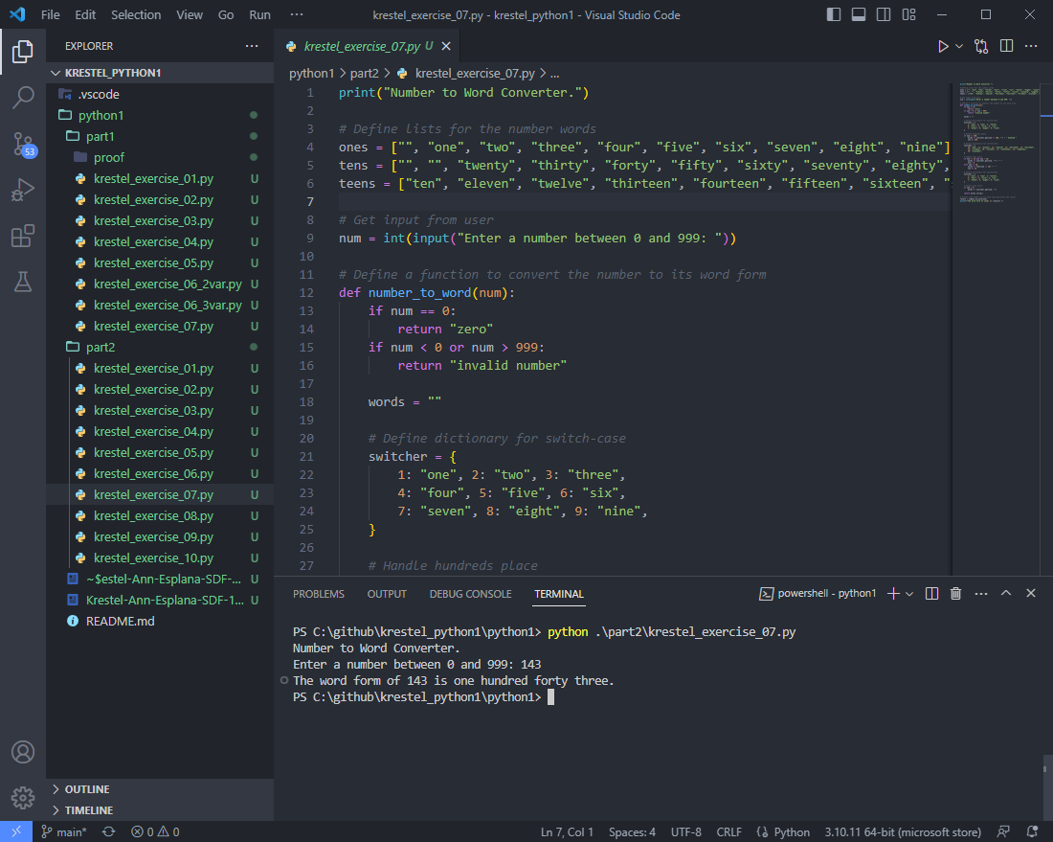

1. Write a program that converts a given ordinary number into its equivalent Roman numeral.

Code:



Output:

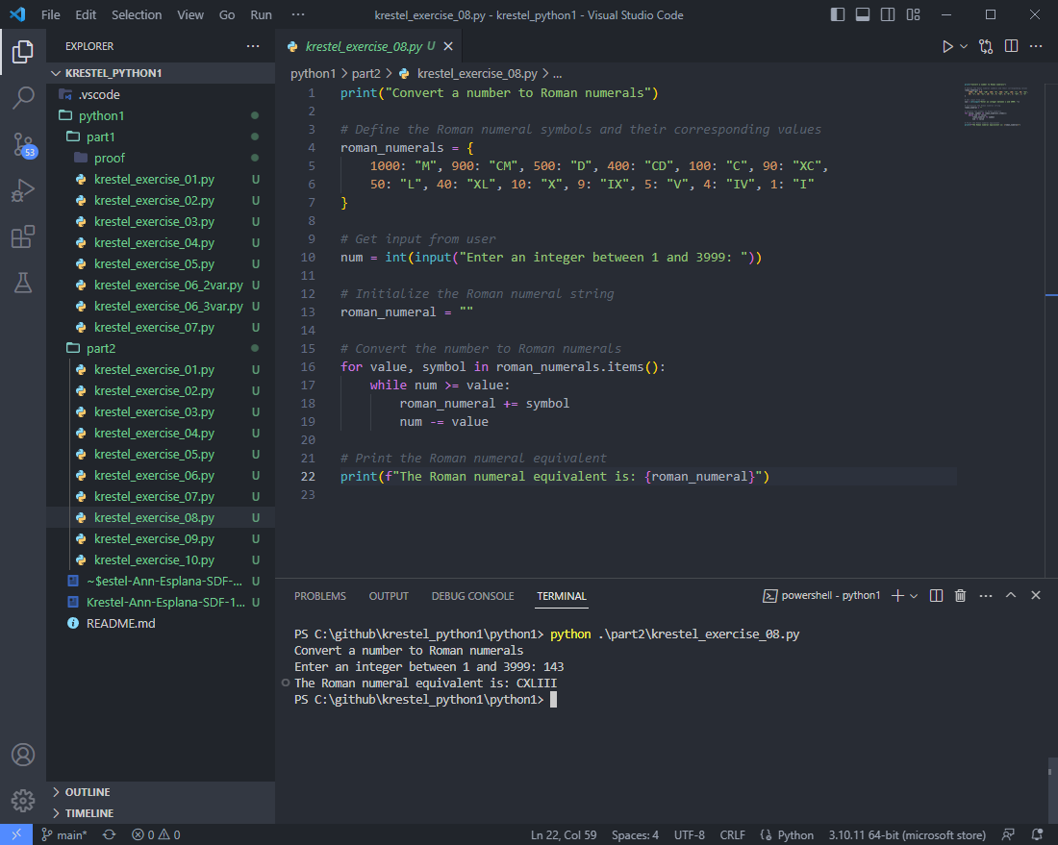

1. Create a program that computes and evaluates the tuition fee for a single trimester based on the chosen mode of payment.

Code:



Output:

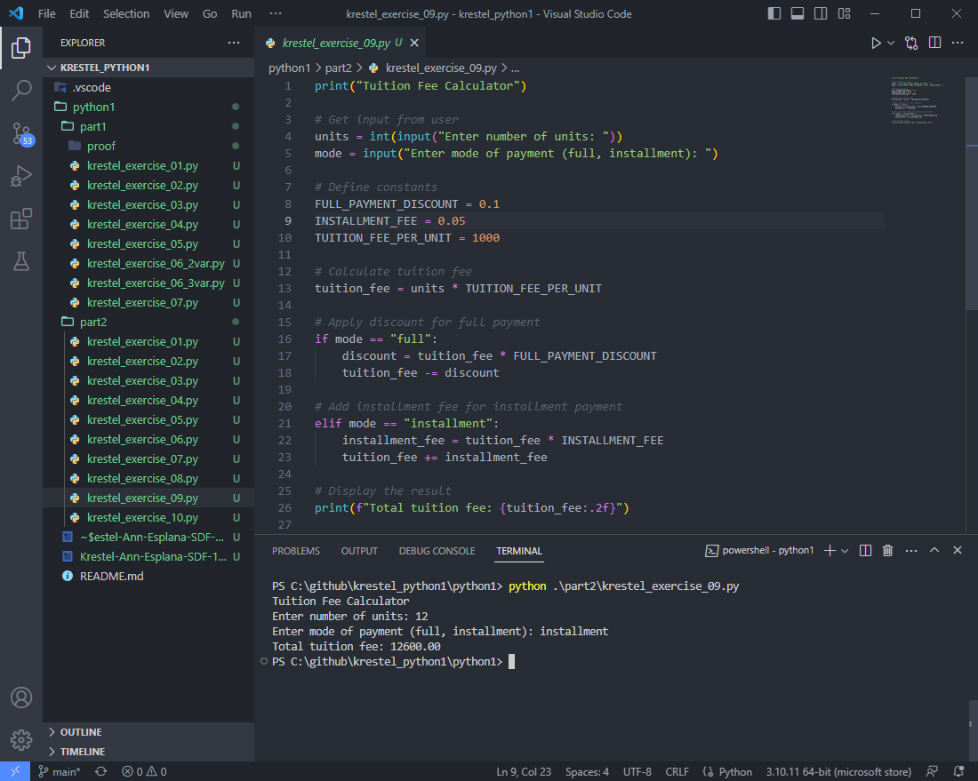

1. Design a program that takes a percentile grade as input and outputs its equivalent letter grade based on a predetermined range.

Code:



Output:

