A Compact Thermo-Optic Fault Detection Framework
for Silicon Microring Resonators
Dimitar Kretski
Center for Hydro- and Aerodynamics (CHA), Varna, Bulgaria
ORCID: 0000-0001-5108-2243

Abstract
We present a compact thermo-optic fault detection framework for silicon microring resonators comprising a physics-based first-order thermal model, a realistic colored-noise simulation (Gaussian + 1/f + random-walk drift), and a Monte Carlo evaluation methodology that compares detectors through full Delay–False Alarm Rate (FAR) operating frontiers rather than isolated operating points. Three structurally distinct detection strategies are evaluated: fixed threshold, CUSUM, and the W-formula safety layer W(t) = Q(t)·D(t) − T(t). Under N = 200 Monte Carlo trials per configuration, CUSUM consistently improves upon the fixed-threshold detector. Within the evaluated operating range, the W-formula detector achieves shorter detection delays at the cost of higher FAR, occupying a distinct region of the Delay–FAR space. A robustness sweep across six noise configurations shows that the relative ranking of the detectors did not change across the investigated conditions. No claim of optimality is made; several established methods — including BOCPD, Shiryaev–Roberts, and recursive GLR — were not evaluated. All results are simulation-based; experimental validation is identified as the essential next step.

I. Introduction
Silicon photonic microring resonators are core components of optical transceivers, sensing systems, and wavelength-division multiplexed (WDM) links. Their resonance wavelength shifts at approximately 70–80 pm/°C due to the thermo-optic effect, making them sensitive to thermal disturbances and susceptible to failure of thermal management components such as thermo-electric coolers (TEC).
Early detection of thermal faults directly limits the consequences of degradation: a faster alarm reduces thermal overshoot, shortens recovery time, and prevents resonance excursion beyond the tracking range of an active controller. The detection delay is therefore a first-order quality metric — yet it must be balanced against the false alarm rate (FAR), because spurious alarms disrupt system operation.
Prior comparative studies typically evaluate detectors at a single operating point, making it difficult to distinguish between a fundamentally superior detector and one that is simply better-tuned. We address this by sweeping each detector's decision threshold to obtain a full operating frontier in Delay–FAR space, following a methodology adapted from sequential detection theory [5].
This paper contributes: (1) a parameterised compact thermo-optic model with explicit provenance annotations; (2) a realistic colored-noise simulation; (3) operating frontier evaluation of three structurally distinct detectors; and (4) adaptation of the deterministic W-formula safety layer [2] — originally a domain-independent health metric — to thermo-optic monitoring, with analysis of its Delay–FAR trade-off and robustness across noise conditions.

II. Thermo-Optic Compact Model
The resonance wavelength shift is modelled as Δλ = k(T)·(T − T_{amb}), with k(T) = k₀ + (dk/dT)·(T − T_{ref}). Thermal dynamics follow a first-order RC model:
Cth · dT/dt = P_{diss} − (T − T_{amb}) / R_{th}
R_th and C_th are derived from the heater efficiency and thermal time constant. The heater response supports arbitrary polynomial order. A calibration function accepts measured (power, wavelength-shift) pairs and returns R², RMSE, degrees of freedom, and per-parameter standard errors.

Table I. Model parameters and provenance.
Parameter | Value | Unit | Provenance
k₀ | 72.9 | pm/°C | Literature [3]
dk/dT | 0.0 | pm/°C² | Estimated (no lit. value found)
Heater eff. | 100.0 | pm/mW | Literature range [3]
τ_th | 7 × 10⁻⁶ | s | Literature [4]
σ_Gaussian | 2.0 | pm | Estimated
σ_pink | 1.0 | pm | Estimated
σ_drift | 0.5 | pm/√s | Estimated

III. Noise Model and Simulation
Each trial simulates a total time of 2.5 × fault_onset at 70 ns resolution (τ_th / 100). A fault is introduced as a ramp in thermal resistance over 20 µs followed by a sustained step, parameterised by a multiplier on R_th. The baseline noise model superimposes: (i) white Gaussian noise (σ = 2 pm), (ii) 1/f pink noise via the Voss–McCartney algorithm (amplitude 1 pm), and (iii) a random-walk drift (0.5 pm/√s). The drift term is the principal driver of false alarms for fixed-threshold detectors.

IV. Detector Formulations

A. Fixed Threshold
Alarm when r(t) = T_implied(t) − T_model(t) exceeds µ_pre + m·σ_pre. Multiplier m swept over {3, 4, 5, 6, 7, 8, 10}.

B. CUSUM
S_i = max(0, S_{i−1} + (r_i − µ_pre) − k), alarm when S_i > h. Fixed k_σ = 2.0; h_σ swept over {2, 3, 4, 5, 6, 7, 8, 10, 15}. CUSUM is asymptotically optimal under i.i.d. Gaussian residuals (Lorden 1971 [1]).

C. W-Formula Safety Layer
The W-formula W = Q·D − T was originally proposed in [2] as a domain-independent adaptive health metric. The two detectors belong to different mathematical classes: CUSUM linearly accumulates signed deviations of r(t); W(t) is a nonlinear function of drive power, model fidelity, and cumulative thermal stress. They are not algebraic reformulations of one another. The domain-specific variable redefinitions for thermo-optic monitoring are:
Q(t) = P_diss(t)/mean(P_diss) [normalised drive power]
D(t) = exp(−|r(t)|/σ_pre) [model fidelity, ∈ (0,1]]
T(t) = ∫|r|dt/(σ_pre·T_window) [cumulative thermal stress]
Alarm when W(t) < w_thresh, where w_thresh is set at the p-th percentile of the pre-fault W trace computed on each trial independently — making the threshold adaptive to the noise level of that trial. Percentile p swept over {0.01%, 0.05%, 0.1%, 0.25%, 0.5%, 1%, 2%, 5%, 10%}. The minimum achievable FAR (~3.5 × 10⁻⁴) reflects the noise correlation structure under this calibration strategy.

V. Results

A. Operating Frontiers (fault ×2.2)
Fig. 1 shows the Delay–FAR operating frontier for all three detectors (N = 200 trials per threshold, 95% bootstrap CI on delay, shaded bands).
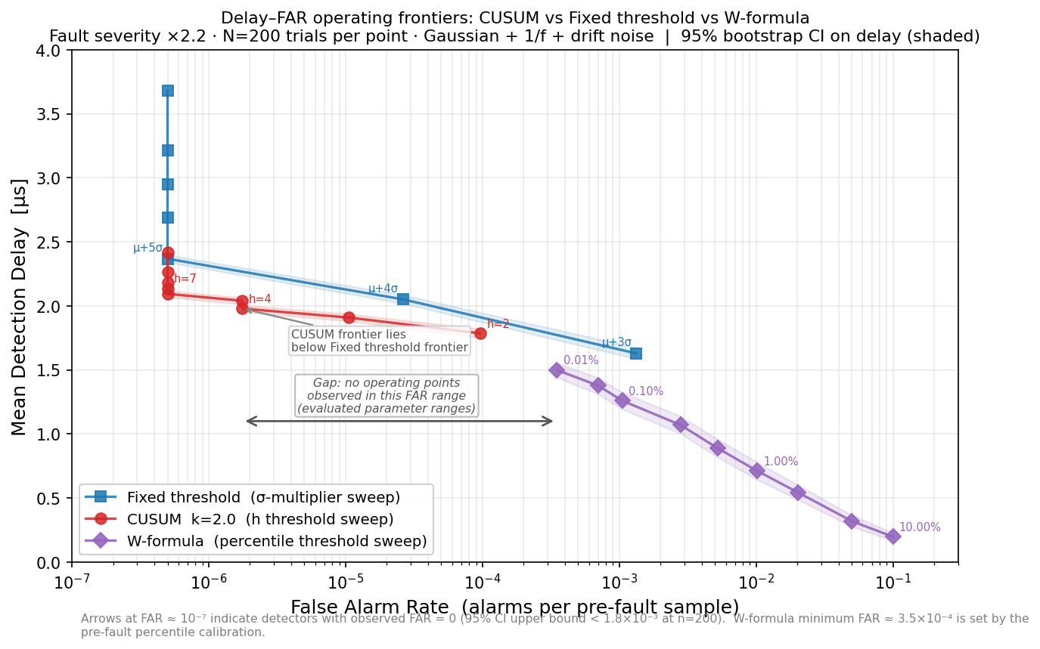
Fig. 1. Delay–FAR operating frontiers. Fault ×2.2, N=200 trials per point. Lower-left is better.
Table II. Summary of operating frontier results (fault ×2.2).
Detector | Best delay | Lowest FAR | Note
Fixed µ+3σ | 1.63 µs | 1.3 × 10⁻³ | Fastest; highest FAR
Fixed µ+5σ | 2.37 µs | 0 (< 1.8 × 10⁻³) | Canonical zero-FAR point
CUSUM h=2 | 1.79 µs | 9.6 × 10⁻⁵ | Fastest CUSUM
CUSUM h=6 | 2.09 µs | 0 (< 1.8 × 10⁻³) | Canonical zero-FAR point
W-form. 10%ile | 0.20 µs | 0.10 | Fastest; FAR impractical
W-form. 0.01%ile | 1.50 µs | 3.5 × 10⁻⁴ | Most conservative W setting

Within the evaluated operating range, CUSUM consistently achieves shorter detection delay than the fixed-threshold detector at comparable FAR (7–17% improvement at matched FAR). The W-formula frontier occupies a distinct region of the Delay–FAR space. Within the evaluated parameter ranges, no operating points were observed between 10⁻⁶ and 3.5 × 10⁻⁴ FAR. At its most conservative threshold (FAR ≈ 3.5 × 10⁻⁴), W-formula achieves 1.50 µs — shorter than any evaluated CUSUM or fixed-threshold point with FAR ≤ 10⁻⁴.

B. Fault Severity Dependence
All detectors achieve Pd = 1.000 for R_th multipliers ≥ 1.1, confirming robust detection of faults as small as 10% increase in thermal resistance. Detection delay decreases monotonically with increasing fault severity across all detectors.
Table III. Detection delay [µs] by fault severity, 95% bootstrap CI. Pd = 1.000 for all.
R_th mult. | Fixed µ+5σ | CUSUM k=2, h=6 | W-form. 0.01%ile
×1.1 | 8.09 [7.99, 8.18] | 6.66 [6.57, 6.75] | —
×1.2 | 5.63 [5.56, 5.70] | 4.66 [4.60, 4.72] | —
×1.5 | 3.58 [3.53, 3.63] | 3.07 [3.03, 3.11] | —
×2.0 | 2.58 [2.54, 2.61] | 2.25 [2.22, 2.28] | —
×2.2 | 2.37 [2.34, 2.40] | 2.09 [2.07, 2.12] | 1.50 [1.44, 1.55]
— W-formula severity sweep reserved for future work.

C. Robustness Across Noise Configurations
Experimental design. The robustness sweep varies one noise parameter at a time from the baseline (σ_Gaussian = 2 pm, σ_pink = 1 pm, σ_drift = 0.5 pm/√s, τ_th = 7 µs, fault onset = 200 µs). For each configuration, N = 200 trials are run. The W-formula threshold is set adaptively as the 0.01st percentile of the pre-fault W trace computed per trial — so the threshold recalibrates to the noise level of each configuration automatically. CUSUM uses fixed k_σ = 2.0, h_σ = 6.0; Fixed uses µ+5σ. No parameter retuning was performed for any detector.
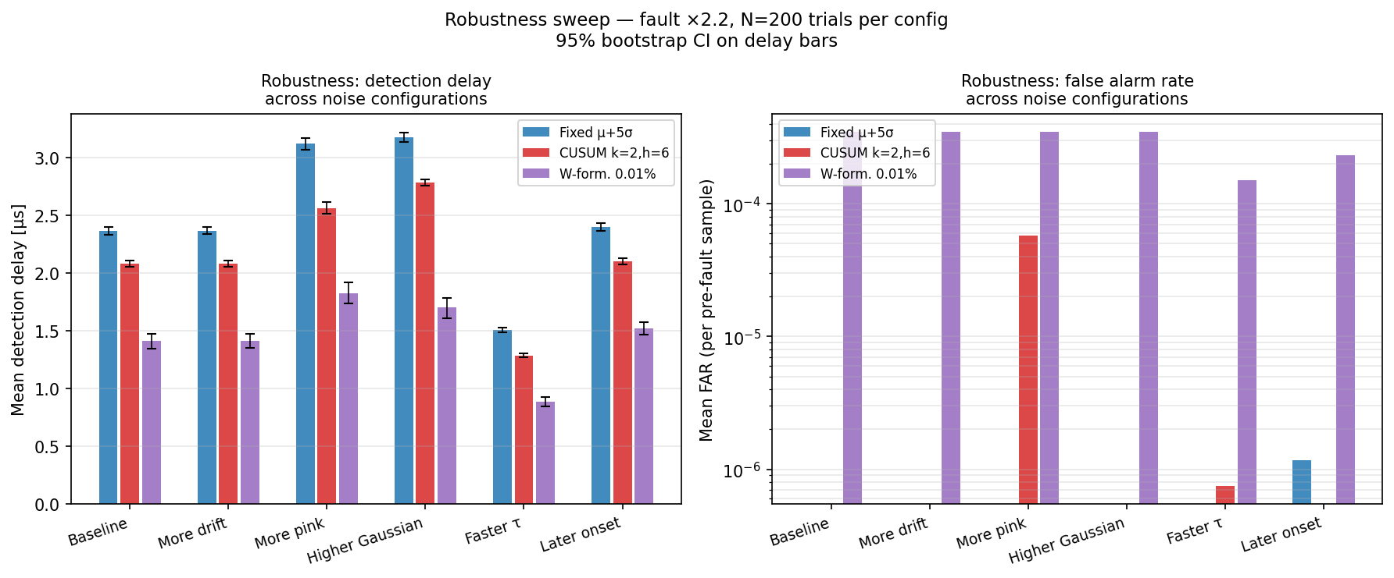
Fig. 2. Robustness sweep: mean detection delay and FAR across six noise configurations (N=200 trials each, 95% CI on delay bars).
Table IV. Detector ranking by detection delay across noise configurations.
Noise configuration | 1st (fastest) | 2nd | 3rd | W-FAR
Baseline | W (1.41 µs) | CUSUM (2.08 µs) | Fixed (2.36 µs) | 3.5 × 10⁻⁴
More drift (×4) | W (1.41 µs) | CUSUM (2.08 µs) | Fixed (2.37 µs) | 3.5 × 10⁻⁴
More pink (×3) | W (1.82 µs) | CUSUM (2.56 µs) | Fixed (3.12 µs) | 3.5 × 10⁻⁴
Higher σ (×2) | W (1.70 µs) | CUSUM (2.78 µs) | Fixed (3.18 µs) | 3.5 × 10⁻⁴
Faster τ (3 µs) | W (0.88 µs) | CUSUM (1.28 µs) | Fixed (1.50 µs) | 1.5 × 10⁻⁴
Later onset | W (1.52 µs) | CUSUM (2.10 µs) | Fixed (2.40 µs) | 2.3 × 10⁻⁴

Within the investigated noise configurations, the relative ranking of the evaluated detectors did not change: W-formula achieved the shortest detection delay in all six cases, followed by CUSUM, followed by Fixed threshold. The W-formula FAR, within the investigated configurations, remained in the range 1.5 × 10⁻⁴ to 3.5 × 10⁻⁴, reflecting the adaptive per-trial calibration that scales the threshold to the pre-fault noise level. This robustness property is partly a consequence of the adaptive calibration strategy and should not be generalised beyond the evaluated conditions.

VI. Discussion
Structural distinctness of W and CUSUM. The two detectors belong to different mathematical classes. CUSUM linearly accumulates signed deviations of the residual r(t) and is asymptotically optimal under i.i.d. Gaussian noise. W(t) = Q(t)·D(t) − T(t) is a nonlinear function of drive power, an exponential model-fidelity term, and cumulative thermal stress. The detectors are not algebraic reformulations of one another; no algebraic transformation W = f(CUSUM) or CUSUM = g(W) is known. A formal proof of non-equivalence in the measure-theoretic sense is beyond the scope of this paper.
CUSUM vs Fixed threshold. The consistent improvement of CUSUM confirms that sequential evidence accumulation is beneficial even under colored noise. The improvement is modest (7–17% in delay at matched FAR) because the 1/f and drift components are non-stationary, partially degrading CUSUM's advantage relative to purely Gaussian conditions.
W-formula operating region and adaptive calibration. The W-formula is not a direct replacement for CUSUM: it achieves shorter delays but at higher FAR. Its threshold is calibrated per trial from the pre-fault W trace, which means the FAR is partly determined by the noise correlation structure rather than a fixed design parameter. The robustness of the relative ranking across noise configurations is partly attributable to this adaptive calibration.
Scope of comparisons and optimality. No claim of optimality is made for any evaluated detector. Several established sequential change-point methods — including Bayesian Online Changepoint Detection (BOCPD), Shiryaev–Roberts, recursive GLR, EWMA, and Kalman innovation monitors — were not evaluated in this study. Future work should include these methods to obtain a more complete picture of the achievable Delay–FAR trade-off.
Limitations. All results are simulation-based; the model is calibrated to literature values, not measured device data. FAR = 0 entries carry an upper bound of 1.8 × 10⁻³ at N = 200. W-formula FAR stability is reported within the investigated conditions only.

VII. Conclusion
We have presented a compact thermo-optic fault detection framework for silicon microring resonators. By sweeping detector thresholds to obtain full Delay–FAR operating frontiers, we demonstrate that CUSUM improves upon fixed-threshold detection consistently within the evaluated operating range, while the W-formula safety layer extends the observable frontier toward shorter detection delays. A robustness sweep across six noise configurations shows that the relative ranking of the three detectors did not change across the investigated conditions. The presented framework provides a reproducible benchmark for future experimental studies and for comparison with additional detection methods not evaluated here.

References
[1] E. S. Page, "Continuous inspection schemes," Biometrika, vol. 41, pp. 100–115, 1954.
[2] D. Kretski, "ORAC-NT Embedded Framework," Zenodo, DOI: 10.5281/zenodo.19553825, 2025.
[3] A. Bahadori et al., "Thermal Heterogeneous Integration of Silicon Photonics," J. Lightwave Technol., vol. 36, pp. 3919–3930, 2018.
[4] W. Sun, R. Wang, J. Li, H. Zhang, Z. Jia, and Q. Li, "Integrated microheater on the 4H-silicon-carbide-on-insulator platform and its applications," arXiv:2506.15035, 2025.
[5] H. V. Poor and O. Hadjiliadis, Quickest Detection. Cambridge University Press, 2009.

