**10 Breathtaking Waterfalls in the World**

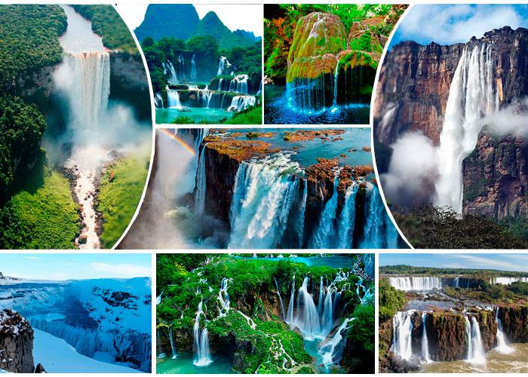

The world of nature is intriguing, energising and full of amazements. Several studies have shown that being in nature makes us happier, more productive and reduces our stress too. But, when it comes to Nature’s spectacles, nothing beats waterfalls.

Waterfalls are mesmerising, breathtaking and simply adorable. The beauty of the waterfalls often captures our imagination. The water running down the hills, the greenery and the picturesque landscape are quite thrilling

Here we look at some of the most breathtaking waterfalls in the world.

**1.Niagara Falls, USA & Canada**

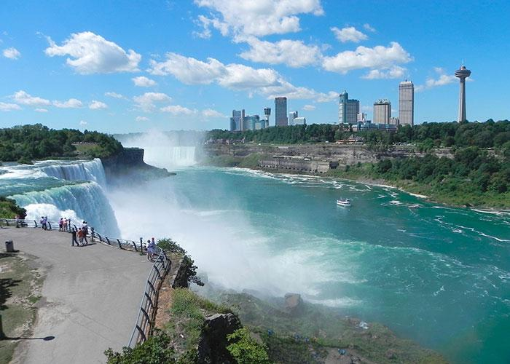

Niagara Falls, easily the first one that comes to mind when you talk about waterfalls. Niagara Falls is a collective name for the three waterfalls that lie on the border of USA and Canada.

Certainly, among the most beautiful waterfalls in the world. The Niagara Falls have the highest flow rate in the whole of North America and have a drop of more than 50 meters.  
  
Niagara is a famous waterfall throughout the world. It is one of the top attractions in both USA and Canada.

It is one of the most wondrous destinations in Eastern Canada and in North America. Millions of tourists visit the Niagara Falls every year.  
  
The misty cruise across the waters near the waterfall is a magnificent & fun experience.

**2. Iguazu Falls, Brazil & Argentina**

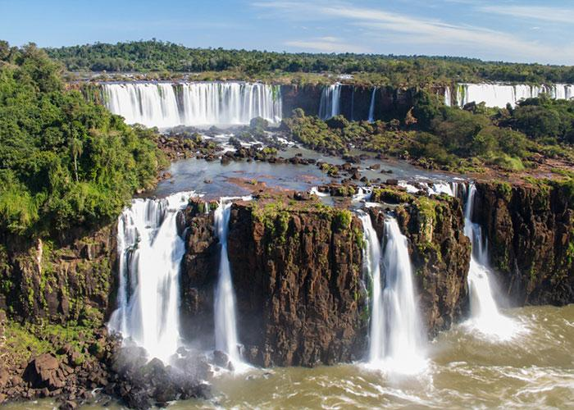

The waterfall is located on the border of Brazil and Argentina.

This waterfall is made up of 275 waterfalls, spreading across the width of almost 2 miles. The fall has a height of 82M and width of 2700M.  
  
The falls are the largest waterfalls in the world. Most of the waterfall lies on the Argentina side, there are some falling in Brazil too.   
  
An intriuging story around the waterfall is that the deity wanted to marry a woman, Naipi, who eloped with her mortal lover Taroba in a canoe. The deity sliced the river and created the waterfalls in a mad rush of anger subjecting the lovers to the eternal fall.

**3. Angel Falls, Venezuela**

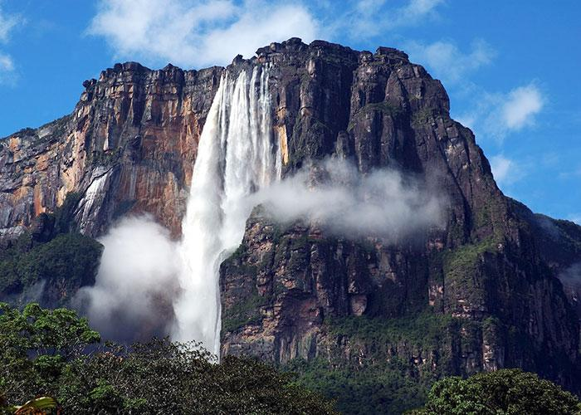

Angel Falls is located in the Venezuelan jungle in Canaima National Park. The fall has a height of 979 m. The waterfall is named after the Jimmie Angel. He was an American aviator who discovered the waterfall in 1938.   
  
The fall is so high that water evaporates before it hits the ground. Angel Falls is the tallest waterfall in the world.  
  
The wildlife, nature and exquisite scenery of Canaima National park where the fall is located are a sight for the Gods.

**4. Victoria Falls, Zimbabwe & Zambia**

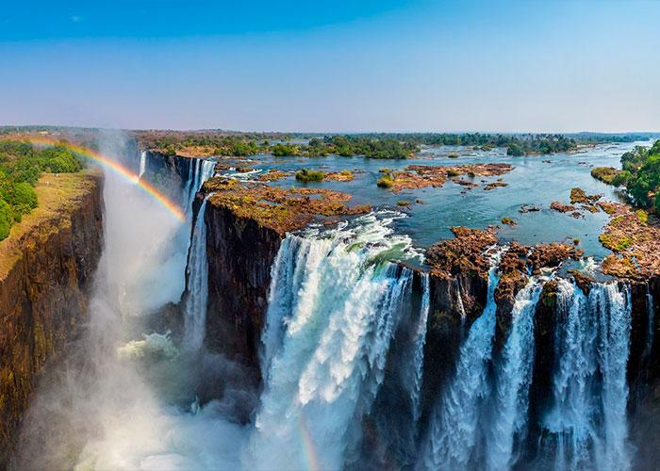

Victoria Falls is as beautiful as things can get. No wonder, it is among the seven natural wonders of the world.

It has a height of 108 m. It has a combined width of 1708 m. It is regarded as the largest waterfall in terms of sheet of falling water. It is among the

most beautiful places to visit for a nature lover.   
  
The fall is named after the reigning Queen Victoria. The waterfall is equipped with a pool where visitors can swim. The water spray from Victoria can be seen from a whopping distance of 50 km.

**5.Plitvice Falls, Croatia**

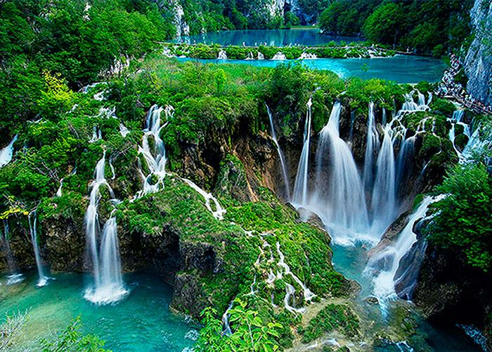

The fall is located in the Plitvice Lakes National Park of Croatia. The park is among the oldest in Croatia and has a very picturesque landscape. The waterfall is not very tall, but has beautiful surroundings.  
  
Plitvice is a combination of hundreds of waterfalls. The colour of the water also varies from crystal clear to Azure and to turquoise.   
  
It is one of the most waterfalls in the world and has colorful lakes too. The surroundings, boardwalks and lakes all add to the richness of the place.

A traveller’s delight for sure.

**6. Kaieteur Falls, Guyana**

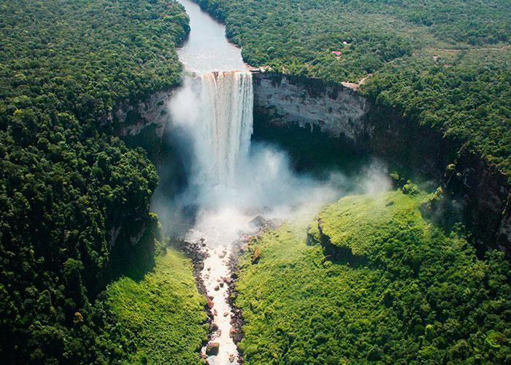

Located in Amazon rainforest, the Kaieteur Falls is the largest single drop waterfall in the world in terms of the volume of water flowing over it. The waterfall is located in Guyana.  
  
The Waterfall has a height of 226 m. There are also several cascades in between the elevation. The height and volume of water flowing through it make it one of the most stunning spectacles.

The falls were discovered in 1870 by a party led by Charles Barrington Brown. He was a British geologist appointed as a government surveyor to the colony of Guyana.   
  
The tallest single drop waterfall in the world is a major tourist attraction in Guyana. It is located in the Kaieteur National Park in the center of Guyana's rainforest.

**7. Gullfoss Falls, Iceland**

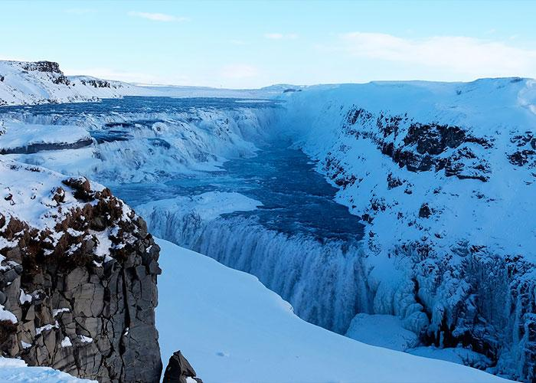

Iceland is one of the coolest places in the world and it has numerous waterfalls too. The water often freezes and the waterfalls become ice cold.  
  
Gullfoss remains the favorite for tourists around the world. The chilling cold waterfall, tall mountains and natural beauty make Gullfoss a top vacation destination.  
  
It is also called Golden Falls. The waterfall is located in southwest Iceland. It has a height of 11 m and width 21 m. But, the location and the country in which the fall is located are simply amazing.

Gullfoss Waterfall is quite unique because view of the falls is from above, the mountains are covered with ice and waterfall appears going underground!

**8. Bigar Falls, Romania**

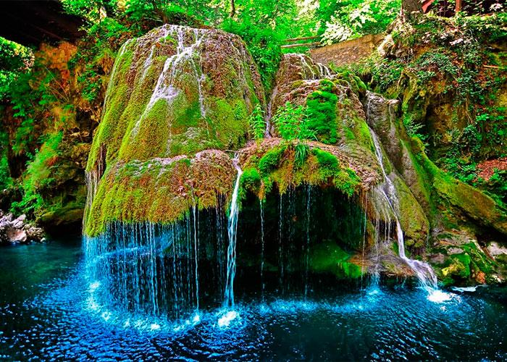

The Bigar Falls is situated in a protected nature reserve in Romania. It is one of the most beautiful waterfalls in the world.   
  
This waterfall is unique in the way the water spreads and falls from the mountains covered with greenery. The landscape is very colorful.   
  
It is a natural marvel, located exactly on the 45th parallel north, at the halfway point between the Equator and the North Pole.

The waterfall stands out with its mesmerising beauty. It is one of the most beautiful in Romania, it is the top waterfall on the list of eight unique waterfalls in the world, according to World Geography.

**9. Ban Gioc Detian Falls in Vietnam & China**

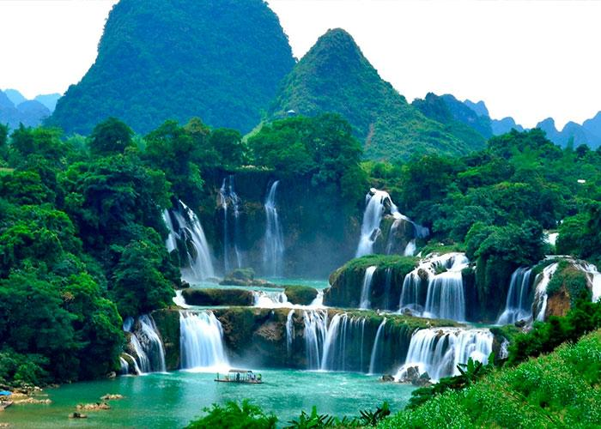

It is the 4th largest waterfall lying on an international border. The Ban Gioc Detian Falls lies in Vietnam and China.   
  
It mostly appears as two waterfalls but during the rainy season, it becomes one. The waterfall makes a thundering sound when water hits the rocks. The sound can be heard from quite a distance.

The height of the waterfall is is 29.8 m, the site has two sister waterfalls. The bubbling water running down lush green mountains and create a spectacular view.

**10. Nohkalia Falls, India**

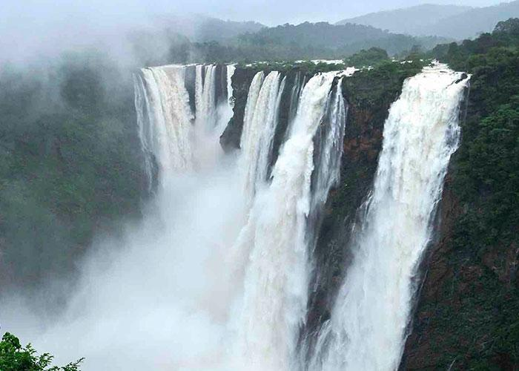

Nohkalikai Falls is located near Cherrapunji, which is one of the rainiest places in India. It has a height of 335 m. The waterfall is the tallest in India and the fourth highest waterfall in the world.   
  
The most scintillating feature of the waterfall is that the pool formed on the land is blue during winter, but turns green in summer.   
  
Since it is located near Cherrapunji, which receives heavy rainfall, there is no shortage of water as these falls are in full flow almost throughout the year.

This waterfall offers a great view with water gushing through the tall mountains, broad forests cover the mountain & misty clouds create enthralling ambience. It is a must visit place.