

**(23CSE111) OBJECT ORIENTED PROGRAMMING**

**LAB MANUAL**

**CSE-1st YEAR II SEMESTER (2025-2026)**

|  |  |  |  |
| --- | --- | --- | --- |
| **Submitted by** | | **Submitted to** | |
| **NAME:** | **pvskrishnakanth** | **NAME:** | **RAJ KUMAR BATCHU** |
| **ROLL NO:** | **AV.SC.U4CSE24304** | **DEPARTMENT:** | **CSE** |
| **SECTION:** | **CSE-B** | **DESIGNATION:** | **Asst.Professor** |

|  |  |
| --- | --- |
| **MARKS:** |  |
| **SIGNATURE:** |  |
| **DATE:** |  |

|  |  |  |  |  |
| --- | --- | --- | --- | --- |
| **S.No.** | **Task** | **Page No.** | **Remarks** | **Signature** |
| **1** | a.Download and Installation Process of Java  b. Simple Java Program for printing basic details of student | **3**  **8** |  |  |
|  | a)Write a java program for SI?  b)Write a program in java for area of rectangle.  c) Write a program in java for area of triangle using heron’s formula.  d) (a):Write a program in java for converting temperature from celsius to fahrenheit.  (b):Write a program in java for converting temperature from fahrenheit to celsius.  e) Write a program in java for factorial of a number.  f) Write a program in java for fibonacci series. |  |  |  |
| **3** | a.)Write a java program with the following instructions:  1. Create a class with name Car  2. Create 4 attributes named car_color, rand, fuel_type, mileage  3. Create 3 methods named Start(), Stop(),Service();  4. Create 3 objects named car1, car2, car3 for the class Car  b)Write a java program to create a class BackAccount with two methods deposit( ) and withdraw( )  1. In deposit( ) whenever an amount is deposited it has to be updated with current amount  2. In withdraw( ) whenever an amount is withdrawn it has to be less than current amount else print “Insufficient funds”. |  |  |  |
| **4** | 1)Write a java program with class named “Book”. The class should contain various attributes such as “Title of the book , author , year of publication “. It should also contain a constructor with parameters details of the book.  2)To create a java program with class named Myclass with a static variable “Count” of “int type”, Initialized to 0 and a constant variable “pi” of type double initialized to 3.1415 as attributes of that class Now, define a constructor for “Myclass” that increments the “Count” variable each that an object of Myclass is created. Finally , print the final values of “Count” and “pi” variables. |  |  |  |
|  |  |  |  |  |
|  |  |  |  |  |
|  |  |  |  |  |

Week1

Aim: To download and install java.

Procedure:

* Go to any web browser and search for “Oracle” and then open “Oracle” website.
* You will find “ download Java” in the oracle interface and click on that.
* And later select the version you want to download (version JDK21 is best).
* 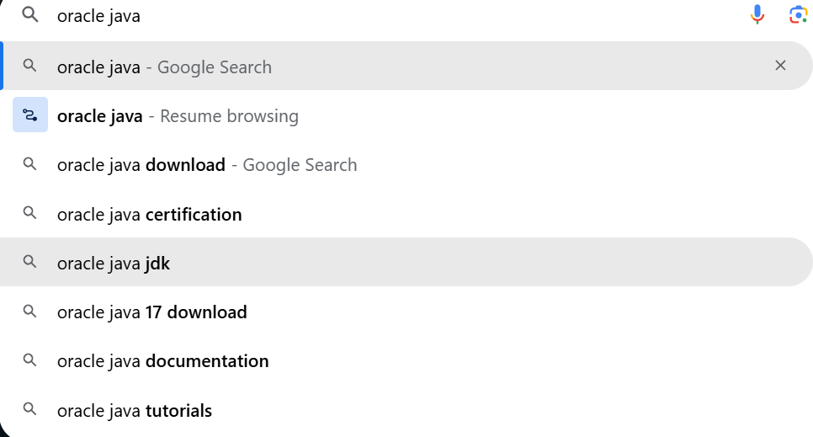Select the Operating System(OS) of your PC and click on the link “x64 installer” to download .
* **Click on “java downloads”**

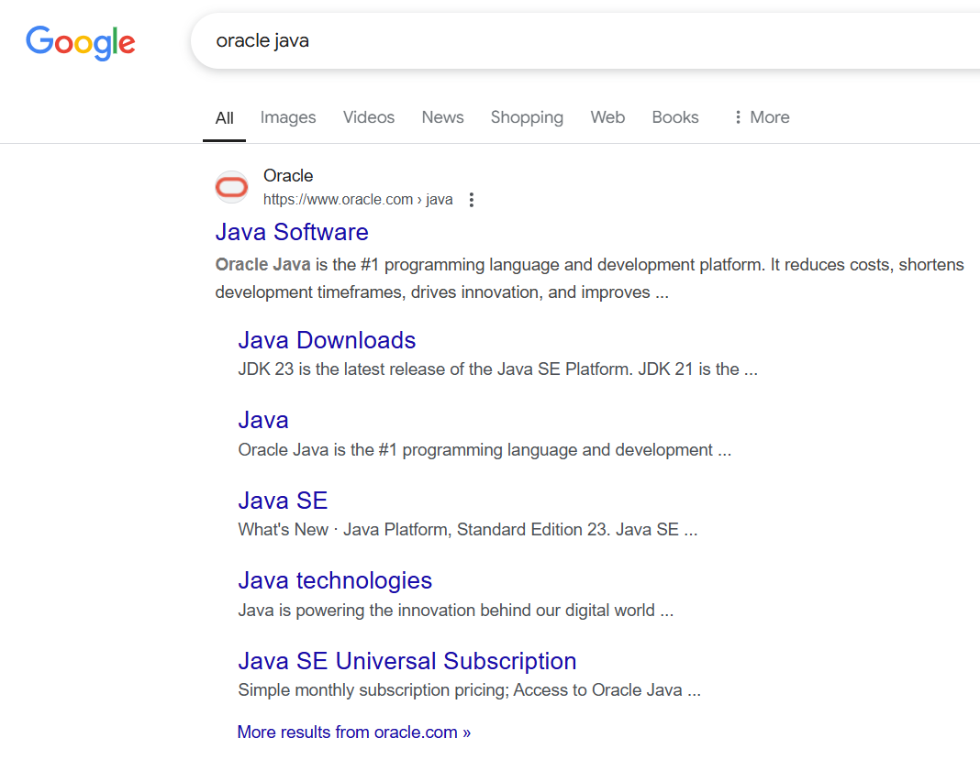

* **Installation:**
* **Click on next**

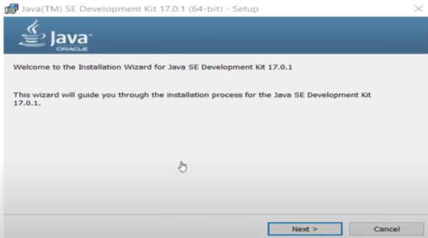

* **click on next**

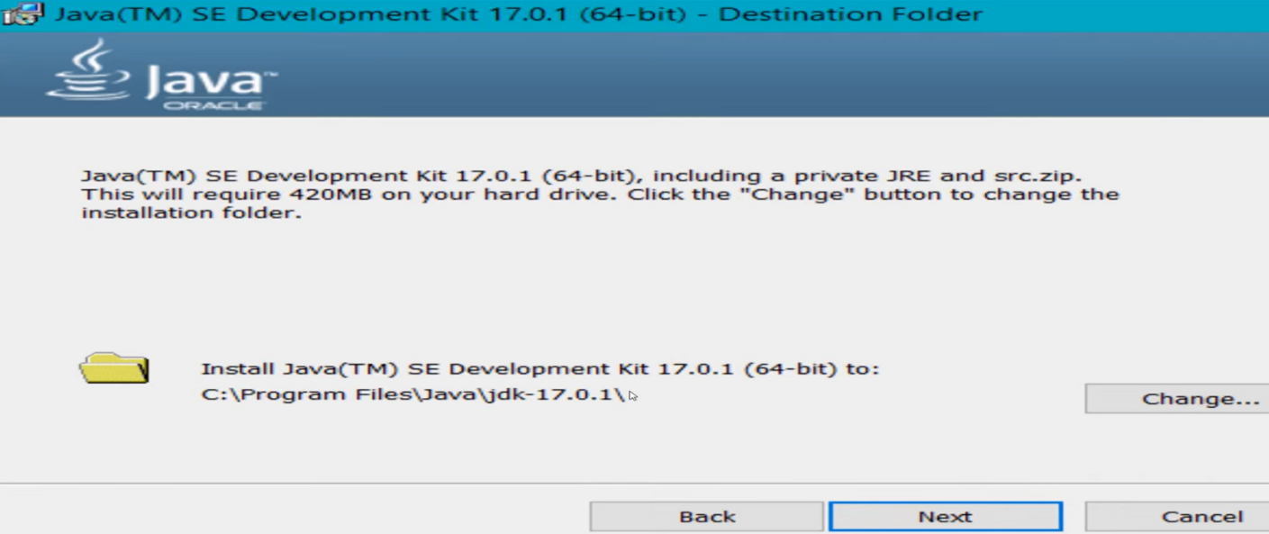

* 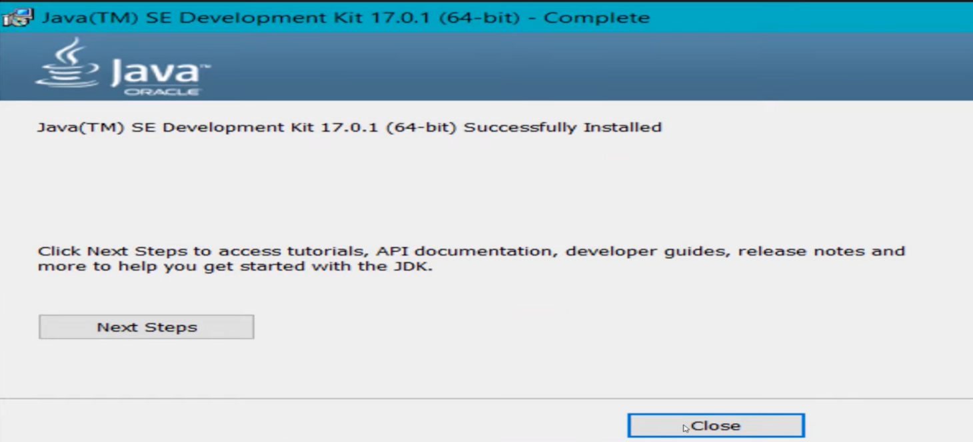**click on close**
* **to check whether java is downloaded correctly or not:**
* 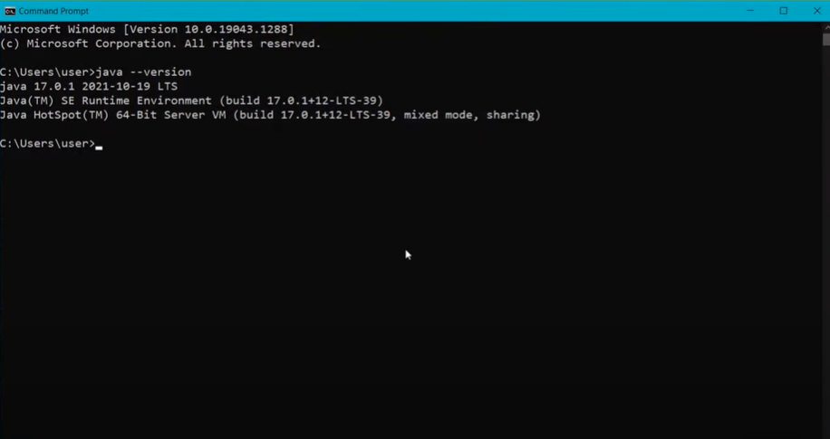**open command window and type “java --version”**
* **to set the path:**
* **Go to “start” and se “Edit the search environment variables”**
* **Click on open and continue to click on Environment variables**

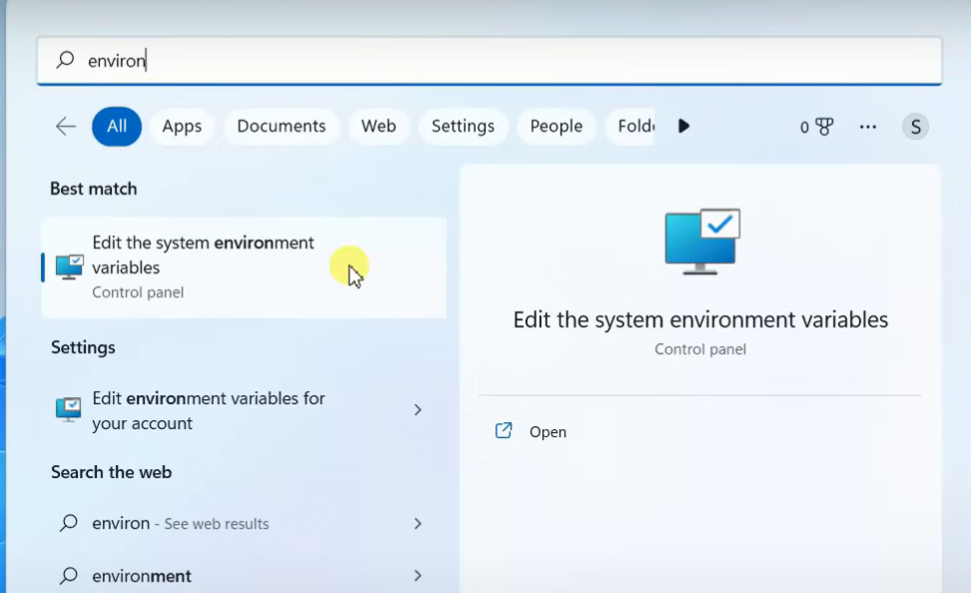

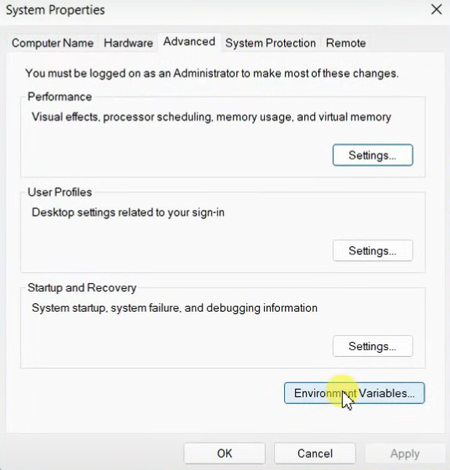

* **Select the “path” option in “system variables”**

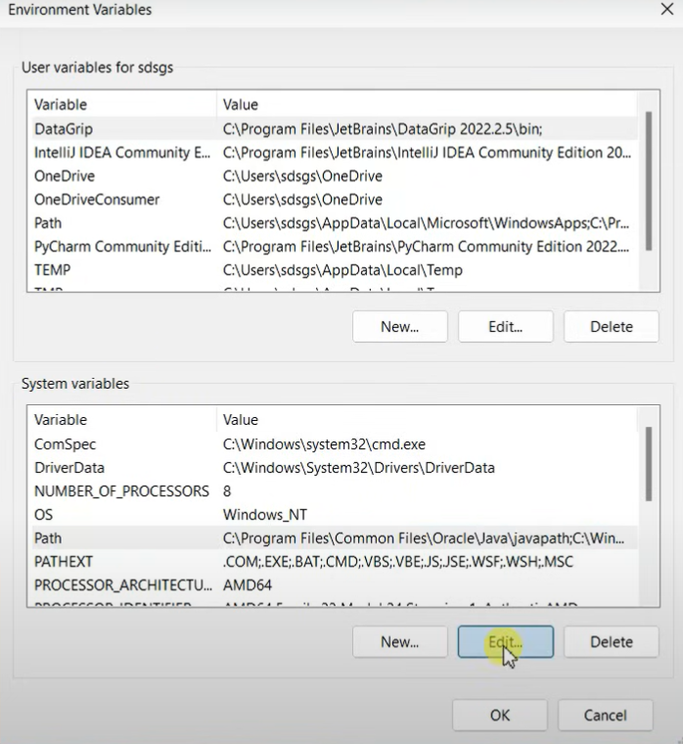

* **Now click on new paste the path of java**

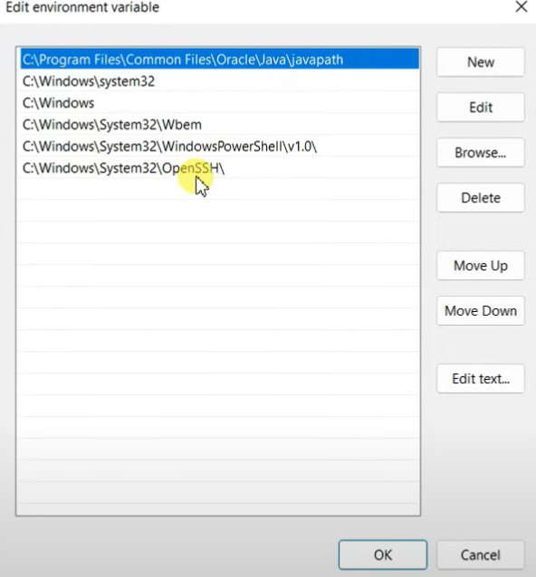

* **To check whether the path is properly set or not:**
* **Open command window and type “javac --version”.**
* **If it is showing the exact version of java you are installed then the path is set properly.**
* **Now create a text document with “.java” extension and open in notepad ,**

**To write code.**

**2) AIM : Write a java code to print the message “student details”.**

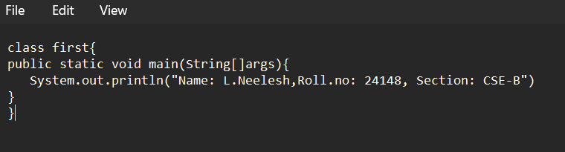**PROCEDURE:**

**OUTPUT:**

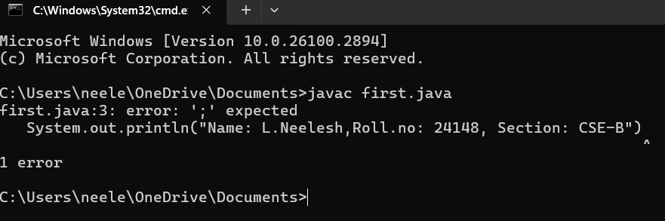

**ERRORS:**

|  |  |  |
| --- | --- | --- |
| **S.no** | **Error** | **Rectification** |
| **1)** | **MyFirst.java:2: error: ‘;’ expected**  **System.out.println(“Name: L.Neelesh,Roll.no: 24148, Section: CSE-B”)**  **^** | **In the code,semicolon must be added at the end of line.** |

**IMPORTANT POINTS:**

**1)System.out.println(“this string will be printed”) – this line of code is used to print any string.**

**2)if you want to save your java file as “first” then “class first { “ should be written**

**3.Aim: To write the basic program in java.**

**Procedure:**

**Input:**

**class main{**

**public static void main(String[]args){**

**System.out.println("Name: L.Neelesh,Roll.no: 24148, Section: CSE-B");**

**}**

**}**

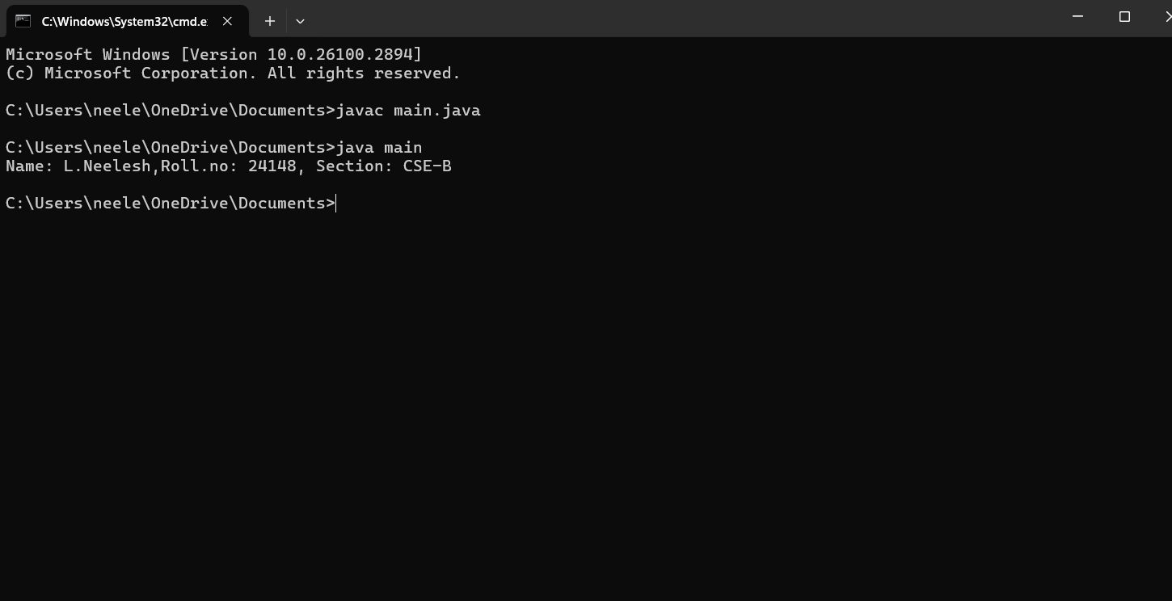 **Output:**

**WEEK-2:**

**PROGRAM-1:** Write a java program for SI?

import java.util.Scanner;

class simple_interest{

public static void main(String[] args){

Scanner si=new Scanner(System.in);

System.out.println("enter the principle:");

int p=si.nextint();

System.out.println("enter the rate of interest:");

int r=si.nextint();

System.out.println("enter the time:");

int t=si.nextint();

float simple_interest=(p*r*t)/100;

System.out.println("simple interest is: " + simple_interest);

}

}

Output: 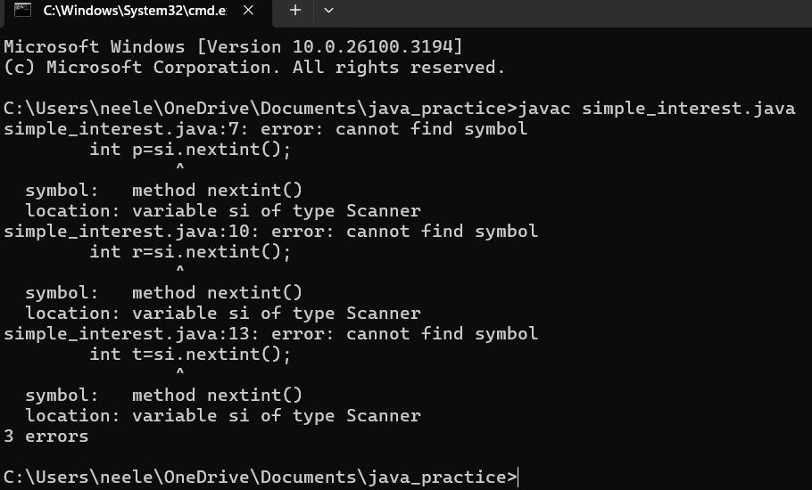

|  |  |  |
| --- | --- | --- |
| code | error | rectification |
|  | int r=si.nextint(); | Int r=si.nextInt(); |

Program-1(rectification):

import java.util.Scanner;

class simple_interest{

public static void main(String[] args){

Scanner si=new Scanner(System.in);

System.out.println("enter the principle:");

int p=si.nextInt();

System.out.println("enter the rate of interest:");

int r=si.nextInt();

System.out.println("enter the time:");

int t=si.nextInt();

float simple_interest=(p*r*t)/100;

System.out.println("simple interest is: " + simple_interest);

}

}

**Output:**

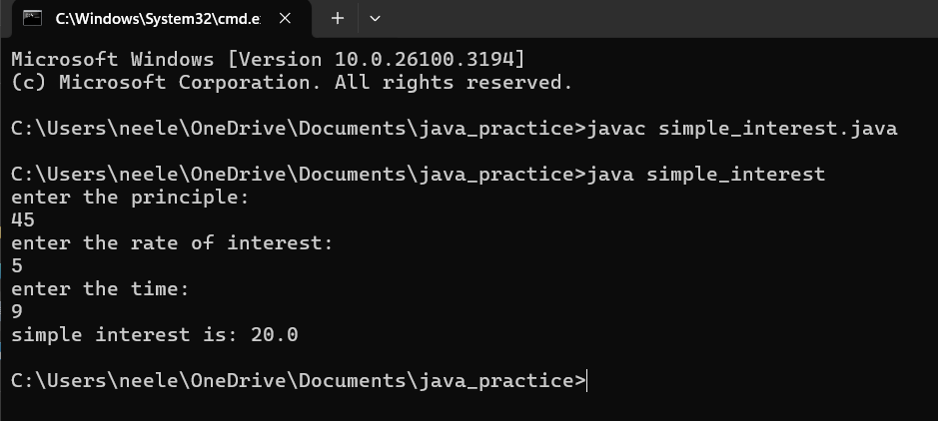

**PROGRAM-2:** Write a program in java for area of rectangle.

import java .util. Scanner;

class area_rectangle{

public static void main(String[] args){

Scanner a=new Scanner(System.in);

System.out.println("enter the length:");

float l=a.nextFloat();

System.out.println("enter the width:");

float w=a.nextFloat();

float area=l**w;

System.out.println("area of rectangle is" + area);

}

}

Output:

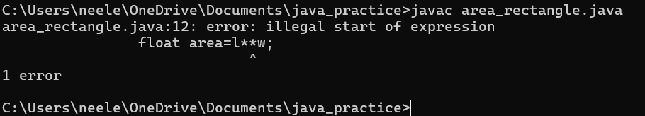

|  |  |  |
| --- | --- | --- |
| code | error | rectification |
|  | Float area=l**w; | For multiplication we should use “ * ” for one time,so  Float area=l*w; |

**Program-2 (rectification):**

**import java .util. Scanner;**

**class area_rectangle{**

**public static void main(String[] args){**

**Scanner a=new Scanner(System.in);**

**System.out.println("enter the length:");**

**float l=a.nextFloat();**

**System.out.println("enter the width:");**

**float w=a.nextFloat();**

**float area=l*w;**

**System.out.println("area of rectangle is" + area);**

**}**

**}**

**Output:**

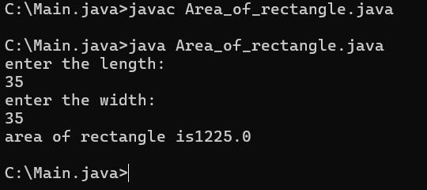

**PROGRAM-3:**Write a program in java for area of triangle using heron’s formula.

**import java.util.Scanner;**

**class heronsformula{**

**public static void main (String[] args){**

**Scanner input=new Scanner(System.in);**

**System.out.println("enter the value for a :");**

**Double a=input.nextDouble();**

**System.out.println("enter the value for b :");**

**Double b=input.nextDouble();**

**System.out.println("enter the value for c :");**

**Double c=input.nextDouble();**

**Double s=(a+b+c)/2;**

**System.out.println("S is the value of semi perimeter"+s);**

**Double x=s*(s-a)*(s-b)*(s_c);**

**System.out.println("the value of x is:"+x);**

**Double area=Math.sqrt(x);**

**System.out.println("the area of triangle is :"+area);**

**}**

**}**

**Output:**

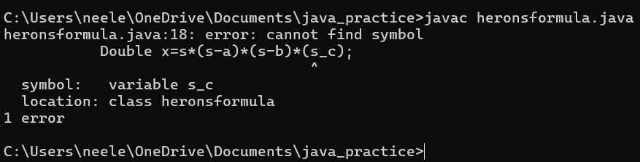

|  |  |  |
| --- | --- | --- |
| code | error | rectification |
|  | In formula ,  X=s*(s-a)*(s-b)*(s_c) | Instead of “ – “ we used “_” there fore we got an error  X=s*(s-a)*(s-b)*(s-c) |

**Rectification:**

**import java.util.Scanner;**

**class heronsformula{**

**public static void main (String[] args){**

**Scanner input=new Scanner(System.in);**

**System.out.println("enter the value for a :");**

**Double a=input.nextDouble();**

**System.out.println("enter the value for b :");**

**Double b=input.nextDouble();**

**System.out.println("enter the value for c :");**

**Double c=input.nextDouble();**

**Double s=(a+b+c)/2;**

**System.out.println("S is the value of semi perimeter"+s);**

**Double x=s*(s-a)*(s-b)*(s-c);**

**System.out.println("the value of x is:"+x);**

**Double area=Math.sqrt(x);**

**System.out.println("the area of triangle is :"+area);**

**}**

}

**Output:**

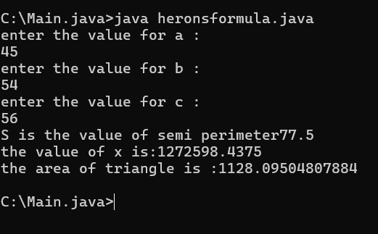

**PROGRAM-4(a):**Write a program in java for converting temperature from celsius to fahrenheit.

import java.util.Scanner;

class temperature_conversion{

public static void main(String[] args){

Scanner input=new Scanner(System.in);

System.out.println("enter the Celcius :");

float ctemp=input.nextFloat();

float ftemp;

ftemp=(ctemp*9/5)+32;

System.out.println("temperature Fahrenheit: + ftemp);

}

}

Output:

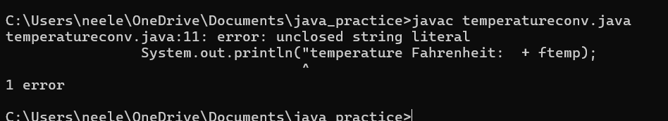

|  |  |  |
| --- | --- | --- |
| code | error | rectification |
|  | System.out.println(“temperature Fahrenhiet: +ftemp) | System.out.println(“temperature  Fahrenhiet: “+ftemp) |

**Rectification:**

import java.util.Scanner;

class temperature_conversion{

public static void main(String[] args){

Scanner input=new Scanner(System.in);

System.out.println("enter the Celcius :");

float ctemp=input.nextFloat();

float ftemp;

ftemp=(ctemp*9/5)+32;

System.out.println("temperature Fahrenheit: " + ftemp);

}

}

***Output:***

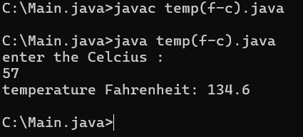

**PROGRAM-4(b):**Write a program in java for converting temperature from fahrenheit to celsius.

import java.util.Scanner;

class temperature_conver{

public static void main(String[] args){

Scanner input=new Scanner(System.in);

System.out.println("enter the temperature in Fahrenheit:");

float ftemp=input.nextFloat;

float ctemp;

ctemp=(ftemp-32)*5/9;

System.out.println("temperature in celcius: + ctemp);

}

}

Output:

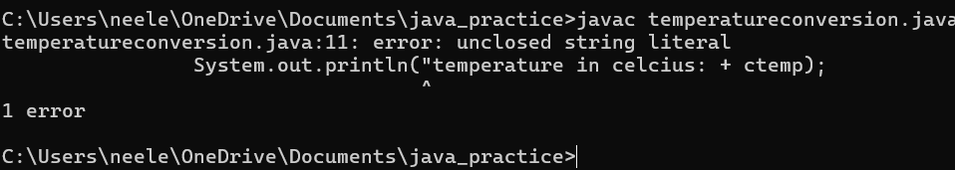

|  |  |  |
| --- | --- | --- |
|  | error | Rectification |
|  | Strings  System.out.println("temperature in celcius: + ctemp); | System.out.println("temperature in celcius:” + ctemp); |

Rectification:

import java.util.Scanner;

class temperature_conver{

public static void main(String[] args){

Scanner input=new Scanner(System.in);

System.out.println("enter the temperature in Fahrenheit:");

float ftemp=input.nextFloat();

float ctemp;

ctemp=(ftemp-32)*5/9;

System.out.println("temperature in celcius: " +ctemp);

}

}

output:

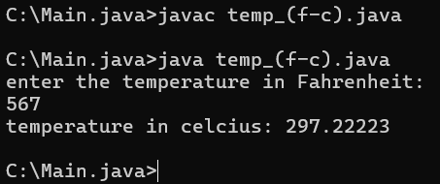

**PROGRAM-5:**Write a program in java for factorial of a number.

import java.util.Scanner;

class factorial {

public static void main(String[] args) {

Scanner f=new Scanner(System.in);

System.out.println("enter the number: ");

int number=f.nextInt();

long factorial = 1;

for(int i = 1; i <= number; i++){

factorial *= i;

}

System.out.println("Factorial of " + number + " is: " + factorial);

}

}

Output:

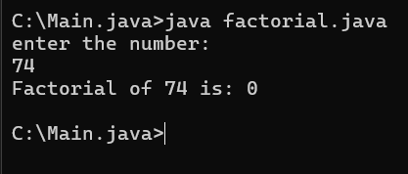

|  |  |  |
| --- | --- | --- |
| **code** | **error** | **rectification** |
|  | **For root in java we**  **don’t use **.** | **Use Math.sqrt**  **statement.**  **Double**  **area=Math.sqrt(x);** |

**PROGRAM-6:**Write a program in java for fibonacci series.

import java.util.Scanner;

class Fibonacci {

public static void main(String[] args) {

Scanner f=new Scanner(System.in);

System.out.println("enter the number: ");

int n=f.nextInt();

int firstTerm = 0, secondTerm = 1;

System.out.println("Fibonacci Series up to " + n + " numbers:");

for (int i = 1; i <= n; +i) {

System.out.print(firstTerm + " ");

int nextTerm = firstTerm + secondTerm;

firstTerm = secondTerm;

secondTerm = nextTerm;

}

}

}

Output:

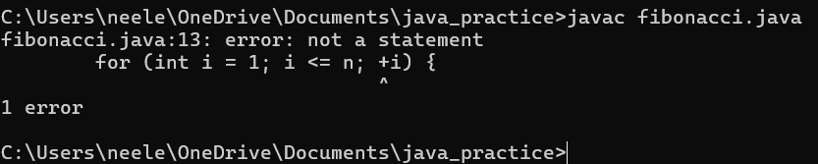

|  |  |  |
| --- | --- | --- |
| code | error | rectification |
|  | For increment we have used +i | We must use ++i for increment |

Rectification:

class Fibonacci {

public static void main(String[] args) {

Scanner f=new Scanner(System.in);

System.out.println("enter the number: ");

int n=f.nextInt();

int firstTerm = 0, secondTerm = 1;

System.out.println("Fibonacci Series up to " + n + " numbers:");

for (int i = 1; i <= n; ++i) {

System.out.print(firstTerm + " ")

int nextTerm = firstTerm + secondTerm;

firstTerm = secondTerm;

secondTerm = nextTerm;

}

}

}

Output:

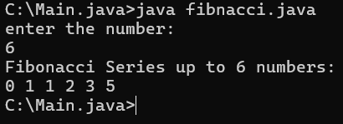

**Week-3**

1. **Aim:Create the java program with the following instructions**
2. **Create a class with name Car**
3. **Create 4 attributes named Car_Color , Car_brand, fuel_type, mileage**
4. **Create 3 method named Start( ) , Stop( ),  Service( )**
5. **Create 3 objects Car1 ,  Car2 , Car3**
6. **Create a constructor which should print “Welcome to Car Garage”**

**code: class Car{**

**public String carColor;**

**private String carBrand;**

**private String fuelType;**

**public int mileage;**

**Car(String carColor , String carBrand , String fuelType , int mileage){**

**this.carColor = carColor;**

**this.carBrand = carBrand;**

**this.fuelType = fuelType;**

**this.mileage = mileage;**

**System.out.println(carColor + " " + carBrand + " " + fuelType + " " + mileage);**

**}**

**public void Start(){**

**System.out.println("The car has just started");**

**}**

**public void Stop(){**

**System.out.println("The car has just stopped");**

**}**

**public void Service(){**

**System.out.println("The car is in good condition");**

**}**

**public static void main(String[] args){**

**System.out.println(“Welcome to car Garage”);**

**Car Car1 = new Car("Black","Hyundai","Petrol",100);**

**Car1.Start();**

**Car Car2 = new Car("White","Suzuki","Diesel",150);**

**Car2.Stop();**

**Car Car3 = new Car("Red","Benz","Petrol",200);**

**Car3.Service();**

**}}**

**Output:**

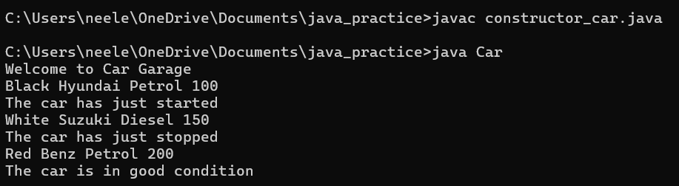

**Error:**

|  |  |  |
| --- | --- | --- |
| **s.no** | **Expected Error** | **Reason** |
| **1** | **}** | **} is expected at end of the calass** |
| **2** | **Setting the parameters inside  the constructer** | **Without setting the constructor we cannot pass the values** |

**Class Daigram:**

|  |
| --- |
| **Car** |
| **+ carColor : String**  **- carBrand : String**  **- fuelType : String**  **+ mileage : int** |
| **+ Car( ) : void**  **+ Start( ) : void**  **+ Stop( ) : void**  **+ Service( ) : void** |

Important points:

* Private is an access specifier , It means attributes can be used in particular class only.
* Method is a part of code which only runs when it is called.

**2)Aim:** **Write a java program to create a class BackAccount with two methods deposit( ) and withdraw( )**

1. **In deposit( ) whenever an amount is deposited it has to be updated with current amount**
2. **In withdraw( ) whenever an amount is withdrawn it has to be less than current amount else print “Insufficient funds”.**

**class bank_account{**

**private String Name;**

**private int AccNo, CurrBal ;**

**BankAccount(String Name, int AccNo, int CurrBal){**

**this.Name = Name;**

**this.AccNo = AccNo;**

**this.CurrBal = CurrBal;**

**System.out.println("The customers are : " + this.Name + " ");**

**}**

**public int deposit(int dAmt){**

**CurrBal = CurrBal + dAmt ;**

**return CurrBal;**

**}**

**public void withdraw(int wAmount){**

**if(wAmount < CurrBal){**

**CurrBal = CurrBal - wAmount ;**

**System.out.println(CurrBal);**

**}**

**else{**

**System.out.println("Insufficient funds");**

**} }**

**public static void main(String[] args){**

**BankAccount Neelesh = new BankAccount("Neelesh",1500,10000);**

**Neelesh.withdraw(25000);**

**Neelesh.withdraw(1800);**

**int FinalAmount =Neelesh.deposit(20000);**

**System.out.println(FinalAmount);**

**} }**

**Output:**

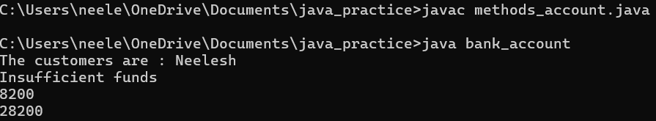

**Errors :**

|  |  |  |
| --- | --- | --- |
| **s.no** | **Expected Errors** | **Reason** |
| **1** | **Giving the parameters inside the constuctor** | **We cannot pass the values inside the constructor without setting first** |
| **2** | **}** | **} is sometimes missing at the end of class** |

**Class Diagram :**

|  |
| --- |
| **BankAccount** |
| **-Name : String**  **- AccNo :String**  **-CurrlBal :String** |
| **+ Bank Account() :  void**  **+deposit() :int**  **+withdraw() : void** |

Important points:

* The constructor is called when an object of a class is created. It can be used to set initial values for object attributes.
* The name of the constructor must match with the name of the class.
* The constructor doesn’t have a return type.

**Week-4**

1)Aim: Write a java program with class named “Book”. The class should contain various attributes such as “Title of the book , author , year of publication “. It should also contain a constructor with parameters details of the book.

i.e. “ Title of the book, author and year of publication”. Display the details of two books by creating two objects.

**Code:**

class Book { // Class representing a book

String title; // Attributes of the book

String author;

int yop; // Year of publication

Book(String title, String author, int yop) { // Constructor to initialize book details

this.title = title;

this.author = author;

this.yop = yop;

}

void display() { // Method to display book details

System.out.println("Title: " + title);

System.out.println("Author: " + author);

System.out.println("Year of Publication: " + yop);

}

}

class Details { // Main class to test the Book class

public static void main(String[] args) { // Creating book objects with details

Book b1 = new Book("Staed", "Amul", 1910);

Book b2 = new Book("Python", "Madam", 2024);

b1.display(); // Displaying book details

b2.display();

}

}

Output:

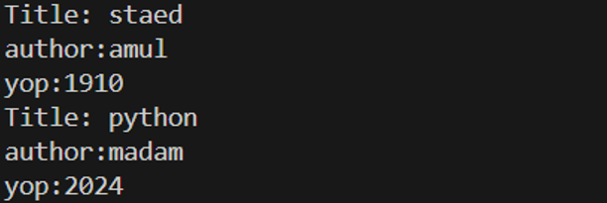

|  |  |  |
| --- | --- | --- |
| S.No. | Expected Error | Reason |
| 1 | Setting the parameters inside the constructor | We cannot pass the values inside constructor without setting them first |

**Errors :**

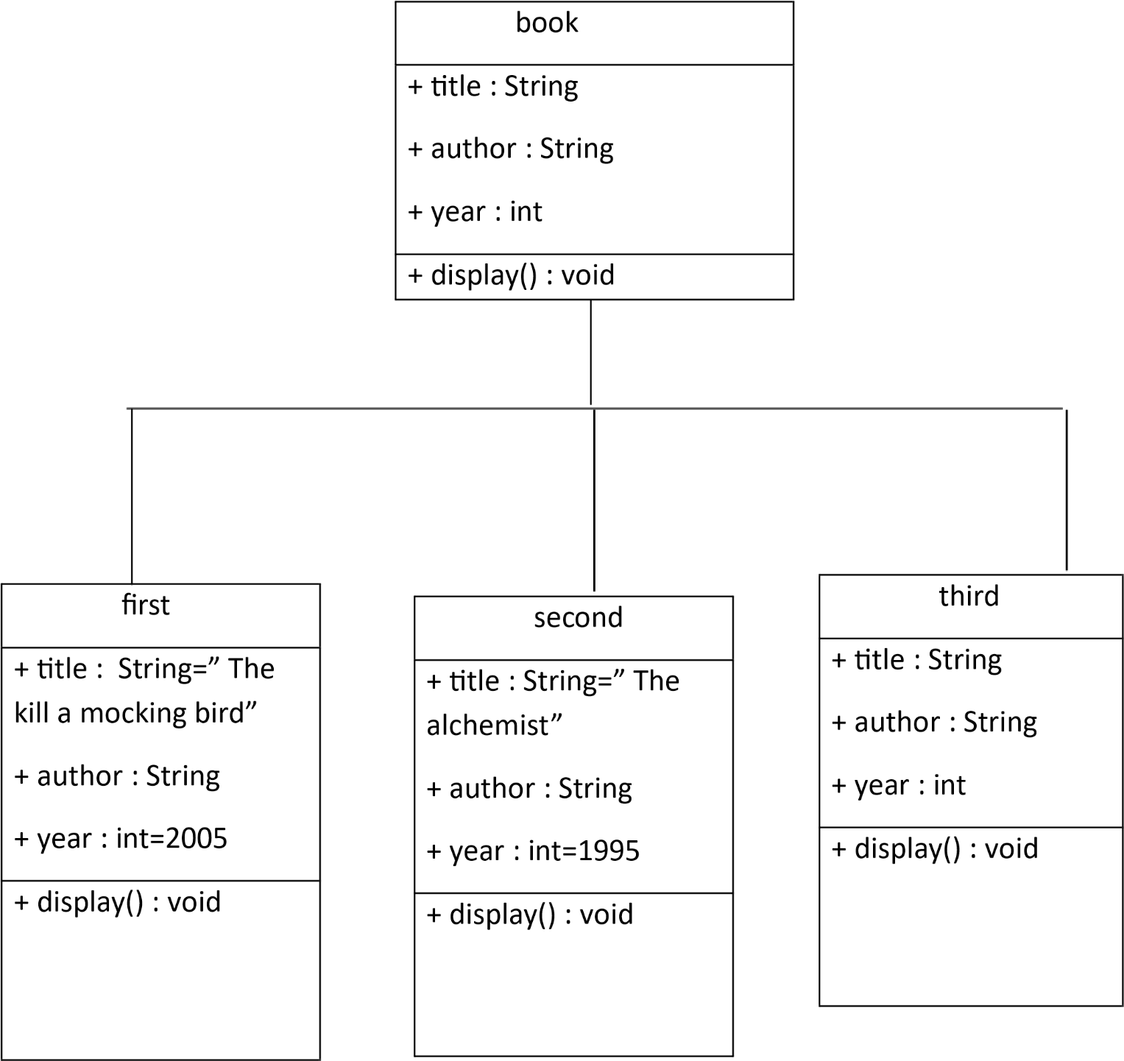

Class diagram:

Important points:

1.Constructors are special methods used to initialize objects.They have the same name as the class and no return type.It can have parameters to initialize the object with specific values.Here book is a constructor.

2.Methods are used to encapsulate functionality within a class.

**2)Aim:** To create a java program with class named Myclass with a static variable “Count” of “int type”, Initialized to 0 and a constant variable “pi” of type double initialized to 3.1415 as attributes of that class Now, define a constructor for “Myclass” that increments the “Count” variable each that an object of Myclass is created. Finally , print the final values of “Count” and “pi” variables.

**Code:**

class myclass{

static int count=0;

    final double pi=3.1415;

    void myclass(){

        count=count+1;

        System.out.println("Count: "+count);

        System.out.println("pi: "+pi);

    }}

class details{ // Main class

           public static void main(String[] args) { //main function

        myclass obj1=new myclass();

        myclass obj2=new myclass();

        myclass obj3=new myclass();

        myclass obj4=new myclass();

        myclass obj5=new myclass();

        obj1.myclass();

        obj2.myclass();

        obj3.myclass();

        obj4.myclass();

        obj5.myclass();

      }}

Output:

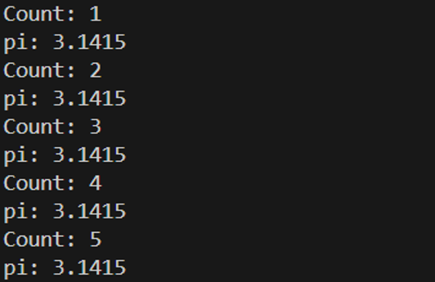

**Errors :**

|  |  |  |
| --- | --- | --- |
| **S.No.** | **Expected Error** | **Reason** |
| **1** | **.variable** | **We must mention variable name to call the variable** |
| **2** | **static** | **Static variables contain only one value** |

**Class diagram:** 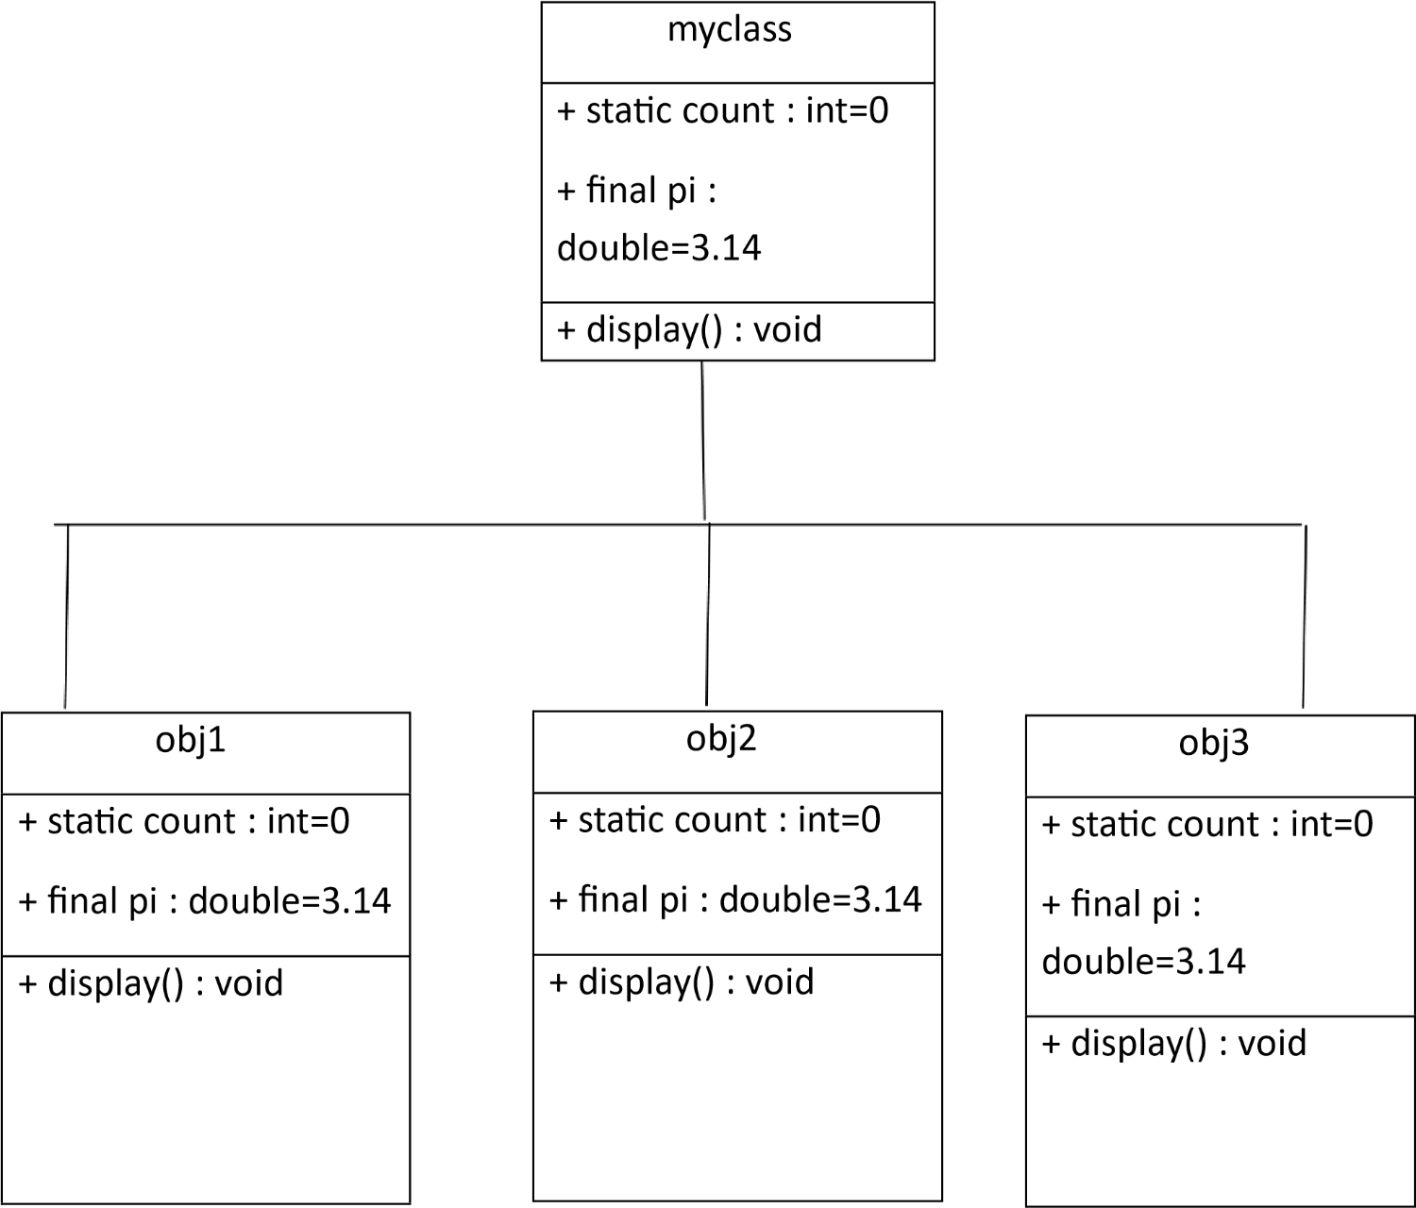

**Important points:**

1.Declared a ‘static’ variable ‘count’ to keep the track of the number of objects are created static modifier indicates that the variable is a class level variable.

2.Declared a ‘final’ variable to ‘PI’ to represent a constant value ‘final’ modifier indicates that the variables value cannot be changed after it is initialized.

3.The ‘count’ variable is ‘static’ ,so it can be accessed using the class name.