CHATGPT EXISTING SYSTEM:

ChatGPT is build upon either GPT-3.5 or GPT-4- Members of OpenAI’s

Proprietary series of generative Pre-trained transformer (GPT) Models.

EXISTING PLATFORMS:

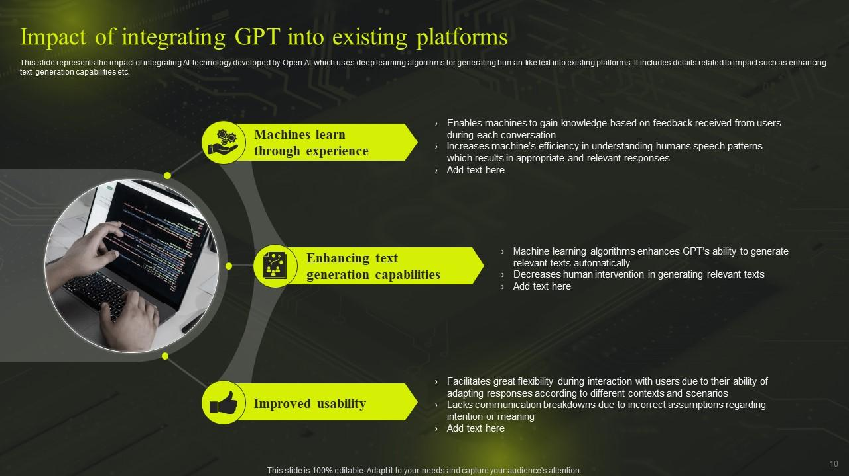

AI TECHNOLOGY:

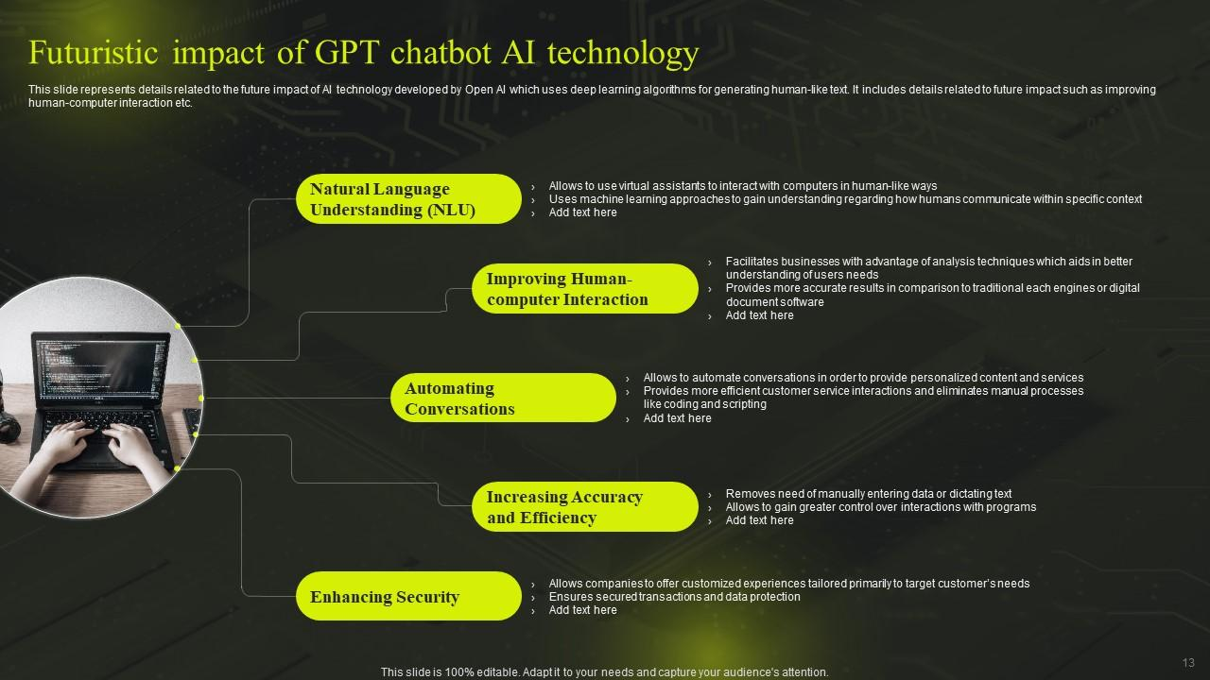

CHATTBOT SYSTEM LEVEL:

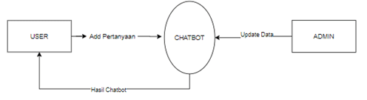

CHATBOT MODULE:

Chatbot is a machine-learning based conversational dialog engine build in python which makes it possible to generate responses based on collections of known conversations.

Classification of chatbot:

We can classify the chatbots mainly into two types, one with intelligence which can process the data and generates its own response, another is with no intelligence pre defined knowledge Base models.

Chatbots classification:

Purpose location type of interface the number of users a form of access algorithm functional.