 | 

CNN FOR SIGNAL CLASSIFICATION AND
GCNN FOR VLSI TIMING PREDICTION
A SUMMER INTERNSHIP REPORT
Submitted by
KRISH BHAVSAR
(230130111040)
In partial fulfillment of the academic requirements of the
7th Semester of
BACHELOR OF ENGINEERING
in
Electronics and Communication Engineering
Carried out at
Indian Institute of Information Technology Vadodara
Government Engineering College, Sector 28, Gandhinagar
Gujarat Technological University, Ahmedabad
July, 2026

Government Engineering College, Sector 28, Gandhinagar
Department of Electronics and Communication Engineering
CERTIFICATE
This is to certify that the Summer Internship work embodied in this report entitled “CNN for Signal Classification and GCNN for VLSI Timing Prediction” was carried out by Krish Bhavsar (230130111040) at the Indian Institute of Information Technology Vadodara, in partial fulfilment of the requirements of the subject Summer Internship (3170001) of the 7th Semester of the Bachelor of Engineering (B.E.) degree in Electronics and Communication Engineering of Gujarat Technological University. This internship work has been carried out under my supervision and is found to be satisfactory to the best of my knowledge and to the satisfaction of the department.

______________________ | ______________________
Prof. Jignesh K. Bhavsar | Dr. T. B. Sheth
Internal Guide | Head of the Department

COMPLETION CERTIFICATE
Certificate of completion of the internship issued by the Indian Institute of Information Technology Vadodara, for the period 03/07/2026 to 16/07/2026.


Government Engineering College, Sector 28, Gandhinagar
DECLARATION
I hereby declare that the internship report entitled “CNN for Signal Classification and GCNN for VLSI Timing Prediction”, submitted in partial fulfilment of the requirements for the award of the degree of Bachelor of Engineering in Electronics and Communication Engineering to Gujarat Technological University, Ahmedabad, is a bonafide record of the original work carried out by me during my summer internship at the Indian Institute of Information Technology Vadodara, from 3 July 2026 to 16 July 2026, under the supervision of Dr. Kamal Kishor Jha and the guidance of my institute guide Prof. Jignesh K. Bhavsar.
I further declare that no part of this report has been directly copied from any student's report or taken from any other source without providing due reference.
Date: ______________
Place: Gandhinagar
Name of the Student
Krish Bhavsar (230130111040)
Sign of the Student
______________________

ACKNOWLEDGEMENT
I am grateful to everyone who helped me to complete my summer internship on “CNN for Signal Classification and GCNN for VLSI Timing Prediction”, carried out from 3 July 2026 to 16 July 2026.
I sincerely thank the Indian Institute of Information Technology Vadodara for giving me the opportunity to work as a research intern. I express my deep gratitude to my supervisor, Dr. Kamal Kishor Jha, for accepting me as an intern, for defining the problem, for agreeing to change its direction when the results called for it, and for his patient guidance and careful review of the work at every stage. His insistence that every number be reproducible shaped this work.
I express my heartfelt thanks to my internal guide, Prof. Jignesh K. Bhavsar, for his guidance, encouragement and support throughout the internship and the preparation of this report. I am equally thankful to Dr. T. B. Sheth, Head of the Department of Electronics and Communication Engineering, to the faculty coordinators of the summer internship, and to all the faculty members of the department for their support.
I also thank Government Engineering College, Sector 28, Gandhinagar, and Gujarat Technological University for including the summer internship in the curriculum and giving students an early exposure to work outside the classroom.
Finally, I thank my family and my friends for their constant support.
Krish Bhavsar
Enrolment No.: 230130111040

ABSTRACT
This report describes the summer internship carried out at the Indian Institute of Information Technology Vadodara under Dr. Kamal Kishor Jha. For the GTU subject Summer Internship (3170001) the period considered is 3 July 2026 to 16 July 2026; the report describes the complete work of the research internship, which applied deep learning first to a biomedical signal and then to the timing of digital circuits.
A one-dimensional squeeze-and-excitation residual network classified the 8,528 single-lead recordings of the PhysioNet/CinC 2017 dataset into four rhythm classes with 80.5 % accuracy and a macro F1 of 0.730. The same recordings were converted into spectrogram, scalogram and DWT images and classified by eighteen two-dimensional networks and two residual translations; the best reached a macro F1 of 0.660, below the one-dimensional network, and the work was re-scoped.
The main phase built CalibTimer, a graph neural network with 40,730 parameters that predicts static timing at every pin of a placed but unrouted design. Twenty-seven sky130 designs were taken through the OpenROAD flow and parsed from their Verilog, DEF, SPEF, SDF, SDC and Liberty files into pin-level graphs. The network propagates arrival time level by level, as a timing engine does, and reads gate delays from the Liberty tables through a learned lookup. Trained on fifteen designs and tested on seven unseen ones, it reached a mean arrival-time R² of 0.8988, with 94 to 99 % of the pins of every design within 0.25 ns; a whole design is evaluated in 8 to 160 ms. Split-conformal calibration on held-out designs gave a slack interval of ± 2.35 ns with a measured coverage of 96.5 to 100 % against 90 % required.
Twelve tests were run against the code and the trained model. They reproduced the reported results exactly and found that the input-delay feature had been zero for every design because of a parsing defect, which explains the weakest test result; a corrected parser reads all 4,317 input-delay constraints.

LIST OF FIGURES
Fig 2.1 Flow of the work carried out during the internship 3
Fig 2.2 Work carried out in the two weeks of the GTU period 3
Fig 3.1 Ten seconds of each of the four rhythm classes of the PhysioNet/CinC 2017 dataset 3
Fig 3.2 Arrival time, required arrival time and slack on a timing path 3
Fig 3.3 Position of the pre-routing prediction in the OpenROAD flow 3
Fig 4.1 Size of the 27 benchmark designs (logic cells, log scale) 3
Fig 4.2 Real placed layouts of two test designs, drawn from their DEF files 3
Fig 5.1 Class distribution of the dataset 3
Fig 5.2 Architecture of the one-dimensional SE-ResNet 3
Fig 5.3 Training history of the one-dimensional SE-ResNet 3
Fig 6.1 From a one-dimensional signal to a two-dimensional image 3
Fig 6.2 One recording as a spectrogram, a scalogram and a DWT image 3
Fig 6.3 Test macro F1 of the 18 networks of the architecture sweep 3
Fig 6.4 Architecture of the two-dimensional SE-ResNet 3
Fig 6.5 Accuracy and macro F1 of the one- and two-dimensional models 3
Fig 6.6 Confusion matrices: 1-D SE-ResNet and a 2-D CNN on scalograms 3
Fig 7.1 From the design files to a trainable graph 3
Fig 7.2 The heterogeneous pin-level timing graph (schematic) 3
Fig 7.3 The real timing graph of seq_detector, built by the parser 3
Fig 7.4 A real Liberty delay table (sky130_fd_sc_hd__nand2_1, A to Y) 3
Fig 7.5 Division of the 27 designs into training, test and calibration groups 3
Fig 8.1 Block diagram of the CalibTimer network 3
Fig 8.2 The CellLUTModule: a learned read of the Liberty table 3
Fig 8.3 Level-ordered propagation of arrival time 3
Fig 8.4 Per-design effect of the candidate fixes 3
Fig 9.1 Training curve of the final model 3
Fig 9.2 Arrival-time R² on each unseen test design 3
Fig 9.3 Predicted against true arrival time for three test designs 3
Fig 9.4 Distribution of the arrival-time error on each test design 3
Fig 9.5 Arrival time on the real die of usbf_device: true, predicted and error 3
Fig 9.6 The failures against the input delay, and the arrival time predicted at the input pins 3
Fig 9.7 The split-conformal calibration procedure 3
Fig 9.8 Measured coverage of the calibrated interval on each test design 3
Fig A1.1 No Objection Certificate issued by the EC Department 3
Fig A2.1 Selection email and acceptance 3

LIST OF TABLES
Table 2.1 Week-wise schedule of the GTU summer-internship period 3
Table 3.1 Summary of the papers studied 3
Table 4.1 Software used 3
Table 4.2 Hardware used 3
Table 4.3 The 27 benchmark designs (read from their DEF and SDC files) 3
Table 5.1 Classes of the PhysioNet/CinC 2017 dataset 3
Table 5.2 Training settings of the one-dimensional networks 3
Table 5.3 Results of the one-dimensional networks on the test set 3
Table 5.4 Per-class results of the one-dimensional SE-ResNet on the test set 3
Table 6.1 The three time-frequency representations 3
Table 6.2 Kernel-size ablation (simple two-dimensional CNN) 3
Table 6.3 Best results of the two-dimensional networks on the test set 3
Table 6.4 Per-class results of the two-dimensional SE-ResNet on the test set 3
Table 6.5 Best model of each phase 3
Table 7.1 Files read for each design 3
Table 7.2 The twelve node features 3
Table 7.3 The three groups of designs 3
Table 8.1 Training configuration of the final model 3
Table 8.2 Experiments: mean arrival-time R² on the seven test designs 3
Table 9.1 Results on the seven unseen test designs 3
Table 9.2 Arrival time at the primary-input pins (medians) and the overall error bias 3
Table 9.3 Measured coverage of the calibrated slack interval (± 2.3499 ns) 3
Table 9.4 Time to predict a whole design, against routing and STA 3
Table 9.5 Arrival-time R² on the seven test designs: this work and the reference papers 3
Table 9.6 Test cases 3
Table 10.1 Problems encountered and solutions 3

LIST OF ABBREVIATIONS
Abbreviation | Full form | Abbreviation | Full form
AF | Atrial Fibrillation | LUT | Look-Up Table
AT | Arrival Time | MAE | Mean Absolute Error
BN | Batch Normalisation | MLP | Multi-Layer Perceptron
CNN | Convolutional Neural Network | MSE | Mean Squared Error
CTS | Clock Tree Synthesis | NOC | No Objection Certificate
CWT | Continuous Wavelet Transform | ORFS | OpenROAD Flow Scripts
DAC | Design Automation Conference | PDK | Process Design Kit
DAG | Directed Acyclic Graph | PI | Primary Input
DEF | Design Exchange Format | PMMS | Project Management and Monitoring System (GTU)
DWT | Discrete Wavelet Transform | RAT | Required Arrival Time
ECG | Electrocardiogram | ReLU | Rectified Linear Unit
EDA | Electronic Design Automation | SDC | Synopsys Design Constraints
GCNN | Graph Convolutional Neural Network | SDF | Standard Delay Format
GNN | Graph Neural Network | SE | Squeeze-and-Excitation
GPU | Graphics Processing Unit | SPEF | Standard Parasitic Exchange Format
GTU | Gujarat Technological University | STA | Static Timing Analysis
IIIT | Indian Institute of Information Technology | STFT | Short-Time Fourier Transform
LEF | Library Exchange Format | VLSI | Very Large Scale Integration

TABLE OF CONTENTS
Declaration iii
Acknowledgement iii
Abstract iii
Chapter 1: Overview of the Organisation 3
1.1 About IIIT Vadodara 3
1.2 Research Internship Programme 3
1.3 Supervisor and Area of Work 3
1.4 Facilities Used During the Internship 3
Chapter 2: Introduction to the Internship 3
2.1 Internship Summary 3
2.2 Purpose 3
2.3 Objectives 3
2.4 Scope 3
2.5 Flow of the Work 3
2.6 Schedule 3
Chapter 3: Literature Review 3
3.1 The ECG Signal and Arrhythmia 3
3.2 Convolutional Neural Networks 3
3.3 Graph Neural Networks 3
3.4 Static Timing Analysis 3
3.5 Papers Studied 3
3.6 Gap Identified 3
Chapter 4: Tools and Environment 3
4.1 Software Environment 3
4.2 Hardware 3
4.3 The OpenROAD Flow and the sky130 Library 3
4.4 The Benchmark Designs 3
Chapter 5: Phase 1: One-Dimensional CNN on ECG 3
5.1 Problem Statement 3
5.2 The Dataset 3
5.3 Preprocessing 3
5.4 Network Architecture 3
5.5 Training 3
5.6 Results of Phase 1 3
Chapter 6: Phase 2: Two-Dimensional CNN on Time-Frequency Images 3
6.1 Motivation 3
6.2 Generating the Images 3
6.3 Architecture Sweep and Kernel Ablation 3
6.4 Residual Networks 3
6.5 Results of Phase 2 3
6.6 Why the Approach Was Discontinued 3
Chapter 7: Phase 3: CalibTimer — Data and Graph Construction 3
7.1 Overview 3
7.2 Design Files and Parser 3
7.3 Graph Construction 3
7.4 Node and Edge Features 3
7.5 Division of the Designs 3
Chapter 8: Phase 3: CalibTimer — Model and Training 3
8.1 Network Architecture 3
8.2 Reading the Liberty Tables 3
8.3 Level-Ordered Propagation 3
8.4 Loss Function and Training 3
8.5 Experiments 3
Chapter 9: Results and Testing 3
9.1 Measures Used 3
9.2 Training Behaviour 3
9.3 Accuracy on the Unseen Test Designs 3
9.4 The Failure Case and What Was Done 3
9.5 Conformal Calibration of the Slack Prediction 3
9.6 Speed 3
9.7 Comparison with Reference Papers 3
9.8 Testing 3
Chapter 10: Conclusion and Discussion 3
10.1 Overall Analysis of the Internship 3
10.2 Main Results 3
10.3 Environment and Support at IIIT Vadodara 3
10.4 Problems Encountered and Their Solutions 3
10.5 Skills and Learning Outcomes 3
10.6 Limitations 3
10.7 Future Scope 3
10.8 Summary 3
Appendix 1: No Objection Certificate from the Department 3
Appendix 2: Selection (Joining) Email from IIIT Vadodara 3
Appendix 3: Feedback Form by Industry Expert (Annexure 2) 3
Appendix 4: Selected Code Listings 3
References 3

Chapter 1: Overview of the Organisation

1.1 About IIIT Vadodara
The Indian Institute of Information Technology Vadodara (IIIT Vadodara) was established in 2013 under the public-private partnership model of the Government of India, with the Government of India, the Government of Gujarat and industry partners as stakeholders. It is an Institute of National Importance under the Indian Institutes of Information Technology (Public-Private Partnership) Act, 2017, and offers undergraduate, postgraduate and doctoral programmes. The internship was carried out at its Gandhinagar campus, which made it possible to attend the institute in person and to meet the supervisor regularly.

1.2 Research Internship Programme
IIIT Vadodara runs a research internship programme in which students of other institutes work on a research problem under a faculty member. I applied to this programme and on 15 June 2026 the internship coordinator informed me that I had been selected for a research internship under the supervision of Dr. Kamal Kishor Jha; I accepted the offer on 16 June 2026. The selection email, which describes the research internship as one of at least two months, is reproduced in Appendix 2.
For the GTU subject Summer Internship (3170001) the period considered in this report is 3 July 2026 to 16 July 2026, the period for which the Department of Electronics and Communication Engineering issued its No Objection Certificate (Appendix 1). The research itself did not start or stop on those dates. The ECG work had begun after selection in June, and the timing-prediction work that began in the second GTU week continued under the research internship afterwards. This report describes the complete work, and Table 2.1 records what was done in each of the two GTU weeks.

1.3 Supervisor and Area of Work
Dr. Kamal Kishor Jha is an Assistant Professor in the Department of Electronics and Communication Engineering at IIIT Vadodara, where he has served since 2015. He holds a Ph.D. and an M.Tech. in VLSI Design from the Indian Institute of Information Technology and Management, Gwalior. His research covers low-power VLSI design, nanoelectronics, computer architecture, hardware accelerators for deep neural networks, and machine learning for chip design.
The internship sat at the meeting point of two of those interests. It began with neural networks for a biomedical signal, the kind of model such accelerators are built to run, and moved to a neural network that helps design the chip itself, by predicting the timing of a digital circuit before the expensive routing step. The change of direction was decided jointly with the supervisor, for the reasons given in Chapter 6.

1.4 Facilities Used During the Internship
- A personal laptop with an NVIDIA GeForce RTX 3050 6 GB graphics processor, used for every training run reported here.
- The Windows Subsystem for Linux, in which the OpenROAD physical design flow and the OpenSTA timing engine were run.
- Open-source software throughout: Python, PyTorch, TensorFlow/Keras, SciPy, PyWavelets, the OpenROAD Flow Scripts and the SkyWater sky130 process design kit.
- Regular review meetings with the supervisor, in which results were checked and the next task was decided.

Chapter 2: Introduction to the Internship

2.1 Internship Summary
I completed the summer internship required by the subject Summer Internship (3170001) of the seventh semester of the B.E. programme of Gujarat Technological University at the Indian Institute of Information Technology Vadodara. The internship was carried out offline.
The title of the work is “CNN for Signal Classification and GCNN for VLSI Timing Prediction”. It has three phases. A one-dimensional convolutional neural network was first built to classify single-lead electrocardiogram recordings. The same recordings were then converted into time-frequency images and classified with two-dimensional networks, to test whether that route is better; it was not, and the work was re-scoped. The third and main phase built CalibTimer, a graph neural network that predicts the static timing of a digital integrated circuit at every pin after placement but before routing.

2.2 Purpose
Timing closure is one of the most expensive parts of chip design. The timing of a design is known accurately only after its wires have been routed, and routing a large design can take an hour or more. A model that predicts post-routing timing directly from the placed design would let a designer compare placements in seconds. The purpose of the internship was to learn how such a model is designed, trained on real industrial data and evaluated honestly, starting from the more familiar ground of convolutional networks on signals.

2.3 Objectives
- To study convolutional neural networks and apply them to the classification of single-lead electrocardiogram recordings.
- To find out experimentally whether time-frequency images classified by a two-dimensional network do better than a one-dimensional network on the raw signal.
- To study the physical design flow of digital circuits, static timing analysis, and the file formats in which a placed design and its timing are described.
- To design, implement and train a graph neural network that predicts static timing results at every pin of a placed, unrouted design.
- To evaluate that network on benchmark designs it has never seen, attach a statistically valid interval to its slack predictions, and test the whole pipeline.

2.4 Scope
The work covers data preparation, model design, training, evaluation, calibration and testing in software. The benchmark designs were taken through the open-source OpenROAD flow to obtain the input files and the reference timing; the flow was used as a tool and was not modified. No silicon was fabricated and no commercial electronic design automation tool was used. Clinical use of the ECG models is outside the scope of the work.

2.5 Flow of the Work
The order in which the work moved is shown in Fig 2.1. Each step was taken because of what the previous one showed: the two-dimensional route was a fair test of a popular idea and lost to the one-dimensional network, the timing problem called for a graph rather than an image, and the testing at the end of the work found a defect that explains one of the two designs on which the model falls short.
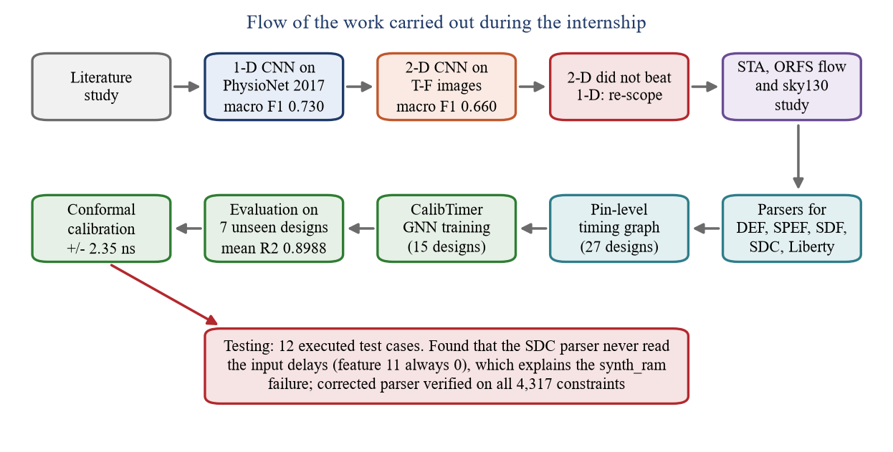
Fig 2.1 Flow of the work carried out during the internship

2.6 Schedule
The work carried out in each of the two GTU weeks is given in Table 2.1 and Fig 2.2. The dates follow the time-stamps of the project files.
Table 2.1 Week-wise schedule of the GTU summer-internship period
Week | Dates | Work carried out | Chapter
1 | 03/07/2026 to  09/07/2026 | Consolidation of the one-dimensional ECG results and a study of how the network could be deployed on hardware; regeneration of spectrogram, scalogram and DWT images for all 8,528 recordings on one common split; the 18-run two-dimensional architecture sweep and the kernel-size ablation; first reading on machine learning for timing | 5, 6
2 | 10/07/2026 to  16/07/2026 | Two-dimensional SE-ResNet and residual baseline; comparison with the one-dimensional network and the decision to re-scope; literature study on graph neural networks for timing prediction and on static timing analysis; set-up of the environment, study of the DEF, SPEF, SDF, SDC and Liberty formats, first parsers and the first graph neural network training runs on real designs | 3, 4, 7

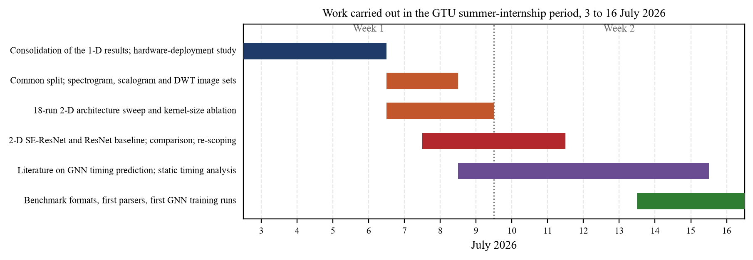
Fig 2.2 Work carried out in the two weeks of the GTU period

Chapter 3: Literature Review

3.1 The ECG Signal and Arrhythmia
The electrocardiogram records the electrical activity of the heart. One normal beat produces a P wave, from the depolarisation of the atria, a QRS complex, from the ventricles, and a T wave, from ventricular repolarisation. The interval between successive R peaks is the RR interval. Atrial fibrillation, the arrhythmia of most interest in this dataset, shows as the absence of a clear P wave and an irregular RR interval, so both the shape of the beat and the rhythm carry information (Fig 3.1).
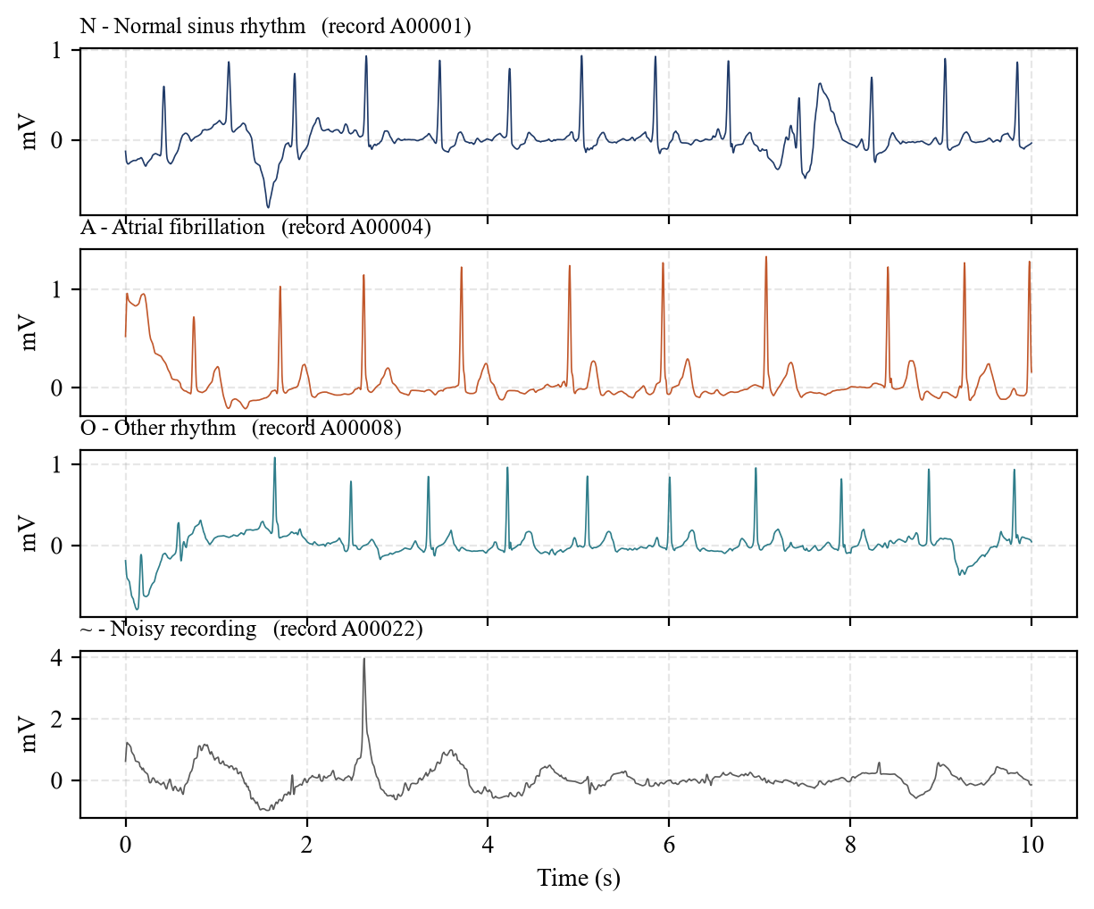
Fig 3.1 Ten seconds of each of the four rhythm classes of the PhysioNet/CinC 2017 dataset

3.2 Convolutional Neural Networks
A convolutional layer slides a small learned filter along its input. For a one-dimensional input x, a filter w of length K and a bias b, the output at position n is given by Eq. 3.1. A two-dimensional layer does the same over both axes of an image. Early layers learn simple shapes such as slopes and peaks; later layers combine them into patterns such as a whole QRS complex.
y[n] = b + Σₖ w[k] · x[n + k], k = 0 … K−1 (3.1)
Two refinements were used. A residual block adds its input to its output, which gives the gradient a direct path backwards and allows deeper networks to be trained [11]. A squeeze-and-excitation (SE) block [12] reduces each of the C channels of a feature map to its mean z, and rescales the channels by learned weights s (Eq. 3.2), where σ is the logistic sigmoid and W₁, W₂ are small dense layers.
s = σ( W₂ · ReLU( W₁ · z ) ), ŷᶜ = sᶜ · yᶜ (3.2)

3.3 Graph Neural Networks
A graph neural network attaches a learned vector hᵥ to every node v of a graph and updates it from messages sent along the edges. In one round of message passing, every node collects messages from its neighbours N(v) and combines them with its own state (Eq. 3.3), where M and U are small multi-layer perceptrons. Because the same weights are used at every node, one trained network can be applied to a graph of any size, which is exactly what a circuit of unknown size requires.
hᵥ⁽ˡ⁺¹⁾ = U( hᵥ⁽ˡ⁾ , Σᵤ∈N(v) M( hᵤ⁽ˡ⁾ , eᵤᵥ ) ) (3.3)

3.4 Static Timing Analysis
Static timing analysis checks whether a digital circuit meets its clock period without simulating it [9]. The design is represented as a directed acyclic graph of pins. The arrival time (AT) of a pin is the latest time at which a signal can reach it; it is computed in topological order as the maximum, over all arcs into the pin, of the arrival time at the source of the arc plus the delay of the arc (Eq. 3.4). The slack of a timing endpoint is its required arrival time (RAT), set by the clock period, minus its arrival time (Eq. 3.5). A negative slack is a timing violation.
AT(v) = maxᵤ→ᵥ [ AT(u) + d(u, v) ] (3.4)
slack(v) = RAT(v) − AT(v) (3.5)
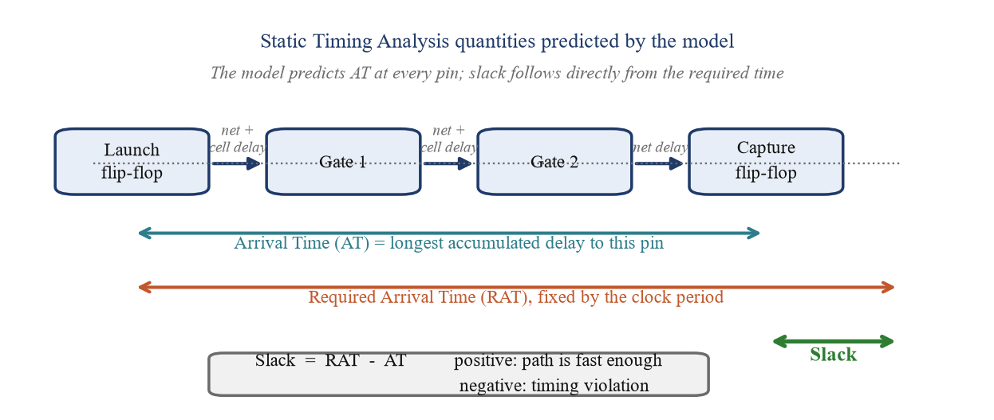
Fig 3.2 Arrival time, required arrival time and slack on a timing path
The delay of a gate is not computed from a formula but read from the characterisation data of the standard-cell library, stored in the Liberty format as a table indexed by the input slew and the output capacitive load. Wire delay depends on the length and capacitance of the wire, which are known accurately only after routing; this is why timing before routing is difficult to estimate and why a learned predictor is useful (Fig 3.3).
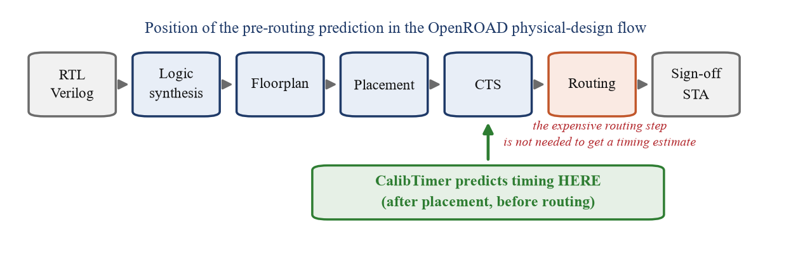
Fig 3.3 Position of the pre-routing prediction in the OpenROAD flow

3.5 Papers Studied
The papers studied are summarised in Table 3.1. The figures quoted in the table were checked against the papers themselves.
Guo et al. [1] was the starting paper for the timing work. It represents a placed design as a heterogeneous graph of pins with separate net and cell edges, embeds the nets with three rounds of message passing, and then propagates arrival time level by level as a timing engine does, reading cell delays through a learned interpolation of the Liberty tables. It publishes a benchmark of 21 sky130 designs divided into 14 for training and 7 for testing, and reports an arrival-time R² averaged over the test designs of 0.8957. CalibTimer follows its structure and uses the same test designs.
Bodhe et al. [2] (E2ESlack) build an end-to-end framework around that model, add a parser for the timing files and an algorithmic computation of the required arrival time, and train on 23 circuits. They report arrival-time R² values for the same seven test designs whose mean is 0.9169. Barboza et al. [6] predict timing before routing with feature-based machine learning and showed that the pessimism of classical estimates can be reduced. Chang and Kim [7] and Li et al. [8] apply graph neural networks, the latter with graph attention, to the same pre-routing problem. Zhang et al. [5] study how a timing predictor can be moved between technology nodes, and Hu et al. [4] model RC interconnect timing with a physics-informed tree network. Bairamkulov and Friedman [3] give the graph formulation of timing and clocking that underlies all of them.
For the ECG work, the PhysioNet/CinC 2017 challenge paper by Clifford et al. [10] defines the dataset and its four classes, and the residual [11] and squeeze-and-excitation [12] papers define the blocks used in Phases 1 and 2. Lin et al. [13] introduce the focal loss used to cope with the class imbalance.
Table 3.1 Summary of the papers studied
Reference | Task | Method | Data | Reported result
Guo et al. [1], DAC 2022 | Pre-routing AT and slack | Timing-engine-inspired GNN, learned LUT read | 21 sky130 designs, 14/7 split | Test AT R² avg. 0.8957
Bodhe et al. [2], E2ESlack | Pre-routing slack, TNS/WNS | Model of [1] + parser + RAT algorithm | 34 circuits, 23 for training | Same 7 test designs, AT R² mean 0.9169
Barboza et al. [6], DAC 2019 | Pre-routing timing | Feature-based ML | Placed designs | Reduced pessimism vs. classical estimates
Chang and Kim [7], 2024 | Pre-route timing and optimisation | GNN models | Benchmark designs | GNN-based timing prediction
Li et al. [8], 2025 | Pre-routing slack | Graph attention network | Benchmark designs | Scalable slack prediction
Zhang et al. [5], TCAD 2025 | Cross-node pre-routing timing | Transfer across technology nodes | Multiple nodes | Prediction across nodes
Hu et al. [4], NeurIPS 2023 | RC interconnect timing | Physics-informed tree GNN | RC trees | Delay and slew vs. SPICE
Clifford et al. [10], 2017 | AF detection from short ECG | Challenge and dataset | 8,528 recordings | Four-class benchmark

3.6 Gap Identified
Two points came out of the literature study. First, published pre-routing predictors report a single number, the predicted arrival time or slack, with no statement of how far it can be trusted on a new design; a designer who must decide whether a path is safe needs an interval, not just a point. Second, comparisons between papers are difficult because they differ in how the coefficient of determination is computed and over which pins. The work was therefore directed at a model that follows the established timing-engine structure, is evaluated per design on the official unseen designs over the pins that carry real timing labels, and attaches a calibrated interval to its slack predictions.

Chapter 4: Tools and Environment

4.1 Software Environment
All software used is open source; the versions in Table 4.1 are those installed in the project environments. No commercial licence was needed at any stage.
Table 4.1 Software used
Item | Version | Used for
Python | 3.11.7 | All data processing, training and analysis
PyTorch (CUDA 12.1) | 2.5.1 | Graph neural network of Phase 3
PyTorch (CUDA 12.6) | 2.12.1 | Two-dimensional networks of Phase 2
TensorFlow / Keras | 2.21.0 | One-dimensional networks of Phase 1
NumPy, SciPy, pandas | 2.4.6, 1.17.1, 3.0.5 | Arrays, signal processing, tables
PyWavelets, OpenCV | — | Wavelet transforms and image generation
scikit-learn | — | Splits, classification reports, confusion matrices
Matplotlib, NetworkX | 3.11.2, 3.6.1 | All figures, graph drawing
OpenROAD Flow Scripts | — | Synthesis, floorplan, placement and CTS
OpenSTA | 3.1.0 | Reference static timing analysis (training labels)
SkyWater sky130 PDK | sky130_fd_sc_hd | Standard cells, LEF and Liberty data
Windows Subsystem for Linux | Ubuntu | Linux environment for the design flow

4.2 Hardware
Table 4.2 Hardware used
Item | Detail
Processor platform | Personal laptop, Windows 11
Graphics processor | NVIDIA GeForce RTX 3050 Laptop GPU, 6 GB
Use | Training and inference of every model reported here

4.3 The OpenROAD Flow and the sky130 Library
Each benchmark design was synthesised, floorplanned, placed and given a clock tree with the OpenROAD Flow Scripts on the sky130 high-density library, and its reference timing was produced with OpenSTA. For each design the flow leaves the files listed in Table 7.1, which are the input of the parser described in Chapter 7. The Liberty library contains 1,241 timing arcs, each with seven-by-seven delay and slew tables.

4.4 The Benchmark Designs
Twenty-seven designs were used. Table 4.3 gives their size, read directly from the DEF and SDC files: the die dimensions, the number of placed components and of logic cells (components other than fillers, taps and decoupling cells), the number of nets and input-output pins, and the clock period. The designs span almost four orders of magnitude (Fig 4.1), from 24 logic cells in priority_enc to 90,108 in aes256.
Table 4.3 The 27 benchmark designs (read from their DEF and SDC files)
Design | Group | Die (µm) | Comp. | Logic cells | Nets | I/O | Clock (ns)
BM64 | train | 710 × 721 | 57,983 | 10,809 | 10,615 | 1030 | 20
aes128 | train | 1355 × 1365 | 238,867 | 66,635 | 62,048 | 387 | 11.43
aes192 | test | 1647 × 1658 | 327,794 | 72,884 | 68,861 | 451 | 12.37
aes256 | train | 1533 × 1544 | 309,677 | 90,108 | 83,541 | 515 | 15
aes_cipher | train | 703 × 713 | 65,607 | 17,445 | 17,106 | 393 | 10.09
alu4bit | train | 71 × 71 | 194 | 142 | 168 | 21 | 10
blabla | train | 1056 × 1067 | 123,336 | 17,359 | 15,715 | 1422 | 65
cic_decimator | train | 142 × 153 | 2,676 | 877 | 899 | 44 | 10
cla8b | calib. | 40 × 40 | 171 | 62 | 88 | 29 | none
des | train | 683 × 694 | 59,687 | 16,526 | 16,063 | 188 | 20
gcd | calib. | 80 × 80 | 751 | 484 | 517 | 56 | 1.1
genericfir | train | 549 × 559 | 34,719 | 9,975 | 9,982 | 61 | 10
jpeg_encoder | test | 1684 × 1695 | 337,006 | 65,813 | 61,479 | 51 | 15.78
picorv32a | train | 660 × 670 | 57,366 | 16,446 | 15,629 | 411 | 24.73
priority_enc | calib. | 60 × 60 | 217 | 24 | 32 | 14 | none
salsa20 | train | 1040 × 1051 | 121,934 | 21,837 | 20,749 | 79 | 36.73
seq_detector | calib. | 36 × 36 | 131 | 25 | 27 | 6 | 10
spm | test | 93 × 104 | 1,028 | 321 | 356 | 38 | 10
synth_ram | test | 458 × 469 | 24,305 | 6,956 | 6,886 | 94 | 50
uni_counter4b | calib. | 42 × 42 | 207 | 55 | 67 | 16 | 10
usb | train | 169 × 180 | 3,376 | 934 | 955 | 46 | 12.55
usb_cdc_core | train | 223 × 234 | 6,729 | 2,182 | 2,206 | 55 | 15.6
usbf_device | test | 652 × 663 | 59,757 | 20,167 | 20,104 | 181 | 14.6
wbqspiflash | train | 262 × 272 | 9,017 | 2,834 | 2,874 | 106 | 18.86
xtea | test | 236 × 247 | 8,136 | 2,892 | 3,062 | 262 | 26.03
y_huff | test | 565 × 576 | 42,451 | 14,506 | 14,527 | 749 | 11.35
zipdiv | train | 176 × 186 | 4,022 | 1,236 | 1,296 | 109 | 19.09

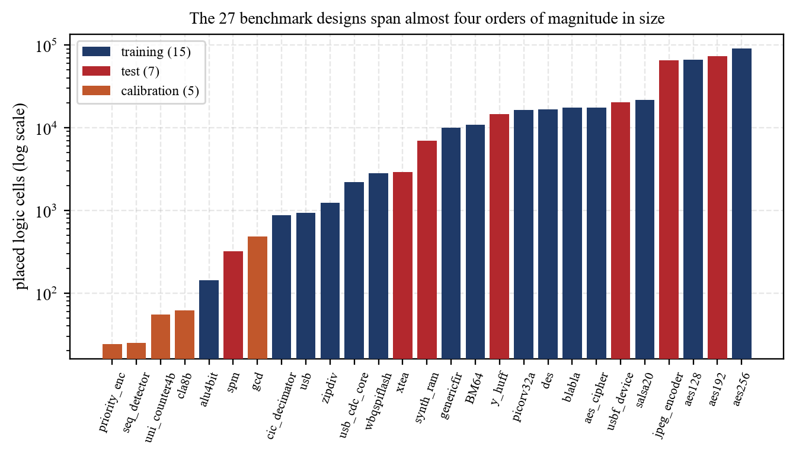
Fig 4.1 Size of the 27 benchmark designs (logic cells, log scale)
Fig 4.2 shows two of the test designs exactly as they were placed, drawn from the coordinates in their DEF files and the cell sizes in the library LEF. The small serial-parallel multiplier spm has 321 logic cells, 64 of them flip-flops; the USB function controller usbf_device has 20,150.
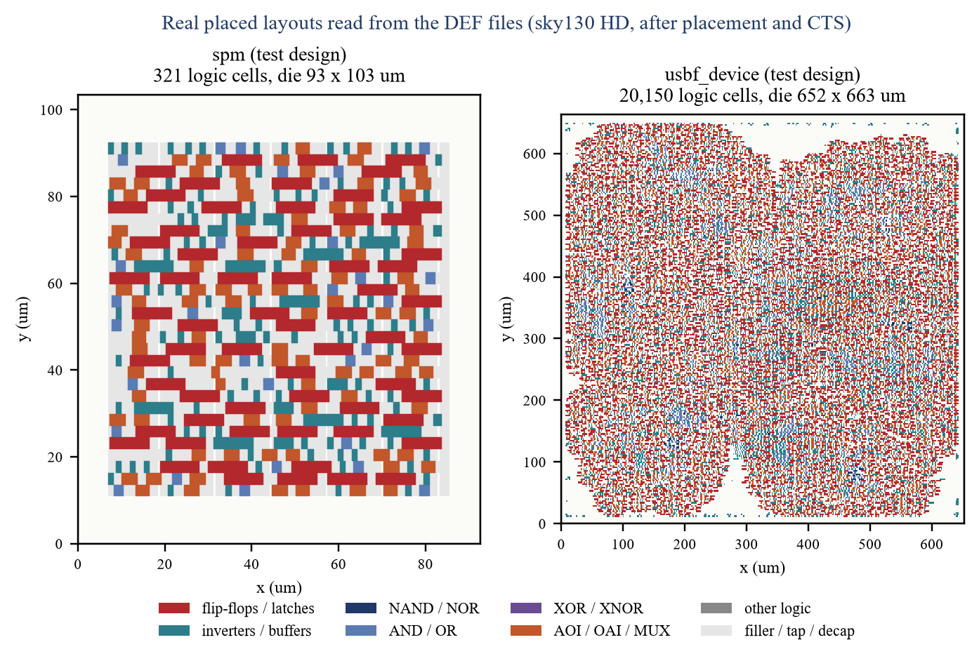
Fig 4.2 Real placed layouts of two test designs, drawn from their DEF files

Chapter 5: Phase 1: One-Dimensional CNN on ECG

5.1 Problem Statement
The task of the first phase was to classify short single-lead ECG recordings into four classes: normal sinus rhythm, atrial fibrillation, other rhythm, and recordings too noisy to classify. It is a one-dimensional pattern-recognition problem on a sampled signal, which is the natural setting for a one-dimensional convolutional network: its filters behave like matched filters tuned to the shape of a heartbeat.

5.2 The Dataset
The PhysioNet/CinC Challenge 2017 dataset [10] contains 8,528 single-lead recordings sampled at 300 Hz, from 9 to 61 seconds long, each with one label. The classes are strongly unbalanced (Table 5.1, Fig 5.1): a classifier that always answers “normal” would already be 59.5 per cent accurate, which is why the macro F1 score is used to compare the models.
Table 5.1 Classes of the PhysioNet/CinC 2017 dataset
Label | Class | Recordings | Share
N | Normal sinus rhythm | 5,076 | 59.5 %
A | Atrial fibrillation | 758 | 8.9 %
O | Other rhythm | 2,415 | 28.3 %
~ | Too noisy to classify | 279 | 3.3 %
 | Total | 8,528 | 100 %

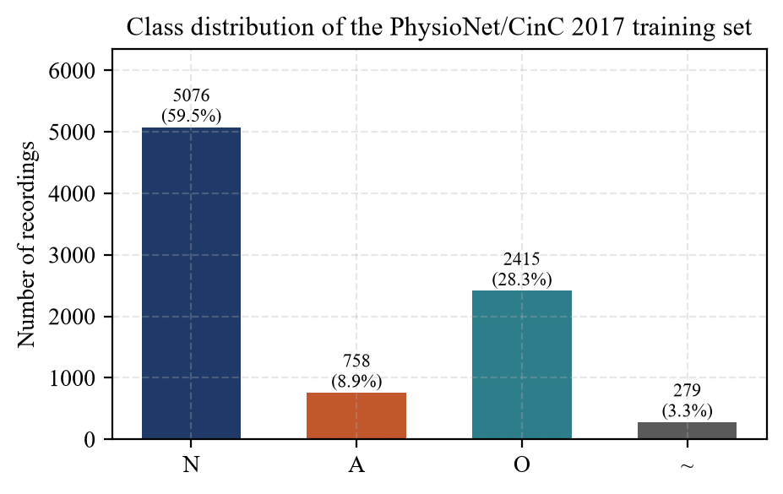
Fig 5.1 Class distribution of the dataset

5.3 Preprocessing
Every recording was brought to a fixed length of 9,000 samples, thirty seconds at 300 Hz: longer records were truncated and shorter ones extended by edge padding, which repeats the last sample rather than inserting an abrupt step of zeros. Each record was normalised to zero mean and unit variance using its own statistics, so that differences in electrode gain do not reach the network. The data were divided into training, validation and test subsets by recording, in a stratified manner.

5.4 Network Architecture
Several networks were compared, from a plain convolutional baseline to a residual network with squeeze-and-excitation blocks. The best is shown in Fig 5.2: a stem convolution of 128 filters of length 25, four residual blocks of the same width, each with an SE gate that narrows the 128 channels to 16 and back, global average pooling, and two dense layers with dropout. A filter of 25 samples spans about 83 ms, the order of a QRS complex, so one filter can respond to a whole beat feature.
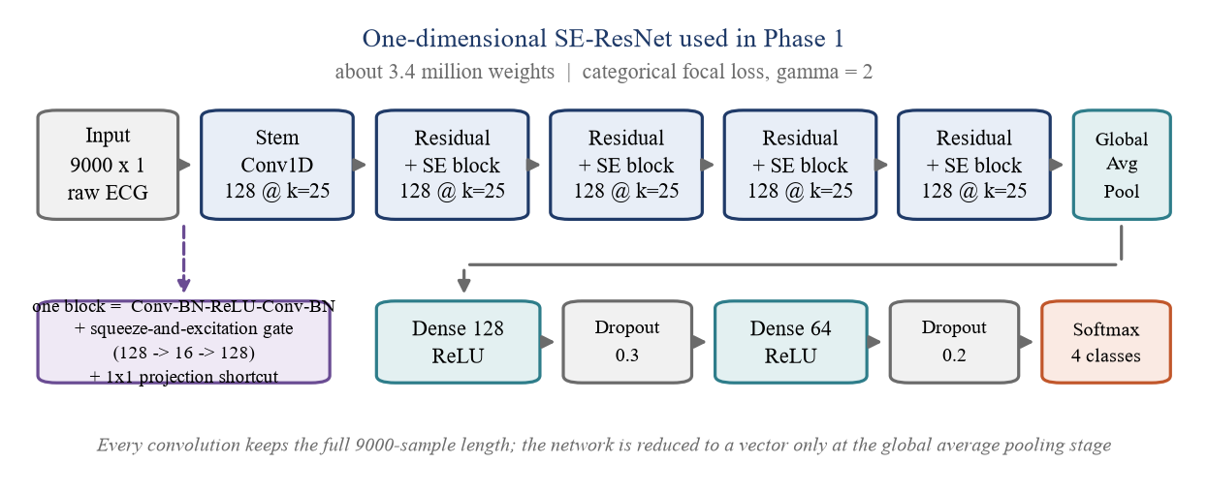
Fig 5.2 Architecture of the one-dimensional SE-ResNet

5.5 Training
Because the normal class is eighteen times as frequent as the noisy class, the focal loss [13] was used (Eq. 5.1). It scales the cross-entropy of each sample by (1 − pₜ)^γ, where pₜ is the probability given to the true class, so the gradient is dominated by the samples still classified wrongly; γ = 2 was used.
FL(pₜ) = − αₜ (1 − pₜ)^γ log(pₜ) (5.1)
Table 5.2 Training settings of the one-dimensional networks
Setting | Value
Input | 9,000 samples × 1 channel
Loss | Categorical focal loss, γ = 2
Optimiser | Adam, learning rate 1e-3
Batch size | 32
Early stopping | on validation macro F1
Learning-rate schedule | reduce on plateau
Test set | 1,706 held-out recordings

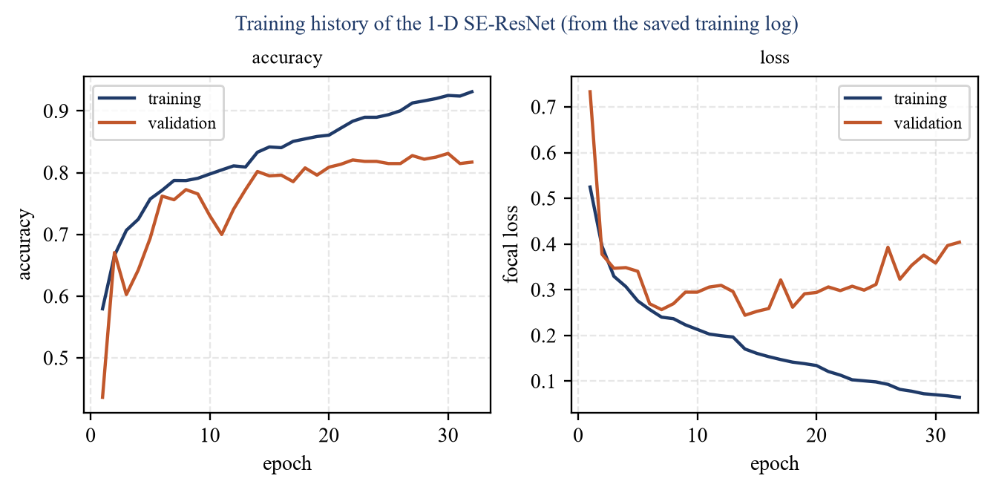
Fig 5.3 Training history of the one-dimensional SE-ResNet
The training history (Fig 5.3) was read from the log saved during training. The best validation accuracy, 0.831, was reached at epoch 30, and the model of that epoch was kept.

5.6 Results of Phase 1
Table 5.3 Results of the one-dimensional networks on the test set
Model | Test accuracy | Macro F1 | Test loss
Baseline 1-D CNN | 0.7790 | 0.7169 | 0.5828
1-D CNN with four convolution blocks | 0.7315 | 0.6840 | 0.8184
Simple CNN with squeeze-and-excitation | 0.7761 | 0.6942 | 0.6312
SE-ResNet, 128 filters, kernel 25 | 0.8048 | 0.7302 | 0.2402

Table 5.4 Per-class results of the one-dimensional SE-ResNet on the test set
Class | Precision | Recall | F1 score | Recordings
N normal | 0.8936 | 0.8601 | 0.8765 | 1,015
A atrial fibrillation | 0.8258 | 0.7171 | 0.7676 | 152
O other rhythm | 0.7125 | 0.7081 | 0.7103 | 483
~ noisy | 0.4188 | 0.8750 | 0.5665 | 56
Macro average | 0.7127 | 0.7901 | 0.7302 | 1,706
Weighted average | 0.8207 | 0.8048 | 0.8096 | 1,706

The SE-ResNet reached 80.5 per cent accuracy and 0.730 macro F1 on 1,706 held-out recordings, with a per-class recall of 0.86 for normal rhythm, 0.72 for atrial fibrillation, 0.71 for other rhythms and 0.88 for noisy records. The weakest class is “other rhythm”, which is a collection of everything that is neither normal nor atrial fibrillation and so has no single waveform signature. Simply adding convolution blocks made the plain network worse (0.684 against 0.717); what helped was the kind of depth, residual blocks with attention, which also cut the test loss from 0.583 to 0.240.

Chapter 6: Phase 2: Two-Dimensional CNN on Time-Frequency Images

6.1 Motivation
A common idea in the literature is to convert a one-dimensional signal into a time-frequency image and classify it with an image network, which makes the frequency content explicit and opens up the large body of two-dimensional architectures. Phase 2 tested whether that idea holds for this dataset (Fig 6.1).
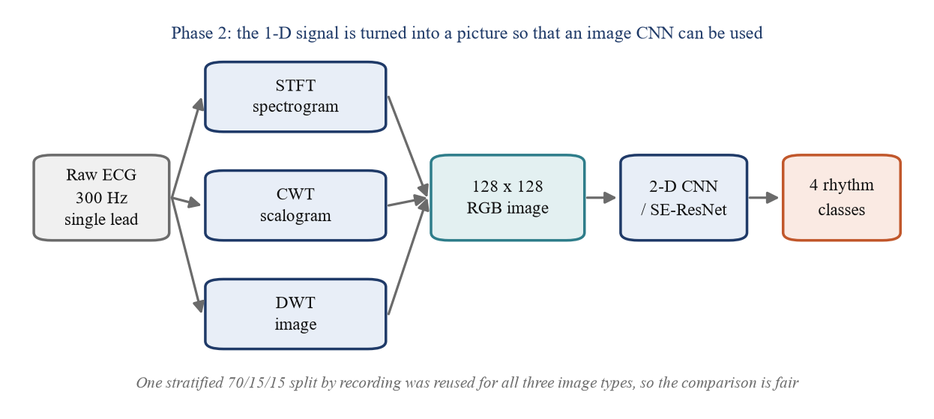
Fig 6.1 From a one-dimensional signal to a two-dimensional image

6.2 Generating the Images
Three representations were generated for all 8,528 recordings as 128 × 128 colour images (Table 6.1, Fig 6.2). One stratified split into 5,968 training, 1,280 validation and 1,280 test recordings was made once and reused for every image type, so that the networks differ only in the representation they see.
Table 6.1 The three time-frequency representations
Representation | Transform | What it shows
Spectrogram | Short-time Fourier transform, 64-sample window, 32 overlap | Energy in fixed frequency bands against time
Scalogram | Continuous wavelet transform | Energy against scale and time; finer time resolution at high frequency
DWT image | Discrete wavelet transform, Daubechies-4, multi-level | Decomposition levels stacked as rows; compact but coarse

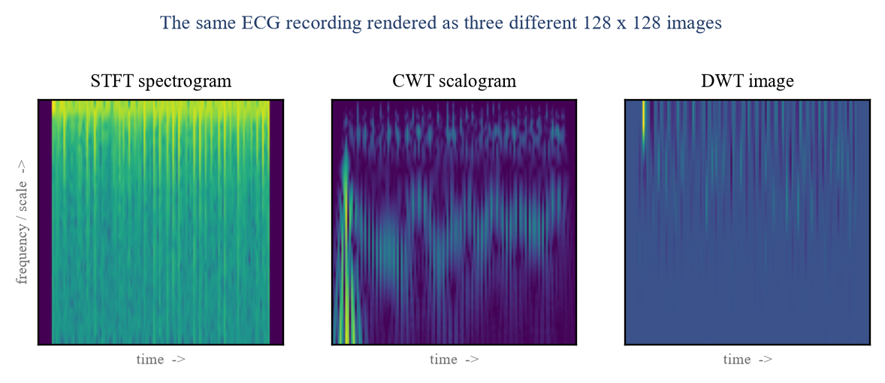
Fig 6.2 One recording as a spectrogram, a scalogram and a DWT image

6.3 Architecture Sweep and Kernel Ablation
A configurable network was swept over two, three and four convolution blocks and one or two dense layers, giving six architectures, each trained on each of the three image types: eighteen networks in all (Fig 6.3). The DWT image was the worst representation in all six configurations, while the spectrogram and the scalogram were close, the spectrogram ahead in four configurations and the scalogram in two. Deeper networks were better in all but one case, and the best of the eighteen, four blocks with one dense layer on scalograms, reached 0.641 macro F1. A further ablation compared kernel sizes on the same task (Table 6.2).
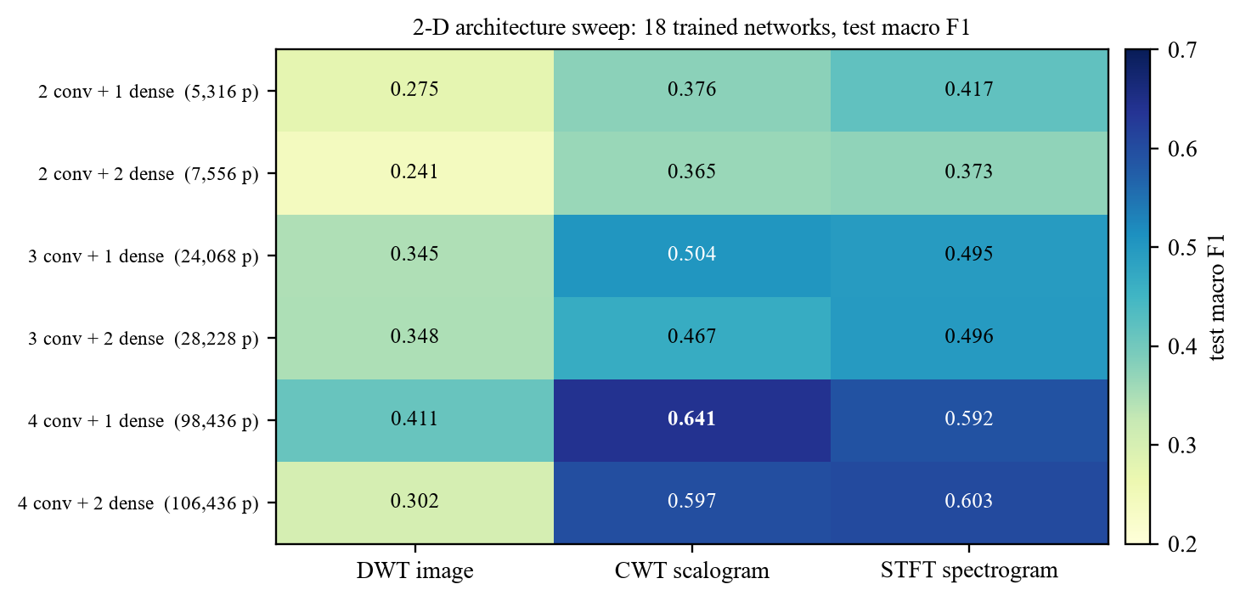
Fig 6.3 Test macro F1 of the 18 networks of the architecture sweep
Table 6.2 Kernel-size ablation (simple two-dimensional CNN)
Kernel | Test accuracy | Macro F1
2 × 2 | 0.6195 | 0.3003
3 × 3 | 0.6438 | 0.3973
mixed | 0.6219 | 0.3171

6.4 Residual Networks
Two deliberate translations of the Phase 1 network were then built so that the only remaining variable was signal against image (Fig 6.4). The squeeze-and-excitation version keeps the residual blocks and attention gates and uses 3 × 3 kernels with widths of 64, 128 and 128; the plain residual baseline uses 5 × 5 kernels, the same kernel area as the one-dimensional kernel of 25. Both were trained with the focal loss and with random-crop-and-repeat-pad augmentation.
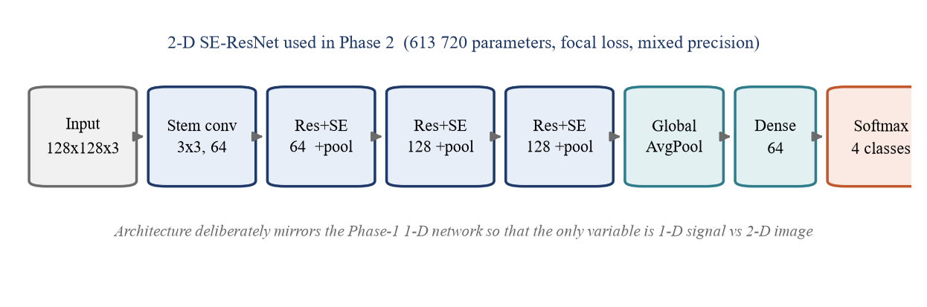
Fig 6.4 Architecture of the two-dimensional SE-ResNet

6.5 Results of Phase 2
Table 6.3 Best results of the two-dimensional networks on the test set
Model and input | Parameters | Test accuracy | Macro F1
2-D SE-ResNet, spectrograms | 613,720 | 0.7586 | 0.6605
2-D ResNet baseline, spectrograms | — | 0.7539 | 0.6536
Sweep best: 4 conv + 1 dense, scalograms | 98,436 | 0.7227 | 0.6408
Sweep best on spectrograms (4 conv + 2 dense) | 106,436 | 0.7000 | 0.6027
Sweep best on DWT images (4 conv + 1 dense) | 98,436 | 0.5312 | 0.4109

Table 6.4 Per-class results of the two-dimensional SE-ResNet on the test set
Class | Precision | Recall | F1 score | Recordings
N normal | 0.7878 | 0.9357 | 0.8554 | 762
A atrial fibrillation | 0.7706 | 0.7434 | 0.7568 | 113
O other rhythm | 0.7277 | 0.4050 | 0.5204 | 363
~ noisy | 0.4219 | 0.6429 | 0.5094 | 42
Macro average | 0.6770 | 0.6817 | 0.6605 | 1,280

The weakness of the image route is concentrated in the “other rhythm” class, whose recall falls to 0.405 against 0.708 for the one-dimensional network: the fine timing irregularities that separate it from normal rhythm are blurred when the recording is reduced to a 128 × 128 image.
The residual baseline also overfitted clearly: 0.813 macro F1 on the training data against 0.654 on the test data. Turning a signal of 9,000 values into an image of 49,152 values adds input without adding information, so with a fixed number of recordings the network has more room to memorise.

6.6 Why the Approach Was Discontinued
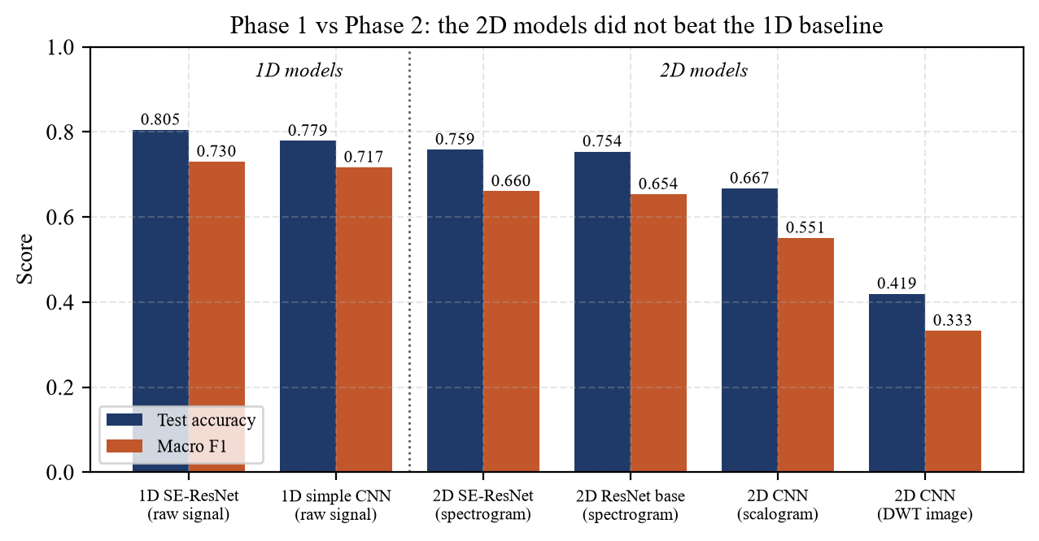
Fig 6.5 Accuracy and macro F1 of the one- and two-dimensional models
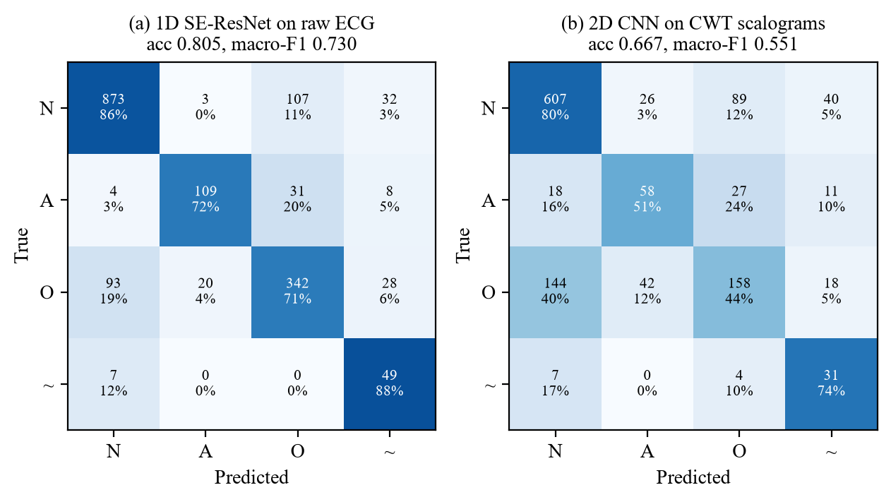
Fig 6.6 Confusion matrices: 1-D SE-ResNet and a 2-D CNN on scalograms
Table 6.5 Best model of each phase
 | Phase 1: 1-D, raw signal | Phase 2: 2-D, image
Test accuracy | 0.8048 | 0.7586
Macro F1 | 0.7302 | 0.6605
Input values per recording | 9,000 | 49,152
Preprocessing | normalisation only | a transform of every record

The conclusion was negative. On every measure the best two-dimensional network was below the one-dimensional network it had been translated from, while costing a transform of every recording and a much larger input. A one-dimensional convolution can already learn frequency-selective filters, and at this dataset size the extra input dimension hurt more than the explicit frequency axis helped. The result was reviewed with the supervisor, and rather than keep tuning an idea that had been given a fair test and lost, the internship was re-scoped to a problem whose natural structure is a graph.

Chapter 7: Phase 3: CalibTimer — Data and Graph Construction

7.1 Overview
CalibTimer takes a design that has been placed but not routed and predicts, for every pin, the arrival time and slew, and the delay of every wire and every gate arc; slack follows from the predicted arrival time. The system has three parts: a parser that turns the design files into a graph, the network, and a calibration step that turns a predicted slack into an interval. This chapter covers the first part.

7.2 Design Files and Parser
Table 7.1 Files read for each design
File | Content | Used for
.synthesis_preroute.v | Structural Verilog netlist | Pins and their connections
.def | Placement (DEF) | x, y of every cell and pin; die area
.spef | Extracted parasitics (SPEF) | Capacitance of every net
.sdf | Annotated delays (SDF) | Cell-arc and net delay labels
.at.sdf | Timing result of OpenSTA | True arrival time, slew and RAT per pin
.cts_1.sdc | Timing constraints (SDC) | Clock period and input delays
sky130 .lib | Liberty library | 7 × 7 delay and slew tables per arc

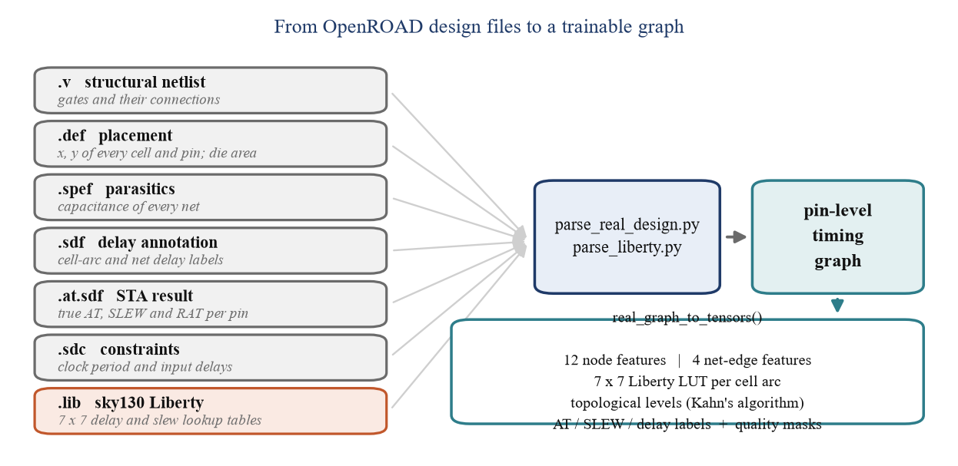
Fig 7.1 From the design files to a trainable graph
Writing the parsers was a substantial part of the phase, because the formats are verbose and differ in dialect. Two defects found and fixed during the work were in this stage: timing endpoints were at first identified wrongly, and the true arrival times read from the .at.sdf file were at first parsed and then silently replaced by a propagated estimate. A third, found only by the tests of Chapter 9, is described in Section 9.4. Results obtained before each fix are not reported.

7.3 Graph Construction
Each design becomes a directed graph in which a node is one pin of a cell or one primary input or output (Fig 7.2). A net edge joins the pin that drives a net to every pin the net feeds and carries the wire delay; a cell edge joins an input pin of a gate to its output and is one timing arc of the gate.
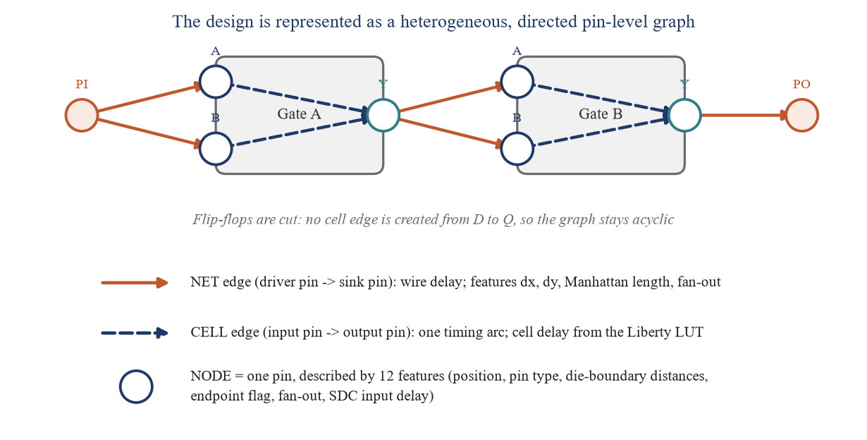
Fig 7.2 The heterogeneous pin-level timing graph (schematic)
Flip-flops need care. A sequential cell is recognised by its clock pin, and no cell edge is created from its data input to its output, since the output does not depend on the input within one clock cycle. Without this rule a flip-flop whose output feeds back into its own input cone creates a loop, the graph stops being acyclic and no topological order exists.
SEQUENTIAL_CLOCK_PORTS = {"CLK", "CLK_N", "GCLK"}
is_sequential = any(p in SEQUENTIAL_CLOCK_PORTS for p in conns.keys())
...
if is_sequential:
continue # pins become nodes, but no D -> Q cell edge
for ik in in_keys:
cell_edges.append((ik, out_key, cell_type))
Fig 7.3 shows the actual graph that the parser builds for the smallest calibration design, seq_detector, drawn by topological level: 64 pins, 43 net edges and 20 cell edges over 8 levels. Every one of the 27 designs was checked in the same way (Section 9.8); the graph of the largest, jpeg_encoder, has 1,485,105 pins.
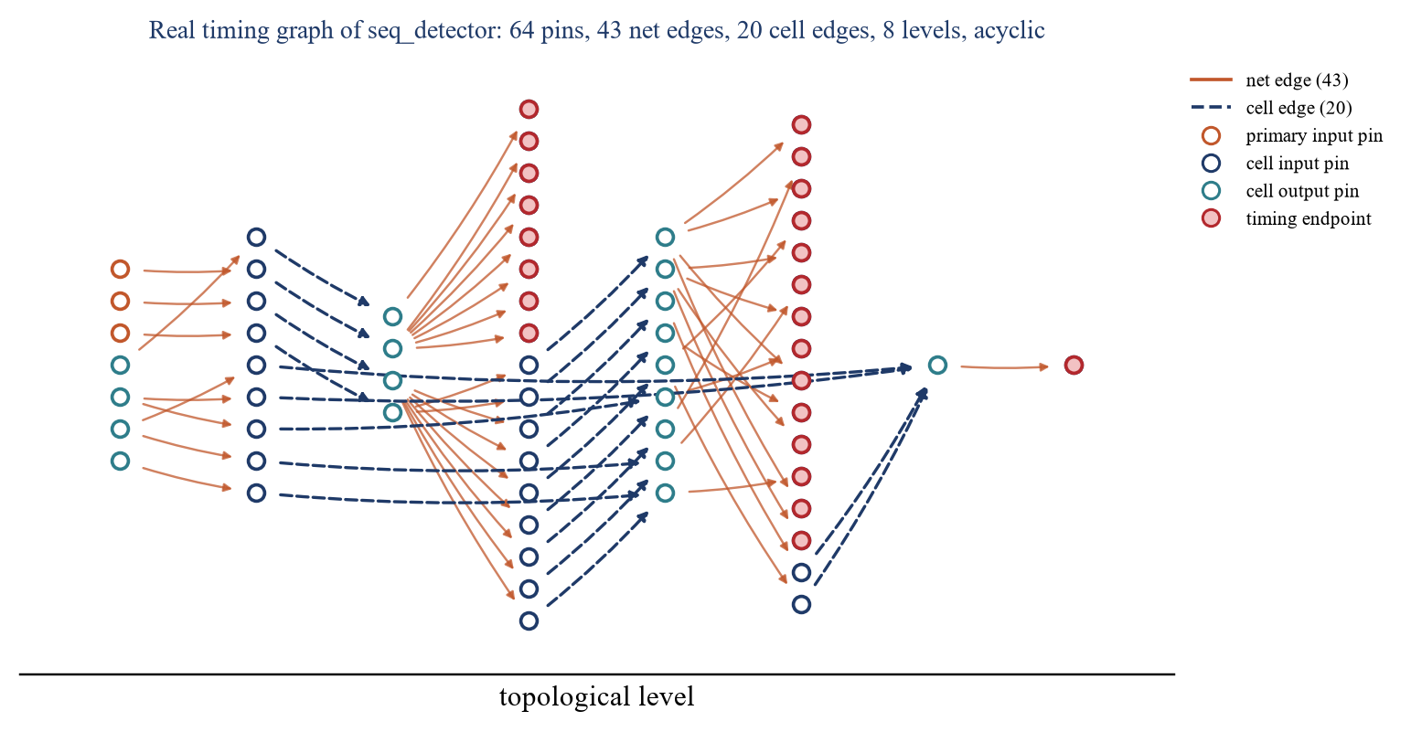
Fig 7.3 The real timing graph of seq_detector, built by the parser

7.4 Node and Edge Features
Every pin is described by twelve numbers, all available before routing (Table 7.2). Every net edge carries four: the horizontal and vertical separation of its pins, their Manhattan distance and the fan-out of the driver. Every cell edge carries a one-hot code of the cell type and the seven-by-seven delay and slew tables of its arc, read from the Liberty file.
Table 7.2 The twelve node features
Index | Feature | Reason
0, 1 | x and y position, normalised | Wire delay depends on distance
2, 3, 4 | Primary input, cell input, cell output | Pin types behave differently
5–8 | Distance to the four die edges | Wiring environment near the boundary
9 | Timing endpoint flag | Pins at which slack is evaluated
10 | Fan-out, normalised | Load seen by a driver
11 | Input delay from the SDC, normalised | Arrival time at a primary input (see Section 9.4)

Fig 7.4 shows one of the 1,241 Liberty arcs exactly as the model receives it: the delay of a two-input NAND gate grows with output load and with input slew, from 0.015 ns to 1.378 ns across the table.
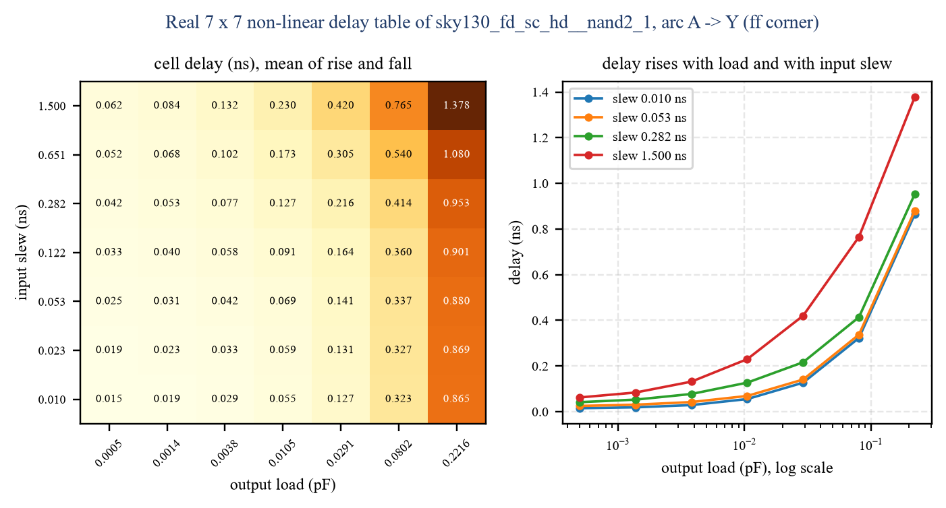
Fig 7.4 A real Liberty delay table (sky130_fd_sc_hd__nand2_1, A to Y)

7.5 Division of the Designs
The 27 designs are divided into three groups that never overlap (Fig 7.5, Table 7.3). Seven are the test designs of the reference work [1] and are never trained on; five small designs were generated separately and are reserved for calibration, since training on them would destroy the statistical validity of the calibration; the remaining fifteen are used for training. The separation is enforced in code: the training script holds the test and calibration names in fixed sets and stops if either appears among the training designs. This guard was added after exactly such an overlap had been found in an earlier version.
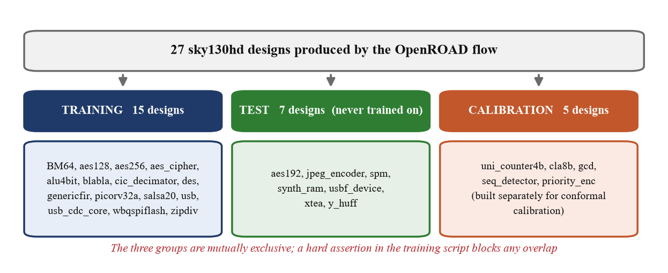
Fig 7.5 Division of the 27 designs into training, test and calibration groups
Table 7.3 The three groups of designs
Group | Count | Designs
Training | 15 | BM64, aes128, aes256, aes_cipher, alu4bit, blabla, cic_decimator, des, genericfir, picorv32a, salsa20, usb, usb_cdc_core, wbqspiflash, zipdiv
Test | 7 | aes192, jpeg_encoder, spm, synth_ram, usbf_device, xtea, y_huff
Calibration | 5 | uni_counter4b, cla8b, gcd, seq_detector, priority_enc

PAPER_TEST_DESIGNS = {"jpeg_encoder", "usbf_device", "aes192", "xtea",
"spm", "y_huff", "synth_ram"}
CALIBRATION_DESIGNS = {"uni_counter4b", "cla8b", "gcd",
"seq_detector", "priority_enc"}
train = [d for d in all_designs if d not in PAPER_TEST_DESIGNS
and d not in CALIBRATION_DESIGNS]
assert not [d for d in train if d in PAPER_TEST_DESIGNS], "LEAKAGE GUARD"
assert not [d for d in train if d in CALIBRATION_DESIGNS], "LEAKAGE GUARD"

Chapter 8: Phase 3: CalibTimer — Model and Training

8.1 Network Architecture
The network has two stages (Fig 8.1). The first embeds every pin; the second propagates arrival time and slew through the graph in topological order, exactly as a timing engine does. The whole network has 40,730 trainable parameters.
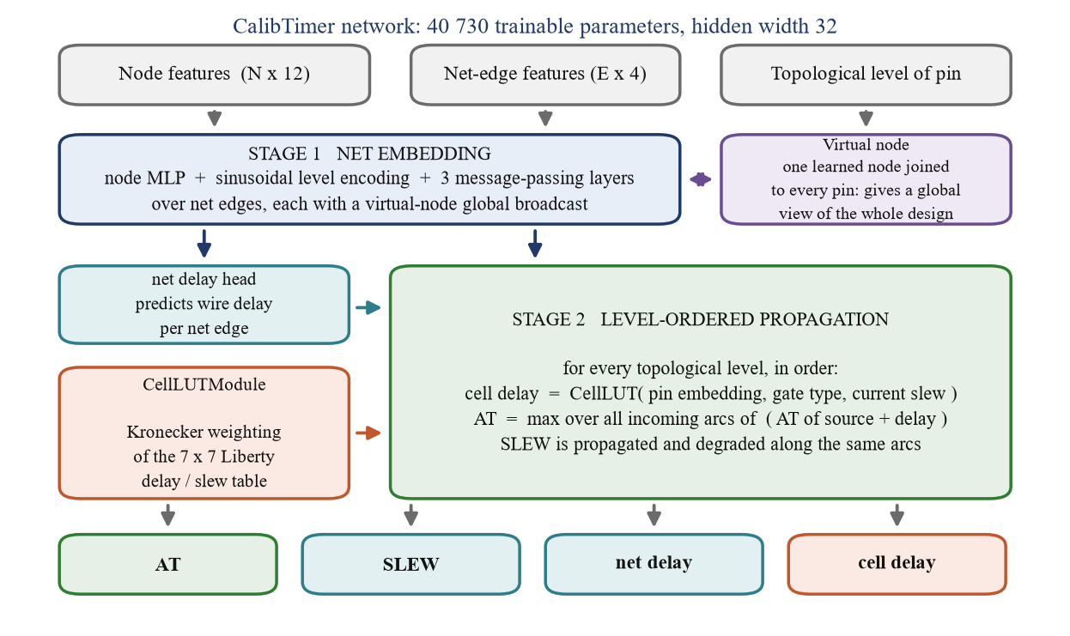
Fig 8.1 Block diagram of the CalibTimer network
In the first stage the twelve node features pass through a small multi-layer perceptron, and a sinusoidal encoding of the pin's topological level is added. Three rounds of message passing (Eq. 3.3) follow along the net edges, each with a residual update. A single virtual node, joined to every pin, is updated from the mean of all pin embeddings and broadcast back before each round, which gives every pin a path of length two to information from anywhere in the design.

8.2 Reading the Liberty Tables
Gate delay is not predicted freely: it is read from the Liberty table T of the arc (Fig 8.2). From the pin embedding, the cell type and the current input slew, a small network predicts seven weights α along the slew axis and seven weights β along the load axis, each normalised by a softmax. Their outer product weights the 49 entries of the table, and a small learned correction c is added (Eq. 8.1). The network therefore learns where to read the characterisation data rather than inventing delays, which is the main reason it needs only about forty thousand parameters.
d̂ = Σᵢ Σⱼ αᵢ βⱼ Tᵢⱼ + 0.2 c (8.1)
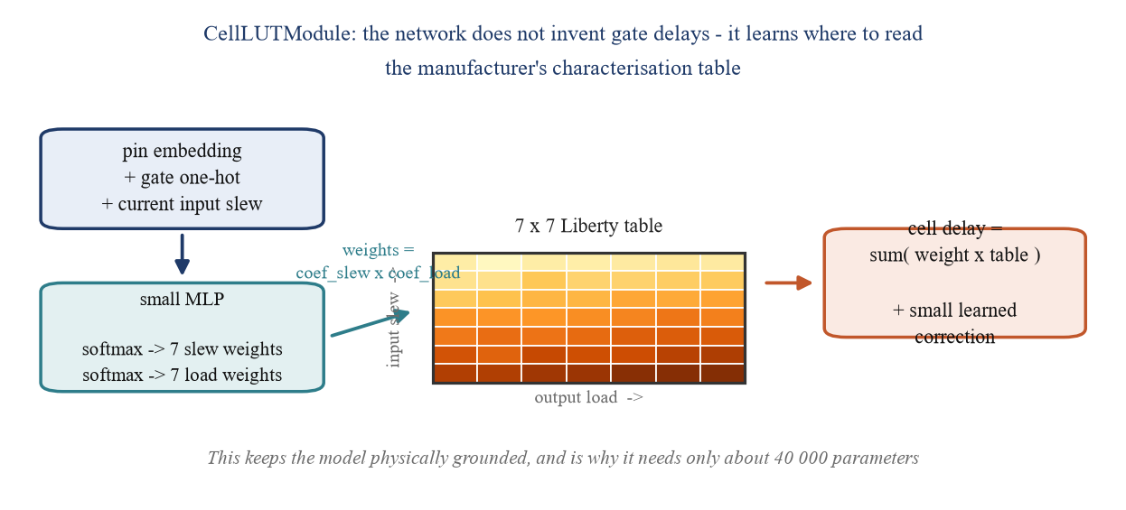
Fig 8.2 The CellLUTModule: a learned read of the Liberty table
coefs = self.coef_mlp(feat) # (E, 2k)
coef_slew = torch.softmax(coefs[:, :self.k], dim=-1) # alpha, slew axis
coef_load = torch.softmax(coefs[:, self.k:], dim=-1) # beta, load axis
weight = torch.einsum('ei,ej->eij', coef_slew, coef_load)
delay_pred = (weight * lut_delay).sum(dim=(1, 2)) \
+ self.correction_mlp(feat).squeeze(-1) * 0.2

8.3 Level-Ordered Propagation
In the second stage the pins are visited level by level, in the order computed once per design with Kahn's algorithm (Fig 8.3). At each level the arrival time is updated by Eq. 3.4 over all incoming net and cell arcs, and slew is propagated along the same arcs. Primary inputs are never the destination of an arc, so a small network predicts a starting arrival time for every pin from its own features, with a softplus so that it cannot be negative.
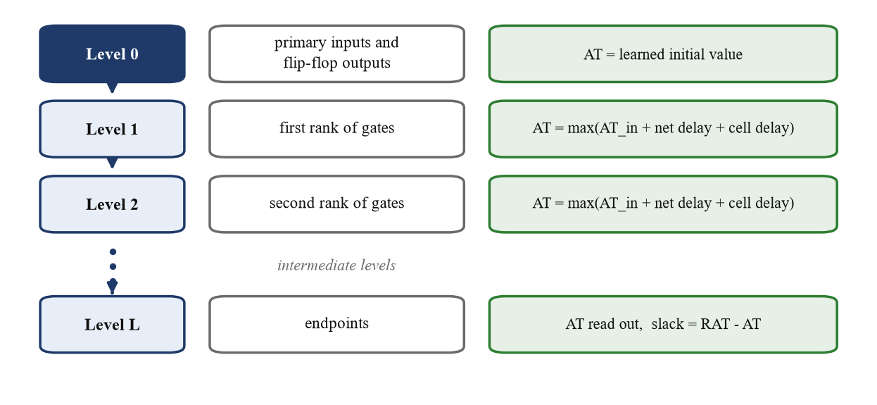
Fig 8.3 Level-ordered propagation of arrival time
for lvl in levels: # topological order
ne = net_by_level[lvl]
cand_at = AT[net_src[ne]] + net_delay[ne]
AT = torch.maximum(AT, AT.index_reduce(0, net_dst[ne], cand_at, "amax"))
ce = cell_by_level[lvl]
cd, cs = self.cell_lut(cell_feat[ce], lut_delay[ce], lut_slew[ce])
cand_at = AT[cell_src[ce]] + cd.clamp(min=0.001)
AT = torch.maximum(AT, AT.index_reduce(0, cell_dst[ce], cand_at, "amax"))

8.4 Loss Function and Training
The network is trained on four quantities at once (Eq. 8.2). Arrival time is weighted most heavily; slew is supervised because it indexes the Liberty table; the net and cell delays are intermediate quantities and are given a smaller weight.
L = 2.0·MSE(AT) + MSE(SLEW) + 0.3·MSE(d_net) + 0.3·MSE(d_cell) (8.2)
During training the propagation can use either the true delays or the delays the network has just predicted. True delays keep early training stable; predicted delays are what happens at test time. The probability of using the true delays is therefore lowered linearly over the run (Eq. 8.3, epoch e of E), so that by the end the network practises the conditions it will be tested under.
p_true(e) = 1 − (e − 1) / (E − 1) (8.3)
Table 8.1 Training configuration of the final model
Setting | Value
Hidden dimension / message-passing layers | 32 / 3
Liberty table resolution | 7 × 7
Trainable parameters | 40,730
Optimiser | Adam, learning rate 2e-3, weight decay 1e-4
Learning-rate schedule | Reduce on plateau, factor 0.5
Gradient clipping | Maximum norm 1.0
Epochs / early-stopping patience | 500 / 25 evaluations
Model selection | Mean of the per-design arrival-time R²

8.5 Experiments
Three candidate improvements were tested, each as a single change against the same baseline: using the SDC input delay directly as the arrival time of primary inputs (fix 1), normalising the topological level by the depth of each design (fix 2), and weighting the arrival-time loss towards pins with a large arrival time (fix 3). Together they helped jpeg_encoder and y_huff and hurt spm, xtea and synth_ram, for a lower mean even after 500 epochs (Table 8.2, Fig 8.4), so all three were reverted. Section 9.4 shows why fix 1 could not have worked.
Table 8.2 Experiments: mean arrival-time R² on the seven test designs
Run | Change | Epochs | Best epoch | Mean R²
Final model | none | 500 | 370 | 0.8988
Run C | fixes 1 + 2 + 3 | 300 | 300 | 0.8787
Run D | fixes 1 + 2 + 3 | 500 | 400 | 0.8919
Cycle 3 | fixes 1 to 7 at once | — | — | 0.869

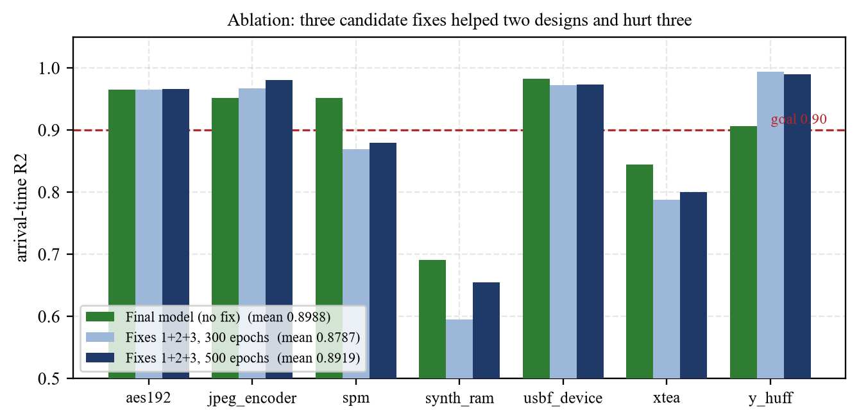
Fig 8.4 Per-design effect of the candidate fixes

Chapter 9: Results and Testing

9.1 Measures Used
Accuracy is measured by the coefficient of determination R² between predicted values ŷ and true values y over the evaluated pins (Eq. 9.1), and by the mean absolute error in nanoseconds (Eq. 9.2). R² = 1 is a perfect prediction and R² = 0 is no better than predicting the mean.
R² = 1 − Σ (yᵢ − ŷᵢ)² / Σ (yᵢ − ȳ)² (9.1)
MAE = (1/n) Σ | yᵢ − ŷᵢ | (9.2)
The headline figure is the mean of the seven per-design R² values. Pooling all pins instead would be dominated by the largest designs, which contribute more than a million evaluated pins each against about four thousand for the smallest, and could hide a failure on a small design. The goal set at the start of the phase was R² ≥ 0.90 on every test design.

9.2 Training Behaviour
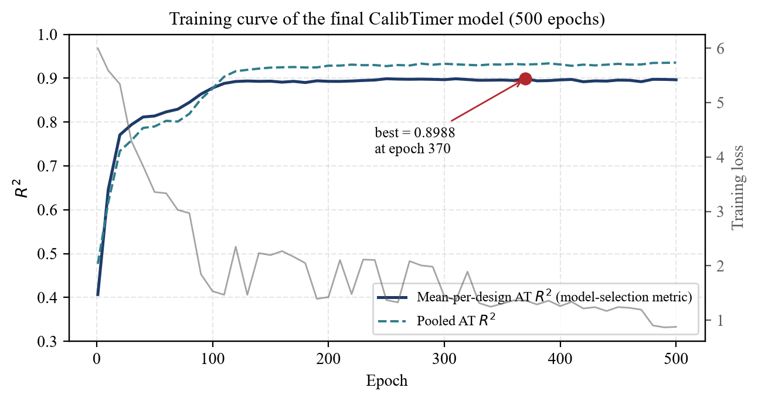
Fig 9.1 Training curve of the final model
The model reaches 0.878 after 100 epochs and 0.894 after 130, then improves very slowly to 0.8988 at epoch 370 (Fig 9.1). The pooled curve keeps rising after the per-design curve has flattened, which is the effect described above and the reason the per-design mean was used to select the model.

9.3 Accuracy on the Unseen Test Designs
Table 9.1 Results on the seven unseen test designs
Design | Evaluated pins | AT R² | MAE (ns) | Within 0.25 ns | Slack R²
usbf_device | 235,855 | 0.9824 | 0.0367 | 96.6 % | 0.9951
aes192 | 1,260,521 | 0.9654 | 0.0455 | 98.2 % | 0.9753
spm | 4,206 | 0.9515 | 0.0314 | 94.2 % | 0.9961
jpeg_encoder | 1,281,201 | 0.9513 | 0.0337 | 99.0 % | 0.9836
y_huff | 166,619 | 0.9063 | 0.0457 | 97.1 % | 0.9737
xtea | 31,743 | 0.8441 | 0.0441 | 98.4 % | 0.9883
synth_ram | 96,105 | 0.6909 | 0.2825 | 95.3 % | 0.9725
Mean of the seven |  | 0.8988

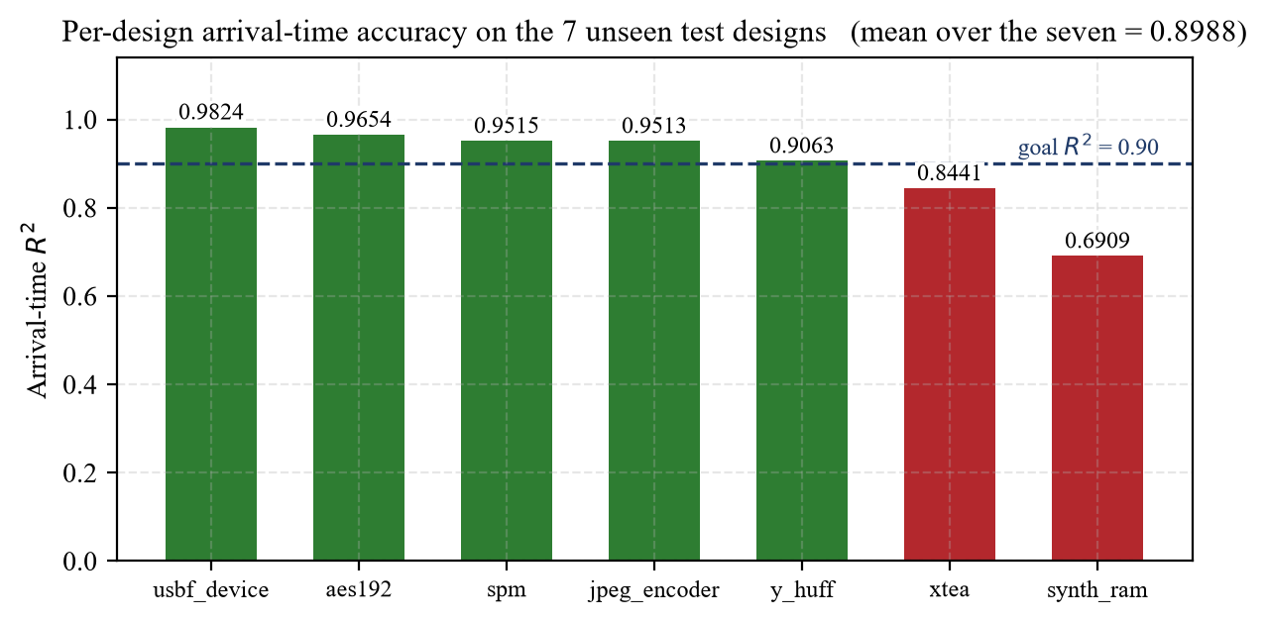
Fig 9.2 Arrival-time R² on each unseen test design
Five of the seven designs exceed the goal and four exceed 0.95 (Table 9.1, Fig 9.2). In absolute terms the error is small: on six of the seven designs the mean error is between 0.031 ns and 0.046 ns, and between 94 and 99 per cent of the pins of every design are predicted to within a quarter of a nanosecond (Fig 9.4). The slack column is not independent evidence: slack is the exact required time minus the predicted arrival time, so its error is the arrival-time error with the sign reversed, and its R² is higher only because slack has a larger spread.
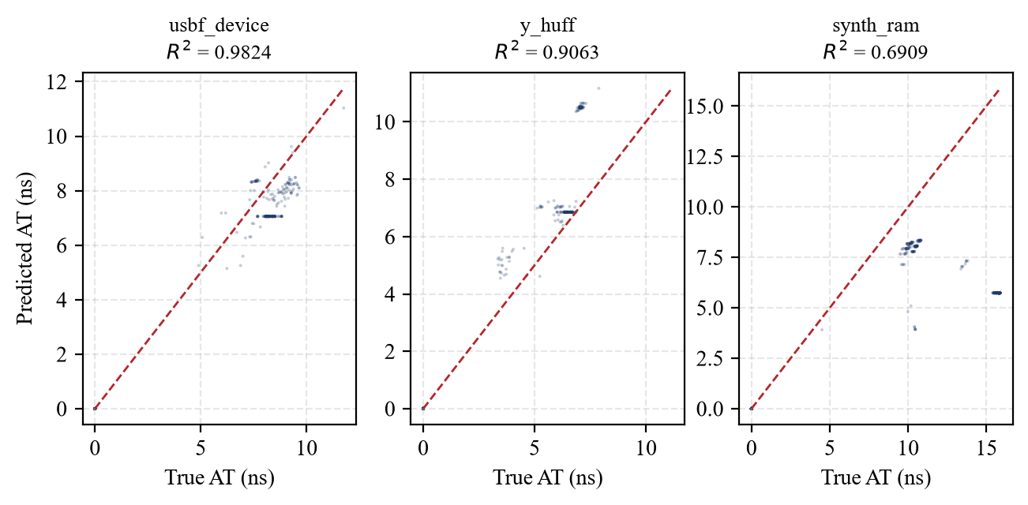
Fig 9.3 Predicted against true arrival time for three test designs
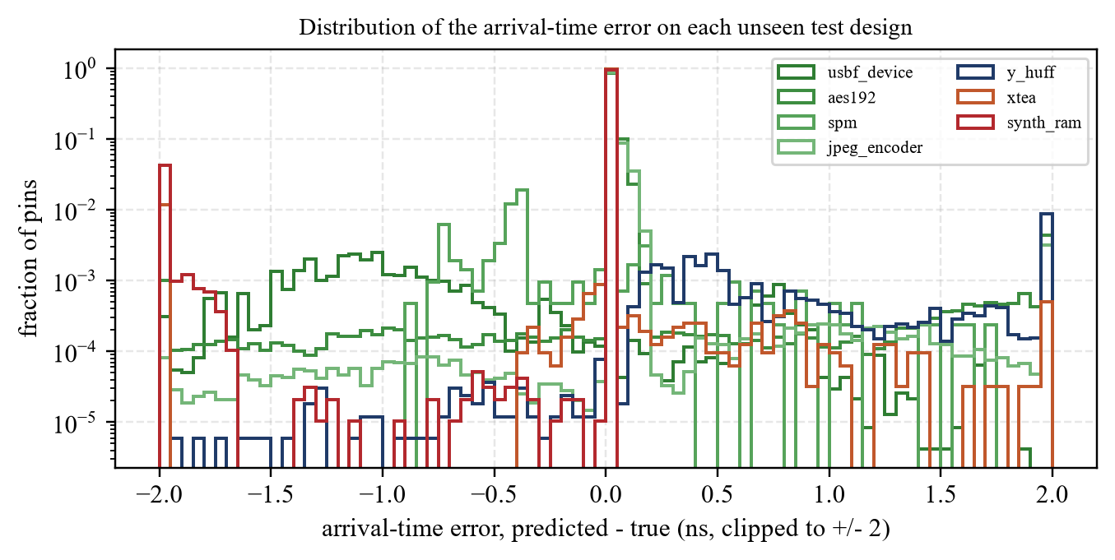
Fig 9.4 Distribution of the arrival-time error on each test design
Fig 9.5 places the predictions back on the real die of usbf_device: the true and the predicted arrival time of 89,107 placed pins, and their difference. The two maps are almost indistinguishable, and the error is spread thinly over the whole die rather than concentrated in one region.
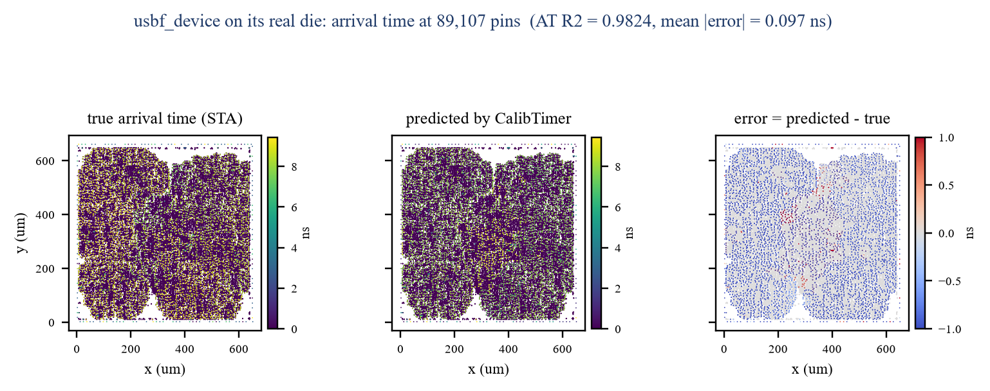
Fig 9.5 Arrival time on the real die of usbf_device: true, predicted and error

9.4 The Failure Case and What Was Done
Two designs miss the goal: xtea at 0.8441 and synth_ram at 0.6909. The working explanation during training was that they lay outside the training distribution, xtea in its input delay and synth_ram in its logic depth, and fixes 1 and 2 of Section 8.5 were aimed at exactly those. Neither helped. The tests of Section 9.8 showed why: both explanations were wrong, and one of the fixes had been acting on an input that was always zero.

What the tests found
- Depth is not the cause. synth_ram has only 24 topological levels, while the training designs reach 146 (picorv32a), 128 (salsa20) and 122 (blabla); xtea's 98 levels are also inside the training range.
- The input-delay feature was dead. Every SDC file states its input delays in the form set_input_delay 5.2060 -clock [get_clocks {clock}] -add_delay [get_ports {data_in1[0]}]. The parser's pattern skipped forward only to the first square bracket, which belongs to get_clocks, so it never reached get_ports. It matched none of the 4,317 input-delay constraints in the 27 designs, and node feature 11 was zero on every pin of every design. Fix 1 therefore set the arrival time of every primary input to exactly 0 ns.
- The failures line up with input delay. The true arrival time at a primary input equals its SDC input delay exactly. The five designs that pass have input delays of 2.0 to 3.2 ns; the two that fail have the two largest, xtea 5.2 ns and synth_ram 10.0 ns (Fig 9.6a, Table 9.2).
Table 9.2 Arrival time at the primary-input pins (medians) and the overall error bias
Design | SDC input delay (ns) | True AT at inputs (ns) | Predicted AT at inputs (ns) | Mean error (ns) | AT R²
spm | 2.000 | 2.000 | 1.614 | -0.0168 | 0.9515
y_huff | 2.270 | 2.270 | 3.850 | +0.0451 | 0.9063
aes192 | 2.474 | 2.474 | 7.508 | +0.0261 | 0.9654
usbf_device | 2.920 | 2.920 | 1.410 | -0.0306 | 0.9824
jpeg_encoder | 3.156 | 3.156 | 7.801 | +0.0301 | 0.9513
xtea | 5.206 | 5.206 | 2.727 | -0.0357 | 0.8441
synth_ram | 10.000 | 10.000 | 3.137 | -0.2824 | 0.6909

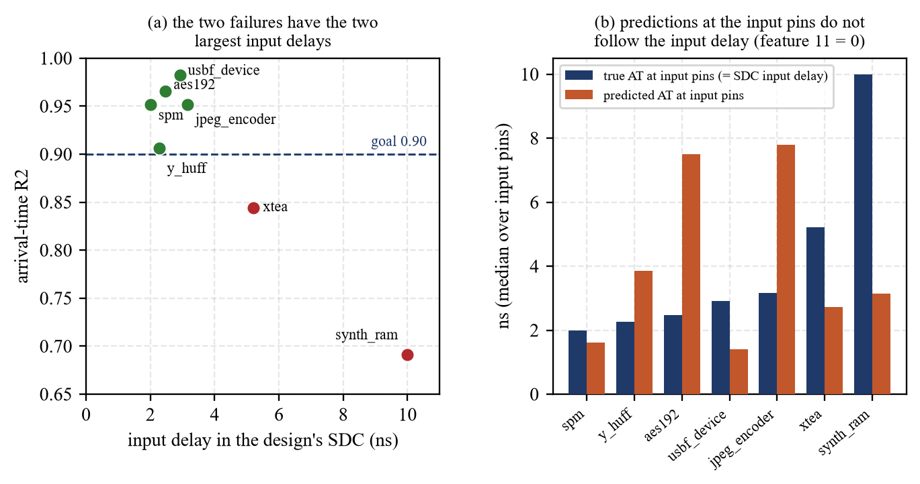
Fig 9.6 The failures against the input delay, and the arrival time predicted at the input pins
For synth_ram the explanation holds. Its inputs truly arrive at 10.0 ns, but with feature 11 at zero the network has no way to know this and starts them at about 3.1 ns. It is the only test design with a systematic bias, −0.28 ns against at most 0.05 ns on the other six, which is what launching every input-driven path about seven nanoseconds early would produce. For xtea the evidence is weaker: its bias is as small as that of the passing designs, so its input delay cannot be the whole story, and the cause of its lower score is not yet established.
A corrected pattern was written and checked against every SDC file; it reads all 4,317 constraints, including bus ports such as data_in1[0].
# before: stops at the first '[', which is [get_clocks ...]
r'set_input_delay\s+([\d.]+)[^\[]*\[get_ports\s*\{?\s*([^\}\]]+?)\s*\}?\s*\]'
# after: skips any options, including [get_clocks {...}]
r'set_input_delay\s+([\d.]+)\b.*?\[get_ports\s+(?:\{([^}]+)\}|([^\]\s]+))\s*\]'
Because the feature changes the data the model is trained on, the corrected parser requires a new training run; that run is the first item of future work (Section 10.7). The numbers reported in this chapter are those of the model as trained.

9.5 Conformal Calibration of the Slack Prediction
A single predicted number is of limited use to a designer deciding whether a path is safe; what is needed is an interval that contains the true value with a stated probability. Split conformal prediction [14] provides one without any assumption about the distribution of the errors (Fig 9.7). The trained model is run on the calibration designs, which were held out of training for this purpose; the absolute slack error sᵢ of every calibration pin is computed; and the half-width q of the interval is the finite-sample-corrected quantile of those errors (Eq. 9.3), where n is the number of calibration pins and α the permitted miss rate. Every new prediction then carries the interval of Eq. 9.4.
q = the ⌈(n + 1)(1 − α)⌉-th smallest of sᵢ = | slackᵢ − slack̂ᵢ | (9.3)
C(x) = [ slack̂(x) − q , slack̂(x) + q ] (9.4)
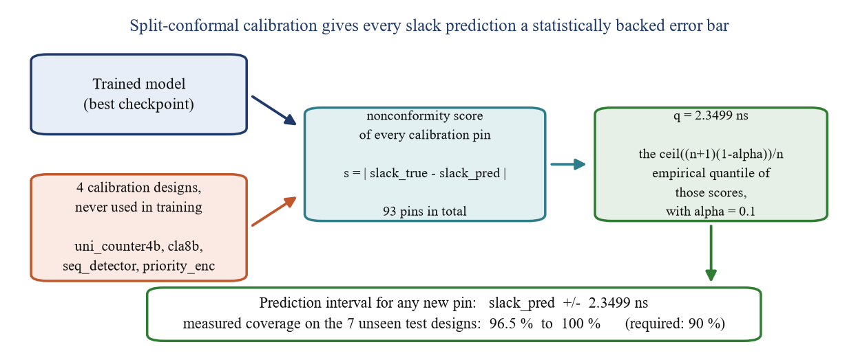
Fig 9.7 The split-conformal calibration procedure
With α = 0.1, that is a required coverage of 90 per cent, calibration on 93 pins from four calibration designs gave q = 2.3499 ns. The fifth, gcd, was left out because its graph is not acyclic (test T3). The coverage of the interval was then measured on the seven unseen designs, over 3,076,250 pins (Table 9.3, Fig 9.8).
Table 9.3 Measured coverage of the calibrated slack interval (± 2.3499 ns)
Design | Pins checked | Required | Measured coverage
aes192 | 1,260,521 | 90.0 % | 99.7 %
jpeg_encoder | 1,281,201 | 90.0 % | 99.7 %
spm | 4,206 | 90.0 % | 100.0 %
synth_ram | 96,105 | 90.0 % | 96.5 %
usbf_device | 235,855 | 90.0 % | 100.0 %
xtea | 31,743 | 90.0 % | 98.8 %
y_huff | 166,619 | 90.0 % | 99.2 %
All test pins | 3,076,250 | 90.0 % | 99.6 %

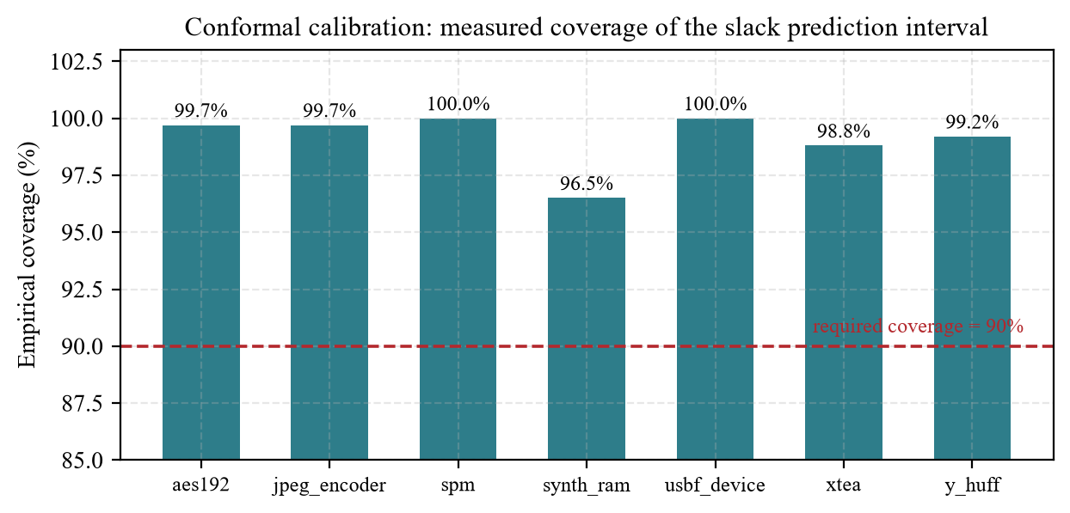
Fig 9.8 Measured coverage of the calibrated interval on each test design
The calibration holds on every design, including synth_ram, the design the model predicts worst, which is precisely where a designer needs the guarantee most. Coverage well above 90 per cent means the interval is conservative, wider than it strictly needs to be, because the four calibration designs are small circuits of a few hundred cells; a larger and more varied calibration pool would tighten it.

9.6 Speed
The point of a predictor is to avoid routing. Table 9.4 gives the time CalibTimer takes on each test design on the laptop of Table 4.2, measured from the design files to the predicted arrival time at every pin, beside the time the reference work [1] reports for its OpenROAD routing plus timing analysis of the same designs. The machines differ, so the ratio is indicative only; the network itself evaluates a complete design in 8 to 160 ms.
Table 9.4 Time to predict a whole design, against routing and STA
Design | Pins | Parse (s) | Tensors (s) | Network (ms) | Total (s) | Routing + STA in [1] (s)
spm | 4,728 | 0.05 | 4.79 | 8 | 4.86 | 18.2
xtea | 40,810 | 0.66 | 0.40 | 37 | 1.10 | 178.9
synth_ram | 111,277 | 1.57 | 0.74 | 57 | 2.37 | 461.3
y_huff | 202,190 | 2.91 | 1.62 | 35 | 4.56 | 1177.4
usbf_device | 281,685 | 4.23 | 2.36 | 47 | 6.63 | 1546.0
aes192 | 1,424,098 | 18.71 | 12.64 | 151 | 31.51 | 1786.6
jpeg_encoder | 1,485,105 | 20.46 | 14.85 | 160 | 35.46 | 4261.3

The first design processed (spm) includes the one-time loading of the Liberty library, about 4.5 s. Excluding it, prediction takes from about one second for xtea to 35 seconds for jpeg_encoder, against 179 s and 4,261 s respectively for routing and analysis.

9.7 Comparison with Reference Papers
Table 9.5 places CalibTimer beside the two papers that report results on the same seven test designs. The figures of the other papers are as their authors report them. The comparison is indicative: the reference work computes R² over all graph nodes, whereas CalibTimer evaluates only the pins that carry a real timing label, and E2ESlack trains on 23 circuits against 15 here.
Table 9.5 Arrival-time R² on the seven test designs: this work and the reference papers
Design | Guo et al. [1] | E2ESlack [2] | This work
jpeg_encoder | 0.8820 | 0.9169 | 0.9513
usbf_device | 0.9252 | 0.9202 | 0.9824
aes192 | 0.8605 | 0.9530 | 0.9654
xtea | 0.9135 | 0.9534 | 0.8441
spm | 0.8975 | 0.9605 | 0.9515
y_huff | 0.9256 | 0.8231 | 0.9063
synth_ram | 0.8656 | 0.8911 | 0.6909
Mean | 0.8957 | 0.9169 | 0.8988
Training designs | 14 | 23 | 15

CalibTimer's mean is close to that of the reference work and below that of E2ESlack. Per design it is the best of the three on jpeg_encoder, usbf_device and aes192, the three largest designs, and the weakest on xtea and synth_ram, the two designs with the largest input delays, consistent with the defect of Section 9.4.

9.8 Testing
The tests in Table 9.6 were run against the code and the trained model of the final run, on the real design files. A test passes when the actual output agrees with the expected output.
Table 9.6 Test cases
ID | Test condition | Expected | Actual | Result
T1 | Leakage guard on the 27 design folders | 15 train, 7 test, no overlap | 27 found; 15 train, 7 test; 0 overlap | Pass
T2 | A test design injected into the training list | Assertion stops the run | Assertion fired: LEAKAGE GUARD | Pass
T3 | Every design parses into an acyclic graph | 27 of 27 acyclic | 26 of 27; gcd contains a cycle | Fail (gcd)
T4 | Feature widths of the tensors | 12 node, 4 net-edge | 12 node, 4 net-edge | Pass
T5 | Clock period read from the SDC | Present for sequential, absent for combinational designs | spm 10, xtea 26.03, synth_ram 50; cla8b and priority_enc none | Pass
T6 | Liberty tables loaded | nand2_1 A→Y found, 7 × 7 | 1241 arcs; found; 7 × 7 | Pass
T7 | Checkpoint reloaded with the run's own source snapshot | Loads without error | Loads | Pass
T8 | Checkpoint reloaded with the current source | Loads | Width mismatch 247 vs 248 (a slew input was added later) | Fail
T9 | Re-measure AT R² from the saved model | Equal to the report | spm 0.9515, xtea 0.8441 (reported 0.9515, 0.8441) | Pass
T10 | Primary inputs not frozen at 0 ns | Predicted AT > 0 | min 0.31 ns (spm), 1.53 ns (xtea) | Pass
T11 | Input delays read from the SDC files | 4,317 of 4,317 | 0 of 4,317; feature 11 = 0 everywhere. Corrected pattern: 4,317 of 4,317 | Fail, fixed
T12 | Conformal coverage on each test design | ≥ 90 % | 96.5 % to 100 % | Pass

Three tests failed, and each failure is informative. T3 explains why gcd was excluded from calibration. T8 shows that a stored source snapshot is not optional: the current code can no longer load the reported model, and without the snapshot of the run the result could not have been reproduced in T9. T11 found the defect of Section 9.4, which had survived every training run because the network trains without error on a feature that is constant.

Chapter 10: Conclusion and Discussion

10.1 Overall Analysis of the Internship
The internship covered a complete research cycle three times, at increasing depth. The first phase built a working pipeline and a convolutional network evaluated with a metric suited to an unbalanced problem. The second tested a popular idea fairly and found it did not hold here, which led to a change of direction rather than more tuning. The third was a genuine research problem: a model matched to the structure of the data, an input pipeline written from industrial formats, an evaluation strict enough for the numbers to mean something, a calibration step that gives them a guarantee, and a set of tests that found what training alone had not.

10.2 Main Results
- A one-dimensional SE-ResNet classifies the PhysioNet/CinC 2017 recordings with 80.5 % accuracy and 0.730 macro F1.
- Eighteen two-dimensional networks and two residual translations on time-frequency images reach at best 0.660 macro F1, below the one-dimensional network.
- CalibTimer, with 40,730 parameters, predicts pin-level arrival time on seven unseen sky130 designs with a mean R² of 0.8988; four exceed 0.95, and 94 to 99 % of the pins of every design are within 0.25 ns.
- Split-conformal calibration gives a slack interval of ± 2.35 ns whose measured coverage is 96.5 to 100 % on every test design, against 90 % required.
- The network evaluates a whole design in 8 to 160 ms; from design files to prediction takes 1 to 35 s, against 18 to 4,261 s reported for routing and timing analysis.
- Testing found that the input-delay feature was always zero because of a parsing defect, which explains the synth_ram result; a corrected parser reads all 4,317 constraints.

10.3 Environment and Support at IIIT Vadodara
The working environment was that of a research group. The supervisor, Dr. Kamal Kishor Jha, set the direction, reviewed the results at each stage, and insisted that every reported number be reproducible and that test data never leak into training. That insistence is why every run in this report was stored with its own source snapshot, which in the end made it possible to reproduce the reported model exactly and to find the defect described in Chapter 9.

10.4 Problems Encountered and Their Solutions
Table 10.1 Problems encountered and solutions
Problem | Solution
2-D image networks did not beat the 1-D network | Fair comparison on a common split; project re-scoped to timing prediction
Class imbalance in the ECG data | Focal loss; macro F1 as the comparison metric
Timing endpoints identified wrongly | Cell-edge drivers added to the exclusion set; earlier results discarded
True arrival times parsed but then replaced by an estimate | Real .at.sdf values written into the labels; earlier results discarded
Calibration designs leaking into training | Fixed test and calibration sets with assertions in the training script
Loops in the graph through flip-flops | No D → Q cell edge for sequential cells
Primary inputs frozen at an arrival time of 0 | Learned initial arrival time per pin
Delay predictions and arrival-time loss interfering | Predicted delays detached before propagation
Out-of-memory error on the largest designs | Per-level results collected and written once after the loop
Pooled R² hiding failures on small designs | Mean of per-design R² used for model selection
Current code cannot load the reported model | Source snapshot stored with every run
Input-delay feature always zero | Corrected SDC pattern, verified on all 4,317 constraints; retraining planned

10.5 Skills and Learning Outcomes
- Reading research papers critically and checking how a reported number was obtained.
- Designing and training one- and two-dimensional convolutional networks, with residual and attention blocks and loss functions for unbalanced data.
- Understanding the physical design flow and static timing analysis.
- Parsing industrial formats: Verilog, DEF, SPEF, SDF, SDC and Liberty.
- Implementing a graph neural network from first principles in PyTorch.
- Applying split conformal prediction to obtain a distribution-free interval.
- Writing tests that check a result rather than assume it, and keeping a record of experiments so that every number can be traced to its files.

10.6 Limitations
- The model was trained with the input-delay feature at zero; the effect of the corrected parser has not yet been measured.
- The cause of the lower score on xtea is not established.
- Slew and net delay are predicted far less accurately than arrival time.
- The calibration pool is four small designs, which makes the interval conservative, and the fifth, gcd, has a cyclic graph.
- All results are for one process, sky130, at one corner.

10.7 Future Scope
- Retrain with the corrected input-delay parser and measure the change on every test design, xtea and synth_ram in particular.
- Investigate the remaining error on xtea.
- Re-synthesise gcd so that its graph is acyclic, and enlarge the calibration pool with larger and more varied designs to tighten the interval.
- Predict the required arrival time directly, to report total and worst negative slack for the whole design.
- Add placement density and congestion as inputs, and test transfer to another technology node.

10.8 Summary
The internship connected signal processing, machine learning and VLSI design, three subjects of my Electronics and Communication Engineering course, in one piece of work. It began with convolutional networks on a heart signal and ended with a graph neural network that predicts the timing of a digital circuit before it is routed, with a calibrated interval around every slack prediction. It taught me that a result is only as good as the way it is evaluated and tested: the most useful finding of the last phase came not from training a better model but from testing the one I had.

Appendix 1: No Objection Certificate from the Department
No Objection Certificate No. GECGn/EC/7th-SI/NOC/2026/06/025, dated 08/06/2026, issued by the Head of the Department of Electronics and Communication Engineering, Government Engineering College, Gandhinagar, for the summer internship from 03-07-2026 to 16-07-2026.

Fig A1.1 No Objection Certificate issued by the EC Department

Appendix 2: Selection (Joining) Email from IIIT Vadodara
Selection email from the internship coordinator of IIIT Vadodara, dated 15 June 2026, copied to Dr. Kamal Kishor Jha, and the acceptance sent on 16 June 2026.

Fig A2.1 Selection email and acceptance

Appendix 3: Feedback Form by Industry Expert (Annexure 2)
The feedback form completed by the industry expert supervisor, Dr. Kamal Kishor Jha, is attached on the following page.


Appendix 4: Selected Code Listings
A4.1 Topological levels with Kahn's algorithm
indeg = [0] * N
succ = [[] for _ in range(N)]
for a, b in g["net_edges"] + g["cell_edges"]:
succ[a].append(b); indeg[b] += 1
level = [0] * N
q = deque(i for i in range(N) if indeg[i] == 0)
while q:
u = q.popleft()
for v in succ[u]:
level[v] = max(level[v], level[u] + 1)
indeg[v] -= 1
if indeg[v] == 0:
q.append(v)

A4.2 The twelve node features
x = torch.tensor([[
p["x"] / canvas_scale, p["y"] / canvas_scale,
float(p["kind"] == "PI"), float(p["kind"] == "IN"), float(p["kind"] == "OUT"),
p["dist_left"] / die_w, p["dist_right"] / die_w,
p["dist_bottom"] / die_h, p["dist_top"] / die_h,
float(i in endpoint_set),
fanout_count.get(i, 0) / 10.0,
true_input_delay.get(i, 0.0) / INPUT_DELAY_NORM_SCALE, # feature 11
] for i, p in enumerate(pins)], dtype=torch.float)
assert x.shape[1] == NODE_FEATURES # 12

A4.3 Message passing with the virtual node
for i, layer in enumerate(self.update_mlps):
h = h + vn # broadcast global state
msg = self.msg_mlp(torch.cat([h[net_src], edge_h], dim=-1))
agg = torch.zeros_like(h).index_add_(0, net_dst, msg)
h = layer(torch.cat([h, agg], dim=-1)) + h # residual update
vn = vn + self.vn_update_mlps[i](h.mean(dim=0, keepdim=True))

A4.4 Split-conformal quantile
def conformal_quantile(scores, alpha):
n = len(scores)
k = math.ceil((n + 1) * (1 - alpha)) # finite-sample correction
if k > n:
raise ValueError("calibration set too small for this alpha")
return sorted(scores)[k - 1]

A4.5 Test T11: reading the input delays
BUG = re.compile(r'set_input_delay\s+([\d.]+)[^\[]*\[get_ports\s*\{?\s*([^\}\]]+?)\s*\}?\s*\]')
FIX = re.compile(r'set_input_delay\s+([\d.]+)\b.*?\[get_ports\s+(?:\{([^}]+)\}|([^\]\s]+))\s*\]')
for each design:
lines = [l for l in sdc.splitlines() if l.startswith('set_input_delay')]
print(len(lines), len(BUG.findall(sdc)), len(FIX.findall(sdc)))
# total over 27 designs: 4317 lines, 0 matched (BUG), 4317 matched (FIX)

References
1. Guo, Z., Liu, M., Gu, J., Zhang, S., Pan, D. Z. and Lin, Y. (2022) ‘A timing engine inspired graph neural network model for pre-routing slack prediction’, Proceedings of the 59th ACM/IEEE Design Automation Conference (DAC).
2. Bodhe, S., Zhang, Z., Hamidizadeh, A., et al. (2025) ‘E2ESlack: an end-to-end graph-based framework for pre-routing slack prediction’, arXiv:2501.07564.
3. Bairamkulov, R. and Friedman, E. G. (2023) Graphs in VLSI. Cham: Springer.
4. Hu, Y., Li, J., et al. (2023) ‘SyncTREE: fast timing analysis for integrated circuit design through a physics-informed tree-based graph neural network’, Advances in Neural Information Processing Systems (NeurIPS).
5. Zhang, X., Zhu, B., Liu, F., Jiang, J., Wang, Z., Xu, P., et al. (2025) ‘Prerouting timing prediction across different technology nodes’, IEEE Transactions on Computer-Aided Design of Integrated Circuits and Systems, 44(7), p. 2697 onwards.
6. Barboza, E. C., Shukla, N., Chen, Y. and Hu, J. (2019) ‘Machine learning-based pre-routing timing prediction with reduced pessimism’, Proceedings of the 56th Design Automation Conference (DAC).
7. Chang, K. and Kim, T. (2024) ‘Pre-route timing prediction and optimization with graph neural network models’, Integration, the VLSI Journal.
8. Li, J., Hu, J., Wu, Y. and Yang, X. (2025) ‘Pre-routing slack prediction based on graph attention network’, Automation, 6(2), 20.
9. Bhasker, J. and Chadha, R. (2009) Static Timing Analysis for Nanometer Designs: A Practical Approach. New York: Springer.
10. Clifford, G. D., Liu, C., Moody, B., et al. (2017) ‘AF classification from a short single lead ECG recording: the PhysioNet/Computing in Cardiology Challenge 2017’, Computing in Cardiology,
11. He, K., Zhang, X., Ren, S. and Sun, J. (2016) ‘Deep residual learning for image recognition’, Proceedings of the IEEE Conference on Computer Vision and Pattern Recognition (CVPR).
12. Hu, J., Shen, L. and Sun, G. (2018) ‘Squeeze-and-excitation networks’, Proceedings of the IEEE Conference on Computer Vision and Pattern Recognition (CVPR).
13. Lin, T.-Y., Goyal, P., Girshick, R., He, K. and Dollár, P. (2017) ‘Focal loss for dense object detection’, Proceedings of the IEEE International Conference on Computer Vision (ICCV).
14. Vovk, V., Gammerman, A. and Shafer, G. (2005) Algorithmic Learning in a Random World. New York: Springer.
15. Ajayi, T., Chhabria, V. A., Fogaça, M., et al. (2019) ‘Toward an open-source digital flow: first learnings from the OpenROAD project’, Proceedings of the 56th Design Automation Conference (DAC).
16. SkyWater Technology and Google (2020) SkyWater SKY130 open source process design kit. https://github.com/google/skywater-pdk.
17. Paszke, A., et al. (2019) ‘PyTorch: an imperative style, high-performance deep learning library’, Advances in Neural Information Processing Systems (NeurIPS).
18. Wang, H., Zhang, Z., Xiong, H., Zou, D., Chen, Y. and Jin, H. (2024) ‘GRAND: a graph neural network framework for improved diagnosis’, IEEE Transactions on Computer-Aided Design of Integrated Circuits and Systems, 43(4), p. 1288 onwards.
19. Yang, T., He, G. and Cao, P. (2022) ‘Pre-routing path delay estimation based on transformer and residual framework’, 27th Asia and South Pacific Design Automation Conference (ASP-DAC).
20. Wang, Y., He, X., Zhao, R., Wang, Y., Liu, C. and Guo, Y. (2025) ‘SI-aware wire timing prediction at pre-routing stage with multi-corner consideration’, 30th Asia and South Pacific Design Automation Conference (ASP-DAC).
21. Wang, B., Shen, G., Li, D., Hao, J., Liu, W., Huang, Y., Wu, H., Lin, Y., Chen, G. and Heng, P. A. (2022) ‘LHNN: lattice hypergraph neural network for VLSI congestion prediction’, Proceedings of the 59th Design Automation Conference.
22. Mirhoseini, A., Goldie, A., et al. (2021) ‘A graph placement methodology for fast chip design’, Nature, 594, pp. 207–212.
23. Liu, Y., Ju, Z., Li, Z., et al. (2022) ‘GraphPlanner: floorplanning with graph neural network’, ACM Transactions on Design Automation of Electronic Systems.
24. Lu, Y.-C., Pentapati, S. and Lim, S. K. (2020) ‘VLSI placement optimization using graph neural networks’, Georgia Institute of Technology.

