US Tariffs and China's Knitwear Exports: Order Shifts and the Fabric Supply Chain
Nov 10, 2026 · @Hanxi

Summary
After the US raised tariffs in 2025, US imports of knitted apparel (HS 61) from China fell 36% in a year, while total US imports fell only 1.6%. The orders did not disappear; they moved to other countries.
- China's share fell sharply. China's share of US knitted-apparel imports dropped from 22.4% in 2024 to 14.6% in 2025. Since March 2025, Vietnam has overtaken China as the largest source every month.
- Vietnam and Cambodia took most of the orders. Of the $3.83 billion China lost, 76% went to five countries: Vietnam took 35% and Cambodia 23%. The shift was even stronger for sweaters (HS 6110).
- Fabric still comes from China. From 2023 to 2025, China's knitted-fabric (HS 60) exports to Cambodia and Bangladesh grew 48% and 43%, far faster than its 16% growth worldwide. Garment assembly moved, but the fabric is still bought from China. This pattern does not hold for Vietnam, where the growth was only 10%.

Background and research questions
Starting in 2025, the US raised tariffs on Chinese goods several times. Knitted apparel is labor-intensive with thin margins, so buyers are price-sensitive and can move orders to factories in other countries fairly easily. This makes it a good case for studying trade diversion caused by tariffs.
This report answers two questions:
- How much did the tariffs affect China's knitted-apparel exports to the US?
- Did orders shift to Vietnam, Bangladesh and other countries, and do those countries still buy their fabric from China?
HS codes used:
Code | Description | Used for
HS 61 | Knitted or crocheted apparel and accessories | Overall order shift
HS 6110 | Sweaters, pullovers, cardigans and similar | Shift within one product category
HS 60 | Knitted or crocheted fabrics | Whether upstream fabric supply stayed in China
Tariff timeline (additional US tariffs on Chinese goods, on top of the Section 301 tariffs in place since 2018–2019):
Effective date | Measure | Rate on Chinese goods
2025-02-04 | IEEPA "fentanyl" tariff | 10%
2025-03-04 | Fentanyl tariff raised | 20%
2025-04-09 | "Reciprocal" tariff of 34% takes effect; raised to 125% the same week after retaliation | 145% combined
2025-05-14 | Geneva agreement: reciprocal tariff cut to 10% for 90 days, later extended twice | 30% combined
2025-08-07 | New reciprocal rates for other countries: Vietnam 20%, Bangladesh 20%, Cambodia 19%, Indonesia 19%, India 25%; transshipped goods 40% | China unchanged at 30%
2025-11-10 | After the Busan summit, fentanyl tariff cut to 10% | 20% combined
2026-02-20 | Supreme Court rules 6–3 that IEEPA does not authorize tariffs; fentanyl and reciprocal tariffs end | 0%
2026-02-24 | Temporary global tariff under Section 122 (until 2026-07-24) | 10%
2026-07-24 | Section 301 "forced labor" tariff replaces the expired Section 122 tariff | 12.5%
In the data, China's knitwear exports to the US began to fall steeply in May 2025, right after tariffs reached 145% in April. Sources are listed at the end.

Data and method
All data comes from UN Comtrade, in US dollars. US import figures are as reported by the US.
Dataset | Reporter · flow | Partners | Codes | Frequency and period
US knitted-apparel imports | US · imports | World, China, Vietnam, Bangladesh, Cambodia, India, Indonesia | 61, 6110 | Monthly, Jan 2023 – Aug 2026
China knitted-fabric exports | China · exports | World, Vietnam, Bangladesh, Cambodia | 60 | Annual, 2023–2025
The analysis was done in Python (pandas, matplotlib) with three main methods:
- Market share: each country's imports divided by total US imports from the world.
- Same-period comparison: 2026 data only covers January to August, so comparisons with earlier years use January–August of each year.
- Diversion breakdown: each country's 2024→2025 increase divided by China's decrease, giving the share of China's lost orders that each country picked up.
Code and full tables are in the project repository: github.com/Kridenx/knitwear-analysis.

Finding 1: China's knitwear exports to the US fell sharply
US imports of knitted apparel from China fell from $10.63 billion in 2024 to $6.81 billion in 2025, a drop of 36%.
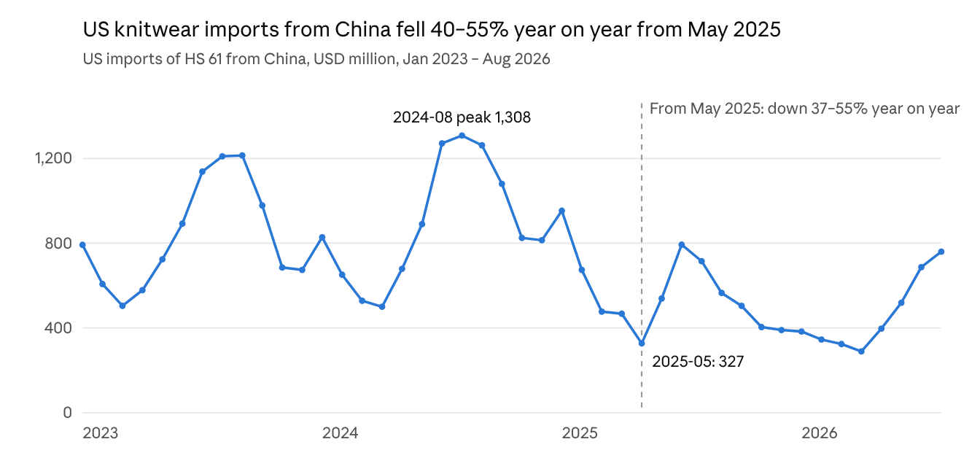
UN Comtrade, US imports of HS 61 from China, monthly
The decline began in May 2025, down 52% year on year, and every month through December was down 37% to 55%. January–August 2026 totaled $3.70 billion, another 25% below the same period of 2025. Since May 2026, however, monthly values have matched or slightly exceeded the same months of 2025, so the decline appears to be leveling off.

Finding 2: Orders moved to Vietnam, Cambodia and others
Total US demand for knitted apparel barely changed; the orders China lost went mainly to Vietnam and Cambodia.
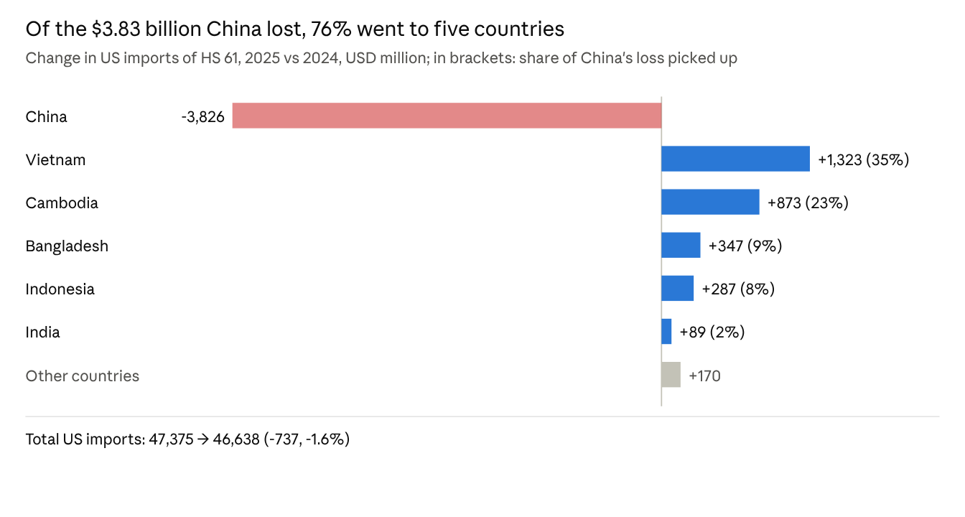
UN Comtrade, US imports of HS 61, annual, 2024–2025
In market share, China fell from 22.4% in 2024 to 14.6% in 2025, Vietnam rose from 18.0% to 21.1%, and Cambodia from 5.9% to 7.9%. Since March 2025, Vietnam's monthly exports to the US have exceeded China's every month.
The shift was even stronger for sweaters (HS 6110). China's sweater exports to the US fell 40%, a loss of $1.09 billion. Cambodia grew 44% and picked up 37% of that loss, more than Vietnam's 24%.

Finding 3: Garments moved, fabric still bought from China
Cambodia and Bangladesh, two of the fastest-growing knitwear exporters to the US, also had the fastest growth in knitted-fabric imports from China, at nearly three times the growth of China's fabric exports worldwide.
Country | China's fabric exports to it, 2023 (USD million) | 2025 (USD million) | Fabric growth | Its knitwear exports to the US, growth 2023→2025
Cambodia | 1,788 | 2,648 | +48% | +52%
Bangladesh | 1,506 | 2,150 | +43% | +23%
Vietnam | 4,775 | 5,270 | +10% | +25%
World (benchmark) | 21,515 | 24,959 | +16% | +3% (total US imports)
In Cambodia the two growth rates move almost together, suggesting its new US orders are likely made with Chinese fabric. Vietnam is the exception: its exports to the US grew 25%, but its fabric imports from China grew only 10%, below the world average. It may rely on local or other sources of fabric. So the "garments moved, fabric stayed in China" pattern holds for Cambodia and Bangladesh, but not for Vietnam.
Source: UN Comtrade, China HS 60 exports, annual; US HS 61 imports, annual totals.

Limitations and next steps
These results show that the tariffs and the order shift happened at the same time; they do not yet prove that the tariffs caused the shift.
- Values only, no quantities. A fall in import value could come from lower volumes or lower unit prices. Six-digit HS data includes piece counts or weights and could separate the two.
- Fabric data is annual only. China's fabric exports to Cambodia and Bangladesh had already risen about 30% in 2024, before the tariffs. This suggests production was already relocating, and the tariffs may have sped it up.
- No controls for other factors. Exchange rates, US retail inventory cycles and capacity changes in each country all affect the results. A difference-in-differences design, using untariffed products as a control group, could isolate the tariff effect.
- US import definitions. Goods transshipped through third countries or with misdeclared origin are counted under the transit country, which may overstate the size of the shift.
Worth watching: China's monthly share fell to a low of 9.6% in March–April 2026, then recovered to 16.8% in August. It is not yet clear whether this is a seasonal rebound or a reversal of the trend. The recovery came after the Supreme Court struck down the IEEPA tariffs in February 2026, which makes it a natural next test of the tariff effect.

Sources
- UN Comtrade: all trade data
- China Briefing: US-China Tariff Rates: 2025–2026 US tariff timeline on China
- White House: Further Modifying the Reciprocal Tariff Rates (EO 14326): August 2025 reciprocal rates by country
- Cornell LII: Learning Resources v. Trump (2026): Supreme Court ruling

