XML2J XML Generator
User Manual version 2.5.0

Table of Contents
1. Overview 3
2. Prerequisites 3
3. Preparation 3
4. Usage 4
4.1. Command Line Options 4
4.1.1. Custom Header -h 4
4.1.2. Custom serialVersionUID -s 4
4.1.3. POM 4
4.2. Configuration 5
4.3. Configuration Examples 7
4.4. Generator Invocation 9
4.5. MessageHandler 9
5. Example 10
5.1. The subst XML schema 10
5.2. Input and runtime configuration 11
5.2.1. Property file substA.prop 12
5.2.2. Property file substABC.prop 12
5.2.3. Property file substCon.prop 13
5.2.4. Property file substConC.prop 13
6. Features and Limitations 14

Overview
This document describes the steps to set up the XML2J XML Generator v. 2.5 and the steps required generating code using the generator.

Prerequisites
To use the XML2J XML Generator 2.5:
- You MUST have Java 1.7 or later.
- You MUST have Saxon XSLT and XQuery Processor: SAXON 6.5.5, which can be obtained here: http://prdownloads.sourceforge.net/saxon/saxon6-5-5.zip. It is also included in the directory libs relative to the xml2j-gen root.

Preparation
Unpack the file xml2j.zip into a local directory on the development workstation.
Define an environment variable XML2J_HOME. This must point to the root of your xml2j-gen installation.

After unpacking within the xml2j-gen directory you will see the following directory structure:

conf | Contains the specification of the generator configuration (XSD). This file is used by the generator to detect errors in the configuration file.
doc | The documentation for the XML2J Generator.
docs | Reference documentation (HTML).
samples | Set of samples (iso20022) illustrating the code generator.
tutorial | A set of examples illustrating the capabilities/features of the XML2J Generator.
xml2j.jar | The generator binary

The Tutorial directory contains a set of examples, designed to illustrate how the code generator maps XML onto Java. Each subdirectory follows the same structure illustrated by the choice example:
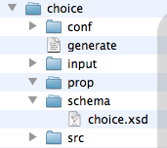

conf | The configuration for the XML2J Generator
docs | The optionally generated Java reference documentation
input | Sample input files (XML)
prop | Property file(s) for this example, used by the example program
schema | The XML Schema, which is both used for validation and by the generator
src | The generated source code

Usage

Command Line Options

Custom Header -h
The header the code generator inserts in the generated source files can be customized, using the -hfilename commandline option.

E.g.
java -jar xml2jg.jar -w ./tutorial/choice -c conf/cfg.xml -s 3 -h custom.txt

/******************************************************************************
-----------------------------------------------------------------------------
XML2J XML to Java code generator
-----------------------------------------------------------------------------
+++++++++++++++++++++++++++++++++++++++++++++++++++++++++++++++++++++++++++++
CUSTOM HEADER * CUSTOM HEADER * CUSTOM HEADER * CUSTOM HEADER * CUSTOM HEADER
CUSTOM HEADER * CUSTOM HEADER * CUSTOM HEADER * CUSTOM HEADER * CUSTOM HEADER
+++++++++++++++++++++++++++++++++++++++++++++++++++++++++++++++++++++++++++++

This code was generated using xml2j v. 2.5.0
License: Lolke B. Dijkstra
Module: CHOICE
Generation date:

******************************************************************************/

In the example above, the file custom.txt contains the following:
+++++++++++++++++++++++++++++++++++++++++++++++++++++++++++++++++++++++++++++
CUSTOM HEADER * CUSTOM HEADER * CUSTOM HEADER * CUSTOM HEADER * CUSTOM HEADER
CUSTOM HEADER * CUSTOM HEADER * CUSTOM HEADER * CUSTOM HEADER * CUSTOM HEADER
+++++++++++++++++++++++++++++++++++++++++++++++++++++++++++++++++++++++++++++

Custom serialVersionUID -s
The option -s followed by a number causes the generator to use that number as the serialVersionUID.
The above command would generate:
/**
* default serial version UID
*/
private static final long serialVersionUID = 3L;
in the source code of the generated classes. This enables the use of difference serialVersionUIDs for different versions of the underlying XML schema.

POM
The pom option generates the Maven pom files for your project. It follows the structure in the configuration file. Following the example in figure 1, it generates a parent pom in the tutorial directory and one pom for each children in the respective sub-directories (choice, zoo).

Configuration
Before you can use the generator to generate code for your project you need to configure it. The configuration file is shown in figure 1.

Figure 1 – Generator Configuration
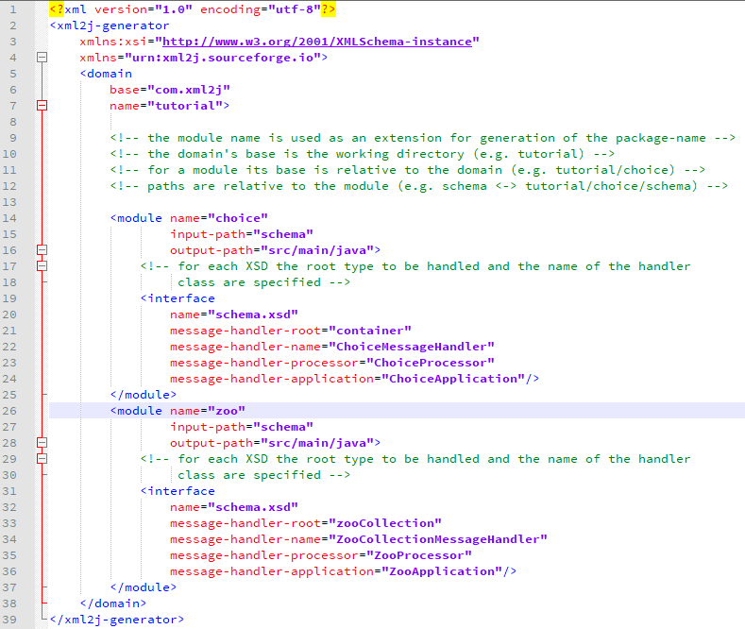
Figure 1 – Generator Configuration Example
To detect errors made during editing, the parser checks the configuration file against the configuration XSD (conf/xml2j.xsd).

The domain is the top level element for your project. Domain attribute name is appended to the Java package name (whose base is com.xml2j by default) and applies for all contained elements. The base package 'com.xml2j' can be changed by using the base attribute. Using the instructions shown in figure 1 the generator generates com.xyz. Per configuration file the generator supports only one domain. To generate code for multiple domains, use multiple configuration files. Both domain.base and domain.name are optional; if name is not present the package is the base package (in this case com.xyz).

The module indicates the module within the domain. The package in which the classes are generated is given by the Java package name followed by the module attribute name (e.g. com.xyz.tutorial.choice). The messageHandler are generated in a subpackage handlers e.g. com.xyz.tutorial.ext.handlers).

For each module the following information must be provided:
name | the module name (see above)
input-path | the directory where the generator looks for the schemata (one per interface)
output-path | the directory where the generator outputs the source code

A module has one or more interfaces, each of which is specified by the interface element.
- Each interface relates to precisely one schema file (XSD).

For each interface the following information is provided:
name | The name of the corresponding schema (XSD).
message-handler-root | The name of the XML element that is the root element of the instance document.
root-type-rename (optional) | The name the type the generator will substitute for the root type. It is used to prevent type name collisions. (This will also change the root-type handler since it is derived from the root-type by appending Handler to the name.)  For example within SEPA for all interfaces (XML Schema files) the type of the root element is ‘Document’ (not to be confused with the name of the root element, which also happens to be Document).  Figure 2 shows it is renamed to be unique. For more information please refer to section 5.4.
message-handler-name | The name of the generated messageHandler class. This class reads the XML document from an input source.
message-handler-processor  (optional) | The name of the (optionally) generated MessageProcessor class.
Message-handler-runnable  (optional) | The name (optionally) of the runnable class that is generated. The runnable class extends ParserRunnable, which implements Runnable.
Message-handler-application-task (optional) | The name (optionally) of the application task class.
message-handler-application  (optional) | The name of the (optionally) generated ParserApplication class.  - If message-handler-application is not present, no main is generated.  - If both runnable and application are specified, the generator generates a sample main using multi-threading.  - If both message-handler-application-task and message-handler-application are present, the generator generates a sample main with no threading.  - If only message-handler-application is present (no runnable and no application-task) then the generator assumes message-handler-application-task = message-handler-application + “Task”

The messageHandler automatically positions at the message-handler-root (which is the first element in the hierarchy that is processed).

As of version 2.4 the application class does no longer contain the generated main function, instead the main is generated as part of the ApplicationMain class.

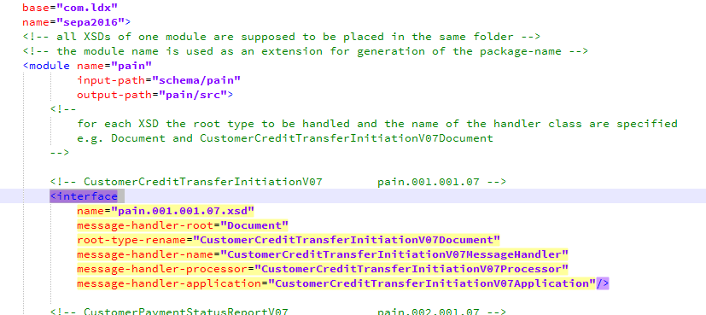
Figure 2 – Generator Configuration

According to the example configuration, the XML2J Generator reads the schemata from the subdirectory sepa/schema and generates the sources into subdirectory sepa/pain/src.

The highlighted section in Figure 2 illustrates the usage of the optional message-handler-application and message-handler-processor attributes. In this case (because runnable is not specified) the main application is generated using a just the main thread. A main task is assumed (because message-handler-application-task is not specified) to take the name CustomerCreditTransferInitiationV07ApplicationTask.

Configuration Examples
Example 1:
Generate code for all of the pain messages in a package named com.mycompany.sepa.payments.
To do this domain@base would be 'çom.mycompany' and module@name would be ‘payments’ instead of ‘pain’.
Example 2:
Generate all of the pain and pacs messages in a package named com.xml2j.sepa.payments.
To do this for each of the pacs XSD files an interface element must be added to the configuration file.

Three more examples:
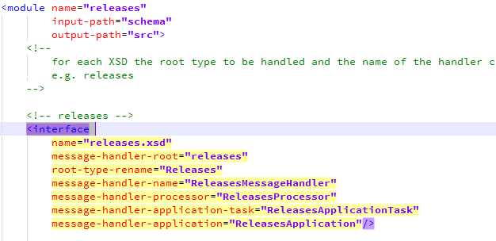
In this example both message-handler-application and message-handler-application-task are specified, the generator generates the application-task and main with the task directly used within the main thread.

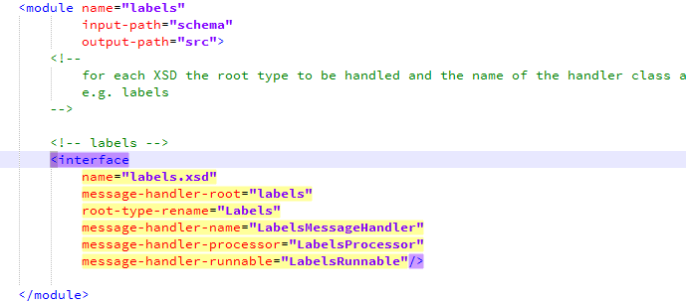
In this example the generator generates a runnable, which can be used in multiple threads, but no main is generated.
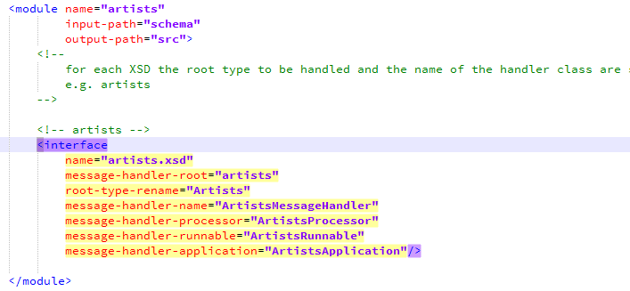
In this example the application is generated and adds a runnable parser task to a thread pool (using DefaultThreadManager).

Generator Invocation
Once configured, using the generator from the command line/terminal window is straightforward.
Assuming Java has been properly set up, at the prompt type the following command:

The xml2j.jar is the generator. The generator takes the following options:

-c | the name of the configuration the generator should use
-p | instructs the code generator to include the methods for printing (the default is to exclude them)

XML2J_HOME which is to be set to the path where XML2J is installed.

MessageHandler
The message-handler-root tells the generator which element is the root element. By default the generator uses the corresponding type name from the XML schema to generate the Java data class and Java handler class. However, in the case of SEPA in every XML schema the root type is Document. Consequently, following the default, the generator would overwrite the messageHandler for every schema (i.e. pain.001, pain.002, etc.)! For SEPA the best way to prevent this from happening is by instructing the generator to use an alternative name for the type using the root-type-rename attribute. For example (fig. 1) the generator substitutes Pain001V03Document for type Document in the case of pain.001.001.03.xsd. This is because within the standard all types have unique names, except for the root type. An alternative often used is a different module for each interface/schema. The module's name is then used to create the fully qualified name of the class.

Example
In this section we illustrate different runtime configurations by examining the subst example. You can find this example in the tutorials subdirectory.

The subst XML schema
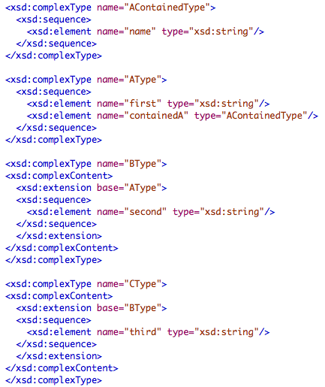
The above excerpt illustrates the family of types AType, BType and CType of which AType is the super type. In Java we modelled this using an extends relationship.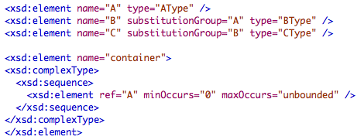
The element declaration section tells the Schema processor that B and C may be substituted wherever A occurs. The precondition for such element substitution being that the corresponding sub types are extensions from the base type.

The final container type embeds a collection of A elements.
Now let’s have a quick look at the generated Java code:
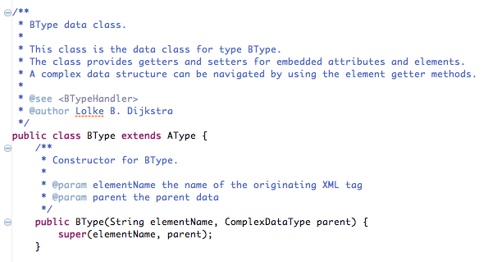
We find that the BType extends AType. Further within the container class there is a list of AType, resembling the XML Schema model.

Input and runtime configuration
Now we have a look at the input:
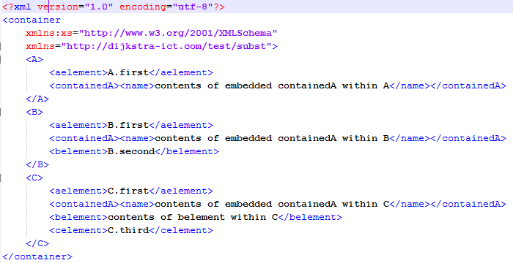
We see that we have a container with tree elements, one of each type. The processor we built just prints out the Java objects sent by the framework.

We can run this sample in a variety of ways:

Property file substA.prop
Configuration:
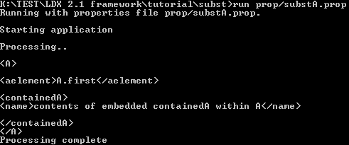
# process A
container/A/@detach=true
container/A/@process=true

This tells the framework two things:
- “A” should be detached from its parent container
- “A” should be processed (that is sent to the processor)

Output:

Property file substABC.prop
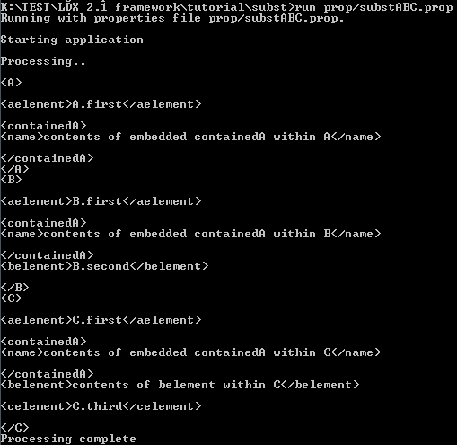
Configuration:
# process A
container/A/@detach=true
container/A/@process=true

# process B
container/B/@detach=true
container/B/@process=true

# process C
container/C/@detach=true
container/C/@process=true

Property file substCon.prop

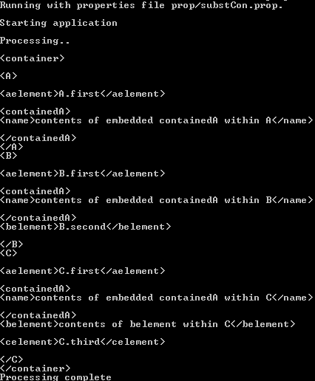
Configuration:
# process container
container/@process=true

Command:
Java -jar subst.jar input/subst.xml schema/subst.xsd prop/substCon.prop

Property file substConC.prop
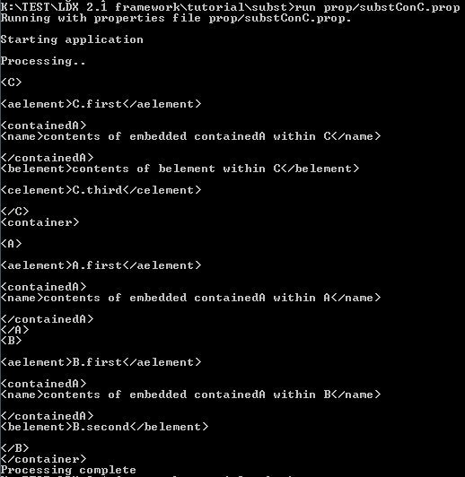
Configuration:
# process container
container/@process=true

# process C
container/C/@detach=true
container/C/@process=true

This one is interesting: it tells the framework to process the container, and to process and detach C. Both A and B will be contained in the container, whereas C will be processed separately.

Features and Limitations
Currently not supported:
- XML anyType, union, list
- import within schemata
- targetNamespace other than the default

