Grace Wesson & Victoria Tonsall-Mitchell

### CEO gender effects on stock performance

Through answering each of the following questions, Team Awesome seeks to answer if appointing a female CEO impacts the performance of stocks, for publicly traded companies:

1. **Is there an immediate impact on stock performance? Is it positive or negative?**
   1. **We found stocks initially remained flat or had small decreases after a female CEO was selected, and some companies began to show a rebound around month two.** 
      1. 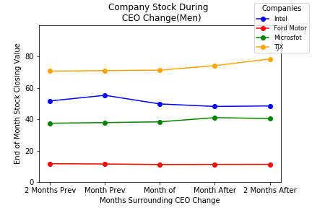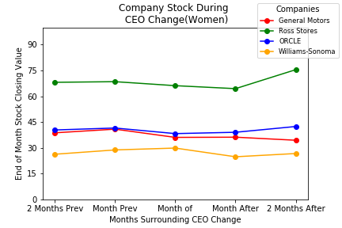
2. **Are there differences in changes across industries? (plotting changes by industry)**
   1. **Change across industry is inconclusive with this dataset. Additional research is needed to truly indicate if particular industries are more or less impacted by CEO gender.** 
      1. 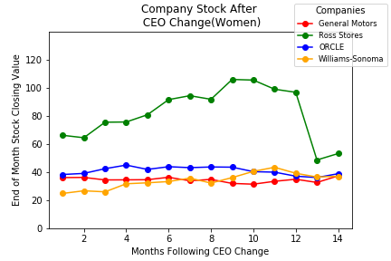
3. **Is there a long-term effect on stock changes?** 
   1. **Similar to question two, additional research is needed, but we did find there is actually a slight improvement in stock prices of companies headed by female CEOs.**

### The Companies

Using the 2019 Fortune 500 list, we selected 20 publicly traded companies; 10 with female CEOs and 10 with male CEOs. The companies range in industries from technology, to insurance, to retailing.

For each company headed by a female CEO, we selected a company in the same, or closely related industry, headed by a male CEO. Doing so allowed us to compare companies who attract similar investors.

### Stock Information

Constructing an API call allowed us to pull historical and current stock data to use in drawing comparisons and contrasts in stock performances over time. With this information, we were able to show stock performances before and after the appointing of female CEOs as compared to companies who were run by male CEOs.

### Data Limitations

One of the key limitations of our data set is there is no way to determine how other factors influenced changes in stock behavior. Other factors could include economic downturns, consumer confidence, employment rates, and individual company history and performance.

### Conclusions

With our current dataset, the hypothesis is inconclusive. Additional refinements are needed to deliver a conclusive answer as to how, if at all, a CEO’s gender effects the performance of a company’s stock. Such changes to the data set would be expanding the scope to more companies, choosing companies outside of the Fortune 500, and taking a deeper look into industry specific changes. Additionally, we found that although minor changes could be seen in monthly closing prices, daily stock data would most likely provide a stronger insight into the immediate reactions of investors.